**Setting up a Springboot App with Eureka**

1. Go to <https://start.spring.io/> or Navigate to STS (Spring Tool Suite): STS > File > Spring Starter Project

Showing Example from STG:

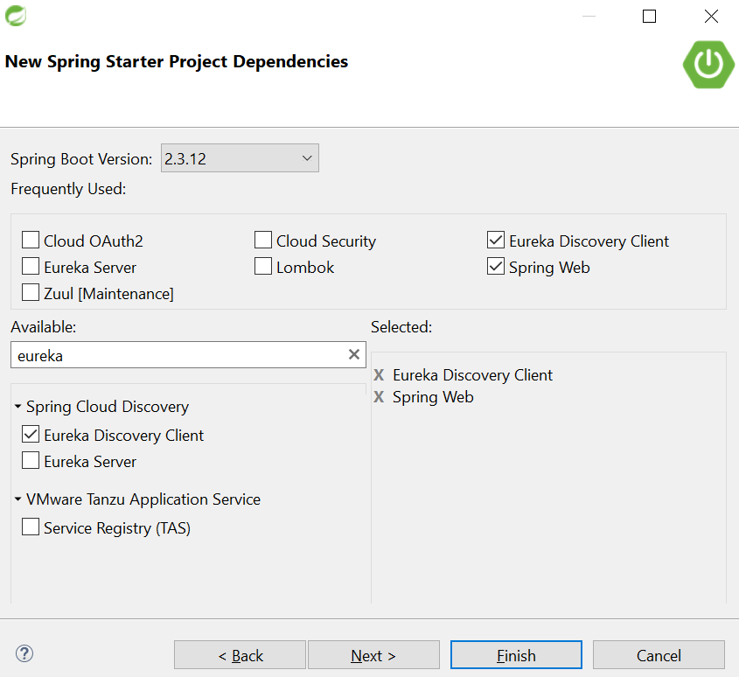

1. Add the Dependencies as shown above.
2. Project will be download within the STS.
3. Go to application.properties and add app name-

spring.application.name=Order-Service



1. Create application.yml and add below –

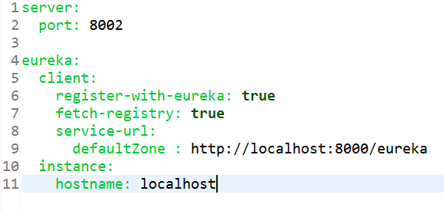

1. Eureka is now set up.