High-Level Design (HLD)
Darviq-Buzz: A Social Platform Built as
Microservices
Polyglot persistence (PostgreSQL + Apache Cassandra), event-driven fan-out (RabbitMQ),
and real Prometheus + Alertmanager observability

Document Title | Darviq-Buzz -- High-Level Design
Prepared For | Portfolio / DevOps-SRE Practice Platform
Prepared By | Ravi Shekhar Gurram
Version | 1.0
Repository | D:/Projects/Social/Darviq-Buzz (local; not yet pushed to a remote)

Document Control

Solution Identification
Field | Value
Product / Solution Name | Darviq-Buzz
Sponsor / Context | Personal portfolio -- microservices, polyglot persistence, and observability practice
Author | Ravi Shekhar Gurram
Classification | Internal / Portfolio -- not for production use

Revision History
Version | Date | Author | Description
0.1 | 2026-09-20 | Ravi Shekhar Gurram | Initial draft covering architecture, polyglot persistence, event backbone, and access management
1.0 | 2026-09-20 | Ravi Shekhar Gurram | Finalized after live verification of the full user journey, fan-out-on-write, and alerting

Approval
Name | Role | Date | Signature
Ravi Shekhar Gurram | Author / Reviewer | 2026-09-20 | (self-reviewed -- portfolio project)

Table of Contents
Right-click here and choose 'Update Field' to generate the Table of Contents.

References, Definitions, and Abbreviations

References
Ref | Description
R1 | Repository README.md -- architecture, running instructions, verification notes
R2 | services/*/models.py -- per-service schema definitions (Postgres/Cassandra)
R3 | prometheus/alerts.yml -- alert rule definitions
R4 | k8s/network-policies.yaml -- NetworkPolicy definitions for the homelab deployment

Definitions
Term | Definition
Fan-out-on-write | Precomputing each follower's feed at post-creation time (one Timeline row per follower) instead of assembling it at read time
Partition read | A Cassandra query that reads a single partition key -- the cheapest, most scalable query shape in Cassandra
Trusted internal caller | A service (here, web-bff) that asserts an already-verified identity header directly, rather than re-verifying a JWT on every call
Business account | A User row with account_type=business plus category/contact fields -- reuses the same follow/post/feed machinery as a personal account

Abbreviations
Abbreviation | Meaning
BFF | Backend for Frontend
JWT | JSON Web Token
TTL | Time to Live
DM | Direct Message
SLO | Service Level Objective
FK | Foreign Key
CRUD | Create, Read, Update, Delete

1. Overview

1.1 Background
A previous single-Flask-app version of this project had genuinely well-designed domain logic (auth, feed assembly, follow/friend graphs, reactions, comments, reposts, hashtags, stories, DMs) but its templates, static assets, Helm chart, Terraform, Ansible, and tests were completely empty -- the app could not render a single page despite claiming to be verified end-to-end. This project is a from-scratch rebuild: the real domain logic was ported into a proper microservices architecture, and a genuinely working, browser-usable application was built and verified on top of it.

1.2 Solution Summary
Darviq-Buzz is an 11-service microservices application built as a deliberate practice platform for polyglot persistence, event-driven architecture, and observability -- not merely "a working app." PostgreSQL backs the three services that need ad hoc filtering and simple read-after-write consistency on modest tables (users, notifications, media); Apache Cassandra backs the six services with genuinely partition-friendly, high-write social data (social graph, posts, engagement, stories, messaging, feed). RabbitMQ decouples the write path from its side effects: creating a post does not block on fanning it out to every follower's feed or notifying anyone who reacts to it.

1.3 Scope of Document
This HLD covers the full application: service decomposition, the polyglot persistence rationale, the event-driven fan-out-on-write feed architecture, access management between services, scalability characteristics, and the metrics/alerting layer. It reflects the application as verified locally via Docker Compose and, separately, as deployed to a homelab Kubernetes cluster (see Section 6 for what differs between the two).

1.4 Assumptions and Dependencies
- Docker and Docker Compose are available for local verification; a Kubernetes cluster (kind, in this project's case) is required for the homelab deployment path.
- No external identity provider is used -- user-service issues and verifies its own JWTs.
- RabbitMQ, Postgres, and Cassandra are each single-instance for this practice deployment; the architecture does not assume clustering for any of them.
- media-service's S3 upload path requires real AWS credentials to exercise; without them it deliberately and correctly falls back to local disk storage.

1.5 Exclusions
- A native mobile client -- the gateway's JWT-based API surface is designed for one, but none is built yet.
- Multi-region or multi-cluster deployment -- out of scope for a homelab practice platform.
- A production-grade CI/CD pipeline for the 11-service architecture -- the previous single-container design's Jenkinsfile/Helm/Terraform/Ansible are stale and explicitly deferred.

2. Solution Architecture

2.1 Logical Architecture
web-bff serves real, server-rendered pages directly to the browser and is a trusted internal caller of every other service -- it asserts an already-authenticated session's username via an X-User-Username header rather than re-verifying a JWT on every call, the same trust model a search-service calling a catalog-service directly would use. A separate gateway (JWT verification + reverse proxy) exists as the external-facing API surface for a future mobile or third-party client; web-bff does not go through it.
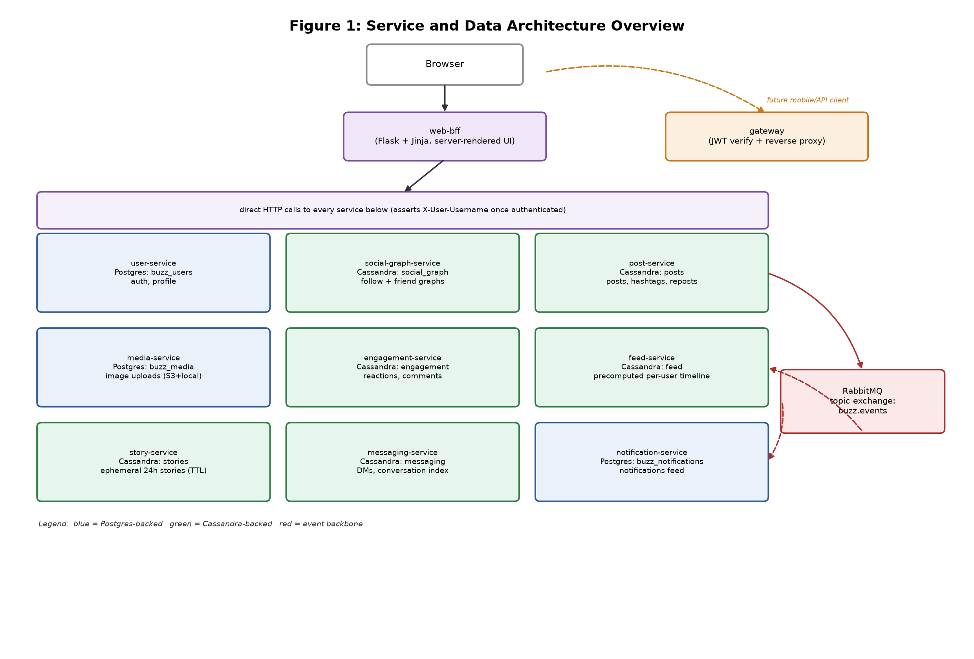
Figure 1: Service and data architecture overview

2.1.1 Component Description

2.1.1.1 web-bff
Flask + Jinja, real server-rendered UI (not a JSON API with a placeholder frontend). Holds the JWT in a signed server-side session cookie -- the browser never sees it -- and attaches it as an Authorization header on calls it makes on the user's behalf.

2.1.1.2 user-service, notification-service, media-service (Postgres)
These three own the data Cassandra is genuinely a poor fit for: a user's own profile row (read-after-write consistency matters immediately after signup/edit), a paginated notifications list with a read/unread flag, and a media asset registry that needs ad hoc lookups. This is a deliberate architectural split, not two databases for the sake of it -- see each service's models.py for the schema-level reasoning.

2.1.1.3 social-graph, post, engagement, story, messaging, feed-service (Cassandra)
Six services on genuinely partition-friendly, high-write social data: the follow and friend graphs, posts/hashtags/reposts, reactions and comments, ephemeral TTL-based stories, direct messages with a deterministic conversation-id index, and the precomputed per-user timeline. Every one of these is queried by a single, known partition key in the hot path -- exactly the shape Cassandra rewards.

2.1.1.4 RabbitMQ (topic exchange: buzz.events)
Decouples post-service (and others) from the side effects of a write: fanning a post out to every follower's feed, and notifying users of likes/comments/follows/friend requests. Each event is consumed independently by feed-service and notification-service; a slow or down consumer does not block the publisher.

2.2 Interface Description
Interface | Protocol | Direction | Purpose
Browser -> web-bff | HTTPS, server-rendered HTML | Client -> App | The actual application UI
web-bff -> every service | HTTP + X-User-Username header | Internal | Trusted-caller pattern, no re-verification of the JWT
Future client -> gateway | HTTPS + JWT Bearer token | External API | External-facing surface (mobile/3rd-party), not used by web-bff
post-service -> RabbitMQ | AMQP, topic exchange buzz.events | Publish | post.created, post.reposted, post.liked, post.commented
RabbitMQ -> feed-service / notification-service | AMQP consume | Subscribe | Fan-out-on-write and notification generation
Every service -> Prometheus | HTTP GET /metrics | Scrape | Request count + duration, plus service-specific metrics

2.3 Deployment Architecture
Two verified deployment paths exist for this application, exercising different parts of the stack:
Path | What it verifies
docker compose up -d --build (local) | The full 11-service stack, all 3 datastores, RabbitMQ, and Prometheus/Alertmanager, with the complete browser user journey exercised live
Homelab Kubernetes (kind) | Real container-orchestration concerns: resource limits, liveness/readiness probes, NetworkPolicies, in-cluster DNS, and rolling updates -- see Section 6 for the specific issues this surfaced and how they were fixed

2.4 Redundancy and Resilience
This is a single-replica practice deployment, not a highly-available production system. Resilience decisions made deliberately at this scale: RabbitMQ consumers ack/nack each message independently (one slow fan-out does not stall the whole consumer thread), and Cassandra's own replication (configured for a 3+ node cluster in a real deployment; single-node here) is what would provide durability at production scale, not application-level retry logic.

3. Data Architecture

3.1 Why Postgres and Cassandra Together
The split is drawn by actual data-access pattern, not an arbitrary rule of "some SQL, some NoSQL":
Need | Cassandra's fit | Postgres's fit
Ad hoc filtering / pagination on a modest table | Poor -- requires denormalizing or a secondary index workaround | Native
Immediate read-after-write consistency for one row | Eventually consistent by default at usable write levels | Native
Very high write volume, always queried by one known partition key | Excellent -- this is Cassandra's designed use case | Works, but doesn't scale writes the same way
user-service, notification-service, and media-service land in the left column of needs; social-graph-service, post-service, engagement-service, story-service, messaging-service, and feed-service land in the right.

3.2 The Fan-Out-on-Write Feed
The original design assembled a feed at read time: fetch every followed user's recent posts, merge, and sort in application code -- real, but it only scales to personal-app traffic. feed-service now precomputes the feed at write time instead.
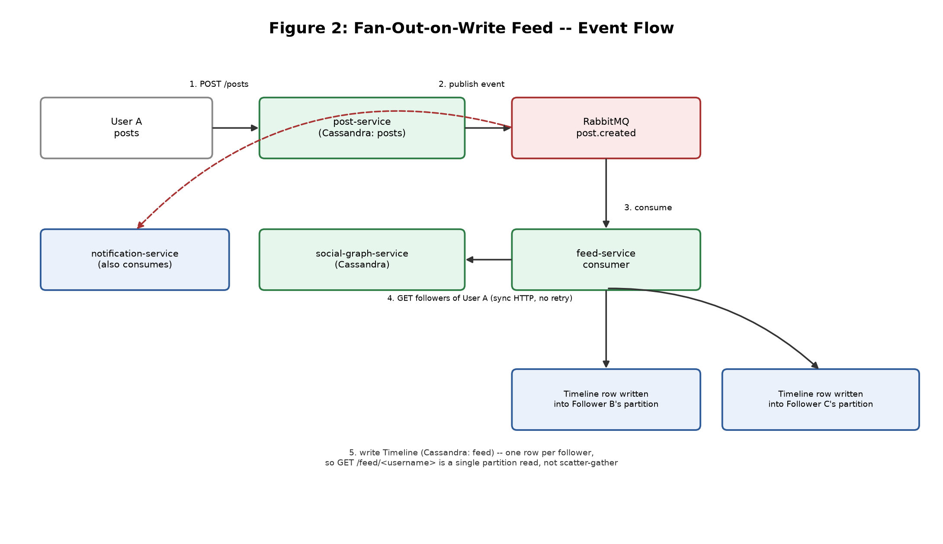
Figure 2: Fan-out-on-write feed -- event flow
post-service publishes post.created/post.reposted; feed-service consumes the event, looks up the author's followers via social-graph-service, and writes one Timeline row into every follower's own Cassandra partition. Reading a feed (GET /feed/<username>) is then a single partition read, not a scatter-gather across every followed user.

3.3 Data Model Summary
Service | Store | Key entities
user-service | Postgres: buzz_users | User (auth, profile, account_type, business fields)
social-graph-service | Cassandra: social_graph | Following/Followers, FriendRequest/Friendship
post-service | Cassandra: posts | Post, Hashtag, Repost
engagement-service | Cassandra: engagement | Like (6 reaction types), Comment
story-service | Cassandra: stories | Story (TTL-based ephemeral)
messaging-service | Cassandra: messaging | Message, ConversationIndex
feed-service | Cassandra: feed | Timeline (precomputed per-user feed)
notification-service | Postgres: buzz_notifications | Notification (recipient, actor, type, read)
media-service | Postgres: buzz_media | Media asset registry (bytes on S3 or local disk)

4. Access Management

4.1 Authentication
user-service issues and verifies its own JWTs (7-day expiry) at registration and login. Passwords are hashed with bcrypt (12 rounds) and are subject to a strict policy enforced both client-side (immediate feedback) and server-side (the actual authority): minimum 10 characters, at least one uppercase letter, one lowercase letter, one digit, and one special character.

4.2 Trusted-Caller Pattern (web-bff)
web-bff holds the session's JWT server-side and asserts the authenticated username via an X-User-Username header on every internal call, rather than re-verifying the JWT on every hop. Every backend service trusts this header implicitly because web-bff is the only caller reaching it directly on the internal network (enforced by Kubernetes NetworkPolicies in the homelab deployment -- see Section 4.4).

4.3 External API Surface (gateway)
gateway verifies the JWT itself (the caller here is untrusted, e.g. a future mobile app) and forwards the same trusted X-User-Username header downstream once verified -- the same header contract web-bff uses, so a service does not need to know or care which trusted caller it came from.

4.4 Network-Level Access Control
The homelab Kubernetes deployment adds Kubernetes NetworkPolicies restricting which pods may reach Cassandra, Postgres, and RabbitMQ -- for example, cassandra-allow-app-services permits ingress only from the specific services (and the one-shot keyspace-init Job) that actually need to reach it, denying every other pod in the namespace by default.

4.5 Least Privilege in Practice
A concrete bug found during the homelab deployment illustrates this being enforced for real, not just declared: the keyspace-init Job's pod had no app label, so it did not match the NetworkPolicy's selector even though the policy's author had already listed it as an intended allowed source -- its traffic was silently dropped until the Job's pod template was given the matching label. See Appendix C.

5. Observability: Metrics and Alerts

5.1 Metrics
Every service exposes GET /metrics in Prometheus format: request count and duration histograms labeled by service/route/status, plus service-specific metrics where they matter (feed-service's fan-out duration and follower-count histograms; media-service's upload duration and S3-vs-local-fallback counter).

5.2 Alert Rules
Alert | Trigger | Status
ServiceDown | up == 0 for 15s | Verified live: stopped a container and watched it fire within ~25s, then clear on restart, including the resolve transition
BuzzAvailabilitySLOFastBurn / SlowBurn | Multi-window burn-rate against a 99.9% availability SLO | Same pattern as the equivalent Nyaya-Setu alert
BuzzLatencySLOBreach | P99 latency < 1s SLO breach | Written, not live-triggered
FeedFanoutStalled / NotificationConsumerStalled | Async-pipeline health checks | Honestly documented as unable to distinguish "broken" from "genuinely quiet" at low traffic
MediaS3FallbackRateHigh | S3 fallback rate above threshold | Fires by default in local dev (no real AWS credentials) -- correct behavior, not a bug

5.3 Alertmanager
Routes every alert to a no-op default receiver -- enough to observe the firing/resolved lifecycle in Alertmanager's own UI without wiring a real Slack/email/PagerDuty target for a local practice stack.

6. Scalability
Growth dimension | What happens
More users/posts | Cassandra's partition-per-entity model (one partition per user's timeline, per conversation, etc.) scales horizontally by adding nodes -- no design change needed
More reads on the feed | Already O(1) partition reads thanks to fan-out-on-write; read load does not grow with the number of accounts a user follows
More event volume | RabbitMQ consumers ack/nack per-message independently; feed-service and notification-service scale by adding consumer replicas, not by redesigning the queue
More services | The trusted-caller header pattern and per-service database ownership mean a new service integrates without touching existing ones' schemas

6.1 What the Homelab Deployment Surfaced (real, not theoretical)
Deploying to Kubernetes surfaced genuine resource-sizing and platform issues that a pure Docker Compose run never would have -- documented here because they are part of this system's real operational behavior, not swept under the rug:
- user-service's CPU limit (200m) was throttling bcrypt's deliberately CPU-hard password hashing to 2.2 seconds per hash; raised to 1000m dropped it to ~0.27s.
- Every Flask service ran its dev server single-threaded (no threaded=True), so a real request could queue behind a Kubernetes health-check probe hitting the same pod.
- An intermittent in-cluster DNS resolution failure (a known glibc-resolver race under load) caused sporadic "service unavailable" errors; fixed with the standard Kubernetes-documented mitigation (dnsConfig.options: single-request-reopen) plus a short application-level retry as a second line of defense.

7. Known Limitations and Future Work
- feed-service's synchronous call to social-graph-service (inside the RabbitMQ consumer) has no retry or circuit breaker -- a slow/down social-graph-service stalls that one fan-out, not the whole consumer, but the fan-out itself is not retried.
- No cross-service foreign keys (e.g. a notification's recipient_username is not a real FK into user-service's table) -- a deleted user leaves orphaned rows elsewhere. A real microservices tradeoff, not a bug to fix with a shared database.
- user.followed/friend.request_* style events are fire-and-forget with no transactional outbox -- a down RabbitMQ at publish time means the event is simply never seen.
- The homelab k8s manifests, Jenkins pipeline, GitOps, and infra-as-code for this 11-service architecture are a deferred follow-on phase; the previous single-container design's equivalents are stale.

8. Deliverables and Artifacts
Repository: D:/Projects/Social/Darviq-Buzz (git-tracked locally).

8.1 Repository Layout
Path | Contents
services/<name>/ | 11 Flask services, each with its own models.py, app.py, requirements.txt, Dockerfile
postgres/init.sql | Creates the 3 Postgres databases on first container start
k8s/ | Homelab Kubernetes manifests: namespace, all 11 deployments/services, NetworkPolicies, Cassandra/RabbitMQ/Postgres
prometheus/alerts.yml | Alert rule definitions
alertmanager/alertmanager.yml | Alertmanager routing config
docker-compose.yml | Full local stack: all 3 datastores, RabbitMQ, all 11 services, Prometheus, Alertmanager

8.2 How to Run It
docker compose up -d --build
# App is at http://localhost:8000 -- sign up, everything works, no manual seeding

Appendix A: Service Inventory
Service | Port | Store
web-bff | 8000 | -- (session only)
gateway | 5000 | -- (JWT verify + proxy)
user-service | 5001 | Postgres
social-graph-service | 5002 | Cassandra
post-service | 5003 | Cassandra
engagement-service | 5004 | Cassandra
story-service | 5005 | Cassandra
messaging-service | 5006 | Cassandra
feed-service | 5007 | Cassandra
notification-service | 5008 | Postgres
media-service | 5009 | Postgres

Appendix B: Reaction Types
engagement-service supports 6 reaction types on a post (richer than a single generic "like"): like, love, haha, wow, sad, angry.

Appendix C: Verification Evidence
Layer | Status
Full user journey (Docker Compose) | Verified live via real HTTP requests with cookie sessions: register, login, post (text + image), react, comment, repost, follow, send/accept a friend request (confirmed the auto-follow side effect), post a story, send a DM, see a notification appear, mark all read
Fan-out-on-write | Verified live: posted as one user, confirmed the post appeared in a different, already-logged-in follower's precomputed feed without that follower's own action
ServiceDown alert | Verified live: stopped a container, watched the alert fire in Prometheus within ~25s, confirmed the resolve transition on restart
Homelab Kubernetes deployment | Verified live end-to-end after fixing 4 real bugs surfaced only by actually deploying: probe timeouts too short for cqlsh/rabbitmq-diagnostics, a NetworkPolicy label mismatch on the keyspace-init Job, bcrypt CPU throttling, and an intermittent in-cluster DNS resolution failure
Strict password policy | Verified live: a weak password is rejected with the exact list of missing requirements; a compliant one succeeds

