High-Level Design (HLD)
Scalable Disk Monitoring Solution for Multi-Account AWS Environments
Ansible-first design, leveraging AWS Systems Manager and CloudWatch

Document Title | RCP-Style HLD: Scalable Disk Monitoring Solution for AWS
Prepared For | Solutions Architect Assignment
Prepared By | Ravi Shekhar Gurram
Version | 1.0
Repository | https://github.com/ravishekharg/aws-disk-monitoring

Document Control
Solution identification
Product / Solution Name | Scalable Disk Monitoring Solution for AWS
Sponsor / Context | Solutions Architect interview assignment
Author | Ravi Shekhar Gurram
Classification | Public (submitted via public GitHub repository)

Revision history
Version | Date | Author | Description of Change
0.1 | 2026-09-18 | Ravi Shekhar Gurram | Initial draft covering architecture, access management, data collection/aggregation, and scalability
1.0 | 2026-09-18 | Ravi Shekhar Gurram | Finalized for submission; added live-verification evidence (Appendix C) after running the solution end to end against a mock AWS endpoint

Approval
Version | Date | Approver | Role | Remarks
1.0 | 2026-09-18 | N/A | Self-submitted assignment | For interview review

Table of Contents
Right-click here and choose 'Update Field' to generate the Table of Contents.

References, Definitions, and Abbreviations

References
Ref | Title | Location
[1] | Assignment brief: Scalable Disk Monitoring Solution for Cloud Environments | Provided by interviewer
[2] | Solution repository (Ansible roles, IaC, demo script) | https://github.com/ravishekharg/aws-disk-monitoring
[3] | AWS Systems Manager (SSM) documentation | https://docs.aws.amazon.com/systems-manager/
[4] | AWS Organizations - Cross-account roles | https://docs.aws.amazon.com/organizations/
[5] | Ansible amazon.aws / community.aws collections | https://docs.ansible.com/ansible/latest/collections/amazon/aws/

Definitions
Term | Definition
Hub / Automation account | The single AWS account that hosts the Ansible control node and the IAM role used to reach every other account
Spoke / Member account | An AWS account containing monitored VMs (one per acquired business unit in this scenario)
Rollup metric | A CloudWatch metric published without a per-instance dimension, used so one alarm can cover an entire account regardless of VM count
Enrollment | The process by which a newly launched VM becomes eligible for monitoring (verified + tagged)

Abbreviations
Abbreviation | Full Form
IAM | Identity and Access Management
SSM | AWS Systems Manager
STS | AWS Security Token Service
OU | Organizational Unit (AWS Organizations)
SNS | Simple Notification Service
HLD | High-Level Design
CNF | Cloud-Native Function (used generically here for a monitored workload)
IaC | Infrastructure as Code
MTTR | Mean Time To Repair

1. Overview

1.1 Background
The organization operates a large multi-cloud estate, grown through a series of acquisitions. It manages multiple AWS accounts, Azure subscriptions, and GCP projects, each with numerous virtual machines (VMs). Leadership has raised concerns that a disk-space exhaustion event on any of these VMs could lead to unplanned downtime, and has asked for a monitoring solution that catches this early -- built on the existing Ansible configuration-management stack, bringing in cloud-native services only where they provide a substantial, clearly justified benefit over what Ansible alone can do.

1.2 Solution Summary
This document designs that solution for AWS (the provider chosen for this exercise; the same access-management and scaling patterns generalize to Azure/GCP with their respective equivalents -- see Section 1.6). Ansible remains the tool that actually collects and computes disk utilization, using its own fact-gathering rather than a new monitoring agent. AWS Systems Manager (SSM) replaces SSH for connectivity across every account, removing key management entirely. CloudWatch is adopted -- and only CloudWatch -- as the aggregation/alerting layer, because it is the one piece genuinely outside what Ansible itself can provide: real-time alarming, historical retention, and a single cross-account dashboard.

1.3 Scope of Document
This HLD covers the AWS implementation end to end: cross-account access management, VM discovery and enrollment, disk-usage collection, metric aggregation and presentation, alerting, and the mechanisms that let the solution scale as accounts and VMs are added. It does not cover the Azure/GCP-specific implementations, nor does it cover monitoring dimensions other than disk utilization (CPU, memory, network) -- those would follow the same architecture with additional collected facts.

1.4 Architecture / Design Decisions and Assumptions
- AWS Organizations is already in use (or can be adopted) to group the acquired companies' accounts under one management account.
- Every monitored VM's AMI/launch template ships the SSM Agent (true for Amazon Linux 2/2023 and current Ubuntu/Debian AMIs, and for any custom golden AMI built with it included) -- see Section 3.1 for why this is a hard prerequisite, not a soft one.
- Disk-space thresholds (80% warning / 90% critical) are a reasonable organization-wide default; individual accounts can override them via Ansible group_vars without changing the underlying design.
- A single monitoring/observability AWS account is designated to host the cross-account CloudWatch dashboard.
- Windows VMs are out of scope for the reference implementation but are addressed as a documented extension (Section 9).

1.5 Dependencies
- AWS Organizations must be configured with the target accounts under a monitored OU.
- Ansible control node (or CI/CD runner) with network egress to AWS APIs.
- Ansible collections: amazon.aws, community.aws, ansible.posix (see repository requirements.yml).

1.6 Exclusions
- Azure Subscriptions and GCP Projects -- explicitly out of scope per the assignment brief, which asks for one provider.
- Third-party monitoring platform evaluation -- explicitly excluded by the assignment's stated leadership preference.
- SNS topic/subscription provisioning -- referenced by this design but not created by the reference implementation (see Section 8, Known Limitations).

2. Solution Architecture

2.1 Logical Architecture
The solution follows a hub-and-spoke pattern. One Automation (hub) account runs the Ansible control node; every business unit's AWS account is a member (spoke) account containing the monitored VMs. Figure 1 shows the account-level relationships; Figure 2 shows the collection-to-alerting data flow inside one member account.
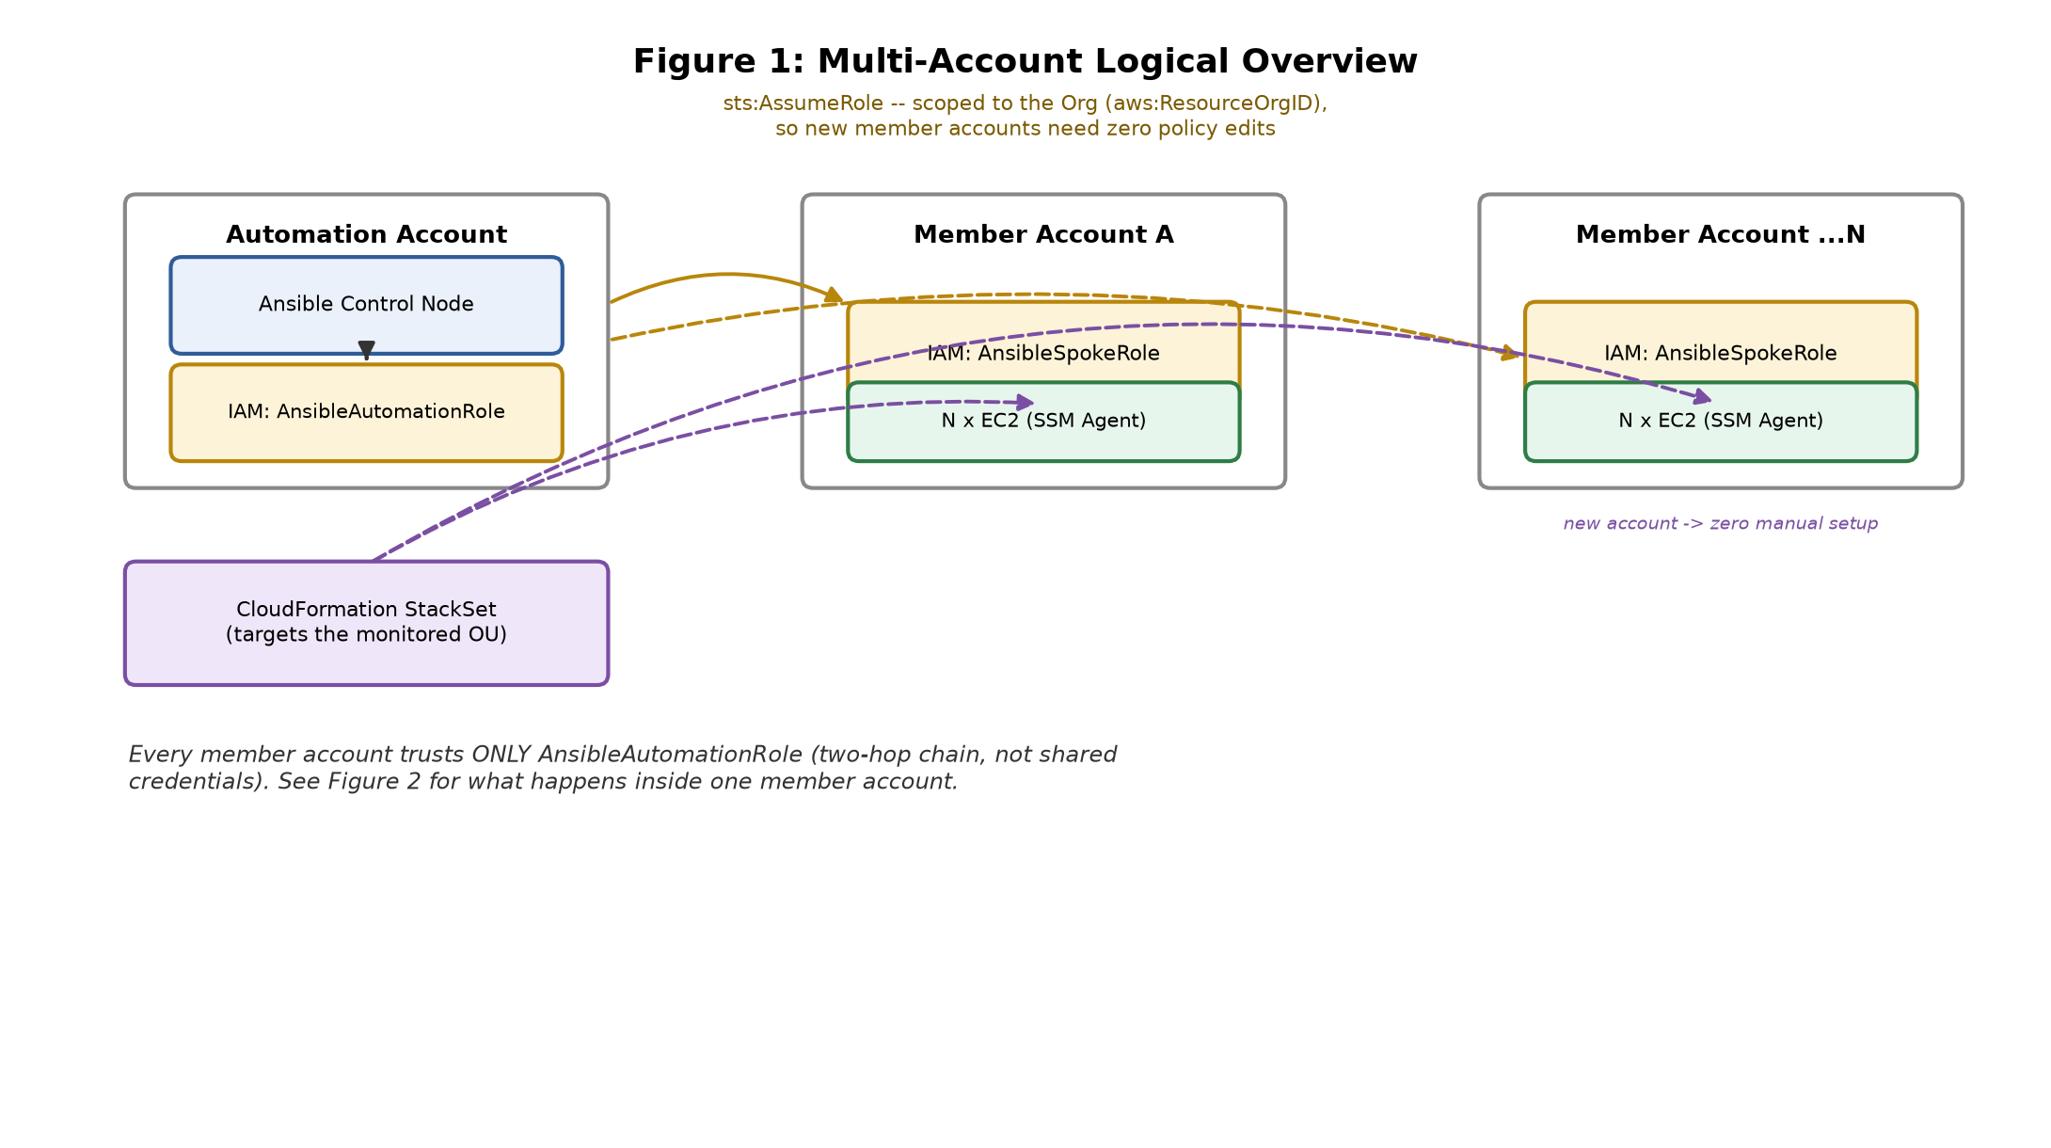
Figure 1: Multi-account logical overview

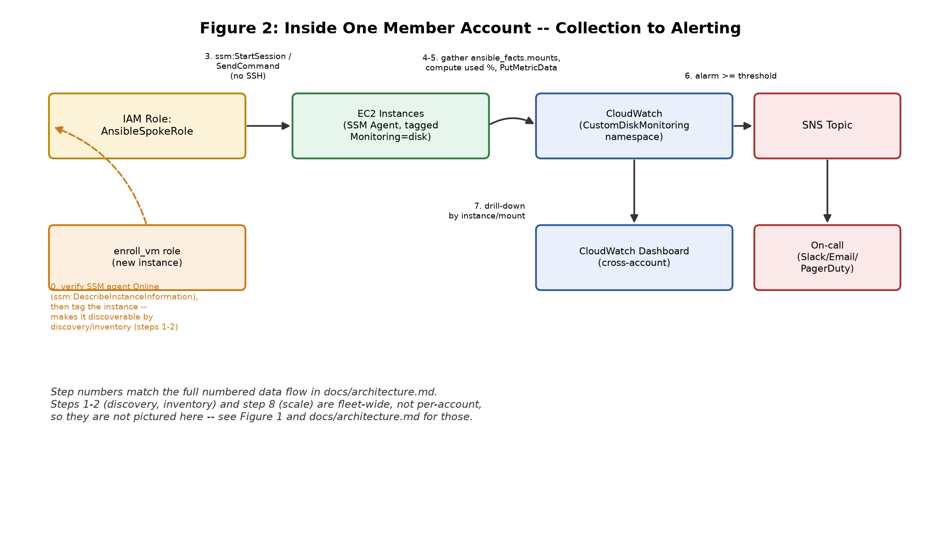
Figure 2: Inside one member account -- collection to alerting
Figure 2's step numbers correspond exactly to the full numbered data flow in the repository's docs/architecture.md (steps 1, 2, and 8 -- discovery, inventory, and scale -- are fleet-wide rather than per-account, so they appear only in Figure 1 and in that document).

2.1.1 Component Description

2.1.1.1 Ansible Control Node (Automation Account)
Runs the playbooks on a schedule (cron, EventBridge-triggered ECS Fargate task, or an AWX/Ansible Automation Platform job template -- see Section 2.3). Holds no long-lived per-account credentials; it authenticates once as AnsibleAutomationRole and reaches every member account through that single role.

2.1.1.2 AnsibleAutomationRole (Automation Account)
An IAM role trusted by the control node's own identity (an EC2 instance profile, an ECS task role, or an AWX service account). Its only permission is sts:AssumeRole into AnsibleSpokeRole, scoped to the AWS Organization via the aws:ResourceOrgID condition key -- see Section 3 for why this is what makes onboarding a new account a zero-edit operation.

2.1.1.3 AnsibleSpokeRole (every member account)
Deployed identically into every member account by a CloudFormation StackSet. Trusts only AnsibleAutomationRole. Its permissions are scoped tightly to what disk monitoring actually needs: SSM connectivity, and CloudWatch PutMetricData/PutMetricAlarm limited to one namespace (see Appendix B for the full policy).

2.1.1.4 Monitored EC2 instances
Standard EC2 instances running the SSM Agent (via the golden AMI/launch template) and tagged Monitoring=disk once enrolled (Section 4). No monitoring agent beyond SSM is installed; disk usage is read by Ansible's own fact-gathering during a normal connection, not by a resident collector process.

2.1.1.5 CloudWatch, SNS, and the cross-account dashboard
CloudWatch receives the published metrics and evaluates the account-level alarms against them (Section 5). Alarm state changes notify an SNS topic, which fans out to on-call channels. CloudWatch's cross-account observability (Observability Access Manager) rolls every member account's metrics into one dashboard in the designated monitoring account, without copying data or granting broad cross-account read access.

2.2 Interface Description
Interface | Protocol / API | Direction | Purpose
Automation -> Spoke role | AWS STS AssumeRole (HTTPS) | Hub -> Member | Cross-account authentication
Control node -> EC2 | AWS Systems Manager (Session Manager / Run Command) | Hub -> Member | Command execution, no SSH
Control node -> CloudWatch | AWS API: PutMetricData, PutMetricAlarm | Hub -> Member | Metric/alarm publication
CloudWatch -> SNS | CloudWatch Alarm Actions | Internal to member account | Alert delivery
SNS -> On-call | Email / HTTPS webhook (Slack) / PagerDuty integration | Member -> External | Notification
Member CloudWatch -> Dashboard account | CloudWatch cross-account observability (OAM) | Member -> Monitoring account | Centralized presentation

2.3 Deployment Architecture
The control node can be deployed three ways, in increasing order of operational maturity, without any change to the Ansible content itself:
Option | Description | Best for
Cron on an EC2 instance | Simplest; a single scheduled instance in the hub account runs the playbook | Proving the design; small estates
EventBridge Scheduler -> ECS Fargate task | Serverless; no always-on instance; one task per account/region for parallelism | Medium estates, cost-conscious
AWX / Ansible Automation Platform | If already part of the existing stack: register this repo as a Project, the generated inventory as a source, and the playbook as a scheduled Job Template | Large estates needing RBAC, run history, multiple execution nodes

2.4 Redundancy and Resilience
A single control-node run failing does not lose data -- Ansible's free strategy (Appendix A) lets independent hosts/accounts progress without one bad host blocking the rest, and the next scheduled run re-publishes current state regardless. CloudWatch alarms use treat_missing_data: notBreaching so a transient collection gap does not itself trigger a false alarm. The control node itself, if run as an ECS Fargate task, inherits ECS's own restart/scheduling resilience rather than requiring bespoke HA design.

3. Access Management

3.1 Connectivity: SSM instead of SSH
 | SSH (traditional) | SSM (this design)
Inbound ports | 22 open somewhere reachable | None -- agent-initiated outbound only
Credentials | Keypairs to generate, distribute, rotate, revoke per account | None persistent -- IAM + short-lived STS sessions
Cross-account | A jump host / VPN per account, or shared keys | Native: one IAM trust chain, no network path needed
Audit trail | Depends on host-level logging | Every session/command in CloudTrail centrally
Bastion/jump host to maintain | Yes | No
Every VM's AMI/launch template ships the SSM Agent; Ansible connects via the community.aws.aws_ssm connection plugin. There is deliberately no SSH fallback -- see Section 4 for why this makes agent presence a launch-time contract rather than an Ansible-enrollment-time one.

3.2 Cross-Account Access: the Two-Hop Role Chain
Rather than per-account credentials, access flows through exactly two IAM roles, shown in Figure 1:
- AnsibleAutomationRole (hub account) -- assumed by the control node's own identity; its only permission is assuming AnsibleSpokeRole anywhere in the Organization.
- AnsibleSpokeRole (every member account) -- trusts only AnsibleAutomationRole; its permissions are scoped to exactly what this solution needs (SSM connectivity + PutMetricData/PutMetricAlarm in one namespace).
The hub role's AssumeRole permission is scoped via the aws:ResourceOrgID condition key, not an explicit account-ID list -- so it automatically covers every current and future member account with zero policy edits (Section 6).

3.3 Onboarding a New Account
A CloudFormation StackSet, targeting the monitored Organizational Unit, deploys AnsibleSpokeRole into every account in that OU automatically -- existing accounts and any added later. Onboarding an acquired company's AWS account is therefore “add it to the OU”; no person edits IAM policy, Ansible inventory, or the dashboard by hand.

3.4 Least Privilege
AnsibleSpokeRole's inline policy (full text in Appendix B) is scoped narrowly: EC2 describe permissions for inventory, SSM permissions for connectivity, and CloudWatch permissions restricted to the CustomDiskMonitoring namespace and the disk-usage-* alarm name prefix via IAM condition keys -- this role cannot read or modify any other metric, alarm, or resource in the account.

4. VM Discovery and Enrollment

4.1 Discovery
generate_account_inventories.py runs in the hub account and calls organizations:ListAccounts once to enumerate every member account, then writes one AWS CLI profile (role_arn + source_profile pointing at AnsibleAutomationRole) and one Ansible dynamic-inventory file (the amazon.aws.aws_ec2 plugin) per account into inventory/accounts/. Re-running it -- on a schedule, or before every playbook run -- is how newly created accounts are picked up; no inventory file is ever hand-edited. Within an account, instances are discovered by the Monitoring=disk tag and filtered to running -- opt-in, not every instance that happens to exist. Ansible merges every file in an inventory directory natively, so the entire multi-account fleet is addressed as -i inventory/accounts/.

4.2 Enrollment
Enrollment answers a different question from discovery: how does a VM earn the Monitoring=disk tag in the first place? The enroll_vm role, intended to be triggered automatically by an EventBridge rule on ec2:RunInstances, does two things against the AWS control plane (not the instance itself):
- Polls ssm:DescribeInstanceInformation until the new instance reports PingStatus: Online -- proving the SSM Agent contract actually held, rather than assuming it did.
- Applies the Monitoring=disk tag via amazon.aws.ec2_tag, making the instance visible to discovery (Section 4.1) on the next inventory refresh.
This role deliberately does not attempt to install the SSM Agent itself. That is not a missing feature: the aws_ssm connection plugin requires the agent already running just to connect at all, so an instance with no agent is unreachable by this design's own definition -- there is no SSH fallback to bootstrap it another way. Agent presence is therefore a golden-AMI/launch-template responsibility, verified (not created) at enrollment time.

5. Data Collection and Aggregation

5.1 Collection
The disk_monitor role uses Ansible's own fact-gathering (ansible_facts.mounts) -- no monitoring agent installed on any VM beyond the SSM Agent already required for connectivity, and no df output to parse. Used-percent per mount is computed with plain Jinja arithmetic after filtering out pseudo-filesystems (tmpfs, overlay, ...) and noisy mount points (/snap, /run, ...) that would otherwise generate meaningless metrics at fleet scale.

5.2 Aggregation
Results are published as CloudWatch custom metrics from the control node -- not from the VM -- using the same assumed AnsibleSpokeRole session already active for that account. Two granularities are published:
Metric | Dimensions | Purpose
DiskUsedPercent | Account, InstanceId, MountPoint | Per-instance/per-mount drill-down on the dashboard
DiskFreeGB | Account, InstanceId, MountPoint | Absolute free space, alongside the percentage
DiskUsedPercentFleetMax | Account only | The rollup an account-level alarm actually watches (Section 5.4)
No AWS collection module publishes arbitrary custom metric data (only alarm management exists as a ready-made module), so a small custom module, cloudwatch_put_metric_data, wraps PutMetricData -- built on the same AnsibleAWSModule base class every other module in these collections uses, for correct/consistent auth and region handling.

5.3 Presentation
CloudWatch's cross-account observability (Observability Access Manager) rolls every member account's metrics into a single dashboard in a designated monitoring account, without copying data between accounts or granting broad cross-account read access.

5.4 Alerting: Why a Summary Metric
CloudWatch alarms watch one fully specified metric and dimension set each. Alarming per instance-and-mount would mean one alarm per (instance, mount) pair -- thousands of idle alarms at real fleet scale. Instead, every host in an account publishes into the same DiskUsedPercentFleetMax metric (dimensioned only by Account), and CloudWatch's own Maximum statistic does the fan-in: one warning alarm (>= 80%) and one critical alarm (>= 90%) per account fire the moment any contributing instance breaches, with no per-instance alarm bookkeeping to maintain as the fleet grows. The detailed per-instance metrics remain on the dashboard for drill-down once an alarm has fired.

6. Scalability
Growth dimension | What happens
New AWS account | Add to the monitored OU -> StackSet auto-deploys AnsibleSpokeRole -> next inventory-generation run discovers it. Zero manual steps.
New VM in an existing account | Launched with the standard tag/agent -> enroll_vm confirms + tags it -> discovered on the next inventory refresh. Zero manual steps.
More total VMs (control-plane load) | Ansible's free strategy avoids lock-step batching; splitting execution by account/region (one Fargate task per account) parallelizes horizontally instead of one long serial run.
More alarms needed | Alarms are per-account, not per-instance/mount, so alarm count scales with accounts, not VMs (Section 5.4).

7. Security Considerations

7.1 Security Assumptions
- AWS Organizations and its management account are already governed under existing corporate access controls (out of scope to redesign here).
- The initial bootstrap identity used to deploy AnsibleAutomationRole is backed by SSO/Identity Center, not a static IAM user, in any real rollout.

7.2 Potential Security Risks and Mitigations
Risk | Mitigation
Over-broad AssumeRole scope | Scoped via aws:ResourceOrgID (org-only) rather than a wildcard principal; MaxSessionDuration capped at 1 hour
Spoke role privilege creep over time | Inline policy scoped to one CloudWatch namespace and one alarm name prefix via IAM conditions; reviewed via the same IaC template used to deploy it
Credential leakage | No long-lived credentials exist anywhere in the design -- only short-lived STS sessions
Alarm/notification tampering | PutMetricAlarm/DescribeAlarms permissions restricted to the disk-usage-* alarm prefix only

7.3 Data Classification
The data collected (mount point paths, used-percent, free-space GB) contains no customer or personal data. Metrics are stored in CloudWatch under each account's own encryption-at-rest defaults; no data leaves the account boundary except the aggregated, non-sensitive view surfaced through cross-account observability.

8. Known Limitations and Future Work
- SNS topic/subscription provisioning is referenced (sns_topic_arn in group_vars) but not created by this repository -- a small addition to the same StackSet.
- The account-level rollup metric trades granularity for alarm scalability: identifying which instance breached still means reading the dashboard, not the alert text alone. A follow-up Lambda could enrich the SNS message with the specific instance ID at alarm time.
- Windows VMs would use ansible.windows.win_disk_facts in place of ansible_facts.mounts -- same publish/alarm logic downstream, not yet implemented.
- A CI pipeline (GitHub Actions) running ansible-lint and cfn-lint on every change is planned but not yet wired up.

9. Deliverables and Artifacts
All artifacts referenced in this document are in the public repository:
https://github.com/ravishekharg/aws-disk-monitoring

9.1 Repository Layout
Path | Contents
ansible/roles/disk_monitor/ | Collection, aggregation, and alarm-management task files, plus the custom cloudwatch_put_metric_data module
ansible/roles/enroll_vm/ | VM enrollment logic (Section 4.2)
ansible/scripts/generate_account_inventories.py | Multi-account discovery (Section 4.1)
ansible/playbooks/monitor_disk.yml | Entry point for the real fleet
ansible/playbooks/enroll_vm.yml | Entry point for enrolling one new instance
ansible/playbooks/test_disk_facts_local.yml | No-AWS smoke test of the collection logic
ansible/playbooks/demo_full_role_mock_aws.yml | The full role, run by demo/run_demo.sh
iac/spoke-role/template.yaml | AnsibleSpokeRole CloudFormation template (StackSet-deployable)
iac/automation-role/template.yaml | AnsibleAutomationRole CloudFormation template
demo/run_demo.sh | Live end-to-end demonstration against a mock AWS endpoint
docs/architecture.md | Extended architecture notes and full request/data-flow walkthrough

9.2 How to Run It
- Against a real AWS Organization:
ansible-galaxy collection install -r ansible/requirements.yml
python3 ansible/scripts/generate_account_inventories.py --hub-profile automation-hub
ansible-playbook -i ansible/inventory/accounts/ ansible/playbooks/monitor_disk.yml
- With no AWS account at all (see Appendix C for what this proved):
bash demo/run_demo.sh

Appendix A: Ansible Execution Model
playbooks/monitor_disk.yml uses strategy: free, meaning hosts and accounts progress independently rather than in lock-step batches -- a slow or unreachable instance in one account does not delay collection in another. Fact caching (jsonfile, 300s timeout) avoids re-gathering the full fact set on every task within a run.

Appendix B: AnsibleSpokeRole Permissions Summary
Full CloudFormation source: iac/spoke-role/template.yaml. Summarized here:
Action | Resource / Condition
ec2:DescribeInstances, ec2:DescribeTags | * (read-only, needed for inventory)
ssm:DescribeInstanceInformation, SendCommand, GetCommandInvocation, StartSession, TerminateSession, ResumeSession | *
s3:PutObject/GetObject/DeleteObject | ansible-ssm-transfer-<account-id>-* (SSM file-transfer staging bucket only)
cloudwatch:PutMetricData | Condition: cloudwatch:namespace = CustomDiskMonitoring
cloudwatch:PutMetricAlarm, DescribeAlarms, DeleteAlarms | arn:...:alarm:disk-usage-* only

Appendix C: Verification Evidence
Consistent with treating this as a real design rather than a described-but-untested one, the following was actually executed, not just written:
Layer | Status
Ansible playbook/role syntax | Verified: ansible-playbook --syntax-check passes clean (ansible-core 2.21) for every playbook.
Disk-fact collection + threshold logic | Verified live against a real machine's real filesystem -- correctly computed used-percent per mount and flagged a mount at 100% used against the critical threshold.
Two-hop cross-account IAM chain | Verified live: created both IAM roles for real, assumed the first, then assumed the second from that session, confirming the resulting identity with sts:GetCallerIdentity at each hop.
Custom module + alarm management | Verified live: the real disk_monitor role, running as the assumed AnsibleSpokeRole session, published 9 real PutMetricData calls and created 2 real alarms against a mock AWS endpoint (moto); confirmed independently afterward via list-metrics/describe-alarms.
CloudFormation templates | Verified: both pass cfn-lint clean.
enroll_vm role | Syntax-check clean; not live-tested (would need a real or convincingly faked SSM-registered instance).

Real issues were found and corrected during this process rather than smoothed over: an initially assumed community.aws.cloudwatch_metric module does not exist in either AWS collection (there is no ready-made PutMetricData wrapper, hence the custom module); cloudwatch_metric_alarm turned out to live in amazon.aws, not community.aws, and its comparison parameter takes CloudWatch's full enum string (GreaterThanOrEqualToThreshold), not a symbolic operator; and ansible.cfg's initial stdout_callback setting silently required a collection not declared in requirements.yml, only surfacing when a playbook was actually run rather than syntax-checked.

