Link to Shinyapps.io

<https://ravishmanglani.shinyapps.io/RavishManglani_FinalExam/>

Screenshot of bar chart private schools

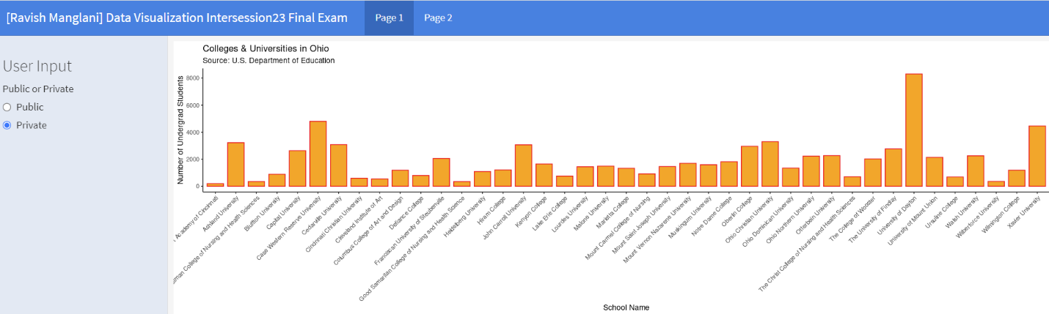

Screenshot of bar chart public schools

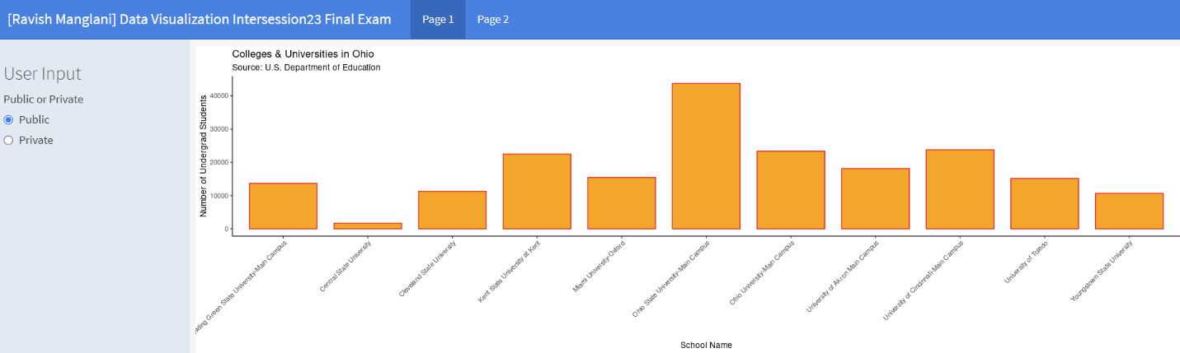

Screenshot of map public schools

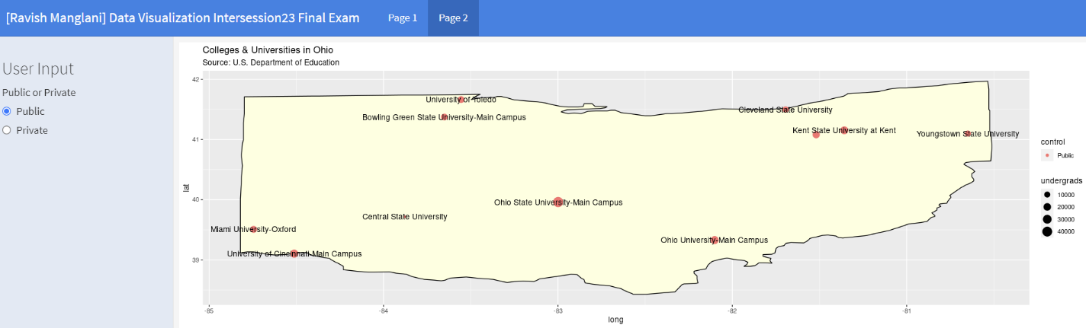

Screenshot of map private schools

