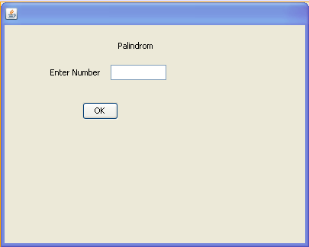

private void jButton1ActionPerformed(java.awt.event.ActionEvent evt) {
int num=Integer.parseInt(jTextField1.getText());
int r,temp,newnumber = 0;
temp=num;
do
{
r=num%10;
newnumber=newnumber*10+r;
num=num/10;
}
while (num !=0);
if (newnumber==temp)
JoptionPane.ShowMessageDialog(null,"Number is Palindrom");
else
JoptionPane.ShowMessageDialog(null,"Number is not Palindrom");
}

