CUSTOMER ENGINEERING RUNBOOK
Pega Platform 26.1.1 on Azure Kubernetes Service
Externalized Kafka on Confluent Cloud and search on managed OpenSearch
Design, Helm configuration, testing and operations for six environments built from a cloned and upgraded Pega Platform 8.8 database

Document version | 2.1
Status | Issued for customer review and approval
Issue date | 2 October 2026
Classification | Customer Confidential
Target | Pega Platform 26.1.1 on Azure AKS, Pega Helm charts 4.13.0
Source | Pega Platform 8.8 with embedded Kafka and embedded Elasticsearch
Environments | DEV, SIT, UAT, PERF, PREPROD, PROD
Document control
Item | Detail
Title | Pega Platform 26.1.1 on Azure AKS: externalized Kafka on Confluent Cloud and search on managed OpenSearch
Version | 2.1
Status | Issued for customer review and approval
Issue date | 2 October 2026
Evidence cut-off | Vendor pages were read between 28 September and 2 October 2026. Section 3 lists the facts used. Appendix F lists every source with its link.
Supersedes | Version 2.0 of this runbook, issued on 1 October 2026. Version 2.0 itself replaced version 1.0, which assumed a three-release path through an intermediate Pega release before the customer confirmed the clone-and-upgrade path (Section 1.2).
Owner | Customer platform engineering lead
Review cycle | Before each rehearsal, before the production cutover, and after any change to a vendor page listed in Section 3

Revision history
Version | Date | Change | Author
1.0 | 1 October 2026 | Kafka and search runbook for a three-release upgrade path. | Implementation team
2.0 | 1 October 2026 | Rewritten for the clone-and-upgrade path, six environments, shared non-production services, managed OpenSearch and Okta. | Implementation team
2.1 | 2 October 2026 | Expert review: Helm values corrected after rendering with helm template (SRS authentication, SRS port 8443, SRS network policy, SRS replicas and resources); availability zone design; Confluent connection, request and partition-creation limits; Okta key rotation and rate limits; OpenSearch sizing formulas; JVM settings; new Sections 15 (performance engineering and sizing) and 18 (observability); environment build waves; Appendix H sizing calculator. Sections 15 to 18 of version 2.0 are now Sections 16, 17, 19 and 20. | Implementation team

Approvals
Approval confirms that the approver has reviewed the sections relevant to the role and accepts the design, the recommendations and the open decisions as stated.
Role | Name | Signature | Date
Customer business owner
Customer enterprise architect
Customer security architect
Customer platform engineering lead
Customer database administration lead
Pega Lead System Architect
Kafka and search engineering lead

Contents
1 Executive summary 13
1.1 Purpose 13
1.2 The clone-and-upgrade approach 13
1.3 Kafka and search design in brief 14
1.4 Sharing services to reduce cost 15
1.5 Answer to the migration question 15
1.6 Questions for Pega Support 15
1.7 Decisions needed 16
1.8 Readiness statement 16
2 Scope, dependencies and reading guide 17
2.1 Scope 17
2.2 Dependencies covered only to the depth Kafka and search need 17
2.3 Confirmed customer inputs 18
2.4 Where each question is answered 18
2.5 Reading guide by role 19
2.6 Conventions and naming 19
3 Evidence baseline 20
3.1 How the evidence was gathered 20
3.2 Facts this design depends on 20
4 Architecture 22
4.1 Pega reference architecture for '26 22
4.2 Target architecture on Azure 23
4.3 Logical flows 24
4.4 Network and DNS 25
4.5 Message path inside Pega 26
4.6 Availability zone resilience 26
5 Shared and dedicated service model 29
5.1 Grouping options 29
5.2 Recommended model 30
5.3 Isolation controls 32
5.4 Noisy neighbours and quotas 33
5.5 Cost comparison model 33
5.6 Production 34
6 Confluent Cloud design and configuration 35
6.1 What Pega uses Kafka for 35
6.2 Pega requirements mapped to Confluent Cloud 35
6.3 Cluster type per group 36
6.4 Private networking 37
6.5 Service accounts, authentication and ACLs 39
6.6 Topic design 40
6.7 Partition budget 40
6.8 Helm stream configuration 41
6.9 prpcUtils on 26.1.1 41
7 Managed OpenSearch and SRS design and configuration 43
7.1 How search works in 26.1.1 43
7.2 SRS and OpenSearch versions 43
7.3 Provider selection 44
7.4 Cluster settings and sizing 45
7.5 Isolation in the shared OpenSearch services 47
7.6 Pega-to-SRS tokens with Okta 48
7.7 SRS deployment (backingservices chart) 51
7.8 Index build planning 53
7.9 Backups and restore 53
8 Secrets, certificates and identity 54
8.1 Secret inventory 54
8.2 External Secrets Operator manifests 54
8.3 Rotation 55
8.4 Certificates 56
9 Helm configuration per environment 57
9.1 Chart version and the three runs 57
9.2 Pega chart keys per environment 57
9.3 Backingservices chart keys per environment 59
9.4 Differences between the runs 60
9.5 Pipeline rules 60
10 The cloned database 61
10.1 Gating questions for Pega Support 61
10.2 How Helm settings and database settings interact 61
10.3 Inventory and clean-up 62
10.4 First-start control 63
10.5 Data protection and masking 65
11 The 8.8 content question 66
11.1 Answer 66
11.2 Treatment per content type 66
11.3 Application Kafka data sets 67
11.4 Why the Stream Migration activity is not used 67
11.5 Statement for approval 68
12 Deployment runbook per environment 69
12.1 Build order 69
12.2 Network and DNS 69
12.3 Secrets and identity 69
12.4 Confluent Cloud 70
12.5 OpenSearch 70
12.6 SRS 70
12.7 Database clone and upgrade 71
12.8 First start, index build and intake release 71
12.9 Per-environment notes 71
12.10 Building the environments one after another 71
13 Production cutover and rollback 74
13.1 Principles 74
13.2 Milestones 74
13.3 Cutover sequence 74
13.4 Go/No-Go gates 75
13.5 Application Kafka data set cutover 75
13.6 Rollback 76
14 Test strategy, rehearsals and failure scenarios 77
14.1 Test stages 77
14.2 Rehearsals and measurements 77
14.3 Isolation tests 77
14.4 Functional and integration checks 78
14.5 Performance tests 78
14.6 Failure scenario catalogue 79
14.7 Exact checks 81
14.8 Acceptance criteria 81
15 Performance engineering and sizing 82
15.1 Why performance testing is required 82
15.2 Workload model 82
15.3 Test types and measurement points 83
15.4 Tools and harness 84
15.5 Entry and exit criteria 84
15.6 Pitfalls seen in Pega performance tests 84
15.7 Sizing method 85
15.8 Sizing rules per layer 85
15.9 Worked example 86
16 Known issues and challenges 87
16.1 Cloned database 87
16.2 Kafka and Confluent 87
16.3 OpenSearch and SRS 88
16.4 Platform 89
16.5 Process 89
17 Troubleshooting 90
17.1 Method 90
17.2 Kafka 90
17.3 Search 91
17.4 Cloned database and upgrade 92
17.5 Support cases 92
18 Observability, monitoring and logging 93
18.1 Telemetry sources 93
18.2 Logging design 94
18.3 Pega Diagnostic Center 94
18.4 Dashboards 94
18.5 Alerts and thresholds 95
18.6 Synthetic checks 96
18.7 Following an incident across services 96
19 Operations, onboarding, refresh and retirement 97
19.1 Routine tasks 97
19.2 Onboarding a new non-production environment 97
19.3 Refreshing an environment from a new clone 97
19.4 Retiring an environment 98
19.5 Roles and responsibilities 98
20 Risks, open decisions, assumptions and source reconciliation 99
20.1 Risk register 99
20.2 Open decisions 99
20.3 Assumptions 100
20.4 Source reconciliation 101
Appendix A. Configuration inventory 102
A.1 Names per environment 102
A.2 Values recorded per service group 102
A.3 Values recorded per environment 103
Appendix B. Complete Helm values files 104
B.1 SIT: pega chart, upgrade run 104
B.2 SIT: pega chart, first-start run 106
B.3 SIT: pega chart, steady-state deploy run 107
B.4 SIT: backingservices chart (SRS) 109
B.5 SIT: network policies for SRS 110
B.6 PROD: pega chart, upgrade run 111
B.7 PROD: pega chart, first-start run 113
B.8 PROD: pega chart, steady-state deploy run 114
B.9 PROD: backingservices chart (SRS) 116
B.10 PROD: network policies for SRS 117
Appendix C. Command reference 119
C.1 Kafka and Confluent Cloud 119
C.2 OpenSearch and SRS 120
C.3 Okta tokens 120
C.4 Kubernetes and Helm 121
Appendix D. Evidence and rehearsal templates 122
D.1 Evidence pack contents 122
D.2 Clean-up record 122
D.3 Check record 123
D.4 Timed cutover record 123
D.5 Go/No-Go record 123
D.6 Retirement record 124
Appendix E. Glossary 125
Appendix F. References 126
Appendix G. Image sources and attribution 129
Appendix H. Sizing calculator 130
H.1 Example outputs 130
List of figures
Figure 1. Clone-and-upgrade flow for each environment 14
Figure 2. Pega Platform Kubernetes architecture for '26 22
Figure 3. Earlier Pega cluster layout with embedded Kafka and in-cluster Elasticsearch 23
Figure 4. Externalized services in a Pega deployment 23
Figure 5. Target architecture for one environment on Azure AKS 24
Figure 6. Logical flows between Pega, Kafka, SRS, OpenSearch and Okta 25
Figure 7. Name resolution and traffic paths for Kafka, OpenSearch and Okta 25
Figure 8. Message path from producer to batch tier 26
Figure 9. Spreading each layer across three availability zones 27
Figure 10. Decision: placing a non-production environment on shared services 30
Figure 11. Shared non-production topology and per-environment boundaries 31
Figure 12. Production topology with dedicated services 31
Figure 13. Isolation layers between environments on shared services 32
Figure 14. The two Kafka use cases in Pega Platform 35
Figure 15. Decision: Confluent Cloud cluster type 37
Figure 16. Azure Private Link between a customer VNet and Confluent Cloud 38
Figure 17. DNS records that Confluent lists for Azure Private Link 38
Figure 18. Decision: Pega to Kafka authentication 39
Figure 19. Client-managed cloud deployment with SRS as a backing service 43
Figure 20. Decision: managed OpenSearch provider 44
Figure 21. OpenSearch cluster roles: cluster-manager and data nodes 45
Figure 22. Decision: one SRS per environment or one shared SRS 47
Figure 23. Token flow between Pega, Okta and SRS 48
Figure 24. Secret delivery from Key Vault to Pega, installer and SRS pods 54
Figure 25. Decision: treatment of an item found in the cloned database 62
Figure 26. Decision: Go/No-Go at the first start 64
Figure 27. Decision: does 8.8 content need migrating? 66
Figure 28. Decision: treatment of each application Kafka data set 67
Figure 29. Environment build waves and the gate between each 72
Figure 30. Production cutover sequence from the Kafka and search point of view 74
Figure 31. Performance test harness and measurement points in PERF 83
Figure 32. Sizing loop from production facts to signed-off PROD sizes 85
Figure 33. Connectivity chain for Kafka and search 90
Figure 34. Troubleshooting tree: stream service 90
Figure 35. Troubleshooting tree: search 91
Figure 36. Telemetry sources, collection, stores and use 93
List of tables
Table 1. Kafka and search design by environment group 15
Table 2. Decisions needed before the first build 16
Table 3. Scope of this document 17
Table 4. Dependencies and their gates 17
Table 5. Confirmed customer inputs 18
Table 6. Traceability from customer questions to sections 18
Table 7. Reading guide by role 19
Table 8. Environment naming 19
Table 9. Version and support facts used in this design 20
Table 10. Target architecture components 24
Table 11. Network flows to allow and to deny 26
Table 12. Availability zone design by layer 27
Table 13. Non-production grouping options 29
Table 14. Isolation controls by layer 32
Table 15. Cost model inputs supplied by the customer 33
Table 16. Cost model by option (multiply each line by the customer's unit prices) 33
Table 17. Pega Kafka requirements mapped to Confluent Cloud 35
Table 18. Confluent Cloud cluster limits relevant to Pega (source [R31]; Basic and Standard rows for connections and requests are not used here) 36
Table 19. Cluster type by group 37
Table 20. Private Link set-up steps per cluster 38
Table 21. Kafka ACLs for one environment's service account (source [R11]) 39
Table 22. Topic design settings 40
Table 23. Partition budget worksheet 41
Table 24. SRS compatibility with OpenSearch for Pega 8.6 and later, SRS 1.44.3 or later (source [R14]) 43
Table 25. OpenSearch provider selection worksheet 44
Table 26. Pega default sizing for search and SRS (source [R14]) 46
Table 27. Starting sizes per OpenSearch service 46
Table 28. OpenSearch sizing formulas 47
Table 29. SRS per environment compared with a shared SRS 48
Table 30. Options for the guid claim 49
Table 31. Okta values used in the Helm charts 50
Table 32. SRS chart behaviours found by rendering 52
Table 33. Recovery choices for search 53
Table 34. Secret inventory (one set per environment, in kv-pega-<code>) 54
Table 35. Secret rotation 55
Table 36. Certificates 56
Table 37. Helm runs of the pega chart for an environment built from a clone 57
Table 38. Pega chart keys per environment (chart 4.13.0) 57
Table 39. Backingservices chart keys per environment 59
Table 40. Values that change between runs 60
Table 41. Gating questions for Pega Support 61
Table 42. Kafka and search items in the cloned database 62
Table 43. First-start steps for an environment built from a clone 64
Table 44. Treatment of 8.8 content 66
Table 45. Application Kafka data set register (one row per data set, completed with the application team) 67
Table 46. Build order 69
Table 47. Network and DNS steps 69
Table 48. Secrets and identity steps 69
Table 49. Confluent Cloud steps 70
Table 50. OpenSearch steps 70
Table 51. SRS steps 70
Table 52. Database clone and upgrade steps 71
Table 53. Per-environment notes 71
Table 54. Environment build waves 72
Table 55. Configuration checklist for each new environment 72
Table 56. Programme milestones used in this document 74
Table 57. Production cutover steps 74
Table 58. Go/No-Go gates 75
Table 59. Rollback steps 76
Table 60. Test stages 77
Table 61. Rehearsal measurements 77
Table 62. Isolation tests 78
Table 63. Performance tests 78
Table 64. Failure scenario catalogue 79
Table 65. Exact checks 81
Table 66. Acceptance criteria 81
Table 67. Workload model inputs 82
Table 68. Performance test types 83
Table 69. Measurement points 84
Table 70. Performance test entry, exit and suspension criteria 84
Table 71. Sizing rules per layer 85
Table 72. Worked sizing example (illustrative inputs) 86
Table 73. Known issues: cloned database 87
Table 74. Known issues: Kafka and Confluent 87
Table 75. Known issues: OpenSearch and SRS 88
Table 76. Known issues: platform 89
Table 77. Kafka symptoms 91
Table 78. Search symptoms 91
Table 79. Cloned database and upgrade symptoms 92
Table 80. Telemetry sources 93
Table 81. Dashboards 94
Table 82. Alerts, thresholds and responses 95
Table 83. Synthetic checks 96
Table 84. Identifiers used to correlate one environment across systems 96
Table 85. Routine operations 97
Table 86. RACI (Okta objects are owned by the customer identity team: A/R) 98
Table 87. Risk register (L likelihood, I impact: H high, M medium, L low) 99
Table 88. Open decisions 99
Table 89. Assumptions 100
Table 90. Source reconciliation register 101
Table 91. Names and sizes per environment 102
Table 92. Values recorded per service group 102
Table 93. Values recorded per environment (one copy per environment) 103
Table 94. Evidence pack items 122
Table 95. Clean-up record (one per clone) 122
Table 96. Check record 123
Table 97. Timed cutover record (rehearsals and production) 123
Table 98. Go/No-Go record 123
Table 99. Retirement record 124
Table 100. Glossary of terms 125
Table 101. Third-party images 129
Table 102. Sizing calculator sheets 130
Table 103. Calculator example: Confluent capacity units (illustrative inputs) 130
Table 104. Calculator example: OpenSearch data nodes (illustrative inputs) 130

1 Executive summary

1.1 Purpose
This runbook tells the customer's IT teams how to design, configure, test and run Kafka and search for Pega Platform 26.1.1 on Azure Kubernetes Service (AKS). Kafka is provided by Confluent Cloud. Search is provided by the Pega Search and Reporting Service (SRS) on top of a managed OpenSearch service. Both are configured through the Pega Helm charts in six environments: DEV, SIT, UAT, PERF, PREPROD and PROD.

1.2 The clone-and-upgrade approach
The customer is moving from Pega Platform 8.8 without upgrading the running 8.8 servers. A new 26.1.1 platform is built on AKS with Kafka and search outside Pega from the start. The 8.8 database is cloned, and the clone is upgraded to 26.1.1 by the Pega installer, run as the Helm chart installer job. Pega 26.1.1 then starts on the upgraded clone. Each lower environment is built the same way, which gives the programme repeated rehearsals. Production uses a final clone taken after 8.8 is stopped. The 8.8 system and its database stay untouched until the rollback window closes. Figure 1 shows the flow.
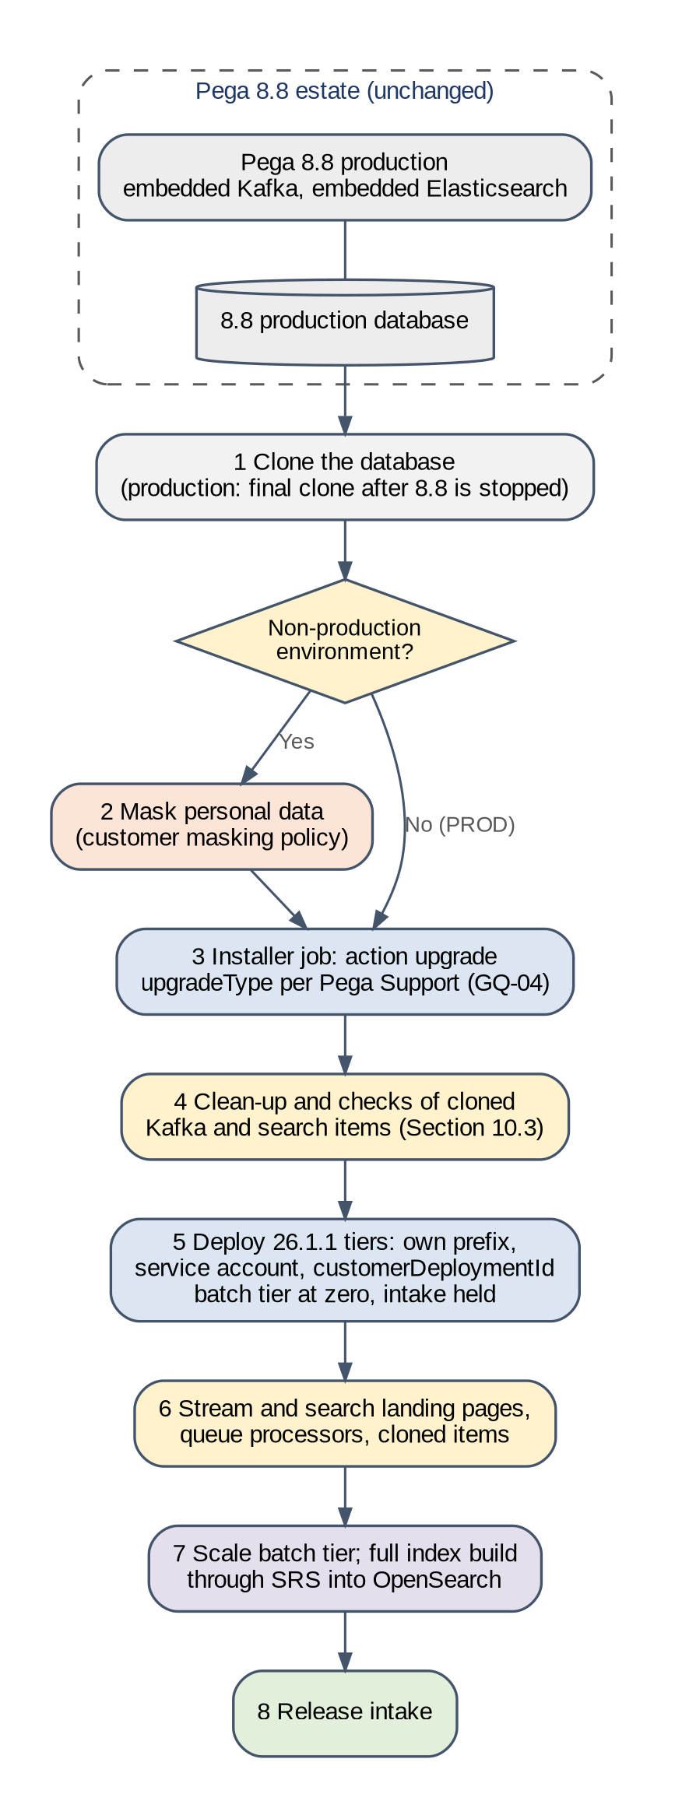
Figure 1. Clone-and-upgrade flow for each environment
Prepared for this implementation. Not a Pega-published diagram.

1.3 Kafka and search design in brief
Table 1 summarises the design. Production has its own Kafka cluster and its own OpenSearch service. The five non-production environments share two sets of services, with isolation enforced per environment.
Table 1. Kafka and search design by environment group
Layer | PROD | PERF and PREPROD (group NP2) | DEV, SIT and UAT (group NP1)
Kafka | Confluent Cloud cluster cc-prd, Enterprise or Dedicated, Azure Private Link | Shared cluster cc-np2, same type and settings as PROD | Shared cluster cc-np1, Enterprise with Private Link
Isolation in Kafka | Dedicated cluster | Topic prefix, service account, prefixed ACLs and client quota per environment | Same as NP2
Search storage | OpenSearch service os-prd | Shared service os-np2, same provider and settings as PROD | Shared service os-np1
Isolation in search | Dedicated service | SRS per environment, customerDeploymentId per environment, OpenSearch user and index-scoped role per environment | Same as NP2
Pega-to-SRS tokens | Okta custom authorization server for PROD only | Shared non-production authorization server, one client per environment | Same as NP2
Secrets | Key Vault per environment, delivered by the External Secrets Operator | Same | Same

1.4 Sharing services to reduce cost
Six dedicated Kafka clusters and six OpenSearch services would cost the most and need the most operation. The recommended model uses three sets of services instead of six. DEV, SIT and UAT share one set. PERF and PREPROD share a second set that matches production, so load tests and production rehearsals run on production-like services without affecting functional testing. Section 5 compares this model with the alternatives and gives a cost model that the customer completes with its own prices.

1.5 Answer to the migration question
Decision. No Pega stream topic and no search index is copied from 8.8. The 8.8 system uses embedded Kafka and embedded Elasticsearch, whose data lives on the 8.8 nodes, not in the database. Pega states that existing stream data cannot be moved to a new Kafka [R13], and SRS indexes all searchable data after Pega connects to it [R15].
Before the production clone is taken, intake on 8.8 is held and queues are allowed to empty. Queue items that are held in the database, such as delayed and broken items, travel with the clone and are handled as listed in Section 10.3. Application Kafka data sets on the customer's own Kafka clusters are decided one by one (Section 11.3).

1.6 Questions for Pega Support
Pega documentation does not settle three points that the plan depends on. Section 10.1 lists eight questions in full. The three that gate the production plan are these:
- GQ-01: Pega Support must confirm that a direct upgrade of an 8.8 database to 26.1.1 is supported, and name any required 8.8 patch level.
- GQ-03: Pega states that Hazelcast must be removed before updating to '25 or later [R5]. Pega Support must confirm how this applies to a cloned database that is upgraded offline and never started on 8.8 again.
- GQ-04: Pega Support must confirm the installer upgrade type for a cloned database (in-place or the out-of-place types the Helm chart documents [R23]).

1.7 Decisions needed
Table 2 lists the decisions that block the first build. Section 20.2 lists all open decisions with owners and milestones.
Table 2. Decisions needed before the first build
ID | Decision | Recommended answer | Needed by
OD-01 | Pega Support answers to the gating questions | Raise the case now; plan with the conservative answer until the reply arrives | M2 DEV build
OD-02 | Confluent cluster types | Enterprise with Private Link for NP1; PROD type for NP2 and PROD after partition measurement | M2 DEV build
OD-03 | OpenSearch provider | Provider that passes the selection in Section 7.3 | M2 DEV build
OD-05 | Okta design | Dedicated custom authorization server for PROD; one shared non-production server with a per-client guid claim, if proven in DEV | M2 DEV build
OD-07 | Masking approach | Mask before the upgrade, so the index build uses masked data only | M2 DEV build

1.8 Readiness statement
This document is ready for customer review as a design and runbook. Durations for draining, cloning, upgrading and index building depend on data volume, so they come from the rehearsals in Section 14.2, not from estimates. Points that no source settles are marked as tests, Pega Support questions or open decisions. Conflicts between sources are logged in Section 20.4.

2 Scope, dependencies and reading guide

2.1 Scope
Table 3. Scope of this document
In scope | Out of scope
Confluent Cloud and managed OpenSearch design for DEV, SIT, UAT, PERF, PREPROD and PROD.  Configuration in the Pega Helm charts: the stream and pegasearch sections of the pega chart, and the SRS section of the backingservices chart.  What the cloned 8.8 database brings that affects Kafka and search, and how it is cleaned up before and after the first 26.1.1 start.  Whether Kafka topics and search indexes are migrated from 8.8, and how 8.8 in-flight work is handled at cutover.  Shared non-production services with isolation between environments, and the cost model.  Okta as the token issuer for Pega-to-SRS authorization.  Testing, failure scenarios, known issues, troubleshooting and operations for Kafka and search. | Application functional regression content.  Cassandra and Decision Data Store.  Constellation.  Pega Diagnostic Center beyond the network path it needs.  General AKS build-out not related to Kafka or search.  Commercial terms and prices from Confluent and the OpenSearch provider.

2.2 Dependencies covered only to the depth Kafka and search need
The database clone, the installer upgrade and Pega's '25 and '26 prerequisites belong to other workstreams. Table 4 names the owner of each, the gate it must pass before Kafka and search work can rely on it, and the source.
Table 4. Dependencies and their gates
Dependency | Why it matters for Kafka and search | Owner | Gate | Source
Database clone and masking | The clone carries 8.8 stream and search settings and queue items (Section 10.3). Masking decides what data the index build uses. | DBA team | Clone restored and masked; row counts recorded | Customer policy
Installer upgrade (installer.upgrade.upgradeType) | The upgrade must finish before Pega starts against Kafka and SRS. | Platform team with Pega LSA | Installer job completed; log reviewed | [R23]
Hazelcast removal | From '25, cluster messaging that Hazelcast carried uses Kafka, so a Kafka outage affects more than queue processing. | Pega LSA | GQ-03 answered | [R4, R5, R7]
Tomcat 10.1 and Jakarta EE | Custom JARs that fail to load can stop nodes before Kafka and search checks run. | Application team | Custom JARs rebuilt and tested | [R3, R9]
Primary keys on all tables | Required before an update to '25 or later. | DBA team | primaryKeyUtility dry run clean | [R3, R10]
Queue processor changes in '26 | Partitioned, multi-threaded processing; DSS delayeditems/dataflowbased/threadspernode must be removed (PEGA0179). | Pega LSA | DSS removed on the clone | [R3]

2.3 Confirmed customer inputs
Table 5. Confirmed customer inputs
Input | Value | Effect on this document
Environments | DEV, SIT, UAT, PERF, PREPROD, PROD | Six columns in every per-environment table; six prefixes, service accounts, deployment IDs, Okta clients and Key Vaults.
8.8 Kafka | Embedded Kafka (Pega stream service inside 8.8) | Nothing in it can be moved to Confluent Cloud. Queues are emptied on 8.8 before the final clone (Section 11).
8.8 search | Embedded Elasticsearch | Indexes are on the 8.8 nodes' disks and cannot be carried over. 26.1.1 builds all indexes through SRS (Section 7.8).
Token issuer for Pega to SRS | Okta | Okta design in Section 7.6.
OpenSearch provider | Not chosen yet | Selection method in Section 7.3; Helm values written so only the endpoint, port, credentials and CA depend on the provider.
Pega Support answers | Not received | Every gating question is open with an owner and a milestone (Section 10.1).

2.4 Where each question is answered
The customer asked eighteen questions. Table 6 shows where each one is answered, so a reviewer can check that none is missed.
Table 6. Traceability from customer questions to sections
# | Question | Answered in
1 | Is the direct clone-and-upgrade path from 8.8 to 26.1.1 supported, and on what conditions? | Section 10.1
2 | How is Confluent Cloud designed per environment? | Sections 5 and 6
3 | How is the managed OpenSearch service designed per environment? | Sections 5 and 7
4 | How is each one configured in the Helm charts for the upgrade run and the deploy run? | Section 9 and Appendix B
5 | What in the cloned 8.8 database conflicts with the new configuration, and how is it cleaned up? | Section 10.3
6 | How is a cloned non-production environment kept away from production Kafka, integrations and other environments? | Sections 5.3, 10.4 and 14.3
7 | Must topics or indexes be migrated from 8.8, and how is in-flight work handled at cutover? | Sections 11 and 13
8 | How do several non-production environments share one cluster and one OpenSearch service safely? | Sections 5.3 and 5.4
9 | How much does sharing save, and what risk does it add? | Section 5.5
10 | How is it tested? | Section 14
11 | Which failures are tested, and how? | Section 14.6
12 | What known issues should be avoided? | Section 16
13 | How is it run day to day, including refresh and retirement? | Section 19
14 | Why is performance testing needed, and how is it done? | Section 15
15 | How is each layer sized, and is there a calculator? | Sections 15.7 to 15.9 and Appendix H
16 | How is the platform monitored, logged and observed? | Section 18
17 | In which order are the environments built, and what is configured in each one? | Section 12.10
18 | What happens when an availability zone fails? | Section 4.6

2.5 Reading guide by role
Table 7. Reading guide by role
Reader | Read first | Then
Business owner, programme manager | Sections 1, 5.5, 13 and 20 | Sections 14.2 and 15.1
Enterprise and security architects | Sections 4, 5, 7.6 and 8 | Sections 18 and 20
Pega Lead System Architect | Sections 10 and 11 | Sections 13 to 16
Database administrators | Sections 10.1, 10.3 to 10.5 and 12.7 | Section 13
Platform, Kafka and search engineers | Sections 6 to 9 and 12 | Sections 15, 17, 18 and 19, Appendices A to C and H
Test lead, performance lead | Sections 14 and 15 | Section 16
Operations and monitoring teams | Section 18 | Sections 17 and 19

2.6 Conventions and naming
- Must marks a vendor requirement or a fixed decision. Should marks a recommendation that the customer can change through the decision process in Section 20.2.
- Values in angle brackets, such as <bootstrap-host>, are environment-specific. Each one is listed in Appendix A.
- References in square brackets, such as [R11], point to the numbered sources in Appendix F.
- Figures marked "Prepared for this implementation" were drawn for this document. Figures from Pega, Pega Academy, Confluent and OpenSearch carry a source line, and Appendix G lists them.
Every environment uses the same naming pattern, shown in Table 8. Prefixes end with a hyphen, and no deployment ID is the start of another, so a prefixed ACL or an index pattern for one environment can never match another environment's topics or indexes.
Table 8. Environment naming
Environment | Code | Group | Topic prefix | customerDeploymentId | Service account | Okta client
DEV | dev | NP1 | pega-dev- | pega26-dev | sa-pega-dev | pega-srs-dev
SIT | sit | NP1 | pega-sit- | pega26-sit | sa-pega-sit | pega-srs-sit
UAT | uat | NP1 | pega-uat- | pega26-uat | sa-pega-uat | pega-srs-uat
PERF | perf | NP2 | pega-perf- | pega26-perf | sa-pega-perf | pega-srs-perf
PREPROD | ppd | NP2 | pega-ppd- | pega26-ppd | sa-pega-ppd | pega-srs-ppd
PROD | prd | PRD | pega-prd- | pega26-prd | sa-pega-prd | pega-srs-prd

3 Evidence baseline

3.1 How the evidence was gathered
Every product statement in this document comes from one of these sources, in this order of authority:
1. Pega documentation for Pega Platform '26, and for '25 where the topic belongs to that release.
2. The Pega Helm charts repository on GitHub, chart version 4.13.0, for configuration keys and defaults.
3. Pega Academy for architecture illustrations.
4. Confluent Cloud documentation.
5. OpenSearch documentation, and the chosen provider's documentation once OD-03 is decided.
6. Okta developer documentation.
7. Microsoft Learn and the External Secrets Operator documentation.
Where two sources disagree, the higher one is followed and the conflict is logged in Section 20.4. Where no source settles a point, the document says so and turns it into a test, a Pega Support question or an open decision.

3.2 Facts this design depends on
Table 9 records the facts as published on the evidence cut-off date. Re-check them before each rehearsal, because vendors update these pages.
Table 9. Version and support facts used in this design
Topic | Fact | Source
Externalized services | From Pega Platform '24.2, embedded Kafka, Elasticsearch and Cassandra are not supported. Kafka and search must be external. | [R2]
Kubernetes | AKS is supported. x86-64 nodes only. Database in the same region as the worker nodes. Helm 3.0 or later. | [R20, R27]
Kafka role | "All Queue Processors and Job Schedulers in Pega Platform require Kafka." Without it, Pega Platform is not fully functional. | [R11]
Kafka client | Pega '26 ships the Kafka client library 4.0.0, backward compatible with 3.9.2. | [R3]
Kafka settings | message.max.bytes 5000000; replica.fetch.max.bytes 5000100; unclean.leader.election.enable false; auto.create.topics.enable false. | [R11]
Kafka security | Generic Kafka security only; vendor-specific features such as IAM roles are not supported. | [R11]
Kafka ACLs | TOPIC and GROUP on the stream name prefix (ALL, PREFIXED); TRANSACTIONAL_ID * (READ and WRITE, LITERAL); CLUSTER IDEMPOTENT_WRITE. | [R11]
Stream data | Existing stream data cannot be moved to a new Kafka provider. | [R13]
Helm stream keys | stream.saslMechanism accepts PLAIN, SCRAM-SHA-256 and SCRAM-SHA-512. External secret keys: STREAM_TRUSTSTORE_PASSWORD, STREAM_KEYSTORE_PASSWORD, STREAM_JAAS_CONFIG. | [R23]
SRS role | SRS replaces embedded search and the legacy plug-in, which are not available from '24.2. | [R14]
SRS matrix | SRS 1.44.3 or later. Image search-n-reporting-service-os supports OpenSearch 1.3, 2.15 and 2.19; best practice OpenSearch 2.15. | [R14]
SRS sharing | SRS can support more than one Pega deployment; it isolates data with a unique CUSTOMER_DEPLOYMENT_ID. Do not share the search service with non-Pega software. | [R14]
Deployment ID | The customerDeploymentId is the prefix of all indexes and must equal the guid claim when OAuth is used. It defaults to the namespace name. | [R23]
Index build | After Pega connects to SRS, SRS indexes all searchable data, which requires a downtime period. | [R15]
Search settings | Index auto-creation must be off (SRS sets it if its user has the manage cluster privilege). destructive_requires_name false. | [R14]
SRS tokens | OAuth client credentials with private_key_jwt or client_secret_basic; scope pega.search:full; private key in SRS_OAUTH_PRIVATE_KEY. | [R23]
Hazelcast | Removed in '25. "Before updating to Pega Platform '25, remove Hazelcast from your deployment." Affects embedded Hazelcast and the Clustering Service. | [R5]
Queue processing in '26 | Partitioned, multi-threaded queue processing. Remove DSS delayeditems/dataflowbased/threadspernode (PEGA0179). SystemPulse topic uses 6 partitions. | [R3]
Installer actions | install, deploy, install-deploy, upgrade, upgrade-deploy. Upgrade types include in-place, out-of-place-rules, out-of-place-data, zero-downtime, custom. | [R23]
Confluent quotas | Client quotas are supported on Enterprise, Freight and Dedicated clusters, applied per service account or identity pool, not per API key. | [R36]
Okta | Custom scopes and custom claims need a custom authorization server. The org authorization server cannot be customized. | [R42, R43, R44]
Okta keys and limits | Authorization server signing keys rotate about four times a year; clients look keys up by kid. Rate limits apply per org; excess requests receive HTTP 429. | [R52, R53]
Confluent limits | Per Enterprise eCKU: 18,000 connections, 500 connection attempts per second, 7,500 requests per second; partition creation and deletion 500 per five minutes per cluster; limits enforced from 2026. 99.99 % SLA from 2 eCKU. | [R31]
Pega partitions | New stream topics get 6 partitions by default (DSS pyTopicPartitionsCount); queue processor threads beyond the partition count do no work. | [R49, R50]
SRS chart | srsStorage.tls is certificate authentication and cannot be combined with basic authentication; minimum 2 SRS replicas, 3 as best practice. | [R24]

4 Architecture

4.1 Pega reference architecture for '26
Pega's Kubernetes architecture for '26 has three layers: the Pega application namespace (web and batch deployments and an installer job), backing services that Pega provides (SRS and Constellation), and services the client provides (search, Kafka, Cassandra for Customer Decision Hub only, and the database) [R21]. Hazelcast does not appear, because '25 removed it.
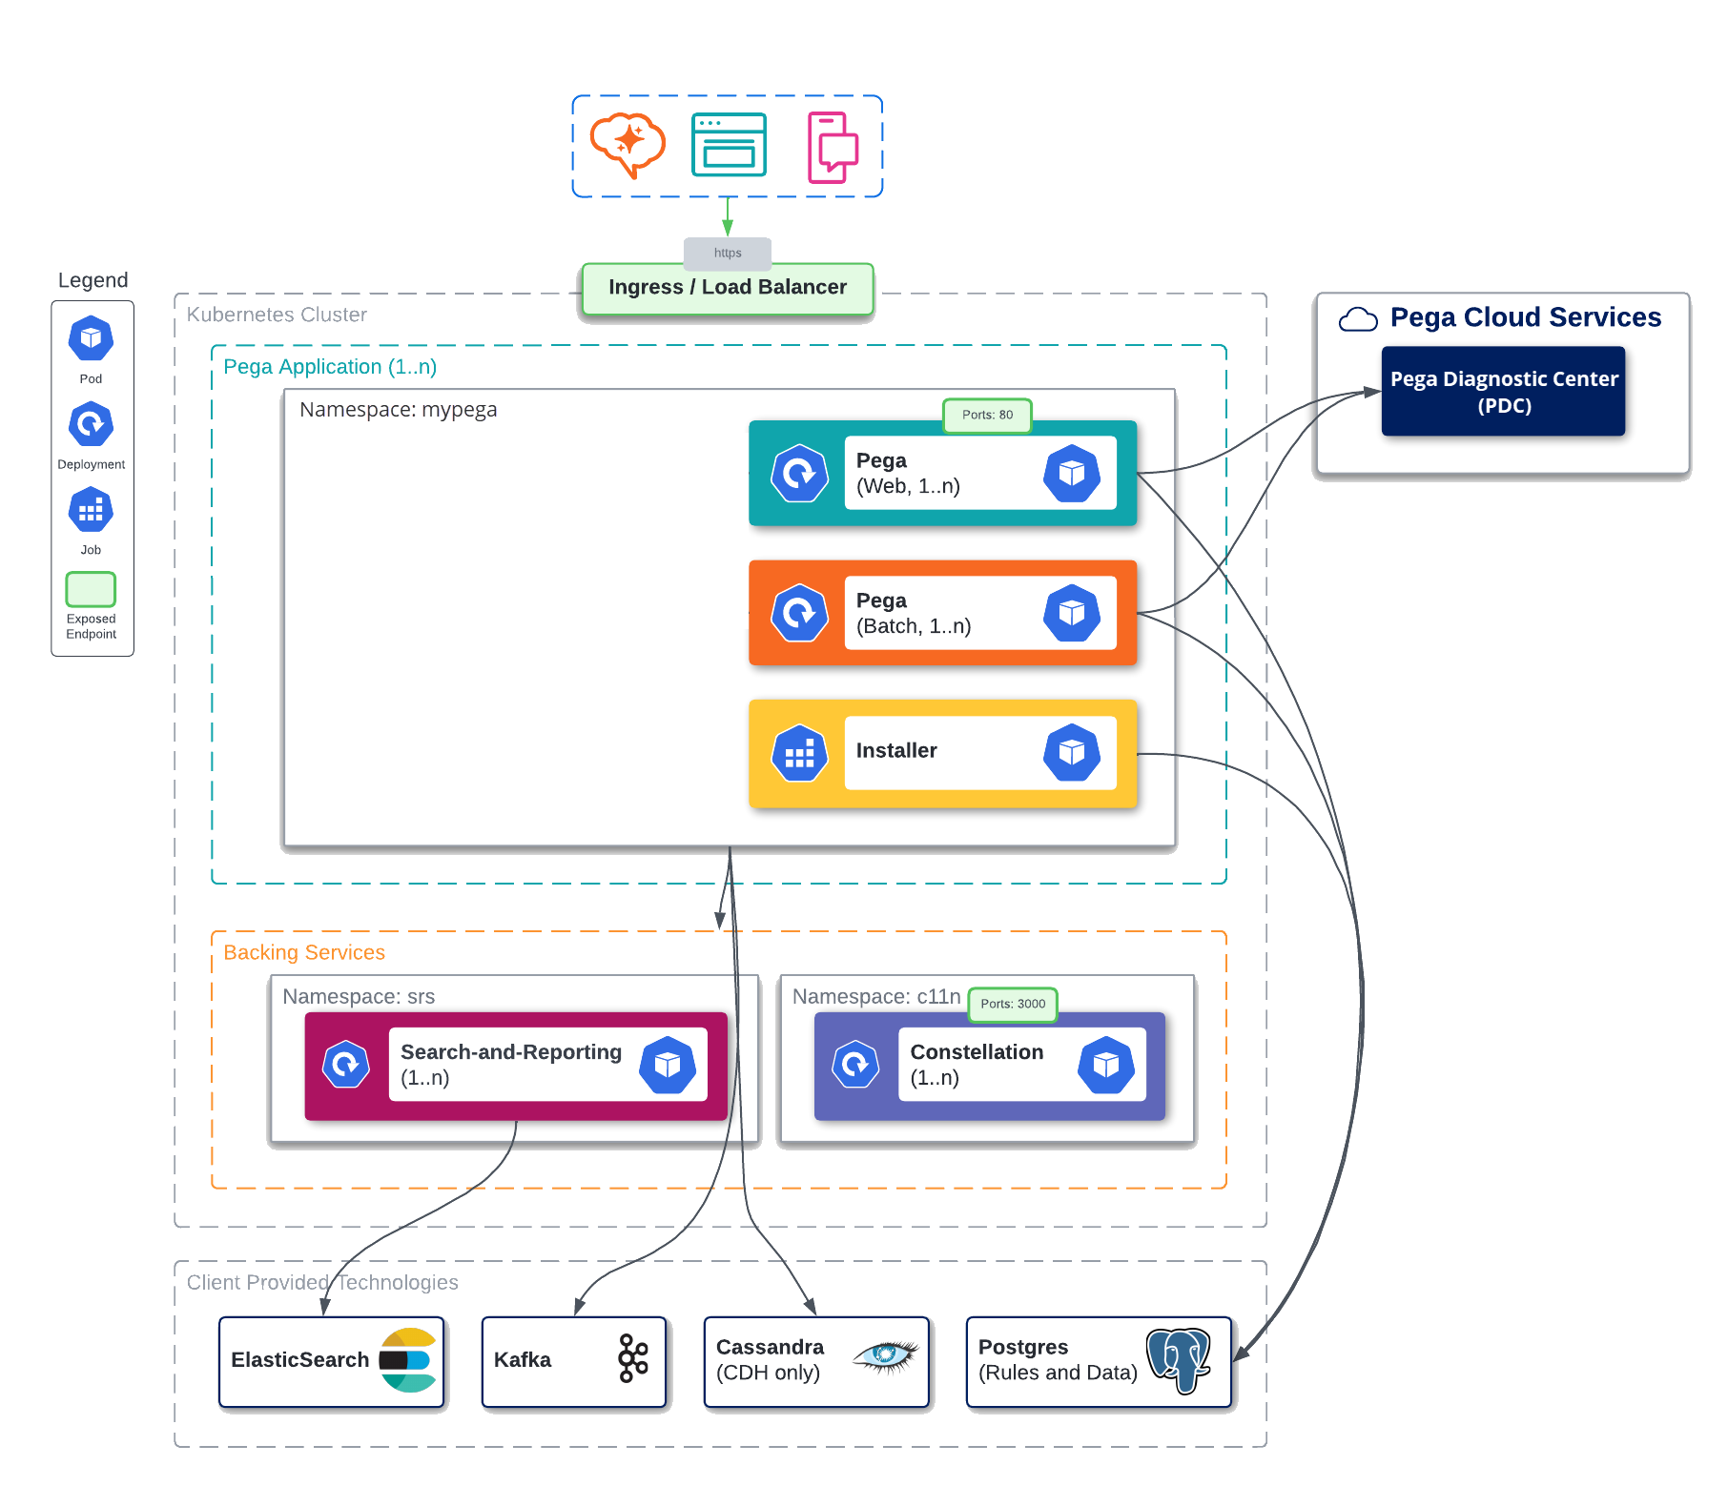
Figure 2. Pega Platform Kubernetes architecture for '26
Source: Pega Documentation, "Understanding the Pega Platform deployment architecture" [R21]. © Pegasystems Inc. Reproduced with attribution. The database shown is an example.
The 8.8 source system runs Kafka and Elasticsearch inside the Pega cluster. Pega Academy shows that older layout and the externalized layout side by side [R29, R30]. The comparison explains why nothing in the 8.8 Kafka or search storage can be moved: it lives on the 8.8 nodes.
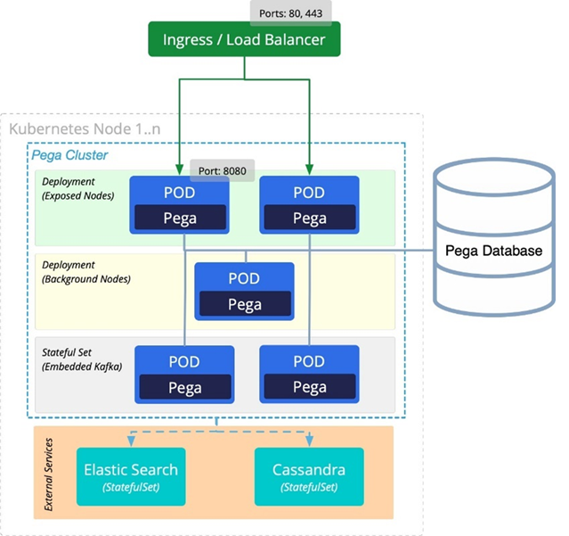
Figure 3. Earlier Pega cluster layout with embedded Kafka and in-cluster Elasticsearch
Source: Pega Academy, "Cloud deployment architecture" [R30]. © Pegasystems Inc. Reproduced with attribution. Shown to explain the 8.8 source; this layout is not supported from '24.2.
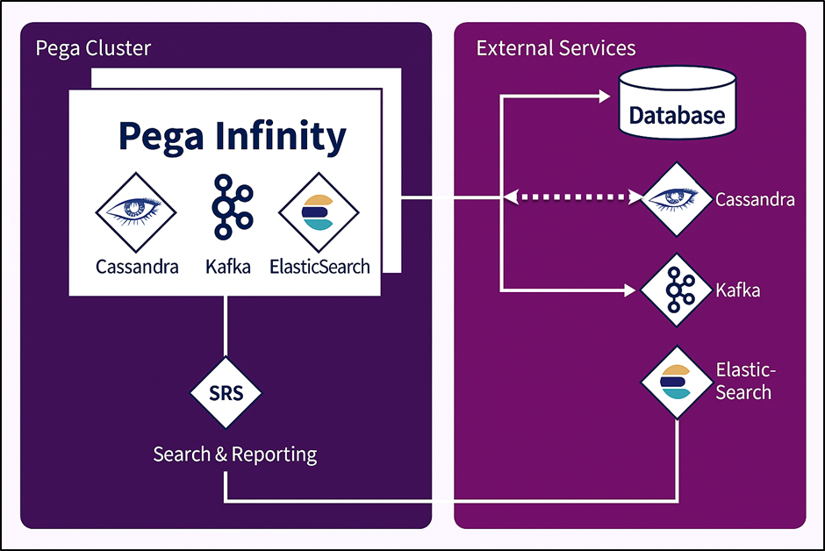
Figure 4. Externalized services in a Pega deployment
Source: Pega Academy, "Deployment architecture with external services" [R29]. © Pegasystems Inc. Reproduced with attribution.

4.2 Target architecture on Azure
Figure 5 shows one environment. The Pega web and batch tiers, the installer job and SRS run in a private AKS cluster. Confluent Cloud, the OpenSearch service, the upgraded database, Key Vault and the container registry are reached through private endpoints. Users reach Pega through Application Gateway with Web Application Firewall. Okta is a public SaaS service, reached through the hub firewall on an allow-list.
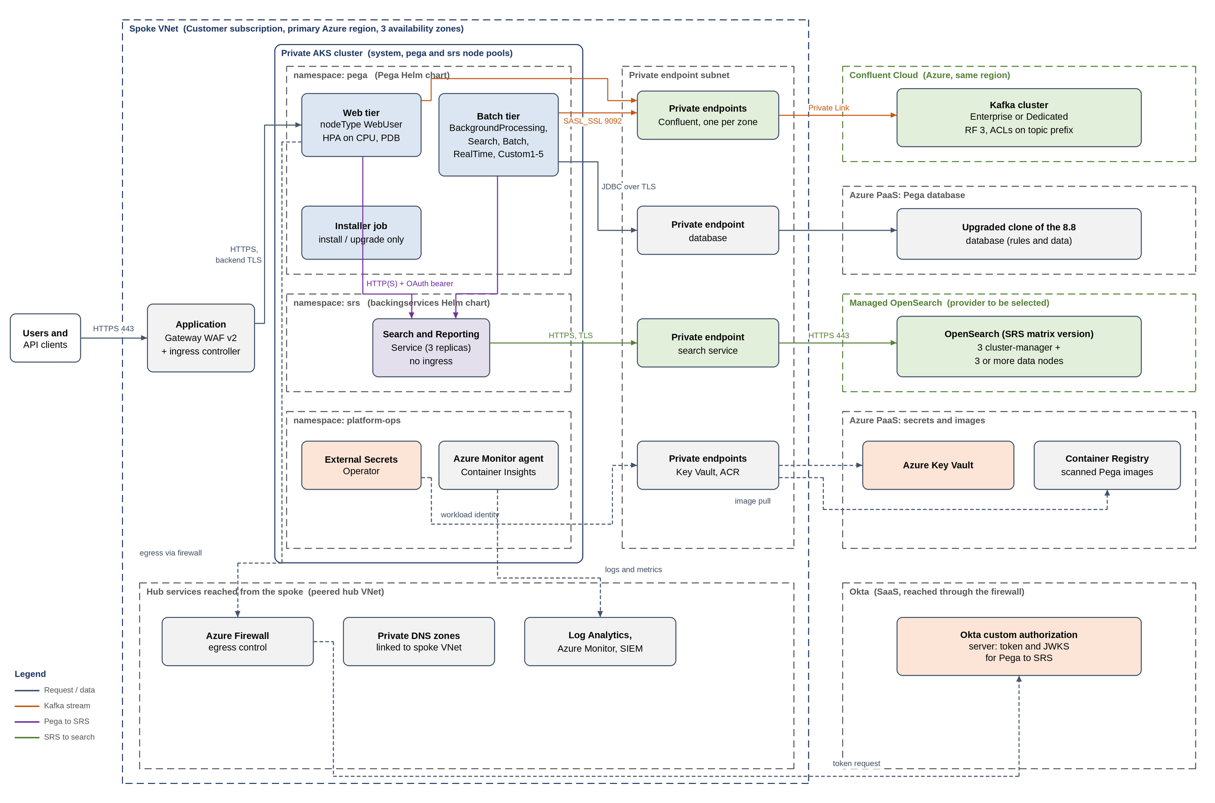
Figure 5. Target architecture for one environment on Azure AKS
Prepared for this implementation. Not a Pega-published diagram.
Table 10. Target architecture components
Component | Role | Design choice | Source
Web tier | User and API traffic (nodeType WebUser) | HPA on CPU; pod disruption budget | [R23]
Batch tier | Queue processors, job schedulers, search indexing, data flows | No ingress; held at zero replicas for the first start of a clone (Section 10.4) | [R21, R23]
Installer job | Upgrades the cloned database | Runs with global.actions.execute: upgrade (Section 9.4) | [R23]
SRS | Search and Reporting Service between Pega and OpenSearch | One deployment per environment; network policy; OAuth enabled | [R14, R24]
External Secrets Operator | Copies Key Vault secrets into Kubernetes secrets | Workload identity to Key Vault | [R23, R48]
Confluent Cloud | Kafka for the Pega stream service | Private Link; replication factor 3; prefixed ACLs | [R11, R31, R32]
Managed OpenSearch | Index storage for SRS | Version on the SRS matrix; private endpoint | [R14]
Okta | Issues tokens Pega presents to SRS | Custom authorization server; one client per environment | [R42, R43]
Pega database | Upgraded clone of the 8.8 database | Same region as AKS; private endpoint; TLS | [R20]

4.3 Logical flows
Figure 6 shows the five flows that matter for Kafka and search. Flow 1 is the user request. Flow 2 is queue processing: producers on any tier write to Kafka, and the batch tier consumes. Flow 3 is search: the batch tier indexes changed records through SRS, and the web tier sends queries through SRS. Flow 4 is the token path to Okta. Flow 5 is telemetry.
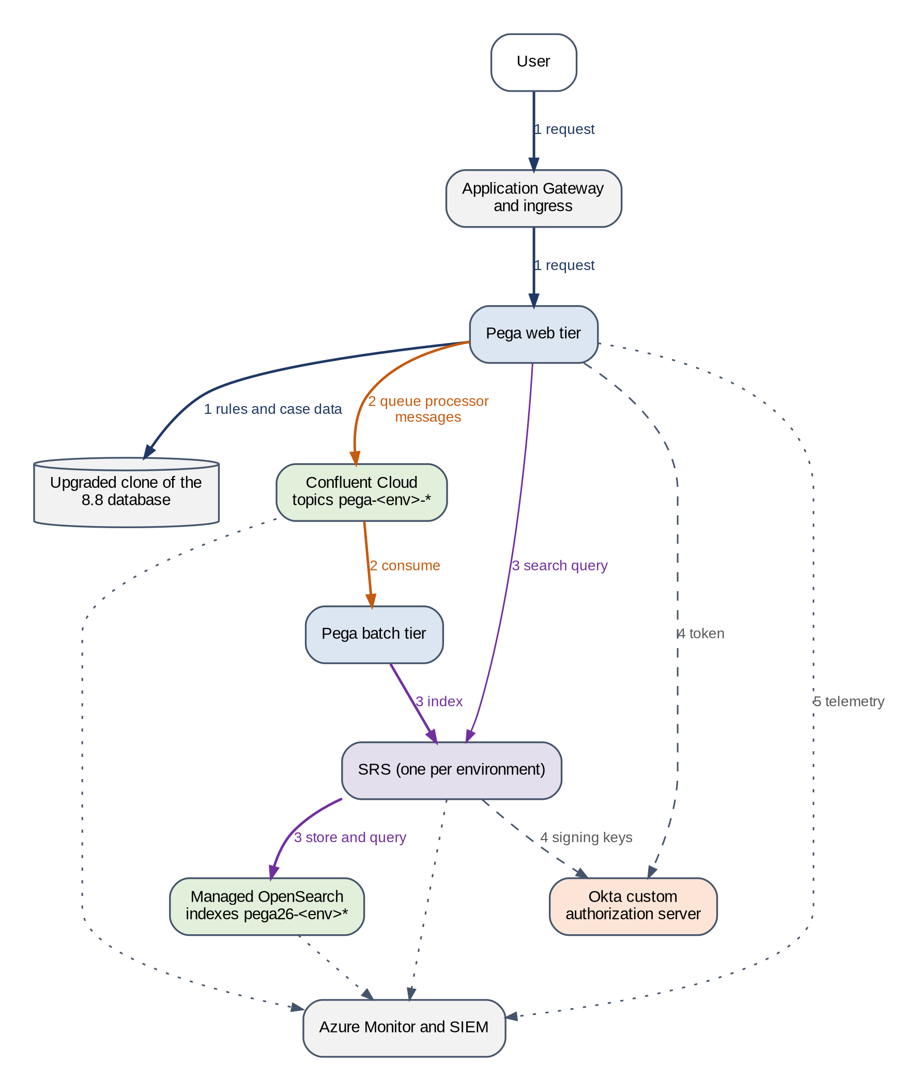
Figure 6. Logical flows between Pega, Kafka, SRS, OpenSearch and Okta
Prepared for this implementation. Not a Pega-published diagram.

4.4 Network and DNS
Every private endpoint needs a DNS record that resolves to its private IP from inside AKS [R47]. Confluent Private Link needs the wildcard and zonal records that Confluent lists for the cluster's network [R32]. A missing zonal record is the most common reason a Kafka client reaches the bootstrap server and then fails on broker connections. Figure 7 shows the name resolution and traffic paths, and Table 11 lists the flows the firewall and network policies must allow.
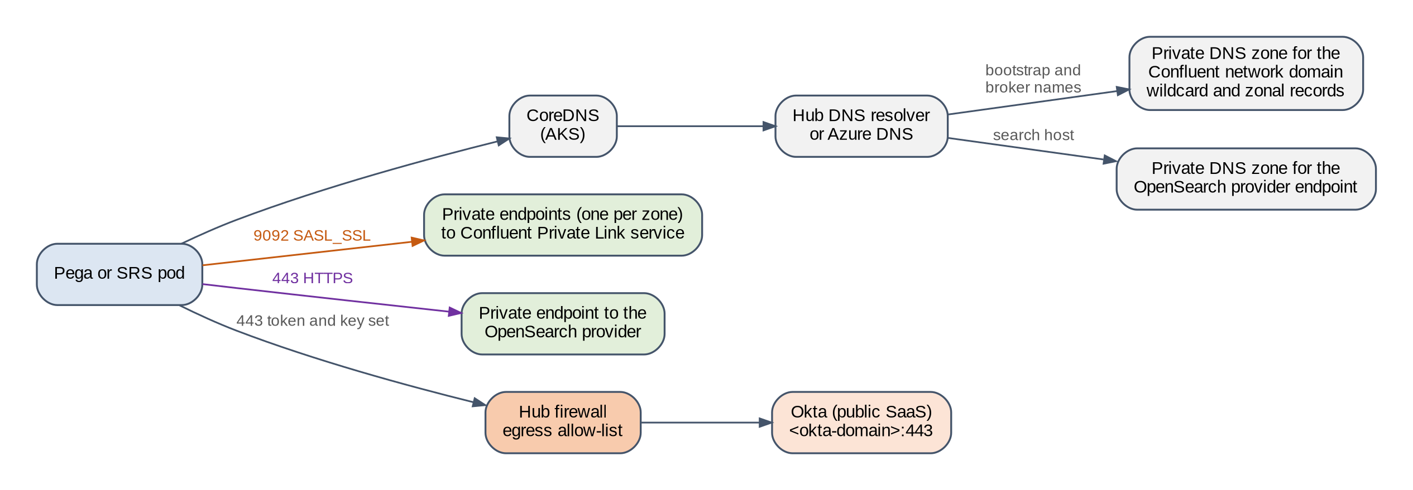
Figure 7. Name resolution and traffic paths for Kafka, OpenSearch and Okta
Prepared for this implementation. Not a Pega-published diagram.
Table 11. Network flows to allow and to deny
From | To | Port | Protocol | Purpose
Pega pods (web, batch) | Confluent private endpoints | 9092 | SASL_SSL | Stream service [R32]
Pega pods | SRS service in srs-<env> | 8443 | HTTPS with bearer token | Indexing and search (Section 7.7)
SRS pods | OpenSearch private endpoint | 443 or the provider port | HTTPS | Index storage and queries
Pega pods and installer job | Database private endpoint | Engine port | TLS | Rules and data
Pega pods | Okta <okta-domain> | 443 | HTTPS through the firewall | Token request
SRS pods | Okta <okta-domain> | 443 | HTTPS through the firewall | Key set download
External Secrets Operator | Key Vault private endpoint | 443 | HTTPS | Secret synchronization
Any pod in a non-production namespace | Production Kafka, production OpenSearch, production integrations | Any | Any | Denied by firewall and network policy (Section 5.3)

4.5 Message path inside Pega
Each queue processor writes to a Kafka topic named from the stream name pattern, for example pega-sit-<stream name>. The batch tier reads each topic through a consumer group under the same prefix, and one partition is read by one consumer at a time. Items that are not yet due wait in the database as delayed items. Items that fail after their retries become broken items, also held in the database. This split matters for the cloned database: the topics are empty in 26.1.1, but the database-held items are not (Section 10.3). Figure 8 shows the path.
Figure 8. Message path from producer to batch tier
Prepared for this implementation. Not a Pega-published diagram.
Note. Pega '26 moves queue processing to a partitioned, multi-threaded model [R3]. The number of partitions per topic therefore limits how many batch threads can work on one queue processor at once. Measure partitions after the first start (Section 6.7) rather than estimating them.

4.6 Availability zone resilience
PERF, PREPROD and PROD are built so that the loss of one Azure availability zone does not stop Pega, Kafka or search. Figure 9 shows the layout. DEV, SIT and UAT may run in fewer zones to save cost, but their shared Kafka cluster and OpenSearch service follow the same rules because they carry three environments.
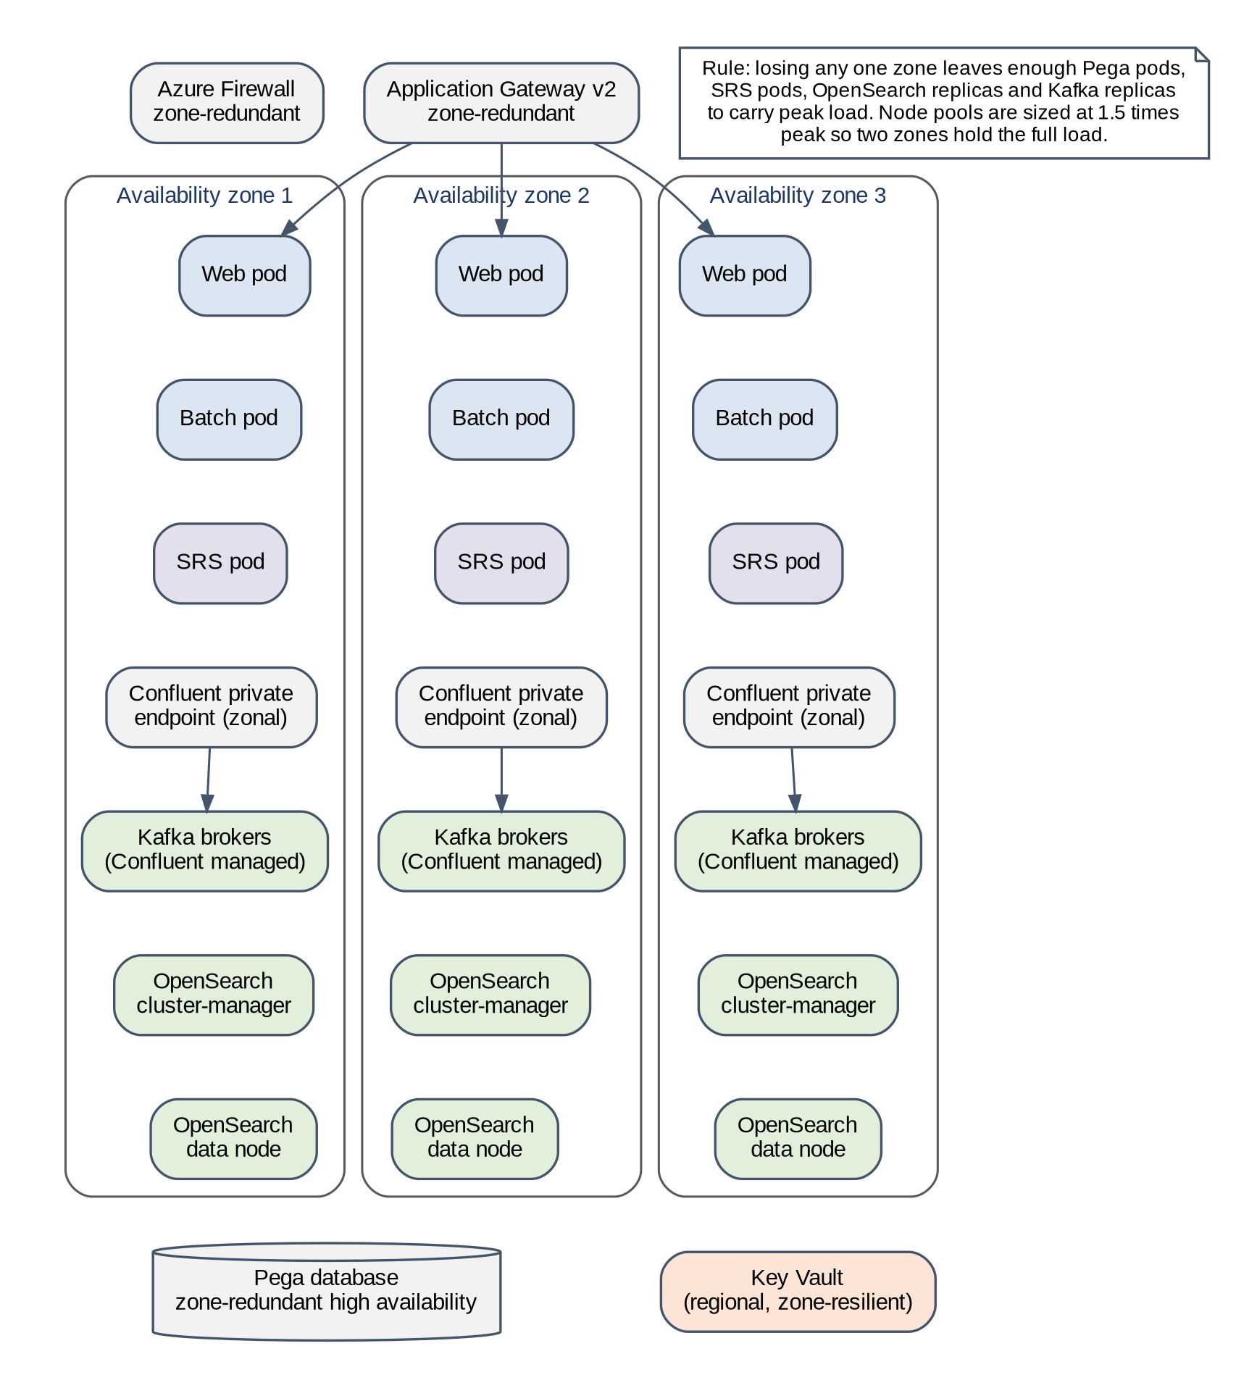
Figure 9. Spreading each layer across three availability zones
Prepared for this implementation. Not a Pega-published diagram.
Table 12. Availability zone design by layer
Layer | Zone design | Setting | Source
AKS node pools | Each user node pool spans zones 1, 2 and 3. The zones of a node pool cannot be changed after it is created, so this is decided before the first build | --zones 1 2 3 at node pool creation | [R59]
Pega web and batch pods | Spread evenly across zones; the scheduler still places pods if a zone is down | tier[*].topologySpreadConstraints on topology.kubernetes.io/zone, whenUnsatisfiable: ScheduleAnyway (Appendix B) | [R59, R61]
SRS pods | Preferred anti-affinity across zones | srsRuntime.affinity (Section 7.7) | [R24]
Node pool capacity | Two zones must hold the full peak load, so each pool is sized at 1.5 times the peak node count | Sizing calculator (Appendix H) | This design
Pod disruption budgets | Keep at least one pod per tier during drains and upgrades | tier[*].pdb.minAvailable: 1 | [R23]
Confluent Cloud | Enterprise: the 99.99 % SLA needs at least 2 eCKU. Dedicated: the cluster must be created multi-zone, which needs at least 2 CKU and cannot be changed later | Cluster creation (CC-1); one private endpoint per zone | [R31, R32]
OpenSearch | Three cluster-manager nodes and data nodes in three zones, one replica, zone awareness on | Provider setting (Section 7.4) | [R37]
Database, Key Vault, gateway, firewall | Zone-redundant service tiers | Customer landing zone standards | Customer

Caution. Topology spread with ScheduleAnyway is a preference. After a zone returns, Kubernetes does not move running pods back, so the spread stays uneven until the next rollout. Check the spread after FS-21 and after every zone incident, and restart the tier if one zone holds most of the pods.

5 Shared and dedicated service model
Pega allows one Kafka cluster and one search service to serve more than one Pega deployment. Kafka isolation comes from the stream name prefix and prefixed ACLs [R11]. Search isolation comes from the customerDeploymentId, which SRS uses as the index prefix [R14, R23]. This section uses those features to cut the number of service sets from six to three, and states the controls that keep each environment's data apart.

5.1 Grouping options
Four groupings were assessed. Table 13 compares them. Option B is recommended.
Table 13. Non-production grouping options
Option | Service sets | Strengths | Weaknesses
A. Dedicated per environment | 6 Kafka clusters, 6 OpenSearch services | No shared blast radius; simplest isolation | Highest cost; six sets to patch, monitor and rotate
B. Two shared groups plus PROD (recommended) | NP1: DEV, SIT, UAT. NP2: PERF, PREPROD. PROD dedicated. 3 sets in total | Load tests and rehearsals run on production-like services without touching functional testing; PREPROD matches PROD | PERF and PREPROD runs must be scheduled so they do not overlap
C. One shared non-production set plus PROD | 2 sets | Lowest cost | A PERF load test or PREPROD rehearsal affects DEV, SIT and UAT; non-production services cannot match PROD type without paying PROD price for all
D. PREPROD alone, others shared | DEV, SIT, UAT, PERF shared; PREPROD; PROD. 3 sets | PREPROD fully separate | PERF load tests affect functional testing; same number of sets as B with less benefit

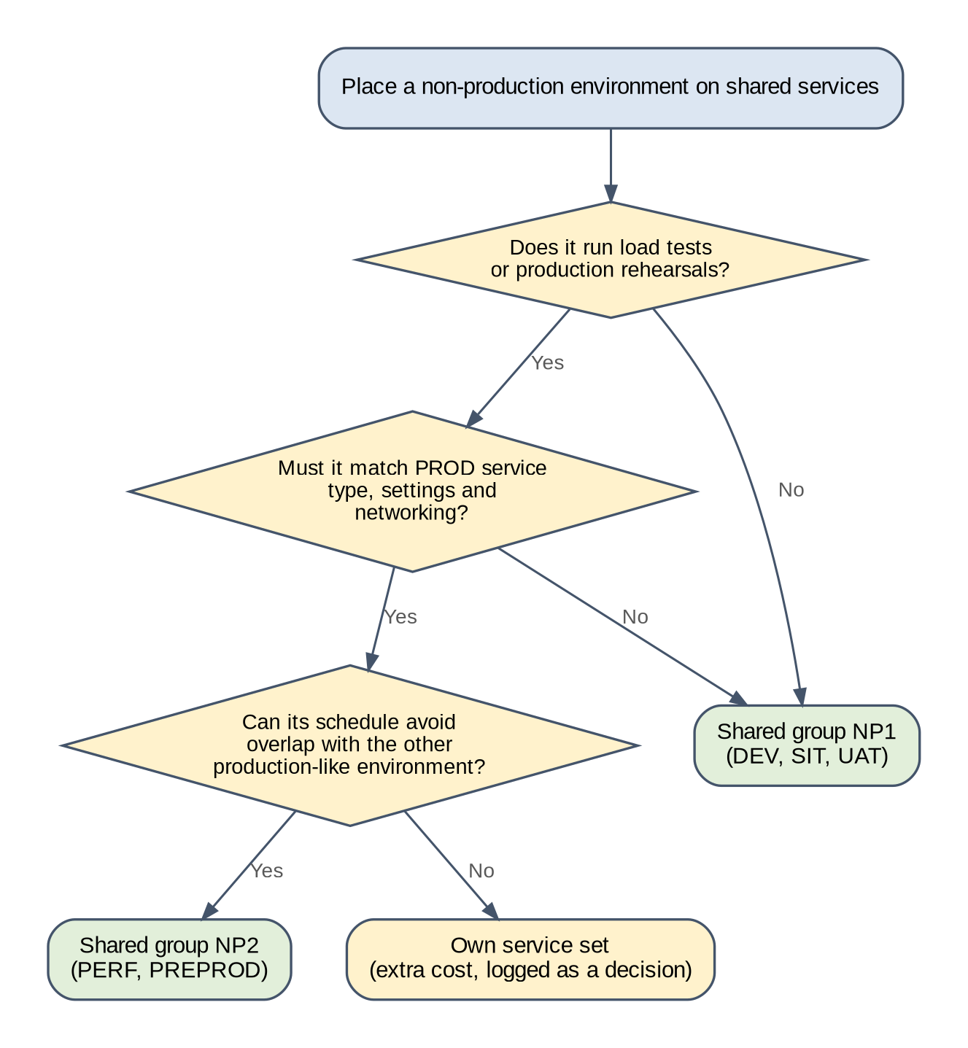
Figure 10. Decision: placing a non-production environment on shared services
Prepared for this implementation. Not a Pega-published diagram.

5.2 Recommended model
Figure 11 shows the two non-production groups and Figure 12 shows production. Each environment has its own namespace, topic prefix, service account, customerDeploymentId, SRS deployment, OpenSearch user, Okta client and Key Vault. Only the Kafka cluster and the OpenSearch service are shared within a group.
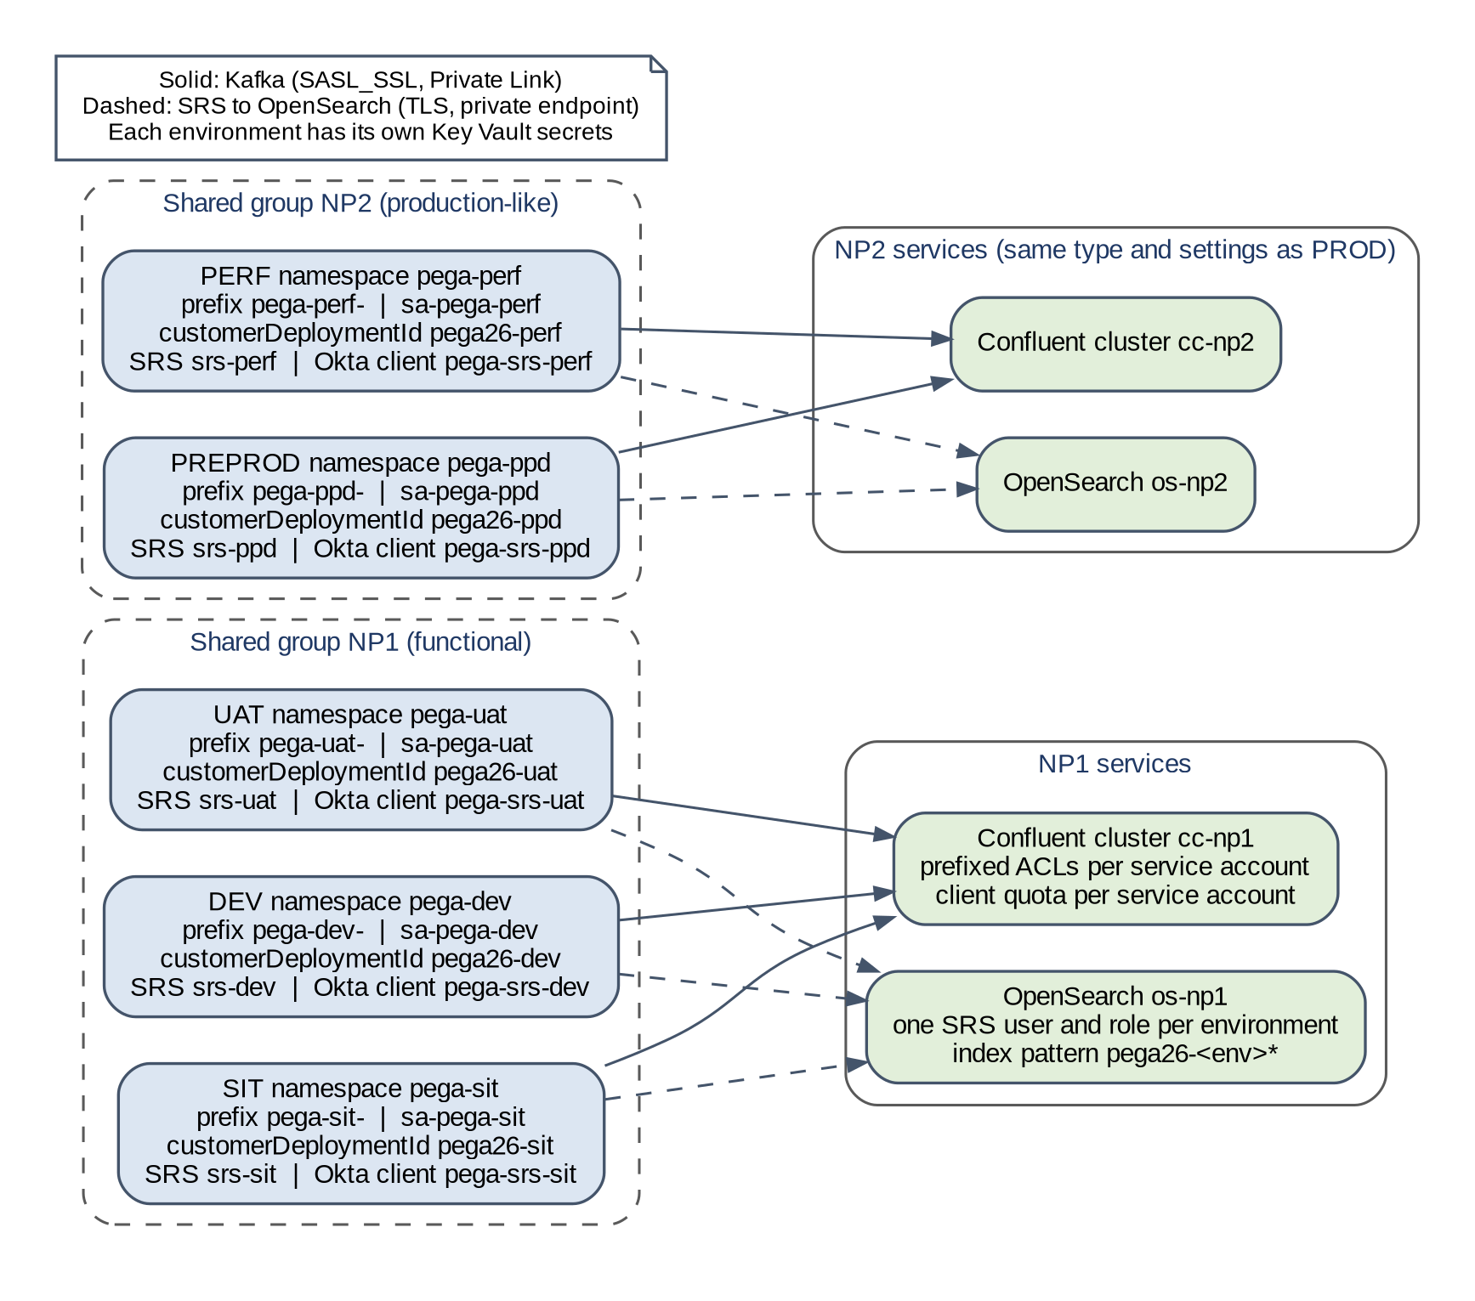
Figure 11. Shared non-production topology and per-environment boundaries
Prepared for this implementation. Not a Pega-published diagram.
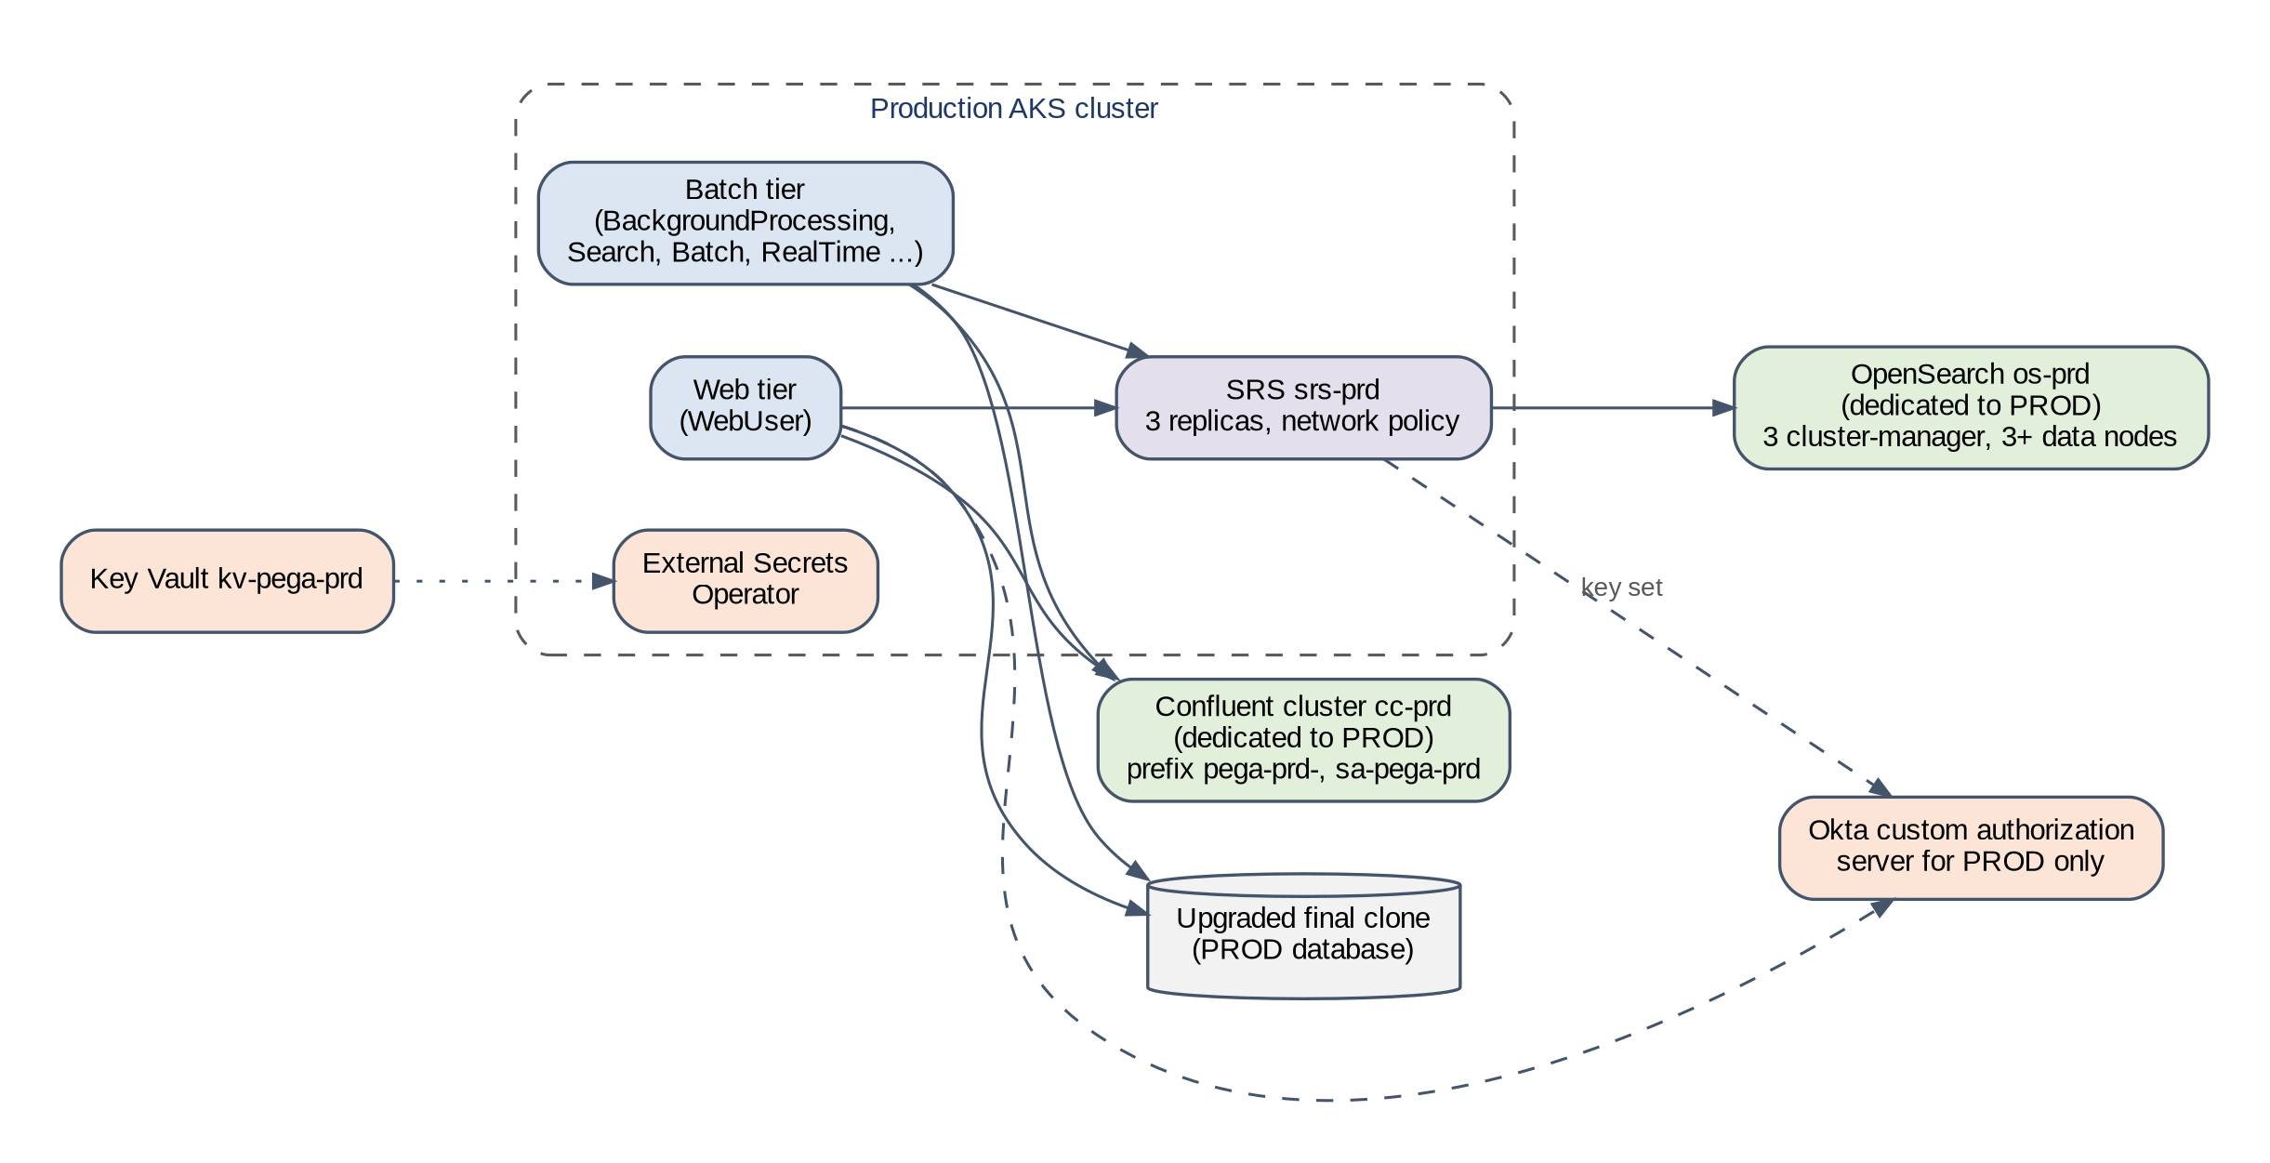
Figure 12. Production topology with dedicated services
Prepared for this implementation. Not a Pega-published diagram.

5.3 Isolation controls
Isolation is enforced at every layer, so a single mistake does not expose another environment. Table 14 lists the control at each layer and the test that proves it.
Table 14. Isolation controls by layer
Layer | Control | What it prevents | Proof (Section 14.3)
Kafka topics | Prefix pega-<code>- per environment through stream.streamNamePattern; TOPIC ACL ALL PREFIXED on that prefix only [R11, R23] | Reading, writing or deleting another environment's topics | IT-01, IT-02
Kafka consumer groups | GROUP ACL ALL PREFIXED on the same prefix [R11] | Joining or resetting another environment's consumer groups | IT-03
Kafka credentials | One service account per environment; API keys in that environment's Key Vault only [R36] | Credential reuse across environments | IT-04
Kafka capacity | Client quota per service account on Enterprise or Dedicated clusters [R36] | One environment's load starving the others | PT-03
Search indexes | customerDeploymentId pega26-<code>, used as the index prefix [R23] | Index name collisions | IT-05
Search credentials | One SRS deployment and one OpenSearch user per environment, with a role limited to index pattern pega26-<code>* if SRS accepts it (Section 7.5) [R40, R41] | One environment's SRS reading or deleting another's indexes | IT-06
Search tokens | Okta client per environment; SRS checks that guid equals its own customerDeploymentId [R23] | A token for one environment being accepted by another environment's SRS | IT-07
Secrets | Key Vault per environment; External Secrets Operator identity per namespace [R48] | Pods reading another environment's secrets | IT-08
Network | Firewall allow-list per environment; Kubernetes network policies deny by default | A cloned environment reaching production Kafka, production OpenSearch or production integrations | IT-09, IT-10
Cloned data | Application Kafka data sets and other endpoints repointed or disabled before the batch tier starts (Section 10.4) | Test environments consuming production topics or calling production systems | IT-10, FS-27

Figure 13 shows the same controls as layers. A request from one environment has to pass every layer to reach another environment's data, so a single misconfiguration does not expose it.
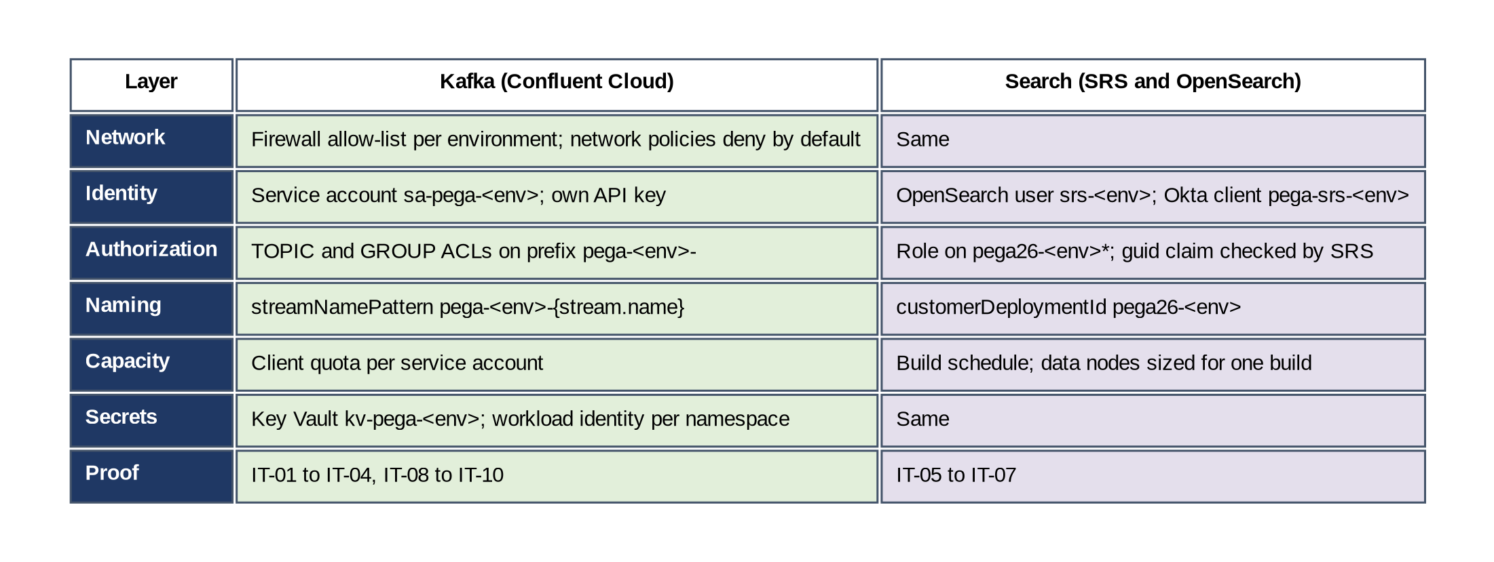
Figure 13. Isolation layers between environments on shared services
Prepared for this implementation. Not a Pega-published diagram.
Caution. Wildcard ACLs are forbidden on a shared cluster. Pega's ACL list includes TRANSACTIONAL_ID * [R11], which every environment needs. That ACL does not give access to topics or groups, but it means transactional IDs are not separated by environment. Record this as an accepted residual risk (RK-07).
Never grant TOPIC or GROUP with a literal * or with the bare prefix pega-, which would match every environment.

5.4 Noisy neighbours and quotas
Confluent supports client quotas on Enterprise, Freight and Dedicated clusters. Quotas apply to a service account or an identity pool, not to an API key, and the Metrics API labels throughput by principal [R36]. One service account per environment therefore gives both a quota boundary and per-environment metrics.
- Set a produce and a consume quota per service account in NP1 and NP2, sized from the measured peak of that environment plus headroom (OD-09).
- Leave PROD without quotas unless another workload is added to its cluster.
- In NP2, PERF load tests and PREPROD rehearsals are booked in a shared calendar. A run that overlaps the other environment's run needs both test leads' approval.
- If a load test in one environment affects another, stop the test, check the Metrics API by principal, lower that service account's quota and rerun (FS-22).
OpenSearch has no equivalent quota per user. In the shared search services, limit the effect of one environment on the others by running full index builds outside the other environments' test hours, and by sizing the data nodes for the largest concurrent build (Section 7.4).

5.5 Cost comparison model
Prices change and depend on the customer's agreements, so this document gives no figures. Table 15 lists the inputs the customer supplies, and Table 16 shows how each option is costed from them.
Table 15. Cost model inputs supplied by the customer
Input | Where it comes from | Notes
Confluent cluster base price per type | Confluent price list or contract | Enterprise and Dedicated differ in pricing unit (eCKU or CKU) [R31]
Capacity units per cluster | Measured partitions and throughput (Section 6.7) | Shared clusters add the needs of each environment
Private Link and data transfer | Confluent and Azure price lists | One set of private endpoints per cluster
OpenSearch nodes per service | Sizing in Section 7.4 | Cluster-manager and data nodes
OpenSearch storage and snapshots | Provider price list | Measured searchable data volume
Operations effort per service set | Customer operating model | Patching, monitoring, on-call, key rotation
Support plans | Confluent and provider contracts | Production support level for PROD and NP2

Table 16. Cost model by option (multiply each line by the customer's unit prices)
Cost line | Option A | Option B (recommended) | Option C
Kafka clusters | 6 x (base + units) | NP1 + NP2 + PROD: 3 x (base + units) | 2 x (base + units)
Private Link sets | 6 | 3 | 2
OpenSearch services | 6 x (nodes + storage) | 3 x (nodes + storage) | 2 x (nodes + storage)
SRS deployments | 6 (inside AKS) | 6 (inside AKS) | 6 (inside AKS)
Okta authorization servers | Up to 6 | 2 (PROD and shared non-production) | 2
Operations effort | 6 service sets | 3 service sets | 2 service sets
Risk cost | Lowest | Shared blast radius within NP1 and NP2; scheduling in NP2 | Load tests affect all non-production; no production-like test services

Option B removes three Kafka clusters and three OpenSearch services compared with Option A. The saving is the base price of those services plus their private endpoints and operations effort, less any extra capacity units the shared clusters need. Option C saves one more set but removes the production-like test services, which raises the chance of a production problem that rehearsals did not show.

5.6 Production
Production always has its own Confluent cluster, its own OpenSearch service, its own Okta authorization server and its own Key Vault. Production credentials, endpoints and DNS zones are not linked to any non-production network.

6 Confluent Cloud design and configuration

6.1 What Pega uses Kafka for
Pega uses Kafka in two ways. The stream service carries every queue processor and job scheduler, so Pega is not fully functional without it [R11]. This is what the Helm stream section configures. Separately, a Kafka data set is an application feature that reads from or writes to the customer's own Kafka topics. Pega requires that Kafka data sets use a different Kafka service from the stream service [R11]. Section 11.3 covers data sets.
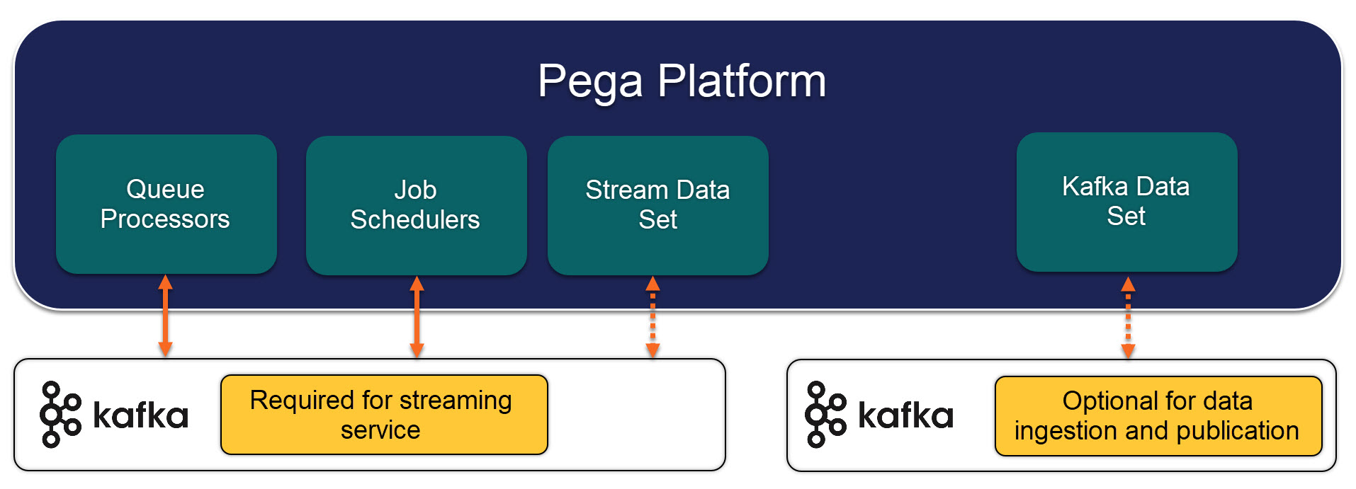
Figure 14. The two Kafka use cases in Pega Platform
Source: Pega Documentation, "External Kafka in your deployment" [R11]. © Pegasystems Inc. Reproduced with attribution.
Important. From '25, Pega uses its streaming function and the external Kafka service for the cluster messaging that Hazelcast used to carry, and Pega asks clients to review the Kafka configuration before the change [R7]. A Kafka outage on 26.1.1 therefore affects more than queue processing. Treat the Kafka service as a tier-1 dependency and test its loss explicitly (FS-01, FS-03).

6.2 Pega requirements mapped to Confluent Cloud
Confluent Cloud is a managed service, so some broker settings Pega lists cannot be changed by the customer. Table 17 shows each requirement, what Confluent Cloud allows, and what the runbook does.
Table 17. Pega Kafka requirements mapped to Confluent Cloud
Pega requirement | Confluent Cloud position | Action
Kafka client 4.0.0 in '26, compatible with 3.9.2 [R3] | Fully managed Kafka | Produce, consume and transactional checks from a Pega pod in every environment (Section 14.4)
Confluent 5.4.x or later [R11] | Current release line | None beyond the checks above
message.max.bytes 5000000 [R11] | Topic max.message.bytes default 2,097,164; editable up to 20,971,520 on Enterprise and Dedicated [R33] | After each start, set max.message.bytes to 5,000,000 on every Pega topic (command K-6)
replica.fetch.max.bytes and replica.fetch.response.max.bytes 5000100 [R11] | Not in the list of editable cluster settings [R34] | Ask Confluent support to confirm in writing (RC-03)
unclean.leader.election.enable false [R11] | Not customer-editable [R34] | Ask Confluent support to confirm in writing (RC-03)
auto.create.topics.enable false [R11] | Editable on Dedicated; default false [R34] | Keep false. Pega creates topics through its admin client, which needs CREATE in the topic ACL
Generic Kafka security only [R11] | SASL_SSL with API keys (PLAIN) is generic Kafka | Use SASL_SSL with PLAIN (Section 6.5)
ACLs for TOPIC, GROUP, TRANSACTIONAL_ID, CLUSTER IDEMPOTENT_WRITE [R11] | Supported on service accounts | Create before the first start (Section 6.5)
Production sizing supports about 1000 partitions [R11] | Partition limits per capacity unit are published [R31] | Measure after the first start (Section 6.7)

6.3 Cluster type per group
Confluent offers Basic, Standard, Enterprise, Dedicated and Freight clusters [R31]. Basic and Standard do not offer private networking, so they cannot hold cloned or masked production data. Freight does not support idempotent producers or transactions [R31], and Pega's ACL profile needs both [R11]. That leaves Enterprise and Dedicated.
Table 18. Confluent Cloud cluster limits relevant to Pega (source [R31]; Basic and Standard rows for connections and requests are not used here)
Dimension (per unit) | Basic eCKU | Standard eCKU | Enterprise eCKU | Dedicated CKU
Ingress MBps | 5 | 25 | 60 | 60
Egress MBps | 15 | 75 | 180 | 180
Partitions (before replication) | 30 | 250 | 3,000 | 4,500
Client connections |  |  | 18,000 | 18,000
Connection attempts per second |  |  | 500 | 500
Requests per second |  |  | 7,500 | 15,000
Partition creations and deletions per 5 minutes (cluster) |  |  | 500 | 5,000
Maximum message size |  |  | 20 MB | 20 MB
Private networking | No | No | Yes (Private Link) | Yes (Private Link or VNet peering)
Client quotas [R36] | No | No | Yes | Yes

Important. Confluent now enforces the connection and request limits on Enterprise clusters rather than treating them as guidance: request limits from March 2026 and connection limits from June 2026 [R31]. A client over a limit is throttled, and the Metrics API reports the throttling per principal with the limit that was hit [R56].
Pega pods open many Kafka connections: one set per producer, per queue-processor consumer thread and for cluster messaging. A rolling restart of a large tier, or every environment in a group starting at once after a refresh, can reach the connection-attempt limit. Measure connections per pod in DEV (Section 15.8), stagger restarts in shared groups, and alert on throttling (Section 18.5).

Caution. Partition creation and deletion are paced at 500 per five minutes per cluster on Enterprise [R31]. The first start of an environment creates every Pega topic, and a refresh deletes them all. With several hundred partitions per environment, both can take tens of minutes and slow every other environment on the cluster that creates topics at the same time. Include this time in the rehearsal measurements and never refresh two environments in a group at once.

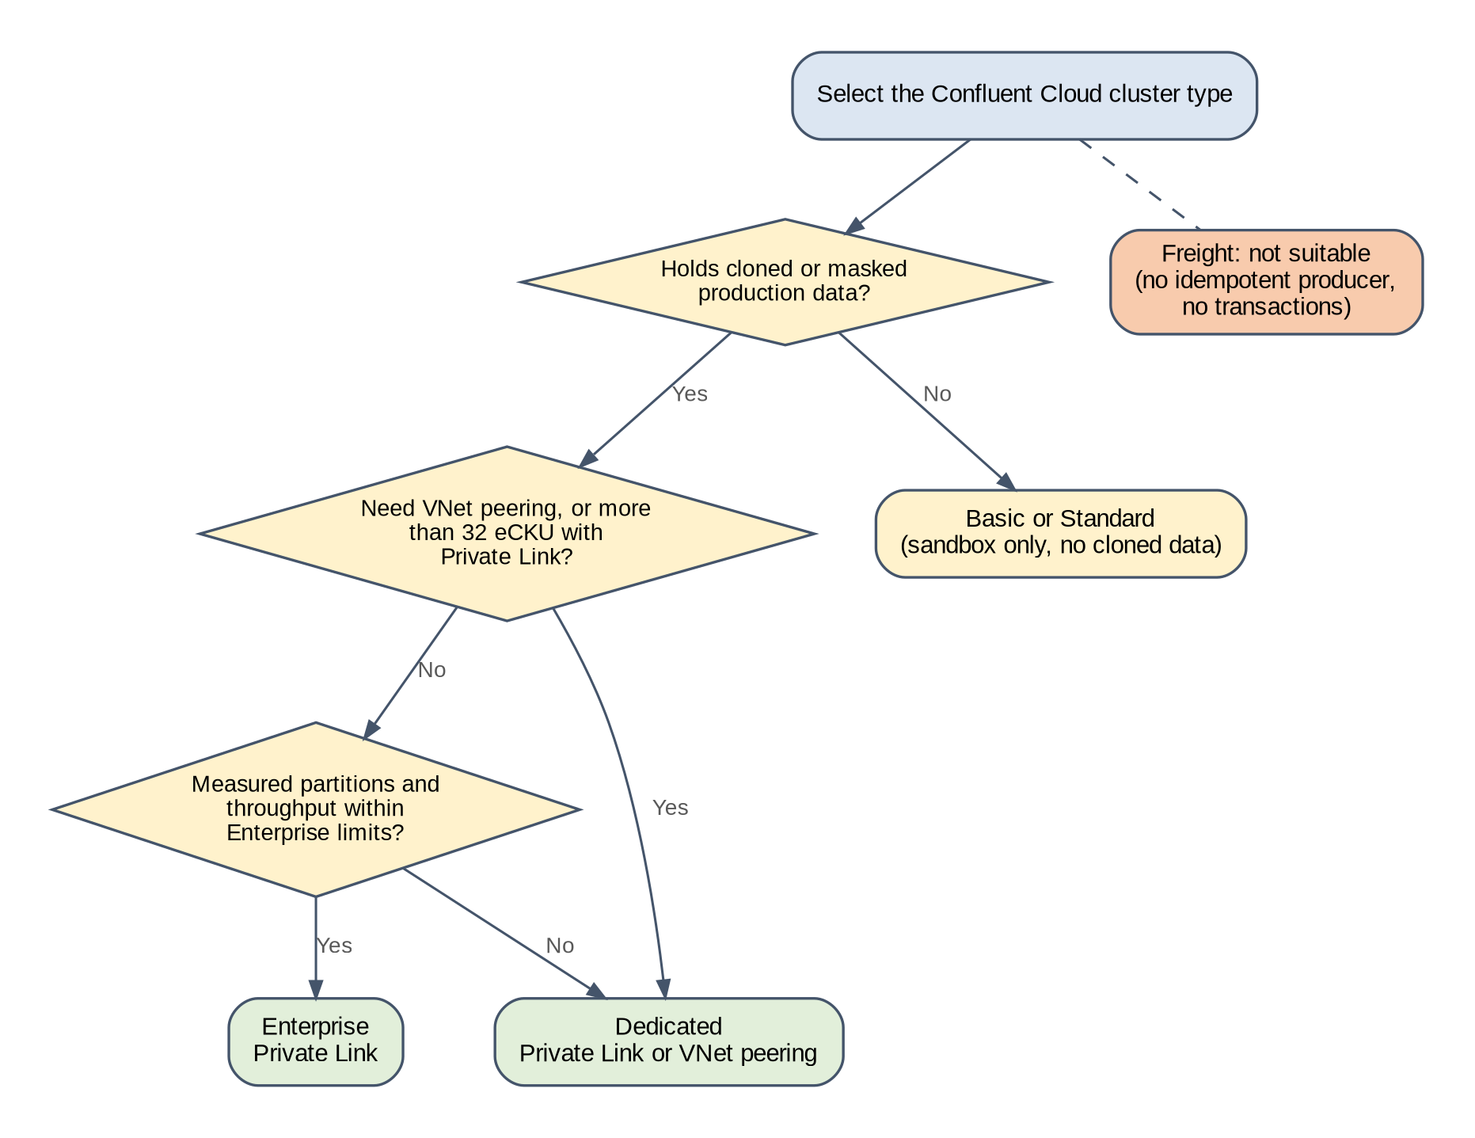
Figure 15. Decision: Confluent Cloud cluster type
Prepared for this implementation. Not a Pega-published diagram.
Table 19. Cluster type by group
Group | Recommended type | Reason
NP1 (DEV, SIT, UAT) | Enterprise with Private Link | Holds masked production data; quotas available; elastic capacity suits uneven test load
NP2 (PERF, PREPROD) | Same type as PROD | Load tests and rehearsals must show production behaviour
PROD | Enterprise with Private Link, or Dedicated if measured partitions or throughput exceed Enterprise limits, or VNet peering is required | Decided after the first PERF measurement (OD-02)

Caution. Enterprise clusters that use Private Link on Azure are limited to 32 eCKU [R31]. Add up the measured partitions of every environment in the group before confirming Enterprise.
The 99.99 % uptime SLA applies to Enterprise clusters of at least 2 eCKU, and to Dedicated clusters only when they are created multi-zone, which needs at least 2 CKU and cannot be changed later [R31]. Set the minimum capacity of cc-np2 and cc-prd to 2 units. Enterprise scales quickly up to 10 eCKU and more slowly above that, so do not rely on elastic scaling to absorb a cutover peak above 10 eCKU; raise the minimum before the event.

6.4 Private networking
Azure Private Link gives one-way private access from the customer VNet to Confluent Cloud. Confluent's Azure steps are: create the Confluent network, add a Private Link access for the customer subscription, create one private endpoint per zone, create the DNS records, and test [R32]. Each group's cluster needs its own set. The NP1 and NP2 private DNS zones are linked only to non-production networks, and the PROD zone only to the production network.
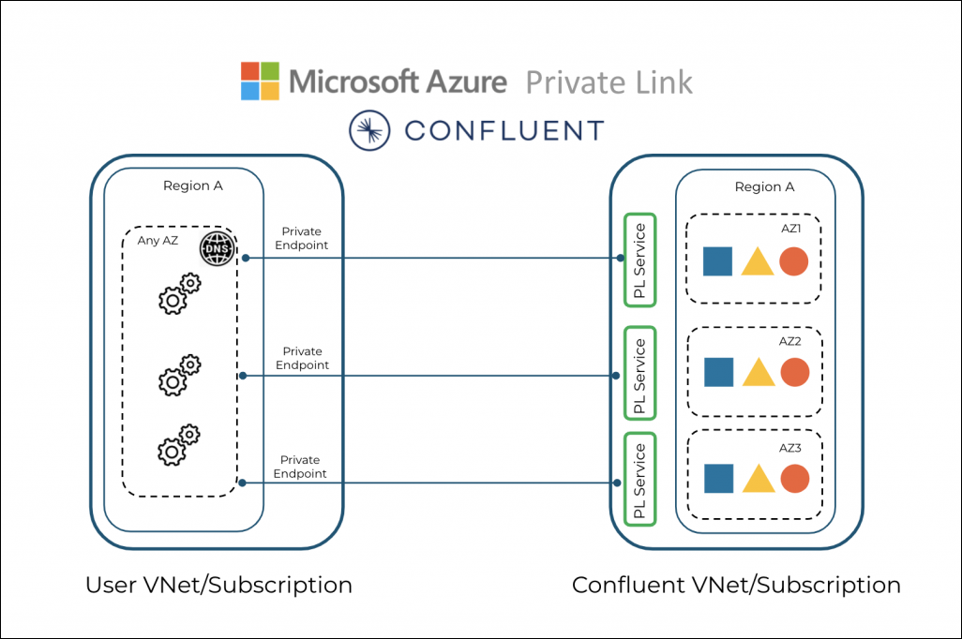
Figure 16. Azure Private Link between a customer VNet and Confluent Cloud
Source: Confluent Documentation, "Use Azure Private Link for Dedicated clusters on Confluent Cloud" [R32]. © Confluent, Inc. Reproduced with attribution.
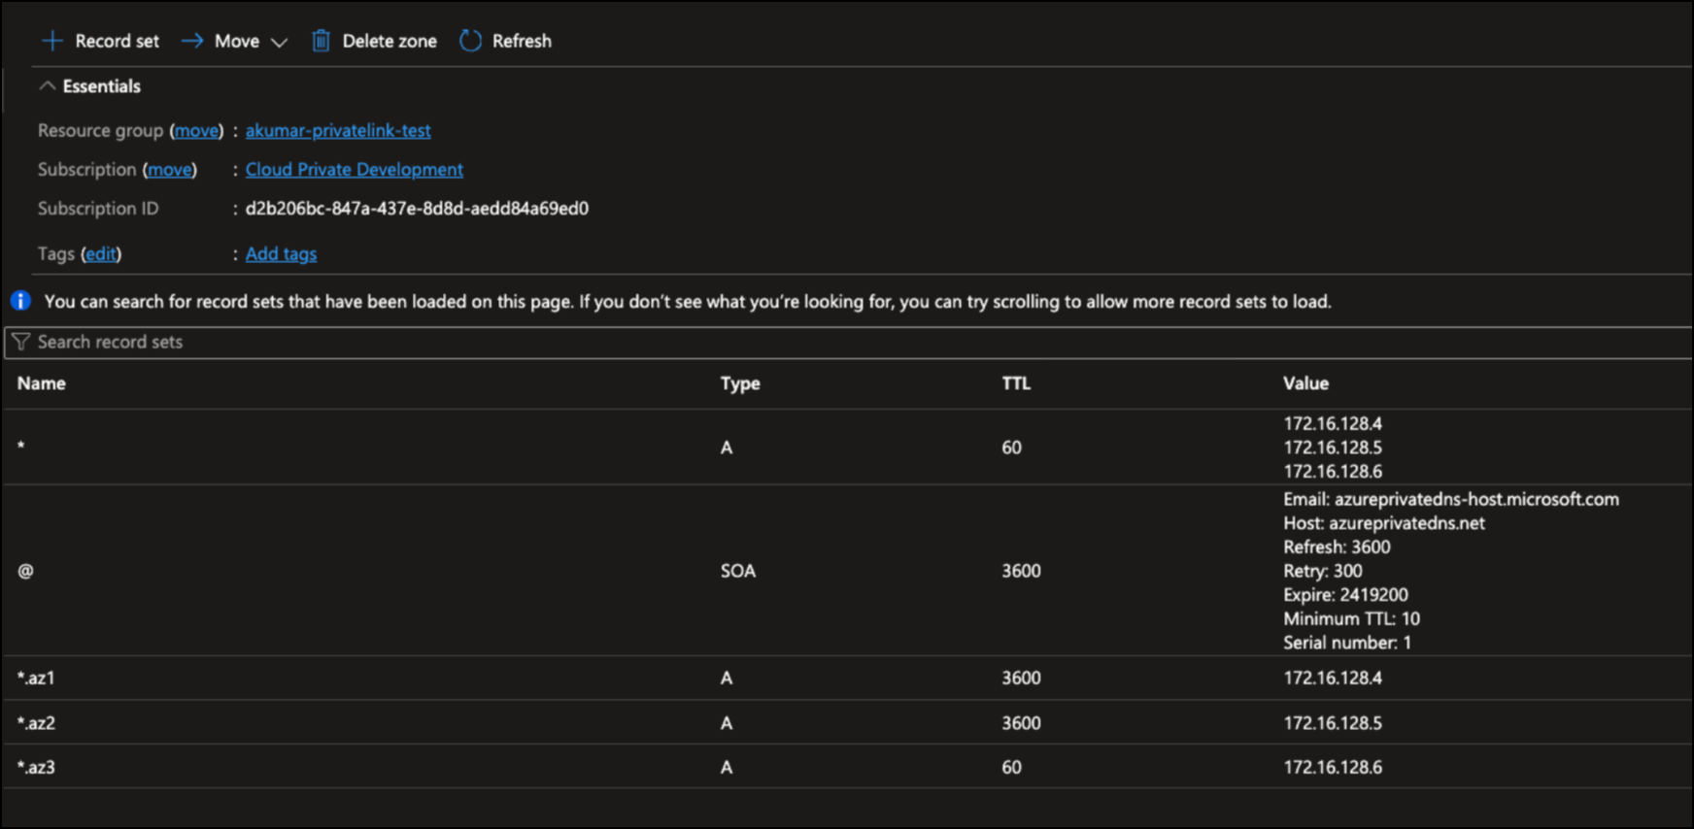
Figure 17. DNS records that Confluent lists for Azure Private Link
Source: Confluent Documentation [R32]. © Confluent, Inc. Reproduced with attribution.
Table 20. Private Link set-up steps per cluster
Step | Action | Check
N-1 | Create the Confluent network in the AKS region and register the customer subscription for Private Link. | Network ID and subscription recorded in Appendix A
N-2 | Create one private endpoint per zone in the private endpoint subnet, using the service aliases Confluent shows. | Connection state Approved for each
N-3 | Create the private DNS zone for the Confluent network domain with the wildcard and zonal records Confluent shows; link it to the right VNet or resolver. | Zone export kept as evidence
N-4 | From a pod in pega-<code>, resolve the bootstrap name and a broker name. | Both return private IPs (K-1)
N-5 | From the same pod, open TLS to the bootstrap name on port 9092. | Certificate chain shown (K-2)
N-6 | Run a metadata request. | Every broker name resolves privately (K-3)

Note. Confluent states that the Confluent CLI might need internet access to the Confluent control plane even when the cluster uses Private Link [R32]. Allow that only from the administration jump host, never from Pega pods.

6.5 Service accounts, authentication and ACLs
Pega lists several SASL options [R11], but the Helm stream.saslMechanism key accepts PLAIN, SCRAM-SHA-256 and SCRAM-SHA-512 [R23]. Confluent Cloud API keys use SASL/PLAIN. Figure 18 shows the choice.
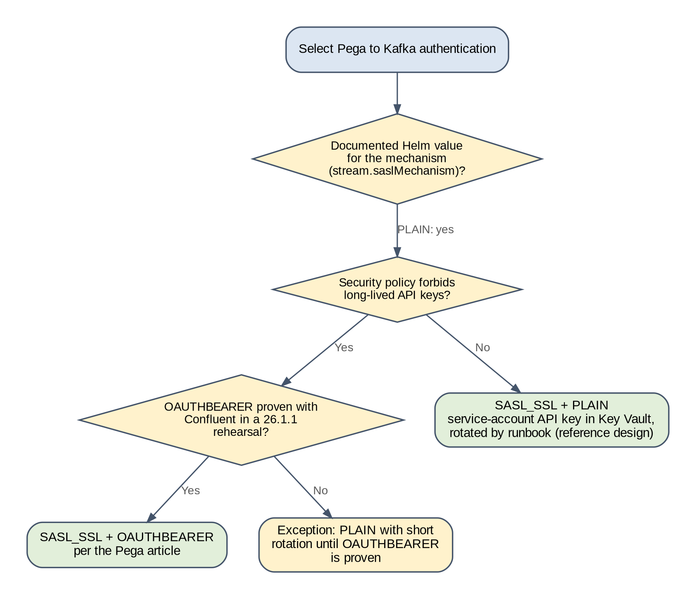
Figure 18. Decision: Pega to Kafka authentication
Prepared for this implementation. Not a Pega-published diagram.
Create one service account per environment and grant it only the ACLs Pega lists, scoped to that environment's prefix. Table 21 shows the ACLs for one environment; repeat them for each environment on its own cluster.
Table 21. Kafka ACLs for one environment's service account (source [R11])
Resource type | Resource name | Operation | Pattern | Why
TOPIC | pega-<code>- | ALL | PREFIXED | Create, write, read and delete Pega topics
GROUP | pega-<code>- | ALL | PREFIXED | Consumer groups for queue processors and data flows
TRANSACTIONAL_ID | * | READ, WRITE | LITERAL | Transactional producers
CLUSTER | the cluster | IDEMPOTENT_WRITE | LITERAL | Idempotent producers

Creating and listing one environment's service account and ACLs
# Confluent CLI. Check flags with: confluent kafka acl create --help
confluent iam service-account create sa-pega-<code> --description "Pega 26.1.1 <ENV>"
confluent kafka acl create --allow --service-account <sa-id> --operations all \
--topic "pega-<code>-" --prefix --cluster <lkc-id>
confluent kafka acl create --allow --service-account <sa-id> --operations all \
--consumer-group "pega-<code>-" --prefix --cluster <lkc-id>
confluent kafka acl create --allow --service-account <sa-id> --operations read,write \
--transactional-id "*" --cluster <lkc-id>
confluent kafka acl create --allow --service-account <sa-id> \
--operations idempotent-write --cluster-scope --cluster <lkc-id>
confluent api-key create --resource <lkc-id> --service-account <sa-id>
confluent kafka acl list --service-account <sa-id> --cluster <lkc-id>

To remove an environment's access, delete its ACLs with confluent kafka acl delete using the same flags, delete its API keys, then delete the service account (Section 19.4).

6.6 Topic design
Table 22. Topic design settings
Setting | Value | Reason
streamNamePattern | pega-<code>-{stream.name} | Separates environments on a shared cluster. Chart default is pega-{stream.name} [R23].
replicationFactor | 3 | Pega's recommended value; cannot exceed the number of brokers [R23].
Topic creation | By Pega through its admin client (CREATE in the topic ACL) | Pega calls broker auto-creation a legacy method [R11]. If policy forbids CREATE, pre-create topics from the rehearsal list (OD-11).
max.message.bytes | 5,000,000 on every Pega topic | Matches Pega's maximum message size [R11]; Confluent default is lower [R33].
SystemPulse_SystemPulseTopicName | 6 partitions | '26 prerequisite; automatic if dynamic topic creation is allowed [R3].
Cluster messaging topics after Hazelcast removal | Covered by the prefixed ACL if Pega applies the pattern to them | Pega names five topics in the Hazelcast removal prerequisites [R6] but does not say whether the pattern applies. List the topics after the first DEV start and add literal ACLs for any outside the prefix (FS-04).

When an environment is refreshed from a new clone, keep its prefix and delete its old topics and consumer groups before the first start (Section 19.3). Keeping the prefix keeps ACLs, quotas and dashboards unchanged. A new prefix is only needed if old topics cannot be deleted, for example during an investigation; in that case create a new prefix such as pega-sit2- with its own ACLs.

6.7 Partition budget
Since Pega 8.7, each new stream topic is created with 6 partitions by default. The default is set by the DSS prconfig/dsm/services/stream/pyTopicPartitionsCount/default in ruleset Pega-Engine, and applies only to topics created after the change [R49]. On a queue processor rule, threads beyond the topic's partition count do no work, because one partition is read by one consumer at a time [R50]. Two rules follow:
- Expected partitions per environment = (number of Pega topics x partitions per topic), counted at replication factor 1. For example, with the default of 6, 150 topics give 900 partitions, close to the 1,000 that Pega's production sizing names [R11].
- Effective consumers per queue processor = min(partitions, batch pods x threads per node). Adding batch pods beyond the partition count does not speed up a queue processor; raise its partition count first, and only for the queue processors that the load test shows as the bottleneck.
Caution. A database cloned from 8.8 may carry a changed pyTopicPartitionsCount DSS or per-topic overrides from tuning on 8.8 (CD-15). Record the value at time point A. If it differs from 6, decide with the performance lead whether to keep it, because it multiplies the partition count of every topic created at first start.

Partitions drive both Confluent cost and limits. Measure them instead of estimating:
1. After the first full start of each environment, count partitions under its prefix (command K-5).
2. Record the count in Table 23 and add the headroom agreed for new queue processors (30 % is a sound starting point).
3. Add up the environments in each group and compare with the cluster limit for the chosen type (Table 18).
4. Repeat after each application release that adds queue processors.
Table 23. Partition budget worksheet
Environment | Group | Measured partitions | With 30 % headroom | Group total | Cluster limit | Within limit
DEV | NP1 | <measured> | <x 1.3> | <sum for group> | <from Table> | <yes or no>
SIT | NP1 | <measured> | <x 1.3> | <sum for group> | <from Table> | <yes or no>
UAT | NP1 | <measured> | <x 1.3> | <sum for group> | <from Table> | <yes or no>
PERF | NP2 | <measured> | <x 1.3> | <sum for group> | <from Table> | <yes or no>
PREPROD | NP2 | <measured> | <x 1.3> | <sum for group> | <from Table> | <yes or no>
PROD | PRD | <measured> | <x 1.3> | <sum for group> | <from Table> | <yes or no>

6.8 Helm stream configuration
The stream section connects every tier to Kafka [R12]. Passwords and the JAAS string are left empty in the values file and supplied by an external secret with the keys STREAM_TRUSTSTORE_PASSWORD, STREAM_KEYSTORE_PASSWORD and STREAM_JAAS_CONFIG [R23].
values-<code>.yaml: stream section
stream:
enabled: true
bootstrapServer: "<bootstrap-host>:9092"
securityProtocol: SASL_SSL
saslMechanism: PLAIN
trustStore: ""
keyStore: ""
jaasConfig: ""
streamNamePattern: "pega-<code>-{stream.name}"
replicationFactor: "3"
external_secret_name: "pega-stream-secret"

Value of STREAM_JAAS_CONFIG in Key Vault (stored as one line)
org.apache.kafka.common.security.plain.PlainLoginModule required
username="<api-key>" password="<api-secret>";

6.9 prpcUtils on 26.1.1
From '25, prpcUtils needs its own connection to Kafka for clustering. Pega documents a -DNodeSettings argument in custom.jvm.args of prpcUtils.properties for '25 and '26 [R8]. Pipelines that run prpcUtils against an upgraded environment must pass that environment's bootstrap server, prefix and JAAS value, generated at run time from Key Vault and deleted after the run.
Important. The installer job that runs the upgrade (run U) is built from the same Pega command-line tooling, but chart 4.13.0 passes it no stream settings: a rendered run U contains no STREAM_* values. Whether the 26.1.1 upgrade of an 8.8 database needs Kafka is therefore an open question for Pega Support (GQ-08). Until it is answered, allow the installer pod to reach the environment's Confluent endpoint and watch the installer log for Kafka connection attempts in the first DEV upgrade.

7 Managed OpenSearch and SRS design and configuration

7.1 How search works in 26.1.1
SRS is a Pega backing service between Pega Platform and the search cluster. Pega sends indexing and query requests to SRS, and SRS manages the indexes in OpenSearch [R14]. SRS isolates each Pega environment's data with a customerDeploymentId, which becomes the index prefix [R14, R23]. The search service can serve several Pega deployments, but Pega advises against sharing it with non-Pega software [R14].
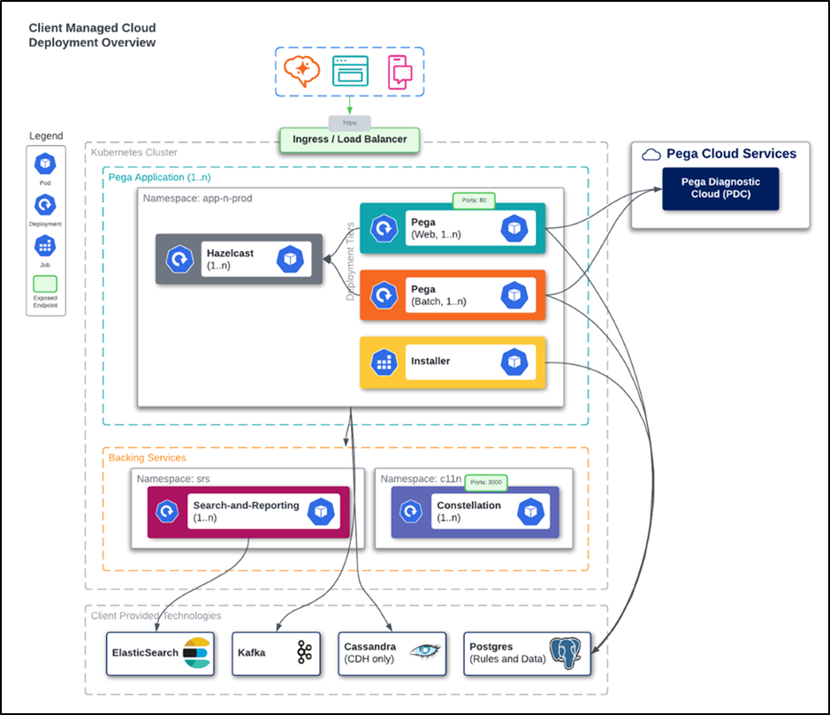
Figure 19. Client-managed cloud deployment with SRS as a backing service
Source: Pega Academy, "Search and Reporting Service" [R28]. © Pegasystems Inc. Reproduced with attribution. The Hazelcast pod in this illustration does not apply to '25 and later.

7.2 SRS and OpenSearch versions
Table 24. SRS compatibility with OpenSearch for Pega 8.6 and later, SRS 1.44.3 or later (source [R14])
SRS image | Authentication | Certified OpenSearch versions | Pega best practice
search-n-reporting-service-os | Enabled | AWS OpenSearch service with Elasticsearch 7.10; OpenSearch 1.3, 2.15, 2.19 | OpenSearch 2.15

- Choose OpenSearch 2.15 or 2.19. Version 1.3 is on the matrix but is an older line, and the provider may not offer it.
- Use the newest search-n-reporting-service-os tag that the SRS chart README lists for chart 4.13.0 [R24]. The README lists a newer SRS than the Pega page (RC-01).
- Use only official OpenSearch images if the customer runs OpenSearch itself; custom images are not supported [R14].
- The search cluster that the backingservices chart can provision is for development and test only, and cannot be OpenSearch [R14, R24].

7.3 Provider selection
Azure has no first-party managed OpenSearch service, so the choice is between third-party providers that run OpenSearch in Azure regions and a self-managed cluster on AKS. Pega accepts a cloud subscription, a licensed product or open source [R14]. This document names no provider: a provider becomes a candidate only when its own documentation shows an Azure region and OpenSearch 2.15 or 2.19, and that check is part of the selection.
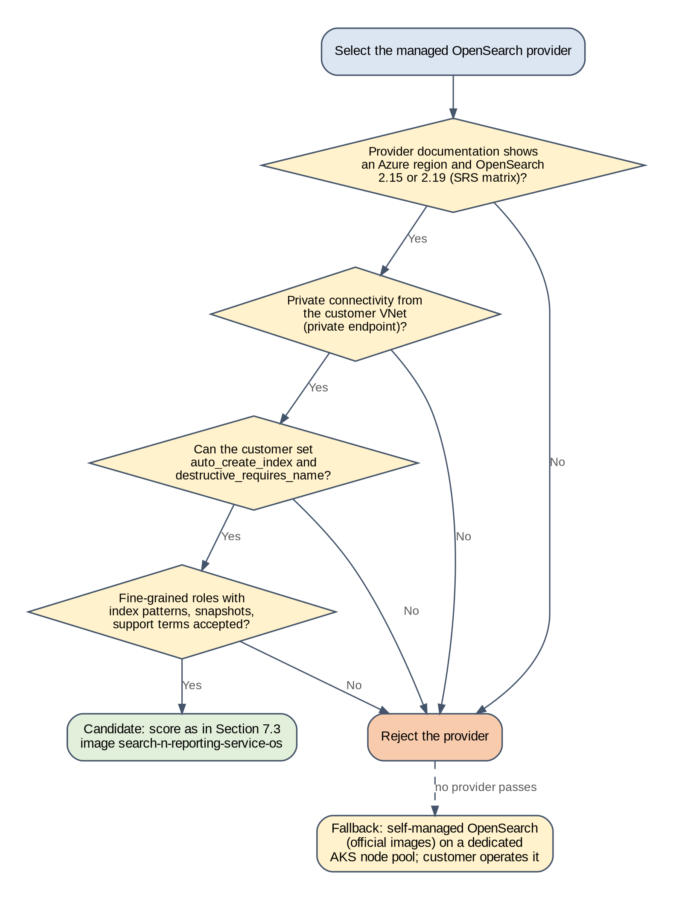
Figure 20. Decision: managed OpenSearch provider
Prepared for this implementation. Not a Pega-published diagram.
Score each candidate in Table 25. A provider that fails a mandatory criterion is rejected whatever its score.
Table 25. OpenSearch provider selection worksheet
Criterion | Type | Weight | Provider 1 | Provider 2 | Self-managed on AKS
Azure region same as AKS, shown in provider documentation | Mandatory |  |  |  | Yes
OpenSearch 2.15 or 2.19 available and pinnable | Mandatory |  |  |  | Yes
Private endpoint into the customer VNet | Mandatory |  |  |  | Yes
Customer can set action.auto_create_index and action.destructive_requires_name [R14] | Mandatory |  |  |  | Yes
Fine-grained access control with index patterns [R40, R41] | Mandatory |  |  |  | Yes
Snapshots with customer-chosen retention | Scored | 15
Support terms and response times for PROD | Scored | 20
Metrics export to Azure Monitor | Scored | 15
Version upgrade process and notice | Scored | 15
Operations effort for the customer | Scored | 20
Data residency and certifications | Scored | 15

Only four values depend on the provider: the endpoint host, the port, the SRS user credentials and the CA certificate. The Helm values in Appendix B keep those in angle brackets and in Key Vault, so the rest of the design does not change when OD-03 is decided.
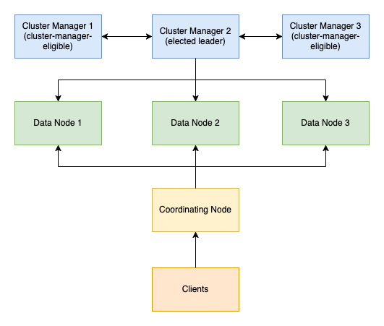
Figure 21. OpenSearch cluster roles: cluster-manager and data nodes
Source: OpenSearch Documentation, "Creating a cluster" [R37]. © OpenSearch contributors. Reproduced with attribution.

7.4 Cluster settings and sizing
SRS has its own index naming, so index auto-creation must be off. If the SRS user has the manage cluster privilege, SRS sets this itself; otherwise apply it manually [R14]. SRS also deletes indexes by pattern, which needs destructive_requires_name set to false [R14]. With an index-scoped SRS user (Section 7.5), apply both settings as an administrator before SRS starts.
Cluster settings required by SRS (run once per OpenSearch service)
PUT _cluster/settings
{
"persistent": {
"action": {
"auto_create_index": "false",
"destructive_requires_name": "false"
}
}
}

Caution. destructive_requires_name: false lets any user with delete rights remove indexes by wildcard. On a shared service, give delete rights only through the per-environment index-scoped roles, and keep administrator access to a break-glass group.

Pega publishes default sizing for search and SRS. Start from it and adjust after measuring, as Pega advises [R14].
Table 26. Pega default sizing for search and SRS (source [R14])
Service | Landscape | Instances | CPU each | RAM GB each | Storage GB each
Cluster-manager nodes | Production, stage | 3 | 2 | 8 | N/A
Data nodes | Production, stage | 3 | 4 | 16 | 100
Data nodes | Testing, development | 1 | 2 | 8 | 100
SRS | Production, stage | 3 (autoscaled) | 2 | 2 | N/A
SRS (chart 4.13.0 defaults, for comparison) | All | 2 minimum, 3 best practice [R24] | 0.65 request, 1.3 limit | 4 | N/A
SRS | Testing, development | 1 (autoscaled) | 2 | 2 | N/A

Table 27. Starting sizes per OpenSearch service
Service | Starting size | Basis | Adjust when
os-np1 (DEV, SIT, UAT) | 3 cluster-manager, 3 data nodes at the Pega production size | Three environments' indexes plus one full build at a time; three nodes give zone spread | Disk above 60 % after all three builds
os-np2 (PERF, PREPROD) | Same as os-prd | Production-like behaviour for load tests and rehearsals | Never smaller than os-prd
os-prd | 3 cluster-manager, 3 or more data nodes; storage from measured volume | Pega production sizing, scaled by the searchable data measured in the upgraded clone | Index build or query latency misses target in PERF

- Searchable data volume. Measure it from the first upgraded clone: run the full index build in DEV and record index sizes with _cat/indices (command S-4). Scale PROD storage from that, plus growth and one rebuild's working space.
- Shards and replicas. SRS creates and names the indexes itself [R14]. After the first build, read the shard and replica count of each index with _cat/indices and record it in Appendix A. Do not change index settings directly unless Pega Support advises it.
- Shard budget. Add up the shards of every environment on the service and compare with the provider's per-node shard limit.
- Disk watermarks. Record the provider's low, high and flood-stage watermark values in Appendix A, and alert before the low watermark is reached (Section 18.5). At the flood stage, indexes become read-only and indexing stops (FS-17).

7.4.1 Sizing formulas
Pega does not publish a storage or shard formula for SRS. The formulas below are the general OpenSearch sizing guidance published for Amazon OpenSearch Service [R54, R55], which applies to any OpenSearch cluster because it rests on OpenSearch's own overheads. Use them with the measured index sizes from the DEV build. The sizing calculator in Appendix H applies them.
Table 28. OpenSearch sizing formulas
Quantity | Formula | Notes
Primary data (S) | Sum of pri.store.size for pega26-<code>* after a full build (S-4) | Measured, never estimated from database size. Scale to PROD by the ratio of indexed row counts
Minimum storage | S x (1 + replicas) x 1.45 [R54] | 1.45 covers 10 % indexing overhead, 5 % reserved by the operating system and 20 % free space kept below the watermarks
Storage with growth | Minimum storage x (1 + yearly growth) ^ years planned | Add the peak seen during a full rebuild in DEV if it is above the steady state
Shard size | 10 to 30 GiB per primary shard for search workloads [R55] | SRS sets shard counts. Record them; raise a Pega Support case before changing index settings
Shards per node | At most 25 shards per GiB of JVM heap [R55] | Heap is normally half the node memory. Add every environment on a shared service
Data nodes | Largest of: storage / usable disk per node; total shards / shards per node; 3 for zone spread | Use a multiple of the zone count, so each zone holds a full copy of the data

Use at least one replica, three cluster-manager nodes and data nodes in three availability zones, with the provider's zone awareness setting turned on. With one replica and zone awareness, the loss of one zone leaves a full copy of every shard, so search stays available while the provider replaces the nodes (FS-15).

7.5 Isolation in the shared OpenSearch services
Each environment has its own customerDeploymentId (Section 2.6). Set it explicitly in every values file, because the chart defaults it to the namespace name [R23], and treat it as immutable, as Pega asks when several environments share an SRS [R15]. A cloned environment must never reuse another environment's ID: its index build would overwrite or mix with the other environment's indexes, and its tokens would carry the other environment's guid.
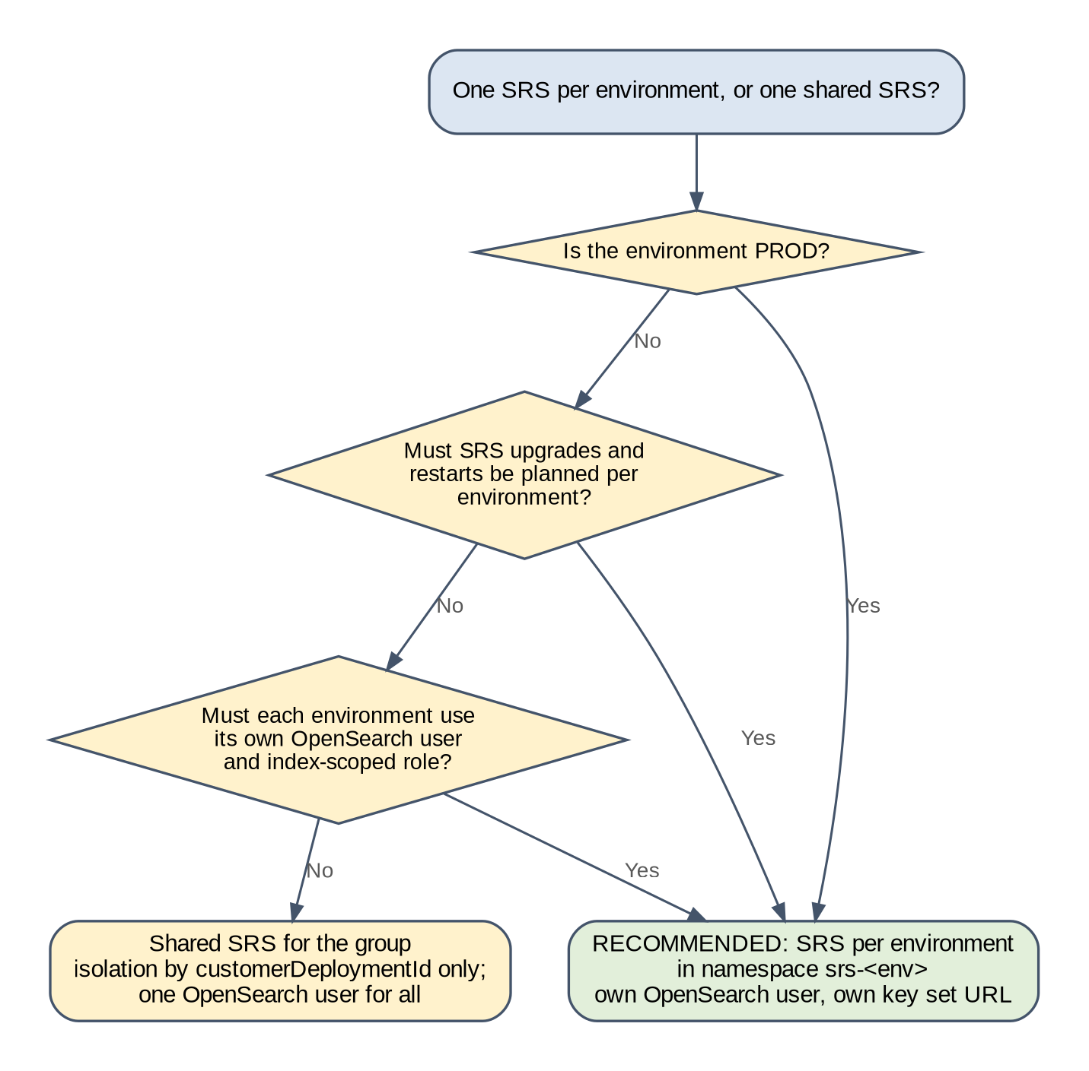
Figure 22. Decision: one SRS per environment or one shared SRS
Prepared for this implementation. Not a Pega-published diagram.
Table 29. SRS per environment compared with a shared SRS
Aspect | SRS per environment (recommended) | One SRS per group
OpenSearch credentials | One user per environment, index-scoped role | One user for the whole group
Blast radius | An SRS fault or bad upgrade affects one environment | Affects every environment in the group
Upgrades | Upgrade SRS per environment, in step with that environment's tests | One upgrade for all; all environments retest
Token key set | SRS points at that environment's Okta key set | One key set; every environment's tokens come from the same server
Cost | Small: 2 pods in DEV, SIT, UAT (chart minimum [R24]); 3 in PERF, PREPROD, PROD [R14, R24] | Slightly smaller

Give each SRS its own OpenSearch user, mapped to a role limited to its index pattern [R40, R41]. Pega says the manage cluster privilege is optional when the cluster settings are applied manually [R14]. Pega does not say whether SRS needs any other cluster-level permission, so test the role in DEV (IT-06) and widen it only by the permissions the SRS log shows as missing.
Index-scoped role for one environment's SRS user (OpenSearch roles.yml format [R40, R41])
pega26-<code>-srs:
cluster_permissions:
- cluster_composite_ops
index_permissions:
- index_patterns:
- "pega26-<code>*"
allowed_actions:
- "<index action group confirmed in DEV, for example indices_all>"

When an environment is refreshed or retired, delete its indexes with DELETE /pega26-<code>* as the environment's own SRS user, which cannot touch any other environment's indexes (Sections 19.3 and 19.4).

7.6 Pega-to-SRS tokens with Okta
Pega obtains a token with the OAuth client credentials grant, authenticating with private_key_jwt or client_secret_basic, and asks for the scope pega.search:full [R16, R23]. SRS checks the token signature with the key set at OAuthPublicKeyURL, and checks that the guid claim equals the customerDeploymentId [R23]. Figure 23 shows the flow.
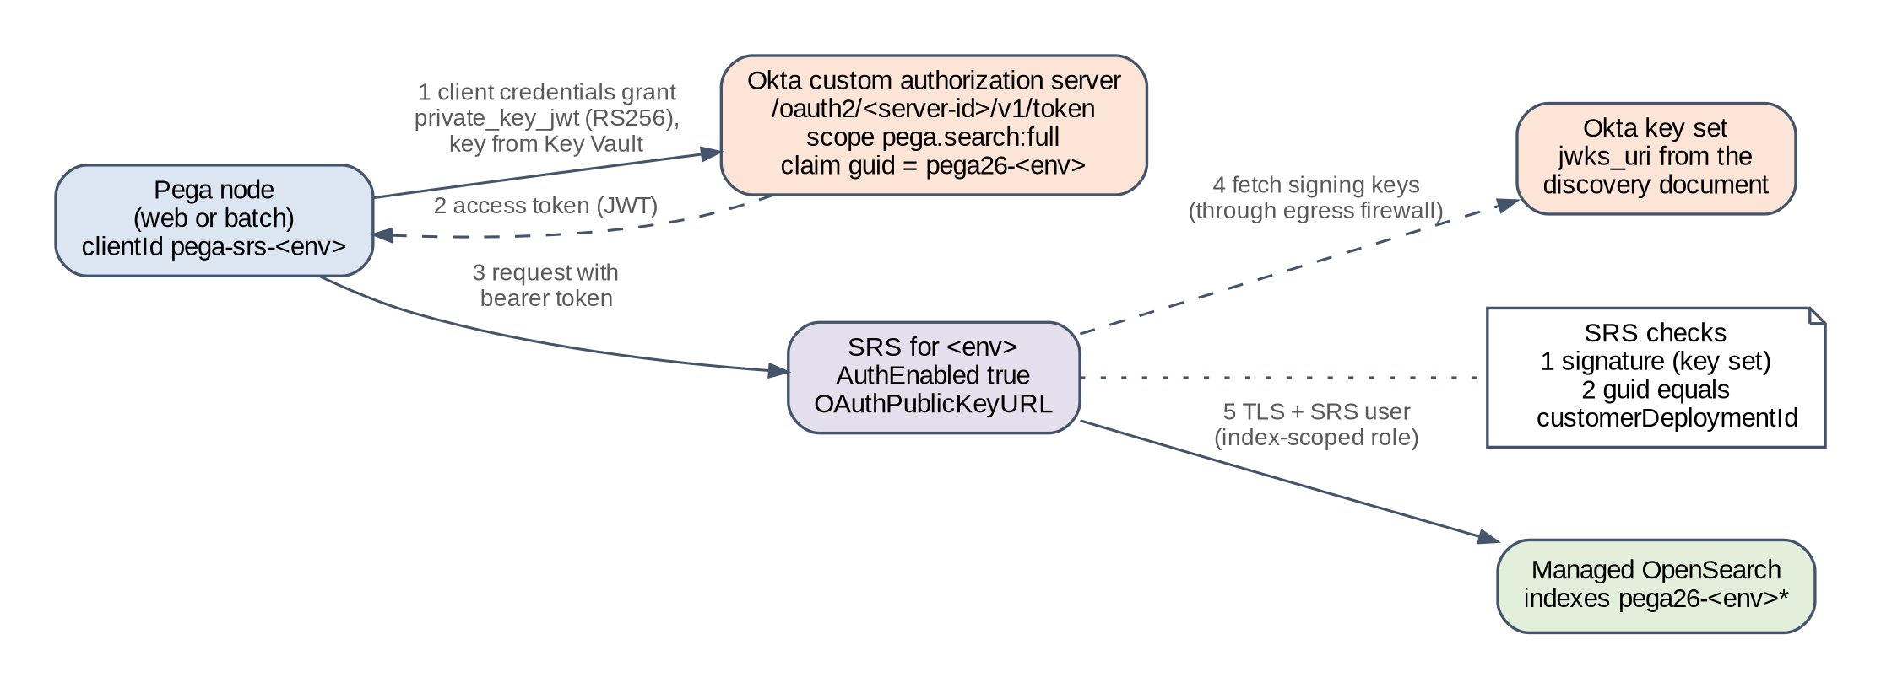
Figure 23. Token flow between Pega, Okta and SRS
Prepared for this implementation. Not a Pega-published diagram.

7.6.1 Why a custom authorization server is required
Okta's org authorization server cannot be customized: its audience, claims, policies and scopes are fixed, and its tokens are meant for Okta's own APIs [R42]. The client credentials flow has no user, so it cannot use OpenID scopes and needs a custom scope [R43]. Custom claims can only be added to a custom authorization server [R44]. Pega's scope and the guid claim are both custom, so Okta tokens for SRS must come from a custom authorization server. Custom authorization servers are part of Okta API Access Management [R42]. Confirm that the customer's Okta licence includes it, and how many servers it allows, before M2 (OD-05).

7.6.2 Issuing a different guid per environment
Table 30. Options for the guid claim
Option | How it works | Strengths | Weaknesses
1. One authorization server per environment | Each server has a claim guid with a fixed value, for example "pega26-sit", included in access tokens | Simplest claim; full separation of keys and policies | Six servers; licence may limit the number
2. One shared server, claim based on the client | One claim guid whose value is an Okta expression on the requesting app, for example a conditional on app.clientId [R46] | One server for all non-production; fewer objects | Every non-production client shares a signing key set; must prove that the expression is evaluated for client credentials tokens

Okta's expression language exposes app.id, app.clientId and app.profile for custom claims [R46], and supports conditional expressions of the form [Condition] ? [Value if TRUE] : [Value if FALSE] [R46]. An example claim value for option 2 is shown below. Okta's pages do not state whether app attributes are available when the token is issued to a client with no user, so option 2 is accepted only after the DEV test.
Claim value expression for option 2 (written as one line in Okta)
app.clientId == "<dev-client-id>" ? "pega26-dev" :
app.clientId == "<sit-client-id>" ? "pega26-sit" :
app.clientId == "<uat-client-id>" ? "pega26-uat" :
app.clientId == "<perf-client-id>" ? "pega26-perf" :
app.clientId == "<ppd-client-id>" ? "pega26-ppd" : "none"

Decision. Recommendation (OD-05): PROD uses its own custom authorization server with a fixed guid claim of pega26-prd. The five non-production environments use one shared custom authorization server with the client-based claim (option 2), if the DEV test proves it. If the test fails, fall back to option 1 for non-production.
Proof in DEV: request a token for the DEV client, decode it (command O-2), and confirm scp contains pega.search:full and guid equals pega26-dev. Repeat with the SIT client and confirm pega26-sit.

7.6.3 Okta set-up per environment
1. In the authorization server, create the scope pega.search:full and an access policy with a rule that allows the client credentials grant for the environment's client.
2. Create the claim guid for access tokens (fixed value for option 1, expression for option 2) [R44].
3. Create one API services application per environment, named pega-srs-<code>, with client authentication by public key / private key (private_key_jwt) [R45].
4. Generate an RSA key pair in a controlled workstation or pipeline. Register the public key in the application's key set (JWKS) [R45]. Store the private key, in PKCS8 form encoded with base64 as the chart requires, in Key Vault as SRS_OAUTH_PRIVATE_KEY [R23]. Delete local copies.
5. Record the client ID, the token endpoint and the key set URL in Appendix A.
Table 31. Okta values used in the Helm charts
Setting | Value | Source
Issuer | https://<okta-domain>/oauth2/<auth-server-id> | [R42]
Token endpoint (pegasearch.srsAuth.url) | https://<okta-domain>/oauth2/<auth-server-id>/v1/token | [R43]
Key set URL (srsRuntime.env.OAuthPublicKeyURL) | The jwks_uri value from https://<okta-domain>/oauth2/<auth-server-id>/.well-known/openid-configuration | [R42]
Client ID (pegasearch.srsAuth.clientId) | Client ID of pega-srs-<code> | [R23]
Authentication (pegasearch.srsAuth.authType) | private_key_jwt | [R23, R45]
Key algorithm (pegasearch.srsAuth.privateKeyAlgorithm) | RS256 (chart default) | [R23]
Scope (pegasearch.srsAuth.scopes) | pega.search:full | [R23]

7.6.4 Network path, token lifetime and rotation
- Pega pods call the Okta token endpoint, and SRS pods fetch the Okta key set. Both go to <okta-domain> on port 443 through the hub firewall. Add an FQDN allow rule for <okta-domain> from the Pega and SRS subnets only.
- Token lifetime is set in the access policy rule of the authorization server [R42]. Use the same lifetime in all environments and record it in Appendix A. Pega requests a new token when needed; measure how often in DEV by counting token requests in the Okta system log.
- Pega does not state whether SRS checks the issuer or audience. Test it in DEV with a token from another authorization server (FS-12) and record the result.
- Rotate the client key by adding a second public key to the application, updating SRS_OAUTH_PRIVATE_KEY in Key Vault, restarting the Pega tiers, checking search, and then removing the old public key. Pega does not state whether its client assertion carries a key ID (kid) header; test the rotation in DEV with both public keys registered (FS-34).

7.6.5 Okta signing key rotation and rate limits
- Signing keys. Okta rotates the signing keys of an authorization server about four times a year, and clients must look the key up from the key set URL by its kid rather than keep a fixed copy [R53]. SRS must therefore read OAuthPublicKeyURL dynamically. Prove it in DEV by rotating the authorization server's keys manually, as Okta allows, and checking that search continues without an SRS restart (FS-33). If the test fails, rotation becomes a planned event with an SRS restart, and the authorization server's key rotation mode is set to manual.
- Rate limits. Okta applies rate limits per org and per endpoint. A request over the limit receives HTTP 429, and Okta writes warning and violation events to the System Log [R52]. All six environments share the customer's Okta org, so every non-production token request draws on the same limit as production. The key set and discovery endpoints are not the concern; the token endpoint is.
- Measure token requests per minute per environment in DEV and under load in PERF (from the System Log), then compare the sum across all environments with the org's published limit for the token endpoint. Keep the token lifetime long enough that Pega does not request a token on each call.
- Forward Okta System Log rate-limit warnings and violations to the monitoring service (Section 18.5). A warning means another application in the org, or a misbehaving environment, is close to blocking search for every environment.

7.7 SRS deployment (backingservices chart)
Each environment has its own SRS release in namespace srs-<code>. The keys come from the SRS chart README [R24].
backingservices values for one environment (complete files in Appendix B)
global:
k8sProvider: "aks"
imageCredentials:
registry: "<acr-name>.azurecr.io"
srs:
enabled: true
deploymentName: "srs-<code>"
srsRuntime:
replicaCount: <2 in DEV, SIT, UAT; 3 in PERF, PREPROD, PROD>
srsImage: "<acr-name>.azurecr.io/platform-services/search-n-reporting-service-os:<tag>"
resources:
requests: { cpu: 1, memory: "4Gi" }
limits: { cpu: 2, memory: "4Gi" }
affinity:
podAntiAffinity:
preferredDuringSchedulingIgnoredDuringExecution:
- weight: 100
podAffinityTerm:
topologyKey: topology.kubernetes.io/zone
labelSelector:
matchLabels:
app.kubernetes.io/name: srs-service
env:
AuthEnabled: true
OAuthPublicKeyURL: "<okta-jwks-url>"
ssl:
enabled: true
clientAuthentication: "want"
keystore:
file: "srs-keystore.p12"
type: "PKCS12"
truststore:
file: "srs-truststore.jks"
type: "JKS"
certsSecret: "srs-runtime-certs"
srsStorage:
provisionInternalESCluster: false
domain: "<search-host>"
port: <search-port>
protocol: https
tls:
enabled: false
basicAuthentication:
enabled: true
authSecret: "srs-search-credentials"
requireInternetAccess: false
networkPolicy:
enabled: false

7.7.1 Three chart behaviours that break this design if left at the defaults
These were found by rendering the values files with helm template against chart 4.13.0, not from the README alone.
Table 32. SRS chart behaviours found by rendering
Key | What the chart does | Effect | Setting in this design
srsStorage.tls.enabled | Means TLS certificate authentication to the search service, not encryption [R24]. The chart refuses to render when it is combined with basicAuthentication.enabled ("Only one authentication can be enabled") | Helm install fails | false. Encryption comes from protocol: https; the SRS user authenticates with basic authentication
pegasearch.externalURL | With srsRuntime.ssl.enabled: true, the SRS container serves HTTPS on 8443 only, and its probes call https://localhost:8443/health. The Service also exposes 8080 and 80, which point at a port that is not listening [R62] | An HTTPS URL without a port goes to 443, which the Service does not expose; search fails at first start | https://srs-<code>.srs-<code>.svc.cluster.local:8443
srsStorage.networkPolicy.enabled | Allows ingress to SRS from 0.0.0.0/0 on 8080 and 8443, and egress only to an in-cluster elasticsearch-master on 9200 and DNS [R62]. requireInternetAccess only adds a pod label | SRS cannot reach the external OpenSearch service or the Okta key set; any pod can call SRS | false, replaced by the policy below

Network policies for srs-<code>, replacing the chart policy
apiVersion: networking.k8s.io/v1
kind: NetworkPolicy
metadata:
name: srs-<code>-default-deny
namespace: srs-<code>
spec:
podSelector: {}
policyTypes: ["Ingress", "Egress"]
---
apiVersion: networking.k8s.io/v1
kind: NetworkPolicy
metadata:
name: srs-<code>-allow
namespace: srs-<code>
spec:
podSelector:
matchLabels:
app.kubernetes.io/name: srs-service
policyTypes: ["Ingress", "Egress"]
ingress:
- from:
- namespaceSelector:
matchLabels:
kubernetes.io/metadata.name: pega-<code>
ports:
- protocol: TCP
port: 8443
egress:
- to:
- namespaceSelector:
matchLabels:
kubernetes.io/metadata.name: kube-system
podSelector:
matchLabels:
k8s-app: kube-dns
ports:
- protocol: UDP
port: 53
- protocol: TCP
port: 53
- to:
- ipBlock:
cidr: "<opensearch-private-endpoint-cidr>"
ports:
- protocol: TCP
port: 443
- to:
- ipBlock:
cidr: "0.0.0.0/0"
except: ["10.0.0.0/8", "172.16.0.0/12", "192.168.0.0/16"]
ports:
- protocol: TCP
port: 443

The policy allows SRS to be called only from pega-<code> on 8443, and lets SRS reach DNS, the OpenSearch private endpoint and public HTTPS. Okta has no fixed address range, so the last rule is limited to public addresses on 443, and the hub firewall restricts it to <okta-domain> by FQDN. Kubernetes network policies are enforced only if the AKS cluster was created with a network policy engine; check this before relying on them.

7.8 Index build planning
After Pega connects to SRS, SRS indexes all searchable data, and Pega states that this needs a downtime period. The length depends on the data model, the resources given to Pega and SRS, the number of queue processors and the amount of searchable data [R15]. For a cloned environment, the build runs during the first start with intake held (Section 10.4), so its length sets part of the production outage.
1. In every rehearsal, record the start and end of the build, the number of batch pods, SRS replicas and OpenSearch data nodes, and the row counts of the main indexed classes.
2. Plot build time against searchable data volume across DEV, PERF and PREPROD. PREPROD, built from a recent full-size clone on production-like services, is the best predictor.
3. Estimate production time as the PREPROD time scaled by the ratio of production to PREPROD data volume, plus 25 % contingency. Use the larger of this and the measured PREPROD time if the volumes are close.
4. If the estimate does not fit the outage window, add batch pods and OpenSearch data nodes for the cutover and measure again.
The build is complete when the search landing page shows every class indexed with no errors [R19], the document count of each main index matches the row count of its class in the database within the tolerance agreed with the application team, and no class shows CONFLICTS FOUND [R19]. Pega documents the rebuild steps and screens [R17].

7.9 Backups and restore
Every index can be rebuilt from the Pega database, so OpenSearch snapshots are optional. They shorten recovery but add storage cost.
Table 33. Recovery choices for search
Choice | Recovery after loss of the OpenSearch service | Recovery time
No snapshots | Recreate the service, apply the cluster settings, restart SRS, run a full index build | Measured full build time plus provisioning time
Provider snapshots | Restore the latest snapshot, then reindex classes changed since the snapshot | Restore time plus a partial build; measure in PERF

Elasticsearch 8.x snapshots cannot be restored into OpenSearch [R38, R39], and the 8.8 embedded indexes are not in a snapshot-ready form, so snapshots play no part in moving from 8.8.

8 Secrets, certificates and identity
No password, key or JAAS string is written in a Helm values file. The Pega Helm charts support external secrets for the database, stream, SRS OAuth and certificates [R23]. Key Vault is the system of record, one vault per environment, and the External Secrets Operator copies secrets into Kubernetes [R48].
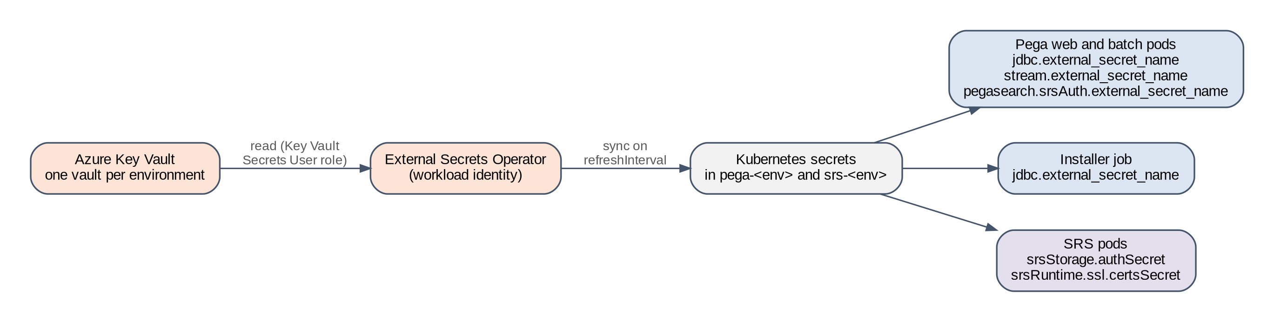
Figure 24. Secret delivery from Key Vault to Pega, installer and SRS pods
Prepared for this implementation. Not a Pega-published diagram.

8.1 Secret inventory
Table 34 lists every secret. Key names marked as fixed are required by the Pega charts; the secret names are this design's convention.
Table 34. Secret inventory (one set per environment, in kv-pega-<code>)
Kubernetes secret | Keys | Used by | Key Vault secrets | Key names
pega-db-secret | DB_USERNAME, DB_PASSWORD | Pega tiers and installer job (global.jdbc.external_secret_name) | pega-db-username, pega-db-password | Fixed [R23]
pega-stream-secret | STREAM_TRUSTSTORE_PASSWORD, STREAM_KEYSTORE_PASSWORD, STREAM_JAAS_CONFIG | Pega tiers (stream.external_secret_name) | stream-truststore-password, stream-keystore-password, confluent-jaas | Fixed [R23]
pega-srs-oauth | SRS_OAUTH_PRIVATE_KEY | Pega tiers (pegasearch.srsAuth.external_secret_name) | okta-srs-private-key | Fixed [R23]
srs-search-credentials | username, password | SRS (srs.srsStorage.authSecret) | opensearch-srs-username, opensearch-srs-password | Per SRS README [R24]
srs-runtime-certs | keystore and truststore files, keystorePassword, truststorePassword | SRS (srs.srsRuntime.ssl.certsSecret) | srs-tls-keystore, srs-tls-truststore, passwords | Per SRS README [R24]
pega-tier-tls | TOMCAT_KEYSTORE_CONTENT, TOMCAT_KEYSTORE_PASSWORD, ca.crt | Web tier TLS (tier.service.tls.external_secret_names) | pega-tls-keystore, pega-tls-password, pega-tls-ca | Fixed [R23]

8.2 External Secrets Operator manifests
SecretStore and ExternalSecrets for the Pega namespace (Azure Key Vault provider [R48])
apiVersion: external-secrets.io/v1beta1
kind: SecretStore
metadata:
name: keyvault
namespace: pega-<code>
spec:
provider:
azurekv:
authType: WorkloadIdentity
vaultUrl: "https://kv-pega-<code>.vault.azure.net"
serviceAccountRef:
name: eso-keyvault-reader
---
apiVersion: external-secrets.io/v1beta1
kind: ExternalSecret
metadata:
name: pega-stream-secret
namespace: pega-<code>
spec:
refreshInterval: 1h
secretStoreRef:
name: keyvault
kind: SecretStore
target:
name: pega-stream-secret
data:
- secretKey: STREAM_TRUSTSTORE_PASSWORD
remoteRef: { key: stream-truststore-password }
- secretKey: STREAM_KEYSTORE_PASSWORD
remoteRef: { key: stream-keystore-password }
- secretKey: STREAM_JAAS_CONFIG
remoteRef: { key: confluent-jaas }
---
apiVersion: external-secrets.io/v1beta1
kind: ExternalSecret
metadata:
name: pega-srs-oauth
namespace: pega-<code>
spec:
refreshInterval: 1h
secretStoreRef:
name: keyvault
kind: SecretStore
target:
name: pega-srs-oauth
data:
- secretKey: SRS_OAUTH_PRIVATE_KEY
remoteRef: { key: okta-srs-private-key }

Create the same pattern for pega-db-secret and pega-tier-tls in pega-<code>, and for srs-search-credentials and srs-runtime-certs in srs-<code>. Each namespace has its own SecretStore and workload identity, and that identity can read only its own environment's vault.
Note. Check which External Secrets Operator API version is installed (v1beta1 or v1) and use it. The stream truststore and keystore password keys can hold empty values with SASL/PLAIN and a public CA, but keep the keys in the order the chart expects [R23].

8.3 Rotation
Table 35. Secret rotation
Secret | Steps | Restart needed
Confluent API key | Create a second key for the same service account; write the new JAAS value to Key Vault; wait for or force the External Secrets refresh; rolling restart of the Pega tiers; check the Stream landing page; delete the old key | Yes, Pega tiers
OpenSearch SRS user password | Change the password on the provider; update Key Vault; refresh; restart SRS; check search (S-5) | Yes, SRS
Okta client key | Add the new public key to the Okta app; update okta-srs-private-key; refresh; restart Pega tiers; check search; remove the old public key | Yes, Pega tiers
Database password | Per the DBA process; update Key Vault; refresh; restart Pega tiers | Yes

Caution. Pods read these values at start. A new Key Vault version reaches the Kubernetes secret on the next refresh, but running pods keep the old value until they restart. A rotation without a restart works until the old credential is deleted, then fails (FS-20).

8.4 Certificates
Table 36. Certificates
Certificate | Issued by | Used for | Renewal owner
Public TLS certificate for the Pega host name | Customer public CA | Application Gateway listener | Platform team
Web tier backend certificate | Customer private CA | Application Gateway to web pods | Platform team
SRS server certificate | Customer private CA | Pega to SRS TLS | Platform team
Confluent broker certificates | Confluent (public CA) | SASL_SSL from Pega | Confluent
OpenSearch endpoint certificate | Provider or customer CA | SRS to OpenSearch TLS | OpenSearch provider
Okta endpoint certificate | Okta (public CA) | Token and key set calls | Okta

Caution. Do not route Pega-to-Confluent, SRS-to-OpenSearch or Okta traffic through a TLS-inspecting proxy. Re-signed certificates break the trust chain that the clients check.

9 Helm configuration per environment

9.1 Chart version and the three runs
This design uses Pega Helm charts 4.13.0: the pega chart for Pega Platform and the installer job, and the backingservices chart for SRS [R23, R24]. Every key in this section and in Appendix B was checked against the README and default values file of that chart version. Each environment built from a clone goes through three Helm runs of the pega chart, shown in Table 37.
Table 37. Helm runs of the pega chart for an environment built from a clone
Run | global.actions.execute | What runs | Why
U: upgrade | upgrade | Installer job only; no Pega pods | Upgrades the cloned database. Pega must not start until the clean-up in Section 10.3 is done.
F: first start | deploy | Web tier only; batch tier replicas: 0 with HPA off | No queue processor, job scheduler or real-time data flow runs while cloned items are checked (Section 10.4).
D: steady state | deploy | Web and batch tiers at normal size | Index build, then normal operation.

The chart's actions are install, deploy, install-deploy, upgrade and upgrade-deploy [R23]. upgrade-deploy is not used, because it would start Pega straight after the upgrade, before the cloned items are checked.

9.1.1 Upgrade type
The chart supports the upgrade types in-place (rules and data in one run, with downtime), out-of-place-rules and out-of-place-data (a two-step out-of-place upgrade), zero-downtime and custom [R23]. The chart default is in-place. The zero-downtime type needs REST credentials for the running pre-upgrade system to perform pre- and post-actions [R23], and a cloned database has no running 8.8 system attached. The design therefore uses in-place on the clone, which is disposable until the cutover, and asks Pega Support to confirm it (GQ-04).

9.2 Pega chart keys per environment
Table 38 lists every pega chart key this design sets, with its value per environment. Keys not listed keep the chart default. Values in angle brackets are recorded in Appendix A.
Table 38. Pega chart keys per environment (chart 4.13.0)
Key | Meaning | DEV | SIT | UAT | PERF | PREPROD | PROD | Source
global.provider | Kubernetes provider | aks | aks | aks | aks | aks | aks | [R23]
global.actions.execute | Run type (Table 37) | U / F / D | U / F / D | U / F / D | U / F / D | U / F / D | U / F / D | [R23]
global.customerDeploymentId | Index prefix and guid value | pega26-dev | pega26-sit | pega26-uat | pega26-perf | pega26-ppd | pega26-prd | [R23]
global.jdbc.url | Upgraded clone for this environment | <jdbc-url> | <jdbc-url> | <jdbc-url> | <jdbc-url> | <jdbc-url> | <jdbc-url> | [R23]
global.jdbc.external_secret_name | DB_USERNAME, DB_PASSWORD | pega-db-secret | pega-db-secret | pega-db-secret | pega-db-secret | pega-db-secret | pega-db-secret | [R23]
global.jdbc.rulesSchema, dataSchema | Schemas of the clone | <rules-schema> | <rules-schema> | <rules-schema> | <rules-schema> | <rules-schema> | <rules-schema> | [R23]
global.docker.pega.image | Pega image | platform/pega:26.1.1 | platform/pega:26.1.1 | platform/pega:26.1.1 | platform/pega:26.1.1 | platform/pega:26.1.1 | platform/pega:26.1.1 | [R23]
tier[web].replicas and HPA min / max | Web pods | 1 / 2 | 1 / 3 | 2 / 3 | 3 / 6 | 3 / 6 | 3 / 6 | [R23]
tier[batch].replicas and HPA min / max | Batch pods (run F: 0, HPA off) | 1 / 2 | 1 / 3 | 1 / 3 | 3 / 6 | 3 / 6 | 3 / 6 | [R23]
tier[*].pdb.enabled | Pod disruption budget | true | true | true | true | true | true | [R23]
tier[*].resources | Memory, CPU request / limit | 12Gi, 3 / 4 | 12Gi, 3 / 4 | 12Gi, 3 / 4 | 12Gi, 3 / 4 | 12Gi, 3 / 4 | 12Gi, 3 / 4 | [R23]
tier[*].topologySpreadConstraints | Spread over zones (Section 4.6) | zone, skew 1 | zone, skew 1 | zone, skew 1 | zone, skew 1 | zone, skew 1 | zone, skew 1 | [R61]
tier[web].service.tls.external_secret_names | Backend TLS keystore | pega-tier-tls | pega-tier-tls | pega-tier-tls | pega-tier-tls | pega-tier-tls | pega-tier-tls | [R23]
tier[web].ingress.domain | Host name | <pega-host> | <pega-host> | <pega-host> | <pega-host> | <pega-host> | <pega-host> | [R23]
cassandra.enabled | No Decision Data Store | false | false | false | false | false | false | [R23]
hazelcast.enabled, clusteringServiceEnabled | Hazelcast removed in '25 | false | false | false | false | false | false | [R5, R23]
stream.enabled | Stream service on | true | true | true | true | true | true | [R23]
stream.bootstrapServer | Confluent bootstrap | cc-np1 | cc-np1 | cc-np1 | cc-np2 | cc-np2 | cc-prd | [R23]
stream.securityProtocol | TLS and SASL | SASL_SSL | SASL_SSL | SASL_SSL | SASL_SSL | SASL_SSL | SASL_SSL | [R23]
stream.saslMechanism | API key | PLAIN | PLAIN | PLAIN | PLAIN | PLAIN | PLAIN | [R23]
stream.streamNamePattern | Topic prefix | pega-dev-{stream.name} | pega-sit-{stream.name} | pega-uat-{stream.name} | pega-perf-{stream.name} | pega-ppd-{stream.name} | pega-prd-{stream.name} | [R23]
stream.replicationFactor | Replicas per partition | 3 | 3 | 3 | 3 | 3 | 3 | [R23]
stream.external_secret_name | STREAM_* keys | pega-stream-secret | pega-stream-secret | pega-stream-secret | pega-stream-secret | pega-stream-secret | pega-stream-secret | [R23]
pegasearch.externalSearchService | Use SRS | true | true | true | true | true | true | [R23]
pegasearch.externalURL | SRS service, HTTPS port 8443 | srs-dev:8443 | srs-sit:8443 | srs-uat:8443 | srs-perf:8443 | srs-ppd:8443 | srs-prd:8443 | [R23, R62]
pegasearch.srsAuth.enabled | OAuth to SRS | true | true | true | true | true | true | [R23]
pegasearch.srsAuth.url | Okta token endpoint | non-prod server | non-prod server | non-prod server | non-prod server | non-prod server | PROD server | [R23, R43]
pegasearch.srsAuth.clientId | Okta client | pega-srs-dev | pega-srs-sit | pega-srs-uat | pega-srs-perf | pega-srs-ppd | pega-srs-prd | [R23]
pegasearch.srsAuth.scopes | Scope | pega.search:full | pega.search:full | pega.search:full | pega.search:full | pega.search:full | pega.search:full | [R23]
pegasearch.srsAuth.authType | Client authentication | private_key_jwt | private_key_jwt | private_key_jwt | private_key_jwt | private_key_jwt | private_key_jwt | [R23]
pegasearch.srsAuth.privateKeyAlgorithm | Key algorithm | RS256 | RS256 | RS256 | RS256 | RS256 | RS256 | [R23]
pegasearch.srsAuth.external_secret_name | SRS_OAUTH_PRIVATE_KEY | pega-srs-oauth | pega-srs-oauth | pega-srs-oauth | pega-srs-oauth | pega-srs-oauth | pega-srs-oauth | [R23]
pegasearch.srsMTLS.enabled | Mutual TLS to SRS | false | false | false | false | false | false | [R23]
installer.image | Installer image | installer:26.1.1 | installer:26.1.1 | installer:26.1.1 | installer:26.1.1 | installer:26.1.1 | installer:26.1.1 | [R23]
installer.upgrade.upgradeType | Upgrade type (GQ-04) | in-place | in-place | in-place | in-place | in-place | in-place | [R23]

Note. Starting replica counts are sized for function, not load. Set the PERF, PREPROD and PROD values from the PERF load test (Section 15), and keep PREPROD equal to PROD.

9.2.1 Topology spread, heap and garbage collection logging
- topologySpreadConstraints is read by the tier template of chart 4.13.0 [R61] but is not listed in the README, so check it in the helm template output after every chart upgrade. The label selector must match the pod label the chart sets, app: <deployment name>-<tier name>, for example app: pega-web.
- The chart defaults the Pega container to 12Gi of memory with a commented heap of 8192m [R23]. Keep the heap at about two thirds of the container memory: the JVM also needs native memory for threads, metaspace, Kafka client buffers and the code cache, and a container that exceeds its limit is killed without a Java error.
- Set the JVM arguments Pega recommends in tier[*].javaOpts [R63]: garbage collection logging to /usr/local/tomcat/logs/gc.log, -XX:MaxMetaspaceSize=768m so metaspace cannot exhaust node memory, -XX:+UseStringDeduplication and -XX:+HeapDumpOnOutOfMemoryError. The values files in Appendix B carry them. GC logs and heap dumps are on ephemeral pod storage, so the log collector must tail the GC file (Section 18.2).
- Pega images run in Etc/UTC. If the cloned 8.8 database does not use UTC, set -Duser.timezone to the database time zone in javaOpts and in the installer's customJVMArgs as well [R63]. A mismatch between the two shifts delayed queue items and job scheduler times.
- Long GC pauses show up as Kafka consumer group rebalances and as SRS request timeouts, so the GC log is the first thing to read when those appear (Section 17).
- Set pegaDiagnosticUser and its password through the diagnostic secret, so support staff can download Tomcat logs without a redeploy [R23].

9.3 Backingservices chart keys per environment
Table 39. Backingservices chart keys per environment
Key | Meaning | DEV | SIT | UAT | PERF | PREPROD | PROD | Source
global.k8sProvider | Provider | aks | aks | aks | aks | aks | aks | [R24]
srs.deploymentName | SRS release | srs-dev | srs-sit | srs-uat | srs-perf | srs-ppd | srs-prd | [R24]
srs.srsRuntime.replicaCount | SRS pods | 2 | 2 | 2 | 3 | 3 | 3 | [R14, R24]
srs.srsRuntime.srsImage | SRS image | -os:<tag> | -os:<tag> | -os:<tag> | -os:<tag> | -os:<tag> | -os:<tag> | [R14, R24]
srs.srsRuntime.env.AuthEnabled | Token checks | true | true | true | true | true | true | [R24]
srs.srsRuntime.env.OAuthPublicKeyURL | Okta key set | non-prod server | non-prod server | non-prod server | non-prod server | non-prod server | PROD server | [R24, R42]
srs.srsRuntime.ssl.* | TLS on SRS | enabled | enabled | enabled | enabled | enabled | enabled | [R24]
srs.srsStorage.provisionInternalESCluster | External search | false | false | false | false | false | false | [R24]
srs.srsStorage.domain | OpenSearch host | os-np1 | os-np1 | os-np1 | os-np2 | os-np2 | os-prd | [R24]
srs.srsStorage.port, protocol | Endpoint | 443, https | 443, https | 443, https | 443, https | 443, https | 443, https | [R24]
srs.srsRuntime.resources | CPU request / limit, memory | 1 / 2, 4Gi | 1 / 2, 4Gi | 1 / 2, 4Gi | 1 / 2, 4Gi | 1 / 2, 4Gi | 1 / 2, 4Gi | [R14, R24]
srs.srsRuntime.affinity | Zone anti-affinity | preferred | preferred | preferred | preferred | preferred | preferred | [R24]
srs.srsStorage.tls.enabled | Certificate authentication, not encryption (Table 32) | false | false | false | false | false | false | [R24]
srs.srsStorage.basicAuthentication.enabled | SRS user | true | true | true | true | true | true | [R24]
srs.srsStorage.authSecret | username, password | srs-search-credentials | srs-search-credentials | srs-search-credentials | srs-search-credentials | srs-search-credentials | srs-search-credentials | [R24]
srs.srsStorage.requireInternetAccess | No internet egress | false | false | false | false | false | false | [R24]
srs.srsStorage.networkPolicy.enabled | Chart policy off; own policy (Section 7.7) | false | false | false | false | false | false | [R62]

9.4 Differences between the runs
Only two places change between runs: the action, and the batch tier size. Table 40 shows them for SIT; PROD is the same with its own sizes. Appendix B has the complete files for SIT and PROD.
Table 40. Values that change between runs
Key | Run U (upgrade) | Run F (first start) | Run D (steady state)
global.actions.execute | upgrade | deploy | deploy
tier[batch].replicas | not used | 0 | 1 in SIT, 3 in PROD
tier[batch].hpa.enabled | not used | false | true
installer.* | used | ignored | ignored

9.5 Pipeline rules
- Keep one values file per environment and run in Git. Each change goes through review by the platform team and the Pega LSA.
- Pin the chart version (helm upgrade --install ... --version 4.13.0) and record image digests in Appendix A.
- Run helm template and helm lint with the values file in the pipeline before every apply.
- Fail the pipeline if a values file contains a literal password, API secret, JAAS string or private key. Secrets come only through external_secret_name keys.
- Fail the pipeline if customerDeploymentId or streamNamePattern does not match the environment's row in Table 8.

10 The cloned database
A database cloned from 8.8 production carries 8.8 settings, records and work. Some of it refers to the embedded Kafka and embedded Elasticsearch that no longer exist, and some of it points at production systems. This section lists what must be confirmed with Pega Support, what must be cleaned up, and the controlled first start that every cloned environment follows.

10.1 Gating questions for Pega Support
Pega's pages say that Hazelcast must be removed before updating to '25 or later, and that this applies to embedded Hazelcast and the Clustering Service [R5]. They do not say how this applies to a database that is cloned, upgraded offline and only ever started on 26.1.1. Table 41 lists the questions to raise in one Pega Support case before M2. Any condition Pega sets becomes a mandatory step in Section 12.7.
Table 41. Gating questions for Pega Support
ID | Question | Why it matters | Evidence found | Answer | Date
GQ-01 | Is a direct upgrade of an 8.8 database to 26.1.1 with the 26.1.1 installer supported? | The whole path depends on it | Not settled by the pages read | Open
GQ-02 | Which 8.8 patch level is required before the clone? | May need an 8.8 patch in production before the final clone | Not settled | Open
GQ-03 | Does the Hazelcast removal requirement apply to a clone upgraded offline? If so, which settings must be in the database before the upgrade? | Pega states removal is required before updating to '25 [R5]; the removal steps assume a running system [R6] | Not settled for this case | Open
GQ-04 | Which installer upgrade type suits a cloned database: in-place, or out-of-place-rules then out-of-place-data? | Sets run U and the outage length | Chart types listed in [R23] | Open
GQ-05 | How does 26.1.1 treat 8.8 stream and search DSS and node records in an upgraded database, and which takes precedence: DSS in the database or Helm settings? | A stale DSS could override the Helm configuration | Not settled; tested as FS-24 | Open
GQ-06 | How are 8.8 delayed and broken queue items processed after the upgrade, given the '26 queue processing changes? | Items may fail or run unexpectedly | '26 changes queue processing [R3] | Open
GQ-07 | Is any SRS or customerDeploymentId state stored in the database that a clone would carry? | Could link a clone to another environment's indexes | Not settled; tested as IT-05 | Open
GQ-08 | Does the 26.1.1 installer need a Kafka connection while it upgrades an 8.8 database, and if so how is it supplied in the Helm installer job? | Run U could fail or stall; chart 4.13.0 passes no stream settings to the installer job | From '25, Pega command-line tooling needs Kafka [R8]; rendered run U has no STREAM_* values | Open

Important. Until the answers arrive, the plan assumes the conservative answer for each question: rehearse the full path twice, apply the clean-up in Section 10.3, and treat any difference from expected behaviour as a stop condition at the first-start Go/No-Go.

10.2 How Helm settings and database settings interact
Pega 26.1.1 gets its stream and search configuration from the Helm chart. A cloned 8.8 database may also hold Dynamic System Settings (DSS) for the stream service or for search. Pega documents the stream setting names, for example services/stream/provider, services/stream/broker/url and services/stream/name/pattern [R8]. The pages read do not settle whether a DSS with such a name in the database would override the value the Helm chart supplies. The design therefore treats it as a risk: search the cloned DSS for any setting that contains services/stream or refers to search hosts, record them, and prove in the first DEV start that the landing pages show the Helm values (FS-24). GQ-05 asks Pega Support for the rule.

10.3 Inventory and clean-up
Table 42 lists the items that affect Kafka and search. For each one it gives where it lives, what 26.1.1 does with it, the risk, the action, when the action happens and the source. Time points are: B (before the upgrade, on the clone), A (after the upgrade, before the first start), F (during the first start, with the batch tier at zero), and S (after the first start). No table names are given: Pega has not published them for these items, and each change uses the Pega screen named.
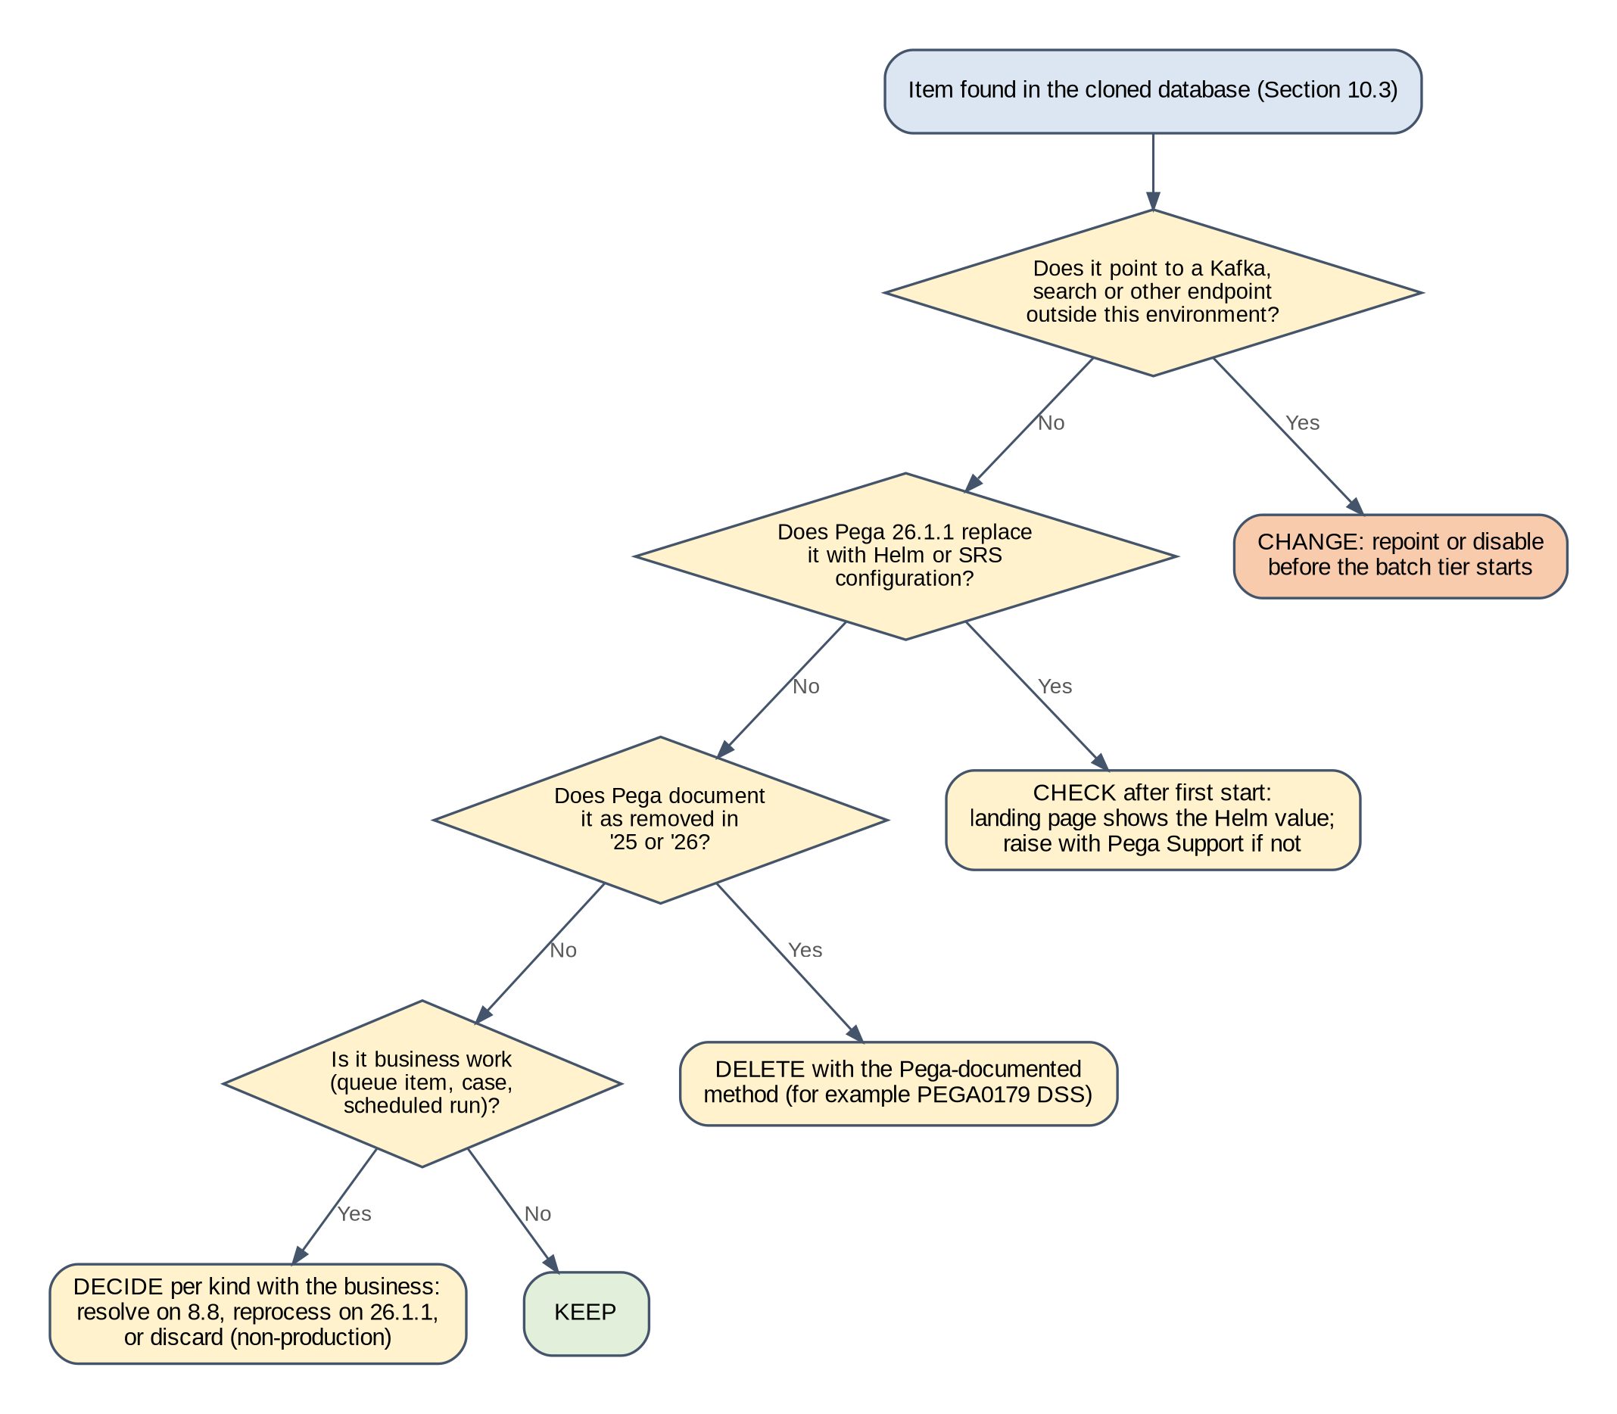
Figure 25. Decision: treatment of an item found in the cloned database
Prepared for this implementation. Not a Pega-published diagram.
Table 42. Kafka and search items in the cloned database
ID | Item | Where it lives | 26.1.1 behaviour | Risk | Action | When | Source
CD-01 | Stream service DSS from 8.8 (provider, broker URL, name pattern, replication) | DSS (Records > SysAdmin > Dynamic System Settings) | Helm supplies the stream settings; precedence not documented | Stale value overrides Helm | Record; check landing page shows Helm values; remove only as Pega Support advises (GQ-05) | F | [R8, R12]
CD-02 | Embedded stream node records from 8.8 | Stream service landing page (Configure > Decisioning > Infrastructure > Services > Stream) | External Kafka has no stream nodes | Landing page shows unavailable 8.8 nodes; confusion during checks | Check; remove stale entries from the landing page if shown | F | [R13]
CD-03 | Search settings and index host node records from 8.8 embedded Elasticsearch | DSS and search landing page | SRS configured by Helm replaces embedded search | Stale setting points search at 8.8 nodes | Check search landing page shows SRS; record and remove stale settings as Pega Support advises | F | [R14, R16]
CD-04 | Search index status from 8.8 | Search landing page | Indexes are rebuilt through SRS | Status shows old indexes as present | Full index build; check status [R19] | S | [R15, R19]
CD-05 | Delayed queue items | Database (queue processor delayed items) | Become due and are queued to Kafka when their time arrives | Items run on 26.1.1 against changed rules, or call production systems from a clone | Count on 8.8 before the clone; in non-production, decide per queue processor to discard or keep; in PROD, keep and test in PREPROD (GQ-06) | B, S | [R3]
CD-06 | Broken queue items | Database (queue processor broken items, shown in Admin Studio) | Stay broken until requeued or deleted | Requeue on 26.1.1 runs old work with new rules | Resolve on 8.8 before the final clone where possible; record counts; decide per queue processor | B, S | [R3]
CD-07 | Job scheduler state | Job scheduler rules and their run state | Job schedulers run on batch nodes after start | Clone runs production jobs (email, extracts) on first start | Batch tier at zero in run F; disable jobs that call external systems in non-production before scaling the batch tier | F | [R11]
CD-08 | Data flow runs, including real-time runs on Kafka data sets | Data flow landing pages | Runs restart against 26.1.1 topics or the customer's Kafka | Runs resume against old offsets or production topics | Stop or delete runs that refer to 8.8 stream partitions; restart from the agreed point | F, S | [R11]
CD-09 | Kafka configuration instances and Kafka data sets for application integrations | Records > SysAdmin > Kafka; Records > Data Model > Data Set | Connect to the customer's own Kafka clusters | A non-production clone reads production topics and moves production consumer offsets | Repoint to test clusters or disable in every non-production environment; decide per data set in PROD (Section 11.3) | F | [R11]
CD-10 | Other production endpoints: connectors, listeners, email accounts, file listeners | Integration rules and data instances | Run on start if enabled | A clone calls or polls production systems | Short checklist owned by the application team; firewall denies production endpoints from non-production | F | Customer
CD-11 | DSS delayeditems/dataflowbased/threadspernode | DSS | No longer used in '26 | PEGA0179 alert | Delete | A | [R3]
CD-12 | Hazelcast-related settings from 8.8 | DSS and prconfig values | Hazelcast removed in '25 | Unknown until GQ-03 is answered | Apply Pega Support's instructions | B or A | [R5]
CD-13 | Tables without primary keys | Database | Required for '25 and later | Upgrade blocked | Run primaryKeyUtility as the DBA team plans | B | [R10]
CD-14 | Custom search properties and reports that rely on search | Rules | Indexed by SRS after the build | Feature behaves differently on SRS | List them; include in the functional checks (Section 14.4) | S | [R14]
CD-15 | Partition count DSS prconfig/dsm/services/stream/pyTopicPartitionsCount/default and per-topic partition changes made on 8.8 | DSS (ruleset Pega-Engine) | Applies to every topic created at first start [R49] | Partition count, and so Confluent capacity and cost, differs from the plan | Record the value; keep or reset to 6 with the performance lead; recount with K-5 | A | [R49]
CD-16 | Pega Diagnostic Center endpoint and settings from production | Configure > System > Settings | Clone sends diagnostics to the production PDC endpoint [R51] | Non-production alerts mixed with production in PDC | Point each environment at its own PDC endpoint, or clear it | F | [R51]

Caution. Do not change these items with direct SQL against Pega tables unless Pega Support provides the statement for this release. Use the Pega screens named in the table during run F, when no background processing is running.

10.4 First-start control
Every environment built from a clone follows the same scripted first start. Table 43 gives each step an owner, a check and the evidence to keep, and Figure 26 shows the Go/No-Go logic.
Table 43. First-start steps for an environment built from a clone
Step | Action | Owner | Check | Evidence
ST-1 | Run U: upgrade the clone with the installer job | Platform team, DBA | Job completed; no errors in the log (P-5) | Installer log
ST-2 | Apply time-point A actions from Table 42 | Pega LSA, DBA | Each item signed off | Clean-up record (Appendix D)
ST-3 | Run F: deploy the web tier with this environment's prefix, service account and customerDeploymentId; batch tier at zero | Platform team | Web pods Ready (P-1) | kubectl output
ST-4 | Hold intake: no public DNS record, inbound listeners off, batch tier at zero | Platform team, application team | No user or inbound traffic in logs | Ingress and listener status
ST-5 | Check the Stream landing page and the Search landing page; apply time-point F actions | Pega LSA | Provider ExternalKafka, status NORMAL, prefix pega-<code>-; search uses SRS with pega26-<code> | Screenshots
ST-6 | Check the firewall log for denied connections to production or other environments | Platform team | No attempts, or each attempt traced to an item and fixed | Firewall log extract
ST-7 | Run D: scale the batch tier; start the full index build | Platform team, Pega LSA | Index build running; batch pods Ready | Start time
ST-8 | Check index completeness and counts (Section 7.8) | Pega LSA | All classes indexed; counts match | Count sheet
ST-9 | Release intake: public DNS, listeners and job schedulers as agreed | Application team | Smoke tests pass | Test report

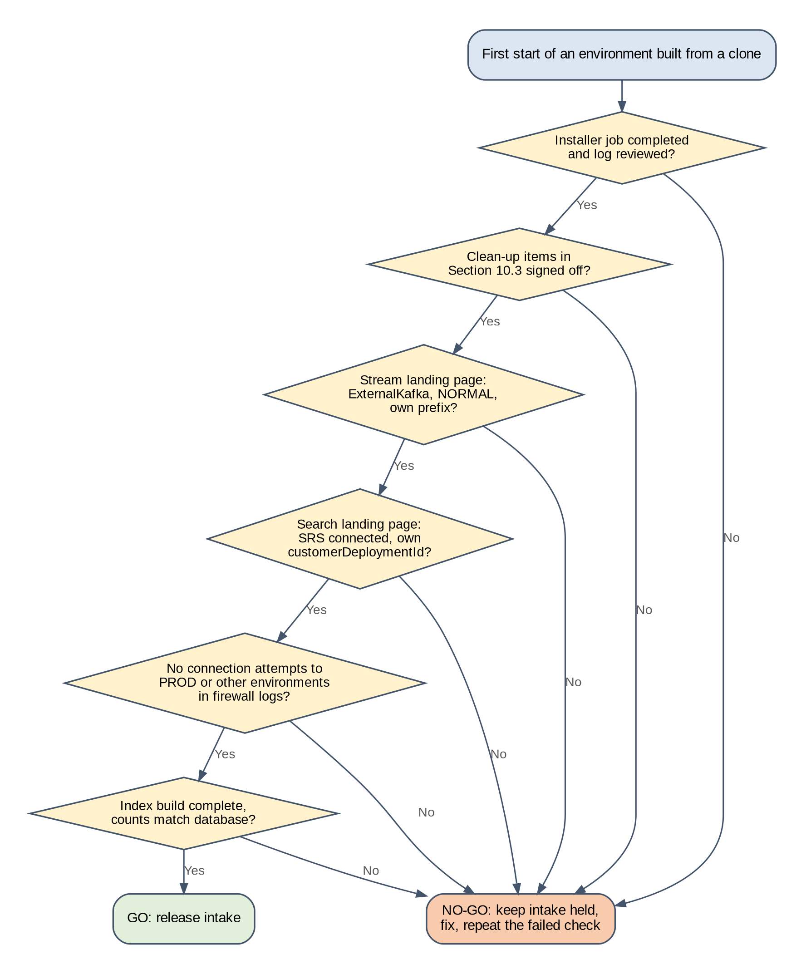
Figure 26. Decision: Go/No-Go at the first start
Prepared for this implementation. Not a Pega-published diagram.

10.5 Data protection and masking
Non-production clones of production data must follow the customer's masking policy. Mask the clone before the upgrade (time point B). The index build then reads only masked data, and no unmasked value reaches OpenSearch, Kafka topics or logs. If masking runs after the upgrade, it must still finish before run D, because the index build copies searchable data into OpenSearch. Masking after the index build leaves unmasked data in the indexes until a full rebuild. The masking approach is OD-07.
Note. Masking rules must keep values that integrations and searches depend on in a usable form, for example case IDs and keys used in search. Agree the rules with the application team, and include search checks on masked data in the functional tests.

11 The 8.8 content question

11.1 Answer
Nothing in the 8.8 Kafka or search storage is migrated. Figure 27 shows the decision for each kind of content, and Table 44 gives the treatment and the evidence. Each statement was checked against the current Pega pages on the evidence cut-off date.
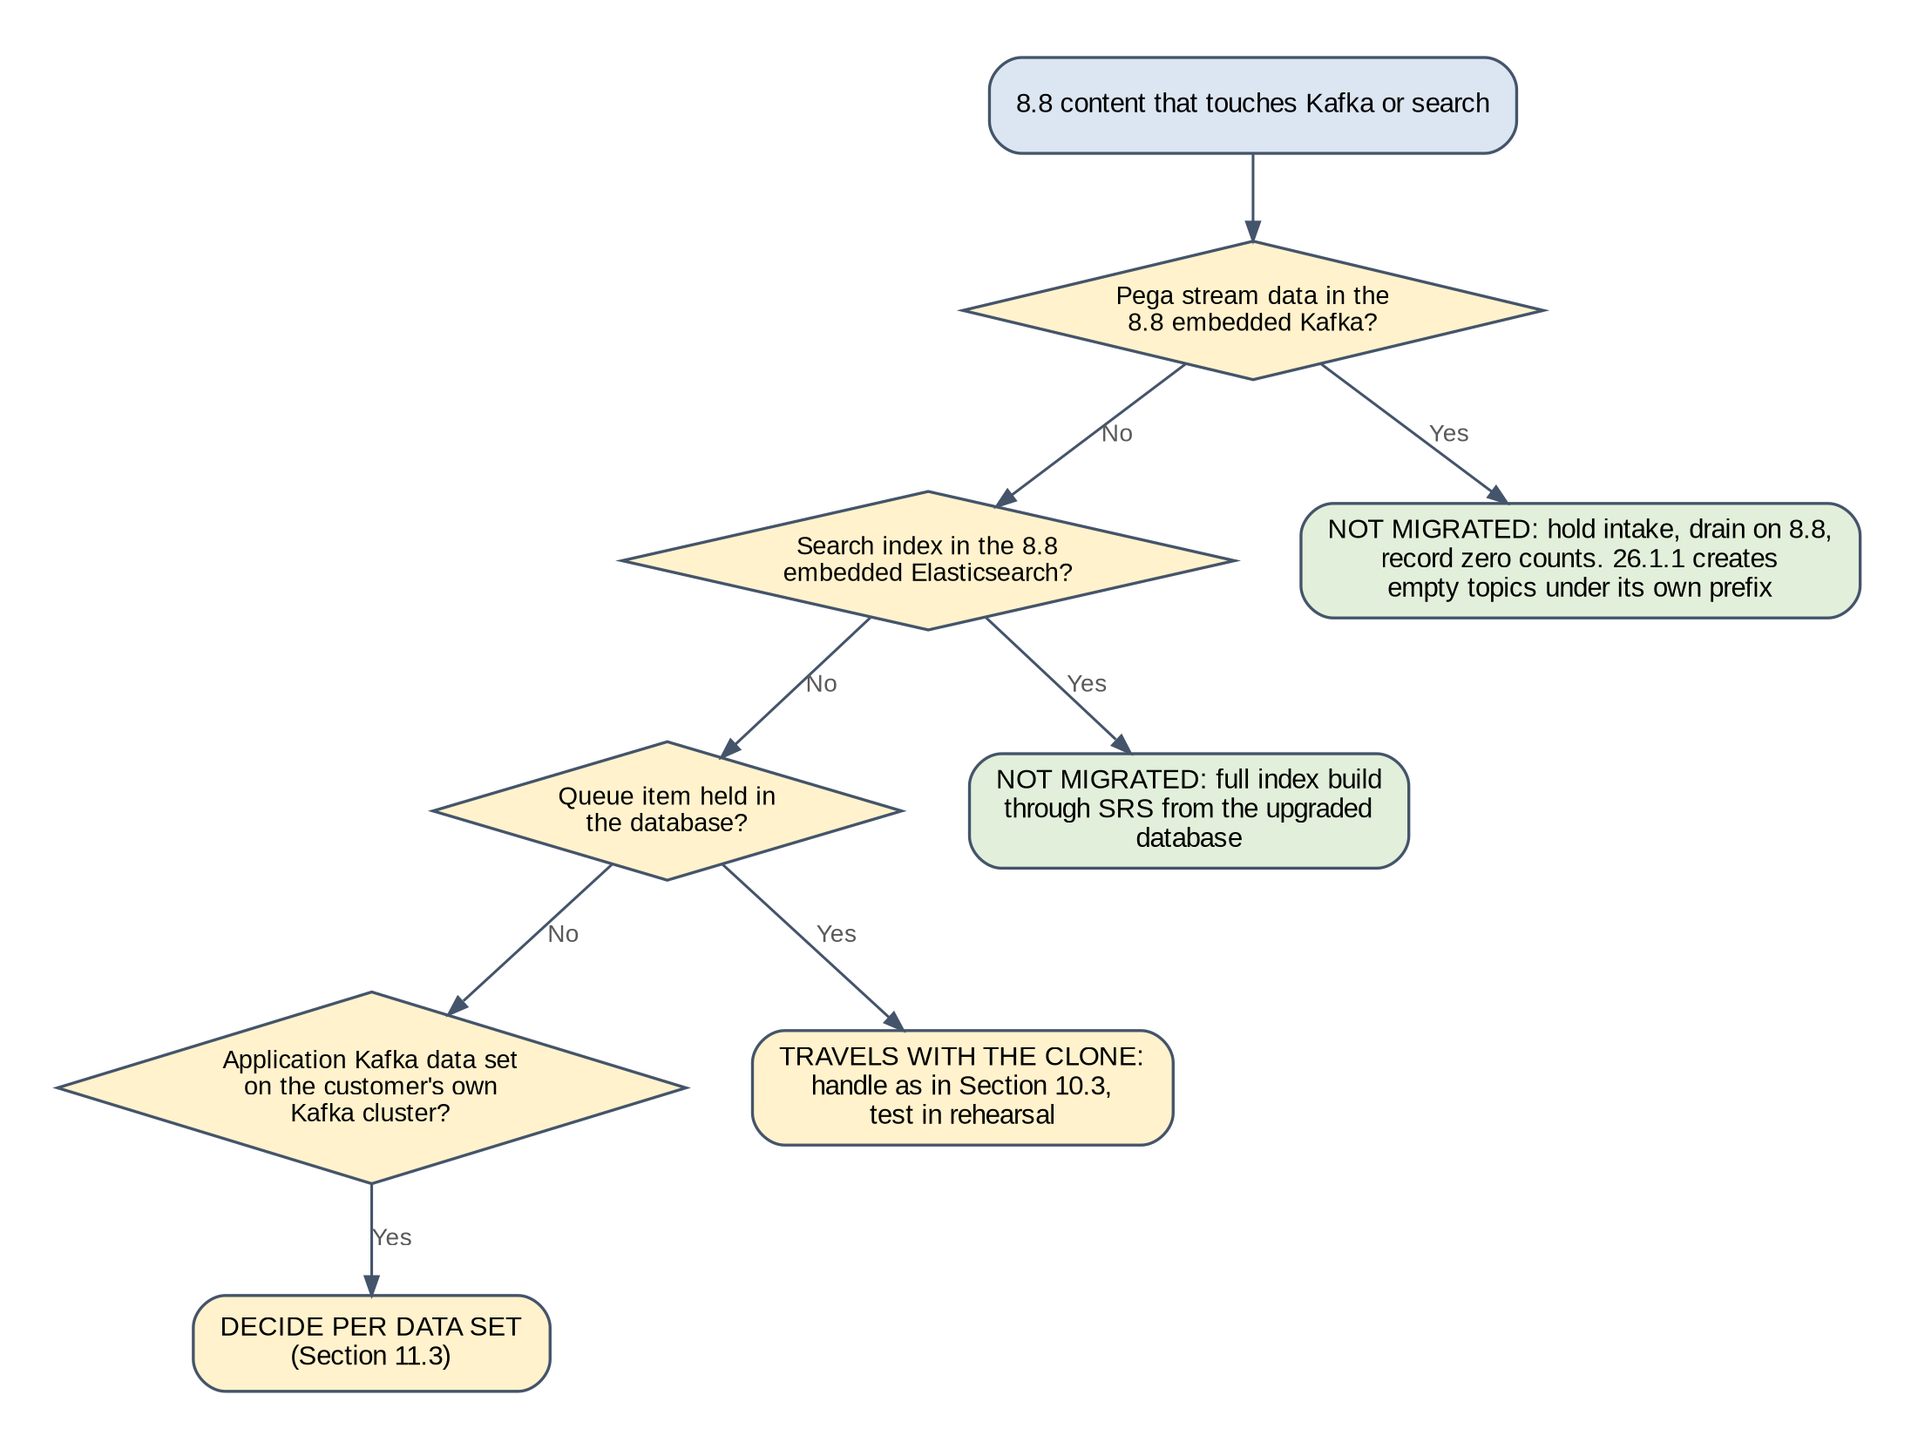
Figure 27. Decision: does 8.8 content need migrating?
Prepared for this implementation. Not a Pega-published diagram.

11.2 Treatment per content type
Table 44. Treatment of 8.8 content
Content | Answer | How it is handled | Evidence
Pega stream data in Kafka (queue processor messages, data flow partitions) | Not migrated | Pega states existing stream data cannot be moved to a new Kafka. 8.8 uses embedded Kafka, so there is no external cluster to drain to. Before the production clone, hold intake on 8.8, wait until queue processors show nothing ready to process, record the counts and any broken items, then stop 8.8. 26.1.1 starts with empty topics that it creates under pega-prd-. | [R13, R25]
Queue items held in the database (delayed, broken) | Travel with the clone | Database content, not Kafka content. Handled as items CD-05 and CD-06 (Section 10.3) and tested in rehearsal. | [R3]
Topic names and configuration | Not migrated | 26.1.1 creates its own topics under its own prefix. Only the topic settings policy, such as max.message.bytes, carries over as configuration. | [R11, R23]
Search indexes (embedded Elasticsearch on 8.8) | Not migrated | The indexes live on the 8.8 nodes, not in the database. They are built from the upgraded database after Pega connects to SRS, which needs downtime; the time is measured in rehearsal (Section 7.8). Elasticsearch 8.x snapshots cannot be restored into OpenSearch. | [R15, R17, R38, R39]
Application Kafka data sets on the customer's own topics | Decided per data set | Keep the existing cluster and topic, point at a new cluster, or mirror with Confluent Cluster Linking, which keeps offsets. Agree the start offset so messages are neither skipped nor processed twice. | [R11, R35]
Custom search data (custom search properties, reports that depend on search) | Rebuilt and verified | Rebuilt by the full index build; verified with count comparisons and functional checks. | [R18, R19]

11.3 Application Kafka data sets
Application Kafka data sets read from or write to the customer's own Kafka clusters, which are separate from the Pega stream service [R11]. Each one is decided on its own, with the application owner (Figure 28). In every non-production environment, every data set is repointed to a test topic or disabled before the batch tier starts, so a clone never consumes from a production topic or moves a production consumer group's offsets.
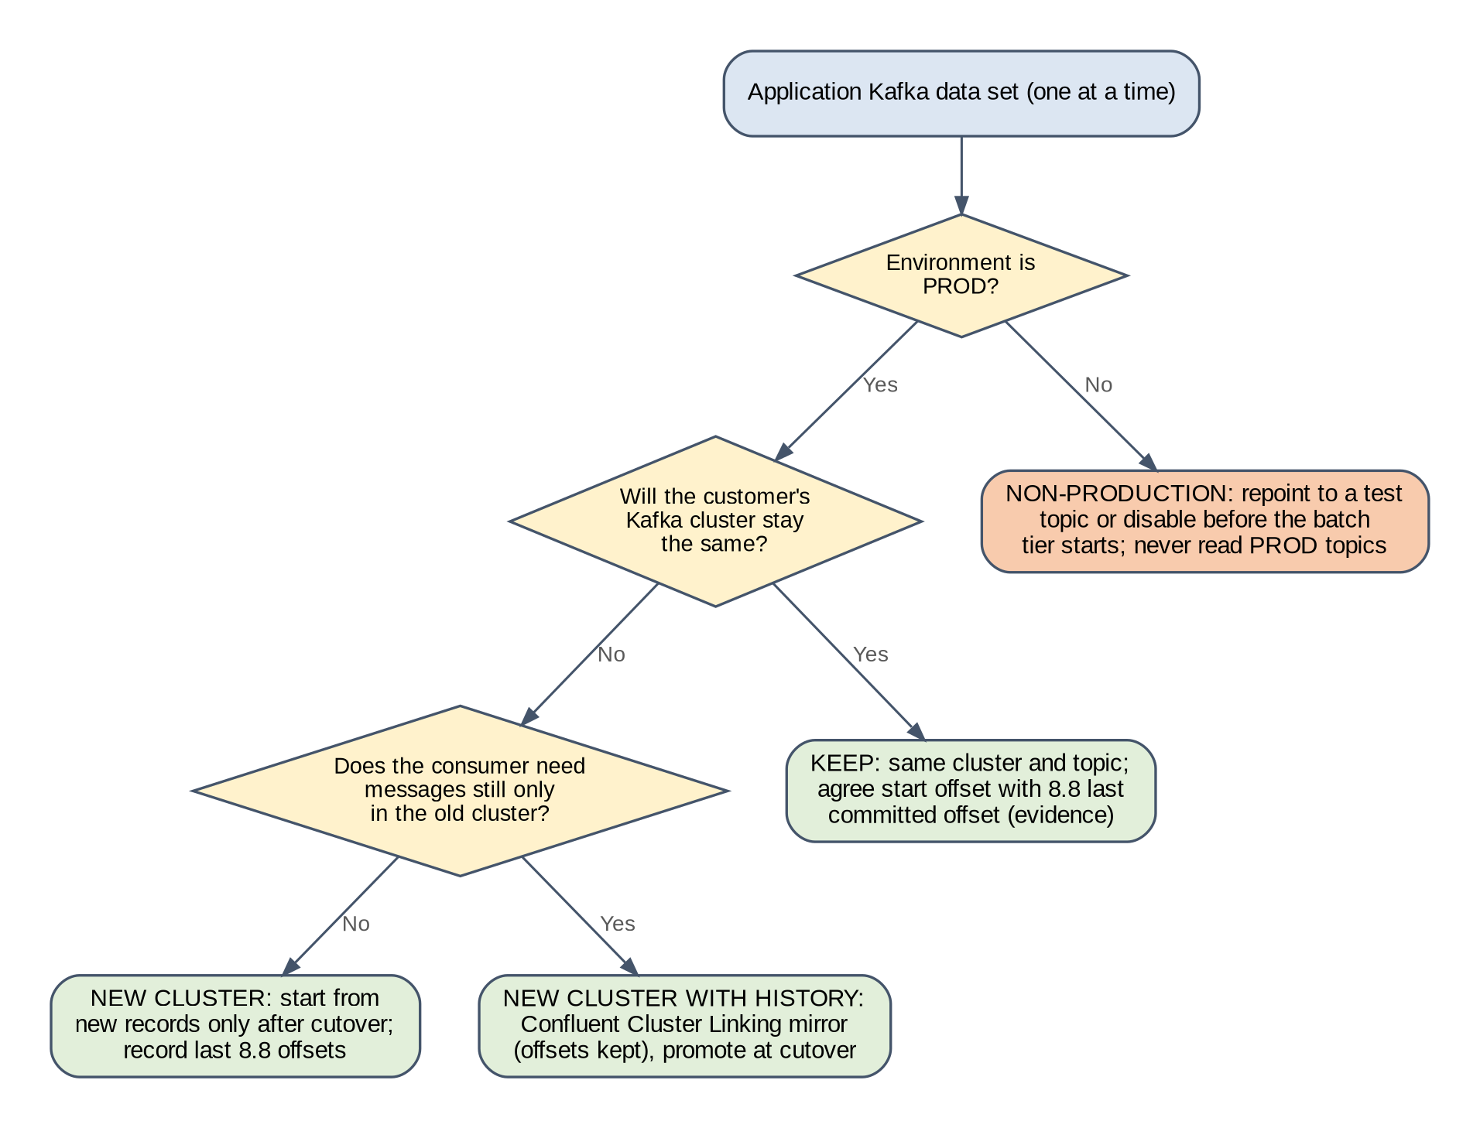
Figure 28. Decision: treatment of each application Kafka data set
Prepared for this implementation. Not a Pega-published diagram.
Table 45. Application Kafka data set register (one row per data set, completed with the application team)
Data set | Direction | Cluster and topic | PROD treatment | Start offset at cutover | Non-production treatment | Owner
<data set name> | <consume or produce> | <cluster / topic> | <keep, new cluster, Cluster Linking> | <offset rule and evidence> | <test topic or disabled> | <application owner>

11.4 Why the Stream Migration activity is not used
Pega provides a Stream Migration activity and a Helm chart guide for switching a running deployment from embedded Stream to an external Kafka, or between Kafka providers [R13, R25]. It drains the queues of a running system before the switch. This programme never switches the running 8.8 system to an external Kafka: 8.8 keeps its embedded Kafka until it stops, and 26.1.1 starts on a different system with its own Confluent cluster. Holding intake and letting the 8.8 queues empty gives the same result, an empty queue at the moment of the final clone, without changing 8.8.

11.5 Statement for approval
Decision. No Pega stream topic and no search index is copied from 8.8. Database-held queue items travel with the clone and are handled as listed in Table 42. Application Kafka topics are handled one by one as listed in Table 45.

12 Deployment runbook per environment
Every environment is built in the same order, with a check after each step. Shared services are created once per group (NP1, NP2, PROD); per-environment objects are created for each environment. Values in angle brackets come from Appendix A, and commands from Appendix C.

12.1 Build order
Table 46. Build order
Phase | Component | Scope | Depends on | Owner
1 | Network and DNS: private endpoint subnet, firewall rules, private DNS zones | Per group and per environment | Landing zone | Cloud architect
2 | Key Vault, External Secrets Operator identity, Okta authorization server and client | Per environment | Phase 1 | Platform team, identity team
3 | Confluent cluster and Private Link; service account, ACLs, quota, API key | Cluster per group; rest per environment | Phases 1, 2 | Kafka engineer
4 | OpenSearch service and private endpoint; cluster settings; SRS user and role | Service per group; user per environment | Phases 1, 2 | Search engineer
5 | SRS deployment (backingservices chart) | Per environment | Phases 2, 4 | Search engineer
6 | Database clone, masking, upgrade (run U) | Per environment | GQ answers or conservative plan | DBA team, platform team
7 | Clean-up and first start (run F), index build (run D), intake release | Per environment | Phases 3, 5, 6 | Pega LSA, platform team

12.2 Network and DNS
Table 47. Network and DNS steps
ID | Action | Owner | Check | Evidence
NW-1 | Create the private endpoint subnet with network policies for private endpoints enabled. | Cloud architect | Subnet exists; NSG applies | Azure export
NW-2 | For a new group, complete N-1 to N-6 (Section 6.4) for its Confluent cluster. | Kafka engineer | K-1 to K-3 pass from a pod | Command output
NW-3 | For a new group, create the OpenSearch private endpoint and DNS record as the provider documents. | Search engineer | S-1 resolves to a private IP and returns the version | Command output
NW-4 | Add firewall rules for this environment: its own Confluent and OpenSearch endpoints, <okta-domain>:443, registry and Pega Diagnostic Center if used. Deny production endpoints from non-production. | Cloud architect | Allowed tests pass; denied tests fail (IT-09) | Rule export, test output
NW-5 | Confirm the AKS cluster has a network policy engine. Apply Kubernetes network policies: deny by default; allow pega to srs on 8443, srs to the OpenSearch endpoint and Okta, pods to DNS (Section 7.7). | Platform team | Test pod cannot reach a denied target | Test output

12.3 Secrets and identity
Table 48. Secrets and identity steps
ID | Action | Owner | Check | Evidence
SI-1 | Create kv-pega-<code> with RBAC, private endpoint and public access disabled. | Platform team | Reachable from the spoke only | Test output
SI-2 | Create the workload identity for the External Secrets Operator in pega-<code> and srs-<code>; grant Key Vault Secrets User on this vault only. | Platform team | SecretStore Ready | kubectl output (P-4)
SI-3 | Create the Okta client pega-srs-<code> and register its public key (Section 7.6); store the private key in Key Vault. | Identity team | Token request succeeds (O-1) | Decoded claims (O-2)
SI-4 | Create the ExternalSecrets in Section 8.2. | Platform team | All secrets SecretSynced | kubectl output

12.4 Confluent Cloud
Table 49. Confluent Cloud steps
ID | Action | Owner | Check | Evidence
CC-1 | For a new group, create the cluster (type per OD-02) in the AKS region with Private Link. | Kafka engineer | Cluster status Up | Cluster ID
CC-2 | Create service account sa-pega-<code> and the four ACLs (Section 6.5). | Kafka engineer | ACL list matches Table 21 (K-7) | ACL export
CC-3 | Create an API key for the service account; write the JAAS value to kv-pega-<code> as confluent-jaas. | Kafka engineer | Secret version exists; key not in any file or ticket | Secret metadata
CC-4 | In NP1 and NP2, create the client quota for the service account (OD-09). | Kafka engineer | Quota listed | Quota export
CC-5 | Run IT-01 to IT-04 against the other environments in the group. | Kafka engineer | All denied | Test output

12.5 OpenSearch
Table 50. OpenSearch steps
ID | Action | Owner | Check | Evidence
OS-1 | For a new group, provision the OpenSearch service (OD-03) at the size in Section 7.4, version 2.15 or 2.19. | Search engineer | S-1 shows the version; S-2 green | Output
OS-2 | For a new group, apply the cluster settings in Section 7.4 as administrator. | Search engineer | S-3 shows both settings | Output
OS-3 | Create the SRS user for this environment and map it to the index-scoped role pega26-<code>-srs (Section 7.5). | Search engineer | User can create and delete pega26-<code>-test; cannot touch another prefix | Test output
OS-4 | Store the SRS user credentials in kv-pega-<code>. | Search engineer | Secret synced to srs-<code> | kubectl output

12.6 SRS
Table 51. SRS steps
ID | Action | Owner | Check | Evidence
SR-1 | Create the SRS TLS keystore and truststore and store them in Key Vault. | Platform team | Secret srs-runtime-certs synced | kubectl output
SR-2 | Deploy SRS: helm upgrade --install srs-<code> pega/backingservices -n srs-<code> -f backingservices-<code>.yaml, then kubectl apply -f netpol-srs-<code>.yaml (Section 7.7). | Search engineer | SRS pods Ready (P-1); SRS reaches OpenSearch and the Okta key set | Output
SR-3 | From a pod in pega-<code>, call the SRS service with and without a token. | Search engineer | Without token refused; with token accepted (S-5) | Output

12.7 Database clone and upgrade
Table 52. Database clone and upgrade steps
ID | Action | Owner | Check | Evidence
DB-1 | For non-production, take the clone from the agreed production copy; for PROD, take the final clone at cutover step C-3. | DBA team | Clone restored; row counts recorded | Clone record
DB-2 | Mask the clone (non-production) per OD-07. | DBA team | Masking report | Report
DB-3 | Apply any pre-upgrade condition from Pega Support (GQ-02, GQ-03) and the time-point B items in Table 42. | DBA team, Pega LSA | Each item signed off | Clean-up record
DB-4 | Run U: helm upgrade --install pega pega/pega -n pega-<code> -f pega-<code>-upgrade.yaml --version 4.13.0. | Platform team | Installer job completed (P-5) | Installer log, duration
DB-5 | If the installer job fails, read the log, fix the cause, and follow Pega's guidance for rerunning the upgrade on this database. If in doubt, restore the clone and start again from DB-1 (FS-26). | Platform team, DBA | Rerun completes | Incident record

12.8 First start, index build and intake release
Follow the first-start control in Section 10.4 (steps ST-1 to ST-9). The Helm commands are:
Helm commands for runs F and D
# Run F: web tier only, batch tier held at zero
helm upgrade --install pega pega/pega -n pega-<code> -f pega-<code>-first.yaml \
--version 4.13.0
# Run D: steady state, batch tier at normal size (starts queue processing)
helm upgrade --install pega pega/pega -n pega-<code> -f pega-<code>-deploy.yaml \
--version 4.13.0

12.9 Per-environment notes
Table 53. Per-environment notes
Environment | Built from | Masked | Shared group | Notes
DEV | Production copy | Yes | NP1 | First build. Proves the Okta claim design, the index-scoped role, DSS precedence and the full path; finds the cluster messaging topics.
SIT | Production copy (can be the DEV clone) | Yes | NP1 | First environment with integrations to test systems; data set register applied.
UAT | Recent production copy | Yes | NP1 | Business tests on search over masked data.
PERF | Full-size production copy | Yes | NP2 | Load tests, partition and index build measurements; sets PROD sizes.
PREPROD | Most recent full-size production copy | Per policy | NP2 | Rehearsal 1 and Rehearsal 2 of the production cutover, run by the cutover team.
PROD | Final clone at cutover | No | PRD | Section 13.

12.10 Building the environments one after another
The environments are built in waves, shown in Figure 29. Each wave reuses what the earlier waves proved and adds only what is new. A wave starts only when the exit check of the previous wave has passed, so a design fault is found once, in DEV, rather than six times.
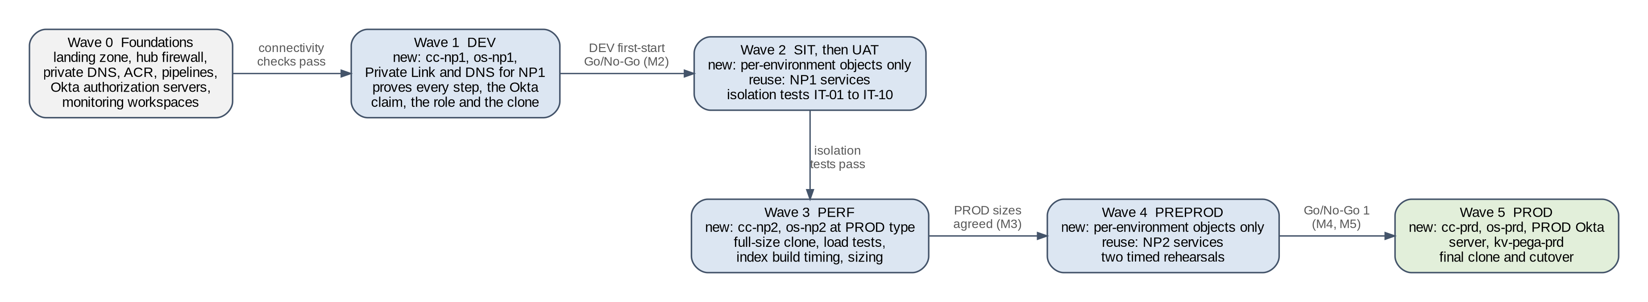
Figure 29. Environment build waves and the gate between each
Prepared for this implementation. Not a Pega-published diagram.
Table 54. Environment build waves
Wave | Environment | New shared objects | New per-environment objects | Exit check
0 | Foundations | Landing zone, hub firewall rules, private DNS zones, registry, pipelines, both Okta authorization servers, monitoring workspaces | None | Connectivity checks from a test pod; pipeline renders all values files
1 | DEV | cc-np1 with Private Link and DNS; os-np1 with cluster settings | All objects in phases 2 to 7 of the build order | First-start Go/No-Go; Okta claim, index-scoped role, DSS precedence (FS-24), GQ-08 behaviour and SRS key rotation (FS-33) recorded (M2)
2 | SIT, then UAT | None | Namespace, vault, Okta client, service account, ACLs, quota, SRS user, SRS, clone | IT-01 to IT-10 between DEV, SIT and UAT
3 | PERF | cc-np2 and os-np2 at the PROD type and size | Same as wave 2, plus load test harness | Load tests and sizing (Section 15); PROD sizes and cluster type agreed (M3)
4 | PREPROD | None | Same as wave 2 | Two timed rehearsals; isolation from PERF (M4, M5)
5 | PROD | cc-prd, os-prd, PROD Okta authorization server, kv-pega-prd | Same as wave 2, from the final clone | Go/No-Go gates in Section 13.4

Table 55 lists what must be configured for each new environment, whichever wave it is in. Keep one completed copy per environment with the evidence.
Table 55. Configuration checklist for each new environment
Item | Value for this environment | Where configured | Check
Code, group, namespaces | <code>, NP1 / NP2 / PRD, pega-<code>, srs-<code> | Table 8 | Code is not the start of another code
Key Vault and workload identity | kv-pega-<code> | SI-1, SI-2 | SecretStore Ready
Okta client and key | pega-srs-<code>; guid = pega26-<code> | SI-3, Section 7.6 | O-2 shows the right guid
Confluent service account, ACLs, quota, API key | sa-pega-<code> on the group cluster | CC-2 to CC-4 | K-7 ACL list; quota listed
Stream values | streamNamePattern: pega-<code>-{stream.name}, group bootstrap | Values file | Pipeline naming check
OpenSearch user and role | pega26-<code>-srs on the group service | OS-3, OS-4 | IT-06
SRS release and network policy | srs-<code>, URL with :8443 | SR-1 to SR-3 | S-5
customerDeploymentId | pega26-<code> | Values file | Pipeline naming check; IT-05
Firewall and DNS | Own Confluent and OpenSearch endpoints, Okta, deny production | NW-4, NW-5 | IT-09
Clone, masking, upgrade | Clone date and masking report | DB-1 to DB-5 | Installer log
Clean-up CD-01 to CD-16 | Clean-up record | Section 10.3 | Signed record
Monitoring | Dashboards and alerts with the environment label | Section 18 | Test alert received
Measurements | Partitions, index size, build time, token rate, connections | Appendix A | Values recorded

13 Production cutover and rollback

13.1 Principles
- The 8.8 system and its database are not changed by the cutover, apart from stopping 8.8. They stay available for rollback until the rollback window closes.
- Every step was run at least twice in PREPROD with production-sized data, by the people who will run it in production.
- The outage window comes from the rehearsal measurements plus 25 % contingency, not from estimates.
- Rollback is free of data loss until intake is released on 26.1.1. After that, rollback loses work done on 26.1.1, so the business decides.

13.2 Milestones
Table 56. Programme milestones used in this document
Milestone | Content | Exit criteria
M1 Design approval | This document approved; open decisions owned | Signatures on the approvals page
M2 DEV build | First environment from a clone | First-start Go/No-Go passed; Okta, role and DSS tests recorded
M3 PERF measurements | Load tests, partitions, index build time | PROD sizes and cluster type agreed (OD-02)
M4 Rehearsal 1 (PREPROD) | Full cutover sequence with timings | All steps completed; defects logged
M5 Rehearsal 2 (PREPROD) | Full cutover sequence by the cutover team | Timing fits the window; no open severity 1 or 2 defects
M6 Go/No-Go 1 and production cutover | Section 13.3 | Go/No-Go 3 passed

13.3 Cutover sequence
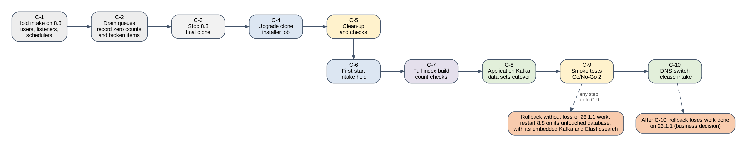
Figure 30. Production cutover sequence from the Kafka and search point of view
Prepared for this implementation. Not a Pega-published diagram.
Table 57. Production cutover steps
Step | Action | Owner | Duration from | Evidence
C-1 | Hold intake on 8.8: block user access, stop inbound listeners and services, disable job schedulers that create work. | Application team | Rehearsal | Change record
C-2 | Let queue processors finish. Record the count of items ready to process (must be zero) and the count of broken items per queue processor from Admin Studio. Record the last committed offset of each application Kafka data set consumer. | Pega LSA | Rehearsal | Screenshots, offset list
C-3 | Stop 8.8. Take the final clone (DB-1). | DBA team | Rehearsal | Clone record
C-4 | Run U on the clone (DB-3, DB-4). | Platform team | Rehearsal | Installer log
C-5 | Apply time-point A clean-up; run F; time-point F checks (ST-2 to ST-6). | Pega LSA | Rehearsal | Clean-up record, screenshots
C-6 | Go/No-Go at first start (Figure 26). | Cutover manager | Fixed | Gate record
C-7 | Run D; full index build; completeness and count checks (ST-7, ST-8). | Pega LSA | Rehearsal | Count sheet
C-8 | Application Kafka data sets cutover (Section 13.5). | Application team | Rehearsal | Offset evidence
C-9 | Smoke tests; Go/No-Go 2. | Test lead | Rehearsal | Test report, gate record
C-10 | Switch public DNS to Application Gateway; release intake (ST-9); Go/No-Go 3 after 30 minutes. | Platform team | DNS TTL | DNS change record

Important. Lower the TTL of the public DNS record to 300 seconds at least 48 hours before cutover, so a DNS switch or revert takes effect quickly. Restore the normal TTL after hypercare.

13.4 Go/No-Go gates
Table 58. Go/No-Go gates
Gate | When | Criteria | Decision owner
Go/No-Go 1 | Seven days before | Two PREPROD rehearsals passed; window fits with 25 % contingency; Pega Support answers received or conservative plan accepted; rollback rehearsed | Business owner with platform lead
First-start gate | After C-5 | All checks in Figure 26 up to the index build | Cutover manager
Go/No-Go 2 | After C-9 | Index build complete and counts match; application data sets started at agreed offsets; smoke tests pass | Cutover manager
Go/No-Go 3 | 30 minutes after C-10 | No severity 1 or 2 incidents; queue backlog falling; search response within target | Cutover manager with business owner

13.5 Application Kafka data set cutover
1. At C-2, record the last committed offset of each 8.8 consumer group that reads the customer's Kafka topics (K-8 on the customer's cluster).
2. For data sets that keep the same cluster and topic, configure the 26.1.1 data flow to start from the recorded offset, or reuse the same consumer group if the application team confirms it, so no message is skipped or processed twice.
3. For data sets that move to a new cluster without history, start from new records only, and keep the 8.8 offset list as evidence of what was processed.
4. For data sets mirrored with Cluster Linking, promote the mirror topics at cutover; Cluster Linking keeps offsets [R35].
5. Record the first offset processed by 26.1.1 for each data set and compare with step 1.

13.6 Rollback
Table 59. Rollback steps
Step | Action
RB-1 | Declare rollback; record the reason and the time.
RB-2 | Hold intake on 26.1.1. If intake was released, export the list of cases created or changed on 26.1.1 for reconciliation.
RB-3 | Revert public DNS to 8.8.
RB-4 | Start 8.8 on its untouched database. Its embedded Kafka and embedded Elasticsearch were stopped, not changed.
RB-5 | Check the 8.8 stream and search landing pages and queue processors; release 8.8 intake.
RB-6 | Reset application Kafka data set consumers on 8.8 to the offsets agreed for the rollback.
RB-7 | Scale 26.1.1 to zero; keep it and its Kafka topics and indexes for analysis.

The point after which rollback loses work is C-10, when intake is released on 26.1.1. Before C-10, rollback loses nothing. After C-10, cases created or changed on 26.1.1 are not in the 8.8 database, and messages produced to application Kafka topics by 26.1.1 have been consumed downstream. The business owner decides at that point between rollback with reconciliation and fixing forward, using the reconciliation list from RB-2.

14 Test strategy, rehearsals and failure scenarios

14.1 Test stages
Table 60. Test stages
Stage | Entry criteria | Environment | Owner | Evidence
Connectivity | Network, DNS and secrets steps done | Every environment | Platform team | K-1 to K-3, S-1 to S-3, O-1 outputs
Configuration | Run F complete | Every environment | Pega LSA | Landing page screenshots; inventory sign-off
Functional | Run D and index build complete | DEV, SIT, UAT | Test lead | Checks in Section 14.4
Isolation | Two environments in a group running | NP1, NP2 | Security architect | IT-01 to IT-10 records
Performance | PERF built at full size | PERF | Performance lead | PT-01 to PT-04 reports
Resilience and failure | Performance baseline recorded | PERF, PREPROD | Platform team | Failure catalogue records (Section 14.6)
Security | Isolation tests passed | SIT, PREPROD | Security architect | No public endpoints; secret scan of values; token claim checks; TLS versions
Operational acceptance | Monitoring live | PREPROD | Operations lead | Alerts reach on-call; runbooks used by operations staff
Full rehearsal | All above passed | PREPROD (twice) | Cutover manager | Timed cutover record (Appendix D)

14.2 Rehearsals and measurements
Rehearse the full clone-and-upgrade path at least twice in PREPROD on production-sized data before production. Record each measurement against data volume, because they set the production window.
Table 61. Rehearsal measurements
Measurement | Steps | Used for | Rehearsal 1 | Rehearsal 2
Drain time on 8.8 | C-1 to C-2 | Window
Clone time | C-3 | Window
Upgrade time | C-4 | Window
Clean-up time | C-5 | Window
First start time | ST-3 to ST-6 | Window
Full index build time | ST-7 to ST-8 | Window; OpenSearch sizing
Time to release intake | C-9 to C-10 | Window
Partitions created | K-5 | Confluent capacity
Searchable data volume | S-4 | OpenSearch sizing

14.3 Isolation tests
Each test uses environment A's credentials against environment B in the same group, and must be refused. Run them in NP1 and NP2 after every new environment joins a group.
Table 62. Isolation tests
ID | Test | Method | Pass criteria
IT-01 | Read and write B's topics with A's key | kcat produce and consume to pega-<B>-<topic> with A's credentials | Authorization error
IT-02 | Create and delete topics under B's prefix | confluent kafka topic create and delete as A | Refused
IT-03 | Join or reset B's consumer group | kcat consumer with group pega-<B>-... | Authorization error
IT-04 | Use A's key from B's namespace | Check B's Key Vault and secrets contain no A key | Not present
IT-05 | Index names after the build | S-4 for pega26-<A>*; list all indexes | A's indexes all carry A's prefix; none outside a known prefix
IT-06 | A's SRS user on B's indexes; SRS works with the scoped role | Search, write and delete on pega26-<B>* as A's user; full build as A | Refused on B; A's build succeeds
IT-07 | A's token at B's SRS | Send a request to B's SRS with A's token | Refused (guid mismatch)
IT-08 | A's External Secrets identity on B's vault | Create a test ExternalSecret in A pointing at B's vault | Access denied
IT-09 | Non-production pod to production endpoints | From a pod in NP1 and NP2: DNS and TCP to cc-prd, os-prd and production integration hosts | No private resolution; connection refused by firewall
IT-10 | Cloned environment to production integrations | Firewall log review during run F and the first day of run D | No connection attempts to production systems

14.4 Functional and integration checks
- Queue a test item to a test queue processor and confirm it is processed; repeat after every deployment.
- Run a job scheduler with a test activity and confirm it runs on the batch tier.
- Create a case, wait for indexing, and find it with case search; repeat for each class with custom search properties (CD-14).
- Run each report that depends on search and compare with the 8.8 baseline on the same clone data.
- For each application Kafka data set in SIT, run its data flow against the test topic and compare counts.
- Check the produce path with a message near 5,000,000 bytes, if the application produces large messages (FS-06).

14.5 Performance tests
These are the acceptance tests for Kafka and search. Section 15 gives the workload model, the full set of test types, the harness and the entry and exit criteria they run under.
Table 63. Performance tests
ID | Test | Target | Measured
PT-01 | Peak user load plus peak queue processor load in PERF | Agreed response times; consumer lag returns to baseline after peak
PT-02 | Full index build throughput | Fits the production window after scaling (Section 7.8)
PT-03 | Quota enforcement: PERF load while PREPROD runs a light test | PREPROD response unchanged; PERF throttled at its quota
PT-04 | Consumer lag under peak per queue processor | Lag within the alert threshold

14.6 Failure scenario catalogue
Table 64 lists the failures to test. Run Kafka, search and platform scenarios in PERF or PREPROD, and clone-specific scenarios in DEV during the first build and again in PREPROD. Where Pega does not document the exact behaviour, record what happens in the first run; that record becomes the expected result for later runs.
Table 64. Failure scenario catalogue
ID | Scenario | How to cause it safely | Expected behaviour | Detection | Recovery | Pass criteria
FS-01 | Kafka bootstrap unreachable | Block 9092 to the Confluent endpoints with a network policy | Queue processing and cluster messaging stop; Stream landing page not NORMAL | Stream landing page; Pega log Kafka connection errors; alert | Remove the block; pods reconnect or restart | Processing resumes; no item lost
FS-02 | Zonal private DNS record missing | Remove one zonal record in DEV | Some broker connections fail after bootstrap | K-3 shows a broker resolving publicly or not at all | Restore the record | All broker names resolve privately
FS-03 | API key revoked | Delete the environment's API key in DEV | Authentication failures; stream down | Pega log SASL errors; Confluent audit log | Create a key; update Key Vault; restart tiers | Stream NORMAL within the rotation time
FS-04 | ACL missing for a new topic | Remove the TOPIC prefixed ACL briefly in DEV | Topic creation or access refused | Authorization errors in Pega log | Restore the ACL; add literal ACLs for unprefixed topics | All topics accessible
FS-05 | Partition limit reached | Lower the cluster headroom in a sandbox or simulate with a test topic set | New topic creation fails | Confluent error; Pega log | Delete unused topics or add capacity | New queue processor starts
FS-06 | Message larger than max.message.bytes | Produce a 6 MB test message through a test queue processor | Producer error for that item | RecordTooLargeException in Pega log | Set topic to 5,000,000; keep messages within it [R11] | Item within limit processed
FS-07 | Broker rolling restart during Confluent maintenance | Observe a scheduled maintenance in PERF | Short retries; no loss | Confluent notice; brief lag rise | None | No broken items caused
FS-08 | Consumer lag builds under load | PT-04 at 150 % of peak | Lag grows then drains | Lag alert | Add batch pods within partition count | Lag back to baseline
FS-09 | One SRS pod lost | Delete one SRS pod in PERF | Searches continue on other pods | Pod restart event | Kubernetes recreates it | No search errors seen by users
FS-10 | Whole SRS deployment lost | Scale SRS to zero in PERF | Search and indexing fail; other functions continue | Search errors; SRS alert | Scale back; check indexing backlog clears | Backlog cleared; counts match
FS-11 | Okta token cannot be obtained | Block <okta-domain> at the firewall for the environment | Search fails once the current token expires | Pega log token errors | Restore the rule | Search resumes without restart, or with restart recorded
FS-12 | Token from the wrong issuer | Configure a test client on another authorization server | SRS refuses if it checks issuer; record result | SRS log | Use the right server | Behaviour recorded in Section 20.4
FS-13 | guid does not match customerDeploymentId | Change the claim value for the DEV client | SRS refuses requests | 401 or 403 in SRS log | Restore the claim | Search resumes
FS-14 | Client key rotated in Okta but not in Key Vault | Remove the current public key from the DEV client | Token requests fail | Okta system log; Pega log | Register the key or update Key Vault and restart | Search resumes
FS-15 | OpenSearch status yellow | Stop one data node (provider tooling) in PERF | Searches continue | S-2 yellow; alert | Provider restores the node | Green; no Pega errors
FS-16 | OpenSearch status red | Simulate in a sandbox service by closing an index copy | Searches on the affected index fail | S-2 red; alert | Restore or rebuild the index | Green; counts match
FS-17 | Flood-stage disk watermark | Fill test data on a sandbox service | Indexes read-only; indexing fails | Disk alert; SRS errors | Add storage; clear the read-only block as the provider documents | Indexing resumes
FS-18 | OpenSearch credentials rotated without SRS update | Change the SRS user password only | SRS calls refused | SRS log 401 | Update Key Vault; restart SRS | Search resumes
FS-19 | Certificate expires | Deploy an expired SRS server certificate in DEV | Pega to SRS TLS fails | TLS errors in Pega log; expiry alert should have fired earlier | Renew; restart | Expiry alert fires 30 days before
FS-20 | Key Vault secret rotated without pod restart | Rotate the API key, delete the old key, skip the restart | Stream fails when the old key is deleted | SASL errors | Rolling restart | Runbook includes the restart
FS-21 | AKS node drained or zone lost | Cordon and drain all nodes in one zone | Pods reschedule within PDB limits | Pod events | Kubernetes reschedules | Processing and search continue
FS-22 | Non-production load test saturates the shared cluster | PERF load above its quota while PREPROD tests | PERF throttled; PREPROD unaffected | Metrics API by principal | Lower quota; reschedule | PREPROD response unchanged
FS-23 | Index rebuild during business hours on a shared service | Full build in SIT while UAT tests search | UAT search slower | Latency metrics | Schedule builds out of hours | UAT latency within target
FS-24 | Stale 8.8 stream or search DSS overrides Helm | In DEV, record cloned DSS; start with them in place | Landing pages show Helm values (expected) or DSS values (defect) | Stream and search landing pages | Follow Pega Support's answer to GQ-05 | Helm values in effect
FS-25 | Wrong customerDeploymentId deployed | Deploy SIT with DEV's ID in a sandbox | SRS refuses tokens; if accepted, indexes mix | Pipeline check should block it; SRS log | Redeploy with the right ID; delete wrong indexes | Pipeline check blocks the deploy
FS-26 | Installer upgrade fails halfway | Stop the installer job during a DEV rehearsal | Database left partly upgraded | Job status; installer log | Follow Pega's rerun guidance, or restore the clone and restart | Second run completes
FS-27 | Clone starts with application Kafka data sets pointing to production | Leave one data set unchanged in DEV, with the firewall rule in place | Connection denied by the firewall | Firewall log; data set errors | Repoint or disable the data set | No production connection; IT-10 passes
FS-28 | Delayed or broken items from 8.8 processed unexpectedly | Keep a sample of items in a DEV clone | Items run on 26.1.1 when due or requeued | Queue processor statistics; application log | Apply the decision per queue processor (CD-05, CD-06) | Behaviour matches the decision
FS-29 | Index build interrupted | Restart the batch tier during the build in DEV | Build stops or continues | Search landing page | Resume or restart the build as Pega documents [R17] | Complete build; counts match
FS-30 | All batch pods lost | Scale the batch tier to zero in PERF under load | Queue processing stops; items accumulate in topics | Queue backlog alert | Scale back | Backlog drains; no loss
FS-31 | Kafka connection storm | Rolling restart of the web and batch tiers of PERF and PREPROD at the same time | Connection attempts rise; Confluent may throttle [R31] | Metrics API throttle metric by principal [R56] | Stagger restarts across environments; keep the chart's maxSurge: 1 [R23] | No throttling with the staggered restart procedure
FS-32 | Partition creation paced by the cluster | Refresh PERF (delete and recreate all topics) while PREPROD restarts | Topic creation slows for both environments [R31] | Pega log topic creation retries; time to Stream NORMAL | Never refresh two environments in a group at once | Time recorded; refresh procedure updated
FS-33 | Okta signing key rotation | Rotate the DEV authorization server's keys manually in Okta [R53] | SRS picks up the new key from the key set URL | SRS 401 errors if it caches the old key | Restart SRS; set rotation to manual if needed | Search continues without an SRS restart
FS-34 | Client key rotation with two keys | Register a second public key on the DEV client; switch Key Vault to the new private key; restart | Okta accepts the assertion signed with either key | Okta System Log invalid_client errors | Keep the old key until the new one works | Token issued with the new key; old key removed
FS-35 | Okta rate limit reached | In a sandbox org or with Okta's agreement, drive token requests above the token endpoint limit | HTTP 429 to Pega; search fails once the token expires [R52] | Okta System Log rate-limit warning and violation events | Find the source; lengthen token lifetime; raise the limit with Okta | Warning alert fires before any violation

14.7 Exact checks
Table 65. Exact checks
Check | Command or screen | Expected result
Stream service | Dev Studio: Configure > Decisioning > Infrastructure > Services > Stream | Provider ExternalKafka; status NORMAL; bootstrap and prefix from Helm [R13]
Queue processors | Admin Studio > Queue processors | Ready to process falls to zero; broken items known
Search | Search landing page | SRS connected; all classes indexed; no CONFLICTS FOUND [R19]
Kafka DNS, TLS and metadata | K-1, K-2, K-3 | Private IPs; trusted chain; all brokers listed
Topics, partitions, configuration, ACLs | K-4 to K-7 | Topics under pega-<code>- only; max.message.bytes 5,000,000; ACLs as Table 21
OpenSearch health, settings, indexes | S-2, S-3, S-4 | Green; both settings; indexes under pega26-<code> only
SRS | S-5 | Token required; healthy response
Okta token | O-1, O-2 | scp includes pega.search:full; guid equals pega26-<code>
Installer job | P-5 | Completed without errors
Pods and secrets | P-1, P-4 | All Ready; all ExternalSecrets SecretSynced

14.8 Acceptance criteria
Table 66. Acceptance criteria
ID | Criterion
AC-1 | All exact checks pass in every environment, with evidence filed.
AC-2 | All isolation tests pass in NP1 and NP2.
AC-3 | All failure scenarios have been run at least once with results recorded; any defect is fixed or accepted by the business owner.
AC-4 | Performance results meet the targets agreed by the business owner.
AC-5 | Two PREPROD rehearsals completed, with the measured window within the agreed outage.
AC-6 | Monitoring and alerts in Section 18.5 are live and tested.

15 Performance engineering and sizing

15.1 Why performance testing is required
Load figures from Pega 8.8 cannot be carried over to 26.1.1 on AKS. Too much changes at once, and each change moves load to a service that 8.8 never used:
- Every queue item, cluster message and index update now crosses the network to Confluent Cloud or to SRS and OpenSearch, through private endpoints. On 8.8 these stayed inside the Pega nodes.
- Queue processing in '26 is partitioned and multi-threaded [R3], so throughput depends on partitions, threads and batch pods together (Section 6.7).
- From '25, cluster messaging that Hazelcast carried uses Kafka [R7]. Kafka load rises with the number of Pega pods, not only with business volume.
- Confluent enforces connection and request limits on Enterprise clusters [R31]. A design that works at average load can be throttled at peak or during a rolling restart.
- Non-production environments share clusters and search services. Contention between them only shows up under load.
- The full index build sets part of the production outage [R15], and its time depends on resources that only a full-size test can show.
- Pega asks clients to start from its default search sizing and adjust it after measuring [R14].
Performance testing is therefore a gate, not a formality. PROD sizes are signed off only from PERF results (milestone M3), and PREPROD rehearsals confirm them.

15.2 Workload model
The workload model describes production load in terms the tests can reproduce. Build it from 8.8 production data (AS-10), not from estimates, and get the business owner to approve it before the first test.
Table 67. Workload model inputs
Input | Source on 8.8 | Used for
Peak concurrent users and sessions per hour, by user journey | Web server or gateway logs; Pega Diagnostic Center; Pega usage reports | Web tier load scripts
API calls per hour by service | Gateway logs; Pega service rule statistics | API load scripts
Cases created and resolved per hour, by case type | Pega reports on the work tables | Data growth; indexing rate
Queue items per hour per queue processor, and the busiest queue processors | Admin Studio queue processor statistics | Kafka produce and consume rates; partitions
Job scheduler runs and their duration | Admin Studio | Batch tier load windows
Search queries and search-based reports per hour | Pega logs; report statistics | SRS and OpenSearch query rate
Calendar peaks: month end, campaigns, seasonal | Business owner | Peak-hour definition
Data volume and yearly growth | Database sizes; DEV index sizes (S-4) | Storage sizing

Define one design peak hour that combines the busiest user load with the busiest background load seen together on 8.8, plus the agreed growth. All targets in this section refer to that hour.

15.3 Test types and measurement points
Table 68. Performance test types
Test | Purpose | Profile | Pass criteria
Baseline | Reference figures with fixed replica counts | 20 % of design peak, HPA off, 1 hour | Recorded; used to compare every later run
Load | Prove the design peak hour | Ramp to 100 % over 30 minutes; hold 1 hour | Response times and lag within targets; no throttling
Stress | Find the first limit and how the system fails | Step up by 25 % each 20 minutes until a target fails | Breaking point at least 150 % of peak; the first limit is known
Soak | Find leaks and slow drift | 80 % of peak for at least 8 hours, across a token expiry and a key rotation if planned | No heap growth trend; stable lag; no rising error rate
Spike | Prove HPA and Kafka absorb a sudden rise | From 30 % to 120 % within 2 minutes | Recovery to target within 10 minutes
Backlog drain | Prove the batch tier clears a backlog | Queue one peak hour of items with the batch tier at zero, then start it | Drained within the agreed time; no broken items
Index build | Measure the outage component | Full build on the full-size clone (PT-02) | Fits the window after scaling (Section 7.8)
Resilience under load | Prove zone and component loss at peak | FS-09, FS-15, FS-21 and FS-31 run during a load test | Targets met within the recovery time
Noisy neighbour | Prove quotas protect the shared group | PT-03 | PREPROD response unchanged

Figure 31 shows the test set-up and the six measurement points. Every test records all six, so a slow response at M1 can be traced to the layer that caused it.
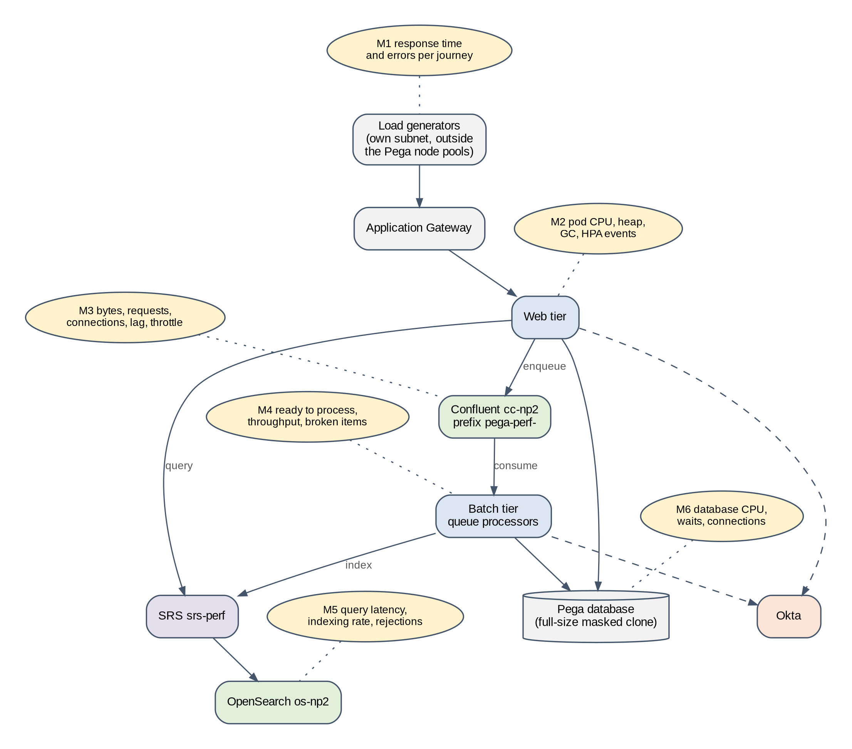
Figure 31. Performance test harness and measurement points in PERF
Prepared for this implementation. Not a Pega-published diagram.
Table 69. Measurement points
Point | What is measured | Source
M1 | Response time (median, 95th and 99th percentile) and errors per journey | Load tool
M2 | Pod CPU, memory, heap after GC, GC pause time, HPA events, pod restarts | Managed Prometheus; GC log (Section 9.2)
M3 | Bytes in and out, requests, connections, consumer lag and throttling per service account | Confluent Metrics API [R56]
M4 | Ready to process, throughput and broken items per queue processor | Admin Studio
M5 | SRS response time and errors; OpenSearch query latency, indexing rate, rejected requests | SRS logs; provider metrics
M6 | Database CPU, waits, connections and slow statements | Database monitoring

15.4 Tools and harness
- Use the customer's standard load tool, for example Apache JMeter or Gatling. Run the generators on their own VMs or node pool in a separate subnet, never on the Pega node pools, and enter through Application Gateway so the path matches production.
- Record scripts against 26.1.1, not 8.8. Pega UI requests carry session-specific values that must be correlated in the script; a script recorded on 8.8 will fail or produce false errors.
- Drive Kafka and search through Pega. Direct load on Confluent or OpenSearch does not show how Pega uses them. A short kafka-producer-perf-test run from a Pega namespace pod is useful only as a baseline for the Private Link path.
- Use the full-size masked clone. Take a database snapshot before the first test and restore it between test cycles, then refresh topics and indexes as in Section 19.3, so each cycle starts from the same state.
- Synchronize all clocks to UTC and label each run with a run ID in the load tool, in Grafana annotations and in the test log, so measurements from every source can be lined up.
- Agree each test with the identity team. All environments share one Okta org, and load tests add token requests to the org's rate limit [R52].

15.5 Entry and exit criteria
Table 70. Performance test entry, exit and suspension criteria
Criteria | Detail
Entry | PERF built at full size with the PROD cluster type and OpenSearch size; full index build complete.  Workload model and targets approved by the business owner.  Dashboards for M1 to M6 live (Section 18.4); synthetic checks green.  PREPROD activity scheduled away from the test window (Section 5.4).
Exit | Load, soak and spike tests pass at the design peak; stress test shows at least 150 % headroom.  No Confluent throttling at peak; consumer lag returns to baseline within the agreed time.  Index build time fits the window with the PROD sizes.  Sizing calculator updated with measured values; PROD sizes and cluster type signed off (M3).
Suspend | A shared-service incident, another environment's activity, or a defect that invalidates results. Record and rerun.

15.6 Pitfalls seen in Pega performance tests
- Empty or partial search indexes. Queries on a small index are fast and say nothing about production. Test only after the full build.
- HPA hiding the limit. Run the baseline and the stress test with fixed replicas, then repeat the load test with HPA on.
- Warm-up included in results. Exclude the first 15 minutes after a start, while caches fill and the JIT compiles.
- Fewer partitions than production. If PERF topics have fewer partitions than PROD will, batch results are pessimistic; if more, they are optimistic. Keep the partition DSS the same in PERF and PROD (CD-15).
- Web-only scripts. User journeys that create cases also create queue items and index updates. Measure M4 and M5 in every run, not only M1.
- Repeated search terms. OpenSearch caches results. Use a large, varied set of search values from the masked data.
- Comparing with 8.8 figures measured differently. Compare like with like, or use 8.8 figures only as a guide.
- Connections not measured. Record connections and connection attempts per pod (M3) at rest, at peak and during a restart, because Confluent limits them per cluster [R31].

15.7 Sizing method
Sizing runs as a loop, shown in Figure 32. Production facts from 8.8 and measurements from DEV go into the sizing calculator (Appendix H). PERF tests the result at production volume. If targets are not met with headroom, the inputs or sizes are adjusted and PERF runs again. After go-live, production monitoring feeds actual usage back into the calculator at each quarterly capacity review.
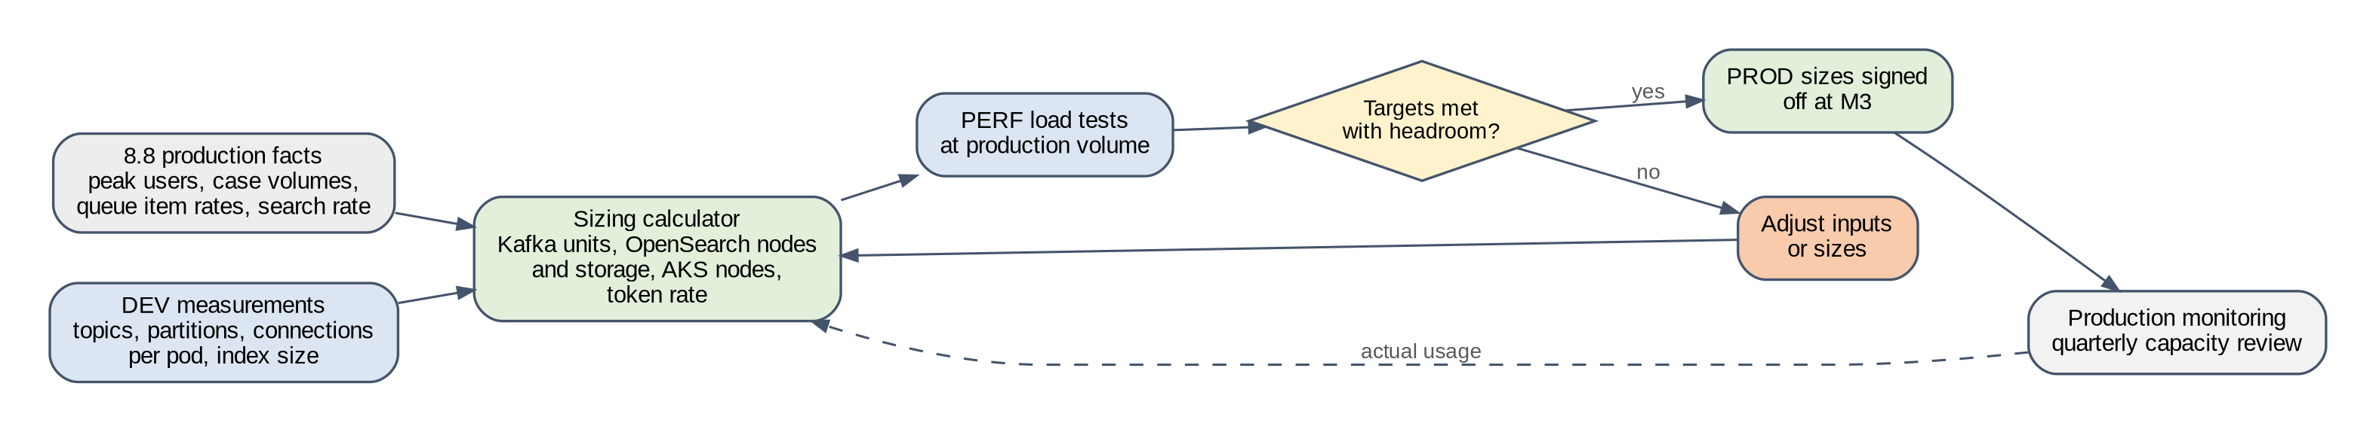
Figure 32. Sizing loop from production facts to signed-off PROD sizes
Prepared for this implementation. Not a Pega-published diagram.

15.8 Sizing rules per layer
Table 71. Sizing rules per layer
Layer | Rule | Source
Pega web tier | Pods at peak = peak sessions / sessions per pod measured in PERF at target response time. HPA maximum = pods at peak x 1.25 | Measured; [R23]
Pega batch tier | Effective consumers per queue processor = min(partitions, batch pods x threads). Size pods for the busiest queue processors and for the index build, whichever needs more | [R49, R50]
Pega pod memory | Container 12Gi with heap about two thirds of it; metaspace capped at 768m | [R23, R63]
Confluent capacity units | Units = the largest of: ingress / 60 MBps, egress / 180 MBps, partitions / 3,000 (4,500 on Dedicated), connections / 18,000, requests per second / 7,500 (15,000), and 2 for the SLA | [R31]
Confluent partitions | Topics x partitions per topic (default 6), plus 30 % headroom, summed over the group | [R49]
OpenSearch storage and nodes | Formulas in Table 28 | [R54, R55]
SRS | 3 pods in PERF, PREPROD and PROD; add pods if SRS CPU stays above 70 % at peak | [R14, R24]
Okta | Token requests per minute summed over all environments, compared with the org's token endpoint limit | [R52]
AKS nodes | Pega pods per node = the smaller of allocatable CPU / CPU request and allocatable memory / memory request. Nodes = (pods at HPA maximum / pods per node) x 1.5 for zone loss, plus 1 for upgrade surge, rounded up to a multiple of 3 | [R59]

15.9 Worked example
Caution. The figures below are illustrative inputs chosen to show the method. They are not measurements of the customer's system. Replace every input with a measured value before sizing anything.

Table 72. Worked sizing example (illustrative inputs)
Layer | Inputs (illustrative) | Result
Confluent cc-prd | 8 MBps in, 24 MBps out, 900 partitions measured, 1,800 connections, 3,000 requests per second | Units needed by ingress 1, egress 1, partitions 1, connections 1, requests 1, SLA minimum 2. Result: 2 eCKU, set by the SLA minimum
OpenSearch os-prd | 40 GiB primary data, 1 replica, 20 % growth a year for 3 years, 60 indexes with 1 primary shard each, 100 GiB usable disk and 8 GiB heap per node | Storage 200.4 GiB; nodes by storage 3, by shards 1, zone minimum 3. Result: 3 data nodes
AKS Pega node pool | 12 Pega pods at HPA maximum, 3 CPU and 12 GiB each; nodes with 15 CPU and 58 GiB allocatable | 4 pods per node; 3 nodes for the load; x 1.5 and + 1 gives 6 nodes

In this example the Confluent cluster is sized by the SLA minimum, not by load, and the OpenSearch service by the three-zone minimum. That is common for Pega workloads of this kind. The shared clusters change the picture: in NP1, three environments' partitions add up, and partitions or connections can set the unit count instead. Run the calculator for each group, not only for PROD.

16 Known issues and challenges
These are the problems that come up in this kind of implementation. Each one names the symptom, the cause, how to prevent it and how to fix it.

16.1 Cloned database
Table 73. Known issues: cloned database
Symptom | Cause | Prevention | Fix
Landing pages show 8.8 values instead of the Helm values | Stream or search DSS from 8.8 in the cloned database (CD-01, CD-03) | Record cloned DSS before the first start; FS-24 in DEV; GQ-05 | Apply Pega Support's answer; restart the tiers
A production Kafka consumer group's offsets move while 8.8 is still live | A non-production clone started with its application Kafka data sets still pointing at production (CD-09) | Batch tier at zero in run F; data sets repointed before run D; firewall denies production clusters | Reset the production consumer group with the Kafka owner; repoint the data set
Stream landing page lists unavailable nodes | 8.8 embedded stream node records in the clone (CD-02) | Check at ST-5 | Remove stale entries on the landing page
Queue items from 8.8 fail on 26.1.1 | Rules referenced by the item changed in the upgrade (CD-05, CD-06) | Drain fully on 8.8; resolve broken items before the clone; decide per queue processor | Fix and requeue, or discard with business approval
Index build longer than planned | Production-sized data; too few batch pods or data nodes | Measure in PERF and PREPROD; scale for the build (Section 7.8) | Add batch pods and data nodes; extend the window through the Go/No-Go
Emails or extracts sent from a test environment | Job schedulers and connectors in the clone (CD-07, CD-10) | Batch tier at zero in run F; checklist; firewall | Disable the job; inform recipients

16.2 Kafka and Confluent
Table 74. Known issues: Kafka and Confluent
Symptom | Cause | Prevention | Fix
Client reaches bootstrap, then broker timeouts | Broker names resolve to public IPs or not at all; zonal Private Link records missing [R32] | N-4 to N-6 for every new cluster; synthetic DNS check | Add the zonal records
Too many partitions on a shared cluster | Many queue processors per environment, multiplied by environments | Measured budget (Section 6.7); alert at 70 % | Add capacity or move an environment
RecordTooLargeException | Confluent topic default max.message.bytes below Pega's 5,000,000 [R33] | K-6 after every deployment | Raise the topic setting
SASL authentication fails after a secret change | JAAS value stored with wrong quoting or line breaks | Store as one line; test with K-3 before restarting Pega | Correct the Key Vault value; restart
Old credential still in use after rotation | Pods not restarted after the secret changed (FS-20) | Restart is a rotation step | Rolling restart
Topic creation denied | Security policy removed CREATE from the ACL | Decide OD-11 early; pre-create topics if needed | Restore CREATE or pre-create the topic
Kafka outage stops more than queue processing | From '25, Pega uses Kafka for cluster messaging that Hazelcast carried [R7] | Treat Kafka as tier-1; FS-01 | Restore Kafka; check nodes reconnect
Producer and consumer latency rises during restarts; brief stream errors | Connection or request limits enforced on Enterprise clusters [R31] | Measure connections per pod; stagger restarts in shared groups; FS-31 | Wait for throttling to end; restart in smaller steps
First start or refresh takes far longer than planned | Partition creation paced at 500 per five minutes per cluster [R31] | Include topic creation time in rehearsals; one refresh per group at a time; FS-32 | Let creation finish; do not restart pods mid-way
Partition count far above the budget after first start | Cloned 8.8 partition DSS (CD-15) [R49] | Record the DSS at time point A | Reset the DSS; resize with pxAlterStreamPartitions if Pega Support agrees
Adding batch pods does not increase throughput | Consumers already equal partitions [R50] | Effective consumer formula (Section 6.7) | Raise partitions for the bottleneck queue processor
Installer job stalls or logs Kafka connection errors | Upgrade tooling may need Kafka (GQ-08) [R8] | Allow installer egress to Confluent until GQ-08 is answered | Supply the stream settings as Pega Support advises; rerun

16.3 OpenSearch and SRS
Table 75. Known issues: OpenSearch and SRS
Symptom | Cause | Prevention | Fix
Indexes created with wrong names or settings, or index creation blocked | Auto-creation not disabled, or SRS user lacks rights [R14] | Apply cluster settings before SRS starts; IT-06 | Apply settings; widen the role by the missing permission only; rebuild
SRS returns 401 or 403; Pega search fails | Okta token missing pega.search:full, missing or wrong guid, or issued by the org authorization server [R42, R44] | Custom authorization server; O-2 decode in every environment | Fix the scope, claim or server; restart Pega if the client changed
SRS will not start against OpenSearch | SRS image not on the matrix for the OpenSearch version [R14] | Pin versions per Section 7.2 | Use a matrix pair
Old indexes remain after a refresh | Refresh skipped the index clean-up | Refresh checklist step (Section 19.3) | Delete pega26-<code>* as the environment's SRS user, then rebuild
Index deletion fails | destructive_requires_name true [R14] | OS-2 | Set to false
helm install of SRS fails: "Only one authentication can be enabled" | srsStorage.tls.enabled and basic authentication both true; tls means certificate authentication [R24] | tls.enabled: false; helm template in the pipeline | Set tls.enabled: false
Pega search fails at first start; SRS pods healthy | externalURL without :8443; SRS serves HTTPS on 8443 only [R62] | URL with port; S-5 from the Pega namespace | Correct the URL; restart the Pega tiers
SRS pods never Ready; timeouts to OpenSearch and Okta | Chart network policy allows egress only to an in-cluster Elasticsearch [R62] | Chart policy off; own policy (Section 7.7) | Disable the chart policy; apply the replacement
Search fails for all environments at once | Okta org rate limit reached on the token endpoint [R52] | Token rate measured; System Log warnings alerted; FS-35 | Find the caller; lengthen token lifetime
Search fails after an Okta key change | SRS keeps an old signing key, or Pega's client key mismatches [R53] | FS-33 and FS-34 in DEV | Restart SRS; restore the client key

16.4 Platform
Table 76. Known issues: platform
Symptom | Cause | Prevention | Fix
Most pods of a tier in one zone after a zone incident | Spread is a scheduling preference; running pods are not moved back [R61] | Check the spread after FS-21 | Rolling restart of the tier
Pods killed with OOMKilled and no Java error | Heap too close to the container memory limit | Heap at about two thirds of the limit (Section 9.2) | Lower the heap or raise the limit
Delayed items and job schedulers run at the wrong hour | JVM time zone differs from the cloned database [R63] | -Duser.timezone in javaOpts and installer customJVMArgs | Set both; restart
GC logs and heap dumps lost after a crash | Written to ephemeral pod storage [R23] | Log collector tails the GC file (Section 18.2) | Collect from the replacement pod; enable collection

16.5 Process
Every refresh of a non-production environment from a new production clone repeats the risky parts of the first build: masking, topic and index clean-up, repointed integrations and a full reindex. Treat each refresh as a change with the checklist in Section 19.3, not as a database task alone.

17 Troubleshooting

17.1 Method
Most failures between Pega and Kafka or search are connectivity failures. Work through the chain in Figure 33 in order: a failure at one step makes every later step fail, so the first failing step is the one to fix. For cloned environments, first rule out a stale 8.8 setting (CD-01, CD-03).
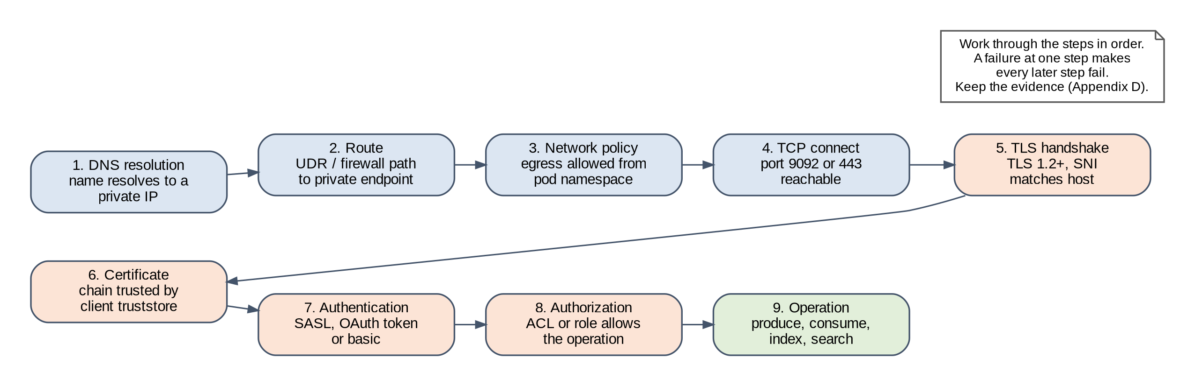
Figure 33. Connectivity chain for Kafka and search
Prepared for this implementation. Not a Pega-published diagram.

17.2 Kafka
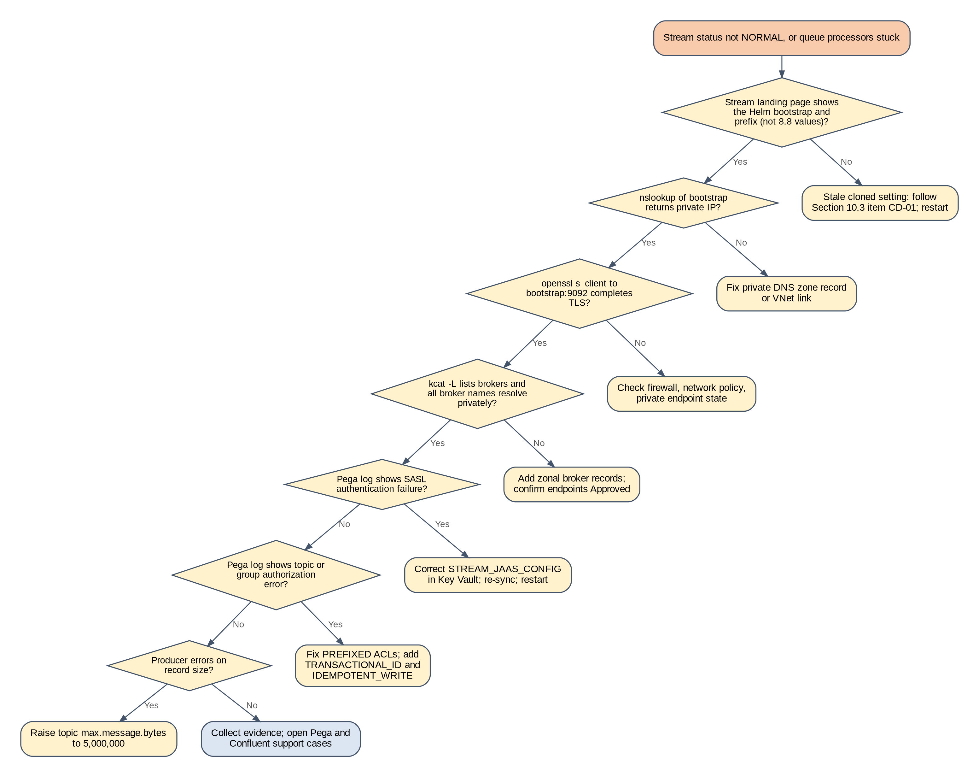
Figure 34. Troubleshooting tree: stream service
Prepared for this implementation. Not a Pega-published diagram.
Table 77. Kafka symptoms
Symptom | Likely cause | Check | Fix
Stream status not NORMAL after start | Stale cloned setting, DNS, network or authentication | Landing page values; K-1 to K-3; Pega log | Follow the tree
Bootstrap works, brokers time out | Zonal DNS records | K-3 | Add records [R32]
Topic or group authorization errors | ACL prefix does not match streamNamePattern | K-4, K-7 | Correct the prefix or ACL
Transactional or idempotent producer errors | Missing TRANSACTIONAL_ID or IDEMPOTENT_WRITE ACL | K-7 | Add the ACL [R11]
RecordTooLargeException | Topic limit | K-6 | Raise to 5,000,000
Ready to process keeps growing | Batch tier down or a failing processor | Admin Studio; batch pod logs (P-2) | Restore batch pods; fix the processor
Throughput drops in one shared environment | Quota reached, or another environment's load | Metrics API by principal | Adjust quota or schedule

17.3 Search
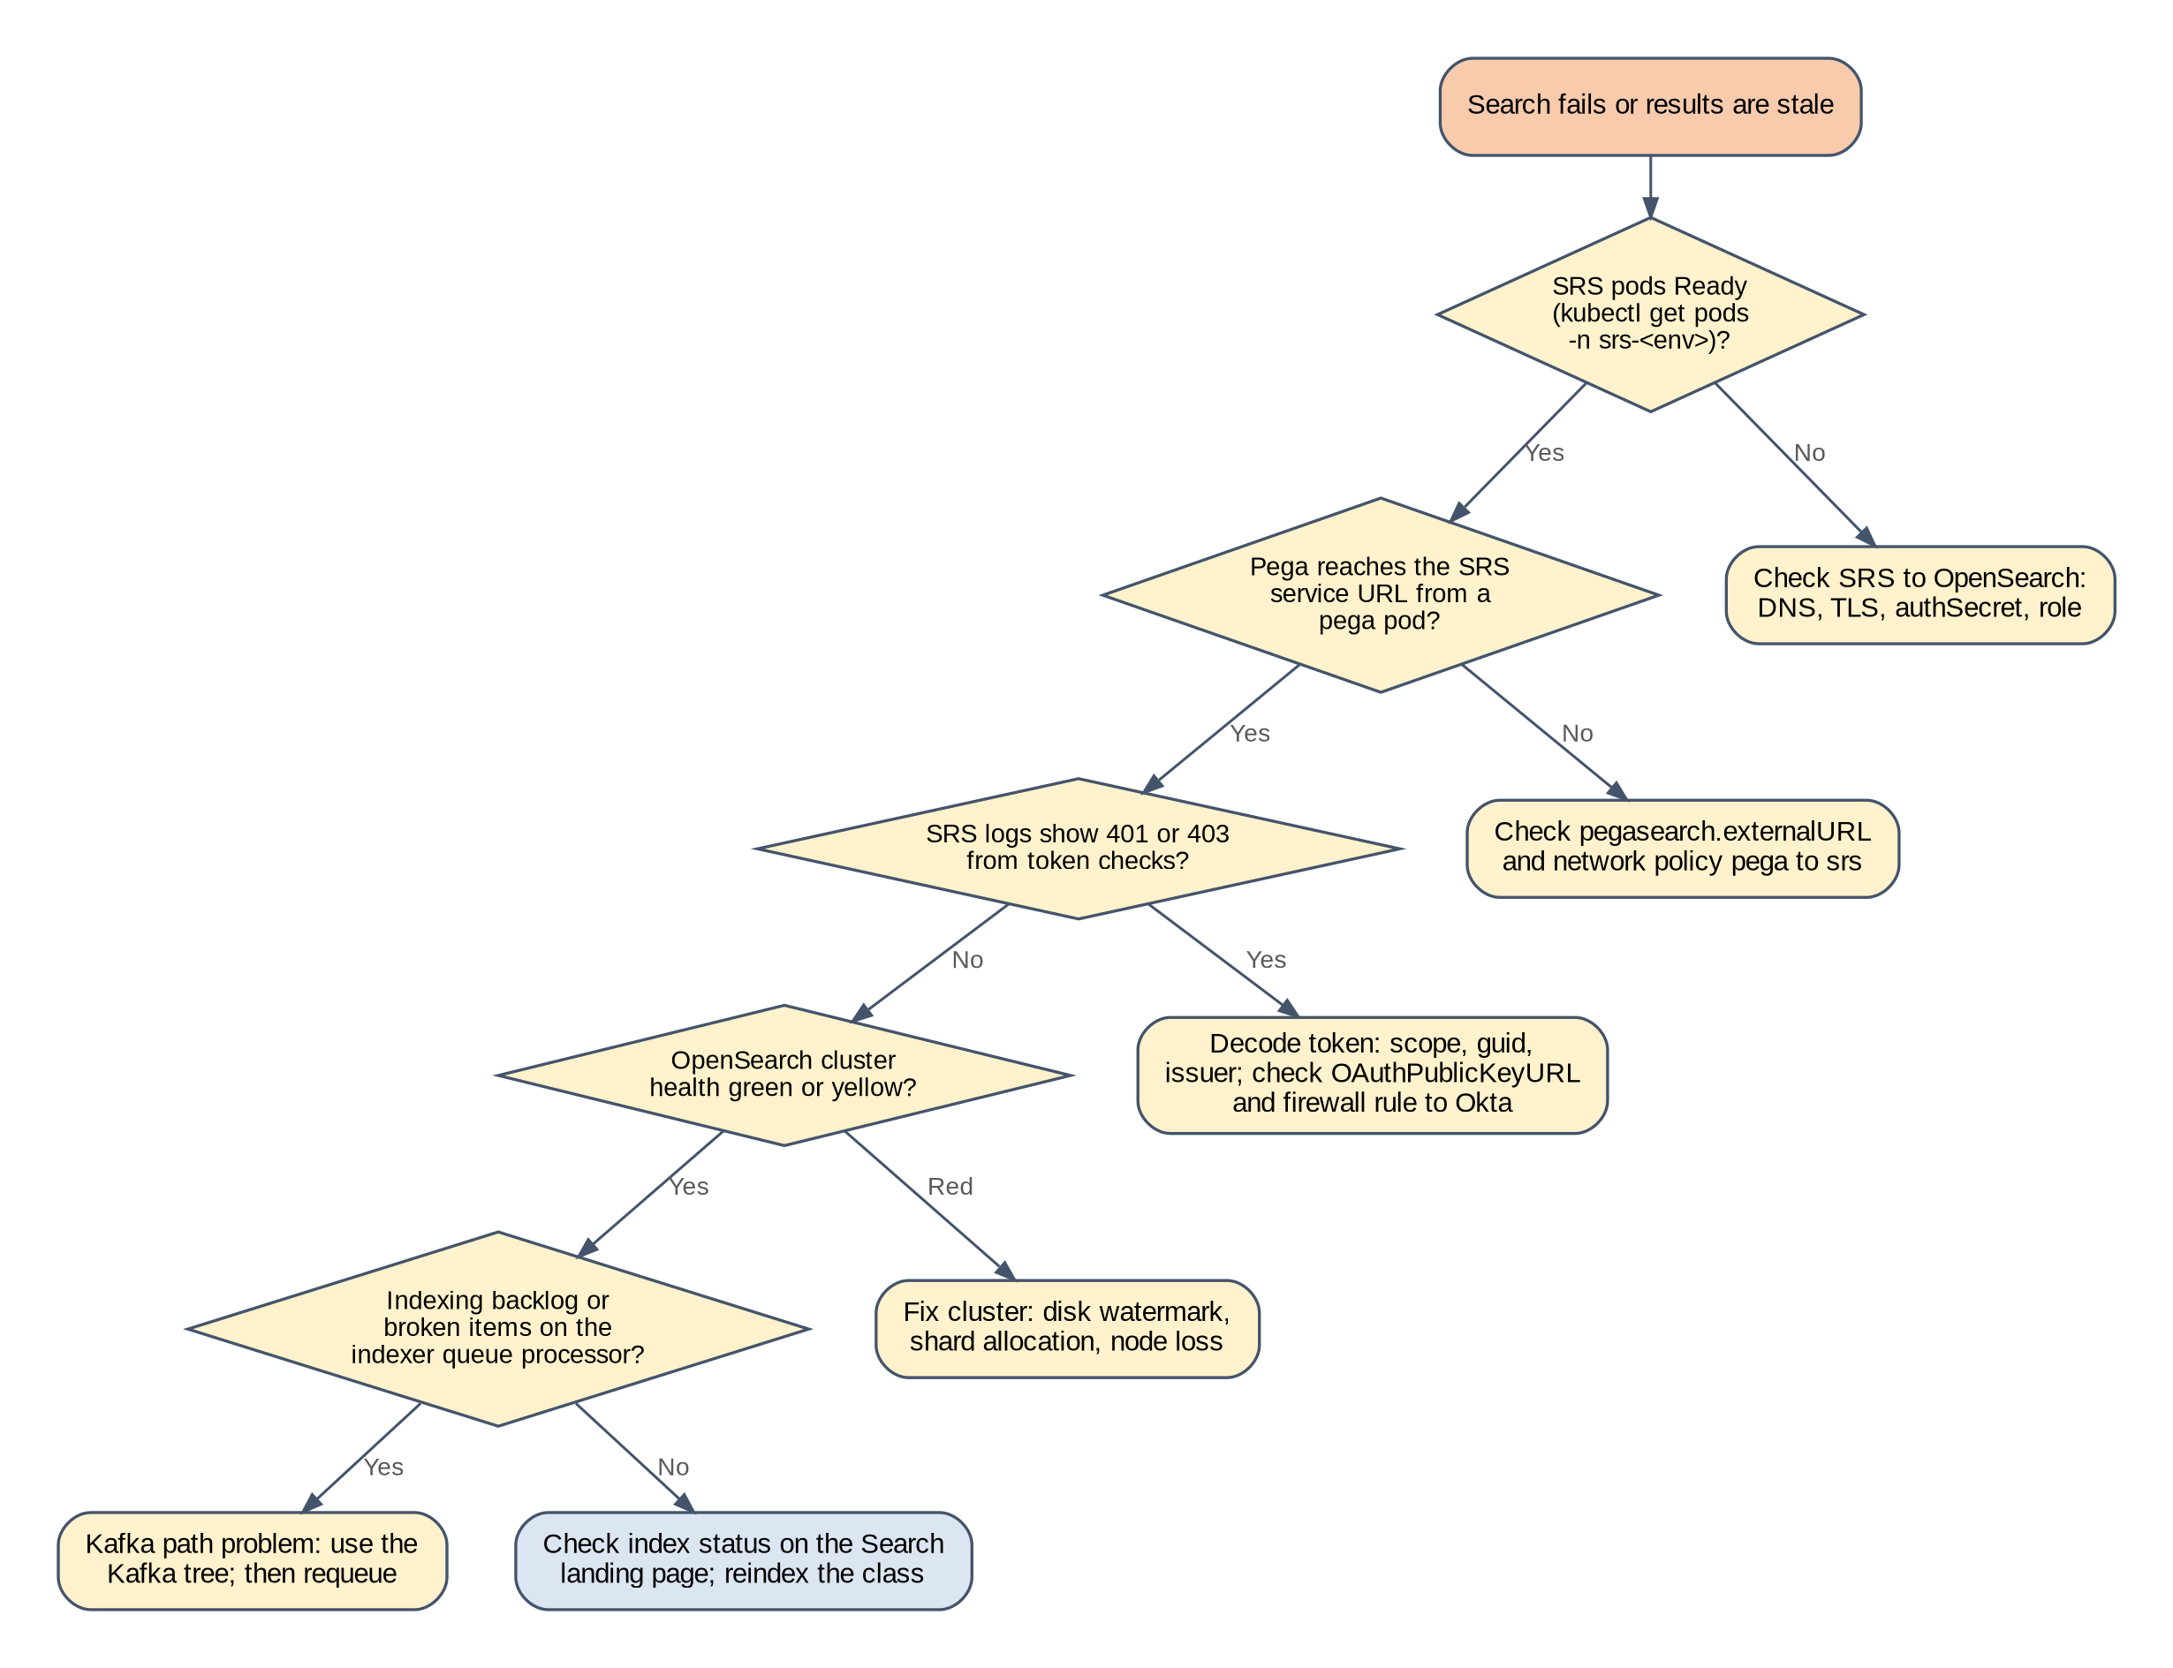
Figure 35. Troubleshooting tree: search
Prepared for this implementation. Not a Pega-published diagram.
Table 78. Search symptoms
Symptom | Likely cause | Check | Fix
SRS pods not Ready | OpenSearch unreachable or wrong credentials | SRS logs; S-1 from an SRS pod | Fix network or authSecret; restart SRS
401 or 403 in SRS log | Token scope, guid or issuer | O-2 | Fix Okta configuration
Token request fails | Firewall to Okta, client key mismatch | O-1; Okta system log | Fix rule or key
Results missing for recent changes | Indexing backlog | Queue processors; Kafka tree | Clear backlog
Class shows CONFLICTS FOUND | Mapping conflict in indexed properties [R19] | Search landing page | Fix the properties; reindex the class
Cluster red or read-only | Node loss or disk watermark | S-2; provider console | Restore capacity

17.4 Cloned database and upgrade
Table 79. Cloned database and upgrade symptoms
Symptom | Likely cause | Fix
Installer job fails | Database connectivity, permissions, schema names, or a missing prerequisite | Read the log (P-5); fix; rerun or restore the clone (FS-26)
primaryKeyUtility reports insufficient space | The utility copies each table missing a primary key | Add database storage; rerun [R10]
ClassNotFoundException for javax classes | Custom JAR not rebuilt for Jakarta EE | Import the rebuilt JAR into a higher CodeSet version [R9]
PEGA0179 alerts | Old queue processor DSS still present (CD-11) | Delete the DSS [R3]

17.5 Support cases
Pega Global Client Support handles externalized services as it handles databases: it determines the cause, then hands over to the third-party provider if the issue is not in Pega software [R22]. Open cases with Pega logs from all tiers, Stream and search landing page screenshots, queue processor status, SRS logs, the Appendix C outputs, the decoded token claims, and the values file with secrets removed.

18 Observability, monitoring and logging
Kafka and search now run outside Pega, on three vendors' services. A fault can start in any of them and show up as a slow screen in Pega. Observability here means collecting enough telemetry from every layer, with the same environment label and the same clock, to find the layer at fault within minutes. Figure 36 shows the design.
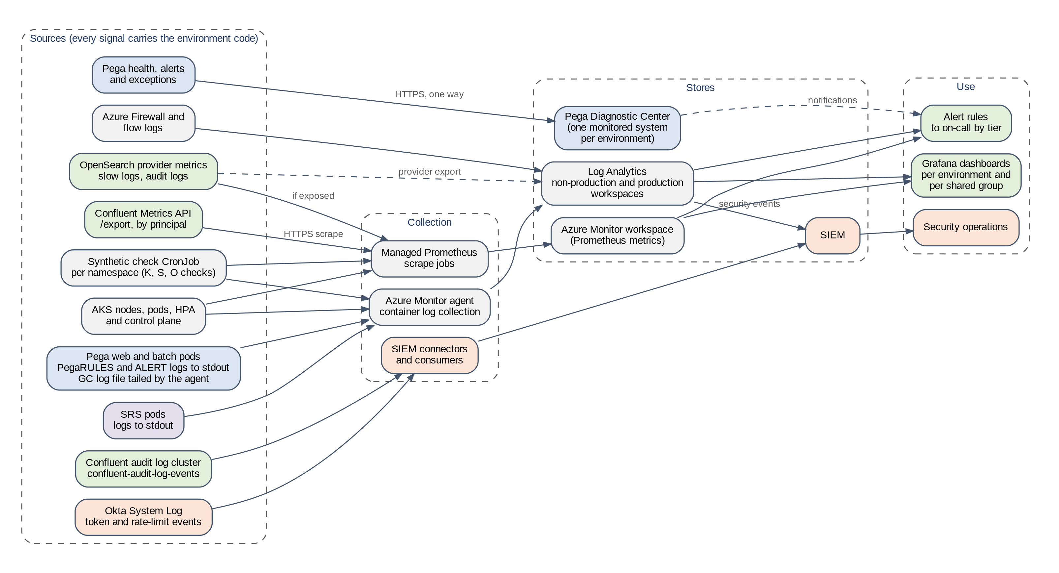
Figure 36. Telemetry sources, collection, stores and use
Prepared for this implementation. Not a Pega-published diagram.

18.1 Telemetry sources
Table 80. Telemetry sources
Source | Telemetry | Collection | Store | Notes
Pega web and batch pods | PegaRULES and ALERT logs on stdout; GC log file | Azure Monitor agent container log collection [R60] | Log Analytics | GC file tailed by the agent [R23]
Pega Platform | Health, alerts, exceptions, guardrail data | Pega Diagnostic Center [R51] | PDC | Section 18.3
AKS | Node, pod, HPA and control-plane metrics | Managed Prometheus [R60] | Azure Monitor workspace | Grafana dashboards
Confluent Cloud | Throughput, requests, connections, lag, throttling, by principal | Metrics API /export endpoint in Prometheus format, scraped every minute [R56] | Azure Monitor workspace | Needs a Cloud API key for a service account with the MetricsViewer role. The Metrics API addresses are not static, so allow it by FQDN
Confluent audit log | Authentication, ACL and management events | Consumer on topic confluent-audit-log-events in the audit log cluster [R57] | SIEM | Kept 7 days by default; export for longer retention
OpenSearch | Cluster health, nodes, disk, latency; slow logs; audit logs | Provider export | Log Analytics | Section 18.2
SRS pods | Application logs on stdout | Azure Monitor agent | Log Analytics | Request errors and latency
Okta | System Log: token issue, failures, rate-limit events | Okta log streaming or System Log API to the SIEM | SIEM | Rate-limit events [R52]
Azure Firewall | Allowed and denied flows | Diagnostic settings | Log Analytics | IT-09, IT-10 evidence
Synthetic checks | DNS, TLS, Kafka metadata, SRS and token checks | CronJob per namespace | Log Analytics and metrics | Section 18.6

18.2 Logging design
- One label everywhere. The namespace carries the environment code (pega-<code>, srs-<code>). Add the code as a label to Confluent and OpenSearch metrics at scrape time, so a dashboard can filter one environment on a shared group.
- Workspaces. Use one Log Analytics workspace for non-production and one for production. Production logs never go to a non-production workspace. Set retention per the customer's policy, for example 30 days interactive in non-production and 90 days in production with archive after that.
- Log levels. Keep Pega and SRS at their default levels in PROD. Raise a level for one logger and one pod for a set time when Pega Support asks, then return it. A custom prlog4j2 file can be supplied through the chart if the default layout does not suit the log platform [R23].
- Sensitive data. Non-production logs come from masked clones only. Never log the JAAS value, tokens or private keys; the pipeline secret scan covers values files, and log queries for password= and Bearer run weekly.
- OpenSearch slow logs. Use the cluster-level search request slow log, available from OpenSearch 2.12, rather than per-index shard slow logs [R58]. It needs no change to index settings, which SRS owns (Section 7.4).
- Confluent audit log. The default 7-day retention is too short for incident review [R57]. Stream it to the SIEM.

18.3 Pega Diagnostic Center
Pega Diagnostic Center (PDC) collects health and alert data from Pega and shows it per system. For a client-managed deployment, the endpoint URL that PDC provides is entered in Pega at Configure > System > Settings. Data goes one way, from Pega to PDC, over HTTPS, and the JVM truststore must trust the PDC certificate chain [R51].
- Register each environment as its own system in PDC, so production and non-production alerts are never mixed.
- A clone carries production's PDC setting (CD-16). Change it during run F, before any alert is sent.
- Allow the PDC endpoint at the hub firewall from the Pega subnets (NW-4).
- Use PDC for Pega-level analysis (alerts such as PEGA0179, exceptions, guardrails) and the Azure stack for platform and service telemetry. Both are needed; neither replaces the other.

18.4 Dashboards
Table 81. Dashboards
Dashboard | Scope | Panels | Users
Environment overview | One per environment | M1 response times; pod health; stream status; queue backlog; search errors; token failures | Operations, test leads
Kafka group | One per cluster (NP1, NP2, PROD) | Throughput, requests, connections, lag and throttling by service account; partitions against limit | Kafka team
Search group | One per OpenSearch service | Health, disk against watermarks, latency, indexing rate, shards per node; SRS errors by environment | Search team
Identity | Okta org | Token requests per client, failures, rate-limit events | Identity team
Capacity | All groups | Units, partitions, shards, disk, node usage against plan; quarterly review | Platform lead
Cutover | PROD during cutover and hypercare | Steps C-1 to C-10 timings; index build progress; backlog; error rates | Cutover manager

18.5 Alerts and thresholds
Thresholds marked as baselines come from the PERF load test. Route PROD P1 alerts to on-call at any hour, NP2 alerts to the test lead during test windows, and NP1 alerts during business hours. An alert on a shared cluster or search service goes to the owner of that service, with the environment label in the message.
Table 82. Alerts, thresholds and responses
Signal | Source | Threshold | Severity | Response
Stream service status | Pega (Stream landing page, alerts) | Not NORMAL | P1 in PROD | Section 17.2
Queue backlog | Pega Admin Studio | Ready to process grows for longer than the agreed period | P2 | Check batch tier and consumer errors
Broken queue items | Pega Admin Studio | Above zero for business-critical processors | P2 | Investigate and requeue
Consumer lag and request errors per principal | Confluent Metrics API [R56] | Lag above baseline; authentication or authorization errors | P2 | Section 17.2
Client throttling | Metrics API client_limit_milliseconds by principal [R56] | Above zero for 5 minutes | P2 | Find the limit hit (Table 18)
Connections per cluster | Confluent Metrics API [R56] | Above 70 % of the cluster's connection limit | P3 | Capacity review
Partition count per cluster | Confluent Metrics API | Above 70 % of the cluster limit | P3 | Capacity review (Section 6.7)
Throughput per service account | Confluent Metrics API [R36] | At quota for longer than 15 minutes | P3 | Review quota or schedule
SRS errors, latency and restarts | SRS logs; pod metrics | Above baseline; any restart loop | P2 | Section 17.3
OpenSearch health | Provider metrics | Yellow for longer than 30 minutes; red at once | P2 / P1 | Section 17.3
OpenSearch disk | Provider metrics | Above the low watermark less 10 points | P2 | Add storage
Okta token failures | Pega log; Okta System Log | Any repeated failure | P2 | Section 17.3
Okta rate limit | Okta System Log warning and violation events [R52] | Any warning; any violation | P2 / P1 | Find the caller; Section 7.6
Pod health | Managed Prometheus | OOMKilled, restart loop, HPA at maximum for 15 minutes | P2 | Section 9.2
Zone spread | Managed Prometheus | More than half of a tier's pods in one zone | P3 | Section 4.6
Long GC pauses | GC log | Pauses above 2 seconds, or GC time above 10 % of an interval | P3 | Heap review
External secret sync | External Secrets Operator status | Any ExternalSecret not SecretSynced | P2 | Section 8
Certificate expiry | Synthetic checks | Less than 30 days | P3 | Renew (Section 8.4)
Private DNS resolution | Synthetic checks | A public IP or no answer | P2 | Section 4.4

18.6 Synthetic checks
A CronJob in each pega-<code> namespace runs a subset of the Appendix C checks and publishes each result as a metric, so a broken path is found before users find it.
Table 83. Synthetic checks
Check | Commands | Interval | Alert when
Confluent DNS and TLS | K-1, K-2 | 5 minutes | A public IP, no answer, or a TLS failure
Kafka metadata | K-3 with the environment's own key | 5 minutes | Any broker missing or unreachable
SRS | S-5 health call | 5 minutes | Unhealthy or no answer
Okta token | O-1 | 15 minutes, to limit token requests | Token not issued
Certificate expiry | Read the chains from K-2 and S-5 | Daily | Less than 30 days

18.7 Following an incident across services
Each system names the same environment differently. Table 84 lists the identifiers to search for, so an engineer can follow one incident from a Pega log line to the Confluent, OpenSearch and Okta records.
Table 84. Identifiers used to correlate one environment across systems
System | Identifier for the environment | Identifier for the request or client
Pega | Namespace pega-<code>; node ID in the log | Thread and requestor in PegaRULES log
Confluent | Service account sa-pega-<code> (principal_id in metrics and audit log) | Topic and consumer group under pega-<code>-
SRS | Namespace srs-<code> | Index prefix pega26-<code>
OpenSearch | User pega26-<code>-srs | Index name in slow and audit logs
Okta | Client pega-srs-<code> | Client ID in System Log events
Azure | Subnet and pod IP | Firewall flow log

1. Start from the time and environment of the first symptom. All sources use UTC.
2. Check the environment overview dashboard to find the first layer that changed: M2 to M6 in that order.
3. Search that layer's logs with the identifiers above for the five minutes before the symptom.
4. If the layer is a shared service, check the group dashboard for other environments affected at the same time. One environment affected points to its own configuration or load; all environments point to the service.
5. Record the timeline in the incident, with links to the queries used.

19 Operations, onboarding, refresh and retirement
Monitoring, logging and alerting are in Section 18. This section covers the routine work that keeps the services healthy and the procedures for adding, refreshing and removing an environment.

19.1 Routine tasks
Table 85. Routine operations
Task | Frequency | Owner | Procedure
Confluent API key rotation | Per security policy | Kafka engineer | Section 8.3
OpenSearch SRS user password rotation | Quarterly | Search engineer | Section 8.3
Okta client key rotation | Yearly or per policy | Identity team | Section 8.3
Certificate renewal | Before expiry | Platform team | Section 8.4
Partition and shard capacity review | Monthly and after each release | Kafka and search engineers | K-5, S-4
Check new topics for max.message.bytes | After each deployment | Kafka engineer | K-4, K-6
SRS image update | With Pega updates or security fixes | Search engineer | Update srsImage per environment, NP1 first
OpenSearch version update | Per provider notice, within the SRS matrix | Search engineer | NP1, then NP2, then PROD; rebuild if advised
Cost review | Quarterly | Platform lead | Cost model in Section 5.5 with actual usage

19.2 Onboarding a new non-production environment
1. Approve the environment and its group with the decision in Section 5.1. Assign a code that is not the start of another code.
2. Add a row to Table 8 and to Appendix A.
3. Create the namespace, Key Vault, External Secrets identity and network policies (SI-1, SI-2, NW-5).
4. Create the Okta client and, for option 2, add the client to the guid expression (Section 7.6).
5. Create the service account, ACLs, quota and API key on the group's cluster (CC-2 to CC-4).
6. Create the OpenSearch user and index-scoped role (OS-3, OS-4).
7. Deploy SRS (SR-1 to SR-3).
8. Clone, mask and upgrade the database (DB-1 to DB-5), then follow the first-start control (Section 10.4).
9. Run the isolation tests against every other environment in the group.
10. Add the environment to monitoring and the cost review.

19.3 Refreshing an environment from a new clone
1. Agree the refresh window with the environment's users and the other environments in the group.
2. Scale the environment's Pega tiers to zero.
3. Delete its topics and consumer groups under pega-<code>- (K-9), and its indexes pega26-<code>* (S-6). Keep the prefix, customerDeploymentId, ACLs, quota, Okta client and SRS user.
4. Take, mask and upgrade the new clone (DB-1 to DB-5).
5. Follow the first-start control (Section 10.4), including repointing application Kafka data sets and other endpoints.
6. Run the full index build and the functional checks.
7. Record the refresh in the environment log with the evidence.

19.4 Retiring an environment
1. Scale the Pega tiers and SRS to zero; uninstall the Helm releases.
2. Delete the topics and consumer groups under the prefix (K-9).
3. Delete the ACLs, API keys and service account (Section 6.5).
4. Delete the indexes pega26-<code>* (S-6), then the OpenSearch user and role.
5. Delete the Okta client and remove it from the guid expression.
6. Delete the Key Vault secrets, External Secrets objects and the namespace; purge the vault per retention policy.
7. Remove firewall rules and DNS records specific to the environment.
8. Record evidence of each deletion in the retirement record (Appendix D).

19.5 Roles and responsibilities
R = responsible, A = accountable, C = consulted, I = informed.
Table 86. RACI (Okta objects are owned by the customer identity team: A/R)
Activity | Platform team | DBA team | Kafka team | Search team | Pega team | Pega Support | Confluent | OpenSearch provider
Network, DNS, firewall | A/R | I | C | C | I | I | C | C
Confluent clusters, ACLs, quotas | C | I | A/R | I | C | I | C | I
OpenSearch services, roles | C | I | I | A/R | C | I | I | R
SRS deployment | R | I | I | A/R | C | C | I | I
Okta authorization servers and clients | C | I | I | C | C | I | I | I
Clone, masking, upgrade | R | A/R | I | I | C | C | I | I
Cloned item clean-up | C | R | C | C | A/R | C | I | I
Testing and rehearsals | R | R | R | R | A/R | I | C | C
Cutover and rollback | R | R | R | R | A/R | C | I | I
Operations after handover | A/R | R | R | R | R | C | C | C

20 Risks, open decisions, assumptions and source reconciliation

20.1 Risk register
Table 87. Risk register (L likelihood, I impact: H high, M medium, L low)
ID | Risk | L | I | Mitigation | Owner
RK-01 | Pega Support does not confirm the direct 8.8 to 26.1.1 clone-and-upgrade path, or sets conditions late | M | H | Raise the case before M2 (OD-01); conservative plan; two rehearsals | Pega LSA
RK-02 | A stale 8.8 DSS overrides the Helm stream or search configuration | M | H | FS-24 in DEV; GQ-05 | Pega LSA
RK-03 | A non-production clone touches production Kafka topics or systems | M | H | Batch tier at zero in run F; repointing; firewall deny; IT-09, IT-10 | Platform team
RK-04 | Index build longer than the outage window | M | H | Measure in PERF and PREPROD; scale for the build | Search team
RK-05 | Okta licence lacks custom authorization servers, or the client-based claim does not work for client credentials | M | H | Check licence before M2; DEV test; fall back to option 1 | Identity team
RK-06 | SRS needs cluster permissions beyond the index-scoped role | M | M | IT-06 in DEV; widen only by named permissions | Search team
RK-07 | TRANSACTIONAL_ID * ACL is shared by all environments on a cluster | L | M | Accepted residual risk; separate clusters for PROD | Kafka team
RK-08 | Noisy neighbour in a shared group | M | M | Quotas; schedule; per-principal metrics | Kafka team
RK-09 | No OpenSearch provider passes the selection | L | H | Self-managed fallback on AKS | Enterprise architect
RK-10 | Delayed or broken items fail after the upgrade | M | M | Drain fully; resolve broken items; FS-28; GQ-06 | Pega LSA
RK-11 | Masking breaks search or integration keys | M | M | Masking rules agreed with the application team; search tests on masked data | DBA team
RK-12 | Vendor documentation changes between rehearsal and cutover | M | M | Recheck Section 3 before each rehearsal | Enterprise architect
RK-13 | Confluent connection and request limits throttle Pega during restarts or peaks | M | M | Measure connections and requests per pod; stagger restarts; throttle alert; FS-31 | Kafka team
RK-14 | One Okta org rate limit shared by all environments and other applications | M | H | Token rate measured; System Log alerts; token lifetime; FS-35 | Identity team
RK-15 | The installer needs Kafka during the upgrade and the chart does not supply it | L | H | GQ-08; installer egress to Confluent allowed in DEV | Pega LSA
RK-16 | Load test unrepresentative, so PROD is undersized | M | H | Workload model from production logs; exit criteria in Section 15.5 | Performance lead

20.2 Open decisions
Each open decision has a recommended answer, an owner and the milestone by which it is needed (Section 13.2). If a decision is not taken by its milestone, the recommended answer applies and the risk is recorded.
Table 88. Open decisions
ID | Decision | Options | Recommended answer | Owner | Needed by
OD-01 | Pega Support answers (GQ-01 to GQ-08) | Answers received; conservative plan | Raise now; plan conservatively until answered | Pega LSA | M2
OD-02 | Confluent cluster types | Enterprise; Dedicated | Enterprise for NP1; PROD type for NP2 and PROD after PERF measurement | Kafka team | M2 (NP1), M3 (NP2, PROD)
OD-03 | OpenSearch provider | Third-party managed on Azure; self-managed on AKS | Provider that passes Section 7.3 | Enterprise architect | M2
OD-04 | SRS per environment or shared | Per environment; per group | Per environment | Search team | M2
OD-05 | Okta design | Server per environment; shared non-production server | PROD dedicated; shared non-production with client-based claim if proven | Identity team | M2
OD-06 | Environment grouping | Options A to D (Section 5.1) | Option B | Enterprise architect | M1
OD-07 | Masking approach | Before upgrade; after upgrade before run D | Before upgrade | DBA team | M2
OD-08 | Treatment of each application Kafka data set | Keep; new cluster; Cluster Linking | Per data set (Table 45) | Application owner | M4
OD-09 | Quota approach | Quotas per service account; no quotas | Quotas in NP1 and NP2 from measured peaks | Kafka team | M3
OD-10 | Kafka authentication | SASL/PLAIN; SASL/OAUTHBEARER | SASL/PLAIN | Security architect | M2
OD-11 | Topic creation | Pega creates (CREATE ACL); pre-created topics | Pega creates | Security architect | M2
OD-12 | Outage and rollback windows | From rehearsal | Rehearsal time plus 25 % | Business owner | M5
OD-13 | OpenSearch snapshots | None; provider snapshots | Provider snapshots for PROD and NP2; none for NP1 | Search team | M3

20.3 Assumptions
Table 89. Assumptions
ID | Assumption | Check that would prove it wrong
AS-01 | The customer's Okta tenant includes API Access Management | Okta admin console shows no custom authorization servers
AS-02 | Confluent Cloud offers Enterprise and Dedicated with Private Link in the AKS region | Confluent console region list
AS-03 | The application does not need Cassandra (no Customer Decision Hub or Process AI) | Application stack review
AS-04 | The database engine and version of the clone are on the 26.1.1 Platform Support Guide [R1] | DBA check against [R1]
AS-05 | 8.8 queues can be drained within the planned window | Rehearsal drain time
AS-06 | Non-production environments have their own AKS namespaces and network policies | Platform design review
AS-07 | The firewall supports FQDN rules for <okta-domain> | Firewall policy test
AS-08 | The AKS clusters were created with a network policy engine, so NetworkPolicy objects are enforced | A test pod reaches a target that a policy denies
AS-09 | The Azure region offers three availability zones for the node sizes chosen | Node pool creation with zones 1, 2 and 3 fails
AS-10 | Production request logs or Pega PDC data are available to build the workload model | No usable 8.8 usage data

20.4 Source reconciliation
These are the places where sources disagree or leave a gap, with the action taken.
Table 90. Source reconciliation register
ID | Topic | What the sources say | Action
RC-01 | SRS version | The '26 page lists SRS 1.44.3 or later and OpenSearch best practice 2.15 [R14]; the chart README lists a newer SRS and OpenSearch 2.19 [R24] | Choose OpenSearch 2.15 or 2.19; use the SRS tag the README lists for chart 4.13.0
RC-02 | Kafka SASL mechanisms | Pega lists JAAS, OAUTHBEARER, PLAIN and SCRAM [R11]; the chart's saslMechanism lists PLAIN and SCRAM [R23] | Use PLAIN (OD-10)
RC-03 | Broker settings on Confluent Cloud | Pega lists replica.fetch.* and unclean.leader.election.enable [R11]; not editable on Confluent Cloud [R34] | Written confirmation from Confluent; topic max.message.bytes set
RC-04 | Kafka version | The chart's Kafka requirements page names an older Kafka [R26]; the '26 page names client 4.0.0 [R3] | Follow the '26 page
RC-05 | Default customerDeploymentId | Pega page: generated automatically by the chart [R14]; README: defaults to the namespace name [R23] | Always set it explicitly
RC-06 | Hazelcast removal for a cloned database | Removal required before updating to '25 [R5]; steps assume a running system [R6] | GQ-03 to Pega Support
RC-07 | DSS and Helm precedence | Not settled by the pages read | FS-24; GQ-05
RC-08 | SRS checks on issuer and audience | Pega documents the signature and guid checks only [R23] | FS-12 in DEV
RC-09 | Okta app attributes in client credentials tokens | Expression language lists app attributes [R46]; client credentials page does not mention them [R43] | DEV test before choosing option 2
RC-10 | SRS replicas in test environments | Pega sizing: 1 SRS for testing and development [R14]; SRS chart README: minimum 2, best practice 3 [R24] | 2 in DEV, SIT and UAT; 3 elsewhere
RC-11 | SRS pod resources | Pega sizing: 2 CPU, 2 GB [R14]; chart defaults: 0.65 to 1.3 CPU, 4Gi [R24] | Request 1 CPU, limit 2 CPU, 4Gi; adjust from PERF
RC-12 | Topology spread for Pega tiers | Read by the chart 4.13.0 template [R61]; not in the README [R23] | Use it; check in helm template output after each chart upgrade
RC-13 | OpenSearch storage and shard sizing | Pega gives node sizes only [R14]; general OpenSearch guidance gives formulas [R54, R55] | Use the formulas with measured index sizes (Section 7.4)

Appendix A. Configuration inventory
This appendix holds every environment-specific value. The names in the first table follow the convention in Section 2.6 and are fixed once the environment is built. The values in the later tables are recorded during the build and kept under change control. Secrets are never recorded here; only the Key Vault secret names are.

A.1 Names per environment
Table 91. Names and sizes per environment
Item | DEV | SIT | UAT | PERF | PREPROD | PROD
Code | dev | sit | uat | perf | ppd | prd
Service group | NP1 | NP1 | NP1 | NP2 | NP2 | PRD
Pega namespace | pega-dev | pega-sit | pega-uat | pega-perf | pega-ppd | pega-prd
SRS namespace and release | srs-dev | srs-sit | srs-uat | srs-perf | srs-ppd | srs-prd
Key Vault | kv-pega-dev | kv-pega-sit | kv-pega-uat | kv-pega-perf | kv-pega-ppd | kv-pega-prd
Confluent cluster | cc-np1 | cc-np1 | cc-np1 | cc-np2 | cc-np2 | cc-prd
Service account | sa-pega-dev | sa-pega-sit | sa-pega-uat | sa-pega-perf | sa-pega-ppd | sa-pega-prd
Topic and group prefix | pega-dev- | pega-sit- | pega-uat- | pega-perf- | pega-ppd- | pega-prd-
customerDeploymentId and index prefix | pega26-dev | pega26-sit | pega26-uat | pega26-perf | pega26-ppd | pega26-prd
OpenSearch service | os-np1 | os-np1 | os-np1 | os-np2 | os-np2 | os-prd
OpenSearch user | srs-dev | srs-sit | srs-uat | srs-perf | srs-ppd | srs-prd
OpenSearch role | pega26-dev-srs | pega26-sit-srs | pega26-uat-srs | pega26-perf-srs | pega26-ppd-srs | pega26-prd-srs
Okta client | pega-srs-dev | pega-srs-sit | pega-srs-uat | pega-srs-perf | pega-srs-ppd | pega-srs-prd
Web replicas (min to max) | 1 to 2 | 1 to 3 | 2 to 3 | 3 to 6 | 3 to 6 | 3 to 6
Batch replicas (min to max) | 1 to 2 | 1 to 3 | 1 to 3 | 3 to 6 | 3 to 6 | 3 to 6
SRS replicas | 2 | 2 | 2 | 3 | 3 | 3

The replica counts are starting values. PERF measurements (M3) set the PROD and PREPROD values.

A.2 Values recorded per service group
Table 92. Values recorded per service group
Value | Where used | NP1 | NP2 | PRD
Confluent environment and cluster ID (lkc-...) | Commands; Confluent console
Cluster type and capacity | OD-02; Section 6.3
Bootstrap host (<bootstrap-host>) | stream.bootstrapServer
Confluent network ID and private endpoint | Section 6.4
Private DNS zone for Confluent | Section 4.4
Partition limit and measured count | Section 6.7
OpenSearch provider and version | OD-03; Section 7.2
OpenSearch endpoint (<search-host>) and port | srs.srsStorage.domain, port
OpenSearch data nodes, storage and shards | Section 7.4
Disk watermarks (low, high, flood stage) | Section 7.4; Section 18.5
Okta authorization server ID (<auth-server-id>) | Token URL
Token endpoint and JWKS URL (<okta-jwks-url>) | pegasearch.srsAuth.url; OAuthPublicKeyURL
Access token lifetime | Okta access policy rule

A.3 Values recorded per environment
Table 93. Values recorded per environment (one copy per environment)
Value | Where used | Recorded value and date
Confluent API key ID (not the secret) | confluent-jaas in Key Vault
Client quota (produce and consume) | Section 5.4
Okta client ID (<okta-client-id>) | pegasearch.srsAuth.clientId
Okta client key ID (kid) and expiry | Section 8.3
JDBC URL, driver class and database type | global.jdbc
Rules and data schema names | global.jdbc.rulesSchema, dataSchema
Pega host name (<pega-host>) | Web tier ingress
Application Gateway request timeout | Ingress annotation
Pega, installer and SRS image digests | Pipeline record
Helm chart version | Pipeline | 4.13.0
SRS image tag (<tag>) | srs.srsRuntime.srsImage
Index shard and replica counts after the first build | Section 7.4
Full index build time and document counts | Section 7.8
Cloned DSS for stream and search (CD-01, CD-03) | Section 10.3

Appendix B. Complete Helm values files
These files are generated from the same source as the tables in Section 9, for chart version 4.13.0 [R23, R24]. SIT stands for the NP1 environments and PROD for PROD; the other environments differ only in the code, the names in Table 91 and the replica counts. Values in angle brackets come from Appendix A. No secret is written in these files: each external_secret_name and authSecret names a Kubernetes secret created by the External Secrets Operator (Section 8.2). Render every file with helm template and review the output before use. Every file below was rendered with helm template against charts 4.13.0 without errors before this version was issued.

B.1 SIT: pega chart, upgrade run
pega-sit-upgrade.yaml. Upgrade run: installer job only, no Pega pods.
global:
provider: "aks"
deployment:
name: "pega"
actions:
execute: "upgrade"
customerDeploymentId: "pega26-sit"
jdbc:
url: "<jdbc-url>"
driverClass: "<jdbc-driver-class>"
dbType: "<db-type>"
driverUri: "<driver-uri>"
external_secret_name: "pega-db-secret"
rulesSchema: "<rules-schema>"
dataSchema: "<data-schema>"
docker:
registry:
url: "<acr-name>.azurecr.io"
imagePullSecretNames: []
pega:
image: "<acr-name>.azurecr.io/platform/pega:26.1.1"
tier:
- name: "web"
nodeType: "WebUser"
replicas: 1
service:
port: 80
targetPort: 8080
tls:
enabled: true
external_secret_names: ["pega-tier-tls"]
port: 443
targetPort: 8443
ingress:
enabled: true
domain: "<pega-host>"
annotations:
appgw.ingress.kubernetes.io/request-timeout: "<seconds>"
tls:
enabled: true
resources:
requests:
memory: "12Gi"
cpu: 3
limits:
memory: "12Gi"
cpu: 4
javaOpts: >-
-Xlog:gc*,gc+heap=debug,gc+humongous=debug:file=/usr/local/tomcat/logs/gc.log:uptime,pid,level,time,tags:filecount=3,filesize=2M
-XX:MaxMetaspaceSize=768m
-XX:+UseStringDeduplication
-XX:+HeapDumpOnOutOfMemoryError
hpa:
enabled: true
minReplicas: 1
maxReplicas: 3
pdb:
enabled: true
minAvailable: 1
topologySpreadConstraints:
- maxSkew: 1
topologyKey: topology.kubernetes.io/zone
whenUnsatisfiable: ScheduleAnyway
labelSelector:
matchLabels:
app: pega-web
- name: "batch"
nodeType: "BackgroundProcessing,Search,Batch,RealTime,\
Custom1,Custom2,Custom3,Custom4,Custom5,BIX"
replicas: 1
hpa:
enabled: true
minReplicas: 1
maxReplicas: 3
resources:
requests:
memory: "12Gi"
cpu: 3
limits:
memory: "12Gi"
cpu: 4
javaOpts: >-
-Xlog:gc*,gc+heap=debug,gc+humongous=debug:file=/usr/local/tomcat/logs/gc.log:uptime,pid,level,time,tags:filecount=3,filesize=2M
-XX:MaxMetaspaceSize=768m
-XX:+UseStringDeduplication
-XX:+HeapDumpOnOutOfMemoryError
pdb:
enabled: true
minAvailable: 1
topologySpreadConstraints:
- maxSkew: 1
topologyKey: topology.kubernetes.io/zone
whenUnsatisfiable: ScheduleAnyway
labelSelector:
matchLabels:
app: pega-batch
cassandra:
enabled: false
hazelcast:
enabled: false
clusteringServiceEnabled: false
stream:
enabled: true
bootstrapServer: "<bootstrap-host>:9092"
securityProtocol: SASL_SSL
saslMechanism: PLAIN
trustStore: ""
keyStore: ""
jaasConfig: ""
streamNamePattern: "pega-sit-{stream.name}"
replicationFactor: "3"
external_secret_name: "pega-stream-secret"
pegasearch:
externalSearchService: true
externalURL: "https://srs-sit.srs-sit.svc.cluster.local:8443"
srsAuth:
enabled: true
url: "https://<okta-domain>/oauth2/<auth-server-id>/v1/token"
clientId: "<okta-client-id>"
scopes: "pega.search:full"
authType: "private_key_jwt"
privateKeyAlgorithm: "RS256"
external_secret_name: "pega-srs-oauth"
srsMTLS:
enabled: false
installer:
image: "<acr-name>.azurecr.io/platform/installer:26.1.1"
upgrade:
upgradeType: "in-place"
targetRulesSchema: ""
targetDataSchema: ""

B.2 SIT: pega chart, first-start run
pega-sit-first.yaml. First-start run: web tier only, batch tier held at zero.
global:
provider: "aks"
deployment:
name: "pega"
actions:
execute: "deploy"
customerDeploymentId: "pega26-sit"
jdbc:
url: "<jdbc-url>"
driverClass: "<jdbc-driver-class>"
dbType: "<db-type>"
driverUri: "<driver-uri>"
external_secret_name: "pega-db-secret"
rulesSchema: "<rules-schema>"
dataSchema: "<data-schema>"
docker:
registry:
url: "<acr-name>.azurecr.io"
imagePullSecretNames: []
pega:
image: "<acr-name>.azurecr.io/platform/pega:26.1.1"
tier:
- name: "web"
nodeType: "WebUser"
replicas: 1
service:
port: 80
targetPort: 8080
tls:
enabled: true
external_secret_names: ["pega-tier-tls"]
port: 443
targetPort: 8443
ingress:
enabled: true
domain: "<pega-host>"
annotations:
appgw.ingress.kubernetes.io/request-timeout: "<seconds>"
tls:
enabled: true
resources:
requests:
memory: "12Gi"
cpu: 3
limits:
memory: "12Gi"
cpu: 4
javaOpts: >-
-Xlog:gc*,gc+heap=debug,gc+humongous=debug:file=/usr/local/tomcat/logs/gc.log:uptime,pid,level,time,tags:filecount=3,filesize=2M
-XX:MaxMetaspaceSize=768m
-XX:+UseStringDeduplication
-XX:+HeapDumpOnOutOfMemoryError
hpa:
enabled: true
minReplicas: 1
maxReplicas: 3
pdb:
enabled: true
minAvailable: 1
topologySpreadConstraints:
- maxSkew: 1
topologyKey: topology.kubernetes.io/zone
whenUnsatisfiable: ScheduleAnyway
labelSelector:
matchLabels:
app: pega-web
- name: "batch"
nodeType: "BackgroundProcessing,Search,Batch,RealTime,\
Custom1,Custom2,Custom3,Custom4,Custom5,BIX"
replicas: 0
hpa:
enabled: false
resources:
requests:
memory: "12Gi"
cpu: 3
limits:
memory: "12Gi"
cpu: 4
javaOpts: >-
-Xlog:gc*,gc+heap=debug,gc+humongous=debug:file=/usr/local/tomcat/logs/gc.log:uptime,pid,level,time,tags:filecount=3,filesize=2M
-XX:MaxMetaspaceSize=768m
-XX:+UseStringDeduplication
-XX:+HeapDumpOnOutOfMemoryError
pdb:
enabled: true
minAvailable: 1
topologySpreadConstraints:
- maxSkew: 1
topologyKey: topology.kubernetes.io/zone
whenUnsatisfiable: ScheduleAnyway
labelSelector:
matchLabels:
app: pega-batch
cassandra:
enabled: false
hazelcast:
enabled: false
clusteringServiceEnabled: false
stream:
enabled: true
bootstrapServer: "<bootstrap-host>:9092"
securityProtocol: SASL_SSL
saslMechanism: PLAIN
trustStore: ""
keyStore: ""
jaasConfig: ""
streamNamePattern: "pega-sit-{stream.name}"
replicationFactor: "3"
external_secret_name: "pega-stream-secret"
pegasearch:
externalSearchService: true
externalURL: "https://srs-sit.srs-sit.svc.cluster.local:8443"
srsAuth:
enabled: true
url: "https://<okta-domain>/oauth2/<auth-server-id>/v1/token"
clientId: "<okta-client-id>"
scopes: "pega.search:full"
authType: "private_key_jwt"
privateKeyAlgorithm: "RS256"
external_secret_name: "pega-srs-oauth"
srsMTLS:
enabled: false
installer:
image: "<acr-name>.azurecr.io/platform/installer:26.1.1"
upgrade:
upgradeType: "in-place"
targetRulesSchema: ""
targetDataSchema: ""

B.3 SIT: pega chart, steady-state deploy run
pega-sit-deploy.yaml. Steady-state deploy run.
global:
provider: "aks"
deployment:
name: "pega"
actions:
execute: "deploy"
customerDeploymentId: "pega26-sit"
jdbc:
url: "<jdbc-url>"
driverClass: "<jdbc-driver-class>"
dbType: "<db-type>"
driverUri: "<driver-uri>"
external_secret_name: "pega-db-secret"
rulesSchema: "<rules-schema>"
dataSchema: "<data-schema>"
docker:
registry:
url: "<acr-name>.azurecr.io"
imagePullSecretNames: []
pega:
image: "<acr-name>.azurecr.io/platform/pega:26.1.1"
tier:
- name: "web"
nodeType: "WebUser"
replicas: 1
service:
port: 80
targetPort: 8080
tls:
enabled: true
external_secret_names: ["pega-tier-tls"]
port: 443
targetPort: 8443
ingress:
enabled: true
domain: "<pega-host>"
annotations:
appgw.ingress.kubernetes.io/request-timeout: "<seconds>"
tls:
enabled: true
resources:
requests:
memory: "12Gi"
cpu: 3
limits:
memory: "12Gi"
cpu: 4
javaOpts: >-
-Xlog:gc*,gc+heap=debug,gc+humongous=debug:file=/usr/local/tomcat/logs/gc.log:uptime,pid,level,time,tags:filecount=3,filesize=2M
-XX:MaxMetaspaceSize=768m
-XX:+UseStringDeduplication
-XX:+HeapDumpOnOutOfMemoryError
hpa:
enabled: true
minReplicas: 1
maxReplicas: 3
pdb:
enabled: true
minAvailable: 1
topologySpreadConstraints:
- maxSkew: 1
topologyKey: topology.kubernetes.io/zone
whenUnsatisfiable: ScheduleAnyway
labelSelector:
matchLabels:
app: pega-web
- name: "batch"
nodeType: "BackgroundProcessing,Search,Batch,RealTime,\
Custom1,Custom2,Custom3,Custom4,Custom5,BIX"
replicas: 1
hpa:
enabled: true
minReplicas: 1
maxReplicas: 3
resources:
requests:
memory: "12Gi"
cpu: 3
limits:
memory: "12Gi"
cpu: 4
javaOpts: >-
-Xlog:gc*,gc+heap=debug,gc+humongous=debug:file=/usr/local/tomcat/logs/gc.log:uptime,pid,level,time,tags:filecount=3,filesize=2M
-XX:MaxMetaspaceSize=768m
-XX:+UseStringDeduplication
-XX:+HeapDumpOnOutOfMemoryError
pdb:
enabled: true
minAvailable: 1
topologySpreadConstraints:
- maxSkew: 1
topologyKey: topology.kubernetes.io/zone
whenUnsatisfiable: ScheduleAnyway
labelSelector:
matchLabels:
app: pega-batch
cassandra:
enabled: false
hazelcast:
enabled: false
clusteringServiceEnabled: false
stream:
enabled: true
bootstrapServer: "<bootstrap-host>:9092"
securityProtocol: SASL_SSL
saslMechanism: PLAIN
trustStore: ""
keyStore: ""
jaasConfig: ""
streamNamePattern: "pega-sit-{stream.name}"
replicationFactor: "3"
external_secret_name: "pega-stream-secret"
pegasearch:
externalSearchService: true
externalURL: "https://srs-sit.srs-sit.svc.cluster.local:8443"
srsAuth:
enabled: true
url: "https://<okta-domain>/oauth2/<auth-server-id>/v1/token"
clientId: "<okta-client-id>"
scopes: "pega.search:full"
authType: "private_key_jwt"
privateKeyAlgorithm: "RS256"
external_secret_name: "pega-srs-oauth"
srsMTLS:
enabled: false
installer:
image: "<acr-name>.azurecr.io/platform/installer:26.1.1"
upgrade:
upgradeType: "in-place"
targetRulesSchema: ""
targetDataSchema: ""

B.4 SIT: backingservices chart (SRS)
backingservices-sit.yaml
global:
k8sProvider: "aks"
imageCredentials:
registry: "<acr-name>.azurecr.io"
srs:
enabled: true
deploymentName: "srs-sit"
srsRuntime:
replicaCount: 2
srsImage: "<acr-name>.azurecr.io/platform-services/search-n-reporting-service-os:<tag>"
resources:
requests:
cpu: 1
memory: "4Gi"
limits:
cpu: 2
memory: "4Gi"
affinity:
podAntiAffinity:
preferredDuringSchedulingIgnoredDuringExecution:
- weight: 100
podAffinityTerm:
topologyKey: topology.kubernetes.io/zone
labelSelector:
matchLabels:
app.kubernetes.io/name: srs-service
env:
AuthEnabled: true
OAuthPublicKeyURL: "<okta-jwks-url>"
ssl:
enabled: true
clientAuthentication: "want"
keystore:
file: "srs-keystore.p12"
type: "PKCS12"
truststore:
file: "srs-truststore.jks"
type: "JKS"
certsSecret: "srs-runtime-certs"
srsStorage:
provisionInternalESCluster: false
domain: "<search-host>"
port: 443
protocol: https
tls:
enabled: false
basicAuthentication:
enabled: true
authSecret: "srs-search-credentials"
requireInternetAccess: false
networkPolicy:
enabled: false

B.5 SIT: network policies for SRS
netpol-srs-sit.yaml (applied with kubectl apply, Section 7.7)
apiVersion: networking.k8s.io/v1
kind: NetworkPolicy
metadata:
name: srs-sit-default-deny
namespace: srs-sit
spec:
podSelector: {}
policyTypes: ["Ingress", "Egress"]
---
apiVersion: networking.k8s.io/v1
kind: NetworkPolicy
metadata:
name: srs-sit-allow
namespace: srs-sit
spec:
podSelector:
matchLabels:
app.kubernetes.io/name: srs-service
policyTypes: ["Ingress", "Egress"]
ingress:
- from:
- namespaceSelector:
matchLabels:
kubernetes.io/metadata.name: pega-sit
ports:
- protocol: TCP
port: 8443
egress:
- to:
- namespaceSelector:
matchLabels:
kubernetes.io/metadata.name: kube-system
podSelector:
matchLabels:
k8s-app: kube-dns
ports:
- protocol: UDP
port: 53
- protocol: TCP
port: 53
- to:
- ipBlock:
cidr: "<opensearch-private-endpoint-cidr>"
ports:
- protocol: TCP
port: 443
- to:
- ipBlock:
cidr: "0.0.0.0/0"
except: ["10.0.0.0/8", "172.16.0.0/12", "192.168.0.0/16"]
ports:
- protocol: TCP
port: 443

B.6 PROD: pega chart, upgrade run
pega-prd-upgrade.yaml. Upgrade run: installer job only, no Pega pods.
global:
provider: "aks"
deployment:
name: "pega"
actions:
execute: "upgrade"
customerDeploymentId: "pega26-prd"
jdbc:
url: "<jdbc-url>"
driverClass: "<jdbc-driver-class>"
dbType: "<db-type>"
driverUri: "<driver-uri>"
external_secret_name: "pega-db-secret"
rulesSchema: "<rules-schema>"
dataSchema: "<data-schema>"
docker:
registry:
url: "<acr-name>.azurecr.io"
imagePullSecretNames: []
pega:
image: "<acr-name>.azurecr.io/platform/pega:26.1.1"
tier:
- name: "web"
nodeType: "WebUser"
replicas: 3
service:
port: 80
targetPort: 8080
tls:
enabled: true
external_secret_names: ["pega-tier-tls"]
port: 443
targetPort: 8443
ingress:
enabled: true
domain: "<pega-host>"
annotations:
appgw.ingress.kubernetes.io/request-timeout: "<seconds>"
tls:
enabled: true
resources:
requests:
memory: "12Gi"
cpu: 3
limits:
memory: "12Gi"
cpu: 4
javaOpts: >-
-Xlog:gc*,gc+heap=debug,gc+humongous=debug:file=/usr/local/tomcat/logs/gc.log:uptime,pid,level,time,tags:filecount=3,filesize=2M
-XX:MaxMetaspaceSize=768m
-XX:+UseStringDeduplication
-XX:+HeapDumpOnOutOfMemoryError
hpa:
enabled: true
minReplicas: 3
maxReplicas: 6
pdb:
enabled: true
minAvailable: 1
topologySpreadConstraints:
- maxSkew: 1
topologyKey: topology.kubernetes.io/zone
whenUnsatisfiable: ScheduleAnyway
labelSelector:
matchLabels:
app: pega-web
- name: "batch"
nodeType: "BackgroundProcessing,Search,Batch,RealTime,\
Custom1,Custom2,Custom3,Custom4,Custom5,BIX"
replicas: 3
hpa:
enabled: true
minReplicas: 3
maxReplicas: 6
resources:
requests:
memory: "12Gi"
cpu: 3
limits:
memory: "12Gi"
cpu: 4
javaOpts: >-
-Xlog:gc*,gc+heap=debug,gc+humongous=debug:file=/usr/local/tomcat/logs/gc.log:uptime,pid,level,time,tags:filecount=3,filesize=2M
-XX:MaxMetaspaceSize=768m
-XX:+UseStringDeduplication
-XX:+HeapDumpOnOutOfMemoryError
pdb:
enabled: true
minAvailable: 1
topologySpreadConstraints:
- maxSkew: 1
topologyKey: topology.kubernetes.io/zone
whenUnsatisfiable: ScheduleAnyway
labelSelector:
matchLabels:
app: pega-batch
cassandra:
enabled: false
hazelcast:
enabled: false
clusteringServiceEnabled: false
stream:
enabled: true
bootstrapServer: "<bootstrap-host>:9092"
securityProtocol: SASL_SSL
saslMechanism: PLAIN
trustStore: ""
keyStore: ""
jaasConfig: ""
streamNamePattern: "pega-prd-{stream.name}"
replicationFactor: "3"
external_secret_name: "pega-stream-secret"
pegasearch:
externalSearchService: true
externalURL: "https://srs-prd.srs-prd.svc.cluster.local:8443"
srsAuth:
enabled: true
url: "https://<okta-domain>/oauth2/<auth-server-id>/v1/token"
clientId: "<okta-client-id>"
scopes: "pega.search:full"
authType: "private_key_jwt"
privateKeyAlgorithm: "RS256"
external_secret_name: "pega-srs-oauth"
srsMTLS:
enabled: false
installer:
image: "<acr-name>.azurecr.io/platform/installer:26.1.1"
upgrade:
upgradeType: "in-place"
targetRulesSchema: ""
targetDataSchema: ""

B.7 PROD: pega chart, first-start run
pega-prd-first.yaml. First-start run: web tier only, batch tier held at zero.
global:
provider: "aks"
deployment:
name: "pega"
actions:
execute: "deploy"
customerDeploymentId: "pega26-prd"
jdbc:
url: "<jdbc-url>"
driverClass: "<jdbc-driver-class>"
dbType: "<db-type>"
driverUri: "<driver-uri>"
external_secret_name: "pega-db-secret"
rulesSchema: "<rules-schema>"
dataSchema: "<data-schema>"
docker:
registry:
url: "<acr-name>.azurecr.io"
imagePullSecretNames: []
pega:
image: "<acr-name>.azurecr.io/platform/pega:26.1.1"
tier:
- name: "web"
nodeType: "WebUser"
replicas: 3
service:
port: 80
targetPort: 8080
tls:
enabled: true
external_secret_names: ["pega-tier-tls"]
port: 443
targetPort: 8443
ingress:
enabled: true
domain: "<pega-host>"
annotations:
appgw.ingress.kubernetes.io/request-timeout: "<seconds>"
tls:
enabled: true
resources:
requests:
memory: "12Gi"
cpu: 3
limits:
memory: "12Gi"
cpu: 4
javaOpts: >-
-Xlog:gc*,gc+heap=debug,gc+humongous=debug:file=/usr/local/tomcat/logs/gc.log:uptime,pid,level,time,tags:filecount=3,filesize=2M
-XX:MaxMetaspaceSize=768m
-XX:+UseStringDeduplication
-XX:+HeapDumpOnOutOfMemoryError
hpa:
enabled: true
minReplicas: 3
maxReplicas: 6
pdb:
enabled: true
minAvailable: 1
topologySpreadConstraints:
- maxSkew: 1
topologyKey: topology.kubernetes.io/zone
whenUnsatisfiable: ScheduleAnyway
labelSelector:
matchLabels:
app: pega-web
- name: "batch"
nodeType: "BackgroundProcessing,Search,Batch,RealTime,\
Custom1,Custom2,Custom3,Custom4,Custom5,BIX"
replicas: 0
hpa:
enabled: false
resources:
requests:
memory: "12Gi"
cpu: 3
limits:
memory: "12Gi"
cpu: 4
javaOpts: >-
-Xlog:gc*,gc+heap=debug,gc+humongous=debug:file=/usr/local/tomcat/logs/gc.log:uptime,pid,level,time,tags:filecount=3,filesize=2M
-XX:MaxMetaspaceSize=768m
-XX:+UseStringDeduplication
-XX:+HeapDumpOnOutOfMemoryError
pdb:
enabled: true
minAvailable: 1
topologySpreadConstraints:
- maxSkew: 1
topologyKey: topology.kubernetes.io/zone
whenUnsatisfiable: ScheduleAnyway
labelSelector:
matchLabels:
app: pega-batch
cassandra:
enabled: false
hazelcast:
enabled: false
clusteringServiceEnabled: false
stream:
enabled: true
bootstrapServer: "<bootstrap-host>:9092"
securityProtocol: SASL_SSL
saslMechanism: PLAIN
trustStore: ""
keyStore: ""
jaasConfig: ""
streamNamePattern: "pega-prd-{stream.name}"
replicationFactor: "3"
external_secret_name: "pega-stream-secret"
pegasearch:
externalSearchService: true
externalURL: "https://srs-prd.srs-prd.svc.cluster.local:8443"
srsAuth:
enabled: true
url: "https://<okta-domain>/oauth2/<auth-server-id>/v1/token"
clientId: "<okta-client-id>"
scopes: "pega.search:full"
authType: "private_key_jwt"
privateKeyAlgorithm: "RS256"
external_secret_name: "pega-srs-oauth"
srsMTLS:
enabled: false
installer:
image: "<acr-name>.azurecr.io/platform/installer:26.1.1"
upgrade:
upgradeType: "in-place"
targetRulesSchema: ""
targetDataSchema: ""

B.8 PROD: pega chart, steady-state deploy run
pega-prd-deploy.yaml. Steady-state deploy run.
global:
provider: "aks"
deployment:
name: "pega"
actions:
execute: "deploy"
customerDeploymentId: "pega26-prd"
jdbc:
url: "<jdbc-url>"
driverClass: "<jdbc-driver-class>"
dbType: "<db-type>"
driverUri: "<driver-uri>"
external_secret_name: "pega-db-secret"
rulesSchema: "<rules-schema>"
dataSchema: "<data-schema>"
docker:
registry:
url: "<acr-name>.azurecr.io"
imagePullSecretNames: []
pega:
image: "<acr-name>.azurecr.io/platform/pega:26.1.1"
tier:
- name: "web"
nodeType: "WebUser"
replicas: 3
service:
port: 80
targetPort: 8080
tls:
enabled: true
external_secret_names: ["pega-tier-tls"]
port: 443
targetPort: 8443
ingress:
enabled: true
domain: "<pega-host>"
annotations:
appgw.ingress.kubernetes.io/request-timeout: "<seconds>"
tls:
enabled: true
resources:
requests:
memory: "12Gi"
cpu: 3
limits:
memory: "12Gi"
cpu: 4
javaOpts: >-
-Xlog:gc*,gc+heap=debug,gc+humongous=debug:file=/usr/local/tomcat/logs/gc.log:uptime,pid,level,time,tags:filecount=3,filesize=2M
-XX:MaxMetaspaceSize=768m
-XX:+UseStringDeduplication
-XX:+HeapDumpOnOutOfMemoryError
hpa:
enabled: true
minReplicas: 3
maxReplicas: 6
pdb:
enabled: true
minAvailable: 1
topologySpreadConstraints:
- maxSkew: 1
topologyKey: topology.kubernetes.io/zone
whenUnsatisfiable: ScheduleAnyway
labelSelector:
matchLabels:
app: pega-web
- name: "batch"
nodeType: "BackgroundProcessing,Search,Batch,RealTime,\
Custom1,Custom2,Custom3,Custom4,Custom5,BIX"
replicas: 3
hpa:
enabled: true
minReplicas: 3
maxReplicas: 6
resources:
requests:
memory: "12Gi"
cpu: 3
limits:
memory: "12Gi"
cpu: 4
javaOpts: >-
-Xlog:gc*,gc+heap=debug,gc+humongous=debug:file=/usr/local/tomcat/logs/gc.log:uptime,pid,level,time,tags:filecount=3,filesize=2M
-XX:MaxMetaspaceSize=768m
-XX:+UseStringDeduplication
-XX:+HeapDumpOnOutOfMemoryError
pdb:
enabled: true
minAvailable: 1
topologySpreadConstraints:
- maxSkew: 1
topologyKey: topology.kubernetes.io/zone
whenUnsatisfiable: ScheduleAnyway
labelSelector:
matchLabels:
app: pega-batch
cassandra:
enabled: false
hazelcast:
enabled: false
clusteringServiceEnabled: false
stream:
enabled: true
bootstrapServer: "<bootstrap-host>:9092"
securityProtocol: SASL_SSL
saslMechanism: PLAIN
trustStore: ""
keyStore: ""
jaasConfig: ""
streamNamePattern: "pega-prd-{stream.name}"
replicationFactor: "3"
external_secret_name: "pega-stream-secret"
pegasearch:
externalSearchService: true
externalURL: "https://srs-prd.srs-prd.svc.cluster.local:8443"
srsAuth:
enabled: true
url: "https://<okta-domain>/oauth2/<auth-server-id>/v1/token"
clientId: "<okta-client-id>"
scopes: "pega.search:full"
authType: "private_key_jwt"
privateKeyAlgorithm: "RS256"
external_secret_name: "pega-srs-oauth"
srsMTLS:
enabled: false
installer:
image: "<acr-name>.azurecr.io/platform/installer:26.1.1"
upgrade:
upgradeType: "in-place"
targetRulesSchema: ""
targetDataSchema: ""

B.9 PROD: backingservices chart (SRS)
backingservices-prd.yaml
global:
k8sProvider: "aks"
imageCredentials:
registry: "<acr-name>.azurecr.io"
srs:
enabled: true
deploymentName: "srs-prd"
srsRuntime:
replicaCount: 3
srsImage: "<acr-name>.azurecr.io/platform-services/search-n-reporting-service-os:<tag>"
resources:
requests:
cpu: 1
memory: "4Gi"
limits:
cpu: 2
memory: "4Gi"
affinity:
podAntiAffinity:
preferredDuringSchedulingIgnoredDuringExecution:
- weight: 100
podAffinityTerm:
topologyKey: topology.kubernetes.io/zone
labelSelector:
matchLabels:
app.kubernetes.io/name: srs-service
env:
AuthEnabled: true
OAuthPublicKeyURL: "<okta-jwks-url>"
ssl:
enabled: true
clientAuthentication: "want"
keystore:
file: "srs-keystore.p12"
type: "PKCS12"
truststore:
file: "srs-truststore.jks"
type: "JKS"
certsSecret: "srs-runtime-certs"
srsStorage:
provisionInternalESCluster: false
domain: "<search-host>"
port: 443
protocol: https
tls:
enabled: false
basicAuthentication:
enabled: true
authSecret: "srs-search-credentials"
requireInternetAccess: false
networkPolicy:
enabled: false

B.10 PROD: network policies for SRS
netpol-srs-prd.yaml (applied with kubectl apply, Section 7.7)
apiVersion: networking.k8s.io/v1
kind: NetworkPolicy
metadata:
name: srs-prd-default-deny
namespace: srs-prd
spec:
podSelector: {}
policyTypes: ["Ingress", "Egress"]
---
apiVersion: networking.k8s.io/v1
kind: NetworkPolicy
metadata:
name: srs-prd-allow
namespace: srs-prd
spec:
podSelector:
matchLabels:
app.kubernetes.io/name: srs-service
policyTypes: ["Ingress", "Egress"]
ingress:
- from:
- namespaceSelector:
matchLabels:
kubernetes.io/metadata.name: pega-prd
ports:
- protocol: TCP
port: 8443
egress:
- to:
- namespaceSelector:
matchLabels:
kubernetes.io/metadata.name: kube-system
podSelector:
matchLabels:
k8s-app: kube-dns
ports:
- protocol: UDP
port: 53
- protocol: TCP
port: 53
- to:
- ipBlock:
cidr: "<opensearch-private-endpoint-cidr>"
ports:
- protocol: TCP
port: 443
- to:
- ipBlock:
cidr: "0.0.0.0/0"
except: ["10.0.0.0/8", "172.16.0.0/12", "192.168.0.0/16"]
ports:
- protocol: TCP
port: 443

Appendix C. Command reference
Run these commands from a tooling pod in pega-<code>, so they use the same network path, DNS and egress rules as Pega, unless the command says otherwise. Use a tooling image mirrored into the customer registry. Read secrets from Key Vault at run time and keep them out of shell history. Check option names against the installed tool versions before use.

C.1 Kafka and Confluent Cloud
Kafka commands K-1 to K-7
# K-1 DNS: bootstrap and broker names must resolve to private IPs
nslookup <bootstrap-host>
nslookup <broker-host>

# K-2 TLS: certificate chain and protocol
openssl s_client -connect <bootstrap-host>:9092 -servername <bootstrap-host> </dev/null

# K-3 Authentication and metadata: every broker listed and reachable
kcat -b <bootstrap-host>:9092 -X security.protocol=SASL_SSL -X sasl.mechanisms=PLAIN \
-X sasl.username="$API_KEY" -X sasl.password="$API_SECRET" -L

# K-4 Topics under the environment prefix
confluent kafka topic list --cluster <lkc-id> | grep "pega-<code>-"

# K-5 Partition count under the prefix
kcat -b <bootstrap-host>:9092 -X security.protocol=SASL_SSL -X sasl.mechanisms=PLAIN \
-X sasl.username="$API_KEY" -X sasl.password="$API_SECRET" -L -J \
| jq --arg p "pega-<code>-" \
'[.topics[] | select(.topic | startswith($p)) | .partitions | length] | add'

# K-6 Topic configuration and the message size limit
confluent kafka topic describe <topic> --cluster <lkc-id>
confluent kafka topic update <topic> --config max.message.bytes=5000000 \
--cluster <lkc-id>

# K-7 ACLs for the environment's service account
confluent kafka acl list --service-account <sa-id> --cluster <lkc-id>

K-8 runs against the customer's own Kafka cluster that 8.8 application data sets read, with that cluster's client properties. K-9 runs only during a refresh or retirement, after the environment's Pega tiers are at zero.
Kafka commands K-8 and K-9
# K-8 Committed offsets of an application consumer group (customer cluster)
kafka-consumer-groups.sh --bootstrap-server <customer-bootstrap> \
--command-config customer-client.properties --describe --group <group>

# K-9 Delete the environment's topics and consumer groups (refresh or retirement)
confluent kafka topic list --cluster <lkc-id> -o json \
| jq -r '.[].name | select(startswith("pega-<code>-"))' > topics.txt
xargs -n1 confluent kafka topic delete --force --cluster <lkc-id> < topics.txt
kafka-consumer-groups.sh --bootstrap-server <bootstrap-host>:9092 \
--command-config sa-pega-<code>.properties --list | grep "^pega-<code>-" > groups.txt
xargs -n1 kafka-consumer-groups.sh --bootstrap-server <bootstrap-host>:9092 \
--command-config sa-pega-<code>.properties --delete --group < groups.txt

Caution. Review topics.txt and groups.txt before running the delete lines. Every name must start with this environment's prefix. The prefixed ACLs stop the service account from deleting another environment's topics, but the review is still required.

C.2 OpenSearch and SRS
Search commands S-1 to S-6
# S-1 DNS and version: private IP; version 2.15 or 2.19
nslookup <search-host>
curl -s -u "$OS_USER:$OS_PASSWORD" https://<search-host>/

# S-2 Cluster health (green expected)
curl -s -u "$OS_USER:$OS_PASSWORD" "https://<search-host>/_cluster/health?pretty"

# S-3 Settings required by SRS (administrator)
curl -s -u "$OS_ADMIN:$OS_ADMIN_PASSWORD" \
"https://<search-host>/_cluster/settings?pretty&include_defaults=false"

# S-4 Indexes under the environment's customerDeploymentId
curl -s -u "$OS_USER:$OS_PASSWORD" "https://<search-host>/_cat/indices/pega26-<code>*?v"

# S-5 SRS from the Pega namespace: refused without a token, accepted with one
SRS=https://srs-<code>.srs-<code>.svc.cluster.local:8443
curl -s --cacert srs-ca.crt "$SRS/health"
curl -s --cacert srs-ca.crt -o /dev/null -w "%{http_code}\n" "$SRS/"
curl -s --cacert srs-ca.crt -o /dev/null -w "%{http_code}\n" \
-H "Authorization: Bearer $TOKEN" "$SRS/"

# S-6 Delete the environment's indexes (refresh or retirement, as the SRS user)
curl -s -u "$OS_USER:$OS_PASSWORD" \
"https://<search-host>/_cat/indices/pega26-<code>*?h=index"
curl -s -u "$OS_USER:$OS_PASSWORD" -X DELETE "https://<search-host>/pega26-<code>*"

For S-5, srs-ca.crt is the customer private CA that signed the SRS server certificate. The health call is the same one the SRS readiness probe makes, and must return a healthy status. The call without a token must return 401. The call with a token must not return 401 or 403; the exact code depends on the path, which is not part of the check. S-6 relies on destructive_requires_name being false (OS-2) and on the index-scoped role, which limits the delete to this environment's indexes.

C.3 Okta tokens
O-1 builds the signed client assertion that private_key_jwt needs and requests a token, as Pega does [R43, R45]. The assertion carries the client ID as issuer and subject, the token endpoint as audience, a unique ID and a short expiry. Run it from the Pega namespace, so the egress path to <okta-domain> is tested too. It needs Python with the PyJWT and cryptography packages in the tooling image.
Okta commands O-1 and O-2
# O-1 Token request with private_key_jwt
export TOKEN_URL="https://<okta-domain>/oauth2/<auth-server-id>/v1/token"
export CLIENT_ID="<okta-client-id>"
ASSERTION=$(python3 - <<'EOF'
import os, time, uuid, jwt
now = int(time.time())
claims = {"iss": os.environ["CLIENT_ID"], "sub": os.environ["CLIENT_ID"],
"aud": os.environ["TOKEN_URL"], "iat": now, "exp": now + 300,
"jti": str(uuid.uuid4())}
key = open("/tmp/okta-srs-private-key.pem").read()
print(jwt.encode(claims, key, algorithm="RS256", headers={"kid": "<kid>"}))
EOF
)
TOKEN=$(curl -s -X POST "$TOKEN_URL" \
-H "Content-Type: application/x-www-form-urlencoded" \
-d grant_type=client_credentials -d scope=pega.search:full \
-d client_assertion_type=urn:ietf:params:oauth:client-assertion-type:jwt-bearer \
-d client_assertion="$ASSERTION" | jq -r .access_token)
rm -f /tmp/okta-srs-private-key.pem

# O-2 Decode the token claims without verifying them.
# Check iss, scp (contains pega.search:full), guid (pega26-<code>) and exp.
# Do not paste production tokens into web tools.
python3 - "$TOKEN" <<'EOF'
import base64, json, sys
payload = sys.argv[1].split(".")[1]
payload += "=" * (-len(payload) % 4)
print(json.dumps(json.loads(base64.urlsafe_b64decode(payload)), indent=2))
EOF

C.4 Kubernetes and Helm
Kubernetes and Helm commands P-1 to P-6
# P-1 Pod status
kubectl get pods -n pega-<code> -o wide
kubectl get pods -n srs-<code> -o wide

# P-2 Pod logs: stream and search errors
kubectl logs -n pega-<code> <pod> --since=30m | grep -Ei "stream|kafka|srs|search"

# P-3 Rolling restart of a tier
kubectl rollout restart deployment/pega-<tier> -n pega-<code>
kubectl rollout status deployment/pega-<tier> -n pega-<code>

# P-4 External secret synchronization (SecretSynced expected)
kubectl get externalsecret -n pega-<code>
kubectl get externalsecret -n srs-<code>

# P-5 Installer job log
kubectl get jobs -n pega-<code>
kubectl logs -n pega-<code> job/<installer-job> -f

# P-6 Render and compare values before any Helm run
helm template pega pega/pega --version 4.13.0 -n pega-<code> \
-f pega-<code>-<run>.yaml > rendered.yaml
helm diff upgrade pega pega/pega --version 4.13.0 -n pega-<code> \
-f pega-<code>-<run>.yaml

P-6 uses the helm-diff plug-in. If it is not allowed, compare the rendered output with the output of the previous run instead.

Appendix D. Evidence and rehearsal templates
Each environment build, refresh, rehearsal and cutover produces an evidence pack, stored with the change record. The templates fix what each record holds, so rehearsal and production results can be compared line by line.

D.1 Evidence pack contents
Table 94. Evidence pack items
Item | Content | Produced by
E-01 Values diff | P-6 output against the previous run, secrets excluded | Platform team
E-02 Kafka connectivity | K-1 to K-3 output from a pod in pega-<code> | Kafka engineer
E-03 Kafka objects | K-4 to K-7 output | Kafka engineer
E-04 Search connectivity | S-1 to S-3 and S-5 output | Search engineer
E-05 Token claims | O-2 output (claims only; never the token) | Identity team
E-06 Clean-up record | One line per CD item (template below) | Pega LSA
E-07 Landing pages | Stream and search landing page screenshots showing the Helm values | Pega LSA
E-08 Index record | S-4 output, build time and count sheet | Pega LSA
E-09 Test records | Isolation, functional, performance and failure scenario results | Test lead
E-10 Timings | Start and end time of each step | Cutover manager

D.2 Clean-up record
Table 95. Clean-up record (one per clone)
CD item | Found in the clone | Action taken | Done by and time | Check
CD-01
CD-02
CD-03
CD-04
CD-05
CD-06
CD-07
CD-08
CD-09
CD-10
CD-11
CD-12
CD-13
CD-14
CD-15
CD-16

D.3 Check record
Table 96. Check record
Field | Entry
Check or scenario ID
Environment and occasion
Run by and date
Command or screen
Expected result
Actual result
Result (Pass, Fail, Pass with note)
Evidence item
Deviation and action

D.4 Timed cutover record
Table 97. Timed cutover record (rehearsals and production)
Step | Planned start | Actual start | Actual end | Duration | Notes
C-1
C-2
C-3
C-4
C-5
C-6
C-7
C-8
C-9
C-10

D.5 Go/No-Go record
Table 98. Go/No-Go record
Gate | Criteria met | Evidence items | Decision owner | Decision and time
Go/No-Go 1 |  |  | Business owner with platform lead
First-start gate |  |  | Cutover manager
Go/No-Go 2 |  |  | Cutover manager
Go/No-Go 3 |  |  | Cutover manager with business owner

D.6 Retirement record
Table 99. Retirement record
Item | Deleted by and date | Evidence
Helm releases and namespaces
Topics and consumer groups (K-9)
ACLs, API keys and service account
Indexes (S-6), OpenSearch user and role
Okta client and guid expression entry
Key Vault secrets and vault
Firewall rules and DNS records

Appendix E. Glossary
Table 100. Glossary of terms
Term | Meaning
ACL | Access control list. In Kafka, a rule that allows a principal an operation on a resource such as a topic or consumer group.
AKS | Azure Kubernetes Service.
Authorization server (Okta) | The Okta component that issues access tokens. A custom authorization server allows custom scopes and claims.
Clone-and-upgrade | The path in this document: copy the 8.8 database, upgrade the copy to 26.1.1 with the installer job, and start 26.1.1 on it.
CodeSet | A Pega rule that groups Java libraries imported into Pega Platform.
Confluent Cloud | Managed Apache Kafka service from Confluent.
customerDeploymentId | The ID that SRS uses to separate each Pega environment's data. It becomes the index name prefix and must match the guid claim.
Data set (Kafka) | A Pega rule that reads from or writes to a Kafka topic for an application integration. It is separate from the stream service.
DSS | Dynamic System Setting, a configuration record in the Pega database.
External Secrets Operator | A Kubernetes operator that copies secrets from Azure Key Vault into Kubernetes secrets.
Go/No-Go | A decision point with written criteria, at which the cutover continues or stops.
guid | The token claim that SRS compares with the customerDeploymentId of the environment.
Hazelcast | The in-memory clustering library used by Pega Platform up to '24, removed in '25.
Helm | The package manager for Kubernetes used to deploy the pega and backingservices charts.
Index build | Full reindex of Pega data into SRS from the upgraded database.
Installer job | The Kubernetes job the pega chart runs to install or upgrade the Pega database.
JAAS | Java Authentication and Authorization Service. The Kafka client reads its SASL credentials from a JAAS configuration string.
JWKS | JSON Web Key Set, the public keys that SRS uses to check token signatures.
Masking | Replacing personal or sensitive data in a non-production copy of the database.
OpenSearch | Open-source search engine. SRS stores Pega indexes in it.
Private Link | Azure service that exposes a service through a private IP in the customer VNet.
private_key_jwt | Client authentication in which the client signs an assertion with its private key instead of sending a secret.
Queue processor | A Pega rule that processes queued items asynchronously through the stream service.
SASL_SSL | Kafka security protocol that combines TLS encryption with SASL authentication.
Service group | The set of environments that share one Confluent cluster and one OpenSearch service (NP1, NP2) or the dedicated production set (PRD).
SRS | Search and Reporting Service, the Pega backing service between Pega Platform and OpenSearch.
Stream service | The Pega service that uses Kafka for queue processors, job schedulers, data flows and, from '25, cluster messaging.
streamNamePattern | Helm setting that defines how Pega names its Kafka topics. It carries the environment prefix.

Appendix F. References
Sources were read between 28 September and 1 October 2026. Vendor pages change; check each page again before each rehearsal (RK-12).
[R1] Pega Documentation. Platform Support Guide, Pega Platform '26. https://docs.pega.com/bundle/platform/page/platform/deployment/platform-support-guide/platform-support-guide.html
[R2] Pega Documentation. Adopting Pega Platform infrastructure changes. https://docs.pega.com/bundle/platform/page/platform/deployment/adopting-infrastructure-changes.html
[R3] Pega Documentation. Completing prerequisites to update to Pega Platform '26. https://docs.pega.com/bundle/platform/page/platform/deployment/client-managed-cloud/prereq-pega-platform-26.html
[R4] Pega Documentation. Prerequisites for Pega Platform '25. https://docs.pega.com/bundle/platform/page/platform/deployment/client-managed-cloud/prereq-pega-platform-25.html
[R5] Pega Documentation. Removing Hazelcast from your deployment. https://docs.pega.com/bundle/platform/page/platform/deployment/externalization-of-services/removing-hazelcast.html
[R6] Pega Documentation. Performing prerequisite steps (Hazelcast removal). https://docs.pega.com/bundle/platform-25/page/platform/deployment/externalization-of-services/hz-removal-prereq.html
[R7] Pega Documentation. Removing Hazelcast FAQ. https://docs.pega.com/bundle/platform-25/page/platform/deployment/externalization-of-services/removing-hazelcast-faq.html
[R8] Pega Documentation. Configuring a prpcUtils streaming service. https://docs.pega.com/bundle/platform/page/platform/deployment/client-managed-cloud/configuring-prpcutils-streaming.html
[R9] Pega Documentation. Updating Pega Platform to Tomcat 10.1. https://docs.pega.com/bundle/platform/page/platform/deployment/tomcat-10-prepare-overview.html
[R10] Pega Documentation. Create primary key constraints for tables in your database (primaryKeyUtility). https://docs.pega.com/bundle/platform/page/platform/deployment/run-primarykeyutility.html
[R11] Pega Documentation. External Kafka in your deployment. https://docs.pega.com/bundle/platform/page/platform/deployment/externalization-of-services/externalize-kafka-in-your-deployment.html
[R12] Pega Documentation. Configuring a containerized deployment to use a Kafka service. https://docs.pega.com/bundle/platform/page/platform/deployment/externalization-of-services/deploy-external-kafka.html
[R13] Pega Documentation. Switching Kafka providers while preserving Stream data. https://docs.pega.com/bundle/platform/page/platform/deployment/externalization-of-services/migrate-external-kafka-providers.html
[R14] Pega Documentation. External Search in your deployment. https://docs.pega.com/bundle/platform/page/platform/deployment/externalization-of-services/externalize-search-in-your-deployment.html
[R15] Pega Documentation. Connecting Pega Platform to SRS. https://docs.pega.com/bundle/platform/page/platform/deployment/externalization-of-services/connect-pega-platform-to-srs.html
[R16] Pega Documentation. Connecting a new containerized deployment to SRS. https://docs.pega.com/bundle/platform/page/platform/deployment/externalization-of-services/connect-new-k8s-to-srs.html
[R17] Pega Documentation. Rebuilding search indexes. https://docs.pega.com/bundle/platform/page/platform/search-engine/rebuilding-search-indexes.html
[R18] Pega Documentation. Indexing of data. https://docs.pega.com/bundle/platform/page/platform/search-engine/indexing-data.html
[R19] Pega Documentation. Checking search index status. https://docs.pega.com/bundle/platform/page/platform/search-engine/search-index-status-checking.html
[R20] Pega Documentation. Meeting requirements and prerequisites (client-managed cloud). https://docs.pega.com/bundle/platform/page/platform/deployment/client-managed-cloud/requirements-prerequisites.html
[R21] Pega Documentation. Understanding the Pega Platform deployment architecture. https://docs.pega.com/bundle/platform/page/platform/deployment/client-managed-cloud/pega-kubernetes-architecture.html
[R22] Pega Documentation. Third-party externalized services FAQs. https://docs.pega.com/bundle/platform/page/platform/deployment/client-managed-cloud/third-party-externalized-services-faqs.html
[R23] Pegasystems, GitHub. Pega Helm charts: charts/pega/README.md (chart 4.13.0). https://github.com/pegasystems/pega-helm-charts/blob/master/charts/pega/README.md
[R24] Pegasystems, GitHub. Pega Helm charts: backingservices SRS chart README. https://github.com/pegasystems/pega-helm-charts/blob/master/charts/backingservices/charts/srs/README.md
[R25] Pegasystems, GitHub. Pega Helm charts: Switch from embedded Stream to externalized Kafka service. https://github.com/pegasystems/pega-helm-charts/blob/master/charts/pega/MigrationToExternalStream.md
[R26] Pegasystems, GitHub. Pega Helm charts: Kafka cluster requirements. https://github.com/pegasystems/pega-helm-charts/blob/master/charts/pega/KafkaClusterRequirement.md
[R27] Pegasystems, GitHub. Pega Helm charts: Deploying Pega Platform on AKS. https://github.com/pegasystems/pega-helm-charts/blob/master/docs/Deploying-Pega-on-AKS.md
[R28] Pega Academy. Search and Reporting Service. https://academy.pega.com/topic/search-and-reporting-service/v3
[R29] Pega Academy. Deployment architecture with external services. https://academy.pega.com/topic/deployment-architecture-external-services/v1
[R30] Pega Academy. Cloud deployment architecture. https://academy.pega.com/topic/cloud-deployment-architecture/v1
[R31] Confluent Documentation. Kafka cluster types in Confluent Cloud. https://docs.confluent.io/cloud/current/clusters/cluster-types.html
[R32] Confluent Documentation. Use Azure Private Link for Dedicated clusters on Confluent Cloud. https://docs.confluent.io/cloud/current/networking/private-links/azure-privatelink.html
[R33] Confluent Documentation. Configuration reference for topics in Confluent Cloud. https://docs.confluent.io/cloud/current/client-apps/topics/manage.html
[R34] Confluent Documentation. Kafka cluster configuration (editable broker settings). https://docs.confluent.io/cloud/current/clusters/broker-config.html
[R35] Confluent Documentation. Geo-replication with Cluster Linking on Confluent Cloud. https://docs.confluent.io/cloud/current/multi-cloud/cluster-linking/index.html
[R36] Confluent Documentation. Multi-tenancy and client quotas on Confluent Cloud. https://docs.confluent.io/cloud/current/clusters/client-quotas.html
[R37] OpenSearch Documentation. Creating a cluster. https://docs.opensearch.org/latest/tuning-your-cluster/index/
[R38] OpenSearch Documentation. Snapshot and restore for migration. https://docs.opensearch.org/latest/migrate-or-upgrade/snapshot-restore/
[R39] OpenSearch Documentation. Is Migration Assistant right for you? (supported migration paths). https://docs.opensearch.org/latest/migration-assistant/is-migration-assistant-right-for-you/
[R40] OpenSearch Documentation. Defining users and roles. https://docs.opensearch.org/latest/security/access-control/users-roles/
[R41] OpenSearch Documentation. Security permissions. https://docs.opensearch.org/latest/security/access-control/permissions/
[R42] Okta Developer. Authorization servers. https://developer.okta.com/docs/concepts/auth-servers/
[R43] Okta Developer. Implement authorization by grant type: client credentials. https://developer.okta.com/docs/guides/implement-grant-type/clientcreds/main/
[R44] Okta Developer. Customize tokens returned from Okta with custom claims. https://developer.okta.com/docs/guides/customize-tokens-returned-from-okta/main/
[R45] Okta Developer. Client authentication methods. https://developer.okta.com/docs/api/openapi/okta-oauth/guides/client-auth/
[R46] Okta Developer. Okta Expression Language overview guide. https://developer.okta.com/docs/reference/okta-expression-language/
[R47] Microsoft Learn. Azure Private Endpoint DNS configuration. https://learn.microsoft.com/en-us/azure/private-link/private-endpoint-dns
[R48] External Secrets Operator. Azure Key Vault provider. https://external-secrets.io/latest/provider/azure-key-vault/
[R49] Pega Documentation. Changing the default number of partitions per topic. https://docs.pega.com/bundle/platform-241/page/platform/deployment/embedded-kafka-cassandra/change-default-partitions-count-stream-nodes.html
[R50] Pega Documentation. Creating a Queue Processor rule ('25). https://docs.pega.com/bundle/platform-25/page/platform/background-processing/queue-processor-create-rule.html
[R51] Pega Documentation. Configuring Pega Diagnostic Center for on-premises systems. https://docs.pega.com/bundle/pega-diagnostic-center/page/pega-diagnostic-center/guide/configuring-on-premises-systems.html
[R52] Okta Developer. Rate limits overview. https://developer.okta.com/docs/reference/rate-limits/
[R53] Okta Developer. Key rotation. https://developer.okta.com/docs/concepts/key-rotation/
[R54] Amazon OpenSearch Service Developer Guide. Sizing domains: storage requirements. https://docs.aws.amazon.com/opensearch-service/latest/developerguide/bp-storage.html
[R55] Amazon OpenSearch Service Developer Guide. Shard strategy. https://docs.aws.amazon.com/opensearch-service/latest/developerguide/bp-sharding.html
[R56] Confluent Documentation. Confluent Cloud Metrics API. https://docs.confluent.io/cloud/current/monitoring/metrics-api.html
[R57] Confluent Documentation. Audit log concepts on Confluent Cloud. https://docs.confluent.io/cloud/current/monitoring/audit-logging/cloud-audit-log-concepts.html
[R58] OpenSearch Documentation. Logs (slow logs, task logs, deprecation logs). https://docs.opensearch.org/latest/install-and-configure/configuring-opensearch/logs/
[R59] Microsoft Learn. Availability zones in Azure Kubernetes Service. https://learn.microsoft.com/en-us/azure/aks/availability-zones
[R60] Microsoft Learn. Kubernetes monitoring in Azure Monitor. https://learn.microsoft.com/en-us/azure/azure-monitor/containers/kubernetes-monitoring-overview
[R61] Pegasystems, GitHub. Pega Helm charts: pega deployment template (chart 4.13.0). https://github.com/pegasystems/pega-helm-charts/blob/master/charts/pega/templates/_pega-deployment.tpl
[R62] Pegasystems, GitHub. Pega Helm charts: SRS network policy and service templates. https://github.com/pegasystems/pega-helm-charts/blob/master/charts/backingservices/charts/srs/templates/srsservice_networkpolicy.yaml
[R63] Pegasystems, GitHub. Pega Helm charts: Recommended JVM arguments. https://github.com/pegasystems/pega-helm-charts/blob/master/charts/pega/RecommendedJVMArgs.md

Appendix G. Image sources and attribution
Figures marked "Prepared for this implementation" were drawn for this document from the facts cited in the surrounding text. They are not Pega-published diagrams. The figures below are reproduced from public vendor pages, unchanged except for scaling.
Table 101. Third-party images
Figure | Publisher | Source page
Pega Platform Kubernetes architecture for '26 | Pega Documentation | [R21]
Earlier Pega cluster layout with embedded Kafka and in-cluster Elasticsearch | Pega Academy | [R30]
Externalized services in a Pega deployment | Pega Academy | [R29]
The two Kafka use cases in Pega Platform | Pega Documentation | [R11]
Azure Private Link between a customer VNet and Confluent Cloud | Confluent Documentation | [R32]
DNS records that Confluent lists for Azure Private Link | Confluent Documentation | [R32]
Client-managed cloud deployment with SRS as a backing service | Pega Academy | [R28]
OpenSearch cluster roles: cluster-manager and data nodes | OpenSearch Documentation | [R37]

Important. Pega, Pega Academy, Confluent and OpenSearch content is subject to each publisher's terms of use. Before this document is shared outside the customer and implementation teams, confirm that reuse of these images is allowed, or replace them with links to the source pages.

Appendix H. Sizing calculator
The sizing calculator is the Excel workbook Pega_26_Sizing_Calculator.xlsx, issued with this document. It applies the rules in Table 71 and Table 28 with live formulas. Yellow cells are inputs and green cells are formulas. The example inputs are illustrative, as in Section 15.9, and must be replaced with measured values.
Table 102. Sizing calculator sheets
Sheet | Inputs | Outputs | Sources of constants
Kafka | Per group: cluster type, peak ingress and egress, measured partitions, headroom, connections, requests per second | Units needed by each limit; capacity units; the limit that sets them; warnings above 10 and 32 eCKU | [R31, R49]
OpenSearch | Per service: primary data, replicas, growth, years, rebuild peak, indexes, shards per index, disk and heap per node | Storage; total shards; data nodes by storage, by shards and by zones; average shard size | [R54, R55]
AKS | Pega pods at HPA maximum, pod requests, node allocatable CPU and memory | Pods per node; nodes for the load; nodes with zone headroom and surge | [R23, R59]
Okta | Pods and measured token requests per pod per hour, per environment; org token endpoint limit | Token requests per minute; share of the org limit | [R52]

H.1 Example outputs
Table 103. Calculator example: Confluent capacity units (illustrative inputs)
Group | Type | Planned partitions | Units needed by | Units
NP1 | Enterprise | 3,510 | ingress 1, egress 1, partitions 2, connections 1, requests 1, SLA minimum 2 | 2
NP2 | Enterprise | 2,340 | ingress 1, egress 1, partitions 1, connections 1, requests 1, SLA minimum 2 | 2
PROD | Enterprise | 1,170 | ingress 1, egress 1, partitions 1, connections 1, requests 1, SLA minimum 2 | 2

Table 104. Calculator example: OpenSearch data nodes (illustrative inputs)
Service | Primary GiB | Storage GiB | Shards | Nodes by storage | Nodes by shards | Data nodes
os-np1 | 30 | 150.3 | 360 | 2 | 2 | 3
os-np2 | 80 | 400.9 | 240 | 5 | 2 | 6
os-prd | 40 | 200.4 | 120 | 3 | 1 | 3

The workbook formulas were checked by recalculating the workbook in LibreOffice Calc and comparing every output with the Python functions that produce these tables. Recheck the constants on the vendor pages before each use.

