

**Name : Raviteja Gopavaram**

**Roll Number: A06**

**Reg Number: 11804302**

**Section: KM007**

**Project Name: Artificial Characters**

**Sample Data Set**

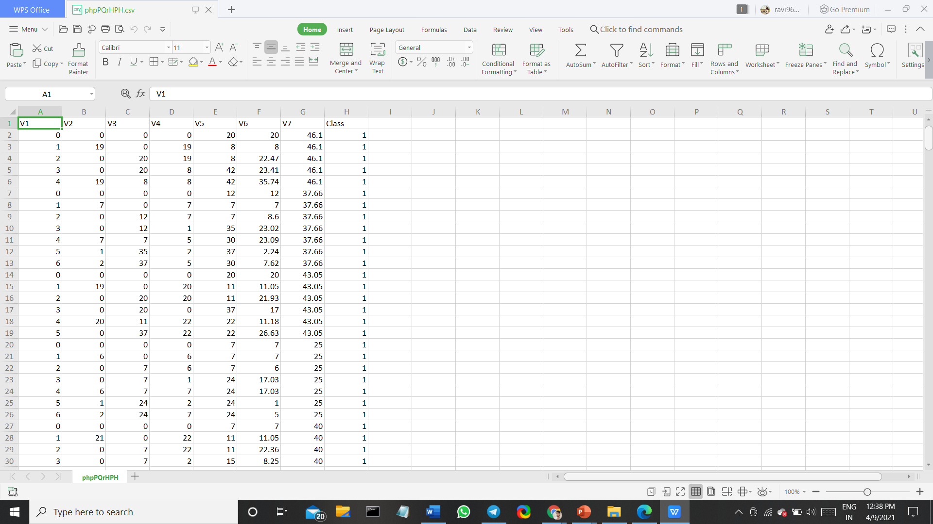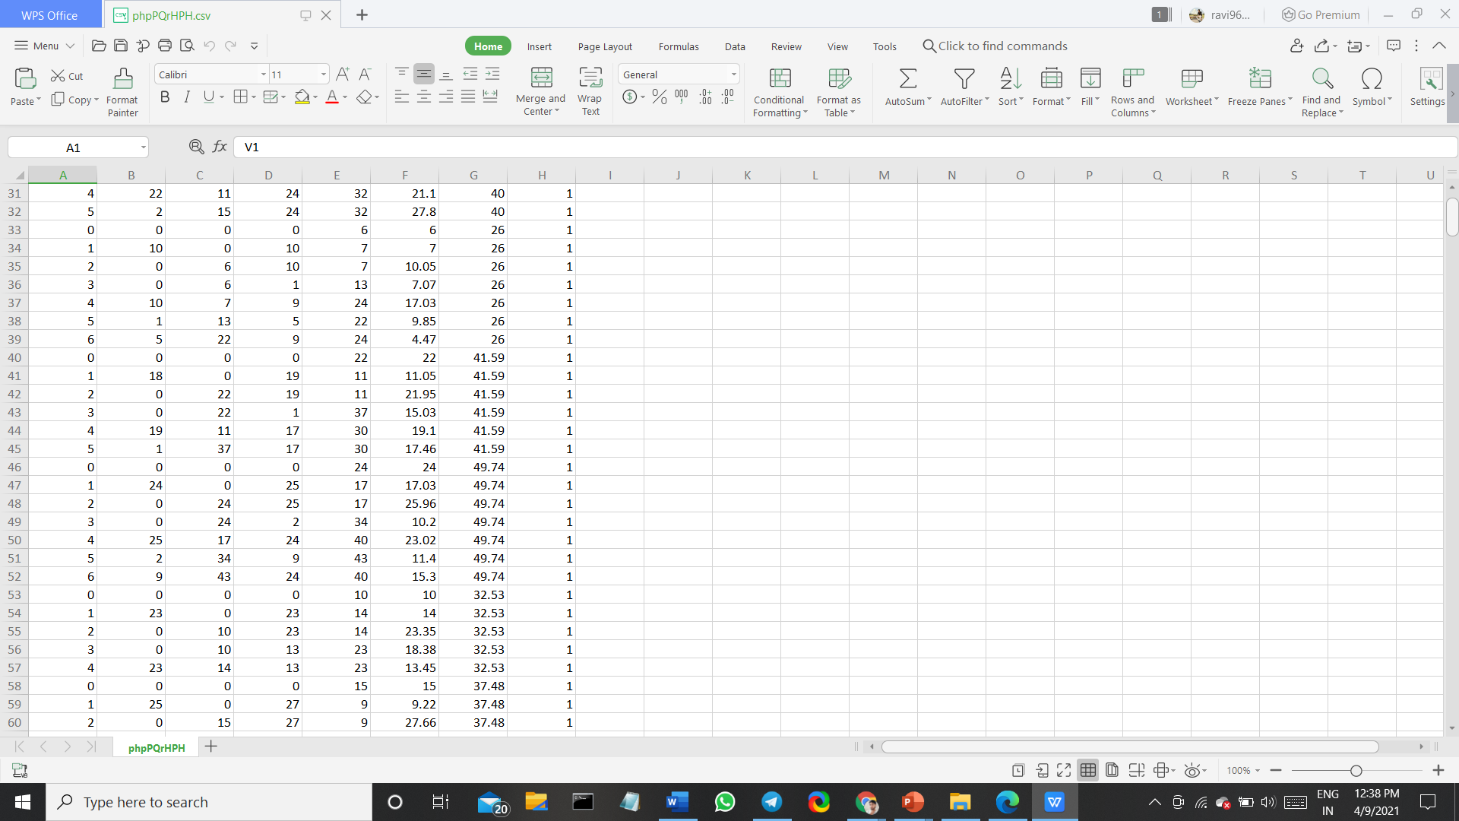

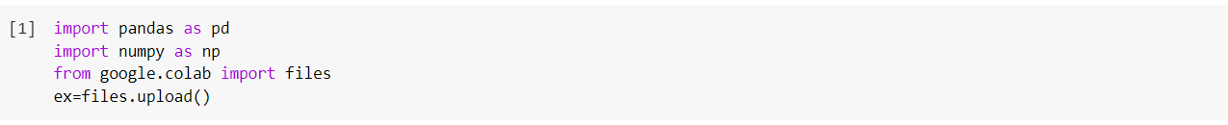**Basic Libraries for the Data And Exploring the Data**

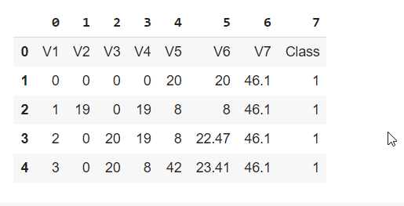

**Understanding the Data**

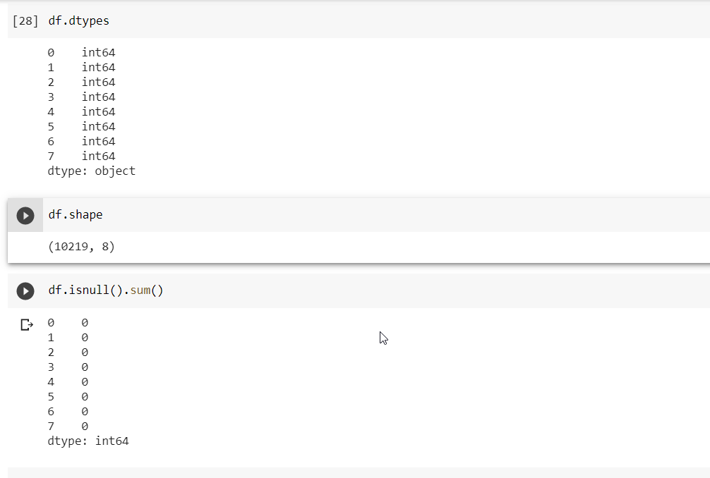

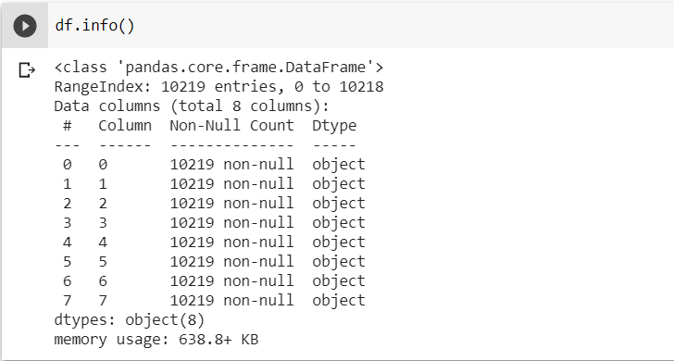

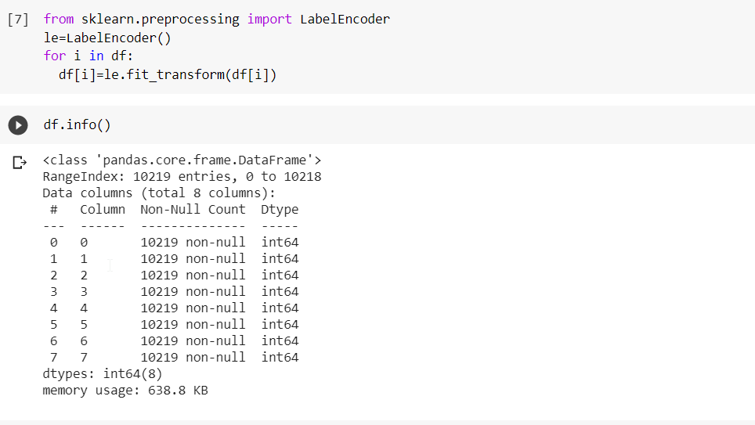

**Importing LabelEncoder**

**Prepared Data**

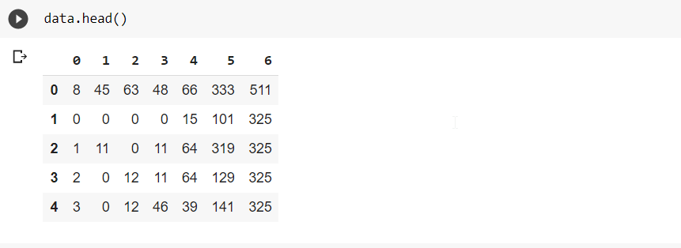

**Data Visualization**

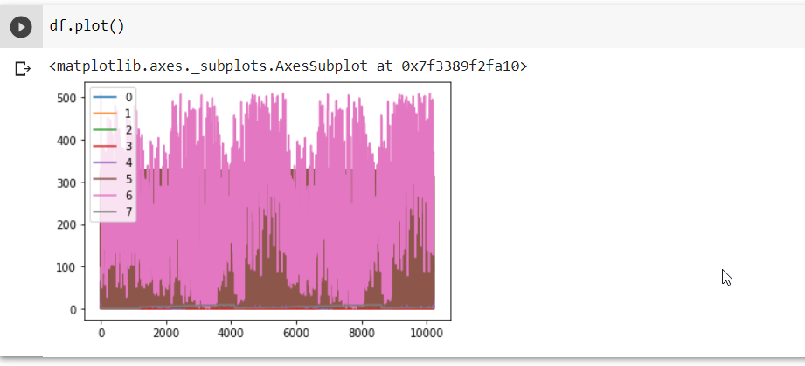

**Scaling Data**

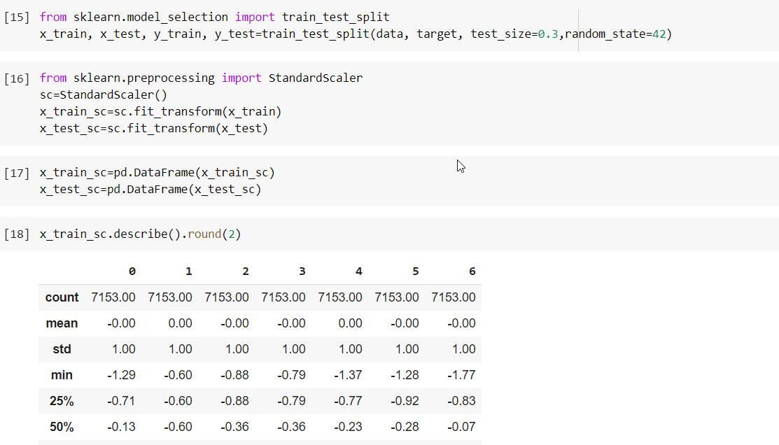

**Importing SVC and Predicting**

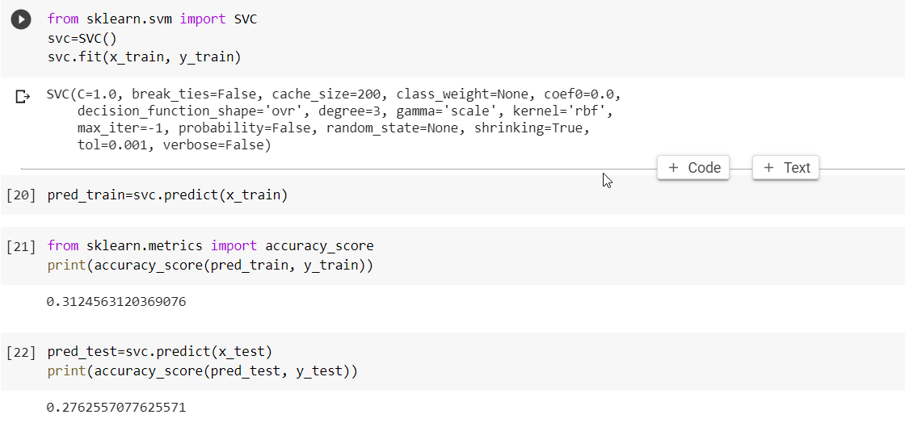

**Importing Accuracy_score and Accurating the Data**

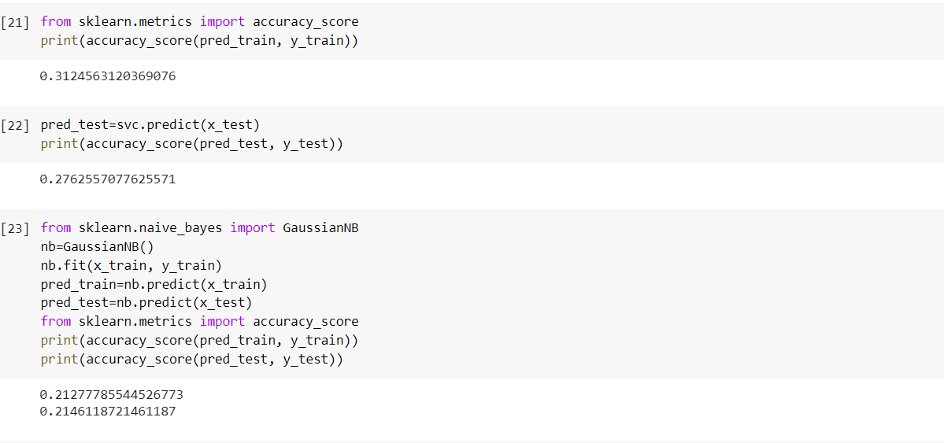

**Decision Tree Classifier**

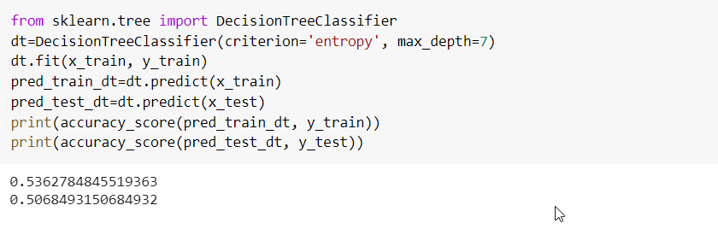

**Bagging Classifier**

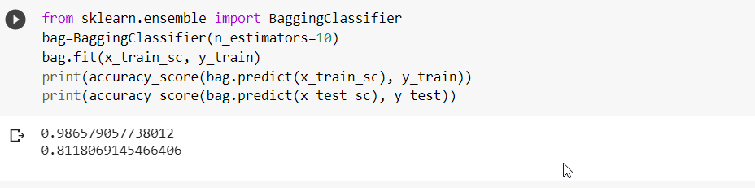

**Random Forest Classifier**

