NAME: - RAVITEJA G

SECTION: - K18PG

ID NO: - | 11804302

SUBJECT :- OPERATING SYSTEM

ROLL NO: - | 21A

MAIL: - ravi984459@gmail.com

GITHUB LINK:

QUESTION:

Design a scheduler with multilevel queue having two queues which will schedule the processes on the basis of pre-emptive shortest remaining processing time first algorithm (SROT) followed by a scheduling in which each process will get 2 units of time to execute. Also note that queue 1 has higher priority than queue

- Consider the following set of processes (for reference)with their arrival times and the CPU burst times in milliseconds.

process | Arrival | Burst
 | time | time
P1 | 0 | 5
P2 | 1 | 3
P3 | 2 | 3
P4 | 4 | 1

SOLUTION:-

#include<stdio.h>

int main()

{

int i, l, total = 0, x, cou = 0, time_quant,j;

int wait_time = 0, turnaround_time = 0,pos,z,p[10],prio[10], a_time[10], b_time[10], temp[10],b;
float average_wait_time, average_turnaround_time;

printf("\nEnter Total Number of Processes:");

scanf("%d", &l);

x = l;

for(i = 0; i < l; i++)

{

p[i]=i+1;

prio[i]=0;

printf("\nEnter total Details of Process[%d]\n", i + 1);

printf("Arrival Time:\t");

scanf("%d", &a_time[i]);

printf("Burst Time:\t");

scanf("%d", &b_time[i]);

temp[i] = b_time[i];

}

printf("\nEnter the Time Quantum:");

scanf("%d", &time_quant);

printf("\nProcess ID\t\tBurst Time\t Turnaround Time\t Waiting Time\t Priority\n");

for(total = 0, i = 0; x != 0;)
{

for(z=0;z<l;z++)

{

int temp1;

pos=z;

for(j=z+1;j<l;j++)

{

if(prio[j]<prio[pos])

pos=j;

}

temp1=prio[z];

prio[z]=prio[pos];

prio[pos]=temp1;

temp1=b_time[z];

b_time[z]=b_time[pos];

b_time[pos]=temp1;

temp1=a_time[z];

a_time[z]=a_time[pos];

a_time[pos]=temp1;

temp1=p[z];

p[z]=p[pos];

p[pos]=temp1;

temp1=temp[z];

temp[z]=temp[pos];

temp[pos]=temp1;

}

{

}

if(temp[i] <= time_quant && temp[i] > 0)

{

total = total + temp[i];

temp[i] = 0;

cou = 1;

}

else if(temp[i] > 0)

{

temp[i] = temp[i] - time_quant;

total = total + time_quant;

}

for(b=0;b<l;b++)

{

if(b==i)

prio[b]+=1;

else

prio[b]+=2;

}

if(temp[i] == 0 && cou == 1)

{

x--;

printf("\nProcess[%d]\t\t%d\t\t %d\t\t %d\t\t%d", p[i], b_time[i], total - a_time[i], total - a_time[i] - b_time[i],prio[i]);

wait_time = wait_time + total - a_time[i] - b_time[i]; turnaround_time = turnaround_time + total - a_time[i]; counter = 0;

}

if(i == l - 1)

{

i = 0;

}

else if(a_time[i + 1] <= total)

{
i++;

}

else

{

i = 0;

}

}

return 0;

}

Output:

Process id | Arrival | Burst | Completion | TAT | Waiting | priority
 | time | time | time |  | time
P1 | 0 | 5 | 12 | 12 | 7 | 15
P2 | 1 | 3 | 10 | 9 | 6 | 10
P3 | 2 | 3 | 11 | 9 | 6 | 12
P4 | 4 | 1 | 7 | 3 | 2 | 7

Average Turn around time= 8.25

Average waiting time= 5.25

REPORT
Definitions of the Terms:

- Burst time: it is the total time taken by the process for its execution on the CPU.

- Arrival time: it is the time when a process enters into the ready state and is ready for its execution.

  - Waiting time: it is the total time spent by the process in the ready state waiting for CPU.

Waiting time = Turnaround time - Burst time

- Turnaround time: it is the total amount of time spent by the process from coming in the ready state for the first time to its completion.

Turnaround time = Burst time + Waiting time

- Response time: it is the time spent when the process is in the ready state and gets the CPU for the first time.

Response time = Time at which the process gets the CPU for the first time - Arrival time

  - Exit time: it is the time when a process completes its execution and exit from the system.

1.Explain the problem in terms of operating system concept? Description:-

The problem in terms of operating system concept designing a scheduler by using multi-level queue concept. In this processes are permanently assigned to queue based on priority or process type or on their memory size. As the above mentioned queue 1 as higher priority. The ready queue under goes three stages system, interactive and foreground process. If in case of having a same time burst or arrival time the process under goes preemptive method or time slicing methods. As above mentioned queue 1 has higher priority. Then queue 1 uses Round robin and queue 2 uses FCFS.

Problem faced may be the starvation may occur. And time consuming for the larger process. Difficulty of using static length (time

quantum) for larger process. These problems may affect the performance of the scheduler.

- Write the algorithm for proposed solution of the assigned problem?

Algorithm: -

Intialize waiting time=0, turn around rtime=0, a[10],b[10];

step 1: printf(“enter no of process”);

n= no of process;

step2 : for(int i=0,i<n;i++)

{

Printf(“enter arrival time ”)

A[i]=arrivial time;

Printf(“enter brust time”);

B[i]=brust time;

}

Printf(“enter quantum time”);

Tq=time quantum;

Step 3:-for(int i=0;i<n;i++)

{

For(int j=i+1;j<n;j++)

{

If(bt[i]>bt[k])

{

Swap the process tq;
Swap the burst time;

Swap the arrivial time;

}

}

}

Step 4:- for(int i=0; i<n;i++)

{

If(brust time[i]<=timequantum&&brust time[i]>0)

{

Total time = total time+brust time[i];

Burst time[i]=0;

Counter=1;

}

Else

{

Brust time[i]=brust time[i]-time quantum; Total=total+time quantum; }

}

Step 5:-

For(int i=0;i<n;i++)

{

If (burst time[i]==0&&counter==1)

{
Waiting time =waiting time+total time-a[i]-b[i];

Printf(“waiting time =%d”;waiting time):

Turn around time=turn around time+total-a[i];

Printf[“turn around time =%d”;turn around time]; bhj

}

}

- Calculate complexity of implemented algorithm. (Student must specify complexity of each line of code along with overall complexity)? Answer:-overall complexity of algorithm is n*n*n

Step 1: complexity is n

Step 2: complexity is 1+2n

Step 3: complexity is 1+n+n*n*n

Step 4: complexity is 1+n+n*n

Step 5: complexity is 1+n*n

4.Explain all the constraints given in the problem. Attach the code snippet

of the implemented constraint.

Code snippet:

used for priority of scheduling:-

for(z=0;z<limit;z++)

{

int temp1;

pos=z;

for(j=z+1;j<limit;j++)

{

if(prio[j]<prio[pos])

pos=j;
}

temp1=prio[z];

prio[z]=prio[pos];

prio[pos]=temp1;

temp1=b_time[z];

b_time[z]=b_time[pos];

b_time[pos]=temp1;

temp1=a_time[z];

a_time[z]=a_time[pos];

a_time[pos]=temp1;

temp1=p[z];

p[z]=p[pos];

p[pos]=temp1;

temp1=temp[z];

temp[z]=temp[pos];

temp[pos]=temp1;

}

{
}

if(temp[i] <= time_quantum && temp[i] > 0)

{

total = total + temp[i];

temp[i] = 0;

counter = 1;

}

else if(temp[i] > 0)

{

temp[i] = temp[i] - time_quantum;

total = total + time_quantum;

}

for(b=0;b<limit;b++)

{

if(b==i)

prio[b]+=1;

else

prio[b]+=2;

}

- Explain the boundary conditions of the implemented code. Description:

→The number of processes should be positive.
→Arrival time should be positive.
- Bust time should be positive.
→Time quantum must be positive and mentioned its units.

6.Explain all the test cases applied on the solution of assigned problem. Output:-

Test cases :-
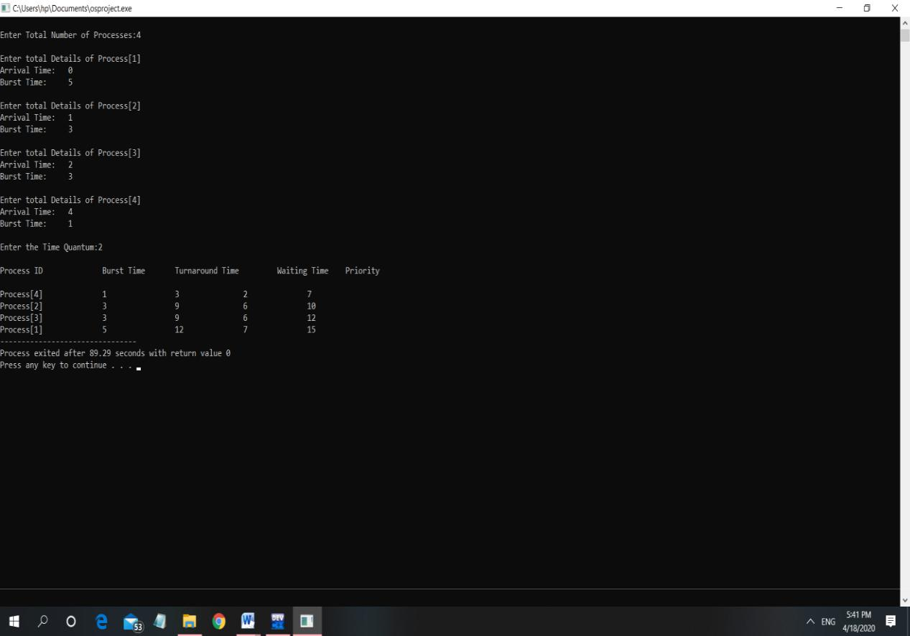
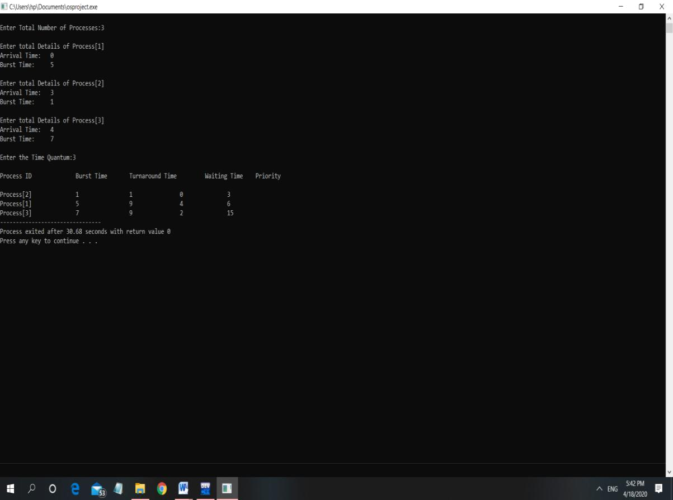

3
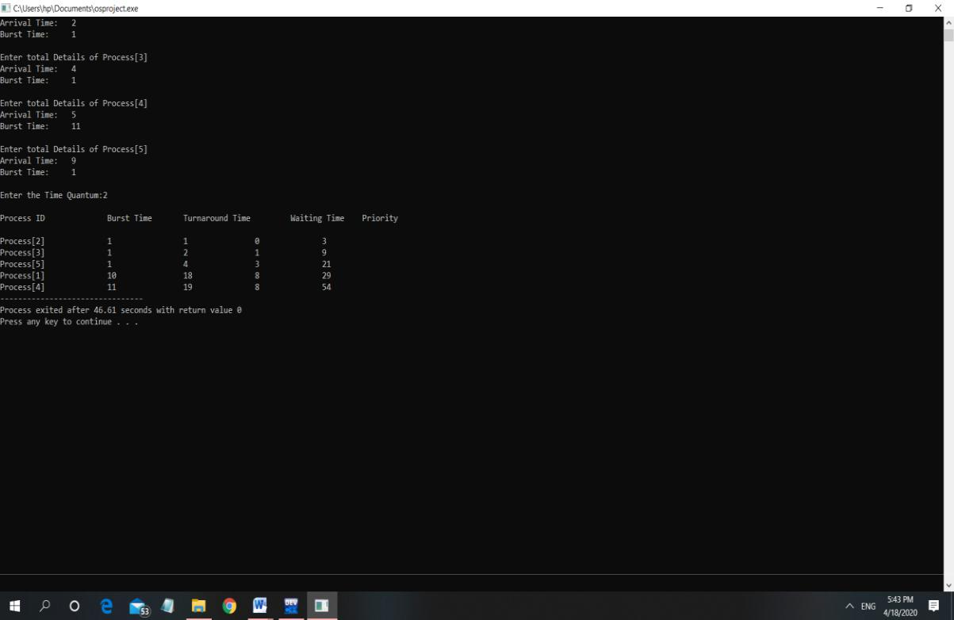
4
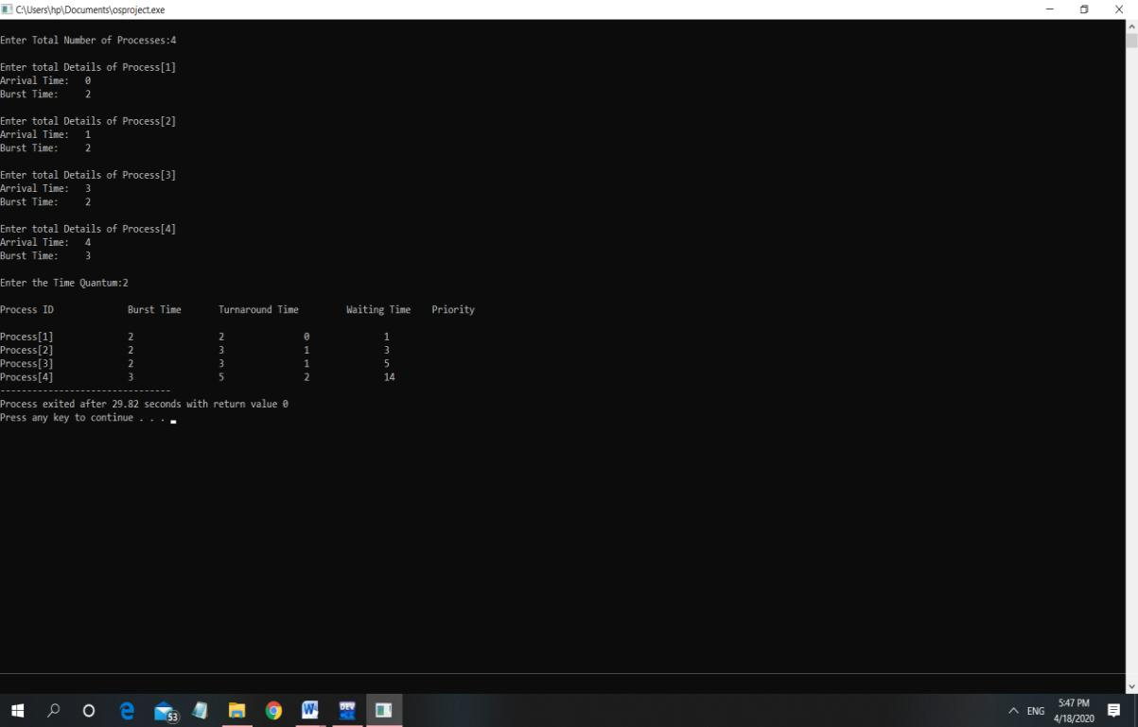

5
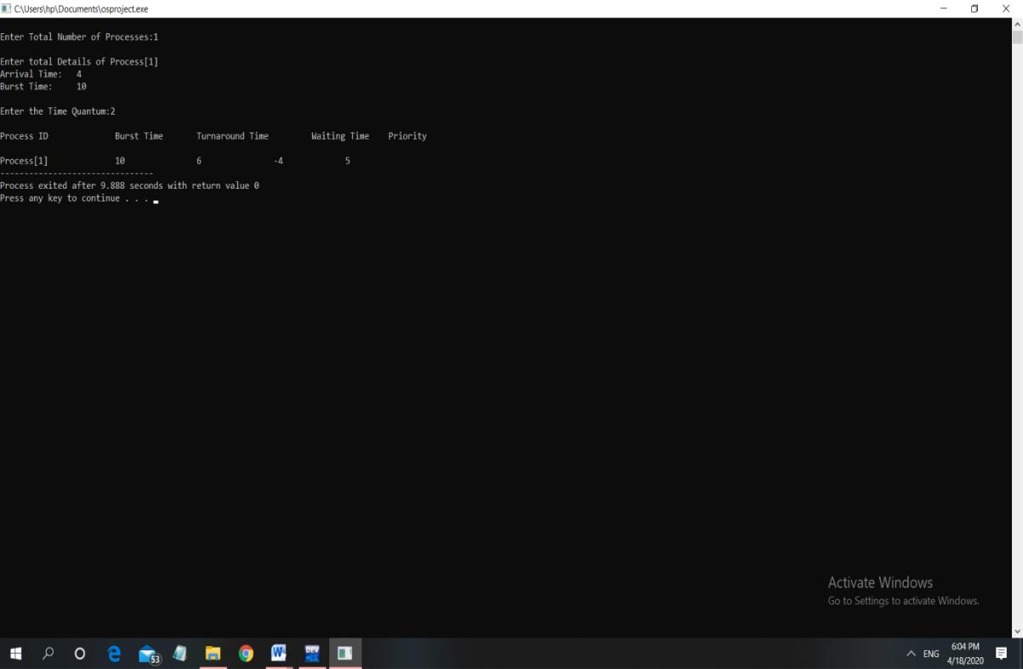

7.Have you made minimum 5 revisions of solution on GitHub?

https://github.com/cheeku17/operating-system/blob/master/operating%20system%20using%20c%20language

  - Plagiarism report?



