GRANDCRUISE: FULL-STACK PREMIUM CAR BOOKING & RENTAL MANAGEMENT PLATFORM
A Mini-Project Dissertation submitted in partial fulfillment of the requirements for the award of the degree of

MASTER OF TECHNOLOGY
in
COMPUTER NETWORKS AND INFORMATION SECURITY

Submitted by

THIPPARTHI RAVITEJA

(24011D6413)

Under the Esteemed Guidance of

DR. K. SANTHI SREE
Professor, Dept of IT


DEPARTMENT OF INFORMATION TECHNOLOGY UNIVERSITY COLLEGE OF ENGINEERING, SCIENCE & TECHNOLOGY JAWAHARLAL NEHRU TECHNOLOGICAL UNIVERSITY HYDERABAD KUKATPALLY, HYDERABAD, TELANGANA, INDIA - 500085
2024-2026

DEPARTMENT OF INFORMATION TECHNOLOGY UNIVERSITY COLLEGE OF ENGINEERING, SCIENCE & TECHNOLOGY JAWAHARLAL NEHRU TECHNOLOGICAL UNIVERSITY HYDERABAD KUKATPALLY, HYDERABAD, TELANGANA, INDIA - 500085

2024-2026


CERTIFICATE
This is to certify that the dissertation entitled “GRANDCRUISE: FULL-STACK PREMIUM CAR BOOKING & RENTAL MANAGEMENT PLATFORM” is being submitted by THIPPARTHI RAVITEJA bearing Roll No: 24011D6413 in partial fulfillment of the degree of Master of Technology in “Computer Networks and Information Security”, to the Department of Information Technology, JNTUH UCESTH is a record of Bonafide work carried out by her under our guidance and supervision.

The results embodied in this Mini-project have not been submitted to any other University or Institute for the award of any degree or diploma.

Internal Guide
Dr. K. SANTHI SREE
Professor, Dept of IT

DEPARTMENT OF INFORMATION TECHNOLOGY UNIVERSITY COLLEGE OF ENGINEERING, SCIENCE & TECHNOLOGY JAWAHARLAL NEHRU TECHNOLOGICAL UNIVERSITY HYDERABAD KUKATPALLY, HYDERABAD, TELANGANA, INDIA - 500085

2024-2026


CERTIFICATE
This is to certify that the dissertation entitled “GRANDCRUISE: FULL-STACK PREMIUM CAR BOOKING & RENTAL MANAGEMENT PLATFORM” is being submitted by THIPPARTHI RAVITEJA bearing Roll No: 24011D6413 in partial fulfillment of the degree of Master of Technology in “Computer Networks and Information Security”, to the Department of Information Technology, JNTUH UCESTH is a record of Bonafide work carried out by her under our guidance and supervision.

The results embodied in this Mini-project have not been submitted to any other University or Institute for the award of any degree or diploma.

Head of the Department
DR. V. UMA RANI
Prof & Head, Dept of IT

DEPARTMENT OF INFORMATION TECHNOLOGY UNIVERSITY COLLEGE OF ENGINEERING, SCIENCE & TECHNOLOGY JAWAHARLAL NEHRU TECHNOLOGICAL UNIVERSITY HYDERABAD KUKATPALLY, HYDERABAD, TELANGANA, INDIA - 500085

2024-2026


DECLARATION
I, RAVITEJA THIPPARTHI, bearing Roll No: 24011D6413, here by declare that report of Post Graduate Mini-Project Work entitled “GRANDCRUISE: FULL-STACK PREMIUM CAR BOOKING & RENTAL MANAGEMENT PLATFORM” which is being submitted to the Department of Information Technology, JNTUH UCESTH in partial fulfillment of the degree Master of Technology in “Computer Networks and Information Security”, Department of Information Technology, is a Bonafide report of work carried out by me.

The material contained in this report has not been submitted to any other University or Institute for the award of any degree or diploma.

THIPPARTHI RAVITEJA
(24011D6413)

ACKNOWLEDGEMENT

I extend my sense of gratitude to my guide Dr. K. SANTHI SREE, Professor, Dept of IT, JNTUH UCESTH, for all the timely support, valuable suggestions, constant guidance, encouragement and moral support during the period of Mini-Project and permitting me to undertake this project.
I extend my sense of gratitude to my guide Mr. VIJAY NARAYANA, Guest faculty, Dept of IT, JNTUH UCESTH, for all the timely support, valuable suggestions, constant guidance, encouragement and moral support during the period of Mini-Project and permitting me to undertake this project.

I would like to express my sincere thanks to Dr. V. UMA RANI, Prof & Head, Dept of IT, JNTUH UCESTH, for providing the working facilities in college.

I would like to express my sincere thanks to Dr. G. VENKATA NARASIMHA REDDY, Principal, JNTUH UCESTH, for providing the working facilities in college.
Finally, I would also like to thank all the faculty and staff of Department of Information Technology, who helped me for completing this Mini-Project.

With Sincere Regards,

THIPPARTHI RAVITEJA
24011D6413

ABSTRACT
GrandCruise is a full-stack premium car booking and rental management platform designed to deliver a seamless, high-end experience for both customers and administrators. Tailored for luxury car fleets featuring brands such as BMW, Mercedes-Benz, Audi, and Porsche, GrandCruise leverages modern web technologies to provide a robust, scalable, and user-friendly solution.
The platform offers intuitive interfaces for browsing, booking, and managing premium vehicles, with advanced features such as real-time availability, secure user authentication, dynamic pricing, and comprehensive booking management. Administrators benefit from powerful tools for fleet oversight, analytics, and customer management, ensuring operational efficiency and superior service delivery.
Built with a focus on performance, security, and scalability, GrandCruise empowers luxury car rental businesses to elevate their digital presence and streamline operations, setting a new standard in the premium mobility market.

TABLE OF CONTENTS
CONTENT | PAGE NO.
ABSTRACT | 6
1. INTRODUCTION | 11
2. EXISTING SYSTEM | 12
2.1. DISADVANTAGES
3. PROPOSED SYSTEM | 13–14
3.1. PROPOSED MODELS
3.2. ADVANTAGES
4. SYSTEM ARCHITECTURE | 15
5. SOFTWARE AND HARDWARE REQUIREMENTS | 16
5.1. SOFTWARE REQUIREMENTS
5.2. HARDWARE REQUIREMENTS
6. SYSTEM IMPLEMENTATION | 17–19
6.1. DJANGO MODELS & DATABASE DESIGN
6.2. REST API IMPLEMENTATION
6.3. FRONTEND REACT COMPONENTS
6.4. AUTHENTICATION & AUTHORIZATION
6.5. ADMIN PANEL IMPLEMENTATION
7. PYTHON, REACT, AND TAILWIND CSS TECHNOLOGIES | 20–28
7.1. PYTHON
7.1.1. HISTORY OF PYTHON
7.1.2. INTRODUCTION TO PYTHON
7.1.3. GOAL OF PYTHON
7.1.4. EXECUTION PROCESS IN PYTHON
7.1.5. LIBRARIES AND PACKAGES IN PYTHON
7.1.6. USES OF PYTHON
7.1.7. ADVANTAGES OF PYTHON
7.2. REACT JAVASCRIPT LIBRARY
7.2.1. HISTORY OF REACT
7.2.2. INTRODUCTION TO REACT
7.2.3. KEY FEATURES OF REACT
7.2.4. REACT ECOSYSTEM
7.2.5. ADVANTAGES OF REACT

7.3. TAILWIND CSS FRAMEWORK
7.3.1. HISTORY OF TAILWIND CSS
7.3.2. INTRODUCTION TO TAILWIND CSS
7.3.3. KEY FEATURES OF TAILWIND CSS
7.3.4. TAILWIND CSS UTILITIES
7.3.5. ADVANTAGES OF TAILWIND CSS
8. DATABASE DESCRIPTION | 29–31
8.1. DATA SOURCES
8.2. DATA STRUCTURE
8.2.1. USER DATA MODELS
8.2.2. VEHICLE DATA MODELS
8.2.3. BOOKING DATA MODELS
8.2.4. SYSTEM CONFIGURATION MODEL
8.3. DATA RELATIONSHIPS
9. TESTING | 32–34
9.1. TYPES OF TESTING
10. SOURCE CODE | 35–44
10.1. DJANGO MODELS
10.2. DJANGO VIEWS
10.3. REACT COMPONENTS
11. PROJECT SCREENSHOTS | 45–50
12. CONCLUSION | 51
13. FUTURE ENHANCEMENTS | 52
REFERENCES

LIST OF FIGURES
Figure | Title | Page
4.1 | System Architecture | 15
11.1 | Home Page and Car details on Hover | 45
11.2 | User Registration Page | 45
11.3 | User Login Page | 46
11.4 | Cars Listing Page | 46
11.5 | Car Details Page | 47
11.6 | Car Booking Page | 47
11.7 | User Bookings Page | 48
11.8 | Admin Bookings Overview | 48
11.9 | Admin Car Management Panel | 49
11.10 | System Settings Page | 50
11.11 | API Root Endpoints (Django REST Framework) | 50

LIST OF TABLES
Table No. | Title | Page
8.1 | User Model Attributes | 29
8.2 | UserProfile Model Attributes | 29
8.3 | Car Model Attributes | 30
8.4 | CarGallery Model Attributes | 30
8.5 | Booking Model Attributes | 31
8.6 | SystemSettings Model Attributes | 31
8.7 | Key Data Relationships | 31

INTRODUCTION
The landscape of personal and business mobility has undergone a significant transformation in recent years, driven by rapid advancements in digital technology and changing consumer expectations. In the premium car rental sector, customers now demand not only access to high-end vehicles but also a seamless, intuitive, and secure digital experience that matches the luxury of the cars themselves. Traditional rental models, often reliant on manual processes and outdated systems, are increasingly unable to meet these evolving needs.
GrandCruise emerges as a response to these challenges, offering a full-stack, premium car booking and rental management platform that redefines the standards of luxury mobility services. The platform is meticulously designed to bridge the gap between elite car rental providers and discerning clients, providing a digital ecosystem where convenience, security, and sophistication converge. GrandCruise leverages state-of-the-art web technologies to deliver a robust, scalable, and user-friendly solution that caters to both customers and administrators.
For customers, GrandCruise offers an unparalleled experience: from browsing a curated selection of luxury vehicles—such as BMW, Mercedes-Benz, Audi, and Porsche—to making real-time bookings, managing reservations, and accessing personalized services. The platform's intuitive interface, real-time availability, and secure payment processing ensure that every interaction is smooth and trustworthy.
For businesses, GrandCruise provides powerful tools for fleet management, analytics, and customer relationship management. Administrators can efficiently oversee operations, optimize fleet utilization, and gain actionable insights through comprehensive dashboards and reporting features. The platform's modular architecture and integration capabilities allow for easy adaptation to business growth and technological advancements.
By setting a new benchmark for digital excellence in the premium car rental industry, GrandCruise empowers both providers and customers to embrace the future of luxury mobility with confidence and ease.

EXISTING SYSTEM
The current landscape of premium car rental systems is hindered by outdated software, fragmented workflows, and limited digital integration. Many platforms were originally designed for standard vehicle rentals and lack the sophistication required for managing luxury fleets. As a result, customers often face slow, outdated websites or apps, unclear vehicle availability, and poor user experiences. The absence of real-time data leads to issues like double bookings and inefficient service delivery.
On the operational side, rental providers still rely heavily on manual processes, paper-based contracts, and disjointed communication, reducing efficiency and service quality. These systems typically lack modern features such as dynamic pricing, personalized recommendations, and integrated analytics—tools essential for customer engagement and business growth. Additionally, many legacy systems pose security and compliance risks due to outdated architecture not equipped for current cybersecurity standards.

DISADVANTAGES
- Manual Processes: Many existing solutions require manual intervention for booking confirmations, vehicle assignments, and record-keeping, leading to errors, inefficiencies, and delays.
- Limited User Experience: Outdated interfaces, lack of mobile responsiveness, and unintuitive navigation hinder customer engagement and satisfaction.
- No Real-Time Updates: The absence of real-time vehicle availability and booking status can result in double bookings, missed opportunities, and customer frustration.
- Poor Integration: Existing systems often lack integration with payment gateways, analytics, CRM tools, and third-party services, resulting in fragmented workflows and data silos.
- Security and Compliance Risks: Legacy systems may not adhere to modern security standards or data protection regulations, putting sensitive customer and business data at risk of breaches or non-compliance.
- Lack of Advanced Features: Most current platforms do not support dynamic pricing, personalized recommendations, or advanced analytics, limiting the ability to optimize business operations and enhance customer experience.

PROPOSED SYSTEM
GrandCruise is a full-stack digital platform crafted for the premium car rental industry. It offers a seamless experience for customers to browse, compare, and book luxury vehicles in real time. With a responsive design for desktop and mobile, it ensures quick access and smooth navigation, meeting the expectations of a modern, tech-savvy clientele.
For business owners, GrandCruise centralizes fleet and booking management, reducing manual work and preventing errors like double bookings. It includes secure payment processing, user authentication, and access control. Built with a modular, scalable architecture, the platform supports future enhancements and helps luxury rental businesses grow efficiently and deliver top-tier service.

PROPOSED MODELS:
- User Module: Enables customers to register, browse available premium vehicles, make bookings, and manage their profiles.
- Admin Module: Provides administrators with tools for fleet management, booking oversight, and customer support.
- Car Management Module: Allows for the addition, modification, and removal of vehicles, including detailed specifications and image galleries.
- Booking Management Module: Handles real-time booking requests, availability checks, payment processing, and status updates.

ADVANTAGES:
- Automated Processes: GrandCruise eliminates manual intervention by automating booking confirmations, vehicle assignments, and record-keeping, reducing errors and operational delays.
- Superior User Experience: The platform features a modern, intuitive, and mobile-responsive interface, ensuring seamless navigation and high customer satisfaction.
- Real-Time Data Synchronization: GrandCruise provides instant updates on vehicle availability and booking status, preventing double bookings and missed opportunities.

- Seamless Integration: The system integrates smoothly with payment gateways, CRM tools, and third-party services, unifying workflows and eliminating data silos.
- Advanced Security & Compliance: GrandCruise adheres to the latest security standards and data protection regulations, safeguarding sensitive customer and business information.
- Advanced Features: The platform supports dynamic pricing, personalized recommendations, and analytics, empowering businesses to optimize operations and enhance the customer experience.

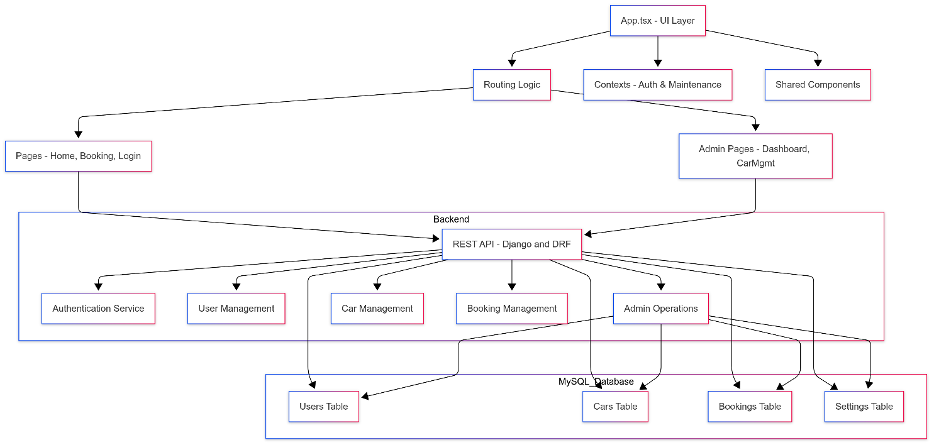
SYSTEM ARCHITECTURE
Fig 4.1: System Architecture

GrandCruise employs a modular, layered architecture designed for scalability and maintainability. The frontend layer, built with React, provides an intuitive user interface for both customers and administrators, handling navigation and state management through contexts and shared components. The backend layer, powered by Django and Django REST Framework, exposes RESTful APIs that encapsulate all business logic, including authentication, user management, car management, and booking operations. Data persistence is handled by a relational database (MySQL) that stores users, cars, bookings, and system settings, while media assets are managed through dedicated storage solutions. The architecture implements secure authentication and role-based access control throughout the stack, ensuring data protection and user privacy. This design supports both cloud and on-premises deployment, enabling high availability and seamless scaling as business requirements evolve.

SOFTWARE AND HARDWARE REQUIREMENTS

SOFTWARE REQUIREMENTS
- Operating System: Windows, Linux, or macOS
- Backend Framework: Django (Python 3.8+)
- Frontend Framework: React (Node.js 16+)
- Database: MySQL
- Browser: Google Chrome, Mozilla Firefox.

HARDWARE REQUIREMNTS
- Processor: Intel Core i5 or equivalent.
- RAM: 8 GB minimum (16 GB recommended).
- Hard Disk: 250 GB or Above.

SYSTEM IMPLEMENTATION
The implementation of GrandCruise follows a comprehensive modular approach with clear separation of concerns between frontend and backend components, ensuring maintainability, scalability, and robust performance. The system architecture is built using Django 5.0.2 with Django REST Framework for the backend API, providing a robust foundation for business logic, data management, and security. The frontend interface is developed using React 18 with TypeScript, offering a dynamic, responsive, and intuitive user experience. MySQL serves as the primary database, providing reliable data persistence with ACID compliance and optimized query performance. The implementation incorporates modern development practices including RESTful API design, token-based authentication, role-based access control, and responsive design principles. The development methodology emphasizes code reusability, component-based architecture, and comprehensive error handling. The system integrates various third-party libraries and tools such as React Query for state management, Tailwind CSS for styling, and django-filter for advanced data filtering capabilities. The following sub-sections detail the key implementation aspects of the platform, covering database design, API development, frontend architecture, security implementation, and administrative functionality.

DJANGO MODELS & DATABASE DESIGN
The database schema is implemented using Django's ORM with four main models: User, Car, Booking, and SystemSettings. The User model extends Django's built-in User model with a UserProfile that includes phone number and address fields. The Car model stores comprehensive vehicle information including brand, model, year, price, specifications, and availability status. The Booking model manages reservation data with status tracking (pending, confirmed, cancelled, completed) and automatic price calculation based on rental duration. The SystemSettings model handles global configuration like maintenance mode and booking policies. All models include created_at and updated_at timestamps for audit trails, and the database uses MySQL with proper indexing for optimal query performance.

REST API IMPLEMENTATION
The REST API is built using Django REST Framework with ViewSets for each model. The API includes endpoints for user management (/api/users/), car catalog (/api/cars/), booking operations (/api/bookings/), and system settings (/api/admin/settings/). Authentication is handled through token-based authentication with support for session and basic authentication. The API implements proper permissions with IsAuthenticated as default and custom permissions like IsStaff for booking operations. Serializers handle data validation and transformation, with nested serialization for related objects. The API supports filtering, searching, and ordering capabilities using django-filter and DRF's built-in features.

FRONTEND REACT COMPONENTS
The frontend is built with React and TypeScript, using React Router for navigation and React Query for state management. The application structure includes pages for home, car browsing, booking, user authentication, and admin functions. Context providers (AuthContext and MaintenanceContext) manage global state for user authentication and system maintenance mode. Shared components include navigation bars, cards, and form elements styled with Tailwind CSS. The frontend communicates with the backend API using Axios for HTTP requests, with proper error handling and loading states. Protected routes ensure only authenticated users can access booking and profile features.

AUTHENTICATION & AUTHORIZATION
Authentication is implemented using Django's built-in authentication system with token-based authentication for API access. User registration and login are handled through the /api/auth/login/ endpoint, which returns authentication tokens. The frontend stores tokens in localStorage and includes them in API request headers. Role-based access control is enforced through Django permissions, with staff users having access to admin functions. Custom permissions ensure users can only access their own bookings while admins can view all data. The system includes maintenance mode functionality that can restrict access to certain features during system updates.

ADMIN PANEL IMPLEMENTATION
The admin panel provides comprehensive management capabilities through both Django's built-in admin interface and custom React components. Django admin offers CRUD operations for all models with proper permissions. Custom admin pages built in React include dashboard views, car management with image uploads, booking oversight, and system settings configuration. The admin interface includes features for managing user accounts, car inventory with detailed specifications, booking status updates, and system-wide settings like maintenance mode and booking policies. All admin operations are protected by authentication and authorization checks.

PYTHON, REACT, AND TAILWIND CSS TECHNOLOGIES
      - PYTHON

7.1.1. History of Python
Python was created by Guido van Rossum and first released in 1991. It was designed to emphasize code readability and simplicity, making it accessible to both beginners and experienced developers. Python's development began in the late 1980s when Guido was working at the Centrum Wiskunde & Informatica (CWI) in the Netherlands. He started the project as a successor to the ABC language, which was designed for teaching and prototyping but had limitations that Guido aimed to address.
During Christmas of 1989, Guido began implementing Python as a hobby project to keep himself occupied during the holidays. His goal was to create an easy-to-use language with a broad set of utilities and extensibility. The first version of Python (version 0.9.0) was released to the public in February 1991. This early version already included many of Python's core features, such as exception handling, functions, and the core data types of list, dict, str, and more.
Python 1.0 was released in 1994, marking Python's first major public release. This version included new features like functional programming tools (lambda, map, filter, and reduce) and built-in support for complex numbers. Python 2.0 was released in 2000, introducing many features that improved the language's functionality and usability, such as list comprehensions, a full garbage collector, and support for Unicode.
Python 3.0 was released in 2008, representing a significant update that was not backward compatible with previous versions. Python 3 was designed to fix inherent design flaws in the language and remove redundant constructs. Some major changes included the print function, new syntax for integer division, and improvements in Unicode handling. Python continues to evolve with new releases, bringing more features and improvements while maintaining its position as one of the most popular programming languages worldwide.

7.1.2. Introduction to Python
Python is a high-level, interpreted programming language renowned for its simplicity, readability, and versatility. Created by Guido van Rossum and first released in 1991, Python has evolved into one of the most widely-used programming languages in the world, embraced by both beginners and experienced developers. Its design philosophy emphasizes code readability, simplicity, and the ability to express concepts in fewer lines of code compared to other languages like C++ or Java.
Python's syntax is clean and easy to read, which reduces the cost of program maintenance. The language supports modules and packages, encouraging program modularity and code reuse. The Python interpreter and the extensive standard library are available in source or binary form without charge for all major platforms and can be freely distributed. Python supports multiple programming paradigms, including procedural, object-oriented, and functional programming.

7.1.3. Goal of Python
The primary goal of Python is to provide a straightforward and efficient way to develop software. Python's design philosophy prioritizes the following principles: Readability - Python syntax is clean and easy to read, making it accessible for beginners and enhancing productivity for experienced developers. Simplicity - Python emphasizes simplicity and clarity, enabling developers to write less code and focus more on solving problems.
Flexibility - Python is a general-purpose language that can be used for a wide variety of applications, from web development and automation to data analysis and artificial intelligence. Comprehensibility - Python aims to be intuitive, allowing developers to quickly understand and modify code, which is particularly beneficial for collaborative projects. The language promotes rapid development and clean, pragmatic design.

7.1.4. Execution Process in Python
Python code is written in plain text files with a .py extension. A Python script can include statements, functions, classes, and modules. Python is an interpreted language, executing code line by line. To run a Python script, you use the Python interpreter through the command line or an integrated development environment (IDE) like PyCharm, VSCode, or Jupyter Notebook.
When a Python script is run, the interpreter first compiles the code into an intermediate form known as bytecode. This step is automatic and transparent to the user. Bytecode is a lower-level, platform-independent representation of your source code. The compiled bytecode is interpreted by the Python Virtual Machine (PVM). The PVM reads and executes the bytecode instructions, interacting with the underlying operating system to perform tasks such as memory management and I/O operations.
Python uses automatic memory management, primarily through garbage collection. The garbage collector automatically deallocates memory that is no longer in use, helping to prevent memory leaks and optimize memory usage. Python provides robust error and exception handling mechanisms. Errors can be caught and managed using try, except, else, and finally blocks. Python offers various tools for debugging, such as pdb (Python Debugger) and IDE-specific debuggers.

7.1.5. Libraries and Packages in Python
Python's extensive standard library and its vibrant ecosystem of third-party packages make it a powerful tool for a wide range of applications. The standard library includes modules like os (operating system interface), sys (system-specific parameters), datetime (date and time utilities), re (regular expressions), math (mathematical functions), and many more. These built-in modules provide essential functionality without requiring additional installation.
For web development, Django and Flask are popular frameworks. Django is a high-level framework that encourages rapid development and clean, pragmatic design, while Flask is a micro-framework that provides the basic tools to build a web application. For data science, libraries like Pandas, NumPy, and Matplotlib are widely used. Pandas offers data structures like DataFrame and Series for data manipulation and analysis.
For machine learning, libraries such as Scikit-learn, TensorFlow, and Keras are essential. Scikit-learn provides simple and efficient tools for data mining and data analysis, including classification, regression, clustering, and dimensionality reduction algorithms. TensorFlow and Keras offer comprehensive tools for building and training machine learning models, including neural networks.

7.1.6. Uses of Python
Python is a versatile programming language widely used in various domains due to its simplicity and readability. Web Development: Python frameworks like Django, Flask, and Pyramid facilitate the development of robust and scalable web applications. These frameworks provide tools for handling HTTP requests, database operations, user authentication, and more.

Data Science and Analytics: Libraries like Pandas, NumPy, and SciPy are essential for data manipulation, analysis, and scientific computing. Python is the language of choice for many data scientists due to its powerful data processing capabilities and extensive visualization libraries like Matplotlib and Seaborn.
Machine Learning and Artificial Intelligence: Python's extensive libraries, such as Scikit-learn, TensorFlow, and Keras, support the development and deployment of machine learning models and AI applications. The language's simplicity and the availability of pre-built algorithms make it ideal for AI development.
Automation and Scripting: Python's simplicity makes it ideal for automating repetitive tasks and scripting, improving productivity and efficiency. The language can interact with operating systems, manipulate files, and control other applications through various APIs.

7.1.7. Advantages of Python
- Ease of Learning: Python's syntax is designed to be easy to understand and write, making it an excellent choice for beginners. The language uses indentation to define code blocks, which enforces good coding practices and makes code more readable.
- Extensive Support Libraries: Python has a rich set of libraries and frameworks that facilitate development in various domains. The Python Package Index (PyPI) contains thousands of packages that can be easily installed using pip, Python's package installer.
- Community and Ecosystem: Python has a large, active community that contributes to its vast ecosystem of open-source libraries and tools. The community provides extensive documentation, tutorials, and support through forums, conferences, and online resources.
- Cross-Platform Compatibility: Python runs on multiple platforms, including Windows, macOS, Linux, and more. This portability makes it easy to develop applications that can run on different operating systems without modification.
- Integration Capabilities: Python can easily integrate with other languages and technologies, such as C/C++, Java, and .NET. This flexibility allows developers to use Python for specific parts of a project while leveraging other technologies where appropriate.

7.2. REACT JAVASCRIPT LIBRARY

7.2.1. History of React
React was created by Jordan Walke, a software engineer at Facebook, and was first deployed on Facebook's News Feed in 2011 and later on Instagram in 2012. It was developed to address the challenges of building complex user interfaces with data that changes over time. React was initially developed as an internal tool at Facebook to solve the problem of building large applications with data that changes frequently.
React was first released to the public in May 2013 at the JSConf US conference. The library was open-sourced and quickly gained popularity among developers due to its innovative approach to building user interfaces. React's component-based architecture and virtual DOM concept revolutionized how developers think about building web applications.
Over the years, React has evolved significantly with major releases introducing new features and improvements. React 16, released in 2017, introduced features like Fragments, Error Boundaries, and Portals. React 18, released in 2022, brought concurrent features, automatic batching, and improved server-side rendering capabilities.

7.2.2. Introduction to React
React is a JavaScript library for building user interfaces, particularly single-page applications. It was developed by Facebook and is used to create interactive UIs efficiently. React allows developers to create large web applications that can change data without reloading the page. Its main goal is to be fast, scalable, and simple.
React uses a component-based architecture, where the UI is broken down into reusable components. Each component manages its own state and can be composed to create complex user interfaces. React uses a virtual DOM (Document Object Model) to improve performance by minimizing direct manipulation of the actual DOM.
React follows a declarative programming paradigm, meaning developers describe what they want the UI to look like, and React handles the DOM updates to match that description. This approach makes the code more predictable and easier to debug compared to imperative approaches.

7.2.3. Key Features of React
- Virtual DOM: React uses a virtual DOM to improve performance. When the state of a component changes, React creates a new virtual DOM tree and compares it with the previous one. Only the differences are applied to the actual DOM, minimizing expensive DOM operations and improving performance.
- Component-Based Architecture: React applications are built using components, which are reusable pieces of UI. Components can be functional (using hooks) or class-based. They can accept props (properties) and manage their own state, making them highly modular and reusable.
- JSX: React uses JSX (JavaScript XML), a syntax extension that allows developers to write HTML-like code in JavaScript. JSX makes it easier to visualize the structure of components and their relationships. It gets compiled to regular JavaScript function calls.
- Unidirectional Data Flow: React follows a unidirectional data flow, where data flows down from parent components to child components through props. This makes the application's data flow predictable and easier to debug.
- Hooks: Introduced in React 16.8, hooks allow functional components to use state and other React features without writing class components. Hooks like useState, useEffect, and useContext provide powerful ways to manage component state and side effects.

7.2.4. React Ecosystem
- React Router: A popular routing library for React applications that allows developers to create single-page applications with multiple views. It provides declarative routing and supports nested routes, dynamic routing, and navigation guards.
- Redux: A predictable state container for JavaScript applications, commonly used with React. Redux helps manage application state in a predictable way, making it easier to debug and test applications. It follows a unidirectional data flow and uses actions and reducers to update state.
- React Query: A library for managing server state in React applications. It provides hooks for fetching, caching, synchronizing, and updating server data. React Query handles caching, background updates, and error handling automatically.
- Material-UI and Ant Design: Popular UI component libraries that provide pre-built, customizable components for React applications. These libraries help developers build consistent and professional-looking user interfaces quickly.

7.2.5. Advantages of React
- Performance: React's virtual DOM and efficient diffing algorithm make it highly performant. By minimizing direct DOM manipulation, React applications can handle complex UIs with smooth user interactions.
- Reusability: React's component-based architecture promotes code reusability. Components can be easily shared across different parts of an application or even across different projects, reducing development time and improving maintainability.
- Large Community: React has a large and active community of developers, which means extensive documentation, tutorials, and third-party libraries are available. This makes it easier to find solutions to common problems and learn best practices.
- Developer Tools: React provides excellent developer tools, including React Developer Tools browser extension, which helps developers inspect component hierarchies, monitor state changes, and debug applications effectively.
- Cross-Platform: React can be used to build web applications, mobile applications (React Native), and even desktop applications (Electron). This versatility makes it a valuable skill for developers working across different platforms.

7.3. TAILWIND CSS FRAMEWORK

7.3.1. History of Tailwind CSS
Tailwind CSS was created by Adam Wathan and was first released in 2017. It was developed as a utility-first CSS framework to address the limitations of traditional CSS frameworks. Wathan, along with other developers, wanted to create a framework that would allow for rapid UI development without the constraints of pre-designed components.
The framework was initially developed as an internal tool for Wathan's consulting work. After seeing its effectiveness in speeding up development and creating consistent designs, he decided to open-source it. Tailwind CSS quickly gained popularity among developers due to its utility-first approach and the flexibility it provides.
Since its initial release, Tailwind CSS has grown significantly in popularity and has been adopted by many companies and developers worldwide. The framework has received regular updates and improvements, with new features and utilities being added to enhance developer experience and design capabilities.

7.3.2. Introduction to Tailwind CSS
Tailwind CSS is a utility-first CSS framework that provides low-level utility classes to build custom designs without leaving your HTML. Unlike traditional CSS frameworks that provide pre-designed components, Tailwind CSS gives developers the building blocks to create any design they can imagine.
The framework is designed to be highly customizable and configurable. Developers can easily modify the default design system, add custom utilities, and extend the framework to match their project's specific needs. Tailwind CSS uses a mobile-first responsive design approach, making it easy to create responsive layouts.
Tailwind CSS is built with modern CSS features and best practices. It uses CSS Grid and Flexbox for layouts, CSS custom properties for theming, and modern CSS features for animations and transitions. The framework is also designed to be performant, with a focus on generating only the CSS that is actually used in the project.

7.3.3. Key Features of Tailwind CSS
- Utility-First Approach: Tailwind CSS provides utility classes for almost every CSS property, allowing developers to build designs directly in their HTML. This approach eliminates the need to write custom CSS for most common design patterns.
- Responsive Design: Tailwind CSS includes responsive variants for all utility classes, making it easy to create responsive layouts. Developers can use prefixes like sm:, md:, lg:, and xl: to apply styles at different breakpoints.
- Dark Mode Support: Tailwind CSS includes built-in support for dark mode, allowing developers to easily create dark and light themes for their applications. The framework provides dark: variants for applying styles in dark mode.
- Customization: Tailwind CSS is highly customizable through its configuration file. Developers can modify colors, spacing, typography, breakpoints, and other design tokens to match their brand or design system.
- PurgeCSS Integration: Tailwind CSS integrates with PurgeCSS to remove unused CSS in production, resulting in smaller file sizes and better performance. This ensures that only the CSS that is actually used is included in the final build.

7.3.4. Tailwind CSS Utilities
- Layout Utilities: Tailwind CSS provides utilities for controlling layout, including display, position, top/right/bottom/left, and z-index. These utilities make it easy to create complex layouts without writing custom CSS.
- Spacing Utilities: The framework includes utilities for margin, padding, width, height, and other spacing properties. These utilities use a consistent spacing scale that can be customized in the configuration.
- Typography Utilities: Tailwind CSS provides utilities for controlling text color, font size, font weight, text alignment, and other typography properties. These utilities make it easy to create consistent typography across an application.
- Background and Border Utilities: The framework includes utilities for background colors, background images, border styles, border colors, and border radius. These utilities provide comprehensive control over the visual appearance of elements.
- Flexbox and Grid Utilities: Tailwind CSS provides utilities for Flexbox and CSS Grid layouts, making it easy to create complex layouts. These utilities include flex direction, justify content, align items, grid columns, and more.

7.3.5. Advantages of Tailwind CSS
- Rapid Development: Tailwind CSS allows developers to build user interfaces quickly by using utility classes directly in HTML. This eliminates the need to write custom CSS for most common design patterns, speeding up development time.
- Consistency: The framework's design system ensures consistency across an application. By using predefined design tokens for colors, spacing, and typography, developers can create cohesive designs without much effort.
- Maintainability: Tailwind CSS promotes maintainable code by reducing the amount of custom CSS needed. Since most styles are applied using utility classes, there's less custom CSS to maintain and debug.
- Performance: The framework's PurgeCSS integration ensures that only the CSS that is actually used is included in the final build. This results in smaller file sizes and better performance for production applications.
- Flexibility: Tailwind CSS provides the flexibility to create any design without being constrained by pre-designed components. Developers have full control over the appearance and behavior of their components.

DATABASE DESCRIPTION
The Car Booking System database stores structured data across user accounts, vehicles, bookings, and global configuration settings. The schema uses Django models for data consistency and relationships.

8.1 DATA SOURCES
The dataset is sourced from:
- User registrations and profiles
- Vehicle inventory and attributes
- Booking records and history
- System-wide configuration values

8.2 DATA STRUCTURE

8.2.1 User Data Models
Attribute | Data Type | Description
username | CharField | Unique login identifier (max_length=150)
email | EmailField | User’s email address (unique)
first_name | CharField | First name (max_length=150)
last_name | CharField | Last name (max_length=150)
is_active | BooleanField | Whether account is active (default=True)
date_joined | DateTimeField | Timestamp when account was created
Table 8.1: User Model Attributes
Attribute | Data Type | Description
user | OneToOneField | Links to User model (CASCADE delete)
phone_number | CharField | Phone number (max_length=15, optional)
address | TextField | Residential address (optional)
created_at | DateTimeField | Profile creation timestamp (auto_now_add=True)
updated_at | DateTimeField | Last modified timestamp (auto_now=True)
Table 8.2: UserProfile Model Attributes

8.2.2 Vehicle Data Models
Attribute | Data Type | Description
brand | CharField | Car brand name (max_length=100)
model | CharField | Model name (max_length=100)
year | IntegerField | Year of manufacture
seats | IntegerField | Number of passenger seats
price_per_day | DecimalField | Daily price (max_digits=10, decimal_places=2)
image | URLField | Main image URL (max_length=500)
description | TextField | Description of the car
fuelType | CharField | Fuel type (max_length=50, optional)
transmission | CharField | Transmission type (max_length=50, optional)
features | JSONField | List of car features (default=list, optional)
specifications | JSONField | Technical specifications (default=list, optional)
mileage | IntegerField | Vehicle mileage (default=0, optional)
engine | CharField | Engine info (max_length=100, optional)
color | CharField | Car color (max_length=100, optional)
category | CharField | Category (e.g. SUV, Sedan) (max_length=100, optional)
rating | FloatField | Average user rating (default=0.0)
reviews | IntegerField | Total number of reviews (default=0)
is_available | BooleanField | Whether the car is available (default=True)
created_at | DateTimeField | Record creation time (auto_now_add=True)
updated_at | DateTimeField | Last modified time (auto_now=True)
Table 8.3: Car Model Attributes
Attribute | Data Type | Description
car | OneToOneField | Linked Car object (CASCADE delete)
gallery_url | URLField | URL for car gallery (max_length=500)
images | JSONField | List of image URLs (default=list, optional)
Table 8.4: CarGallery Model Attributes

8.2.3 Booking Data Models
Attribute | Data Type | Description
user | ForeignKey | Link to User model (CASCADE delete)
car | ForeignKey | Link to Car model (CASCADE delete)
start_date | DateField | Start date of booking
end_date | DateField | End date of booking
total_price | DecimalField | Total cost (max_digits=10, decimal_places=2)
status | CharField | Booking status (pending, confirmed, cancelled, completed)
created_at | DateTimeField | Creation timestamp (auto_now_add=True)
updated_at | DateTimeField | Last updated timestamp (auto_now=True)
Table 8.5: Booking Model Attributes

8.2.4 System Configuration Model
Attribute | Data Type | Description
maintenance_mode | BooleanField | Enables maintenance mode (default=False)
booking_confirmation_required | BooleanField | Booking needs confirmation (default=True)
max_bookings_per_user | IntegerField | Maximum allowed bookings per user (default=3)
default_booking_duration | IntegerField | Default duration in hours (default=24)
updated_at | DateTimeField | Last modified timestamp (auto_now=True)
Table 8.6: SystemSettings Model Attributes

8.3 DATA RELATIONSHIPS
Relationship | Type | Description
User ↔ UserProfile | One-to-One | Each user has one associated profile
User ↔ Booking | One-to-Many | A user can create multiple bookings
Car ↔ CarGallery | One-to-One | Each car has one gallery
Car ↔ Booking | One-to-Many | A car can have multiple bookings
SystemSettings | Singleton | Only one configuration instance exists globally
Table 8.7: Key Data Relationships

TESTING
The purpose of testing is to discover errors. Testing is the process of trying to discover every conceivable fault or weakness in a work product. It provides a way to check the functionality of components, sub assemblies, assemblies and/or a finished product It is the process of exercising software with the intent of ensuring that the software system meets its requirements and user expectations and does not fail in an unacceptable manner. There are various types of test. Each test type addresses a specific testing requirement.

TYPES OF TESTING

Unit testing
Unit testing involves the design of test cases that validate that the internal program logic is functioning properly, and that program inputs produce valid outputs. All decision branches and internal code flow should be validated. It is the testing of individual software units of the application .it is done after the completion of an individual unit before integration. This is a structural testing, that relies on knowledge of its construction and is invasive. Unit tests perform basic tests at component level and test a specific business process, application, and/or system configuration. Unit tests ensure that each unique path of a business process performs accurately to the documented specifications and contains clearly defined inputs and expected results.

Integration testing
Integration tests are designed to test integrated software components to determine if they actually run as one program. Testing is event driven and is more concerned with the basic outcome of screens or fields. Integration tests demonstrate that although the components were individually satisfaction, as shown by successfully unit testing, the combination of components is correct and consistent. Integration testing is specifically aimed at exposing the problems that arise from the combination of components.

Functional testing
Functional tests provide systematic demonstrations that functions tested are available as specified by the business and technical requirements, system documentation, and user manuals.

Functional testing is centered on the following items:
Valid Input: Identified classes of valid input must be accepted.
Invalid Input: Identified classes of invalid input must be rejected.
Functions: Identified functions must be exercised.
Output: Identified classes of application outputs must be exercised.
Systems/Procedures: Interfacing systems or procedures must be invoked.
Organization and preparation of functional tests is focused on requirements, key functions, or special test cases. In addition, systematic coverage pertaining to identify Business process flows; data fields, predefined processes, and successive processes must be considered for testing. Before functional testing is complete, additional tests are identified and the effective value of current tests is determined.

White Box Testing
White Box Testing is a testing in which in which the software tester has knowledge of the inner workings, structure and language of the software, or at least its purpose. It is purpose. It is used to test areas that cannot be reached from a black box level.

Black Box Testing
Black Box Testing is testing the software without any knowledge of the inner workings, structure or language of the module being tested. Black box tests, as most other kinds of tests, must be written from a definitive source document, such as specification or requirements document, such as specification or requirements document. It is a testing in which the software under test is treated, as a black box you cannot “see” into it. The test provides inputs and responds to outputs without considering how the software works.

Top Down Integration
This method is an incremental approach to the construction of program structure. Modules are integrated by moving downward through the control hierarchy, beginning with the main program module. The module subordinates to the main program module are incorporated into the structure in either a depth first or breadth first manner.
In this method, the software is tested from main module and individual stubs are replaced when the test proceeds downwards.

Bottom-up Integration
This method begins the construction and testing with the modules at the lowest level in the program structure. Since the modules are integrated from the bottom up, processing required for modules subordinate to a given level is always available and the need for stubs is eliminated. The bottom up integration strategy may be implemented with the following steps:
  - The low-level modules are combined into clusters into clusters that perform a specific Software sub-function.
  - A driver (i.e.) the control program for testing is written to coordinate test case input and output.
  - The cluster is tested.
  - Drivers are removed and clusters are combined moving upward in the program structure
The bottom up approaches tests each module individually and then each module is module is integrated with a main module and tested for functionality.

SOURCE CODE

10.1 DJANGO MODELS
users/models.py
from django.db import models
from django.contrib.auth.models import User
class UserProfile(models.Model):
user = models.OneToOneField(User, on_delete=models.CASCADE)
phone_number = models.CharField(max_length=15, blank=True, null=True)
address = models.TextField(blank=True, null=True)
created_at = models.DateTimeField(auto_now_add=True)
updated_at = models.DateTimeField(auto_now=True)
def __str__(self):
return f"{self.user.username}'s profile"
class Meta:
verbose_name = "User Profile"
verbose_name_plural = "User Profiles"
cars/models.py
from django.db import models
from django.core.validators import MinValueValidator, MaxValueValidator
class CarCategory(models.Model):
name = models.CharField(max_length=100)
description = models.TextField(blank=True)
def __str__(self):
return self.name
class Meta:
verbose_name_plural = "Car categories"
class CarColor(models.Model):
name = models.CharField(max_length=50)
hex_code = models.CharField(max_length=7, default="#000000")
def __str__(self):
return self.name
class CarEngine(models.Model):
name = models.CharField(max_length=100)
fuel_type = models.CharField(max_length=50)
displacement = models.CharField(max_length=50)
power = models.CharField(max_length=50)
def __str__(self):
return f"{self.name} - {self.fuel_type}"
class CarFeature(models.Model):
name = models.CharField(max_length=100)
description = models.TextField(blank=True)
def __str__(self):
return self.name
class Car(models.Model):
brand = models.CharField(max_length=100)
model = models.CharField(max_length=100)
year = models.IntegerField()
seats = models.IntegerField()
price_per_day = models.DecimalField(max_digits=10, decimal_places=2)
image = models.ImageField(upload_to='cars/', blank=True, null=True)
description = models.TextField()
is_available = models.BooleanField(default=True)
mileage = models.IntegerField(default=0)
category = models.ForeignKey(CarCategory, on_delete=models.SET_NULL, null=True, blank=True)
color = models.ForeignKey(CarColor, on_delete=models.SET_NULL, null=True, blank=True)
engine = models.ForeignKey(CarEngine, on_delete=models.SET_NULL, null=True, blank=True)
features = models.ManyToManyField(CarFeature, blank=True)
created_at = models.DateTimeField(auto_now_add=True)
updated_at = models.DateTimeField(auto_now=True)
def __str__(self):
return f"{self.brand} {self.model} ({self.year})"
class Meta:
ordering = ['-created_at']
class CarGallery(models.Model):
car = models.ForeignKey(Car, on_delete=models.CASCADE, related_name='gallery')
images = models.ImageField(upload_to='car_gallery/')
created_at = models.DateTimeField(auto_now_add=True)
def __str__(self):
return f"Gallery for {self.car}"
class Meta:
verbose_name_plural = "Car galleries"

bookings/models.py
from django.db import models
from django.contrib.auth.models import User
from cars.models import Car
class Booking(models.Model):
STATUS_CHOICES = [
('pending', 'Pending'),
('confirmed', 'Confirmed'),
('cancelled', 'Cancelled'),
('completed', 'Completed'),
]
user = models.ForeignKey(User, on_delete=models.CASCADE)
car = models.ForeignKey(Car, on_delete=models.CASCADE)
start_date = models.DateField()
end_date = models.DateField()
total_price = models.DecimalField(max_digits=10, decimal_places=2)
status = models.CharField(max_length=20, choices=STATUS_CHOICES, default='pending')
created_at = models.DateTimeField(auto_now_add=True)
updated_at = models.DateTimeField(auto_now=True)
def __str__(self):
return f"Booking {self.id} - {self.user.username} - {self.car}"
class Meta:
ordering = ['-created_at']

10.2 DJANGO VIEWS
cars/views.py
from rest_framework import viewsets, permissions, filters
from rest_framework.decorators import action
from rest_framework.response import Response
from django_filters.rest_framework import DjangoFilterBackend
from .models import Car, CarCategory, CarColor, CarEngine, CarFeature, CarGallery
from .serializers import CarSerializer, CarCategorySerializer, CarColorSerializer, CarEngineSerializer, CarFeatureSerializer, CarGallerySerializer
from .filters import CarFilter
class CarViewSet(viewsets.ModelViewSet):
queryset = Car.objects.all()
serializer_class = CarSerializer
permission_classes = [permissions.IsAuthenticatedOrReadOnly]
filter_backends = [DjangoFilterBackend, filters.SearchFilter, filters.OrderingFilter]
filterset_class = CarFilter
search_fields = ['brand', 'model', 'description']
ordering_fields = ['price_per_day', 'year', 'created_at']
ordering = ['-created_at']
@action(detail=True, methods=['post'])
def toggle_availability(self, request, pk=None):
car = self.get_object()
car.is_available = not car.is_available
car.save()
return Response({'status': 'success', 'is_available': car.is_available})
@action(detail=False, methods=['get'])
def available_cars(self, request):
available_cars = Car.objects.filter(is_available=True)
serializer = self.get_serializer(available_cars, many=True)
return Response(serializer.data)
class CarCategoryViewSet(viewsets.ModelViewSet):
queryset = CarCategory.objects.all()
serializer_class = CarCategorySerializer
permission_classes = [permissions.IsAuthenticatedOrReadOnly]
class CarColorViewSet(viewsets.ModelViewSet):
queryset = CarColor.objects.all()
serializer_class = CarColorSerializer
permission_classes = [permissions.IsAuthenticatedOrReadOnly]
class CarEngineViewSet(viewsets.ModelViewSet):
queryset = CarEngine.objects.all()
serializer_class = CarEngineSerializer
permission_classes = [permissions.IsAuthenticatedOrReadOnly]
class CarFeatureViewSet(viewsets.ModelViewSet):
queryset = CarFeature.objects.all()
serializer_class = CarFeatureSerializer
permission_classes = [permissions.IsAuthenticatedOrReadOnly]
class CarGalleryViewSet(viewsets.ModelViewSet):
queryset = CarGallery.objects.all()
serializer_class = CarGallerySerializer
permission_classes = [permissions.IsAuthenticatedOrReadOnly]
bookings/views.py
from rest_framework import viewsets, permissions, status
from rest_framework.decorators import action
from rest_framework.response import Response
from django.utils import timezone
from datetime import datetime
from .models import Booking
from .serializers import BookingSerializer
from .permissions import IsOwnerOrReadOnly
class BookingViewSet(viewsets.ModelViewSet):
serializer_class = BookingSerializer
permission_classes = [permissions.IsAuthenticated, IsOwnerOrReadOnly]
def get_queryset(self):
if self.request.user.is_staff:
return Booking.objects.all()
return Booking.objects.filter(user=self.request.user)
def perform_create(self, serializer):
serializer.save(user=self.request.user)
@action(detail=True, methods=['post'])
def cancel_booking(self, request, pk=None):
booking = self.get_object()
if booking.status == 'confirmed':
booking.status = 'cancelled'
booking.save()
return Response({'status': 'Booking cancelled successfully'})
return Response({'error': 'Cannot cancel this booking'}, status=status.HTTP_400_BAD_REQUEST)
@action(detail=True, methods=['post'])
def confirm_booking(self, request, pk=None):
booking = self.get_object()
if booking.status == 'pending':
booking.status = 'confirmed'
booking.save()
return Response({'status': 'Booking confirmed successfully'})
return Response({'error': 'Cannot confirm this booking'}, status=status.HTTP_400_BAD_REQUEST)

10.3 REACT COMPONENTS
App.tsx
import React from 'react';
import { BrowserRouter as Router, Routes, Route } from 'react-router-dom';
import { AuthProvider } from './contexts/AuthContext';
import { MaintenanceProvider } from './contexts/MaintenanceContext';
import Navbar from './components/Navbar';
import ProtectedRoute from './components/ProtectedRoute';
import Home from './pages/Home';
import Login from './pages/Login';
import Register from './pages/Register';
import Cars from './pages/Cars';
import CarDetails from './pages/CarDetails';
import Bookings from './pages/Bookings';
import BookingPage from './pages/BookingPage';
import Profile from './pages/Profile';
import Maintenance from './pages/Maintenance';
import AdminDashboard from './pages/Admin/AdminDashboard';
import AdminBookings from './pages/Admin/AdminBookings';
import CarManagement from './pages/Admin/CarManagement';
import AdminSettings from './pages/Admin/AdminSettings';
import './App.css';
function App() {
return (
<AuthProvider>
<MaintenanceProvider>
<Router>
<div className="min-h-screen bg-gray-50">
<Navbar />
<main className="container mx-auto px-4 py-8">
<Routes>
<Route path="/" element={<Home />} />
<Route path="/login" element={<Login />} />
<Route path="/register" element={<Register />} />
<Route path="/cars" element={<Cars />} />
<Route path="/cars/:id" element={<CarDetails />} />
<Route path="/bookings" element={<ProtectedRoute><Bookings /></ProtectedRoute>} />
<Route path="/bookings/new/:carId" element={<ProtectedRoute><BookingPage /></ProtectedRoute>} />
<Route path="/profile" element={<ProtectedRoute><Profile /></ProtectedRoute>} />
<Route path="/maintenance" element={<ProtectedRoute><Maintenance /></ProtectedRoute>} />
<Route path="/admin" element={<ProtectedRoute><AdminDashboard /></ProtectedRoute>} />
<Route path="/admin/bookings" element={<ProtectedRoute><AdminBookings /></ProtectedRoute>} />
<Route path="/admin/cars" element={<ProtectedRoute><CarManagement /></ProtectedRoute>} />
<Route path="/admin/settings" element={<ProtectedRoute><AdminSettings /></ProtectedRoute>} />
</Routes>
</main>
</div>
</Router>
</MaintenanceProvider>
</AuthProvider>
);
}
export default App;

pages/Cars.tsx
import React, { useState, useEffect } from 'react';
import { Link } from 'react-router-dom';
import { useAuth } from '../contexts/AuthContext';
import { Car } from '../types';
const Cars: React.FC = () => {
const [cars, setCars] = useState<Car[]>([]);
const [loading, setLoading] = useState(true);
const [error, setError] = useState<string | null>(null);
const [filters, setFilters] = useState({
brand: '',
minPrice: '',
maxPrice: '',
seats: '',
year: ''
});
const { token } = useAuth();
useEffect(() => {
fetchCars();
}, []);
const fetchCars = async () => {
try {
const response = await fetch('http://localhost:8000/api/cars/', {
headers: {
'Authorization': `Bearer ${token}`,
'Content-Type': 'application/json',
},
});
if (!response.ok) {
throw new Error('Failed to fetch cars');
}
const data = await response.json();
setCars(data);
} catch (err) {
setError(err instanceof Error ? err.message : 'An error occurred');
} finally {
setLoading(false);
}
};
const handleFilterChange = (e: React.ChangeEvent<HTMLInputElement | HTMLSelectElement>) => {
const { name, value } = e.target;
setFilters(prev => ({
...prev,
[name]: value
}));
};
const filteredCars = cars.filter(car => {
if (filters.brand && !car.brand.toLowerCase().includes(filters.brand.toLowerCase())) return false;
if (filters.minPrice && car.price_per_day < parseFloat(filters.minPrice)) return false;
if (filters.maxPrice && car.price_per_day > parseFloat(filters.maxPrice)) return false;
if (filters.seats && car.seats !== parseInt(filters.seats)) return false;
if (filters.year && car.year !== parseInt(filters.year)) return false;
return true;
});
if (loading) {
return (
<div className="flex justify-center items-center h-64">
<div className="animate-spin rounded-full h-32 w-32 border-b-2 border-blue-600"></div>
</div>
);
}
if (error) {
return (
<div className="text-center py-8">
<div className="text-red-600 text-xl mb-4">Error: {error}</div>
<button
onClick={fetchCars}
className="bg-blue-600 text-white px-4 py-2 rounded hover:bg-blue-700"
>
Retry
</button>
</div>
);
}
return (
<div className="max-w-7xl mx-auto">
<div className="mb-8">
<h1 className="text-3xl font-bold text-gray-900 mb-4">Available Cars</h1>
<p className="text-gray-600">Discover our premium collection of vehicles</p>
</div>
<div className="bg-white p-6 rounded-lg shadow-md mb-8">
<h2 className="text-xl font-semibold mb-4">Filters</h2>
<div className="grid grid-cols-1 md:grid-cols-2 lg:grid-cols-5 gap-4">
<input
type="text"
name="brand"
placeholder="Brand"
value={filters.brand}
onChange={handleFilterChange}
className="border border-gray-300 rounded px-3 py-2 focus:outline-none focus:ring-2 focus:ring-blue-500"
/>
<input
type="number"
name="minPrice"
placeholder="Min Price"
value={filters.minPrice}
onChange={handleFilterChange}
className="border border-gray-300 rounded px-3 py-2 focus:outline-none focus:ring-2 focus:ring-blue-500"
/>
<input
type="number"
name="maxPrice"
placeholder="Max Price"
value={filters.maxPrice}
onChange={handleFilterChange}
className="border border-gray-300 rounded px-3 py-2 focus:outline-none focus:ring-2 focus:ring-blue-500"
/>
<select
name="seats"
value={filters.seats}
onChange={handleFilterChange}
className="border border-gray-300 rounded px-3 py-2 focus:outline-none focus:ring-2 focus:ring-blue-500"
>
<option value="">All Seats</option>
<option value="2">2 Seats</option>
<option value="4">4 Seats</option>
<option value="5">5 Seats</option>
<option value="7">7 Seats</option>
</select>
<input
type="number"
name="year"
placeholder="Year"
value={filters.year}
onChange={handleFilterChange}
className="border border-gray-300 rounded px-3 py-2 focus:outline-none focus:ring-2 focus:ring-blue-500"
/>
</div>
</div>
<div className="grid grid-cols-1 md:grid-cols-2 lg:grid-cols-3 xl:grid-cols-4 gap-6">
{filteredCars.map((car) => (
<div key={car.id} className="bg-white rounded-lg shadow-md overflow-hidden hover:shadow-lg transition-shadow">
<div className="relative">
{car.image ? (
<img
src={car.image}
alt={`${car.brand} ${car.model}`}
className="w-full h-48 object-cover"
/>
) : (
<div className="w-full h-48 bg-gray-200 flex items-center justify-center">
<span className="text-gray-500">No Image</span>
</div>
)}
<div className="absolute top-2 right-2">
<span className={`px-2 py-1 rounded-full text-xs font-semibold ${
car.is_available
? 'bg-green-100 text-green-800'
: 'bg-red-100 text-red-800'
}`}>
{car.is_available ? 'Available' : 'Unavailable'}
</span>
</div>
</div>
<div className="p-4">
<h3 className="text-lg font-semibold text-gray-900 mb-2">
{car.brand} {car.model}
</h3>
<p className="text-gray-600 text-sm mb-2">Year: {car.year}</p>
<p className="text-gray-600 text-sm mb-3">Seats: {car.seats}</p>
<div className="flex justify-between items-center">
<span className="text-xl font-bold text-blue-600">
${car.price_per_day}/day
</span>
<Link
to={`/cars/${car.id}`}
className="bg-blue-600 text-white px-4 py-2 rounded hover:bg-blue-700 transition-colors"
>
View Details
</Link>
</div>
</div>
</div>
))}
</div>
{filteredCars.length === 0 && (
<div className="text-center py-12">
<p className="text-gray-500 text-lg">No cars found matching your criteria.</p>
</div>
)}
</div>
);
};
export default Cars;

PROJECT SCREENSHOTS


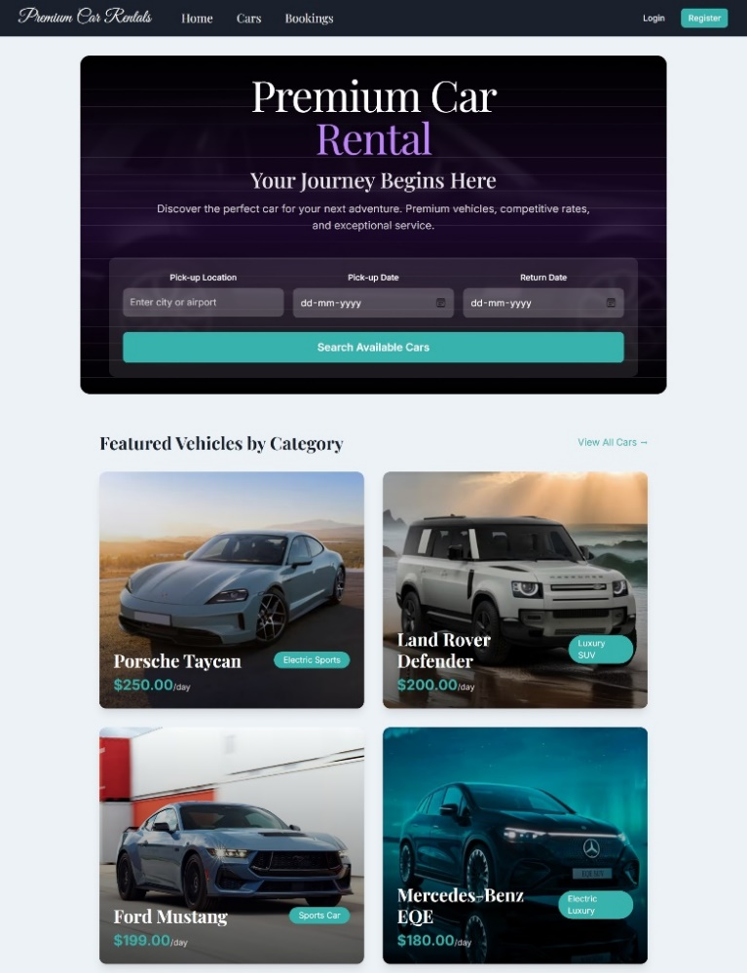
Fig 11.1 Home Page and Car details on Hover

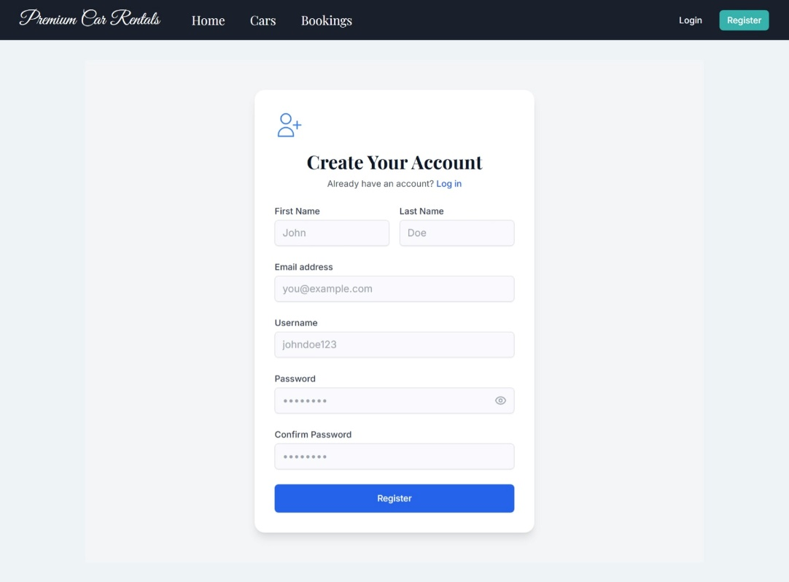
Fig 11.2: User Registration Page
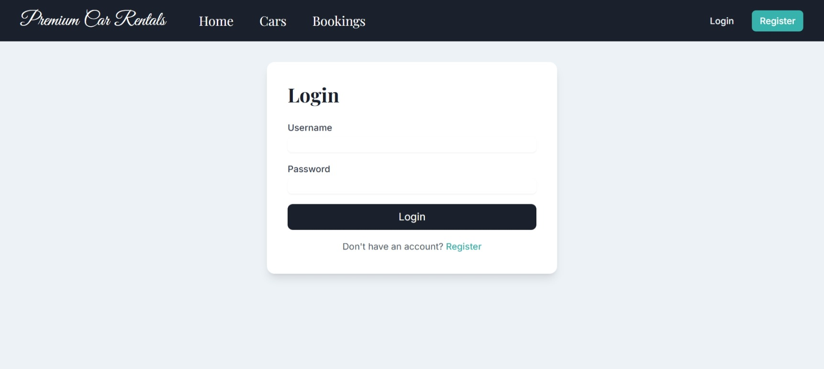
Fig 11.3: User Login Page

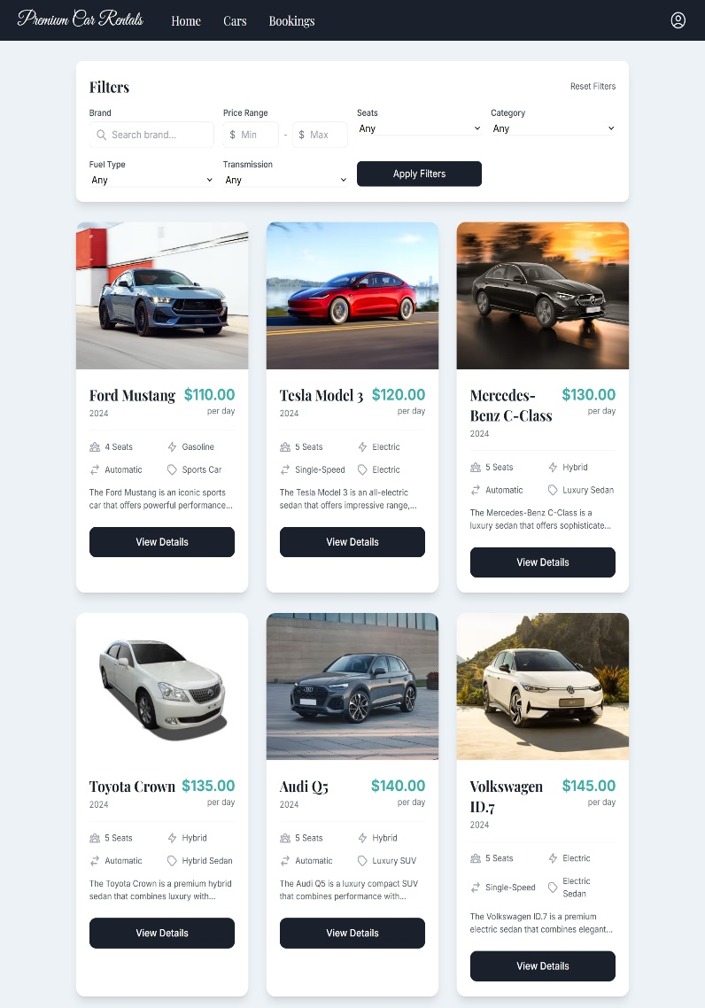
Fig 11.4: Cars Listing Page
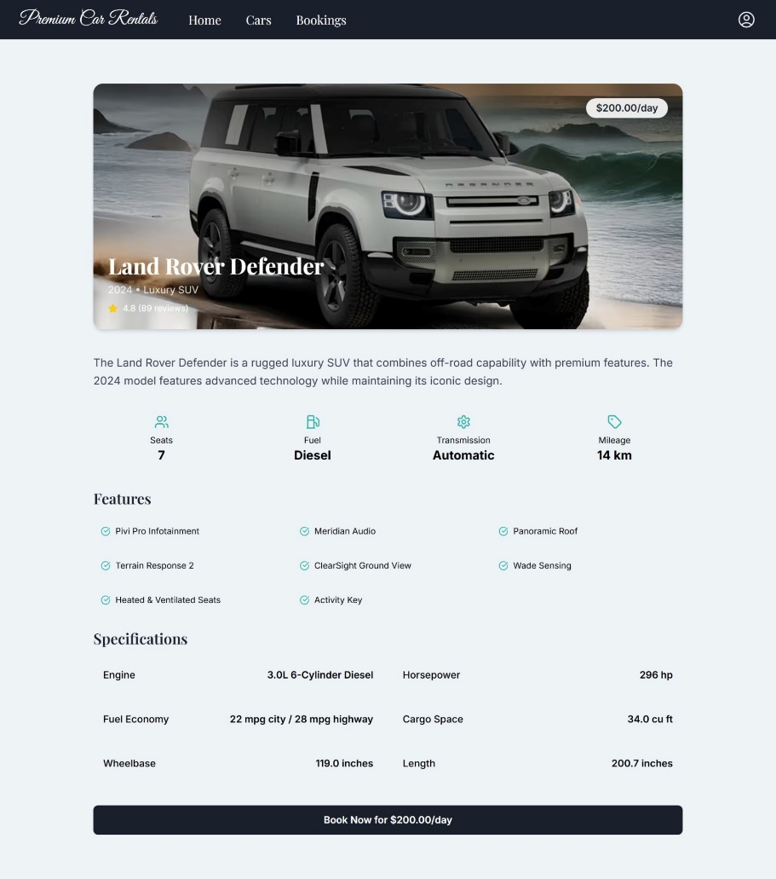
Fig 11.5: Car Details Page

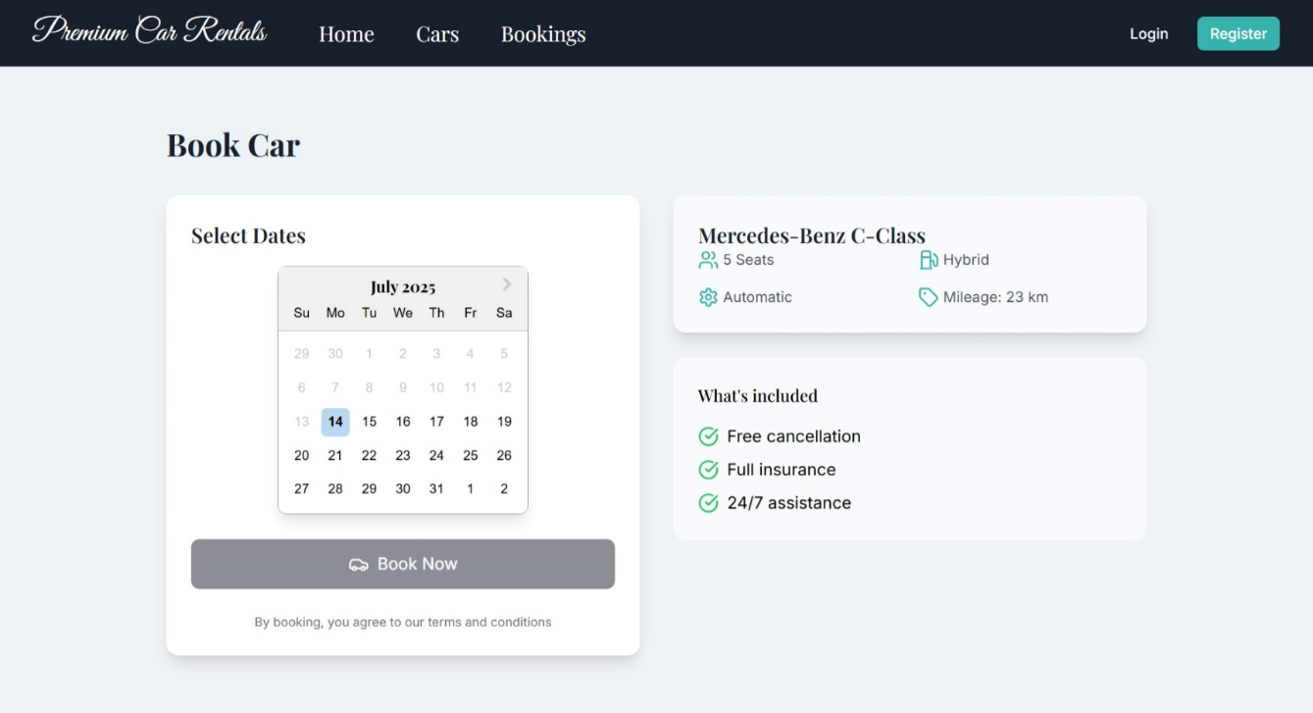
Fig 11.6: Car Booking Page
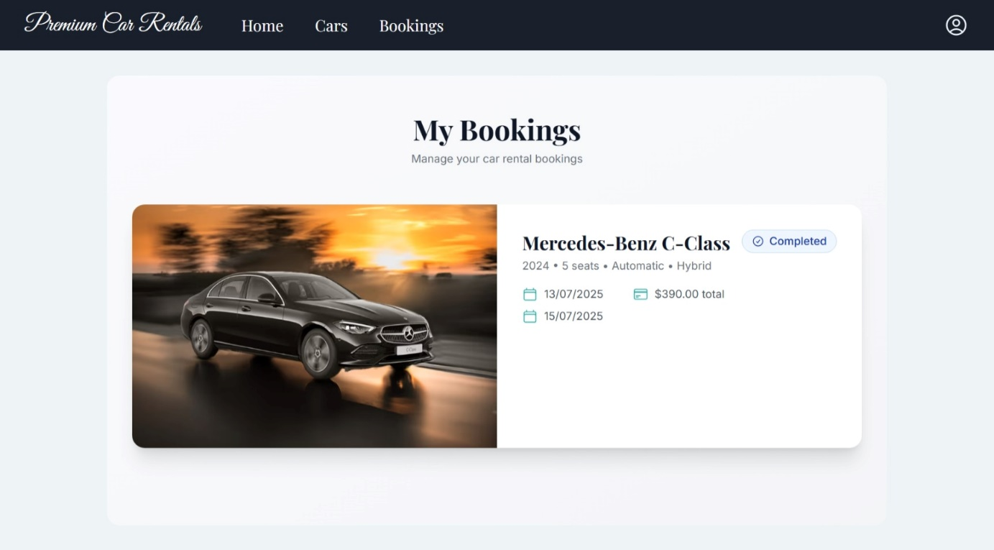
Fig 11.7: User Bookings Page

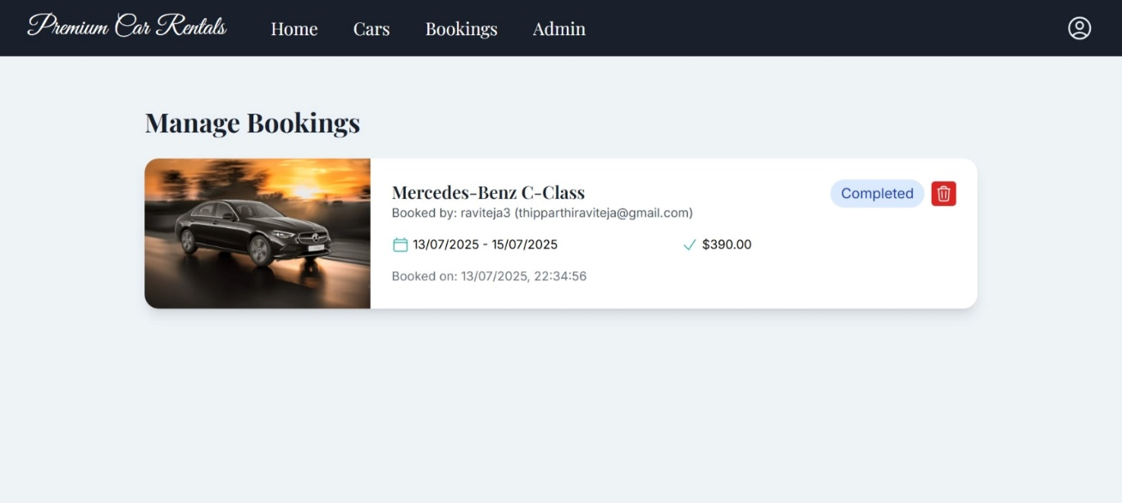
Fig 11.8: Admin Bookings Overview

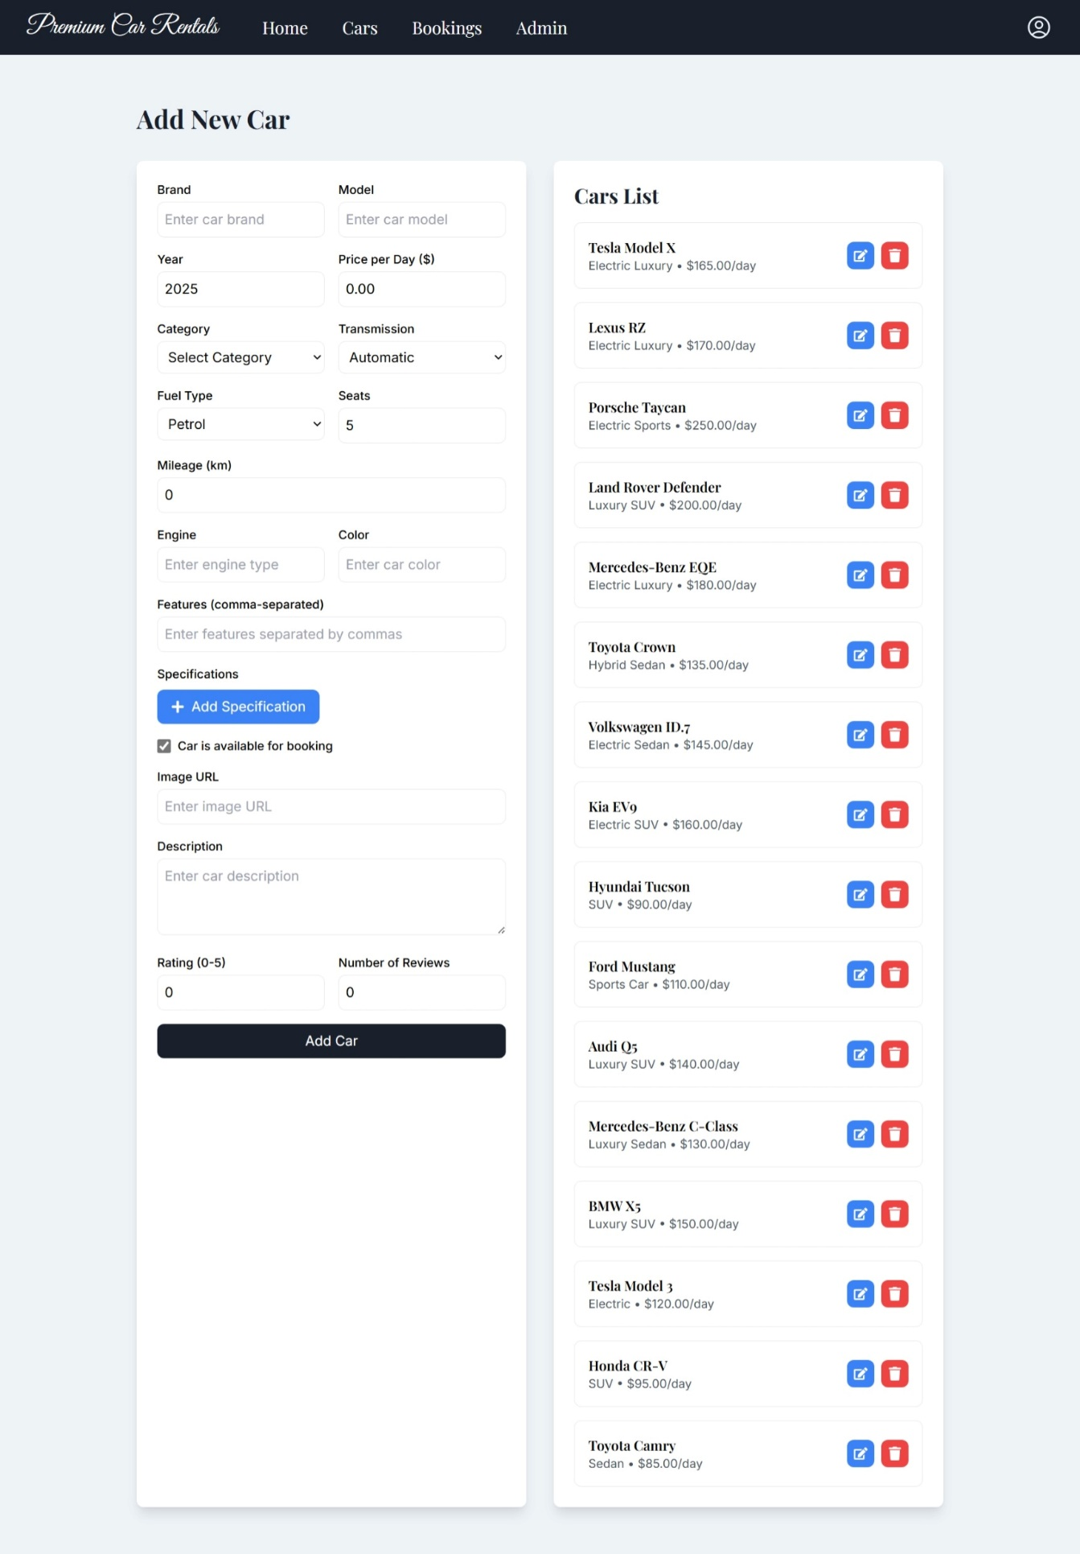
Fig 11.9: Admin Car Management Panel
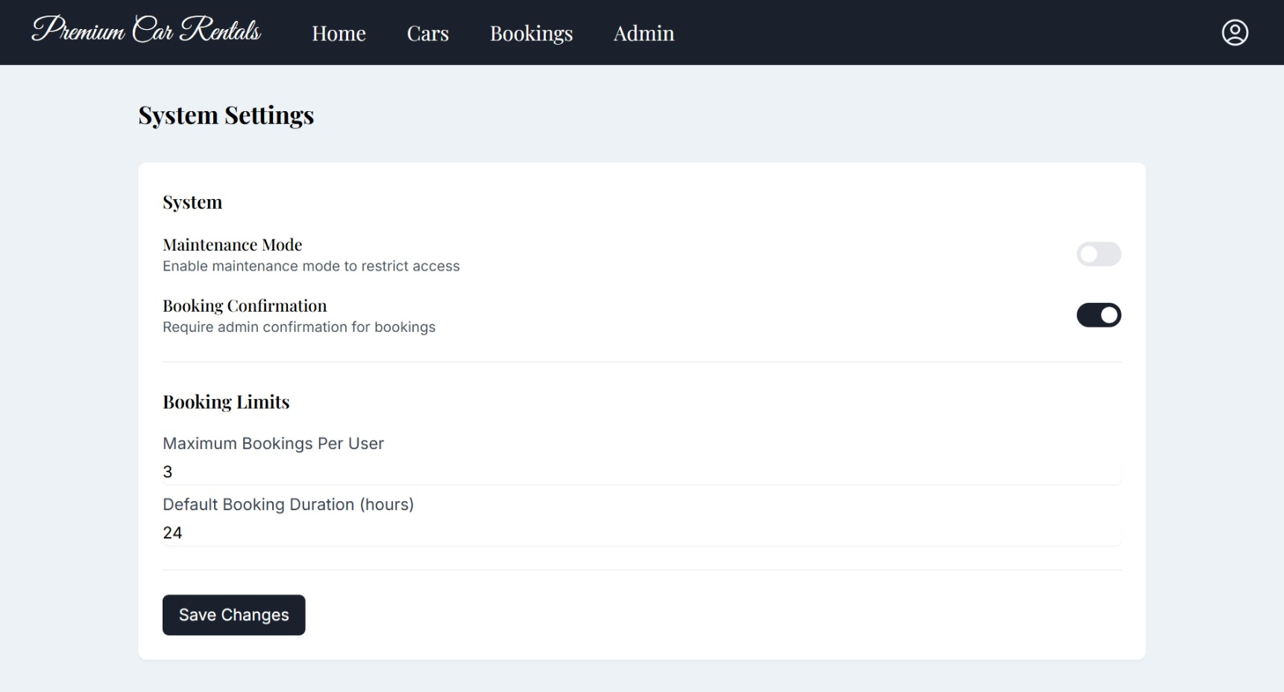
Fig 11.10: System Settings Page

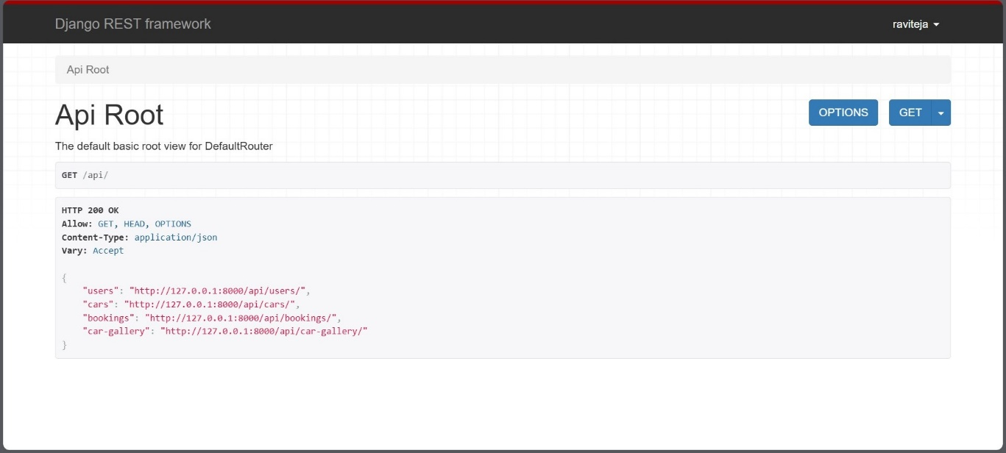
Fig 11.11: API Root Endpoints (Django REST Framework)

CONCLUSION
GrandCruise is a modern full-stack car booking platform developed with Django and React, designed to deliver a seamless and efficient experience for both customers and administrators. It features robust backend APIs using Django REST Framework and a responsive frontend built with React and TypeScript, styled using Tailwind CSS. The system supports JWT authentication for secure access, real-time vehicle availability, automated bookings, and admin tools for fleet management. Its modular architecture ensures scalability and maintainability, enabling easy future upgrades. With RESTful API design, component-based architecture, and responsive UI principles, GrandCruise adheres to full-stack development best practices. It overcomes limitations of traditional rental systems and sets a new benchmark in digital mobility solutions, enhancing both user satisfaction and business process automation.

FUTURE ENHANCEMENTS
Future enhancements for GrandCruise include developing a mobile app using React Native or Flutter for seamless booking and real-time updates on the go. Introducing an in-app wallet or UPI-based payment system would simplify transactions and improve user convenience. Real-time notifications via WebSockets or push alerts would boost engagement. Advanced analytics and AI-driven recommendations could optimize fleet use and personalize vehicle suggestions. Integration with GPS tracking, insurance, and maintenance services would streamline operations. Future innovations may involve blockchain-based smart contracts, IoT for vehicle diagnostics, VR showrooms for immersive experiences, and ride-sharing integration, establishing GrandCruise as a leader in next-gen digital mobility solutions.

REFERENCES
- Waspodo, Bayu, Qurrotul Aini, and Syamsuri Nur. "Development of car rental management information system." In Proceeding International Conference on Information Systems For Business Competitiveness (ICISBC), pp. 101-105. 2011.
- Osman, Mohd Nizam, Nurzaid Md Zain, Zulfikri Paidi, Khairul Anwar Sedek, Mohamad NajmuddinYusoff, and Mushahadah Maghribi. "Online Car Rental System Using Web-Based and SMS Technology." Computing Research & Innovation (CRINN) 2 (2017): 277.
- Fink, Andreas, and Torsten Reiners. "Modeling and solving the short-term car rental logistics problem." Transportation Research Part E: Logistics and Transportation Review 42, no. 4 (2006): 272-292.
- Khaled, Mr Shah Mostafa, Shamsil Arefin, Datta Sree Rajib Kumar, and Ariful Hossain Tuhin. "Software Requirements Specification for Online Car Rental System." (2015).
- Carroll, William J., and Richard C. Grimes. "Evolutionary change in product management: Experiences in the car rental industry." Interfaces 25, no. 5 (1995): 84-104.
- Beck, Kent, Mike Beedle, Arie Van Bennekum, Alistair Cockburn, Ward Cunningham, Martin Fowler, James Grenning et al. "Manifesto for agile software development." (2001): 2006.
- Abrahamsson, Pekka, Outi Salo, Jussi Ronkainen, and Juhani Warsta. "Agile software development methods: Review and analysis." arXiv preprint arXiv:1709.08439 (2017).
- Soares, Hécio A., and Raimundo S. Moura. "A methodology to guide writing Software Requirements Specification document." In 2015 Latin American Computing Conference (CLEI), pp. 1-11. IEEE, 2015.
- Sarker, M. I. H., N. Sultana, M. A. Hossain, and S. C. Das. "Design and Development of Web Based Car Rental System." In 2019 International Conference on Electrical, Computer and Communication Engineering (ECCE), pp. 1-6. IEEE, 2019.
- Singh, P. K., Neha, and Priyanka. "Design and implementation of an online car rental system." In 2017 International Conference on Computing, Communication and Automation (ICCCA), pp. 605-609. IEEE, 2017.

