Email Phishing PSO Extension

In this project as extension we have added PSO algorithm and below are the results of the extended algorithm

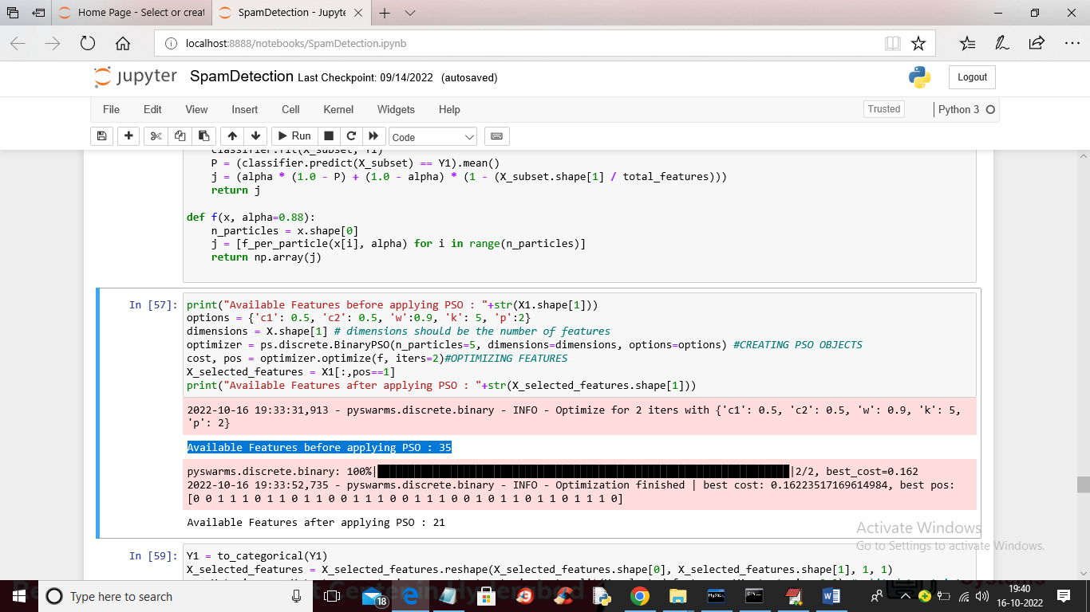

In above screen in blue colour text we can see before applying PSO, PCA features was 35 and after applying PSO those features are reduced to 21 which you can see in next lines.

In below screen we are showing CNN accuracy on PSO features

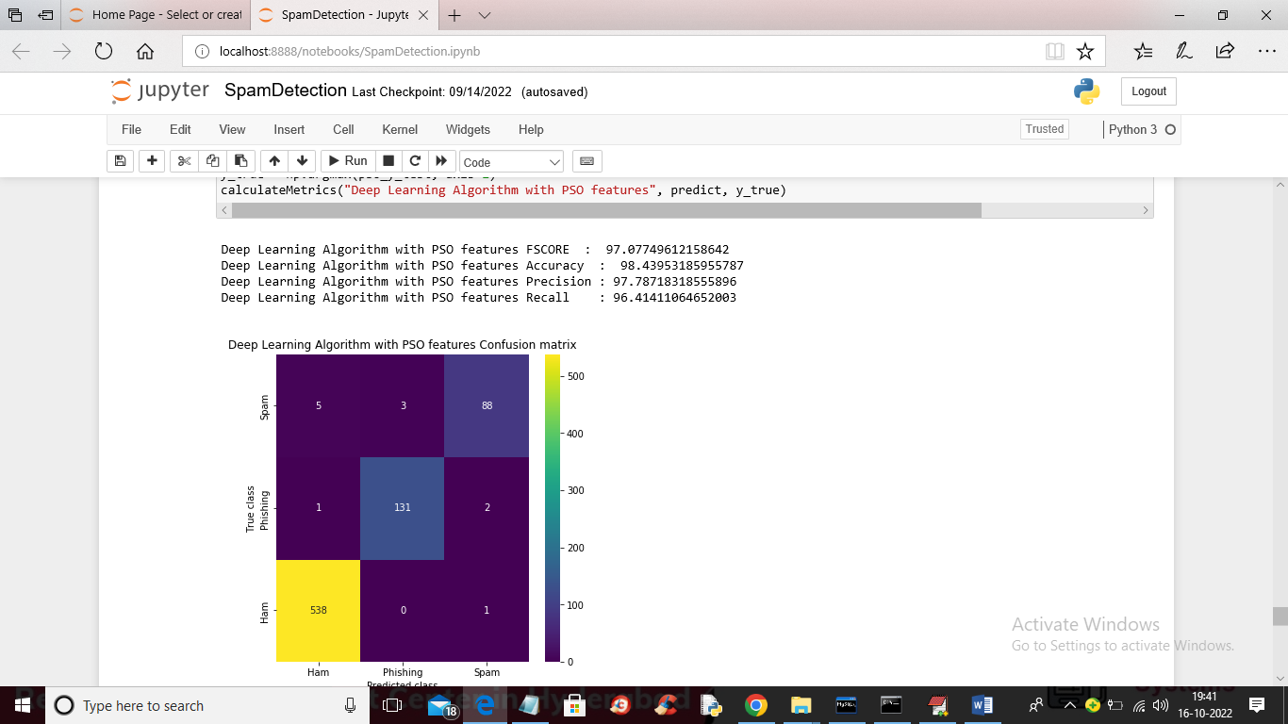

In above screen with PSO features we got 98% accuracy which is higher than all other existing algorithms. In below screen we are showing comparison graph between all algorithms

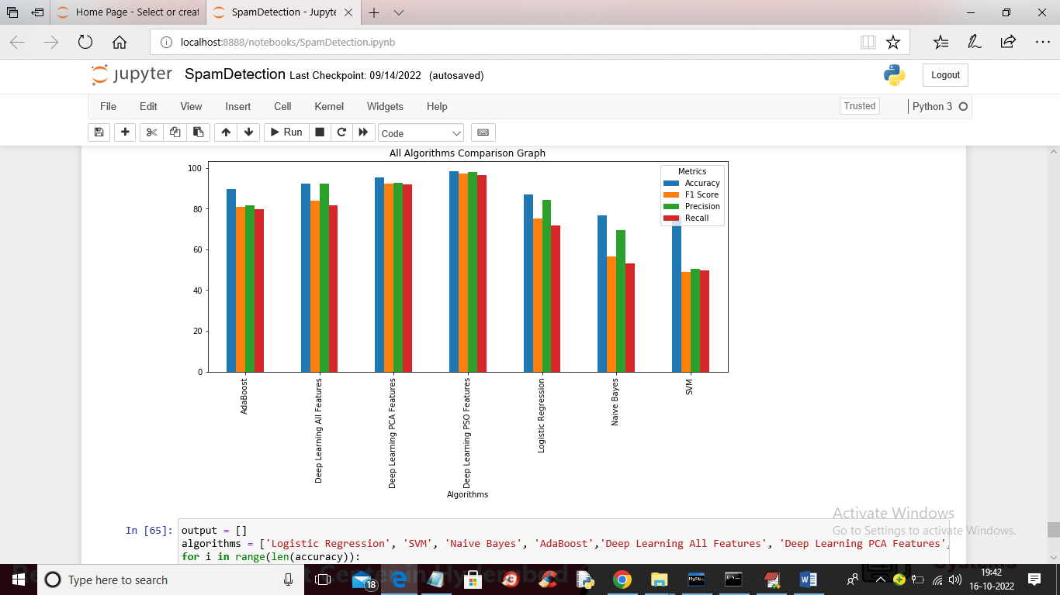

In above graph PSO with Deep Learning got high metric performance. In below screen we can see all algorithms result in tabular format

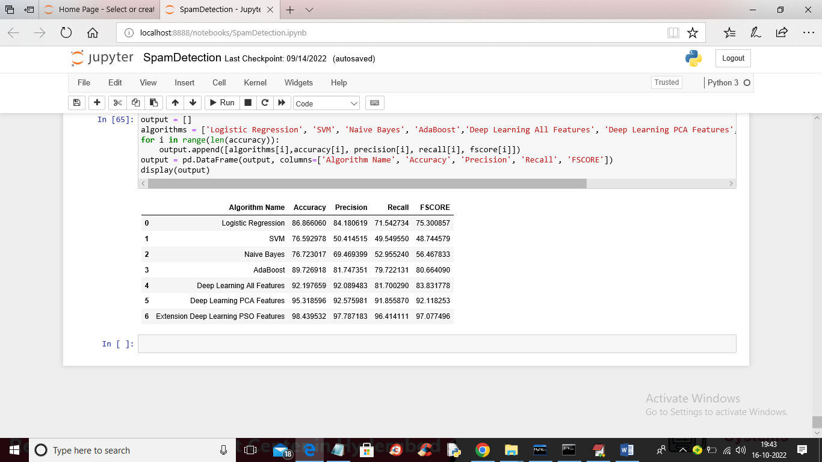

In above table you can see result of all algorithms and in all algorithms PSO with deep learning got high accuracy