INTRODUCTION

Routledge is an Ecommerce Application providing products like Printed books, eBooks, and rental books to customers through E-commerce website. eCommerce Admin tool manages discount management system to provide discounts to various products and these discounts will reflect on Routledge web site, preparing reports, managing user accounts and user roles, customer lookups, managing different orders and invoices.

Currently Rebuilding New Admin Tool from Old Admin Tool

Old Admin Tool URL: [Old Admin Tool](http://use1apuntjobsp1.ap.corplan.net/ecommerce-admin/login.jsf)

New Admin Tool URL: [New Admin Tool Link](http://routledge-admintool-web-prod.ap.corplan.net/#/login)

**ARCHITECHTURE**

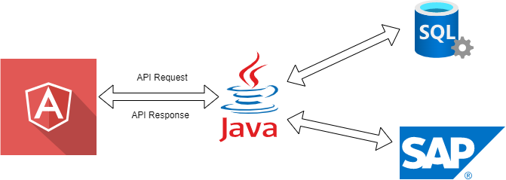

Angular is used for Frond end in Admin Tool Application. Angular will make API calls to core and from core will connect with either SQL or SAP/MuleSoft and send back the response to Angular application to display the data.

**INFRASTRUCTURE**

The required infrastructure setup will be created automatically and dynamically through GitHub when code has been deployed.

The required setup can be created through GitHub and configurations can be found in **main.yml** file in repository.

GitHub Repository for eCommerce Admin Tool is

<https://github.com/tandfgroup/ubw-admintool-web>

Note: eCommerce admin tool will connect either with VPN or ZScalar due to the domains are not public faced domains and those are internal.

|  |  |  |  |
| --- | --- | --- | --- |
|  | PROD | UAT | DEV |
| New Admin Tool | <http://routledge-admintool-web-prod.ap.corplan.net/#/login> | <http://routledge-admintool-web-uat.ap.corplan.net/#/login> | <http://routledge-admintool-web-dev.ap.corplan.net/#/login> |
| Old Admin Tool | <http://use1apuntjobsp1.ap.corplan.net/ecommerce-admin/login.jsf> | <http://use1apuntjobsu1.na.corplan.net:8080/ecommerce-admin/login.jsf> | <http://use1apuntjobsd1.na.corplan.net:8080/ecommerce-admin/login.jsf> |

**Discount Management System (DMS)**

Discount Management is the place where the discounts for the sales can be applied for a particular period and the discounts can be edited or deleted throughout the sale period.

Once we click on the discount management system from the board, we will be navigated to the DMS section where we can see two sections which are **SALES** which will be displayed in a tabular format.

From the table, we can find all the details of a particular discount and from the table itself we can edit, clone, or even delete a particular discount. On top of the table, we can have a search bar from which we can search the discounts.

On the discounts page we will be having three types of discounts which are Active, Scheduled, Expired. Active discounts are the discounts which are currently active. Schedules discounts are the discounts which will be active in future. Expires discounts are the past discounts which are currently Inactive.

In DMS, we also have an option to download all the sales and promotions.

To download the sales or promotions we can click on the green download button which is placed right to the sales status.

The DMS looks like the below screenshot.

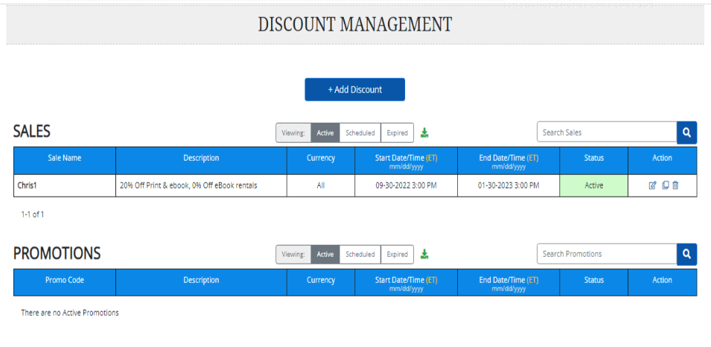

Once we clicks on the download button the sales or promotions will be downloaded and exported to the excel sheet as shown below.

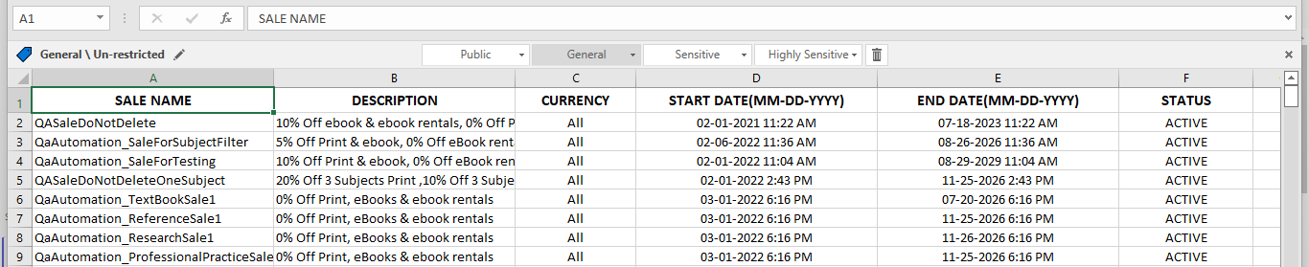

In DMS if we can a new discount either sale or promotion by clicking on the add discount button on the top.

Once we have clicked on add discount, we will be navigated to the add discount page where we will be having a form to fill the details and then add the discount.

We can add 4 kinds of discounts which were

* + Sale by ISBN
  + Sale by Product Attributes
  + Promotion by ISBN
  + Promotion by Product Attributes

**SALE BY ISBN**

In Sale by ISBN, we must include some specific ISBNs in the specific products section, and we can even select the regions and can mention what percentage of discount can be applied for paperback, hardback and eBooks individually.

On the bottom we can have a SALE EVENT page where we can mention the sale parameter.

we can search all the discounted products or that specific sale event products can be searched through the sale event parameter keyword in the Routledge website, then all the products of the specific sale event will be fetched and displayed, we can also upload a banner which will be displayed on the Routledge website during the sales.

Here we can have a tier section where we can set the percentage of discounts that should be applied to hardback, paperback, and eBooks.

The discounts will be auto applied to the products with ISBNs that we include while creating the sale.

While creating a discount of type SALE also we should include the promocode value where this promocode will be auto applied for the ISBNs that we include.

We can add up to 5 tier discounts.

**SALE BY PRODUCT ATTRIBUTES**

Sale by Product Attributes have additional section called **Product attributes** in which we can apply some filters to the products. It will have **Text types** where we can include or exclude different textbook types, and another one is **Subjects** in this subject category we can include the subjects and we can exclude the subjects as well and in **subjects categories** there will be two check boxes to include and exclude the sub-categories. In **Brands** we will have various brands like Apple Academic Press, Chapmann & Hall, CRC Press, etc., those can be included and excluded also.

**PROMOTION BY ISBN**

In promotion by ISBN, we were required to add a valid promocode which can be used to apply while buying the books to gets the discounts.

Unlike sale by ISBN this will not be auto applied to the products, it has to applied to the books manually while check out.

The promocode we add while creating the discount will be applicable to the products only to those ISBNs that were added during the creation of the discount. We can see a stackable promocode if it is checked then it means if any ISBN is on sale and the **stackable promo code** is checkedthen the discount will be applied on top of the sale.one thing to remember in PROMOTIONS is the promocode will not be auto applied unlike it happened in sales.

**PROMOTION BY PRODUCT ATTRIBUTES**

Promotion by Product Attributes is similar to Promotion by ISBN with an additional section called product attributes.

In this category there are different sub categories like the **Text types** where we can include or exclude different textbook types, and another one is **Subjects** in this subject category we can include the subjects and we can exclude the subjects as well and also in subjects we can have a option to include the sub categories or exclude the sub categories by checking the check box.

In **Brands** we will have various brands like Apple Academic Press, Chapmann & Hall, CRC Press etc., those can be included and excluded also.

When a Sale discount is created the promocode will be auto applied to the products mentioned whereas in Promotions discounts the promocode has to be entered while checking out the product from cart.

The product attributes section will only display when either Sale by Product Attributes or Promotion by Product Attributes is selected.

And stackable promocode will only comes when the discount selected from the dropdown is Promotion only it could be either Promotion by ISBN or Promotion by Product Attributes.

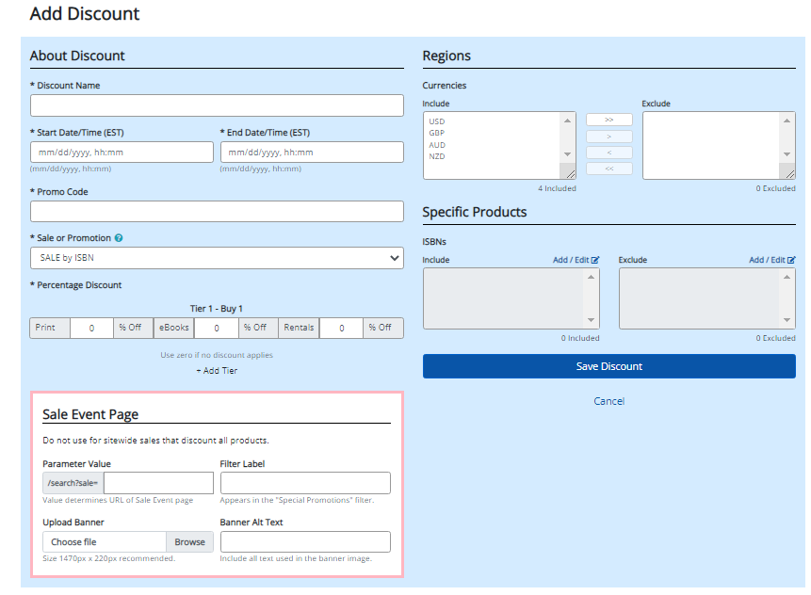

The above screenshot shows the Add Discount Page in DMS where we can add a new discount.

For requirements refer ticket: [GSD-4800](https://taylorfrancis.atlassian.net/browse/GSD-4800)

**CURRENCY EXCHANGE RATES**

Currency Exchange Rate App loads the data about currency exchange rates based on GBP and the currencies displaying in the Currency Exchange Rates app are **GBP, AUD, NZD, USD.**

The currency details are maintained by SAP and those details are provided by MuleSoft through API’s. Angular making API call to core and core team making API call to MuleSoft to get currency details from Jan 2019 to till current month.

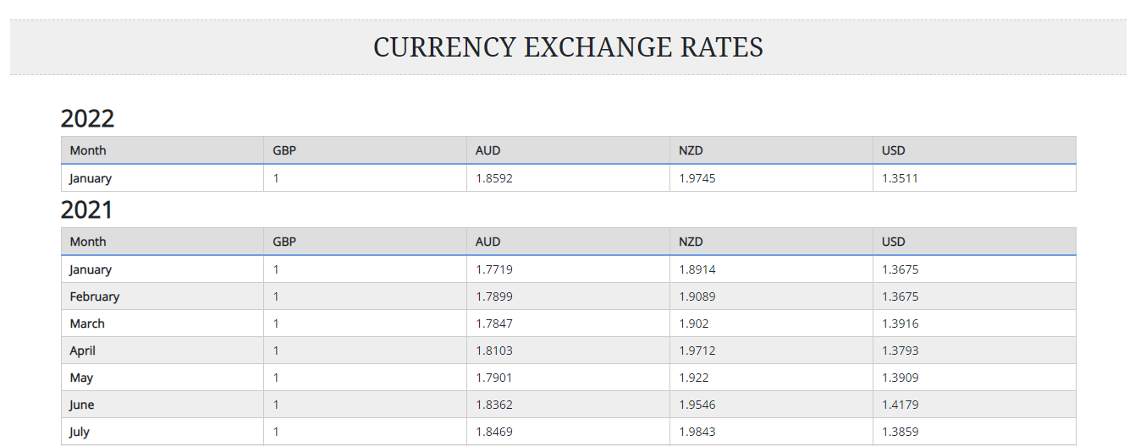

**API used for Currency Exchange Rate**

[**http://routledge-admintool-core-dev.ap.corplan.net/exchangeRate/findAll**](http://routledge-admintool-core-dev.ap.corplan.net/exchangeRate/findAll)

**Ticket:** for complete requirements refer ticket [GSD-3015](https://taylorfrancis.atlassian.net/browse/GSD-3015)

**MONTHLY ORDER REPORT**

Monthly Order report provides total sales and orders of a particular month and also user can see each day sales, orders based on user’s selection of month, Year and Currency.

By default, monthly order report shows current month information in GBP currency till current date of the month.

Based on user selection in month, year, currency and click on **GO** button, the data will load on page.

The loaded data on web page can be exported to spreadsheet by clicking on download button.

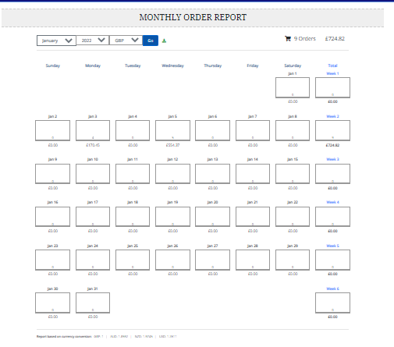

The currency exchange rates for the month can be seen at the bottom of the screen.

**API used for Monthly Order Report**

<http://routledge-admintool-core-dev.ap.corplan.net/report/monthlyOrderReport?month=1&year=2022&currencyType=gbp>

currency types used for this API: GBP, USD, AUD, NZD

**Ticket:** for complete requirements refer ticket [GSD-2634](https://taylorfrancis.atlassian.net/browse/GSD-2634)

**WEB ORDER REPORT**

Web Order report provides order details and the details of the customer between the date range that the user has selected.

Once the user has selected all the fields like start-date, end-date, format and then click on the Go button then a list of all the orders present between the selected date range will be fetched and displayed in a tabular format in UI

By default, Format can be selected as **All**, the user can choose between **Print Only** and **eBook Only** instead of **All** to check the data as he needs to.

Once Print Only is selected then Print book orders details only displayed and if E-book Only is selected then E-book orders details only displayed.

There is an additional option which is Line-items if we select that one then we can see some additional fields in UI like ISBN, SKU, VT CODE, VERSION TYPE etc.

We are doing pagination here like in a single page only 20 items will be displayed, for the next items we can click on the page numbers which were placed below to the UI table.

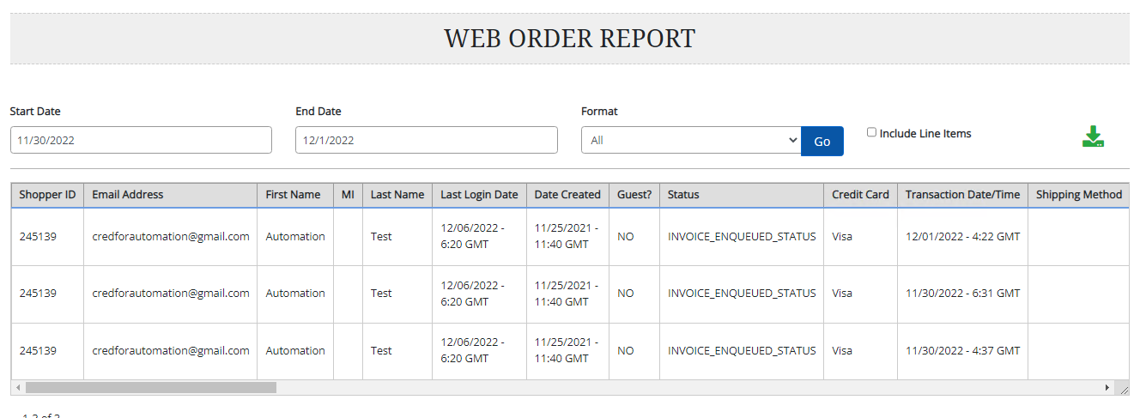

Users can also download the web order report by clicking on the green download button which is placed on the right side of the page.

Once the button is clicked then the web order report is generated and downloaded as a csv file, in that file we will have all the orders data in the date range selected.

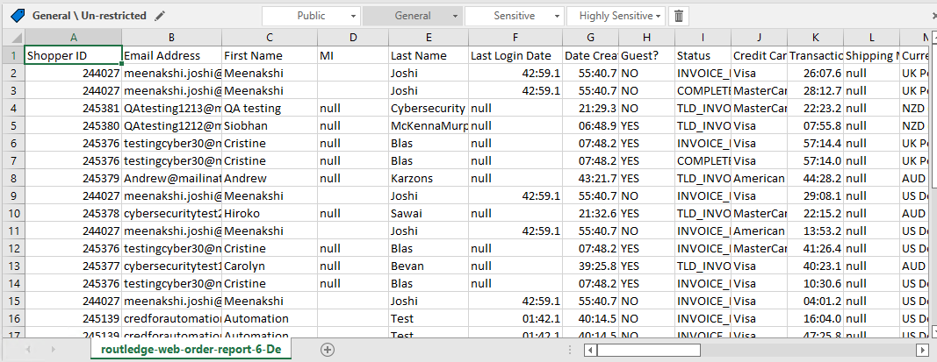

The downloaded excel sheet will looks like the above screenshot.

**API Used for web order report**

<http://routledge-admintool-core-uat.ap.corplan.net/report/weborder>

**Ticket:** For complete requirements refer ticket[**GSD-3873**](https://taylorfrancis.atlassian.net/browse/GSD-3873)

**CUSTOMER LOOKUP**

Customer Lookup gives all the information about the users like

* Invoice details
* Personal details
* Email Subscriptions
* Payment details
* Privileges of a customer
* Shopping carts information
* Email subscriptions of a customer

From the Admintool dashboard we can see the link for **customer loookup** under **customer affiliates.**

Once we click on the link in dashboard user will be navigated to the customer lookup page where we can have a search bar to search for a user either with the last name or with the email.

Once we enter the username or email and click on search, we can see a list of matching results and once we click on a particular user customerID then all the related data of that particular customer will be displayed.

The customer lookup user details page will look like the above where we can have all the user details like the invoices, subscriptions, payments and all.

Once we click on each link then the links will expand, and we can see all the details related to that user in a table format.

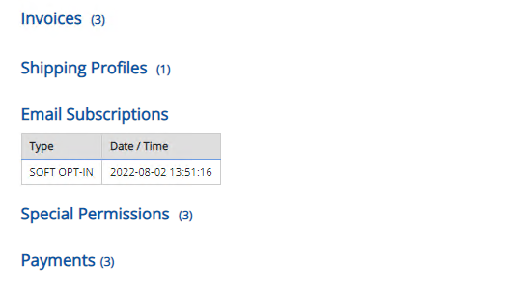

Once we click on the links then we can see the details in a table as shown in above image.

If the user clicks on **back to list** link at the top of the page, then the user will be navigated to the previous page where we can see a list of customer names that matches with the search keyword from there we can click on another user in the list If we want to go see some other user details.

All the details and requirements can be found on the ticket: [GSD-3970.](https://taylorfrancis.atlassian.net/browse/GSD-3970)

**TAX CONFIGURATION**

In the Tax Configuration page, we are showing how much percentages of VAT and shipping tax are being applied for Hard copy products (Paperback, Hardback) and Digital Products(E-books).

The tax values are being taken from the excel sheet and displayed in UI.These values will vary from country to country and region to region.

If the product is Hardback or Paperback in Routledge website then the taxes are being applied from the HARD COPY PRODUCTS section in TAX CONFIGURATION PAGE, and if it is an E-book then the taxes are taken from the DIGITAL PRODUCTS section in the TAX CONFIGURATION PAGE.

Whatever the countries which are listed in the Tax configuration Page which will take the tax percentage as displayed there in their corresponding rows, but what are the other countries which are not listed there but using GBP currency then those countries will fall under the UK Tax rules.

If a book is being shipped from the distribution center of UK, then UK tax rules will be applied and if a book is being shipped from the distribution center of EU, then EU tax rules will be applied.

If the books are being shipped from the EU region, they will have a POD. If the book has POD as PODEURG or PODEUPF then EU tax rules will be applied for that book. If a book does not have any POD, then in that case it will fall under UK tax rules.

In the tax configuration page, we can see the first column is the vat percentage for UK region and the second column is the shipping tax percentage for UK region whereas the third and fourth columns represents the corresponding VAT and shipping tax percentages for EU Region.

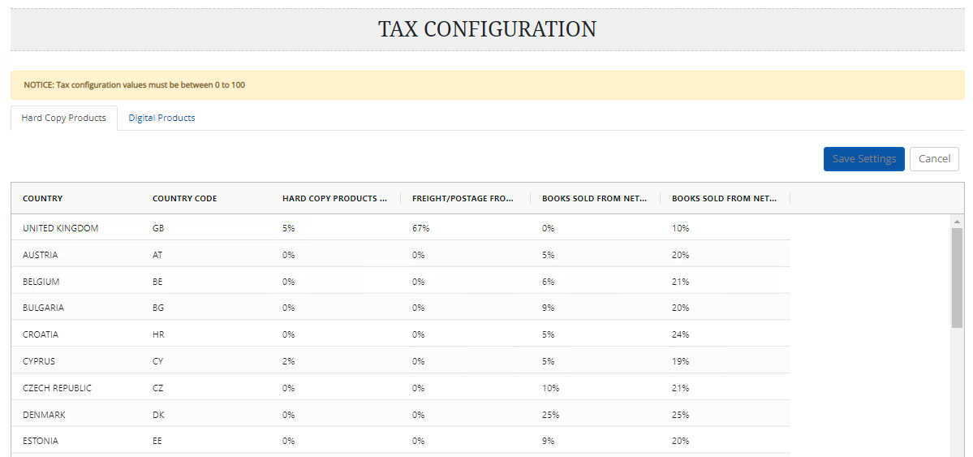For UK and EU tax rules we can refer to this confluence page [UK and EU tax rules](https://taylorfrancis.atlassian.net/wiki/spaces/ROUT/pages/2748088397/Ship+From+Address+Determination+Requirements+for+UK+or+EU+Taxation)

We can edit the values and click on save then the values will be updated and being saved to the database.

The TAX-CONFIGURATION Page looks like the above screenshot.

For complete details and requirements refer to ticket : [GSD-5718](https://taylorfrancis.atlassian.net/browse/GSD-5718)

**PRODUCT SETTINGS**

Product settings page basically gives us information about how many days before a book is available on the website before it has been published.

In product settings page we can see different options like

**Products** **appear (# of days before publishing)** - for this field the value by default is 180, which means a book will be live and available on the website before 180 days of its publishing date, the book is available, but it cannot be available to buy.

**Products Can Be Pre-Ordered (# of days before publishing)**

In GBP,USD regions a book can be pre-ordered before 21 days to its publishing date, and

after the customer has pre-ordered the book the book has to dispatch within 28days of

Publishing.

In AZD,NZD region a book can be pre-ordered before 180 days to it’s publishing date.

We can refer to the above screenshot to know how product settings page will looks like.

For complete requirements refer ticket: [GSD - 5049](https://taylorfrancis.atlassian.net/browse/GSD-5049)

**CATEGORY HELPER**

Category helper is a page where all the **Subject Codes** and **Web Codes** are displayed in a hierarchical tree structure. It is a read only page where we can see all the subject codes and it’s sub-categories and all the web-codes and it’s sub-categories as a tree structure.

In **Subject Codes** the root element is **CRC – CRC ROOT** which is having so many sub-categories like the BUS – Business Management, CHE- Chemistry, ENG – Engineering – General etc.

In **Web codes** the root element is **SC – Subject Code,** Under this root element there are many child elements like SCED – Education, SDEC – Engineering & Technology which may again have some child elements.

The category helper will looks like the below image.

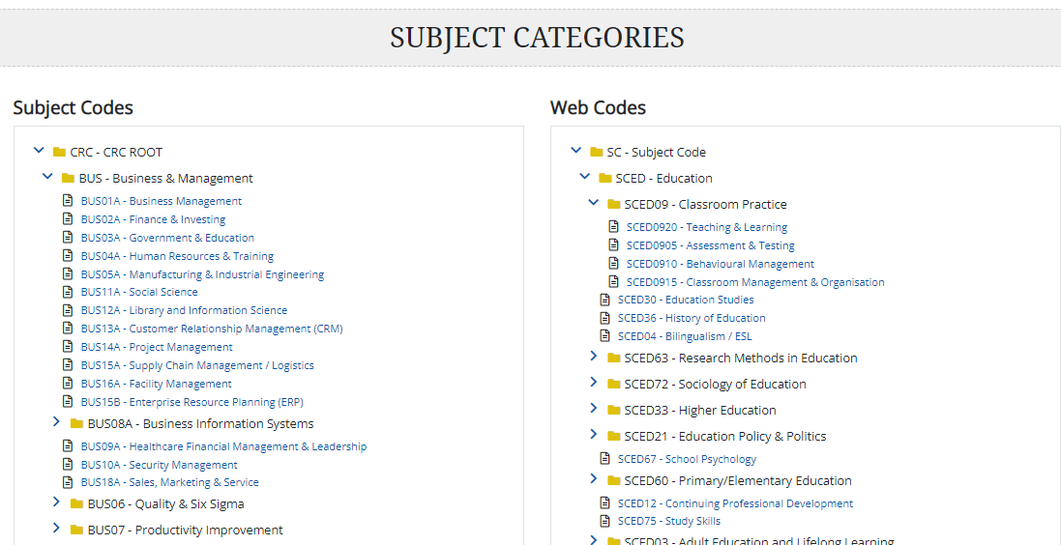

The Category Helper will represent the Subject-Codes, Web-Codes in a hierarchical tree structure like in the above image.

For complete requirements and details refer ticket : [GSD-6454](https://taylorfrancis.atlassian.net/browse/GSD-6454)