Automatic Sanitizer Sprayer

Submitted to

Robotics Club SASTRA

Submitted by

Ravi teja E

Problem statement:

As we all know that present days are such that we must wash our hands frequently. Corona made us to wash our hands punctually. But there is a problem as we can’t wash hands in public places and we can’t even dare to touch the taps in public places. then how we can wash or clean our hands?

I have an idea the, it can spray sanitizer instead of water which can also clean our hands when we keep our hands near it.

Real life application:

It is not only used to spray sanitizer but also water to clean our hands. This application is used to reduce spreading of corona through contact surfaces such as taps.

Components Required:

|  |  |  |
| --- | --- | --- |
| S.no | Component Name | Quantity |
| 1. | Breadboard small | 1 |
| 2. | Connecting / jumper wires |  |
| 3. | Arduino UNO/ESP8266 | 1 |
| 4. | H Bridge Motor Driver(L298N) | 1 |
| 5. | DC Gear motor | 2 |
| 6. | Ultrasonic sensor (HC-SR04) | 1 |
| 7. | Battery (voltage depends on voltage of motor) | 1 |
| 8. | Transistor (IC7805) | 1 |
|  |  |  |
|  |  |  |

**Circuit diagram:**

**PINOUT DIAGRAMS OF EACH COMPONENT USED:**

**a) Arduino uno:**

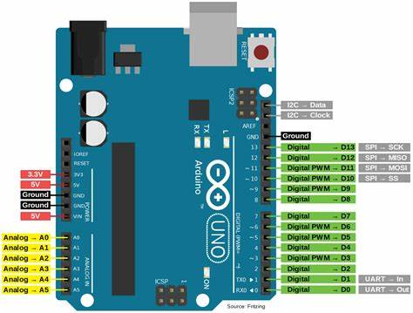

**b) ESP8266:**

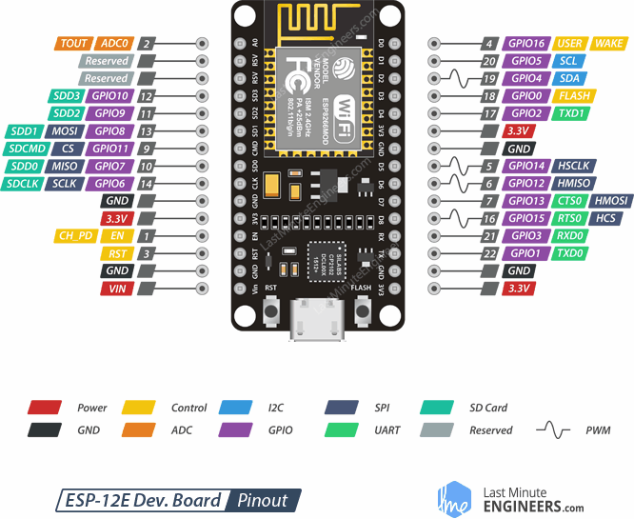

**c)Ultrasonic sensor:**

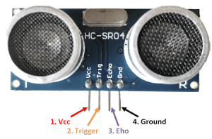

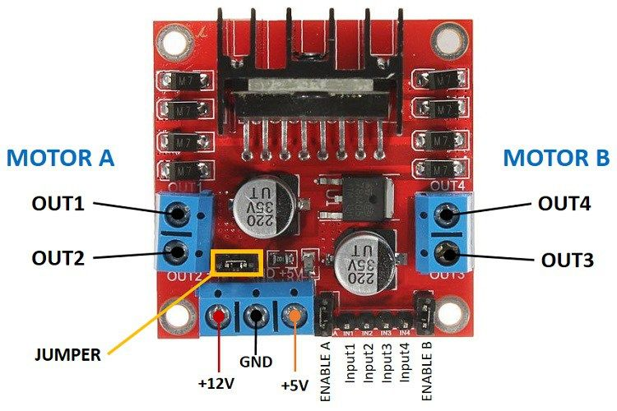**d)Motor driver(L298N):**

**1.) The below circuit diagram represents the connections using ESP8266 module**

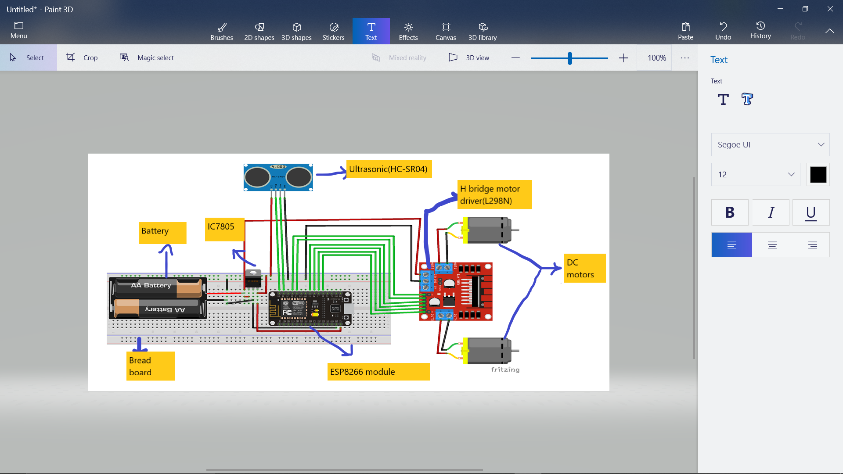

**2.) The below diagram represents circuit diagram using Arduino UNO board**

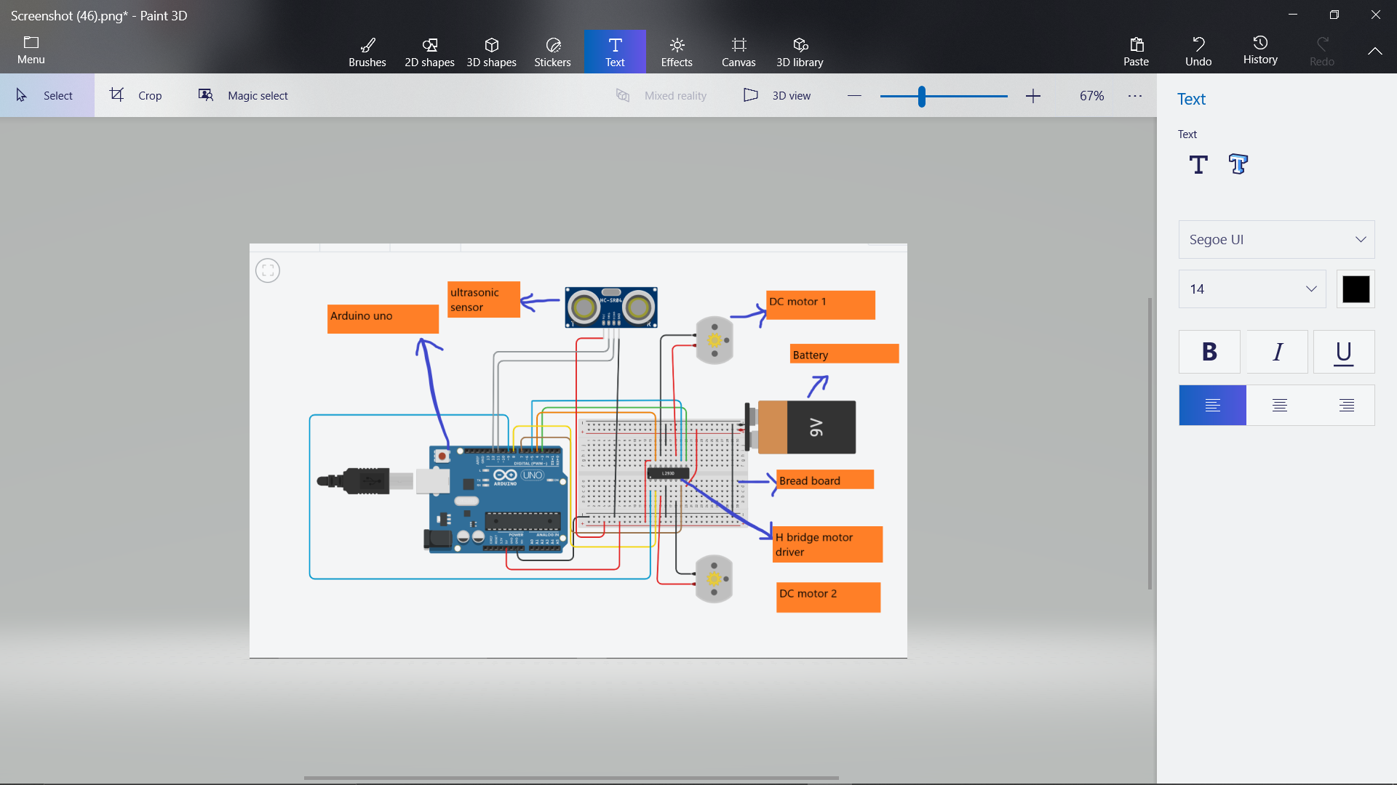

**Simple sketch of my concept:**

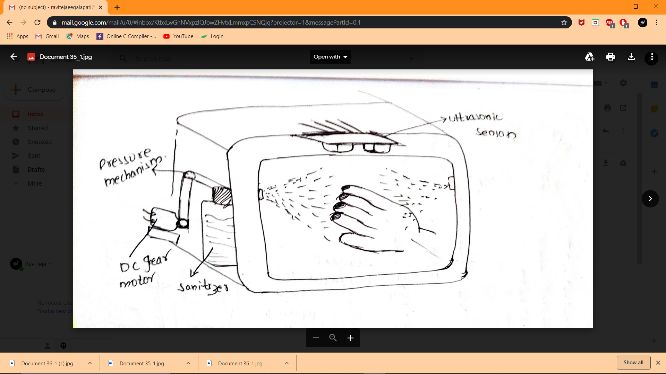

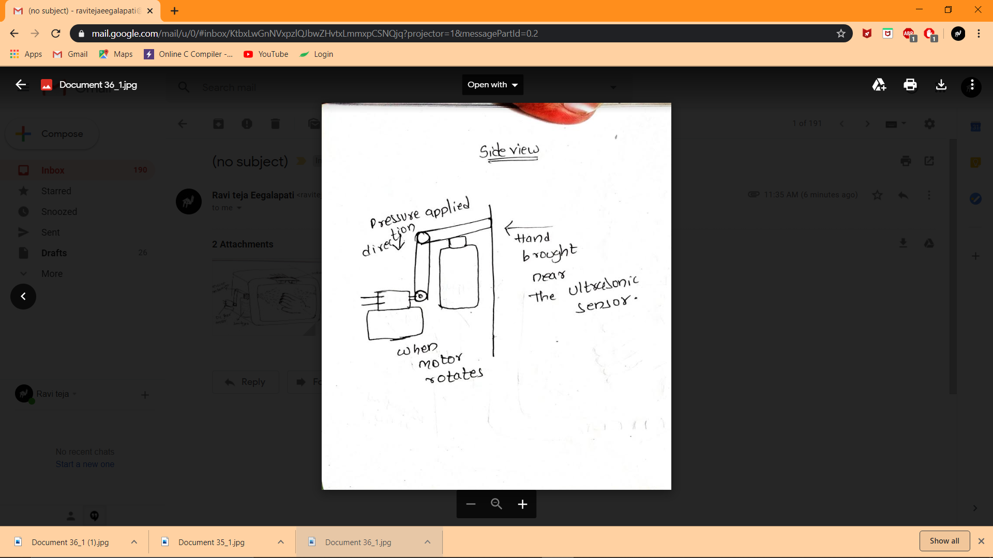

Working princle:

This works very simply.the one we should know is how we should use this . When we place our hand near the sensor it detects the motion and recognises our hand and activates motor driver and torns on the two motors so that the when motor rotates the motion from armeture transforms to the gears and then to the the lever attached to the gears so that lever applies pressure on the spray so that it sprays sanitizer on hands . so it is ver simple working mechanism.

**Code explanation:**

**/* Motor A connections*/**

int enA = 9;

int in1 = 8;

int in2 = 7;

**/* Motor B connections*/**

int enB = 3;

int in3 = 5;

int in4 = 4;

int spd=200;

**/*ultrasonic sensor connections*/**

int trigPin=12; **//declaring trigger pin**

int echoPin=11; **//declaring echo pin**

long duration; **// declaring variable for storing time**

int distance; **// declaring variable for storing distance**

**/* function for opening the box*/**

void SPRAY()

{

analogWrite(enA, spd); **// writing the speed to left motor**

analogWrite(enB, spd); **// writing the speed to right motor**

**/* first motor forward direction*/**

digitalWrite(in1, HIGH);

digitalWrite(in2, LOW);

**/*second motor forward direction*/**

digitalWrite(in3,HIGH);

digitalWrite(in4,LOW);

delay(50);

Serial.println("spray"); **/*prints spray on serial monitor*/**

}

**/*function for stopping the motors*/**

void STOP()

{

analogWrite(enA, spd); **// writing the speed to left motor**

analogWrite(enB, spd); **// writing the speed to right motor**

**/*first motor stops*/**

digitalWrite(in1, LOW);

digitalWrite(in2, LOW);

**/*second motor stops */**

digitalWrite(in3, LOW);

digitalWrite(in4, LOW);

Serial.println("STOP");

}

void setup()

{

pinMode(trigPin, OUTPUT); **// Sets the trigPin as an Output**

pinMode(echoPin, INPUT); **// Sets the echoPin as an Input**

pinMode(enA,OUTPUT);

pinMode(enB,OUTPUT);

pinMode(in1, OUTPUT);

pinMode(in2, OUTPUT);

pinMode(in3, OUTPUT);

pinMode(in4, OUTPUT);

**/*initially stops the motor*/**

digitalWrite(in1, LOW);

digitalWrite(in2, LOW);

digitalWrite(in3, LOW);

digitalWrite(in4, LOW);

Serial.begin(9600);**//for printing data in computer**

}

void loop()

{

digitalWrite(trigPin, LOW);**/*Intialize trigpin to low*/**

delayMicroseconds(2);**/*wait for 2 micro seconds*/**

digitalWrite(trigPin, HIGH); **/* Sets the trigPin on HIGH state for 10 micro seconds*/**

delayMicroseconds(10);

digitalWrite(trigPin, LOW**);/* After 10 micro seconds make it low*/**

duration = pulseIn(echoPin, HIGH); **/* Reads the echoPin, returns the sound wave travel time in microseconds*/**

distance= duration*0.034/2; **/* Calculating the distance*/**

if(distance<10) **/*if the calculated distance is less than 15 cm (can be changed)then this loop will be excecuted and the box will be opened*/**

{

SPRAY(); **/*calls SPRAY function when motion detected*/**

delay (3000);

}

else

{

STOP (); **/*if there are no motion calls stop function*/**

}

}

Conclusion:

This project will definitely helpful for spraying santitizer for hand wash and will help in decreasing spread of corona due to surface contacts.It is very useful in using ultrasonic sensor to detect the gesture.