EOS QUARK
Application Architecture
Architecture Review Document
Document information | Value
Purpose | Application architecture review and approval
Scope | Angular UI, Backend API, Upload Service, Batch Service and Engine Service
Core integrations | Oracle, RabbitMQ, object/document storage, QXPS HTTP and QXPSM SOAP
Prepared | 20 August 2026
Status | For architecture review

Executive overview
EOS Quark is an enterprise document-production application. It combines configured business data with QuarkXPress templates to create controlled QXP, PDF and JPEG outputs. The application separates interactive workflows, file intake, scheduled orchestration and document rendering into focused services connected through REST APIs, RabbitMQ and governed data contracts.

1. Purpose and scope
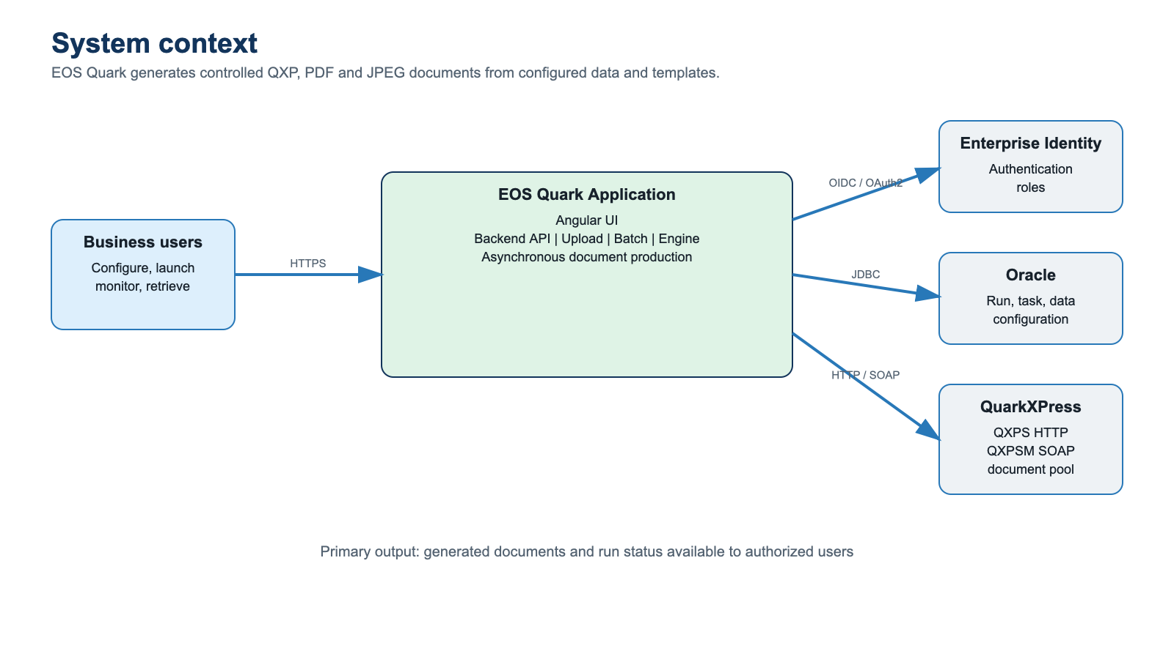
Figure 1 - EOS Quark system context

Business purpose
The application enables authorized users and operational processes to configure, initiate, monitor and retrieve generated reporting documents. A run is the central unit of work: it identifies the report, period, template, input data, tasks, execution status and generated outputs.

In scope
- Interactive report configuration, launch, monitoring and output retrieval.
- Secure intake and registration of source and template documents.
- Scheduled and recovery-based creation or initiation of runs.
- Document composition, validation and rendering through QuarkXPress Server.
- Run status, audit, error handling and operational observability.

2. Logical architecture
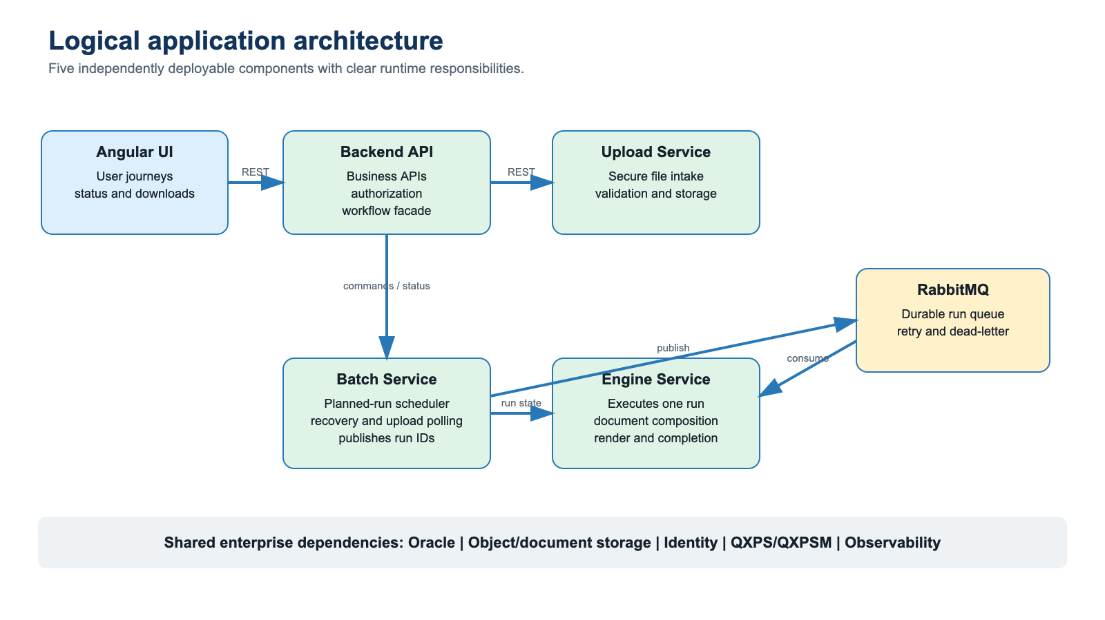
Figure 2 - Logical application architecture
Component | Primary responsibility
Angular UI | User journeys, input validation, run monitoring and output presentation.
Backend API | UI-facing business APIs, authorization, workflow coordination, metadata and status queries.
Upload Service | File intake, validation, quarantine/scan integration, storage and upload registration.
Batch Service | Planned-run scheduling, startup recovery, upload polling and publication of run events.
Engine Service | Single-run processing, task strategies, Quark document operations, rendering and completion.

3. Service boundaries

Boundary principles
- The browser communicates only through approved HTTPS APIs.
- Backend API owns interactive business workflows and authorization.
- Upload Service owns the file-ingestion lifecycle until content is accepted and registered.
- Batch Service owns time-based discovery, recovery and publication of work.
- Engine Service owns all document-generation algorithms and Quark integration.
- Components exchange versioned REST or event contracts; no service imports another service’s internal code.

Responsibility model
Service | Owns | Does not own
Angular UI | Presentation, navigation, client validation | Authoritative authorization or direct database access
Backend API | Business facade, user commands and queries | Long-running rendering or scheduled polling
Upload | Secure file lifecycle and storage registration | Run scheduling or document composition
Batch | Scheduled claims, recovery and event publication | Task algorithms or document rendering
Engine | Run pipeline, task processing, QXPS/QXPSM | Interactive UI workflows or scheduling

4. End-to-end functional flow
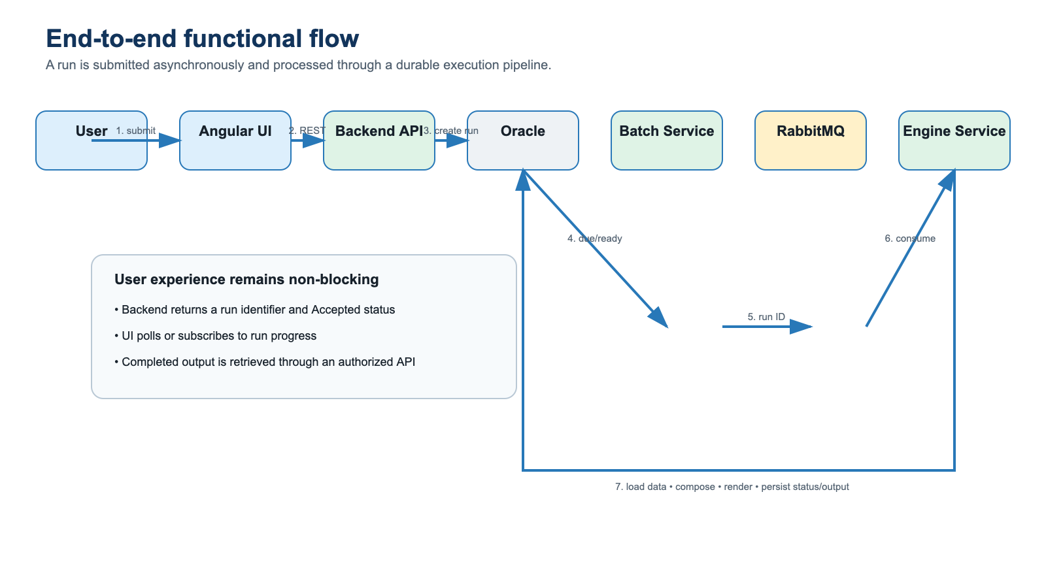
Figure 3 - End-to-end run lifecycle

Run lifecycle
The application uses asynchronous execution. User-facing requests create or activate a run and return control immediately. Batch orchestration publishes a small run event. Engine consumers execute the run and persist stage, outcome and output metadata. The UI obtains progress and output information through the Backend API.

5. Engine service architecture
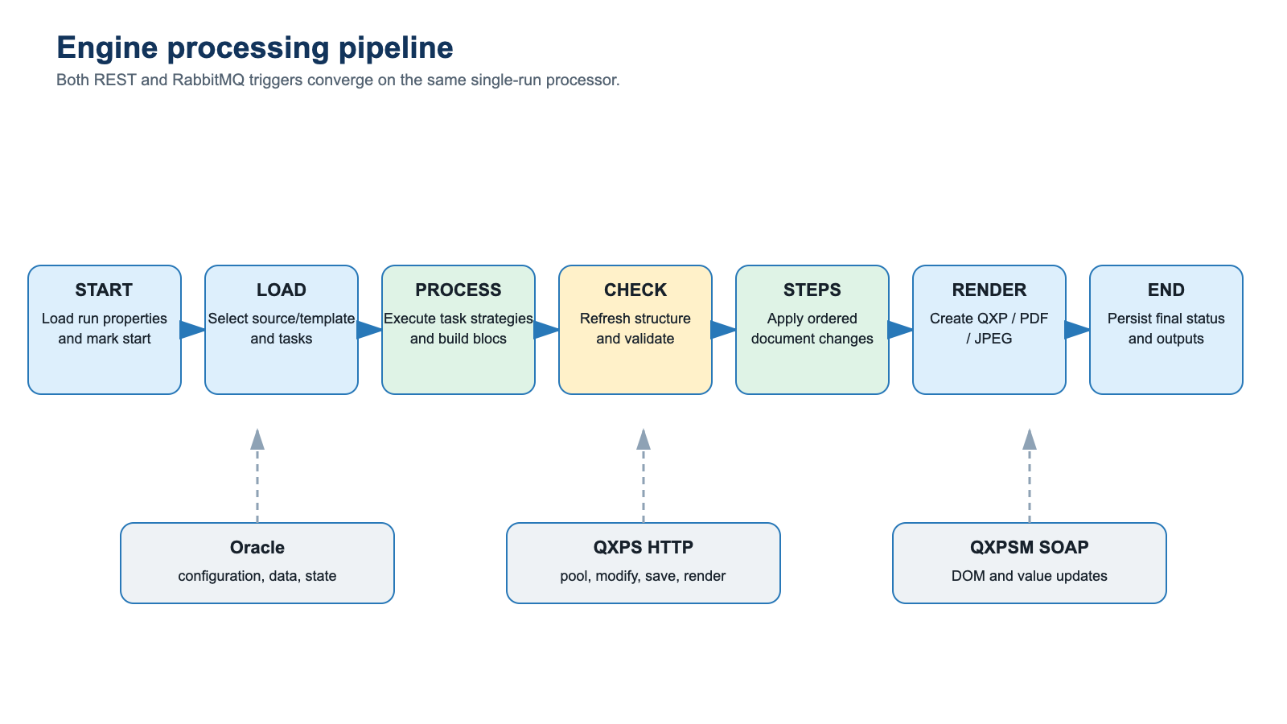
Figure 4 - Engine processing pipeline

Processing model
The Engine Service receives a run identifier from RabbitMQ or the restricted REST entry point. Both entry paths invoke the same run processor. The processor loads Oracle configuration and data, selects the correct document source, executes configured task strategies, builds ordered document changes, validates the document and uses QXPS/QXPSM to apply and render the result.

Supported task families
SYSTEM and SQL value tasks; DOCUMENT and QXP_PREVIOUS file tasks; DYNAMIQUE and COMPARTIMENT structural tasks. Internally, tasks produce ordered blocs that become Quark value or structure operations.

6. Batch service architecture
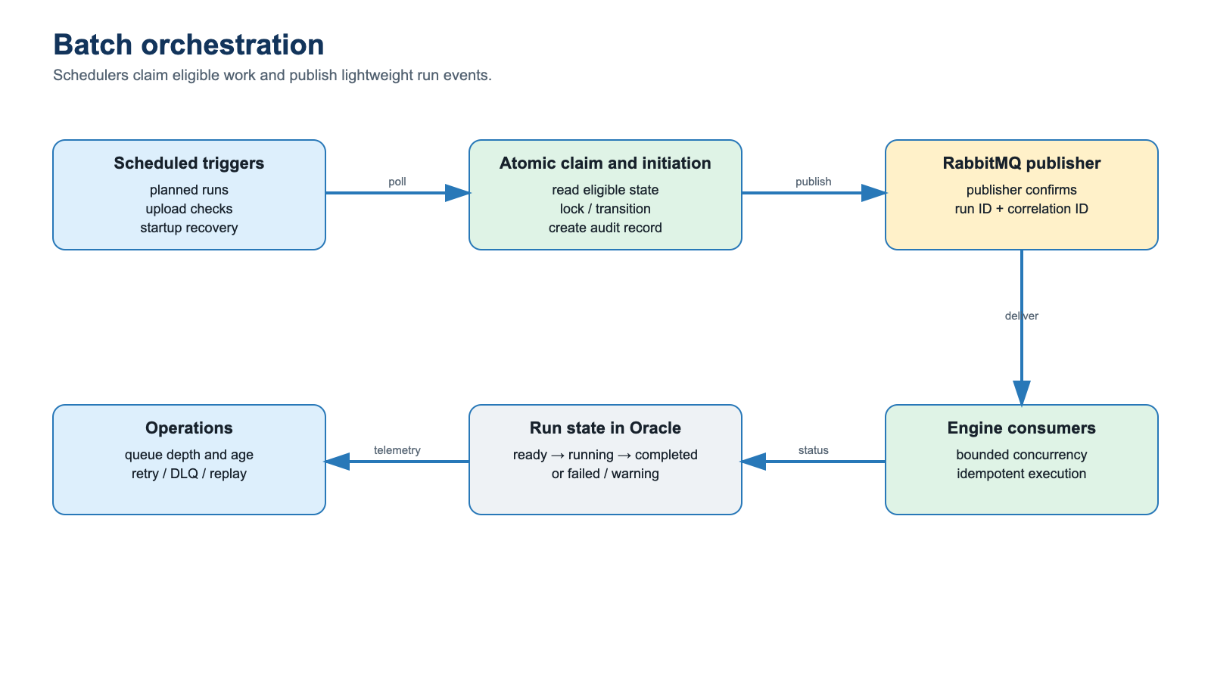
Figure 5 - Batch orchestration and recovery

Batch capabilities
- Process planned runs that are due for execution.
- Check registered uploads and coordinate run creation/initiation.
- Recover eligible pending work during controlled startup processing.
- Atomically claim work before publication to prevent duplicate scheduling.
- Publish run identifiers with correlation metadata and publisher confirmation.

7. Upload architecture
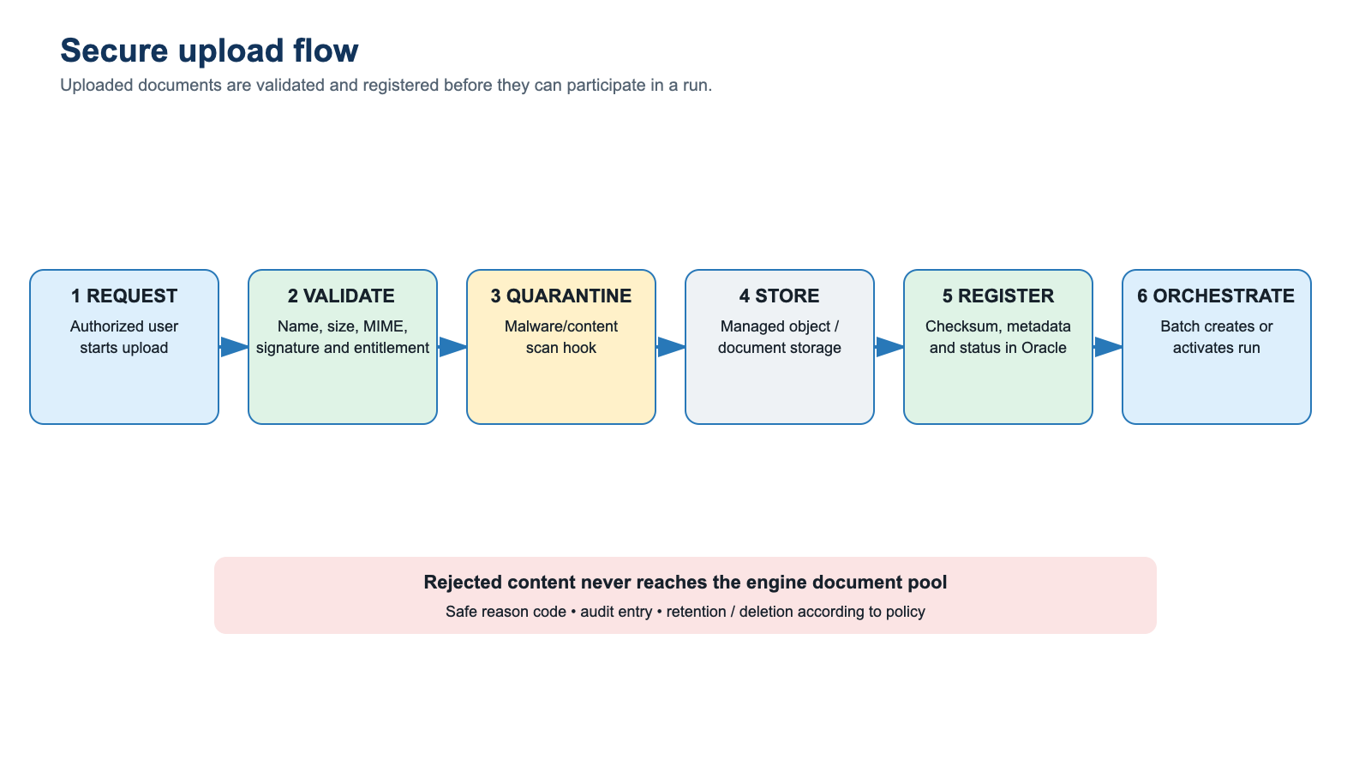
Figure 6 - Secure upload lifecycle

Upload controls
The Upload Service validates file name, extension, MIME signature, size, checksum and business entitlement. Content is quarantined until mandatory scanning completes. Accepted files are stored using stable identifiers and registered in Oracle. Only accepted and registered documents can be used by batch or engine processing.

8. Deployment architecture
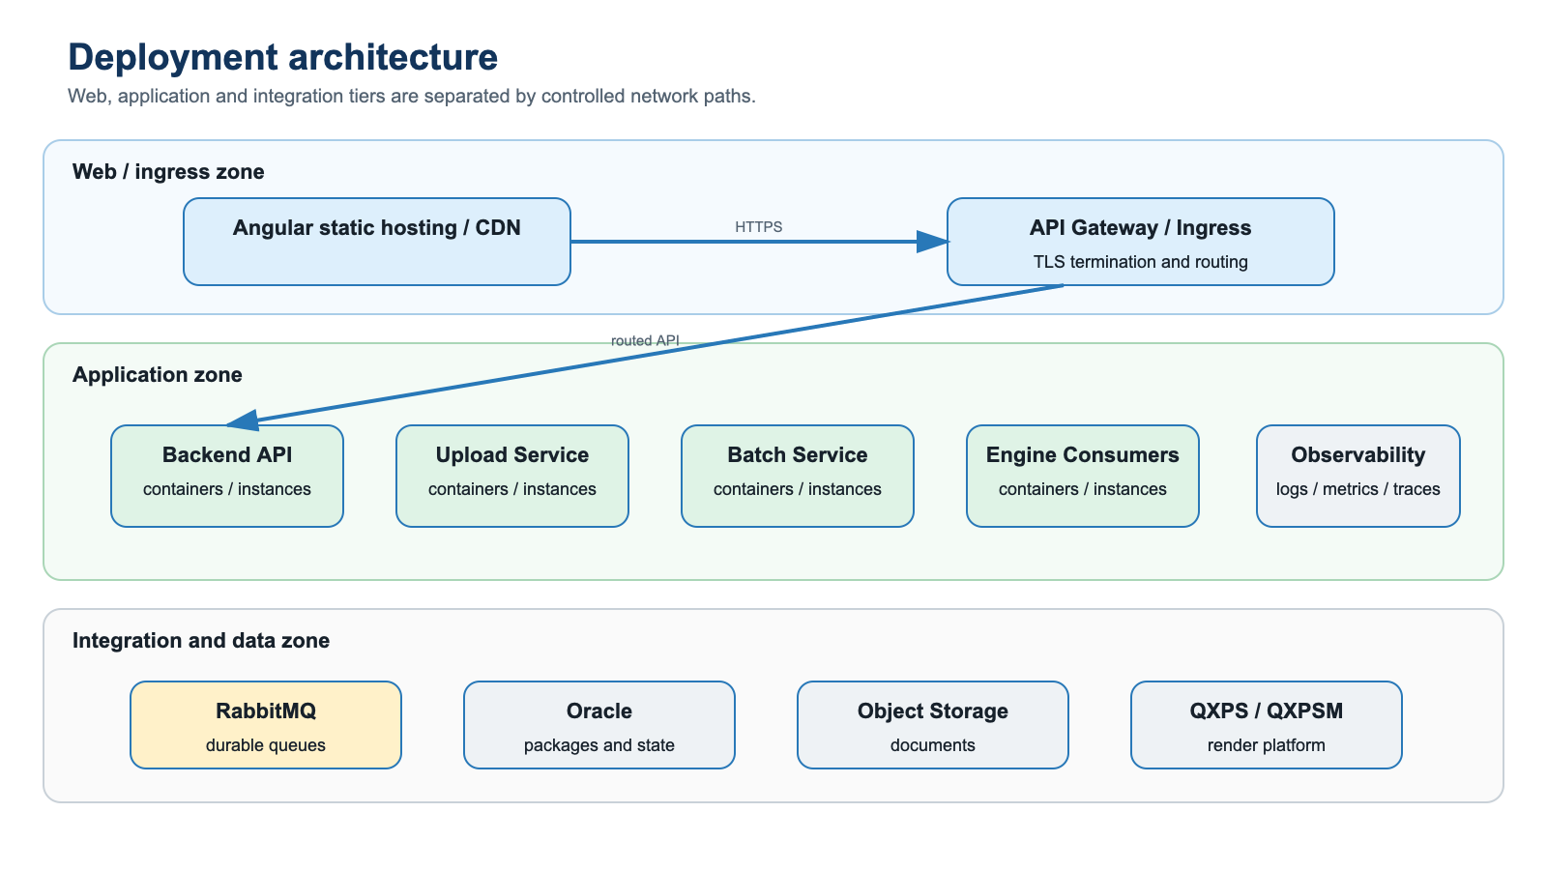
Figure 7 - Deployment and network zoning
Runtime | Deployment and scaling
Angular UI | Versioned static assets behind enterprise ingress/CDN.
Backend API | Stateless replicas with health and readiness probes; horizontal scaling.
Upload Service | Stateless replicas; streaming and explicit payload limits; durable external storage.
Batch Service | Controlled single active scheduler per job using leader/distributed locking.
Engine Service | Multiple consumers scaled by queue depth, document size and QXPS capacity.
RabbitMQ / Oracle / QXPS | Enterprise-managed dependencies with monitored availability and capacity.

9. Data and integration architecture
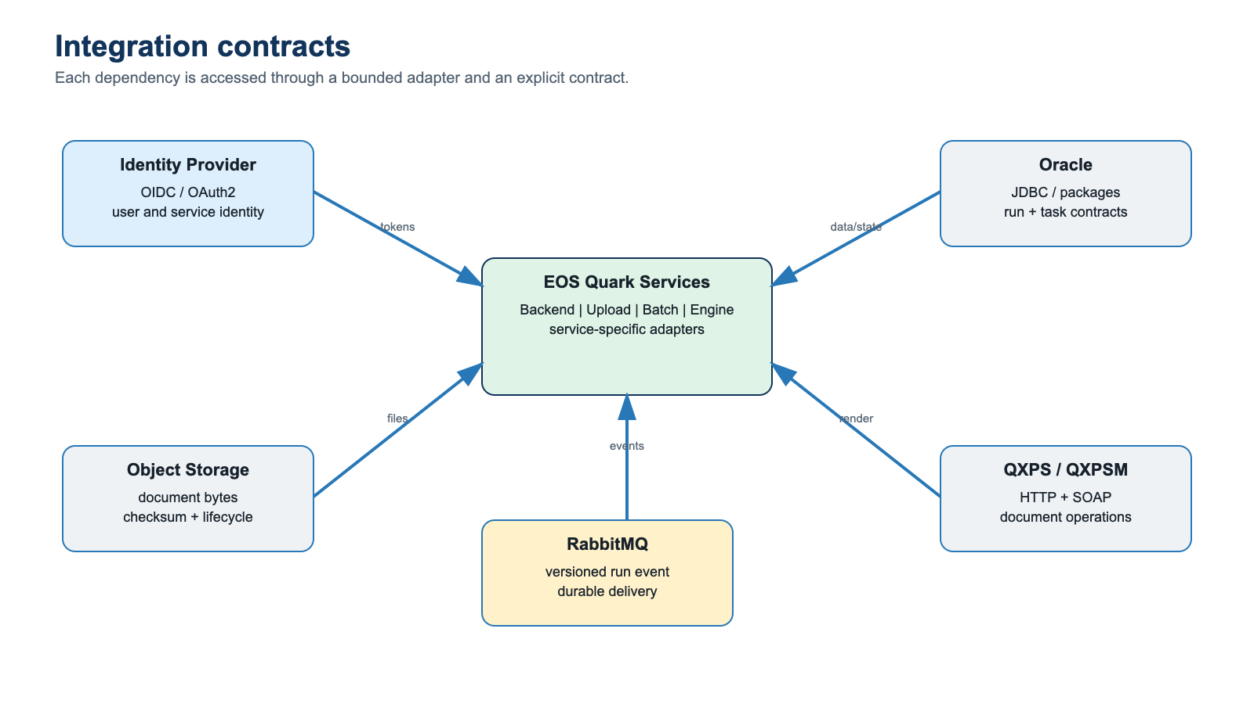
Figure 8 - Data and integration contracts
Integration | Contract and purpose
Angular → Backend/Upload | HTTPS REST; authenticated user commands, queries and file-intake operations.
Batch → Engine | RabbitMQ durable run event; at-least-once delivery with idempotent consumption.
Services → Oracle | JDBC and stored-package contracts for configuration, business data and run state.
Services → storage | Document bytes, checksums, metadata, retention and lifecycle controls.
Engine → QXPS | HTTP document-pool, XML, modify, save and render operations.
Engine → QXPSM | SOAP DOM retrieval and chained document/value operations.

10. Technology stack
Layer | Technology | Purpose
Frontend | Angular | Web user interface.
Service runtime | Java; Spring Boot 2.7.18; Maven | Backend, upload, batch and engine service platform.
API and security | Spring Web/WebFlux, Spring Security, API Bank OpenAPI/security/rate limiter | REST endpoints, API contracts and access control.
Messaging | Spring AMQP and RabbitMQ | Asynchronous run dispatch.
Database | Oracle JDBC; stored packages; Spring Data JPA; Liquibase | Run, task, configuration and status persistence.
Storage/document | AWS Java SDK / S3-compatible capability; Apache PDFBox | Object storage integration and PDF handling.
Quark integration | HTTP client, Spring-WS/JAXB, Apache Axis/JAX-RPC | QXPS HTTP and QXPSM SOAP.
Mapping/utilities | MapStruct, Lombok, Commons IO/Collections | DTO mapping and common utilities.
Testing | Spring Boot Test, Security Test, JUnit, ArchUnit, Gatling tooling | Functional, architectural, security and performance validation.
Delivery | Jenkins pipeline; container runtime | Automated build, test and deployment.

11. Security architecture
Control | Architecture requirement
Authentication | Enterprise OIDC/OAuth2; validated by Backend API and Upload Service.
Authorization | Role and business-entitlement enforcement on every command and output retrieval.
Service identity | Distinct workload identities for Oracle, RabbitMQ, storage and Quark integrations.
Secrets | External secret manager with rotation; no credentials in source or logs.
Transport | TLS for browser/API, messaging, database, storage and supported Quark endpoints.
Upload security | Allow-list, signature validation, quarantine, malware-scan hook, checksum and size limits.
Data protection | Encryption at rest, retention/deletion policy and non-production masking.
Audit | User/service identity, run state, correlation ID, document checksum and output disposition.
Logging | Structured redaction; no document content, tokens, credentials or sensitive bind values.

Trust boundaries
The browser is an untrusted presentation tier. API authorization is authoritative. Application services use separate identities and least-privilege permissions. Quark, Oracle, RabbitMQ and storage are integration-zone dependencies reachable only over approved network paths.

12. Reliability and operations

Reliability controls
- Idempotent event consumption by run ID and event ID.
- Atomic run claim/lock to prevent concurrent execution of the same run.
- Bounded retries with jitter for retryable dependency failures.
- Dead-letter queue for terminal or exhausted messages, with controlled replay.
- Manual acknowledgement only after a durable run-state transition.
- Engine concurrency limited by memory, document size and QXPS capacity.
- Scheduler leader lock prevents duplicate planned-run publication.

Observability
Area | Key telemetry
Run | Correlation ID, stage, status, duration, warning/error code and output metadata.
Queue | Depth, oldest age, publish/ack/reject/redelivery and dead-letter counts.
Batch | Poll duration, eligible/claimed/published counts and scheduler lock status.
Upload | Bytes, validation/scan/storage outcome and quarantine backlog.
Dependencies | Oracle pool/call latency; QXPS/QXPSM latency, payload size and errors.
Runtime | CPU, heap, GC, threads, temporary storage and restart count.

13. API and event design
Contract | Design
Run submission | Asynchronous command returning 202 Accepted, run identifier and correlation identifier.
Run status | Versioned resource exposing lifecycle state, processing stage, warnings/errors and output metadata.
Upload | Create/finalize lifecycle with idempotency key, checksum and validation status.
Engine support trigger | Restricted internal endpoint; audited and never exposed directly to the browser.
RabbitMQ run event | schemaVersion, runId, eventId, occurredAt, correlationId and attempt.
Error response | Stable code and safe message using a consistent problem-details structure.

Run state model
READY → RUNNING → COMPLETED | COMPLETED_WITH_WARNING | FAILED. Recovery transitions are explicit, audited and guarded by optimistic or database locking.

14. Architecture review summary
Area | Architecture position
Application pattern | Service-oriented application with five independently deployable components.
User interaction | Angular through secured Backend/Upload APIs only.
Execution model | Asynchronous run processing using RabbitMQ.
Data platform | Oracle packages and schema as governed business-data contracts.
Document platform | QXPS HTTP and QXPSM SOAP isolated behind Engine adapters.
Scalability | Stateless API replicas; singleton-controlled schedules; horizontally scaled engine consumers.
Security | Enterprise identity, least privilege, secret management, upload controls and end-to-end audit.
Reliability | Idempotency, atomic claims, retries, dead-letter handling and bounded concurrency.
Operations | Structured logs, metrics, traces, dashboards, alerts and runbooks.

Review outcome requested
Approval of the EOS Quark application architecture, component boundaries, integration patterns, deployment model and cross-cutting security, reliability and operational controls described in this document.

