Team (executive):

1. Reporting manager in the profile.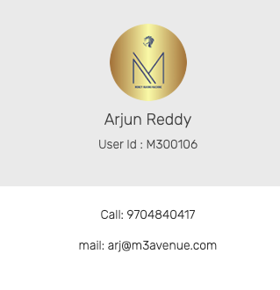
2. Profile pic update error.
3. Except Emergency contact , all other fields should be non- editable.
4. Track my lead> service type should be a drop down ( data == point set ) {Change title in the Point set of admin as Service type}
5. Track my lead> company should be mandt.
6. Track my lead> Assign spelling
7. Track my lead> follow-up date cant be less then current date.
8. Track my lead> change the title TRACK MY WORK of every place to TRACK MY LEAD.

********Leads are still in leads even after converting to clients*********

1. Track my lead> Change the client name to lead name. ( even in bottom list)
2. Track my lead> change the name of the button from **update** to **Add Lead.**
3. Track my lead> in the bottom list> Keep the search enable for all the data, even if the field is displayed inside the record of individual lead.
4. Track my lead> in the bottom list> display only : S.No , Lead Name , Service type, Mobile Num, Amount, income , upload & edit icons ( give this 2 icons in a single cell) Remaining all give nice the edit option.
5. Track my lead> in the bottom list> When we click on edit give the entire form to edit except the mob num. Give a row to add addtn num.
6. Track my lead> in the bottom list>upload docs> give the file name text box.
7. Track my lead> in the bottom list> upload docs> inside the pop- up> inc the button size of ADD ROW & UPLOAD.
8. Track my lead> in the bottom list> preview docs> give an option to add docs along with file name text box.
9. Track my lead> in the bottom list> give the scrollable bar visible.
10. Track my lead> in the bottom list> latest reg date.
11. Track my lead> in the bottom list> maintain remarks history & date.
12. Track my lead> in the bottom list> create a lead id ( format M3+A+Emp id+L+num)
13. Track my lead> in the bottom list> change name UPLOAD DATA to UPLOAD DOCS
14. Track my lead> in the bottom list> add a in tab-bar “Pending clients” . Leads whose docs are Uploaded but in the waiting list to convert will be shown here.
15. Track my lead> in the bottom list>Pending clients> he should have a feature to see & comment in the lead story given by admin against the docs uploaded. (give the feature to admin to give the lead story against the lead so that the executive can see the remarks). I wasn’t briefed on lead story and how we are using it here to check this point.
16. In the admin > screen to convert to client> give 2 tabs > to be client & clients. Once the proper docs are verified, lead is converted to clients for admin, manager , executive. I did’t see this option and also there is no submit option to convert the client status.
17. Track my lead> in the bottom list>Pending clients> add a column beside docs “story” ( here the conversation between executive , manager & admin will be shown as story with the commented date, person & story , reference some chat)
18. Track my clients> once lead is converted to client keep a relation between lead I’d & client I’d. client id format : M3+A+emp+C+num. No client id or lead id is created as of now and also the leads are still showing under leads section even after coverting to clients.
19. Track my clients> give 2 tab-bars, active & history (rejected & Approved) add filter to sort by status of client.
20. Track my clients> add points column &status remarks column & give search box
21. Track my clients> add date filter & default list should be of current month.
22. Track my clients> remove the dashboard /Track my clients , which is in the top right & keep Points sum respective to the screen. I didn’t understand this point nor saw this option anywhere, if it’s to add the points generated by that client amount.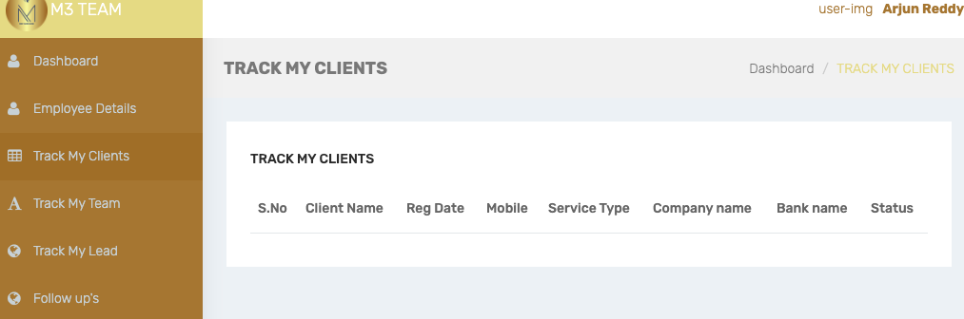
23. Track my clients> client status tracking in **live track flow pictorial (less priority).**
24. Track my team , should not be enabled for executives.