NORTHSTAR BANK
Credit Card Product Guide
Spend Categories · Billing Cycles · Rewards · Statements · Limits
Version 2.1 · Effective April 2026 · For Internal Use & Trainee Reference
This document covers all aspects of NorthStar Bank credit card products relevant to spend analysis, billing, rewards, limits, and customer communication. It is intended as the primary knowledge base for the Credit Card Spend Summarizer capstone project (BFSI-CC-003).
SECTION 1: CARD VARIANTS & FEATURES
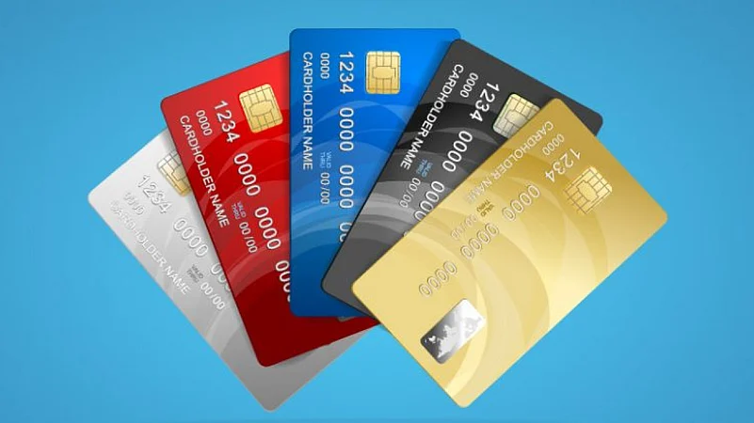
1.1 Card Portfolio Overview
NorthStar Bank offers four credit card variants targeting different customer segments — from everyday spenders to high-net-worth individuals. Each variant has a distinct fee structure, credit limit range, and rewards programme.
Card Variant | Target Segment | Annual Fee | Fee Waiver | Credit Limit Range
NorthStar Classic | First-time / students | Rs. 499 + GST | Spend ≥ Rs. 50,000/yr | Rs. 25,000 – Rs. 1,00,000
NorthStar Gold | Salaried professionals | Rs. 999 + GST | Spend ≥ Rs. 1,00,000/yr | Rs. 1,00,000 – Rs. 3,00,000
NorthStar Platinum | Senior professionals / HNI | Rs. 2,499 + GST | Spend ≥ Rs. 3,00,000/yr | Rs. 3,00,000 – Rs. 10,00,000
NorthStar Signature | Ultra-HNI / corporates | Rs. 5,000 + GST | Spend ≥ Rs. 7,00,000/yr | Rs. 10,00,000 & above

1.2 Key Features by Variant
Feature | Classic | Gold | Platinum | Signature
Complimentary Lounge Access (domestic) None |  | None | 4/year | 12/year
Complimentary Lounge Access (intl) | None | None | 2/year | 6/year
Golf Programme | No | No | No | Yes (12 rounds/yr)
Concierge Service | No | No | Yes | Yes (24x7)
Zero Forex Markup | No | No | No | Yes
Fuel Surcharge Waiver | No | Yes (1-25% off) | Yes (1-25% off) | Yes (full waiver)
EMI Conversion (no-cost) | No | Yes (≥Rs. 5,000) | Yes (≥Rs. 3,000) | Yes (≥Rs. 2,000)
Add-on Cards | 1 | 2 | 4 | 5

SECTION 2: SPEND CATEGORIES &
CLASSIFICATION
2.1 Standard Spend Categories
NorthStar Bank classifies all credit card transactions into the following categories for spend analysis, rewards calculation, and monthly statement generation. The category is assigned based on the Merchant Category Code (MCC) of the transaction.

Category Code | Category Name | Example Merchants | MCC Range (indicative)
FOOD | Food & Dining | Swiggy, Zomato, Domino's, restaurants | 5812, 5814, 5411
GROC | Groceries | BigBasket, D-Mart, Reliance Smart, More 5411, 5422, 5441
TRVL | Travel | IndiGo, Air India, IRCTC, MakeMyTrip, Uber4511, 4112, 7011
SHOP | Shopping | Amazon, Myntra, Flipkart, Nykaa, Croma | 5940, 5691, 5045
ENTR | Entertainment | BookMyShow, Netflix, Hotstar, Spotify, PVR7832, 5813, 4812
FUEL | Fuel | BPCL, HPCL, Indian Oil, Shell | 5541, 5542
HLTH | Health & Medical | Apollo Pharmacy, Practo, hospitals, labs | 5912, 8099, 8011
EDUC | Education | BYJU'S, Coursera, schools, colleges | 8220, 8211, 5942
UTIL | Utilities & Bills | BESCOM, Airtel, BSNL, Jio, LIC, insurance4900, 4813, 6300
JEWL | Jewellery | Tanishq, Kalyan Jewellers, Malabar Gold 5944
ELEC | Electronics | Croma, Reliance Digital, Apple Store | 5731, 5065, 5734
AUTO | Automobile | Car service centres, petrol pumps, auto parts5511, 7531, 5571
INTL | International | Any merchant billed in foreign currency | All MCCs (foreign)
CASH | Cash Advance | ATM withdrawals on credit card | 6010, 6011
OTHR | Others | Transactions not matching above categoriesMisc

* MCC ranges are indicative. NorthStar Bank's internal classification engine may override MCC-based categorisation for certain merchants.
2.2 Category Spend Limits & Alerts
Customers can set monthly spend limits per category via the NorthStar mobile app. The system triggers an SMS/push notification when 80% and 100% of the category limit is reached.
Alert Type | Trigger | Channel
Category Limit 80% | 80% of customer-set category limit reached | Push + SMS
Category Limit Exceeded | 100% of category limit reached | Push + SMS + Email
Unusual Spend | Transaction >3x average in same category | Push + SMS
International Txn | Any transaction flagged as international | SMS (always)

Large Transaction | Single transaction > Rs. 50,000 | Push + SMS

SECTION 3: BILLING CYCLE, STATEMENTS & PAYMENTS
3.1 Billing Cycle Structure
Each NorthStar credit card has a fixed billing cycle based on the card's statement generation date. The billing cycle is 30 days, followed by a 20-day payment due period.
Event | Timeline | Example (Statement Date: 25th)
Billing Cycle Start | Day 1 of cycle | 26th of previous month
Billing Cycle End | Day 30 of cycle | 25th of current month
Statement Generation | Day 30 (end of cycle) | 25th of current month
Payment Due Date | Statement Date + 20 days | 15th of next month
Grace Period Ends | Same as Payment Due Date | 15th of next month
Finance Charges Begin | Day after due date | 16th of next month

* Transactions posted after the statement date will appear in the next month's statement.
* If the due date falls on a bank holiday or Sunday, the payment will be accepted on the next working day without penalty.
3.2 Statement Contents
Monthly statements are sent via email (PDF) and accessible on the NorthStar mobile app and net banking portal. Each statement contains:
• Summary section: Opening balance, total purchases, cash advances, payments, credits, fees, and closing balance
• Spend category breakdown: Total spend per category for the billing month with percentage of total • Transaction listing: Date, merchant name, category, amount, currency (for international), and running balance
• Minimum Amount Due (MAD): 5% of outstanding or Rs. 200 (whichever is higher) • Reward points summary: Points earned this period, redeemed, expired, and total available • EMI schedules: Active no-cost EMI plans with monthly instalments and remaining tenure • Payment options: NEFT details, UPI VPA, QR code for quick payment
3.3 Payment Options & Due Dates
Payment Method | Processing Time | Credit to Card
NorthStar Net Banking | Instant | Immediate
UPI (any app) | Instant | Within 30 minutes
NEFT / RTGS | 2–4 hours | Same day (business hours)
IMPS | Instant | Within 30 minutes

Cheque (branch drop) | 2–3 working days | On clearance
Auto-Debit (NACH mandate) | On due date | On due date

* Auto-Debit can be set for Minimum Amount Due, Fixed Amount, or Total Outstanding.
SECTION 4: REWARDS PROGRAMME
4.1 Reward Points Earn Rate
Card Variant | Base Rate | Dining & Travel | International | Grocery & Fuel
Classic | 1 pt / Rs. 100 | 1 pt / Rs. 100 | 1 pt / Rs. 100 | 1 pt / Rs. 100
Gold | 1 pt / Rs. 100 | 2X (2 pts/Rs. 100) | 2X (2 pts/Rs. 100) | 1 pt / Rs. 100
Platinum | 2 pts / Rs. 100 | 3X (6 pts/Rs. 100) | 3X (6 pts/Rs. 100) | 1 pt / Rs. 100
Signature | 3 pts / Rs. 100 | 4X (12 pts/Rs. 100) | 5X (15 pts/Rs. 100) | 2 pts / Rs. 100

* 1 Reward Point = Rs. 0.25 redemption value against statement credit, vouchers, or product catalogue.
* Reward points are NOT earned on: fuel (surcharge portion), cash advances, EMI transactions, fees & charges, and tax payments.
4.2 Reward Point Redemption
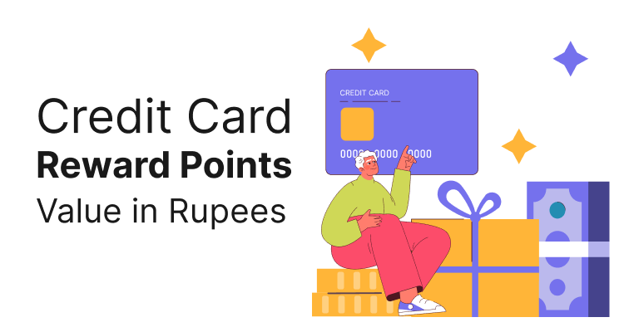
Redemption Type | Min Points | Value per Point | Notes
Statement Credit | 500 pts | Rs. 0.25 | Credited to card account within 2 working days
Partner Vouchers | 200 pts | Rs. 0.30 | Amazon, Flipkart, Myntra, Swiggy, Zomato
Airline Miles | 1,000 pts | 1:1 mile | Air India Flying Returns, IndiGo 6E Rewards
Hotel Points | 1,000 pts | 1:2 pts | Marriott Bonvoy, IHG Rewards
Product Catalogue | 500 pts | Rs. 0.20 | Electronics, appliances, gift cards

4.3 Points Expiry Policy
• Points earned in a calendar year expire on December 31st of the following year (18–24 month window).
• Points are forfeited immediately on card closure or if the account becomes delinquent (90+ days past due).
• Bonus points from promotional campaigns may have shorter expiry periods — check campaign T&Cs.;
• Points expiry reminders are sent 60 days and 30 days before expiry via email and push notification. SECTION 5: FEES, CHARGES & FINANCE COSTS
5.1 Complete Fee Schedule
Charge Type | Classic | Gold | Platinum | Signature
Annual Fee | Rs. 499 | Rs. 999 | Rs. 2,499 | Rs. 5,000
Add-on Card Fee | Rs. 199/card | Rs. 499/card | Rs. 999/card | NIL
Finance Charge (monthly) | 3.49% | 3.49% | 3.25% | 3.00%
Cash Advance Fee | 2.5% (min Rs. 500) | 2.5% (min Rs. 500) | 2.5% (min Rs. 500) | 2.0% (min Rs. 500)
Foreign Currency Markup | 3.50% | 3.50% | 3.50% | 0% (waived)
Late Payment (>Rs. 10,000 due) | Rs. 1,200 | Rs. 1,200 | Rs. 1,000 | Rs. 750
Over-Limit Fee | 2.5% (min Rs. 500) | 2.5% (min Rs. 500) | 2.0% (min Rs. 500) | NIL
Duplicate Statement | Rs. 100 | Rs. 100 | NIL | NIL
Card Replacement | Rs. 200 | Rs. 200 | NIL | NIL

* Finance charges apply only when full outstanding is not paid by due date (revolving credit). * GST @ 18% is applicable on all fees and charges.

5.2 Late Payment Fee Slab
Outstanding Amount Due | Late Payment Fee
Up to Rs. 500 | NIL
Rs. 501 – Rs. 5,000 | Rs. 500
Rs. 5,001 – Rs. 10,000 | Rs. 750
Above Rs. 10,000 | Rs. 1,200 (Classic/Gold) | Rs. 1,000 (Platinum) | Rs. 750 (Signature)

SECTION 6: SPEND SUMMARY — BUSINESS RULES
6.1 How Monthly Spend Summaries Are Computed
The Credit Card Spend Summarizer computes summaries from raw transaction data using the following business rules:
• Include only transactions with txn_type = 'purchase' in spend totals. Exclude: payments, refunds, fees, cash advances.
• Refunds (txn_type = 'refund') reduce the net spend in the corresponding category. • International transactions are flagged separately (is_international = TRUE) and reported as a sub-total.
• EMI transactions are counted as single spend at the time of purchase, not per monthly instalment. • Transactions in foreign currency are converted to INR at the rate on the transaction date. • Category is assigned by the system; the merchant_name field is used for human-readable summaries.
6.2 Sample Spend Summary Output Format
A well-formed spend summary for a billing month should include the following elements:

Summary Element | Description | Example
Total Spend | Sum of all purchases this month | Rs. 42,300
Top Category | Category with highest spend | Travel (Rs. 17,500 — 41%)
No. of Transactions | Count of purchase transactions | 18 transactions
Avg Transaction Value | Total spend / no. of transactions | Rs. 2,350 average
International Spend | Total of is_international = TRUE txns | Rs. 8,200 (2 transactions)
Largest Single Purchase | Max amount in purchase transactions | Rs. 12,000 — Amazon UK
Reward Points Earned | Points from this month's spend | 846 points (≈ Rs. 212 value)
Category Breakdown | Spend per category as % of total | See table below
Month-over-Month Change | vs. previous billing month spend | +12% vs. last month

6.3 Sample Category Breakdown Table (Statement Insert)
Category | No. of Txns | Total Spend | % of Total | Reward Pts Earned
Travel | 3 | Rs. 17,500 | 41.4% | 350 pts
Shopping | 4 | Rs. 10,200 | 24.1% | 204 pts
Food & Dining | 5 | Rs. 6,300 | 14.9% | 189 pts
Entertainment | 2 | Rs. 3,700 | 8.7% | 74 pts
Groceries | 2 | Rs. 2,900 | 6.9% | 58 pts
Utilities | 1 | Rs. 1,700 | 4.0% | 17 pts (capped)
TOTAL | 17 | Rs. 42,300 | 100% | 892 pts

* Reward points for utilities and insurance categories are capped at 500 points per statement month across all such transactions.
6.4 Edge Cases & Handling Rules
Scenario | Handling Rule
Partial refund on a purchase | Net spend = Original amount minus refund amount; category unchanged
Merchant recategorised mid-cycle | Use category at time of posting, not at time of statement generation
Transaction dispute raised | Disputed amount excluded from spend summary until resolved
No transactions in a category | Category omitted from breakdown; not shown as Rs. 0
Split payment (partial by points) | Only cash component counted in spend summary
Cancelled transaction not reversed | Excluded from summary once cancellation confirmed by merchant

SECTION 7: CREDIT LIMIT MANAGEMENT
7.1 Credit Limit Types

Limit Type | Definition
Total Credit Limit | Maximum outstanding allowed on the card at any time
Available Credit Limit | Total Limit minus current outstanding balance
Cash Limit | 20% of total credit limit (usable for cash advances)
Available Cash Limit | Cash Limit minus cash advances already drawn
International Limit | Sub-limit for foreign currency transactions (default = Total Limit)

7.2 Credit Limit Enhancement
• Customers may request a limit increase after 6 months of card usage with a clean repayment track record.
• Auto limit enhancement offered to eligible customers (CIBIL ≥ 750, no missed payments in 12 months).
• Limit increase requires fresh income proof if enhancement exceeds 50% of current limit.
• Temporary limit enhancement available for travel or wedding spend — valid up to 60 days.

SECTION 8: SAMPLE CUSTOMER SCENARIOS

8.1 Scenario Library for Spend Summarizer Testing
The following scenarios are provided to help trainees test their spend summariser with realistic inputs and expected outputs.
Scenario A — Heavy Travel Month
Account | Card | Billing Period | Total Spend | Top Category | Intl Txns
CC-881001 | Gold | Mar 1–Mar 25, 2026 | Rs. 42,300 | Travel (41%) | 2 (SGD + GBP)

Expected summary: Travel dominates; flag international markup charges; reward multiplier applied on travel (2X for Gold).

Scenario B — Routine Monthly Spend
Account | Card | Billing Period | Total Spend | Top Category | Intl Txns
CC-882001 | Platinum | Mar 1–Mar 25, 2026 | Rs. 28,700 | Shopping (35%) | None

Expected summary: No unusual patterns; reward points 3X on dining category; EMI conversion eligible for Rs. 12,000 purchase.

Scenario C — Low Spend / Near Fee Waiver Threshold
Account | Card | YTD Spend | Fee Waiver Target | Remaining | Months Left
CC-883001 | Classic | Rs. 38,200 | Rs. 50,000 | Rs. 11,800 | 3 months

Expected summary: Alert customer they are Rs. 11,800 short of fee waiver threshold with 3 billing cycles remaining.

NorthStar Bank · Credit Card Product Guide · Version 2.1 · April 2026 · Internal Use Only

