STUDENT RECORD MANAGEMENT SYSTEM

Cornerstone project work submitted to Aditya University in partial fulfilment of the requirements for the award of the Degree of
B.Tech. degree in
Artificial Intelligence and Machine Learning (2026-2027)
SUBMITTED BY

M RAVITEJA 25B11AI281

M S S V DURGA PRASAD 25B11AI729
P JASWANTH KRISHNA 25B11AI992
G SAI CHARAN 26B21AI043

UNDER THE GUIDANCE OF T.VIJAYALAKSHMI,
Assistant Professor, Department of AIML


Department of Arificial Intelligence & Machine Learning Aditya University, Aditya Nagar, ADB Road,
Surampalem, Kakinada, District, Andhra Pradesh, India – 533437

DEPARTMENT OF ARTIFICIAL INTELLIGENCE & MACHINE LEARNING

ADITYA UNIVERSITY, ADITYA NAGAR, SURAMPALEM.

CERTIFICATE

This is to certify that the OOPS Through C++ Cornerstone Project report entitled “STUDENT RECORD MANAGEMENT SYSTEM” is being submitted by M.RAVITEJA (25B11AI281), M.S.S.V.DURGA PRASAD(25B11729), P.JASWANTH KRISHNA (25B11AI992) and G.SAI CHARAN (26B21AI043) in partial fulfillment of the requirements for the award of the B.Tech. degree in Artificial Intelligence and Machine Learning. The work documented in this report was carried out as part of the Cornerstone Project for the course OOPS Through C++ (2501CS08) during the academic year 2026–2027, and records the Source Code implementation with coding standard practices and documentation undertaken by the team.
.

Project Guide Head of the Department
T.Vijayalakshmi, Dr. K. Naga Bhargavi,
Assistant professor Associate Professor

DECLARATION

We hereby declare that the OOPS Through C++ Cornerstone Project entitled “STUDENT RECORD MANAGEMENT SYSTEM” is a genuine work carried out by us. The Source Code implementation with coding standard practices and documentation presented in this report are our own work, completed under the guidance of T.VIJAYALAKSHMI ,Assistant Professor, Department of Artificial Intelligence and Machine Learning, Aditya University, Surampalem. We further declare that this work has not been submitted, in full or in part, for the award of any degree of this or any other educational institution.

Project Associates

M.RAVITEJA (25B11AI281)

M.S.S.V DURGA PRASAD(25B11AI729)

P.JASWANTH KRISHNA(25B11AI992)

G.SAI CHARAN(26B21AI043)

Date: 26-10-2026
Place: Surampalem

ACKNOWLEDGEMENT

It is with immense pleasure that we express our indebted gratitude to our project guide Dr. T.VIJAYALAKSHMI,Assistant Professor, Department of Artificial Intelligence and Machine Learning, who guided us throughout the capstone project. We are thankful for the constant encouragement and valuable suggestions received at every review stage.
We are grateful to Dr. K Naga Bhargavi, Head of the Department, for inspiring us and for arranging the facilities and resources needed for this project.
We also extend our sincere thanks to Dr. M V RAJESH, Associate Dean, School of Computing, for his encouragement and support during our project.
We would like to express our sincere gratitude to Dr. G. Suresh – Registrar, Dr. A. Ramesh - Pro VC (E&S), Dr. S. Rama sree - Pro VC (Academics), Dr. M B Srinivas – Vice Chancellor and Dr. M. Sreenivasa Reddy - Dy. Pro-Chancellor and Management, Aditya university, for providing excellent infrastructure and state-of-the-art laboratories.
Finally, we would like to thank our Teaching and Non-Teaching Staff, Parents and Friends who have directly or indirectly supported us in completing this Cornerstone project successfully.

Project Associates

M.RAVITEJA (25B11AI281)

M.S.S.V DURGA PRASAD(25B11AI729)

P.JASWANTH KRISHNA(25B11AI992)

G.SAI CHARAN(26B21AI043)

ABSTRACT

The Student Record Management System is a C++-based application designed to maintain and manage student academic records efficiently. The main objective of this project is to simplify the process of storing, retrieving, updating, and analyzing student information while reducing the difficulties associated with manual record maintenance.
The system is developed using Object-Oriented Programming (OOP) concepts, including classes and objects, along with arrays, strings, functions, loops, and conditional statements. It stores student details such as roll number, name, and marks in five subjects: C++, Database Management Systems (DBMS), Advanced Data Structures and Algorithms (ADSA), Mathematics, and Artificial Intelligence (AI). Each subject carries a maximum of 100 marks.
The system provides various functionalities, including adding new student records, displaying all records, searching for students using their roll numbers, updating existing student details, and deleting student records. It also performs academic performance analysis by calculating total marks and average marks for each student and identifying the highest average, lowest average, and overall class average. Marks validation is implemented to ensure that the entered marks remain within the range of 0 to 100.
This project demonstrates the practical implementation of C++ programming concepts in developing a simple and user-friendly student record management application. It improves the organization and accessibility of student information and provides a foundation for future enhancements, such as file handling, database integration, grade calculation, and report generation.

ABBREVIATIONS

Abbreviation | Full Form
OOP | Object-Oriented Programming
SRMS | Student Record Management System
ID | Identifier
UI | User Interface
DBMS | Database Management System
ADSA | Advance Data Structures and Algorithms
C++ | Programming Language
AI | Artificial Intelligence
CRUD | Create, Read, Update, Delete
I/O | Input / Output
API | Application Programming Interface
IDE | Integrated Development Environment
CSE | Computer Science & Engineering

LIST OF FIGURES

Figure No. | Title of the Figure | Page No.
Fig 1.1 | System architecture of the Student Record Management System | 4
Fig 1.2 | Flowchart of the Student record management process | 6
Fig 1.3 | Class diagram of the Student Record Management System | 7
Fig 2.1 | Student Record Management System | 15
Fig 2.2 | Adding Student details | 16
Fig 2.3 | Displaying Student Info | 16
Fig 2.4 | Marks Analysis | 17
Fig 2.5 | Updating student deatils | 17

LIST OF TABLES

Table No. | Title of the Table | Page No.
Table 1.1 | Planned modules of the Student Record Management System | 2
Table 1.2 | Software and hardware requirements | 3
Table 1.3 | Student record management rules | 8
Table 2.1 | OOP concepts and their use in the project | 10
Table 2.2 | Test cases and results | 17

TABLE OF CONTENTS

CONTENTS | PAGE NO
Title Page | I
Declaration | II
Certificate | III
Acknowledgement | IV
Abstract | V
Abbreviations | VI
List of Figures | VII
List of Tables | VIII
CHAPTER-1 Project Planning | 1
1.1. Problem Statement | 1
1.2. Project Objective | 1
1.3. Planned Modules | 2
1.4. System Architecture (Algorithm & Flowchart) | 3
CHAPTER-2 Project Implementation | 9
2.1. OOP Concepts Used for Implementation | 9
2.2. Code | 11
2.3. Output Screens | 15
CHAPTER-3 Conclusion & Future Scope | 19
3.1. Conclusion | 19
3.2. Future Scope | 19
References | 20

CHAPTER 1
PROJECT PLANNING

  - Problem Statement
Managing student academic records manually can lead to errors, duplicate entries, difficulty in searching for information, and problems updating records. Analysing student performance and maintaining accurate marks can also be time-consuming.
The problem addressed in this project is to develop a Student Record Management System using C++ that stores student details, including roll number, name, and subject marks, in an organised manner. The system supports adding, displaying, searching, updating, and deleting student records.
The application also calculates total marks and average marks, identifies the highest and lowest student averages, and determines the overall class average. Using object-oriented programming concepts and arrays makes the system simple, organised, and easier to maintain and extend.
  - Objective
The main objective is to develop a console-based Student Record Management System in C++ to manage student information and analyse academic performance. The specific objectives are:
- To represent student details using classes and objects.
- To store student information and marks in five subjects.
- To provide options to add, display, search, update, and delete student records.
- To calculate total marks, average marks, highest average, lowest average, and class average.
- To validate subject marks within the range of 0 to 100.
- To apply arrays, strings, functions, and object-oriented programming concepts for efficient record management.
- To provide a simple system that can be enhanced with file handling and database integration in the future.

  - Planned Modules
The project is divided into seven main modules. Each module performs specific operations in the Student Record Management System, making the program organised, easy to understand, and maintain. The modules include student data entry, record display, searching, updating and deleting records, and marks analysis. Table 1.1 presents the planned modules and their corresponding functionalities.
Table 1.1 Planned modules of the Student Record Management System

 | Module | Classes involved | Description
 | Student Data  Management | Student,  StudentRecordManager | Accepts and stores student roll number, name, and marks in five subjects: C++, DBMS, ADSA, Mathematics, and AI.
 | Marks  Validation | Student | Validates subject marks and accepts values only between 0 and 100.
 | Student Record  Display | Student,  StudentRecordManager | Displays student details, subject marks, total marks, and average marks.
 | Student Search | StudentRecordManager | Searches for a student using the roll number through linear search.
 | Student Record Update | StudentRecordManager | Allows users to update existing student details, including name and subject marks.
 | Student Record Deletion | StudentRecordManager | Deletes a student record using the roll number and shifts the remaining records.

The software and hardware needed to build and run the simulator are modest, as shown in Table 1.2.
Table 1.2 Software and hardware requirements

Component | Specification
Programming language | C++ (ISO C++17 or later)
Operating system | Windows 10/11, Linux or macOS
Development tools | VS Code, Code::Blocks or any C++ IDE
Hardware | Intel Core i3 or above, 4 GB RAM, basic storage

  - System Architecture (Algorithm & Flowchart)
    - System architecture
The Student Record Management System follows a simple layered architecture. The presentation layer accepts user input through a menu and displays student details, marks, and analysis results. The application layer handles student record creation, display, searching, updating, deletion, marks validation, and academic performance analysis. The data layer stores student records, including roll numbers, names, and subject marks, in arrays during program execution. The system uses C++ classes and objects to organise data and operations efficiently.
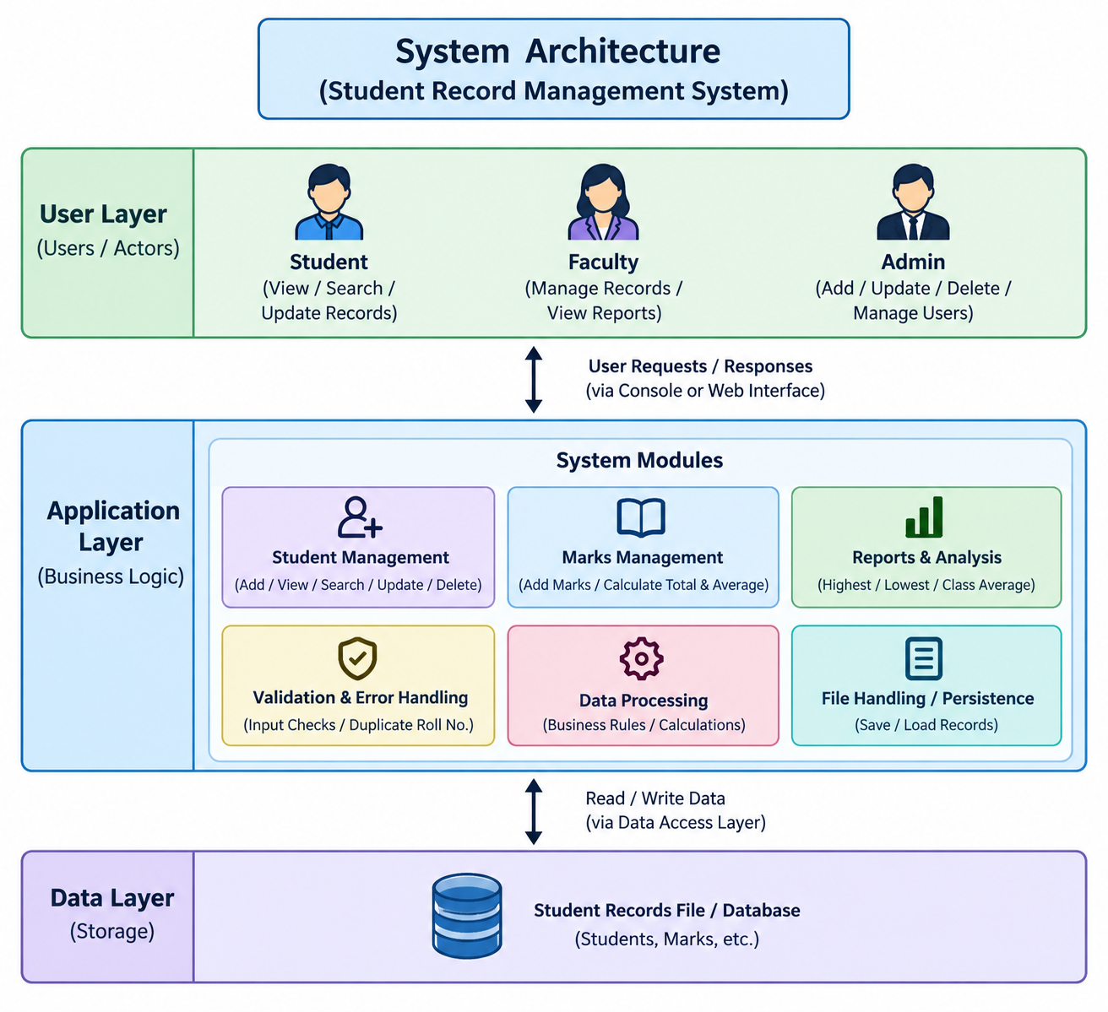
Fig 1.1 System architecture of the Student Record Management System

    - Algorithm
The overall working of the Student Record Management System is described by the following algorithm.
      - Start the program and initialize student manger.
      - Display Display the main menu with options to add, display, search, update, delete, analyse marks, and exit.
      - Read the user's menu choice and process the selected option.
      - If Add Student is selected, read the student's roll number, name, and subject marks, and check the maximum student limit.
      - Validate each subject mark to ensure that it is between 0 and 100.
      - If Display Students is selected, display all saved student records, including subject marks, total marks, and average marks.
      - If Search Student is selected, read the roll number and search for the matching student record.
      - If Update Student is selected, search for the student using the roll number and allow the user to update the student's details.
      - If Delete Student is selected, find the student record, delete it, and shift the remaining records.
      - If Marks Analysis is selected, calculate the total and average marks of each student.
      - Identify the students with the highest and lowest averages and calculate the overall class average.
      - Repeat the main menu until the user selects Exit.
      - Display the closing message and stop the program.
    - Data design and assumptions
The prototype stores student records in memory using arrays. The main design decisions are:
- Student records are managed by a StudentRecordManger object, and each student is identified by a unique roll number.
- Each student record contains the roll number, name, and marks in five subjects: C++, DBMS, ADSA, Mathematics, and AI.
- Each subject mark must be between 0 and 100, and the system validates marks before storing them.
- Student records can be added, displayed, searched, updated, and deleted using the available menu options.
- Total marks, individual averages, highest average, lowest average, and class average are calculated when required.
- The prototype is a console-based application, and student records are not retained after the program ends.
Fig. 1.2 shows the flowchart of the Student Record Management System. The diamond blocks represent decisions, such as menu selection and record validation, while the process blocks represent the seven menu operations. The flowchart also shows how the system repeats the menu until the user selects Exit.

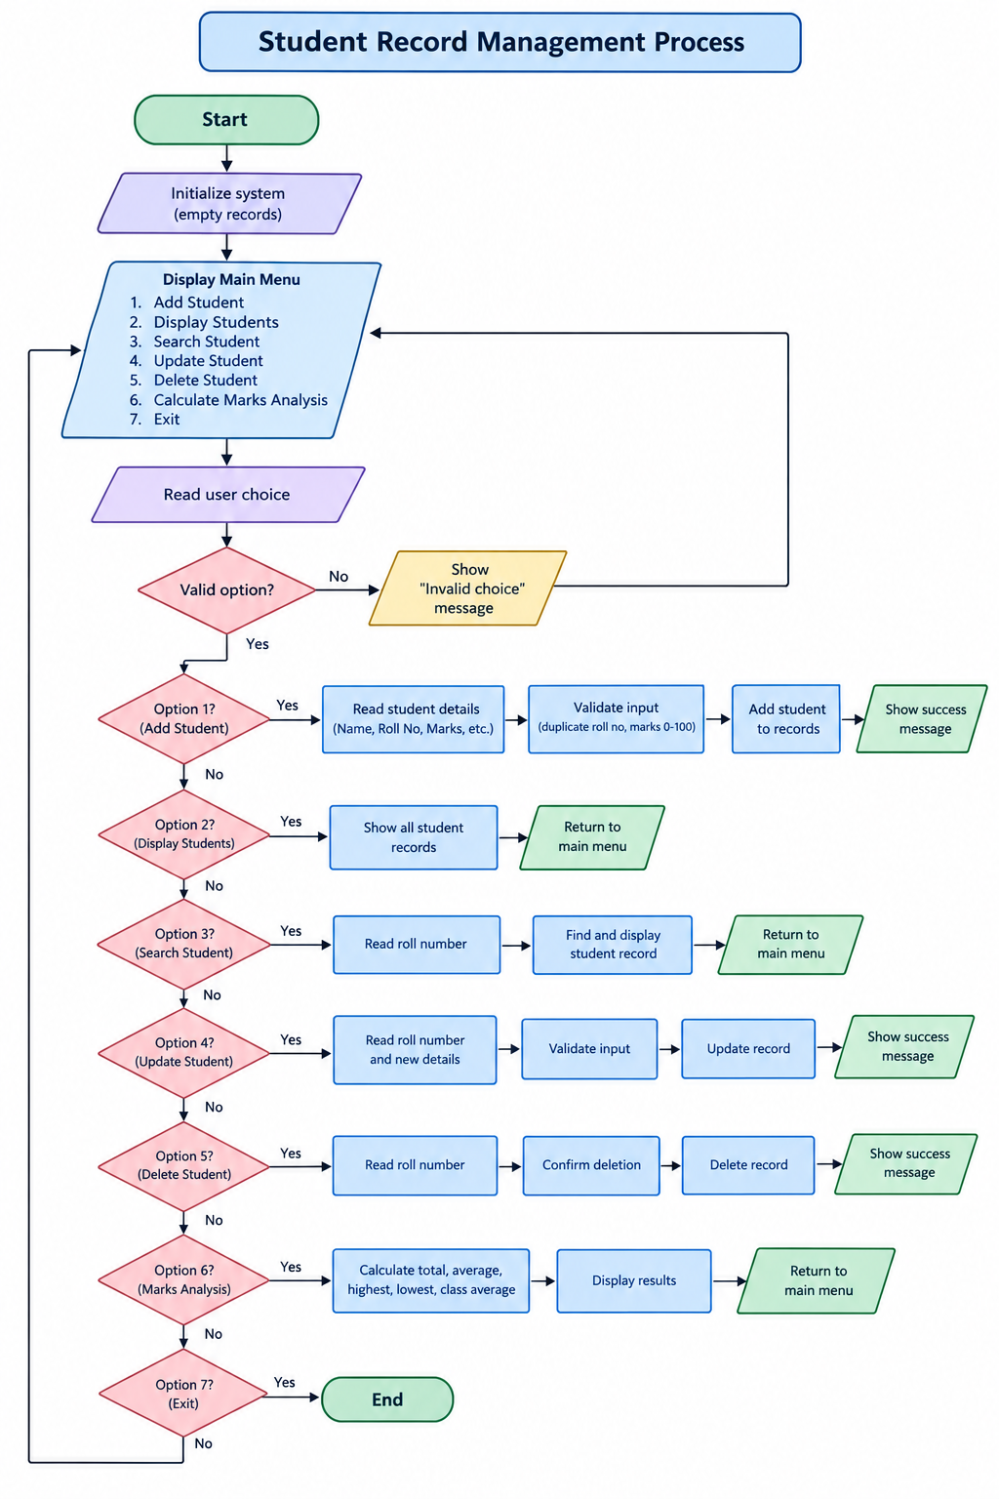

Fig 1.2 Flowchart of the Student Record management process

    - Class diagram
The class diagram shows Student and StudentRecordManager. Student stores student information and subject marks, while StudentRecordManager manages student records and coordinates adding, displaying, searching, updating, deleting, and analysing student information.
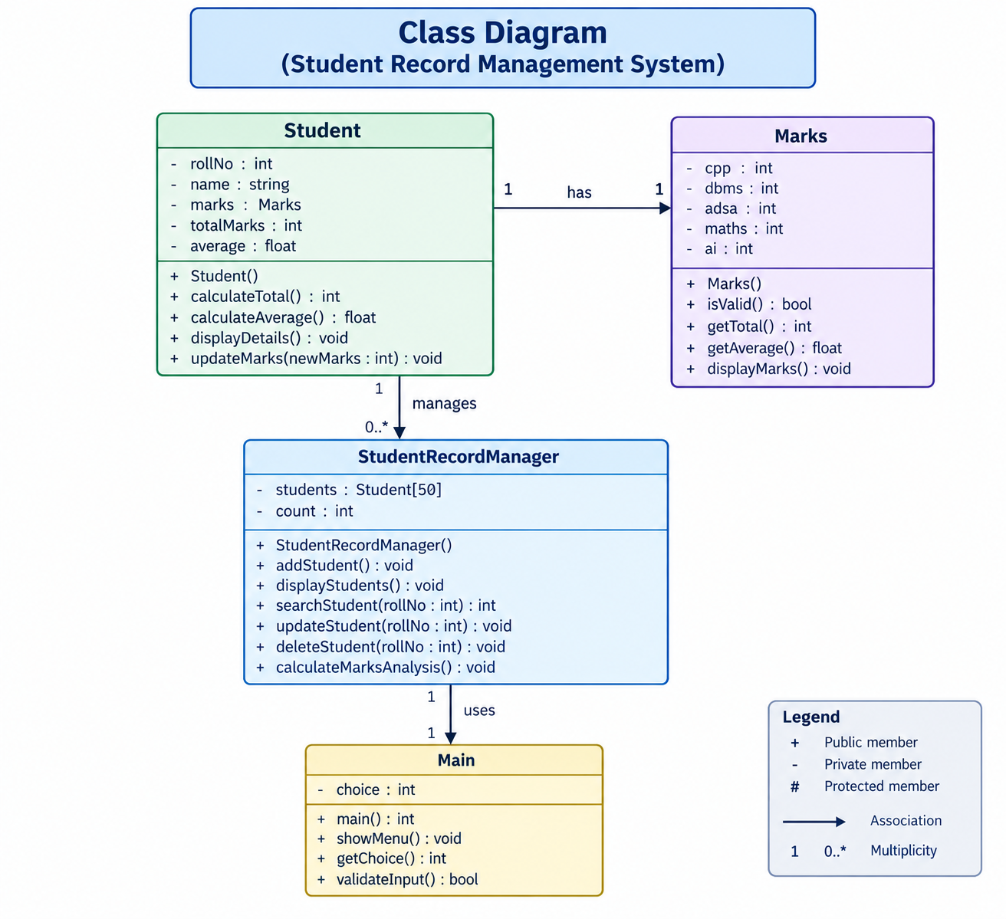

Fig 1.3 Class diagram of the Student Record Management System

The system manages student records, including roll numbers, names, and marks in five subjects, with options to add, display, search, update, and delete records. It validates marks between 0 and 100 and calculates total marks, individual averages, highest and lowest averages, and class average.

Table 1.3 Student record management rules

Rule | Student | StudentRecordManager
Student Details | Stores roll number, name, and marks | Manages student records
Marks Validation | Marks must be 0–100 | Validates entered marks
Record Search | Identified by roll number | Performs linear search
Record Update | Details and marks can be modified | Updates existing records
Record Deletion | Student record is removed | Deletes and shifts records
Marks Analysis | Provides total and average marks | Calculates highest, lowest, and class averages

CHAPTER 2
PROJECT IMPLEMENTATION
  - OOP Concepts Used for Implementation
The Student Record Management System is built around the main principles of Object-Oriented Programming. Each concept is used to organise student information and manage academic records, and Table 2.1 summarises how these concepts are applied in the code.
Classes and objects:
The main components are represented by two classes: Student and StudentRecordManager. Student objects store roll numbers, names, and subject marks, while the manager object handles student record operations.
Encapsulation:
Student details and marks are organised within the Student class, and related operations are defined as member functions. This approach keeps data and its operations together and improves program organisation.
Inheritance:
Inheritance is not explicitly implemented in the current project. However, the class-based design provides a foundation for adding specialised student record classes in future versions.
Abstraction:
StudentRecordManager provides operations such as addStudent(), displayStudents(), searchStudent(), and deleteStudent(). The menu calls these methods without requiring users to understand the internal implementation.
Polymorphism:
Polymorphism is not explicitly implemented in the current project. The system mainly uses classes, objects, and member functions to perform student record management operations.
The Student Record Management System is designed to simplify the process of maintaining student academic records, including roll numbers, names, and marks in five subjects. Manual record management can cause errors, duplicate entries, and difficulty searching for or updating information. This project presents an organised system developed using C++ and Object-Oriented Programming concepts.
Input validation checks subject marks to ensure they remain between 0 and 100. The system also checks record capacity and student roll numbers during record management operations, helping maintain accurate student information.

STL containers and static members

Student records are stored in an array managed by StudentRecordManager. Each student has a roll number, and the system uses it to identify records during searching, updating, and deleting operations.

Table 2.1 OOP concepts and their use in the project
OOP concept | Where it is used | Purpose
Class & object | Student, StudentRecordManager | Organise student data and operations
Constructor | Class initialisation | Initialise objects with valid data
Encapsulatio n | Student data and member functions | Protect and organise data
Inheritance | Not implemented | Can support future extensions
Abstraction | Manager methods and menu | Hide internal implementation details
Polymorphis m | Not implemented | Can support future extensions
Exception handling | Input validation and error messages | Handle invalid entries safely
STL  containers | students, marks | Store collections of records
static / const | IDs and fixed labels | Maintain consistent values

  - Code
The system uses Student and StudentRecordManager classes to store student details, manage subject marks, and perform student record operations.
    - Header files, helper functions and main function

#include <iostream>
#include <string>
#include <limits>
using namespace std;

class Student {
private:
int rollNo;
string name;
int marks[5];

public:
Student() {
rollNo = 0;
name = "";
for (int i = 0; i < 5; i++) {
marks[i] = 0;
}
}

int getRollNo() {
return rollNo;
}

string getName() {
return name;
}

int getTotal() {
int total = 0;
for (int i = 0; i < 5; i++) {
total += marks[i];
}
return total;
}

double getAverage() {
return getTotal() / 5.0;
}

void input() {
cout << "Enter Roll Number: ";
while (!(cin >> rollNo) || rollNo <= 0) {
cout << "Enter a positive roll number: ";
cin.clear();
cin.ignore(numeric_limits<streamsize>::max(), '\n');
}

cin.ignore(numeric_limits<streamsize>::max(), '\n');

cout << "Enter Student Name: ";
getline(cin, name);

string subjects[5] = {
"C++", "DBMS", "ADSA", "Mathematics", "AI"
};

for (int i = 0; i < 5; i++) {
cout << "Enter marks in " << subjects[i]
<< " (0-100): ";

while (!(cin >> marks[i]) ||
marks[i] < 0 || marks[i] > 100) {
cout << "Invalid marks! Enter between 0 and 100: ";
cin.clear();
cin.ignore(numeric_limits<streamsize>::max(), '\n');
}
}
}

void display() {
string subjects[5] = {
"C++", "DBMS", "ADSA", "Mathematics", "AI"
};

cout << "\nRoll Number: " << rollNo << endl;
cout << "Name: " << name << endl;

for (int i = 0; i < 5; i++) {
cout << subjects[i] << ": "
<< marks[i] << "/100" << endl;
}

cout << "Total Marks: " << getTotal() << "/500" << endl;
cout << "Average Marks: " << getAverage() << "/100" << endl;
}
};

class StudentRecordManager {
private:
Student students[50];
int count;

int findStudent(int roll) {
for (int i = 0; i < count; i++) {
if (students[i].getRollNo() == roll) {
return i;
}
}
return -1;
}

public:
StudentRecordManager() {
count = 0;
}

void addStudent() {
if (count >= 50) {
cout << "Student record capacity is full!" << endl;
return;
}

Student s;
s.input();

if (findStudent(s.getRollNo()) != -1) {
cout << "Roll number already exists!" << endl;
return;
}

students[count] = s;
count++;

cout << "Student added successfully!" << endl;
}

void displayStudents() {
if (count == 0) {
cout << "No student records available." << endl;
return;
}

for (int i = 0; i < count; i++) {
cout << "\n--- Student " << i + 1 << " ---" << endl;
students[i].display();
}
}

void searchStudent() {
int roll;
cout << "Enter roll number to search: ";

if (!(cin >> roll)) {
cout << "Invalid input!" << endl;
cin.clear();
cin.ignore(numeric_limits<streamsize>::max(), '\n');
return;
}

int index = findStudent(roll);

if (index == -1) {
cout << "Student not found." << endl;
} else {
students[index].display();
}
}

void updateStudent() {
int roll;
cout << "Enter roll number to update: ";

if (!(cin >> roll)) {
cout << "Invalid input!" << endl;
cin.clear();
cin.ignore(numeric_limits<streamsize>::max(), '\n');
return;
}

int index = findStudent(roll);

if (index == -1) {
cout << "Student not found." << endl;
return;
}

cout << "Enter updated student details:" << endl;

Student updated;
updated.input();

int duplicate = findStudent(updated.getRollNo());

if (duplicate != -1 && duplicate != index) {
cout << "Roll number already exists! Update cancelled." << endl;
return;
}

students[index] = updated;
cout << "Student updated successfully!" << endl;
}

void deleteStudent() {
int roll;
cout << "Enter roll number to delete: ";

if (!(cin >> roll)) {
cout << "Invalid input!" << endl;
cin.clear();
cin.ignore(numeric_limits<streamsize>::max(), '\n');
return;
}

int index = findStudent(roll);

if (index == -1) {
cout << "Student not found." << endl;
return;
}

for (int i = index; i < count - 1; i++) {
students[i] = students[i + 1];
}

count--;
cout << "Student deleted successfully!" << endl;
}

void marksAnalysis() {
if (count == 0) {
cout << "No records available for analysis." << endl;
return;
}

int highest = 0;
int lowest = 0;
double totalAverage = 0;

for (int i = 0; i < count; i++) {
double avg = students[i].getAverage();
totalAverage += avg;

if (avg > students[highest].getAverage()) {
highest = i;
}

if (avg < students[lowest].getAverage()) {
lowest = i;
}
}

cout << "\n--- Marks Analysis ---" << endl;

cout << "Highest Average: "
<< students[highest].getName() << " ("
<< students[highest].getAverage() << ")" << endl;

cout << "Lowest Average: "
<< students[lowest].getName() << " ("
<< students[lowest].getAverage() << ")" << endl;

cout << "Class Average: "
<< totalAverage / count << endl;
}

void menu() {
int choice = 0;

do {
cout << "\n===== STUDENT RECORD MANAGEMENT SYSTEM =====" << endl;
cout << "1. Add Student" << endl;
cout << "2. Display Students" << endl;
cout << "3. Search Student" << endl;
cout << "4. Update Student" << endl;
cout << "5. Delete Student" << endl;
cout << "6. Marks Analysis" << endl;
cout << "7. Exit" << endl;
cout << "Enter your choice: ";

if (!(cin >> choice)) {
cout << "Invalid input! Enter a number from 1 to 7." << endl;
cin.clear();
cin.ignore(numeric_limits<streamsize>::max(), '\n');
continue;
}

switch (choice) {
case 1:
addStudent();
break;
case 2:
displayStudents();
break;
case 3:
searchStudent();
break;
case 4:
updateStudent();
break;
case 5:
deleteStudent();
break;
case 6:
marksAnalysis();
break;
case 7:
cout << "Exiting the system. Thank you!" << endl;
break;
default:
cout << "Invalid choice! Please try again." << endl;
}

} while (choice != 7);
}
};

int main() {
StudentRecordManager manager;
manager.menu();
return 0;
}

  - Output Screens
The following output examples represent the main workflows of the Student Record Management System, including adding student records, displaying student details, searching, updating, deleting records, and marks analysis with validation messages.
. 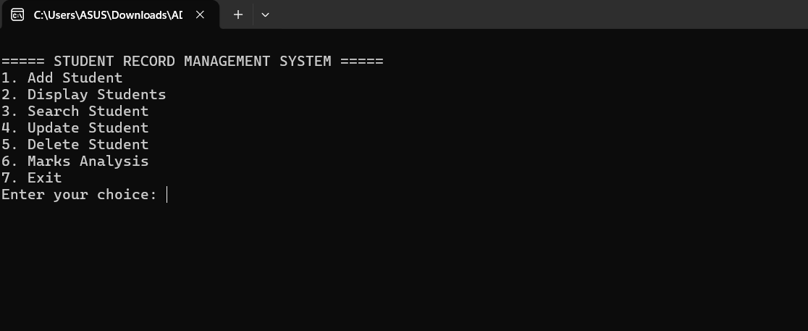

Fig 2.1 Student Record Management System main menu

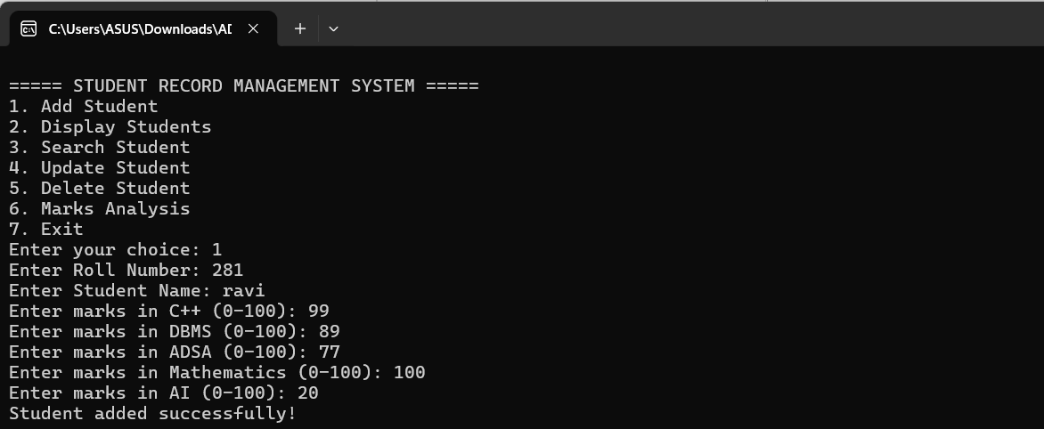

Fig 2.2 adding student details like name,roll number and marks of each subject and displaying the student details.

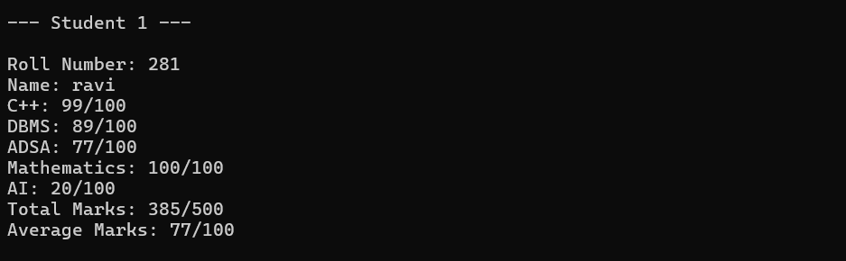

Fig 2.3 Adding student info
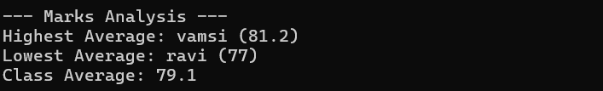
Fig 2.4 Marks Analysis
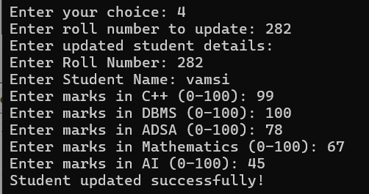

Fig 2.5 Updating student details
.
Table 2.2 Test cases and results

ID | Scenario | Input | Expected result | Result
TC1 | Add student | Option 1, Ravi, Roll No. 101 | Student added successfully | Pass
TC2 | Add another student | Option 1, Sita, Roll No. 102 | Student added successfully | Pass
TC3 | Display students | Option 2 | All student records displayed | Pass
TC4 | Search student | Option 3, Roll No. 101 | Student record displayed | Pass
TC5 | Update student | Option 4, Roll No. 101 | Student record updated successfully | Pass
TC6 | Search invalid roll number | Option 3, Roll No. 999 | Student not found | Pass
TC7 | Delete student | Option 5, Roll No. 102 | Student deleted successfully | Pass
TC8 | Enter invalid marks | Option 1, Marks: 120 | Invalid marks message displayed | Pass
TC9 | Marks analysis | Option 6 | Highest, lowest, and class averages displayed | Pass
TC10 | Exit system | Option 7 | Exiting the system. Thank you! | Pass

ID | Scenario | Input | Expected result | Result
TC11 | Update non-existing student | student  Option 4, Roll No. 999 | Student not found | Pass
TC12 | Invalid menu option | Enter abc, then 10 | Invalid input / Invalid choice message displayed | Pass
TC13 | Save and reload data | Option 1, existing Roll No. 101 | Roll number already exists | Pass

Result analysis:

All thirteen test cases passed. The results confirm that student records can be added, displayed, searched, updated, and deleted successfully. The system validates marks within the range of 0 to 100, rejects duplicate roll numbers, calculates total and average marks, identifies the highest and lowest averages, and calculates the class average. Invalid inputs are handled with appropriate messages without stopping the program. However, student records are stored only in memory and are not retained after the program is closed.

  - Conclusion

CHAPTER 3 CONCLUSION & FUTURE SCOPE

The Student Record Management System provides an organised way to maintain student details, manage subject marks, and analyse academic performance. It reduces reliance on manual record keeping and helps users manage student information in a consistent format.
The project demonstrates how object-oriented programming can be used in a practical application. The Student and StudentRecordManager classes separate responsibilities, while input validation helps maintain accurate student records.
Key outcomes of the project:
- A structured system for adding and displaying student records.
- Student searching, updating, and deletion using roll numbers.
- Validation for duplicate roll numbers and marks outside the range of 0 to 100.
- Calculation of total marks, individual averages, highest average, lowest average, and class average.
- Documentation of the requirements, algorithm, architecture, class design, source code, output screens, and test cases.
The current prototype stores data in memory, so records are not retained after the program closes. It uses a console interface and has a fixed capacity of 50 students. These limitations provide opportunities for future development through file handling, database integration, a graphical user interface, and additional academic reporting features.
  - Future Scope
The modular design allows several improvements to be added in future versions:
    - A graphical or web interface can make student record management easier for students and faculty.
    - Database integration with MySQL or PostgreSQL can preserve student details, marks and academic records permanently.
    - Login accounts and user roles can control who is allowed to add, update or delete student records.
    - Additional features can include grade calculation, report card generation, performance charts, attendance tracking and student ranking.

    - A mobile-friendly website can allow students and faculty to access student records and view academic results easily.
    - Automated tests and activity logs can improve system reliability and help administrators track changes to student records.
    - Reports and dashboards can display student marks, class averages, subject-wise performance and academic rankings.

REFERENCES
- Bjarne Stroustrup, A Tour of C++, Addison-Wesley.
- Herbert Schildt, C++: The Complete Reference, McGraw-Hill Education.
- cppreference.com, C++ Reference Documentation, https://en.cppreference.com/.
- Ian Sommerville, Software Engineering, Pearson.
- Roger S. Pressman and Bruce R. Maxim, Software Engineering: A Practitioner’s Approach, McGraw-Hill.

