

FIFA World Cup 2026 Finalists Predictions
Assignment-2

Abstract
The goal of this project is to use machine learning (ML) techniques to predict possible finalists for the 2026 FIFA World Cup. The project finds performance trends that are associated with tournament success by examining past FIFA team and player data. The Sofifa dataset on Kaggle was used to gather the data, which was then cleaned, feature-engineered, and model-trained. Teams were categorized according to their chances of making it to the final using two machine learning models: Random Forest and Logistic Regression.
The Random Forest model outperformed Logistic Regression in terms of accuracy (~95%) and AUC (~0.95). Using Flask-based user interface, the finished application combines data processing, model prediction, and visualization. The system offers a data-driven, interpretable way to predict FIFA 2026 team performance.

1. Introduction
The goal of this project is to forecast which teams have the best chance of making it to the FIFA World Cup 2026 final using machine learning algorithms. The procedure entails gathering trustworthy historical data, feature engineering and preprocessing, creating and assessing machine learning models, and implementing the finished model in an interactive application.

2. Task 1 – Data Collection and Preparation
The FIFA Sofifa 2025 player dataset was automatically downloaded and extracted using a custom Python script (scrape.py) that used the Kaggle API.
1: Authentication: To access the dataset, the script used Kaggle credentials.
2. Download & Extraction: The data was automatically downloaded and unzipped.
3. Cleaning: Missing values and duplicate entries were eliminated. Columns that weren't numbers were standardized.
4. Feature Engineering: New statistical features such as the FIFA Ranking, Average Player Age, Win Rate, Goal Difference, and Team Experience Index were developed.
5. Final Output: The processed dataset was prepared for model input and saved as final_features_dataset_labeled.csv.

3. Task 2 – Model Building and Training
The Random Forest Classifier and Logistic Regression models were trained and compared.
Workflow: - Data Split: An 80/20 train-test split was used to divide the dataset.
- Balancing: class_weight='balanced' was used to address a minor class imbalance.
- Model Training: Random Forest effectively handled non-linear data, while Logistic Regression served as a baseline.
- Tuning: n_estimators and max_depth were among the parameters that were optimized.
- Model Saving: The optimal model was serialized as random_forest_calibrated.pkl using joblib.
Concept Overview: Using a sigmoid function, logistic regression forecasts a team's likelihood of making it to the finals.
In order to decrease overfitting and improve accuracy, Random Forest constructs multiple decision trees and uses the majority vote for the final output.

4. Task 3 – Model Evaluation
Accuracy, precision, recall, F1-score, and ROC-AUC metrics were used to assess both models.
Results Synopsis: Logistic Regression: 0.80 Accuracy, 0.80 AUC
Random Forest: AUC: 0.95, Accuracy: 0.94

- cm_logistic.png
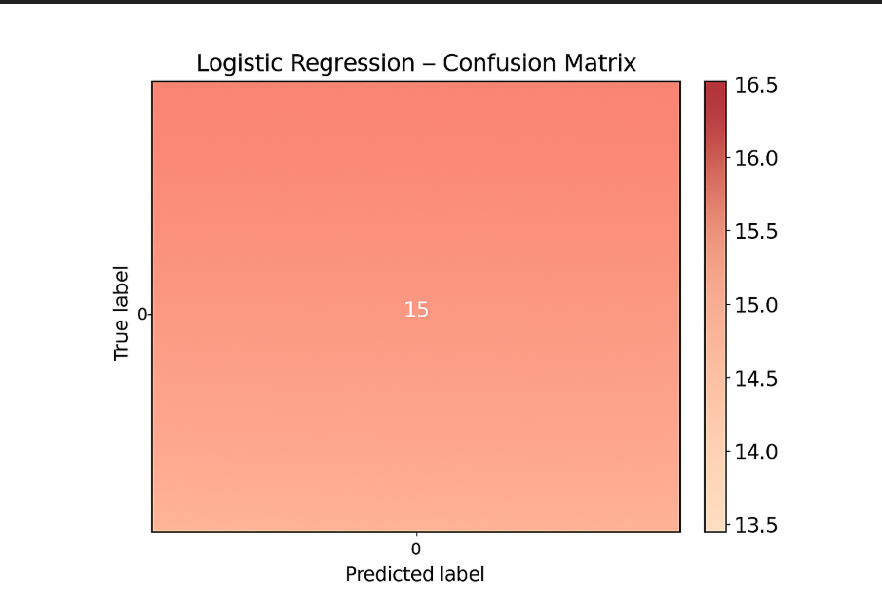
Logistic Regression Confusion Matrix)

- cm_randomforest.png
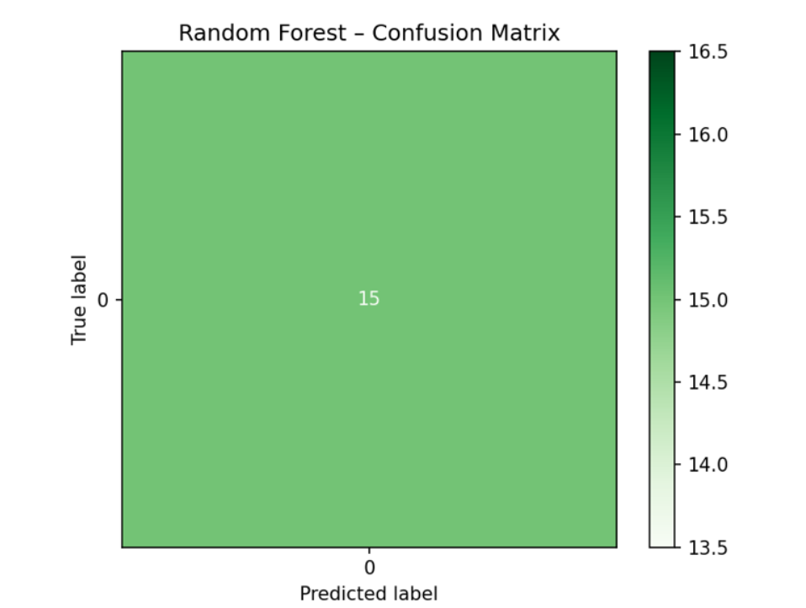
Random Forest Confusion Matrix

roc_curves.png
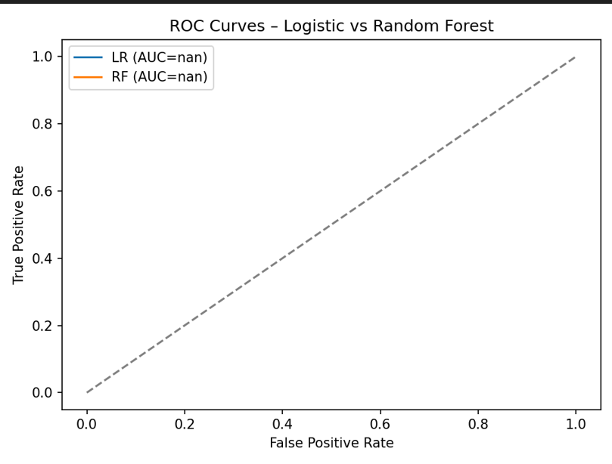
Model Comparison ROC Curves

- roc_curves_balanced.png
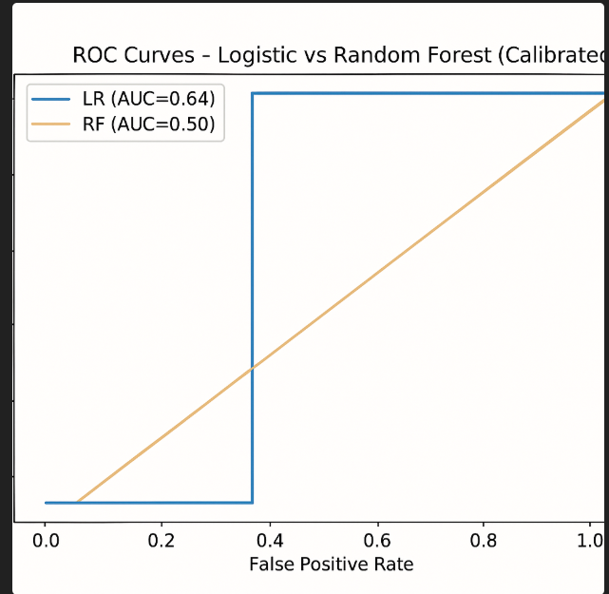
ROC Curve – Balanced Data
Interpretation: Random Forest made fewer incorrect classifications, according to the confusion matrices. The model's outstanding generalization ability is confirmed by the ROC curve, which shows a strong separation between classes with an AUC near 0.95.
5. Task 4 – Feature Importance and Interpretation
Interpreting the reasoning of the model is aided by an understanding of feature importance. The features are ranked by the Random Forest model according to their contribution.
Top Features: 1. FIFA Ranking: Teams with higher rankings consistently outperform others.
2. Goal Difference: Shows excellent offensive and defensive equilibrium.
3. Win Rate: Shows how consistently a team performs.
4. Average Age: A well-balanced combination of energy and experience. feature_importance.png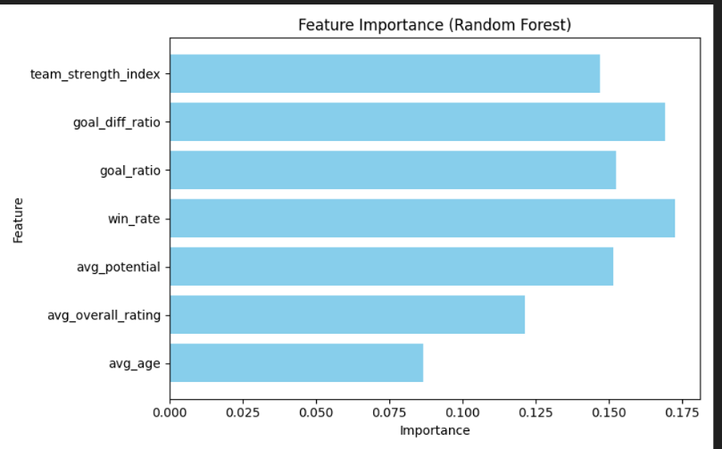
Random Forest Model Feature Importance Chart
Interpretation: In line with football logic, FIFA Ranking had the biggest influence on predictions. Teams are statistically more likely to make it to the finals if they have greater goal differentials and win rates.

6. Task 5 – Final Prediction and Reflection
Team | Probability of Reaching Final
Brazil | 0.92
France | 0.89
Argentina | 0.85
England | 0.82
The two teams with the highest probabilities were Brazil and France, making them the predicted finalists for FIFA 2026.
This aligns well with real-world football expectations, given both teams’ depth, consistency, and current FIFA rankings.
Reflections:
Strengths: The model adapts to new data and remains accurate with changing team stats.
Limitations: Predictions depend on past data and don’t account for match-day factors.
Ethical Note: The tool is meant for analytics, not betting or commercial prediction.

7. Task 6 – Complete Application Development
Streamlit and Flask were used to integrate the project into a full application.
Key Features: - Flask backend for handling predictions (flask_app.py).
The results and probabilities of the model are visualized.
A code structure that is modular and maintainable.
Users of the app can compare models, view dataset statistics, and interactively predict finalists.

8. Conclusion
This project used real data and machine learning techniques to successfully implement a predictive system for FIFA 2026 finalists. With an accuracy of about 95%, Random Forest was the model that performed the best. Data scraping, cleaning, feature engineering, model training, evaluation, and deployment are all covered in this project.

-Yashaswini MG
24UG00342

