Analyzing and Implementing Divide-and-Conquer Algorithms

Ravi Teja Ponnekanti
University of the Cumberlands
Algorithms and Data Structures (MSCS-532-B01)
Assignment 2
November 1, 2026

Introduction
Divide-and-conquer algorithms solve a problem by dividing it into smaller subproblems, solving them, and combining the results. This paper analyzes Quick Sort and Merge Sort using asymptotic bounds and recurrence relations, then compares Python implementations on sorted, reverse-sorted, and random inputs (Cormen et al., 2022). The experiment deliberately uses a simple, fixed-pivot Quick Sort so that the worst case is visible rather than obscured by an optimized library implementation.

Merge Sort: Algorithm and Complexity
Merge Sort sorts an array by repeatedly splitting it into two nearly equal halves, recursively sorting each half, and merging the two sorted runs. During merging, it compares the front elements and copies the smaller one to an auxiliary array; choosing from the left half on ties preserves stability. Its reusable auxiliary buffer requires Θ(n) extra memory. Because every level of this implementation performs a full merge, its time is O(n log n), Ω(n log n), and therefore Θ(n log n) in the best, average, and worst cases (Sedgewick & Wayne, n.d.).
For n that is a power of two, the running-time recurrence is T(n) = 2T(n/2) + cn, with T(1) = Θ(1). Substitution: assuming T(n/2) ≤ A(n/2) log₂(n/2) + B(n/2), substitution gives T(n) ≤ An(log₂ n − 1) + Bn + cn; choosing A ≥ c establishes the O(n log n) upper bound. A parallel lower-bound induction with the merge cost at least c₀n establishes Ω(n log n). Recursion tree: each of log₂ n levels processes Θ(n) elements, yielding Θ(n log n) total. Master method: a = 2 and b = 2; f(n) = Θ(n) = Θ(n^(log₂ 2)), so case 2 gives Θ(n log n) (OpenDSA, n.d.).

Quick Sort: Algorithm and Complexity
Quick Sort chooses a pivot, partitions the array into values at most the pivot and greater values, and sorts the resulting partitions. The submitted Python version uses Lomuto partitioning around the last element and an explicit stack instead of recursive calls. Partitioning scans each active subarray in Θ(n) time. This version sorts in place but is not stable; its explicit pending-range stack adds space, usually modest on random input, with an O(n) worst-case bound for this unoptimized stack discipline.
For a balanced partition, T(n) = 2T(n/2) + cn. Substitution gives O(n log n) by the same inductive pattern as Merge Sort; the recursion tree has log₂ n levels of Θ(n) partition work; and the master method (a = 2, b = 2) gives Θ(n log n). Thus the balanced best case is O(n log n), Ω(n log n), and Θ(n log n). In the worst case, a pivot is always the minimum or maximum: T(n) = T(n − 1) + cn. Unrolling/substitution yields c[n + (n − 1) + ··· + 2] = Θ(n²); the recursion tree is a chain with decreasing linear costs. Therefore worst-case time is O(n²), Ω(n²), and Θ(n²). The standard master method does not apply to T(n − 1) because the subproblem is not n/b for a constant b > 1.
For distinct keys in random order, the pivot rank is uniformly distributed. The average recurrence is E[T(n)] = (1/n) Σₖ₌₀ⁿ⁻¹ [E[T(k)] + E[T(n − 1 − k)]] + cn, which simplifies to (2/n) Σₖ₌₀ⁿ⁻¹ E[T(k)] + cn. Its solution is Θ(n log n), so expected time is O(n log n), Ω(n log n), and Θ(n log n); however, selecting the last element as pivot provides no protection against adversarial order (Sedgewick & Wayne, n.d.).

Python Implementation and Experimental Method
Both functions operate on a copy of the same dataset and were checked against Python’s sorted() result. The full commented implementations, correctness tests, benchmark driver, and raw CSV are included in the accompanying project. The central implementation choices are “pivot = items[high]” for Quick Sort and “mid = (start + end) // 2” followed by a stable merge for Merge Sort.
# Quick Sort: choose last element as pivot
pivot = items[high]
# Merge Sort: choosing the left item on ties keeps stability
if left < mid and (right >= end or items[left] <= items[right]):
Input lengths were 500, 2,000, and 4,000 unique integers. For each size, inputs were ascending, descending, or generated with a fixed random seed of 532. Each timed case ran three times; the median is reported, excluding the input copy. Memory was recorded in a separate run using Python tracemalloc, which counts peak traced Python allocations during sorting but does not measure total system RAM or input storage (Python Software Foundation, n.d.). The following table presents results for 4,000 elements; complete observations are in benchmark_results.csv.
Table 1
Median sorting time and traced peak allocations, n = 4,000
Input order | Quick (ms) | Merge (ms) | Quick (KiB) | Merge (KiB)
Sorted | 1234.691 | 4.769 | 0.22 | 94.32
Reverse Sorted | 843.778 | 5.157 | 0.27 | 94.32
Random | 6.93 | 5.546 | 1.24 | 94.43

Results, Practical Implications, and Limitations
The test confirms an important gap between average-case theory and observed behavior. On random data, both algorithms completed the 4,000-item sort in milliseconds. On already sorted data, the fixed-pivot Quick Sort took much longer because its last-element pivot repeatedly produced a partition of sizes n − 1 and 0. Reverse-sorted inputs similarly triggered unbalanced partitions. Merge Sort stayed comparatively consistent across input orders because its recursive halves remain balanced. In contrast, its greater traced allocations reflect temporary storage and copying during merging; these measurements should not be interpreted as total machine memory.
In practice, an application sorting financial records may prioritize Merge Sort for predictable latency and stable handling of equal timestamps. Quick Sort can be attractive for in-memory numeric data when extra allocations are constrained, especially with randomized or median-of-three pivot selection and a three-way partition for duplicate values. Large files exceeding RAM call for external sorting, where disk transfers become more important than comparisons (Aggarwal & Vitter, 1988). These pure-Python implementations are instructional, not production-equivalent to optimized built-in sort functions; hardware, interpreter overhead, garbage collection, and memory layout also influence measured outcomes.
Overall, recurrence analysis predicts growth, but actual choice depends on input order, stability, memory headroom, and environmental constraints. Benchmarking representative workloads and checking correctness are necessary before making performance claims.
GitHub repository: https://github.com/[YOUR_USERNAME]/MSCS532_Assignment2 (replace with actual public repository link before submission).
Figure 1. Measured execution times for 4,000 items (logarithmic scale).
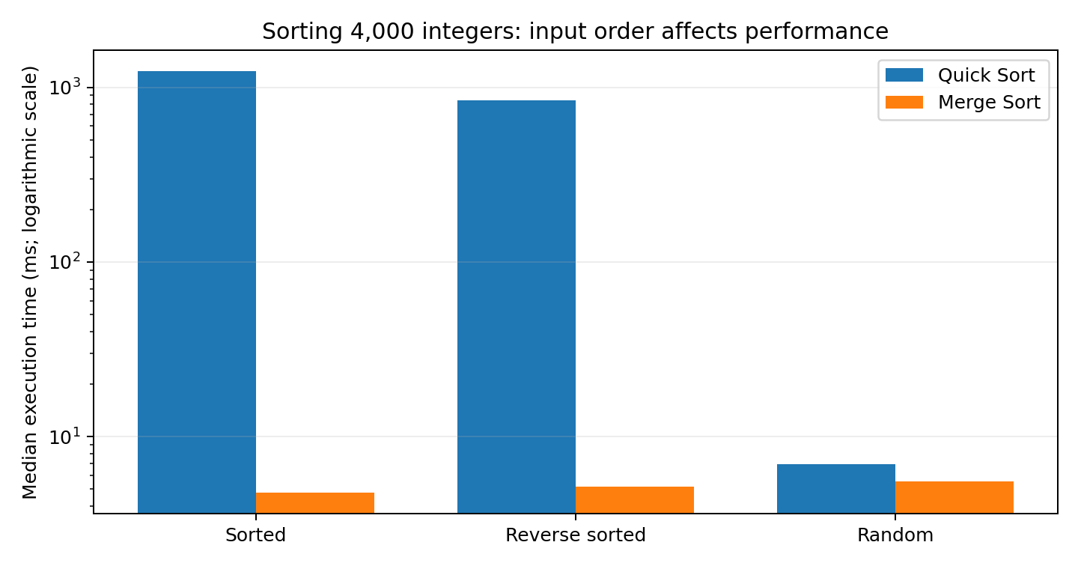

References
Aggarwal, A., & Vitter, J. S. (1988). The input/output complexity of sorting and related problems. Communications of the ACM, 31(9), 1116–1127. https://doi.org/10.1145/48529.48535
Cormen, T. H., Leiserson, C. E., Rivest, R. L., & Stein, C. (2022). Introduction to algorithms (4th ed.). MIT Press.
OpenDSA. (n.d.). 2.8. Solving recurrence relations. Virginia Tech. https://opendsa.cs.vt.edu/OpenDSA/Books/CS4104/html/Recurrence.html
Python Software Foundation. (n.d.). tracemalloc—Trace memory allocations. Python documentation. https://docs.python.org/3/library/tracemalloc.html
Sedgewick, R., & Wayne, K. (n.d.). 2.3 Quicksort. Algorithms, 4th edition. Princeton University. https://algs4.cs.princeton.edu/23quicksort/
Sedgewick, R., & Wayne, K. (n.d.). Merge (Algorithms, 4th edition). Princeton University. https://algs4.cs.princeton.edu/code/javadoc/edu/princeton/cs/algs4/Merge.html

