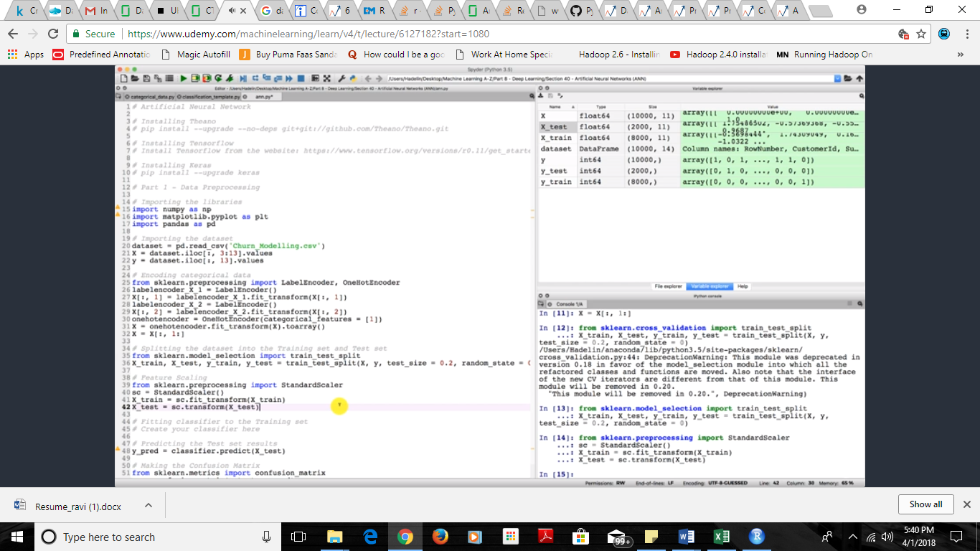

We have theanos,tenserflow packages

But we need to write more logic if we use this so we use keras package which is a wrapper kind of package for both theanos and tensor flow.so we use this package in neural netwoks

We create input layer,hidden layer,outputlayer

No of nodes in each layer = independent features + output layer /2 = 11 + ½ = 6

We add the number of hidden layers to be needed and also input layer and activation types for all layers which is rectifier type for hidden layers and sigmoid for output layer.

While compiling we use stocatic gradient descent which used type adam for updating the models, amd also we set the batch size and no of epochs.

