Time series:

We need to make mean , varience as constant

To make varience constant we apply log to dataset it may be once or twice or even more, we need to apply logs until varience is constants.

After applying logs then we apply differentiation (may be once or more) to make the mean constant

AR I MA(method to find timeseries)

AR auto regressive

I integration

MA moving average

AR I MA(p,d,q)

We need to find p,d,q values for building arima model

So to find q we use acf method

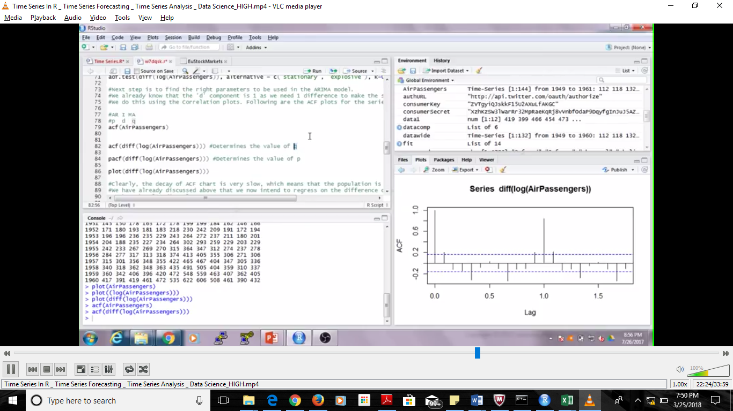

To find the q value we take the line before first inverted line

Here inverted is line 2 so q value is before that line i.e 1

In the sameway we find p value using pacf method

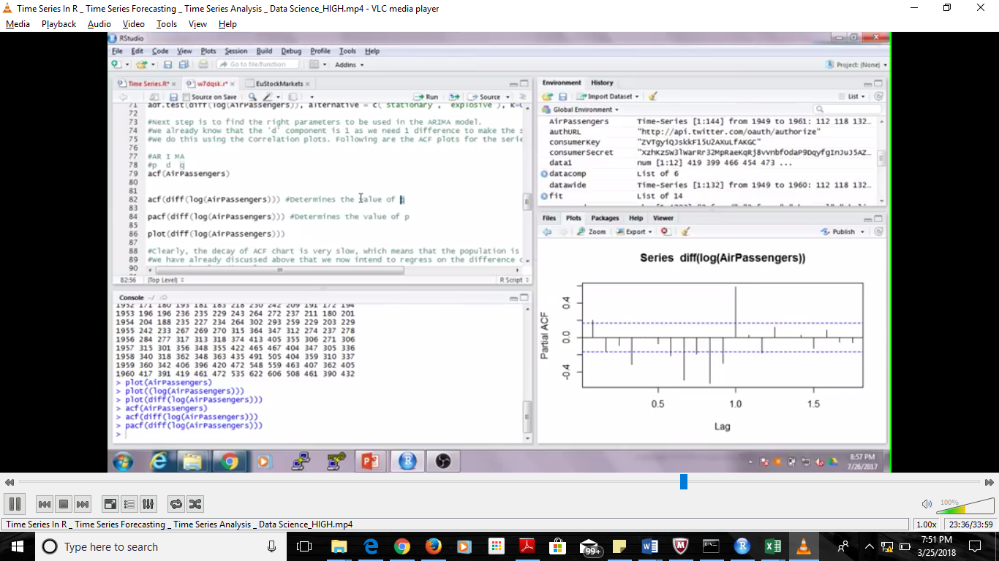

Here first inverted is 1st line (count starts from zero) so here the line before inverted line is 0th line so value of p is 0

Now find value of d : this is how many times we applied differentiation since we pplid only once our d value is 1

Now pass these values in function as mentioned below in order of p,d,q

Also predict as mentioned , its given as 10 here as we are predicting for 10 yrs here if u want u can change

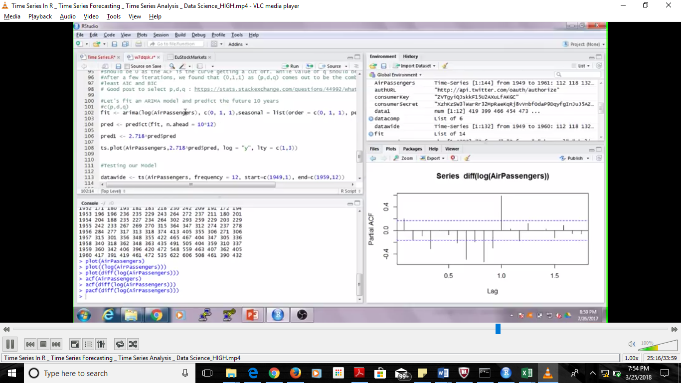

After predicting the va;ues will have log values so change them to normal values , apply exp value to the predicted values to make it normal . Suppose u apply log twice then exp has to beapplied twice