**Spring Boot** is basically an extension of the Spring framework, which provides rapid application development, where we can develop stand-alone web-based applications.

**Features of spring Boot**

Autoconfiguration

EmbededServer

Actuators

Starters

Spring-Profiles

dev-tools

**Difference between Spring and Springboot?**

**Spring:**

1.Spring is a framework to develop web-based applications with java as a language.

2.If we want to run the application, we need to add the server explicitly.

3.We need to do the configurations manually.

4.We require XML file to do the configurations.

5.We need to add the each and every dependency manually.

6.It takes time to develop any application when working with Spring.

Spring Boot streamlines the development of Spring applications by providing pre-configured templates, automatic configurations, embedded servers, and built-in tools for monitoring and management. It reduces the amount of boilerplate code and configuration required, allowing developers to focus more on building business logic. Traditional Spring, while powerful and flexible, requires more manual configuration and setup.

**SpringBoot (features):**

1.SpringBoot is an extended feature of Spring framework which provides rapid application development, where we can develop stand-alone web-based applications.

2.We can run the application directly without adding any server, because it contains embedded server like tomcat, jetty,Undertow etc.,

3.We don't need any XML file for configuration.

4.It provides a feature of Auto configuration.

5.It provides production ready features like bean info, health condition when you add actuator dependency.

6.It provides concept of starters where dependencies are added no need to add manually.

7.It reduces development time and increases productivity time when you develop a web-based application.

8.When we add devtool dependency in pom.xml, application is loaded automatically when we do any changes.

**How Auto-Configuration Works Internally in Spring Boot**

Auto-configuration in Spring Boot is a powerful feature that simplifies the setup of a Spring application by automatically configuring beans based on the classpath, environment, and other conditions. Here's a detailed explanation of the internal workings of auto-configuration:

**1. Auto-Configuration Entry Point**

* **@EnableAutoConfiguration:**
  + When you annotate your main application class with @SpringBootApplication, you are indirectly enabling @EnableAutoConfiguration. This annotation is responsible for triggering the auto-configuration process.

java

Copy code

@SpringBootApplication

public class MyApp {

public static void main(String[] args) {

SpringApplication.run(MyApp.class, args);

}

}

* **@EnableAutoConfiguration Annotation:**
  + This annotation tells Spring Boot to start the auto-configuration process by scanning the classpath for available configuration classes.

**2. Spring Factories Mechanism**

* **spring.factories File:**
  + The core of auto-configuration lies in the spring.factories file, which is located in META-INF directory inside Spring Boot’s JAR files. This file lists all the auto-configuration classes to be loaded.
  + For example, in spring-boot-autoconfigure JAR:

properties

Copy code

org.springframework.boot.autoconfigure.EnableAutoConfiguration=\

org.springframework.boot.autoconfigure.jdbc.DataSourceAutoConfiguration,\

org.springframework.boot.autoconfigure.web.servlet.WebMvcAutoConfiguration,\

org.springframework.boot.autoconfigure.orm.jpa.HibernateJpaAutoConfiguration

* **Loading Configuration Classes:**
  + During startup, Spring Boot reads the spring.factories file and loads the listed auto-configuration classes. These classes are annotated with @Configuration and typically have @Conditional annotations that dictate whether they should be applied.

**3. Conditional Annotations**

* **Conditional Checks:**
  + Auto-configuration classes use various @Conditional annotations to determine whether the configuration should be applied. Examples include:
    - @ConditionalOnClass: Checks if a specific class is on the classpath.
    - @ConditionalOnMissingBean: Ensures that a bean is only configured if it does not already exist.
    - @ConditionalOnProperty: Activates configuration based on the presence or value of a property.
* **Example of an Auto-Configuration Class:**

java

Copy code

@Configuration

@ConditionalOnClass(DataSource.class)

@EnableConfigurationProperties(DataSourceProperties.class)

public class DataSourceAutoConfiguration {

@Bean

@ConditionalOnMissingBean

public DataSource dataSource(DataSourceProperties properties) {

return properties.initializeDataSourceBuilder().build();

}

}

* + In this example, DataSourceAutoConfiguration will configure a DataSource bean only if the DataSource class is present on the classpath and no other DataSource bean is already defined.

**4. Auto-Configuration Processing**

* **Loading and Applying Auto-Configurations:**
  + During the startup process, Spring’s SpringApplication class loads all the auto-configuration classes listed in the spring.factories file.
  + It processes each auto-configuration class, checking the conditions specified in the @Conditional annotations.
  + If all conditions are met, the configuration is applied, and the necessary beans are created and registered in the Spring context.
* **Exclusions and Customizations:**
  + You can exclude specific auto-configuration classes using the exclude attribute in @SpringBootApplication or via configuration properties.
  + Custom beans or properties can override auto-configured beans, allowing developers to fine-tune or replace auto-configured components.

**5. Example Flow:**

Let’s consider a simple example where you include spring-boot-starter-data-jpa in your project:

1. **Dependencies:**
   * The starter brings in JPA, Hibernate, and other necessary libraries.
2. **Classpath Scanning:**
   * Spring Boot detects that JPA is on the classpath.
3. **Loading spring.factories:**
   * The spring.factories file points to HibernateJpaAutoConfiguration and other related classes.
4. **Conditional Annotations:**
   * Spring Boot checks conditions like the presence of JPA-related classes (@ConditionalOnClass) and required properties (@ConditionalOnProperty).
5. **Bean Creation:**
   * If all conditions are met, Spring Boot configures a EntityManagerFactory, DataSource, and other related beans automatically.
6. **Application Startup:**
   * The Spring Boot application starts up with all the necessary components configured and ready to use.

**Summary**

Auto-configuration in Spring Boot works by leveraging the @EnableAutoConfiguration annotation, which triggers the loading of configuration classes defined in spring.factories. These classes use conditional logic to determine whether to apply certain configurations, automatically setting up beans based on the classpath and environment. This mechanism greatly simplifies application setup by eliminating the need for explicit configuration of common components.

**Spring Boot autoconfiguration** represents a way to automatically configure a Spring application based on the dependencies that are present on the classpath. This can make development faster and easier by eliminating the need for defining certain beans that are included in the auto-configuration classes.

**AutoConfiguration and how it works internally?**

It is a feature of Springboot where it will automatically configure the beans with the application context based on the application related properties such as presence of certain classes in the class path, existence of beans and activation of some properties.

**Example:**

When we add SpringbootStarter Spring data Jpa, then in the auto configuration class based on the

@ConditionalOnClass, it will check whether DataSource class is available in class path or not.

@ConditionalOnBean, it will check whether bean with same name created or not.

@ConditionalOnMissingBean , it will check if bean created or not if missing then it will create

@ConditinalOnProperty it will check whether the database properties are there in the application.properties .

Like based on these conditions' configuration is done and is registered with the application context.

Data source bean will be created automatically if we have SpringBoot -starter jpa on class path and database relation config info in properties file

spring.datasource.url=jdbc:mysql://localhost:3306/my_java

spring.datasource.username=root

spring.datasource.password=root

spring.jpa.database-platform=org.hibernate.dialect.MySQL8Dialect

spring.jpa.hibernate.ddl-auto=update

spring.jpa.show-sql=true

RestTemplate will be crated automatically if we add Spring starter web dependency

ViewResolver Bean will cerated based on Spring starter web depency in class path and application prop file

spring.mvc.view.prefix=/WEB-INF/jsp/

spring.mvc.view.suffix=.jsp

**Disabling specific auto-configuration**

If you find that specific auto-configure classes are being applied that you don’t want, you can use the exclude attribute of @EnableAutoConfiguration to disable them.

*@Configuration*

*@EnableAutoConfiguration(exclude={DataSourceAutoConfiguration.class})*

**public** **class** MyConfiguration {

}

If the class is not on the classpath, you can use the excludeName attribute of the annotation and specify the fully qualified name instead. Finally, you can also control the list of auto-configuration classes to exclude via the spring.autoconfigure.exclude property.

### **What Is An Embedded Server?**

An embedded server is embedded as part of the deployable application.

If we talk about Java applications, that would be a JAR.

The advantage with this is you don’t need the server pre-installed in the deployment environment.

With SpringBoot, the default embedded server is **Tomcat**. Other options available are **Jetty** and **UnderTow.**

Embedded servers are quite scalable, and can host applications that support millions of users. These are no less scalable than the conventional fat servers. In a typical microservice architecture, there could be hundreds of microservice instances deployed at a given point in time.

We would like to automate development and deployment of microservices to the maximum extent possible.

A good approach would be to take the application, wrap it in a container image, and manage it as needed using something like Kubernetes.

### Switching To Jetty

By default, the Spring Boot framework uses Tomcat as the embedded server of choice. However, you could override this default setting by specifying certain configuration settings. For instance, if you want to use a Jetty dependency instead, then use an <exclusion> element in the XML configuration file, and specify a <dependency> element as well:

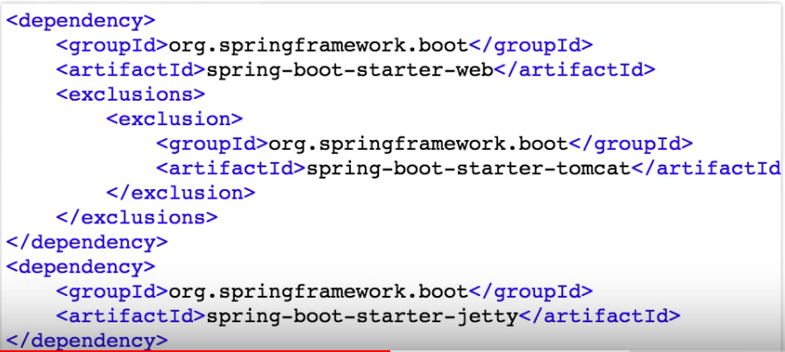

A similar dependency also exists for Undertow.

### What is Spring Actuator? What are its advantages?

An actuator is an additional feature of Spring that helps you to monitor and manage your application when you push it to production. These actuators include auditing, health, CPU usage, HTTP hits, and metric gathering, and many more that are automatically applied to your application.

### How to enable Actuator in Spring boot application?

To enable the spring actuator feature, we need to add the dependency of “spring-boot-starter-actuator” in pom.xml.

<dependency>

<groupId> org.springframework.boot</groupId>

<artifactId> spring-boot-starter-actuator </artifactId>

</dependency>

**management.endpoints.web.exposure.include=* //** to enable all end points add this in prop file

### What are the actuator-provided endpoints used for monitoring the Spring boot application?

Actuators provide below pre-defined endpoints to monitor our application -

* Health
* Info
* Beans
* Mappings
* Configprops
* Httptrace
* Heapdump
* Threaddump
* Shutdown

### How to get the list of all the beans in your Spring boot application?

Spring Boot actuator “/Beans” is used to get the list of all the spring beans in your application.

### How to check the environment properties in your Spring boot application?

Spring Boot actuator “/env” returns the list of all the environment properties of running the spring boot application.

In essence, Actuator brings production-ready features to our application.

**Monitoring our app, gathering metrics, understanding traffic, or the state of our database become trivial with this dependency.**

The main benefit of this library is that we can get production-grade tools without having to actually implement these features ourselves.

Actuator is mainly used to **expose operational information about the running application** — health, metrics, info, dump, env, etc. It uses HTTP endpoints or JMX beans to enable us to interact with it.

Once this dependency is on the classpath, several endpoints are available for us out of the box. As with most Spring modules, we can easily configure or extend it in many ways.

the only two available by default are */health* and */info*.

If we want to enable all of them, we could set *management.endpoints.web.exposure.include=\**. Alternatively, we can list endpoints that should be enabled.

**by default, all Actuator endpoints are now placed under the */actuator* path*.***

* */auditevents*lists security audit-related events such as user login/logout. Also, we can filter by principal or type among other fields.
* */beans*returns all available beans in our *BeanFactory*. Unlike */auditevents*, it doesn't support filtering.
* */conditions*, formerly known as /*autoconfig*, builds a report of conditions around autoconfiguration.
* */configprops*allows us to fetch all *@ConfigurationProperties*beans.
* */env*returns the current environment properties. Additionally, we can retrieve single properties.
* */flyway*provides details about our Flyway database migrations.
* */health*summarizes the health status of our application.
* */heapdump*builds and returns a heap dump from the JVM used by our application.
* */info*returns general information. It might be custom data, build information or details about the latest commit.
* */liquibase*behaves like */flyway*but for Liquibase.
* */logfile*returns ordinary application logs.
* */loggers*enables us to query and modify the logging level of our application.
* */metrics*details metrics of our application. This might include generic metrics as well as custom ones.
* */prometheus*returns metrics like the previous one, but formatted to work with a Prometheus server.
* */scheduledtasks*provides details about every scheduled task within our application.
* */sessions*lists HTTP sessions given we are using Spring Session.
* */shutdown*performs a graceful shutdown of the application.
* */threaddump*dumps the thread information of the underlying JVM.

**Starters**

SpringBoot Starters are maven template, which contains collection of relevant dependencies that are needed to start any functionality, like we add springbootstarter spring data Jpa to do database operations, springbootstarter web to develop web-based applications etc.,

Dependency management is a critical aspects of any complex project. And doing this manually is less than ideal; the more time you spent on it the less time you have on the other important aspects of the project.

Spring Boot starters were built to address exactly this problem. Starter POMs are a set of convenient dependency descriptors that you can include in your application. You get a one-stop-shop for all the Spring and related technology that you need, without having to hunt through sample code and copy-paste loads of dependency descriptors.

We have more than 30 Boot starters available – let's see some of them in the following sections.

## Spring Boot Starter Parent

The spring-boot-starter-parent  is a special starter–

**It also provides default configuration for Maven plugins** (such as *maven-failsafe-plugin*, *maven-jar-plugin*, *maven-surefire-plugin*, *maven-war-plugin*.)

Beyond that, it also inherits dependency management from *spring-boot-dependencies*which is the parent to the s*pring-boot-starter-parent*.

Once, we declare the starter parent in our project**, we don't need to define versions of the dependencies, Maven will download jar files based on the version defined for starter parent in the parent tag.**

For example, if we're building a web project, we can add spring-boot-starter-web directly, and we don't need to specify the version:

## ****The Web Starter****

First, let's look at developing the REST service; we can use libraries like Spring MVC, Tomcat and Jackson – a lot of dependencies for a single application.

Spring Boot starters can help to reduce the number of manually added dependencies just by adding one dependency. So instead of manually specifying the dependencies just add one starter as in the following example:

### What is the starter dependency of the Spring boot module?

Spring boot provides numbers of starter dependency, here are the most commonly used -

* Data JPA starter.
* Test Starter.
* Security starter.
* Web starter.
* Mail starter.
* Thymeleaf starter.

Spring Boot Profiles

While developing the application we deal with multiple environments such as dev, QA, Prod, and each environment requires a different configuration. For eg., we might be using an embedded H2 database for dev but for prod, we might have proprietary Oracle or DB2. Even if DBMS is the same across the environment, the URLs will be different.

To make this easy and clean, Spring has the provision of Profiles to keep the separate configuration of environments.

**Need for Profiles**

Enterprise application development is complex. You have multiple environments

* Dev
* QA
* Stage
* Production

You want to have different application configuration in each of the environments.

*Profiles help to have different application configuration for different environments.*

Spring and Spring Boot provide features where you can specify

* What is the configuration for various environments in different profiles?
* Set the active profile for a specific environment.

Spring Boot would pick up the application configuration based on the active profile that is set in a specific environment.

* application.properties - Configuration for application. Active profile is set in application.properties in this example
* application-dev.properties - Configuration Overrides for dev profile
* application-prod.properties - Configuration Overrides for prod profile

**Setting Active Profile**

Once you have profile specific configuration, you would need to set the active profile in an environment.

There are multiple ways of doing this

* Using -Dspring.profiles.active=prod in VM Arguments
* Use spring.profiles.active=prod in application.properties

In this example let’s set it in application.properties. Lets add another property to application.properties

spring.profiles.active=dev

When you restart the application, you would see that the dev profile is active.

## Configuring Profile Specific Beans

You can take this one step further and configure profile specific beans that are created only in specific profiles.

Let’s add this to SpringBootTutorialBasicsConfigurationApplication.java

@Profile("dev")

@Bean

public String devBean() {

return "dev";

}

@Profile("qa")

@Bean

public String qaBean() {

return "qa";

}

@Profile("prod")

@Bean

public String prodBean() {

return "prod";

}

Using @Profile annotation we can indicate the active profile in which a specific bean should be created.

To test this let’s further enhance SpringBootTutorialBasicsConfigurationApplication.

Let’s print the name of all the beans that are loaded.

public static void main(String[] args) {

ApplicationContext applicationContext = SpringApplication

.run(SpringBootTutorialBasicsConfigurationApplication.class, args);

for (String name : applicationContext.getBeanDefinitionNames()) {

System.out.println(name);

}

}

We are currently using dev profile

spring.profiles.active=dev

When you reload the application, you would see the following in the log

devBean

Spring Boot DevTools

Spring Boot 1.3 provides another module called Spring Boot DevTools. DevTools stands for **Developer Tool.** The aim of the module is to try and improve the development time while working with the Spring Boot application. Spring Boot DevTools pick up the changes and restart the application.

We can implement the DevTools in our project by adding the following dependency in the pom.xml file.

1. **<dependency>**
2. **<groupId>**org.springframework.boot**</groupId>**
3. **<artifactId>**spring-boot-devtools**</artifactId>**
4. **<scope>**runtime**<scope** **>**
5. **</dependency>**

Spring Boot Application Flow

Flow of Spring Boot Application Starts from Our Main Class, where we will be having main method, we will be using @SpringBootApplication annotaion on top of the main class @SpringBoot application is combination of @configuration @EnableAutoConfiguration and @ComponentScan . In our Main class will be having a Main method form main method we will be calling SpringApplication.run method we will be passing our main class name and args as arguments SpringApplication.run(MyApplication.class, args); from run it will internally check the application Context type based on dependency’s in our class path and if it is a web application then it will create webapplicationannotationconfig web application context , after creating application context as we have used component scan it will scan for all the base packages for the classes annotated with @component @contoller @service @repository @bean on methods and then application context will create beans for this classes and register it , when it finds @autowired annotation it will inject the beans, as we have used @enableautofiguration it will check for the autoconfiguration classes based on some conditions like @condiationlon class @conditionalonbean @condiationalonpropery automatically beans will be crated like datasource, resttemplate etc… now at last internally will call tomcat and application will get started

=====

There is main class autogenerated and somehow it do some magic when we run the spring boot application, how come the main method initiate servlet, run the container and all that actually happened when spring boot called this main method. We will unfold this in below article about the **SpringApplication.run** method So lets set go!!.

When we run this class as a java application then our application gets started.

Let’s try to **unfold the magic** which goes behind this SpringApplication.run method.

SpringApplication.run(StudentManagementApplication.class, args), is a static method it **returns** an object of **ConfigurableApplicationContext.**

ConfigurableApplicationContext ctx=SpringApplication.run(StudentManagementApplication.class, args);

Thus spring container gets started once **SpringApplication.run()** method is called.

Also learn: [What is Spring boot Application?](http://learnspringboot.in/getting-start-with-spring-boot/)

Spring container once gets started is responsible for:

1. **Creating all objects:** This is done by component scan remember @SpringBootApplication is a combination of @Configuration + @ComponentScan + @EnableAutoConfiguration.
2. **Dependency Injection**.
3. Managing **the life cycle** of all beans.

Steps Executed under this method –

So in short when the main method runs following **steps** occur:

1. **Application Context** is started.
2. Using application context **autodiscovery** occurs: @ComponentScan
3. All default configurations are set up ie based on dependencies mentioned spring boot automatically sets up defaults. It makes use of intelligence that if we have included spring-web starter then dispatcher servlet is auto-configured. (**@EnableAutoConfiguration**)
4. An embedded servlet container is started. ( No need to set up a separate web server ) . Note embedded servlet container is launched only if the web is mentioned in a dependency

Also Read: [@SpringBootApplication Annotation](http://learnspringboot.in/understand-springbootapplication-annotation/)

So, next time you run the main method, I hope you remember the magic that goes behind is application context, that’s why we recommend you to learn **Spring Core as a prerequisite** to Spring Boot.

Please leave us a comment if you have any issue in understanding above.

[**200 OK**](https://developer.mozilla.org/en-US/docs/Web/HTTP/Status/200)

The request has succeeded. The meaning of the success depends on the HTTP method:

* GET: The resource has been fetched and is transmitted in the message body.
* HEAD: The representation headers are included in the response without any message body.
* PUT or POST: The resource describing the result of the action is transmitted in the message body.
* TRACE: The message body contains the request message as received by the server.

[**201 Created**](https://developer.mozilla.org/en-US/docs/Web/HTTP/Status/201)

The request has succeeded and a new resource has been created as a result. This is typically the response sent after POST requests, or some PUT requests.

[**400 Bad Request**](https://developer.mozilla.org/en-US/docs/Web/HTTP/Status/400)

The server could not understand the request due to invalid syntax.

[**401 Unauthorized**](https://developer.mozilla.org/en-US/docs/Web/HTTP/Status/401)

Although the HTTP standard specifies "unauthorized", semantically this response means "unauthenticated". That is, the client must authenticate itself to get the requested response.

[**402 Payment Required**](https://developer.mozilla.org/en-US/docs/Web/HTTP/Status/402)

This response code is reserved for future use. The initial aim for creating this code was using it for digital payment systems, however this status code is used very rarely and no standard convention exists.

[**403 Forbidden**](https://developer.mozilla.org/en-US/docs/Web/HTTP/Status/403)

The client does not have access rights to the content; that is, it is unauthorized, so the server is refusing to give the requested resource. Unlike 401, the client's identity is known to the server.

[**404 Not Found**](https://developer.mozilla.org/en-US/docs/Web/HTTP/Status/404)

The server can not find the requested resource. In the browser, this means the URL is not recognized. In an API, this can also mean that the endpoint is valid but the resource itself does not exist. Servers may also send this response instead of 403 to hide the existence of a resource from an unauthorized client. This response code is probably the most famous one due to its frequent occurrence on the web.

[**405 Method Not Allowed**](https://developer.mozilla.org/en-US/docs/Web/HTTP/Status/405)

The request method is known by the server but is not supported by the target resource. For example, an API may forbid DELETE-ing a resource.

[**500 Internal Server Error**](https://developer.mozilla.org/en-US/docs/Web/HTTP/Status/500)

The server has encountered a situation it doesn't know how to handle.

[**502 Bad Gateway**](https://developer.mozilla.org/en-US/docs/Web/HTTP/Status/502)

This error response means that the server, while working as a gateway to get a response needed to handle the request, got an invalid response.

[**503 Service Unavailable**](https://developer.mozilla.org/en-US/docs/Web/HTTP/Status/503)

The server is not ready to handle the request. Common causes are a server that is down for maintenance or that is overloaded. Note that together with this response, a user-friendly page explaining the problem should be sent. This response should be used for temporary conditions and the Retry-After: HTTP header should, if possible, contain the estimated time before the recovery of the service. The webmaster must also take care about the caching-related headers that are sent along with this response, as these temporary condition responses should usually not be cached.

[**504 Gateway Timeout**](https://developer.mozilla.org/en-US/docs/Web/HTTP/Status/504)

This error response is given when the server is acting as a gateway and cannot get a response in time.

**How many ways we can access spring boot properties**

• **@Value Annotation:** Directly injects values into fields.

• **@ConfigurationProperties:** Binds properties to a POJO.

• **Environment Object:** Accesses properties programmatically.

• **@PropertySource:** Loads additional property files.( external files)

• **@Configuration Class:** Provides programmatic access to properties.

• **@Profile:** Loads different properties based on active profiles.

• **@PostConstruct:** Initializes properties after bean creation.

@Value("${my.property}")

private String myProperty;

@Component @ConfigurationProperties(prefix = "app")

public class AppProperties {

private String name;

private String version;

@Autowired private Environment env;

public String getProperty() {

return env.getProperty("my.property");

======

@Configuration @PropertySource("classpath:myproperties.properties") public class AppConfig {

// Other configurations }

Spring Boot Base Practical:

When ever we create a basic spring boot project with Spring starter io (current version spring boot 3.3 (date:2024-AUG)) with out any other dependencies by default we get in pom.xml as

<parent>

<groupId>org.springframework.boot</groupId>

<artifactId>**spring-boot-starter-parent**</artifactId>

<version>3.3.2</version>

<relativePath/> //management of versions of dependencies by providing a consistent set of versions for all Spring Boot dependencies. Additionally, it configures default values for many build settings (like the Java version, encoding, and plugins).

</parent>

<properties>

<java.version>17</java.version>

</properties>

<dependencies>

<dependency>

<groupId>org.springframework.boot</groupId>

<artifactId>**spring-boot-starter**</artifactId>

</dependency> // provides autoconfigure,spring boot,spring core etc.

<dependency>

<groupId>org.springframework.boot</groupId>

<artifactId>**spring-boot-starter-test**</artifactId>

<scope>test</scope>

</dependency>

</dependencies>

<build>

<plugins>

<plugin>

<groupId>org.springframework.boot</groupId>

<artifactId>spring-boot-maven-plugin</artifactId>

</plugin>

</plugins>

</build>

The @Transactional annotation in Spring is used to manage transaction boundaries for methods or classes. It ensures that the entire operation is completed successfully before committing the transaction. If any exception occurs during the operation, the transaction is rolled back.

**Key Concepts**

1. **Transaction**: A sequence of operations performed as a single logical unit of work. A transaction is either fully completed or fully failed.
2. **Atomicity**: Ensures that all operations within a transaction are completed successfully. If any operation fails, the entire transaction is rolled back.
3. **Consistency**: Ensures that a transaction brings the system from one consistent state to another.
4. **Isolation**: Ensures that transactions are isolated from each other, preventing them from affecting each other's outcome.
5. **Durability**: Ensures that once a transaction is committed, it remains committed even in the case of a system failure.

**Where to Use @Transactional**

* **Service Layer**: It is commonly used at the service layer where you define the business logic that interacts with the database.
* **Multiple DAO Calls**: When a method contains multiple database operations (DAO calls) that should be executed as a single transaction.
* **Read/Write Operations**: Use it when you need to ensure that read and write operations occur within a transaction boundary.

**How to Use @Transactional**

1. **Method-Level Annotation**:
   * You can apply @Transactional directly on a method to make that method transactional.

**Class-Level Annotation**:

* Apply @Transactional at the class level to make all the methods in the class transactional by default.

**Rollback Behavior**:

* By default, Spring rolls back the transaction only on unchecked exceptions (subclasses of RuntimeException).
* You can specify rollback behavior for specific exceptions.

**Propagation**:

* Controls how the transaction should propagate.
* Common propagation types:
  + REQUIRED (default): Join the existing transaction or create a new one if none exists.
  + REQUIRES_NEW: Suspends the current transaction (if any) and creates a new one.
  + MANDATORY: Requires an existing transaction, throws an exception if none exists.
  + SUPPORTS: Joins the current transaction if one exists; executes non-transactionally otherwise.
  + NOT_SUPPORTED: Executes non-transactionally, suspending the current transaction if one exists.
  + NEVER: Executes non-transactionally, throws an exception if a transaction exists.
  + NESTED: Executes within a nested transaction if a current transaction exists.

**Isolation**:

* Defines the isolation level for a transaction.
* Common isolation levels:
  + DEFAULT: Use the default isolation level of the underlying datastore.
  + READ_UNCOMMITTED: Allows dirty reads, non-repeatable reads, and phantom reads.
  + READ_COMMITTED: Prevents dirty reads, allows non-repeatable reads and phantom reads.
  + REPEATABLE_READ: Prevents dirty reads and non-repeatable reads, allows phantom reads.
  + SERIALIZABLE: Prevents dirty reads, non-repeatable reads, and phantom reads.

**Timeout**:

* Specifies the timeout duration for the transaction. If the method execution takes longer than the specified time, the transaction is rolled back.

**Use Cases and Examples**

1. **Banking Application**:
   * In a banking system, when transferring money from one account to another, you need to ensure that both the debit and credit operations are successful. If either operation fails, the entire transaction should be rolled back to maintain consistency.
2. **E-commerce Application**:
   * In an order processing system, placing an order might involve multiple operations like reducing inventory, charging a credit card, and updating order status. All these operations should be completed successfully as a single transaction.

**Advantages of Using @Transactional**

* **Consistency and Integrity**: Ensures that the data remains consistent and that the database is not left in an inconsistent state in case of a failure.
* **Simplifies Code**: Abstracts the complexity of transaction management, allowing developers to focus on business logic.
* **Flexibility**: Provides various options to control transaction propagation, isolation, and rollback behavior, allowing fine-grained control over transactions.

**Conclusion**

The @Transactional annotation is a powerful tool in Spring for managing transactions, ensuring data consistency, and simplifying transaction management in complex applications. It is commonly used in the service layer of Spring Boot applications and provides various options to control the behavior of transactions.

**Validation Annotations in Spring Boot**

In Spring Boot microservices, validations ensure that the data received in requests (usually through APIs) adheres to certain rules before processing it. Spring Boot provides a powerful and flexible way to handle validations using annotations.

**Common Validation Annotations in Spring Boot**

1. **@Valid** and **@Validated**:
   * **@Valid**: Used to trigger validation for the annotated method parameters. Typically applied to request bodies in controller methods.
   * **@Validated**: Similar to @Valid, but allows group-based validation.

• **@NotNull**:

* Ensures that the annotated field is not null.
* Example: @NotNull private String name;

• **@NotEmpty**:

* Ensures that the annotated field is not null and not empty.
* Example: @NotEmpty private String username;

• **@NotBlank**:

* Ensures that the annotated field is not null, not empty, and contains at least one non-whitespace character.
* Example: @NotBlank private String password;

• **@Size**:

* Ensures that the size of the annotated field is within the specified range.
* Example: @Size(min = 5, max = 10) private String username;

• **@Min** and **@Max**:

* Ensure that the annotated field has a value between the specified minimum and maximum.
* Example: @Min(18) @Max(65) private int age;

• **@Pattern**:

* Ensures that the annotated field matches the specified regular expression.
* Example: @Pattern(regexp = "^[a-zA-Z0-9]{6,12}$") private String password;

• **@Email**:

* Ensures that the annotated field contains a valid email address.
* Example: @Email private String email;

• **@Past, @PastOrPresent, @Future, @FutureOrPresent**:

* Ensure that the annotated date field is in the past, past or present, future, or future or present, respectively.
* Example: @Past private LocalDate birthDate;

• **@Positive and @Negative**:

* Ensure that the annotated numeric field is positive or negative.
* Example: @Positive private int quantity;

Creating custom validation in Spring Boot allows you to define specific rules that aren't covered by the standard validation annotations like @NotNull, @Size, or @Pattern. Below is a step-by-step explanation of how to create a custom validation with a practical use case.

**Use Case: Custom Password Validation**

Let's say you want to create a custom validation annotation to ensure that a password meets the following criteria:

* Must contain at least one uppercase letter.
* Must contain at least one lowercase letter.
* Must contain at least one digit.
* Must contain at least one special character (e.g., !@#$%^&*()).
* Must be between 8 and 20 characters long.

**Steps to Create Custom Validation**

**1. Create the Custom Annotation**

First, define the custom annotation by creating an interface.

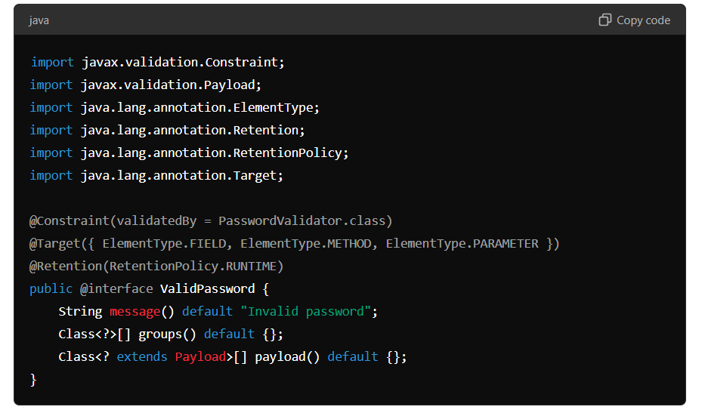

* @Constraint: Specifies the validator class (PasswordValidator).
* @Target: Indicates where the annotation can be applied (e.g., fields, methods, parameters).
* @Retention: Specifies how long the annotation should be retained (in this case, at runtime).

**2. Implement the Validator Class**

Next, implement the logic for the custom validation in a separate class.

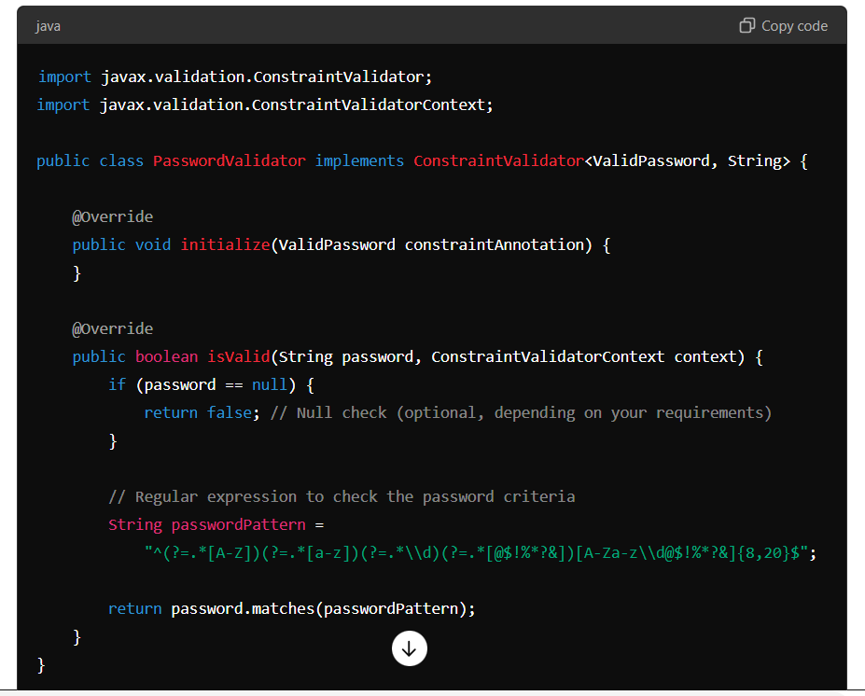

* **ConstraintValidator<ValidPassword, String>**: This interface requires two parameters: the custom annotation and the type of field being validated.
* **isValid method**: Contains the validation logic. If the password matches the regex, it returns true; otherwise, it returns false.

**3. Use the Custom Annotation in a DTO**

Apply the custom annotation to the field you want to validate.

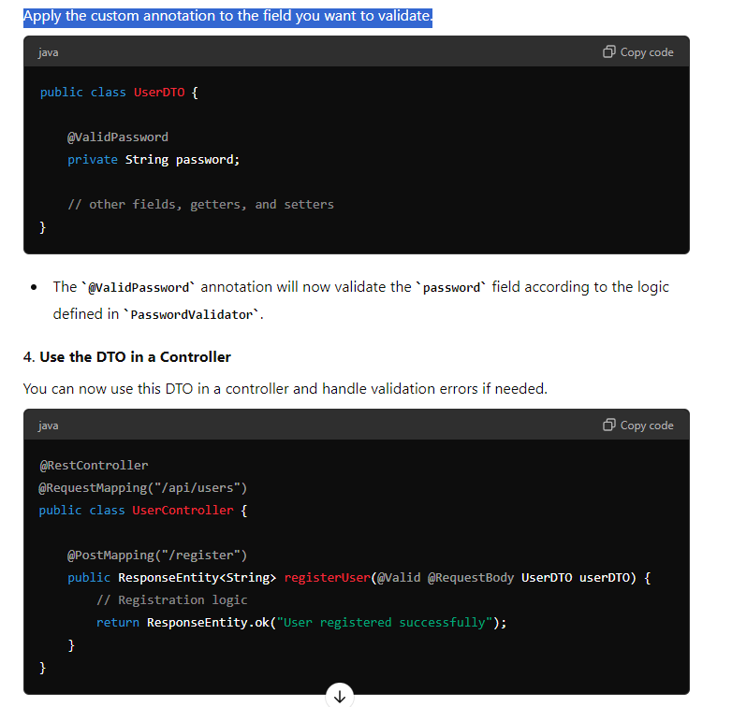

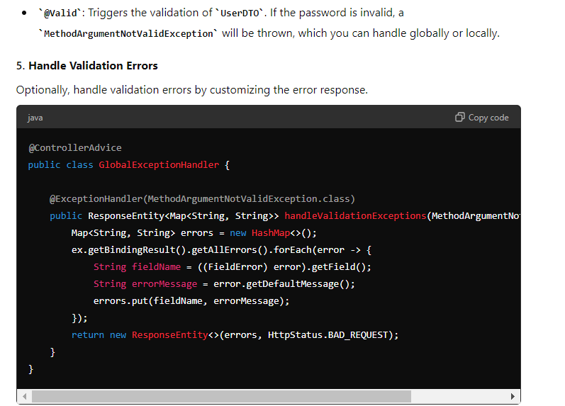

**Summary**

1. **Define a Custom Annotation**: Create an annotation that links to your validator class.
2. **Implement the Validator Class**: Write the logic to check whether the field meets your custom validation criteria.
3. **Apply the Annotation**: Use your custom annotation on fields that need validation.
4. **Handle Validation Errors**: Optionally, customize error handling to provide clear feedback to users.

This approach allows you to extend Spring's validation capabilities to meet specific application needs.

**OAuth2**

Certainly! Let’s consider a real-time use case of setting up OAuth2 in a Spring Boot application. We'll use a simple example of an online bookstore application with three main components:

1. **Authorization Server**: Issues tokens for client authentication.
2. **Resource Server**: Serves protected resources (book details).
3. **Client Application**: A web application that accesses the bookstore's resources.

**Use Case Scenario**

**Scenario**: You have an online bookstore where users can view book details and make purchases. The bookstore has an API that allows access to book details, and you want to secure this API using OAuth2. Users log in through a web client and access their favorite books.

**Step-by-Step Implementation**

**1. Authorization Server**

**Purpose**: Authenticate users and issue access tokens to clients.

**Configuration**:

1. **Define a Spring Boot application for the Authorization Server.**
2. **Set up OAuth2 Authorization Server with client credentials and token endpoints.**

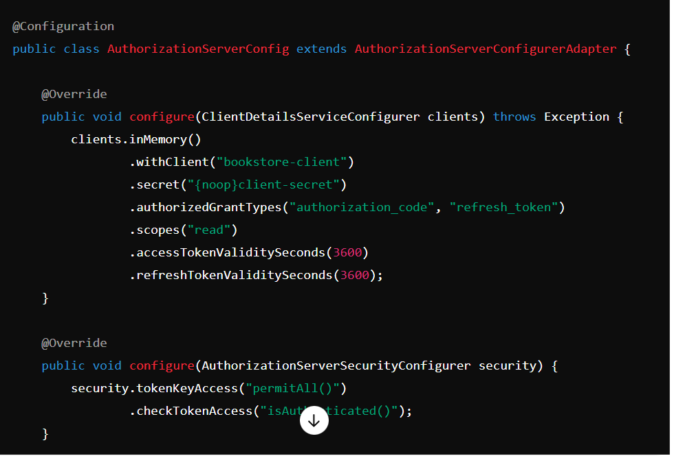

**2. Resource Server**

**Purpose**: Serve book details and ensure that only authorized requests with valid tokens can access it.

**Configuration**:

1. **Create a Spring Boot application for the Resource Server.**
2. **Set up security configuration to secure endpoints.**

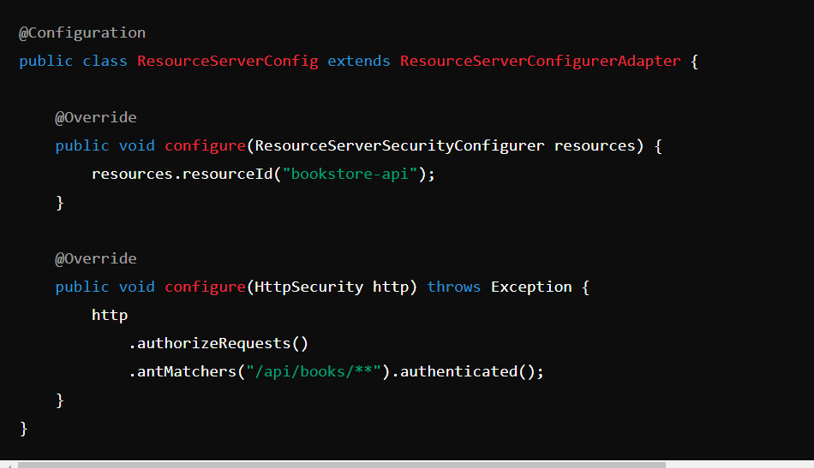

**3. OAuth2 Client Application**

**Purpose**: Allows users to log in, obtain tokens, and access the bookstore's API.

**Configuration**:

1. **Create a Spring Boot application for the client.**
2. **Configure OAuth2 login and token management.**

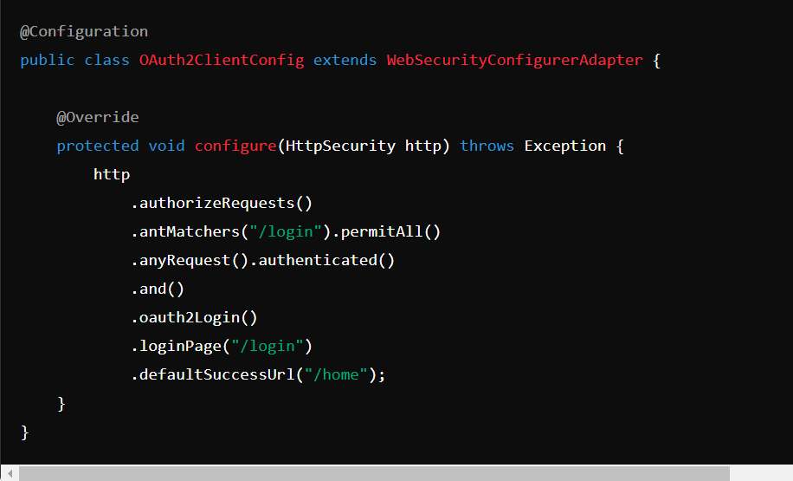

**OAuth2 Authorization Code Grant Flow**

1. **User Requests Access**:
   * The user attempts to access a protected resource on the client application.
   * If the user is not authenticated, the client application redirects the user to the authorization server for authentication.
2. **User Authentication**:
   * The user logs in on the authorization server and grants permissions to the client application.
   * The authorization server then generates an authorization code and redirects the user back to the client application.
3. **Authorization Code Exchange**:
   * The client application receives the authorization code.
   * The client application sends a request to the authorization server's token endpoint to exchange the authorization code for an access token.
   * This request includes the authorization code, client credentials (client ID and secret), and redirect URI.
4. **Access Token Issuance**:
   * The authorization server validates the authorization code and client credentials.
   * If valid, the authorization server responds with an access token (and optionally a refresh token) to the client application.
   * The client application uses this access token to access protected resources on the resource server.