**C Program that generates a input file(input1.txt) with thirteen random numbers**

**PROGRAM:**

#include<stdio.h>

#include<string.h>

#include<limits.h>

int main()

{

int inp[15]={11,22,3,-1,5,-78,66,0,56,743,4,1296,114};

int i;

FILE *fd;

fd=fopen("input1.txt","w+");

for(i=0;i<USHRT_MAX*1500;i++)

{

fprintf(fd,"%d ",inp[i%13]);

if((i+1)%10==0)

fprintf(fd,"\n");

}

fclose(fd);

return 0;

}

This creates a input file of 298MB which results in **THREE** splits as block size in Hadoop is 128MB.That “input1.txt” is uploaded to HDFS.

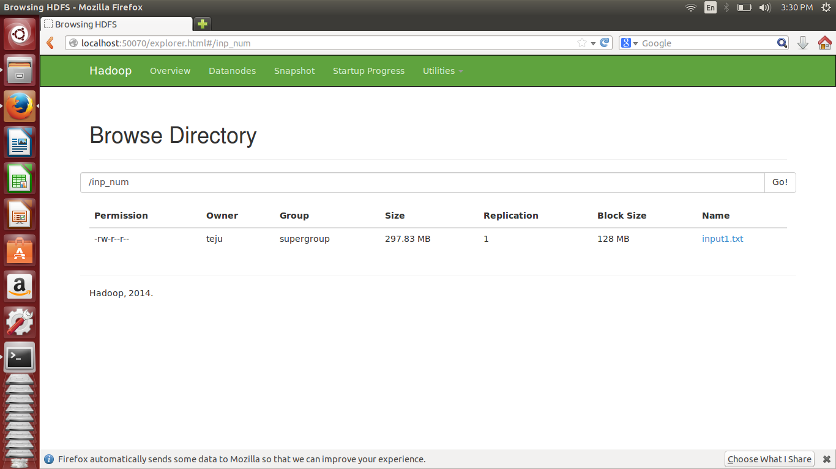

The “input.txt” file looks like:

