**AIM:** To write a java program to illustrate Maps.

**PROGRAM:**

**/*TREE MAPS*/**

import java.util.*;

class TestMap{

public static void main(String args[]){

TreeMap<Integer,String> hm=new TreeMap<Integer,String>();

hm.put(22,"teja");

hm.put(17,"Ravi");

hm.put(1,"naga");

hm.put(13,"thoram");

for(Map.Entry m:hm.entrySet()){

System.out.println(m.getKey()+" "+m.getValue());

}

}

}

**OUTPUT:**

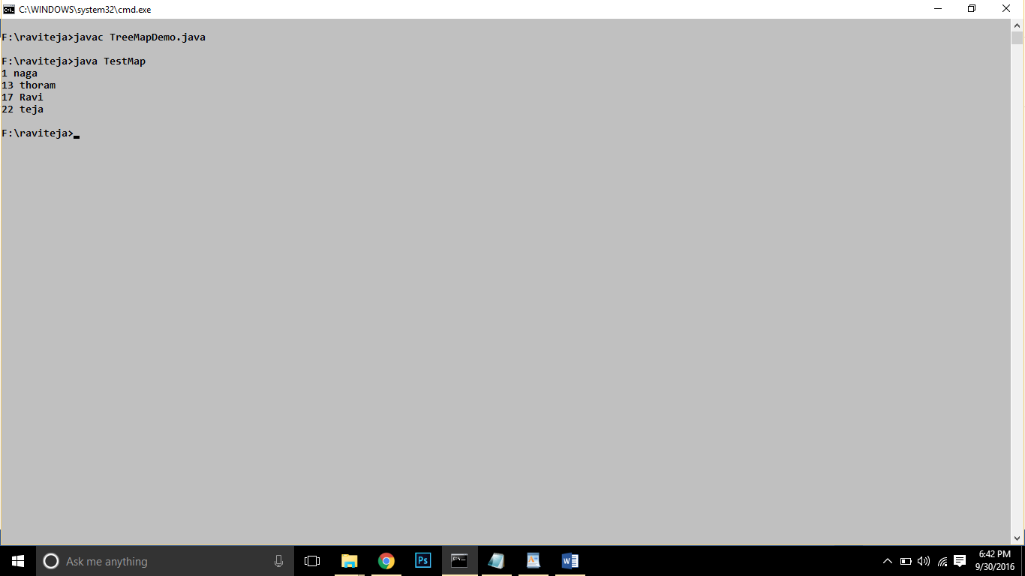

**/*HASH MAPS*/**

import java.util.*;

class TestMapHash{

public static void main(String args[]){

HashMap<Integer,String> hm=new HashMap<Integer,String>();

hm.put(22,"teja");

hm.put(17,"Ravi");

hm.put(1,"naga");

hm.put(13,"thoram");

for(Map.Entry m:hm.entrySet()){

System.out.println(m.getKey()+" "+m.getValue());

}

}

}

**OUTPUT:**

