EXPLORATORY DATA ANALYSIS

Analysis Report

Ravi Teja Buddabathuni

Date:10/28/2016



Bowling Green State University

**Executive Summary**

This report summarizes the data analysis results associated with the popularity of the movie in Facebook based on the genres. The purpose of this report is to document the analysis results of the genre wise popularity of the movie based on its facebook likes using EDA methods to identify the underlying pattern in the dataset.

Firstly, data set is taken from the IMDB website form this [link](https://www.kaggle.com/deepmatrix/imdb-5000-movie-dataset). Later the data set is being cleaned by using MS Excel, Here the priority is taken for the movies released in 2016 and 2015 in USA in English language, and then the below rows were considered:

* Director_Name
* Movie_Name
* Genres
* IMDB_Score
* Facebook_Likes
* Critic_Reviews
* User_Votes
* User_Reviews
* Year

The development of the sampling protocol, including both the initial recommended design and final implemented sampling strategy are discussed in Section 2. The initial Stratified Random sampling design was developed using a Neyman allocation scheme. After presenting this design to the client, a refined GIS analysis was performed and more accurate available sampling areas for each school were calculated. These calculations were used to revise the second-stage random sampling scheme. Additionally, two extra properties were added to the sampling design (one nursery located within 2 Km of the factory and one previously overlooked park) and 12 additional sampling locations were selected along the factory perimeter. After these refinements, the final sampling plan contained 361 sampling locations from 69 distinct non-factory properties (and the factory perimeter). The basic univariate statistics that summarize the contamination data associated with the analyzed metals (for all 360 topsoil samples) are given in Section 3. A total of seven metal concentration measurements were made on each topsoil sample; the metals analyzed in this study include Arsenic (As), Cadmium (Cd), Chromium (Cr), Copper (Cu), Nickel (Ni), Lead (Pb), and Zinc (Zn). The univariate statistics summarize both the raw and natural log transformed metal data, where the transformed data is defined as Y = ln(X+1). The histograms and quantile plots of each log transformed metal data appear to be approximately symmetric (but in some cases also moderately heavy-tailed). Section 4 presents the analysis of the sampling depth effect, based on the 43 sites were topsoil samples were acquired from two sampling depths.. Paired t-tests and sign-

**INTRODUCTION:**

Meet the Data

Data: US Movies publicity in Facebook from the years 2016 and 2015 from IMDB website

Source: <https://www.kaggle.com/deepmatrix/imdb-5000-movie-dataset>

One of the major social networking sites used in the United States for movie publicity is Facebook.

This platform is able to reach many number of audience in an affordable way.

The table below shows the sample data from the data set. Here the main focus is on Genres and Facebook_likes.

|  |  |  |  |  |  |  |  |  |
| --- | --- | --- | --- | --- | --- | --- | --- | --- |
| **Director_Name** | **Movie_Name** | **Genres** | **IMDB_Score** | **Facebook_Likes** | **Critic_Reviews** | **User_Votes** | **User_Reviews** | **Year** |
| Joss Whedon | Avengers: Age of Ultron | Action | 7.5 | 118000 | 635 | 462669 | 1117 | 2015 |
| Zack Snyder | Batman v Superman: Dawn of Justice | Action | 6.9 | 197000 | 673 | 371639 | 3018 | 2016 |
| Anthony Russo | Captain America: Civil War | Action | 8.2 | 72000 | 516 | 272670 | 1022 | 2016 |
| Colin Trevorrow | Jurassic World | Action | 7 | 150000 | 644 | 418214 | 1290 | 2015 |
| James Wan | Furious 7 | Action | 7.2 | 94000 | 424 | 278232 | 657 | 2015 |
| Peter Sohn | The Good Dinosaur | Adventure | 6.8 | 20000 | 298 | 62836 | 345 | 2015 |
| Justin Lin | Star Trek Beyond | Action | 7.5 | 30000 | 322 | 53607 | 432 | 2016 |
| Lana Wachowski | Jupiter Ascending | Action | 5.4 | 44000 | 384 | 139593 | 720 | 2015 |
| David Yates | The Legend of Tarzan | Action | 6.6 | 29000 | 248 | 42372 | 239 | 2016 |

Here the dataset contains 177 rows, so instead of considering the stemplot for identifying shape, spread, skewness, it would be better to prefer boxplot as we have more than 50 values.

**Boxplot for Facebook Likes:**

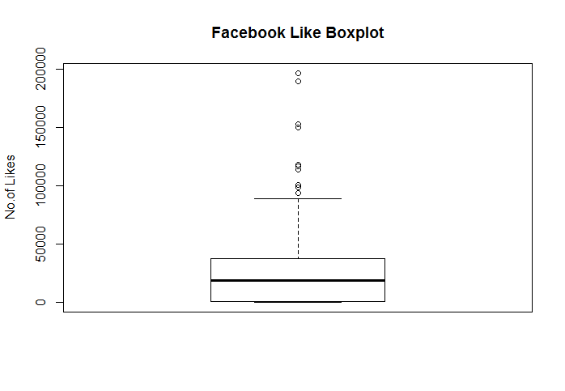

Here from the above boxplot we can say that the median is almost equally distributed from the upper fourth and lower fourth

Median distance from Upper fourth = FU – Median = 38000-19000 = 19000

Median distance from Lower fourth = Median – FL = 19000-936 = 18064

Comparing the whisker length, the length of upper whisker is comparatively high to the length of the lower whisker.

Here we have 11 mild outliers and 4 extreme outliers from the whole dataset of Facebook_Likes.

**Boxplot to compare Genre batches:**

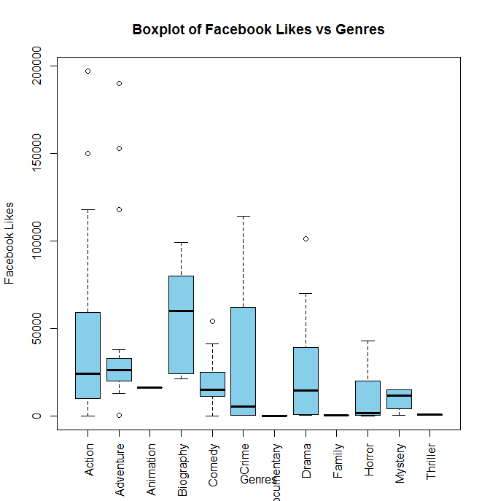

|  |  |  |  |  |  |  |
| --- | --- | --- | --- | --- | --- | --- |
| **Genre** | **N** | **Min** | **FL** | **Median** | **FU** | **Max** |
| Action | 66 | 34 | 10000 | 24000 | 59000 | 197000 |
| Adventure | 26 | 215 | 20000 | 26000 | 33000 | 190000 |
| Animation | 1 | 16000 | 16000 | 16000 | 16000 | 16000 |
| Biography | 6 | 21000 | 24000 | 60000 | 80000 | 99000 |
| Comedy | 25 | 14 | 11000 | 15000 | 25000 | 54000 |
| Crime | 4 | 158 | 231.5 | 5152.5 | 62000 | 114000 |
| Documentary | 2 | 5 | 5 | 63 | 121 | 121 |
| Drama | 24 | 84 | 890 | 14500 | 39000 | 101000 |
| Family | 14 | 9 | 124.5 | 240 | 437 | 634 |
| Horror | 3 | 52 | 378 | 1468 | 20000 | 43000 |
| Mystery | 4 | 312 | 4156 | 11500 | 15000 | 15000 |
| Thriller | 2 | 398 | 398 | 563 | 728 | 728 |

|  |  |  |  |  |  |  |  |
| --- | --- | --- | --- | --- | --- | --- | --- |
| **Genre** | **Spread** | **Step** | **Inner**  **Lower**  **Fence** | **Inner**  **Upper**  **Fence** | **Outer**  **Lower**  **Fence** | **Outer**  **Upper**  **Fence** | **Outliers** |
| Action | 49000 | 73500 | -63500 | 132500 | -137000 | 206000 | 197000, 150000 |
| Adventure | 13000 | 19500 | 500 | 52500 | -19000 | 72000 | 118000, 190000, 153000, 240, 380, 244, 215 |
| Animation | 0 | 0 | 16000 | 16000 | 16000 | 16000 | NA |
| Biography | 56000 | 84000 | -60000 | 164000 | -144000 | 248000 | 54000 |
| Comedy | 14000 | 21000 | -10000 | 46000 | -31000 | 67000 | NA |
| Crime | 61768.5 | 92652.75 | -92421.25 | 154652.75 | -185074 | 247305.5 | NA |
| Documentary | 116 | 174 | -169 | 295 | -343 | 469 | NA |
| Drama | 38110 | 57165 | -56275 | 96165 | -113440 | 153330 | 101000 |
| Family | 312.5 | 468.75 | -344.25 | 905.75 | -813 | 1374.5 | NA |
| Horror | 19622 | 29433 | -29055 | 49433 | -58488 | 78866 | NA |
| Mystery | 10844 | 16266 | -12110 | 31266 | -28376 | 47532 | NA |
| Thriller | 330 | 495 | -97 | 1223 | -592 | 1718 | NA |

From the boxplots mentioned above,

We can see that the spread of Action, Biography, Crime, and Drama is relatively same with some deviations.

And few of the Genres like Animation, Biography, Crime, Documentary, Horror, Mystery and Thriller have only single digit Observations which is less than 5.

Here we notice a 7 outliers in Adventure movies and 2 in Action, and 1 each in Biography and Drama respectively.

**Comparing the dataset by use of Medians:**

As the Median comparison is easy to make conclusions for batches having similar spread, so considering only Action, Adventure, Comedy and Drama.

|  |  |  |
| --- | --- | --- |
| **Genre** | **Spread** | **Median** |
| Action | 49000 | 24000 |
| Adventure | 13000 | 26000 |
| Comedy | 14000 | 15000 |
| Drama | 38110 | 14500 |

Here if Drama genre can get 10890 more likes then it can get same publicity as Action genre movies.

And if comedy genre can get 24110 more likes then it can get same publicity as Drama genre movies.

And if Adventure can get 1000 more likes then the publicity of that will be same as Comedy genre.

Although the compared batches data is right skewed and having few outliers, but by comparing the median facebook likes of each genre and considering Action, Adventure, Comedy and Drama as they have some good amount of observations, we can conclude that, American citizens are more likely to watch Action and Adventure genre movies than Comedy and Drama genre movies.

**Comparison by Spread VS Level Plot:**

|  |  |  |  |  |
| --- | --- | --- | --- | --- |
| **Genre** | **Spread** | **Median** | **Log Median** | **Log Spread** |
|
|
| Action | 49000 | 24000 | 4.38021 | 4.6902 |
| Adventure | 13000 | 26000 | 4.414973 | 4.113943 |
| Animation | 0 | 16000 | 4.20412 | "-Inf" |
| Biography | 56000 | 60000 | 4.778151 | 4.748188 |
| Comedy | 14000 | 15000 | 4.176091 | 4.146128 |
| Crime | 61768.5 | 5152.5 | 3.712018 | 4.790767 |
| Documentary | 116 | 63 | 1.799341 | 2.064458 |
| Drama | 38110 | 14500 | 4.161368 | 4.581039 |
| Family | 312.5 | 240 | 2.380211 | 2.49485 |
| Horror | 19622 | 1468 | 3.166726 | 4.292743 |
| Mystery | 10844 | 11500 | 4.060698 | 4.03519 |
| Thriller | 330 | 563 | 2.750508 | 2.518514 |

|  |  |  |  |
| --- | --- | --- | --- |
|  | Max spread | Min spread | max/min |
| raw data | 0.131762 | 0.012164 | 10.83209 |
| re-expressed data | 61768.5 | 116 | 532.4871 |