**PROJECT REPORT OF HEALTHHUB CLINIC**

**1.INTRODUCTION**

1.1 OVERVIEW

My project name is HealthHub Medical Clinic, a healthcare facility, relies on Zoho Books to manage patient billing andinvoicing. They can track medical service fees, manage insurance payments, and generate statementsfor patients. Zoho Books helps them maintain financial transparency and ensures efficient billingprocesses.

1.2 PURPOSE

HealthHub Clinics, the healthcare division of the Al-Futtaim Group, launched their medical clinic within the premises of the Landmark Group’s Corporate Headquarters at Dubai Marina for its employees.

The in-house clinic is a part of the organization’s “My Health First” programme dedicated towards employee health and wellbeing. The newly opened clinic provides primary care services, management of chronic diseases and preventive care at zero co-pay on consultation and pharmacy – for not only every Landmarker but their dependents too. The clinic will cater to common primary care concerns such as colds, sore throat, infections, respiratory ailments and dermatological issues along with common chronic disease management issues covering diabetes, hypertension, and lipid management.

The variety of services includes specialist care, ECG & sample collection, first aid & minor injury treatment, consultation & medicine delivery for chronic disease management and much more. HealthHub is also extending Telehealth facilities to all Landmark employees, so those not based in the tower can conveniently avail immediate consultation on call.

**2.PROBLEM DEFINITION & DESIGN THINKING**

2.1 Empathy Map

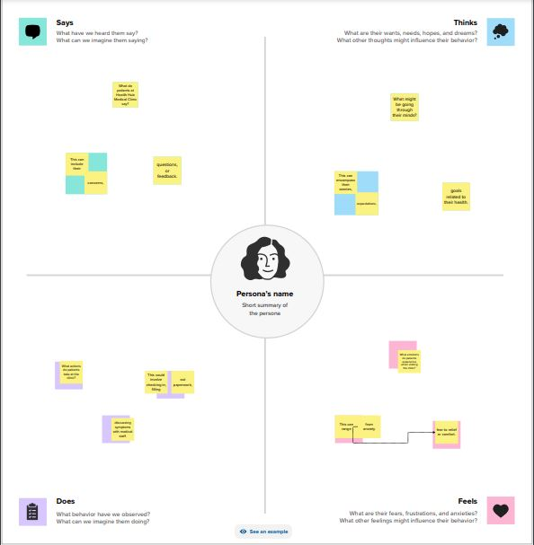

2.2 Ideation & Brainstroming map

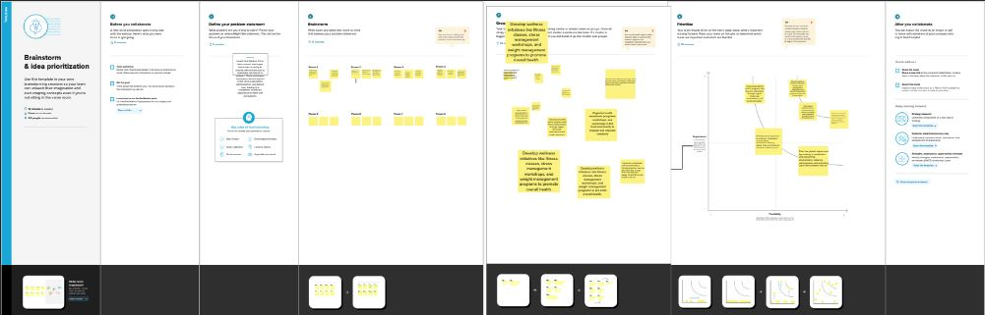

**3.RESULT**

**PROFIT AND LOSS A/C**

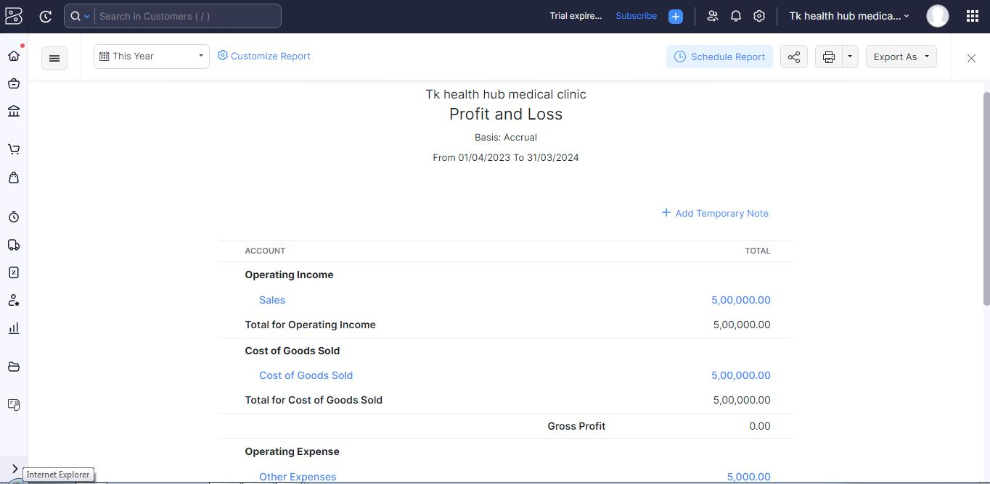

**BALANCE SHEET**

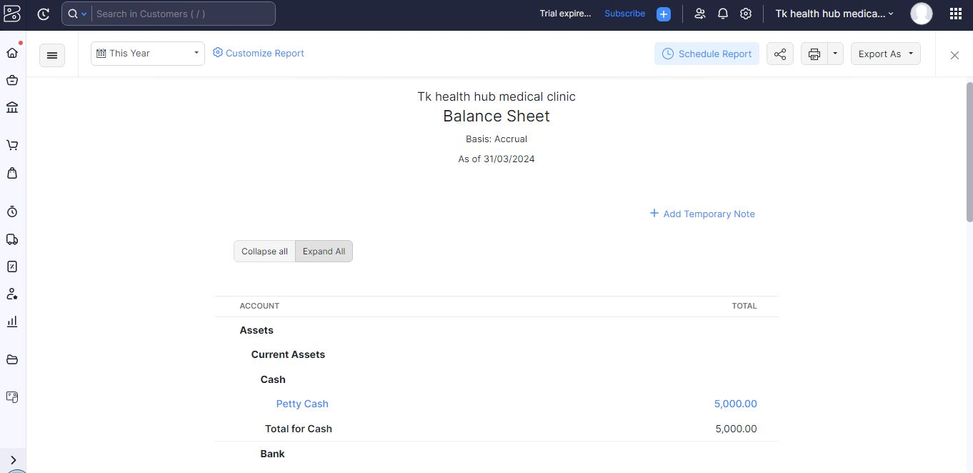

**4. ADVANTAGES & DISADVANTAGES**

**Advantages**

Many patients feel uncomfortable to go to hospital or doctor-chamber. This system creates communication among patients & healthcare professionals maintaining convenience & commitment. Moreover, through Telemedicine medical information and images are kept confidential and safely transferred from one place to another. So, people can believe this system and feel comfort to seek help from it.

It saves lives in the emergency situations, while there is no time to take the patient at a hospital.

In many rural communities or remote places or post-disaster situations, consistent healthcare is unavailable. Telemedicine can be applied in such places or situations to provide emergency healthcare.

This system is useful for the patients residing in inaccessible areas or isolated regions. Patients can receive clinical healthcare from their home without arduous travel to the hospital.

Modern innovations of information technology such as, mobile collaboration has enabled easy information sharing and discussion about critical medical cases among healthcare professionals from multiple locations.

Telemedicine has facilitated patient monitoring through computer or tablet or phone technology that has reduced outpatient visits. Now doctors can verify prescription or supervise drug oversight. Furthermore, the home-bound patients can seek medical-help without moving to clinic through ambulance. Thus, cost of health care has been reduced.

This system also facilitates health education, as the primary level healthcare professionals can observe the working procedure of healthcare-experts in their respective fields and the experts can supervise the works of the novice.

**Disadvantages**

The overall cost of telecommunication system, especially data management apparatus and practical training of medical professionals is great.

Virtual clinical treatment decreases human interaction among the healthcare professionals and patients that increases the risk of error in clinical services, if the service is delivered by inexperienced professional. Moreover, confidential medical information can be leaked through faulty electronic system.

Telemedicine might take longer time for the difficulties in connecting virtual communication due to low internet speed or server problem. Moreover, this system cannot provide immediate treatment, such as, antibiotics.

Low quality of health informatics records, like, X-ray or other images, clinical progress reports, etc. run the risk of faulty clinical treatment.

Telemedicine system requires tough legal regulation to prevent unauthorized and illegal service providers in this sector.

**5. APPLICATIONS**

**GIT HUB AND ZOHO BOOKS** are used to applied the solution.

**6. CONCLUSION**

With busy years ahead for the digital transformation of the Health and Pharma sector, the Health Hub will provide the much need solutions for more innovative, efficient, and accessible healthcare for businesses, health professionals, and patients alike.

If you also share Health Hub’s vision and seek collaboration opportunities on Health through Artificial Intelligence, make sure to visit the official webpage and get in touch with us.

**7.FUTURE SCOPE**

To us, Health means that we work in partnership with our patients doing our best to deliver the right sort of health care for you. We mentor, teach and support our up and coming practitioners-in-training. We provide all our staff with ongoing training to increase their professional knowledge and expand the scope of what they can do for you.

The Hub is all about how we work in teams and in community. Our health care clinicians working in care teams are able to do the following:

Work with a wide range of health care providers and community workers;

Wherever possible, run outreach clinics that allow us to bring health care near to where you live, and where you work; and

Actively involve you, and the communities we work with, in how we deliver health care that works well for everyone.