Work From Home Software Developer Setup
Clean developer desk layout (recommended for MERN stack developers).
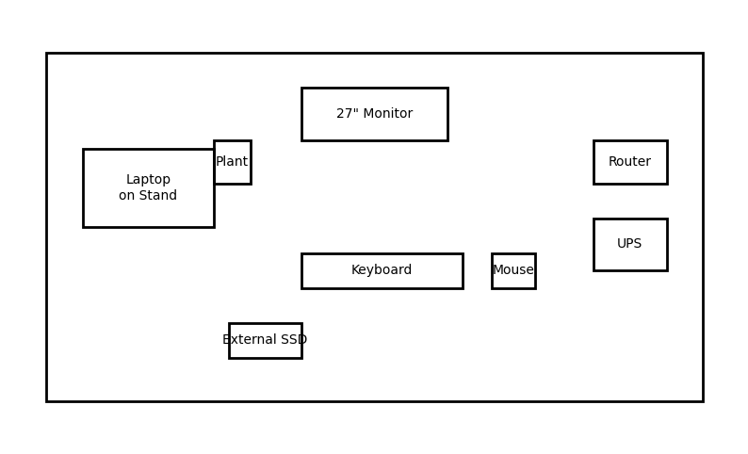

Items List with Buying Links
- Laptop (16GB RAM, 512GB SSD) - https://www.amazon.in/s?k=ryzen+7+laptop+16gb+ram
- 27 inch Monitor (IPS) - https://www.amazon.in/s?k=27+inch+ips+monitor
- Mechanical Keyboard - https://www.amazon.in/s?k=keychron+mechanical+keyboard
- Wireless Mouse - https://www.amazon.in/s?k=logitech+mx+master+3s
- Webcam 1080p - https://www.amazon.in/s?k=logitech+c920+webcam
- Headphones for meetings - https://www.amazon.in/s?k=sony+wh+1000xm5
- Laptop Stand - https://www.amazon.in/s?k=aluminum+laptop+stand
- Ergonomic Chair - https://www.amazon.in/s?k=ergonomic+office+chair
- Developer Desk / Table - https://www.amazon.in/s?k=computer+desk+table
- UPS Power Backup - https://www.amazon.in/s?k=apc+ups+1100va
- External SSD - https://www.amazon.in/s?k=samsung+t7+external+ssd
- WiFi Router - https://www.amazon.in/s?k=wifi+6+router
- Cable Management Kit - https://www.amazon.in/s?k=cable+management+kit+desk
- Monitor Light Bar - https://www.amazon.in/s?k=monitor+light+bar

