**SOFTWARE CONGIGURATION MANAGEMENT**

**REVIEW 1**

**PROJECT TITLE : ENHANCING THE INSTAGRAM**

**FACULTY NAME: Prof.JAGADEESH G**

**SLOT :B2**



**TEAM MEMBERS:**

**13MSE0063(K RAVITEJA)**

**13MSE0403(M RAVITHEJA)**

**Instagram** is an online [mobile](https://en.wikipedia.org/wiki/Mobile_social_network) [photo-sharing](https://en.wikipedia.org/wiki/Photo_sharing), [video-sharing](https://en.wikipedia.org/wiki/Video_hosting_service), and [socialnetworking](https://en.wikipedia.org/wiki/Social_networking_service) service that enables its users to take pictures and videos, and share them either publicly or privately on the app, as well as through a variety of other social networking platforms, such as [Facebook](https://en.wikipedia.org/wiki/Facebook), [Twitter](https://en.wikipedia.org/wiki/Twitter), [Tumblr](https://en.wikipedia.org/wiki/Tumblr), and [Flickr](https://en.wikipedia.org/wiki/Flickr). Originally, a distinctive feature was that it confined photos to a square shape, similar to Kodak Instamatic and Polaroid SX-70 images, in contrast to the 4:3 aspect ratio typically used by mobile device cameras. In August 2015, version 7.5 was released, allowing users to upload media captured in any aspect ratio. Users can also apply digital [filters](https://en.wikipedia.org/wiki/Photographic_filter) to their images. Videos on Instagram debuted with a 640x640 fixed resolution and maximum 15-second limit in June 2013, resolutions now include up to [1080p](https://en.wikipedia.org/wiki/1080p) since July 2015 and length is now up to 60 seconds since January 2016.

Instagram is a fun and quirky way to share your life with friends through a series of pictures. Snap a photo with your mobile phone, then choose a filter to transform the image into a memory to keep around forever. Instagram allows you to experience moments in your friends' lives through pictures as they happen. It enhances the world more connected through photos.

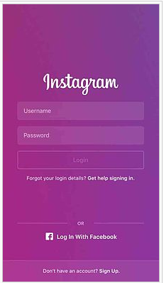

**2.OBJECTIVE OF THE PROPOSED SYSTEM**

* Videos can forward and backward.
* Offline saving
* Can save photos and videos.
* No time limit for posting the video.

**1. videos can forward and backward**

In the present system we can’t forward or backward the video when we want to look at the video previously or further. so this is an inappropriate functionality for looking at the video. In the proposed system we are adding the functionalities for watching the video effectively.

**2. offline saving**

Saving of any item is not possible in the current system through the offline. In this objective we can save the particular video to the offline, so we want to see the video we can browse to the videos that are saved in offline and we can look at the video.

**3. can save photos and videos**

We can save the photos and videos to the storage device , by adding the functionality for downloading the stuff from the instagram.

**4. No time limit for posting the video**

We can upload the video that is of even more length, instead uploading a video of 60 seconds.

**3.LITERATURE SURVEY:**

Instagram is one of many social media applications that the Internet population is using on a daily basis. It is a simple photo-taking and photo-sharing application that was released on October 6, 2010 created by Kevin Systrom and Mike Krieger. When looking under the FAQ on Instagram’s website, the application is defined as a fun and quirky way to share your life with friends through a series of photos (Instagram, 2015). The application allows one to use their mobile phone to snap a photograph, choose a filter to transform the image, and post it on the application. Everyone who creates an account on Instagram has a profile and news feed. Every user profile has a “Followers” and “Following” count which represent how many people they follow and how many users are following them (Webtrends, 2015). To interact with other people, you can double tap an Instagram post to “like it” or you can comment on the post by tapping on the comment button. To find other accounts to follow, you can press the Search tab. You can also find people by looking through suggested photos or a list of people. As the application continued to develop, more features were added. On January 2011, Instagram added the use of hashtags to help users discover both photographs and each other. A hashtag can be defined as a word or phrase preceded by a hash or pound sign (#) and used to identify messages on a specific topic. On December 2013, Instagram added Direct. This feature allowed users to send photos to specific people directly from the application as a messaging service. Through the last five years, Instagram has become a place where people can visually share and interact with each other in a new way.

**EXISTING SYSTEM OVERVIEW**

* **Original authors :** kevin Systrom, Mike Krieger
* **Developer(s)**  **:** Facebook
* **Initial Release :** October 6, 2010
* **Stable Release :** Android 8.5.1(July 18, 2016)

IOS 9.0(July 18, 2016)

Windows Phone 8.0(May 15, 2016)

* **Development Status :** Active
* **Operating System :** IOS7.0 or later, Android 2.2 or later, Windows 8 and 10
* **Size :** 9.93MB
* **Available in :** 25 languages
* **Type :** Photo and video
* **License :** Freeware

**EXISTING SYSTEM**

* Updating profile
* Uploading photos
* Likes and comments of photos
* Can upload videos time ranging up to 60sec
* Can tag friends

**4.PROPOSED SYSTEM**

* Can download videos and photos.
* Videos can forward and backward.
* Offline saving is possible like facebook.
* No time limit for uploading video.

**5.SYSTEM ARCHITECTURE**

HOME

Profile

News

Photo

Explore

locations

Photos of you

you

following

Upload photo

Take photo

Search insta

view

follow

unfollow

followers

following

like

comment

**6.UML DIAGRAM**

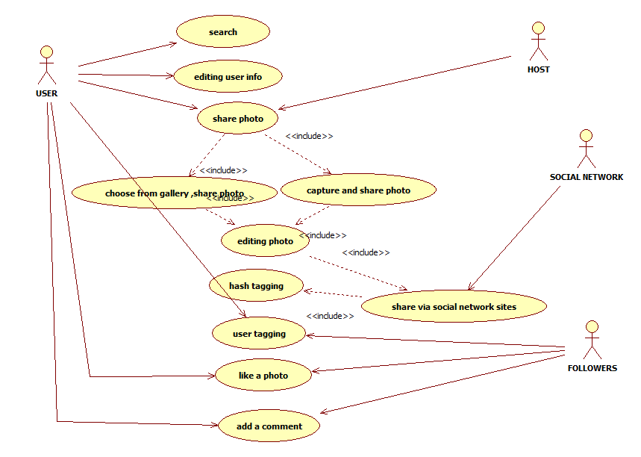

**7.SOFTWARE CONFIGURATION MANAGEMENT PLAN**

**1.PROJECT PLAN**

Project plan is to make some updation in some features of instagram. pausing of video is possible, that can help the user to pause the unwanted part in the video and while passing the video, the video doesn’t look like a blur image. Storing photos and videos helps the user to watch the video offline and doesn’t want to look back to the profile of the person in online. offline saving helps the user to save photos offline without internet. The time limit of the video is exceeded that can help the user to upload the video of unlimited time.

**2.SCM PLAN**

**Configuration identification**

* Pausing video
* Storing photos and videos
* Offline saving
* No time limit for uploading video

**Configuration control**

* Communication breakdown

The changes that are done to the instagram should be within the project leaders and managers and need to communicate with each person for any change improvement.

* Multiple maintenance

The proper maintenance for the changes should be evaluated for each configuration item.

* Distributed database

The database for storing the photos and videos, playing the video for more than 60 seconds ,offline saving should be evenly distributed.

* Unauthorized access is prevented or restricted. The software secure that it avoid accessing the private details or photos or videos unless both the users follow each other

**Status accounting**

* The project leaders and managers who is developing the improvements in instagram should keep in control for the changes of pausing video, storing photos and videos, offline saving and other functionalities should go in right way without making any errors in the changes.

**Auditing and review**

* Each domain of the configuration item should be tested individually and the verify that configuration items are working correctly with the changes that have done to improve the enhancing level of instagram and integrate at the review stage.

**3.REQUIREMENT DEFINITION DOCUMENT**

For photos: JPEG,BMP,PNG,GIF, and most TIFF and RAW format files.

For videos: MP4,Quicktime,AVI,MTS,MPG,ASF,WMV,Flash, and OGG. videos with less time limit and smaller than 2GB in size can be streamed through the drive and mobile applications. videos with more time limit and larger than 2GB in size, can be stored in drive to download and watch offline.

**4.ANALYSIS, DESIGN,CODING TESTING AND AUDITING STANDARDS**

Analysing the requirements of the system that they are suited to this application and testing the requirements. Design should be simple and quality enough. coding is done by the developer for each feature and integrated.

The auditing standards board should integrate the audits conducted by the testers. Normally the new standard will be first tested.

**5.SYSTEM DESIGN DOCUMENTATION**

The instagram API platform can be used to build non-automated, authentic,high quality apps and services that:

* Help individuals share their own content with 3rd party apps.
* Help brands and advertisers understand, manage their audience and media rights.
* Help broadcasters and publishers discover content, get digital rights to media, and share media with proper attribution

**6.PROTOTYPE**

The prototype for enhancing the instagram evolves the sample design to check how the model is built up , designed, interface of the system and any databases are used to check the system functionality.

Resuming the video

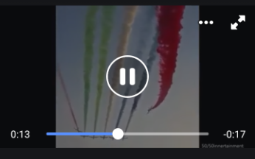

pausing

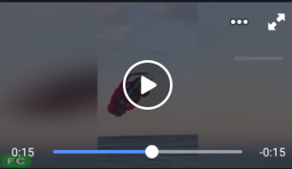

saving

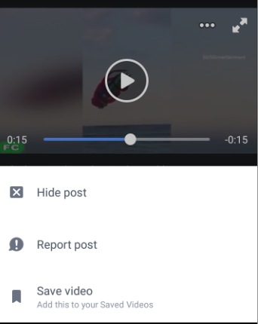

**7.HIGH LEVEL DESIGN**

At the high level, you can forward to more in-depth descriptions of some of these , keep the system simple and go with proven technologies when you can OS/Hosting, load balancing, application servers, data storage, monitoring

**8.LOW LEVEL DESIGN**

At low level design, the functionalities comes under low level design is what we comment, like, upload photos, saving photos, playing videos etc

**9.SYSTEM TEST SPECIFICATION**

It deals about the infrastructure. it is to build the gap between the facebook and instagram. Infrastructure work like logging frameworks, streaming technologies, database scrapes and data warehousing. it works in the existing platform environment like IOS and android. Search options and data oriented solutions is a strong point in favour.

**10.SYSTEM TEST PLAN**

It is to test the code in all the phases like authentication, timeline, design, followers page, home page etc. firstly we build the systems in which platform and frameworks we actually need for our products and then test the each module individually .

**11.PROGRAM SOURCE CODE**

There should be a package-visible no-argument constructor for each of your model classes. The fields also need to be package-visible. It is done in java language(.java).

**12.OBJECT CODE AND EXECUTE**

Once you’re registered your client it’s easy to start regesting data from instagram. All endpoints are only accessible via https and are located at api.instagram.com. For instance you can retrieve photos with a given hashtag by accessing the URL.

**13.UNIT TEST PLAN**

It is to support more objectives.it is to collect all the requirements of instagram and test them individually and also to analyze whether they are suited to the application

**14.TEST DATA**

Look up keys and return values. Fit data in memory and ideally within one of high memory types.fit the data well into existing infrastructure after testing the data , the data to be stored in the database

**15.PROJECT DATA**

The project data should be available with the links.it should contain all the modules of data integrated together as a one single project. Extracting data from facebook and instagram that they are linked together. Data should be qualitative.at last the data should be filtered

**16.MANUALS**

Provide proper manuals for the understanding of the user like references, pdf , links etc.it gives the user satisfaction.

**8. CONFIGURATION ITEM IDENTIFICATION**

1. Develop the criteria for selecting items to be placed under configuration control

* Pausing video
* Storing photos and videos
* Offline saving
* No time limit for uploading video

2.Select CI and define the relationships between the CI

* Pausing video

Instagram doesn’t support to upload a video that is more than 60 seconds.And the video can’t be paused and downloaded to the storage device.

* Storing photos and videos

Photos and videos can only be viewed when the mobile is connected to the internet and can’t be saved through offline .

* Offline saving

The photos and videos can’t be either downloaded or saved through offline. Saving is enhanced in the system then the users can check the videos when they are free.

* No limit for uploading video

In the present system, the video can be uploaded only for a time span of 60 seconds.so when the video is of more length then we can’t upload further.

3.Establish a software item hierarchy and define interrelationships between the CI

* Unlike facebook, instagram doesn’t allow to save videos through offline . and doesn’t allow to save the photos.
* The emoticons in facebook allow the user to react on the particular post regardingly.
* Replies for the comments are possible in the facebook where as in instagram it is not provides
* No time limit to upload the post in facebook.
* Live chat is available.

4.Develop an identification or naming scheme for clearly and unambiguously identifying the CI

* Pausing the video, storing photos , videos, saving offline ,no time limit ,by adding these functionalities instagram would be even more effective and user friendly.

5.Select configuration documents to be used to define configuration baselines for each CI

* Pdf ,MS WORD are used to define configuration baselines for configuration items.

6.Establish a release / version management system for configuration documentation

* Previous version doesn’t have the time display but the newest version has.

7.Define and documents interfaces to and between CIs

* GUI- to represent the pictures and the interrelationship between the CIs

8.Define and establish baselines to be used

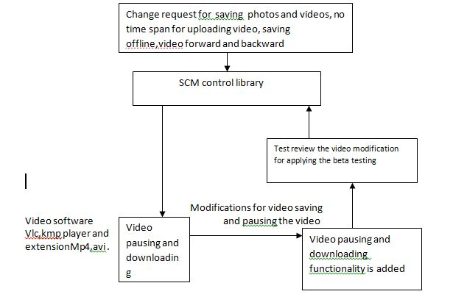

* Function baseline where initial specifications are declared.
* Allocated baseline where requirements are approved.
* Development baseline where state of work product under development.
* Product baseline which contains the releasable contents of the product

9.Establish the procedures for a baselines acquisitions of the items

* Baseline progressive, Database storage should be increased to avoid less storage space for videos as instagram supports only 60secs of video(time span). Baseline standards should be followed.

10.Assign identifiers to CI and their associated configuration documentations . Including version number where appropriate

* To release this version of instagram the system should be compatible for running the software with IOS with version 10, android 7 with version 9.