# About Data :

Within the excel file ‘Lossesʼ are daily claims (values, as at the time of the loss), by loss cause, between 1st January 1999 to 29 December 2007 for one portfolio of a UK insurance company.

Importing the libraries

|  |  |  |
| --- | --- | --- |
| In [1]: | | **import** numpy **as** np **import** pandas **as** pd **import** seaborn **as** sb  **import** matplotlib.pyplot **as** plt  **import** warnings |
|  |  | warnings**.**filterwarnings('ignore') |
|  |  | The first step to any kind of exploration and modelling requires us to load the data file into the |
|  |  | environment. |
| In | [2]: | *# Reading dataset using read_excel method*  data_df **=** pd**.**read_excel('Losses.xlsx') |
|  |  | Let's Check the dimensions of this data |
| In | [3]: | *# Checking*  data_df**.**shape |
|  |  | print("Number of rows: "**+**str(data_df**.**shape[0])) |
|  |  | print("Number of columns: "**+**str(data_df**.**shape[1])) |
|  |  | Number of rows: 47565 |
|  |  | Number of columns: 6 |
|  |  | Let's take a look at the top 5 rows of the data to understand what this file contains. |
| In | [4]: | *# The .head() function helps us to show top 5 records* |
|  |  | data_df**.**head() |

|  |  |  |  |  |  |  |
| --- | --- | --- | --- | --- | --- | --- |
| Out[4]: | DAY | MONTH | MONTH_ID | YEAR | CAUSE | GROSS INCURRED AMOUNT |
|  | 0 1 | January | 1 | 1999 | WINDSTORM | 477.88 |
|  | 1 1 | January | 1 | 1999 | FIRE | 700.00 |
|  | 2 1 | January | 1 | 1999 | WINDSTORM | 99.87 |
|  | 3 1 | January | 1 | 1999 | WINDSTORM | 139.80 |
|  | 4 1 | January | 1 | 1999 | WINDSTORM | 548.66 |

##### To understand the data better that we are going to deal with we would like to have a look at the basic numerical stats of the data like the mean, maximum etc. columnwise.

In [5]:

*# The .describe() function helps us.*

data_df**.**describe()

|  |  |  |  |  |
| --- | --- | --- | --- | --- |
| Out[5]: | DAY | MONTH_ID | YEAR | GROSS INCURRED AMOUNT |
|  | count 47565.000000 | 47565.000000 | 47565.000000 | 47565.000000 |
|  | mean 15.182802 | 6.379270 | 2004.335583 | 1072.416586 |
|  | std 9.224491 | 3.579773 | 2.463259 | 3997.920914 |
|  | min 1.000000 | 1.000000 | 1999.000000 | -31989.780000 |
|  | 25% 7.000000 | 3.000000 | 2002.000000 | 158.630000 |
|  | 50% 15.000000 | 7.000000 | 2005.000000 | 400.000000 |
|  | 75% 23.000000 | 10.000000 | 2006.000000 | 888.610000 |
|  | max 31.000000 | 12.000000 | 2007.000000 | 249499.510000 |

##### describe() method deals only with numeric values. It doesn't work with any categorical values. So if there are any categorical values in a column the describe() method will ignore it and display summary

for the other columns unless parameter include="all" is passed.

##### count tells us the number of NoN-empty rows in a feature. mean tells us the mean value of that feature.

std tells us the Standard Deviation Value of that feature.

##### min tells us the minimum value of that feature.

25%, 50%, and 75% are the percentile/quartile of each features. This quartile information helps us to detect Outliers.

##### max tells us the maximum value of that feature.

In [6]:

*#datatypes of all present attributes in the dataset*

data_df**.**info()

<class 'pandas.core.frame.DataFrame'> RangeIndex: 47565 entries, 0 to 47564 Data columns (total 6 columns):

# Column Non-Null Count Dtype

1. DAY 47565 non-null int64
2. MONTH 47565 non-null object
3. MONTH_ID 47565 non-null int64
4. YEAR 47565 non-null int64
5. CAUSE 47565 non-null object
6. GROSS INCURRED AMOUNT 47565 non-null float64 dtypes: float64(1), int64(3), object(2)

memory usage: 2.2+ MB

In [7]:

*#number of distinct elements in each attribute*

data_df**.**nunique(axis**=**0)

Out[7]:

In [8]:

*# using .isnull().sum()*

data_df**.**isnull()**.**sum()

DAY 31

|  |  |  |
| --- | --- | --- |
| MONTH |  | 12 |
| MONTH_ID |  | 12 |
| YEAR |  | 9 |
| CAUSE |  | 8 |
| GROSS INCURRED | AMOUNT | 19865 |

dtype: int64

##### Checking the Null Values in the data set

Out[8]:

In [9]:

*# using .duplicated().sum()*

data_df**.**duplicated()**.**sum()

DAY 0

MONTH 0

MONTH_ID 0

YEAR 0

CAUSE 0

GROSS INCURRED AMOUNT 0

dtype: int64

##### Checking duplicate entry in the data set

Out[9]:

In [10]:

data_df**.**drop_duplicates(inplace **= True**)

3264

In our dataset 3264 duplicate entry is present. So first we remove it.

Now we will first solve the given three problems and then make our model.

#### Q1. What are the total claims by year and what trends are there? What could be driving these trends?

##### a -What are the total value of claims by year?

In [11]:

year **=** [] total_values**=**[]

**for** i **in** data_df['YEAR']**.**unique():

total_value **=**data_df**.**loc[data_df['YEAR'] **==** i, 'GROSS INCURRED AMOUNT']**.**sum() year**.**append(i)

total_values**.**append(total_value**.**round(2))

''' print(" ")

print("Year", i)

print("Total claims in this year", total_value)'''

dict **=** {'YEAR': year, 'GROSS INCURRED AMOUNT': total_values} df **=** pd**.**DataFrame(dict)

df

|  |  |  |  |
| --- | --- | --- | --- |
| Out[11]: |  | YEAR | GROSS INCURRED AMOUNT |
|  | 0 | 1999 | 1504421.74 |
|  | 1 | 2000 | 3326081.57 |
|  | 2 | 2001 | 3535301.70 |
|  | 3 | 2002 | 3262541.63 |
|  | 4 | 2003 | 3135699.13 |
|  | 5 | 2004 | 4022203.93 |
|  | 6 | 2005 | 6230756.87 |
|  | 7 | 2006 | 9818361.64 |
|  | 8 | 2007 | 15181791.84 |

In [12]:

fig **=** plt**.**figure(figsize **=** (10, 5))

*# creating the bar plot*

plt**.**bar(df['YEAR'], df['GROSS INCURRED AMOUNT'], color**=**['orange', 'red', 'green', 'blue'

plt**.**xlabel("Years") plt**.**ylabel("Gross Amount")

plt**.**title("Total Value Claim by the year") plt**.**show()

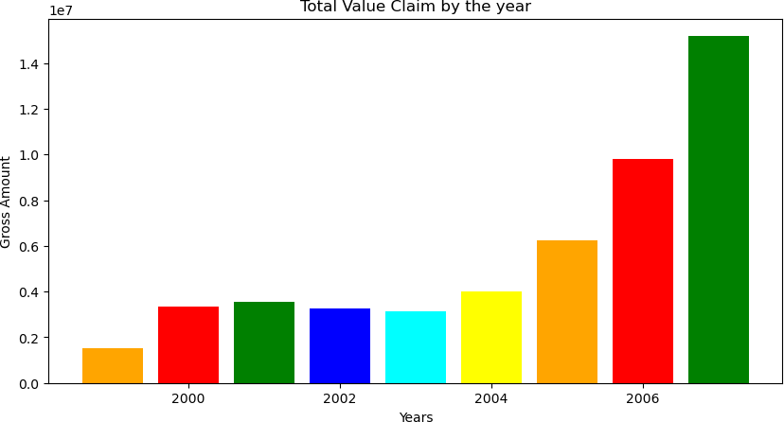

##### What factors, internal and external to the insurer, could be driving any trends that you have identified?

In [13]:

total_values **=** [] cause**=**[]

**for** i **in** data_df['CAUSE']**.**unique():

total_value **=**data_df**.**loc[data_df['CAUSE'] **==** i, 'GROSS INCURRED AMOUNT']**.**sum()

*#print(" ") #print("CAUSE:", i)*

cause**.**append(i) total_values**.**append(total_value**.**round(2))

*#print("Total claims with this cause:", total_value.round(2))*

dict **=** {'CAUSE': cause, 'GROSS INCURRED AMOUNT': total_values}

df1 **=** pd**.**DataFrame(dict) df1

|  |  |  |  |
| --- | --- | --- | --- |
| Out[13]: |  | CAUSE | GROSS INCURRED AMOUNT |
|  | 0 | WINDSTORM | 8751596.65 |
|  | 1 | FIRE | 7050611.03 |
|  | 2 | ESCAPE OF WATER | 3405456.11 |
|  | 3 | SUBSIDENCE | 4773181.49 |
|  | 4 | FLOOD | 9449495.10 |
|  | 5 | ACCIDENTAL DAMAGE | 8681913.23 |
|  | 6 | THEFT | 7156159.83 |
|  | 7 | EARTHQUAKE | 748746.61 |

In [14]:

fig **=** plt**.**figure(figsize **=** (15, 7))

*# creating the bar plot*

plt**.**bar(df1['CAUSE'], df1['GROSS INCURRED AMOUNT'],color**=**['orange', 'red', 'green', 'blu

plt**.**xlabel("CAUSE") plt**.**ylabel("Gross Amount") plt**.**show()

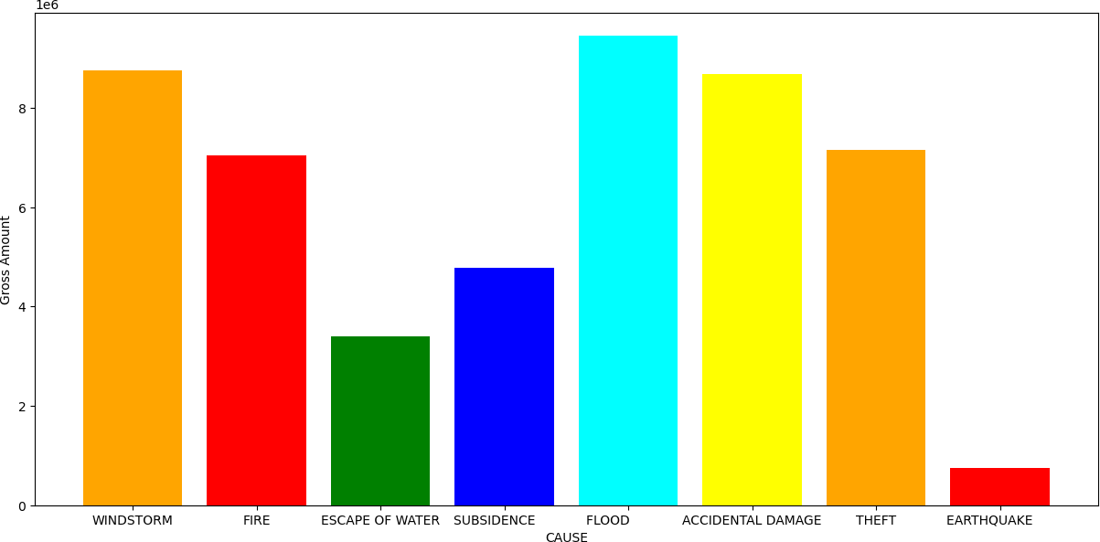

## Q2. Which perils should the company worry about most and why?

##### Which claim types (perils) have the greatest average annual frequency and severity?

In [18]:

values **=** [] causes **=** [] years **=** []

**for** c **in** cause:

**for** i **in** year:

total_value **=**data_df**.**loc[(data_df['YEAR'] **==** i) **&** (data_df['CAUSE']**==**c), 'GROSS values**.**append(total_value)

causes**.**append(c)

years**.**append(i)

dict **=** {'YEAR': years, 'CAUSE': causes, 'CLAIM': values} df2 **=** pd**.**DataFrame(dict)

df2

Out[18]:

In [19]:

print(df2[['YEAR', 'CAUSE','CLAIM']]**.**sort_values('CLAIM', ascending**=False**)**.**head(1))

YEAR CAUSE CLAIM 0 1999 WINDSTORM 586.266214

1 2000 WINDSTORM 814.016582

2 2001 WINDSTORM 588.085560

3 2002 WINDSTORM 617.170224

|  |  |  |  |
| --- | --- | --- | --- |
| 4 | 2003 | WINDSTORM | 554.673421 |
| ... | ... | ... | ... |
| 67 | 2003 | EARTHQUAKE | NaN |

68 2004 EARTHQUAKE NaN

69 2005 EARTHQUAKE NaN

70 2006 EARTHQUAKE NaN 71 2007 EARTHQUAKE 6010.738455

##### 72 rows × 3 columns

YEAR CAUSE CLAIM 29 2001 SUBSIDENCE 10518.961

Here we get that SUBSIDENCE has greatest average annual claims: 10518.961 in the year 2001.

##### What is the average individual claim size by peril across the 9-year time period?

In [17]:

cause_2 **=** [] total_value2 **=** [] **for** c **in** causes:

total_value **=**data_df**.**loc[data_df['CAUSE'] **==** c, 'GROSS INCURRED AMOUNT']**.**sum() cause_2**.**append(c)

total_value2**.**append(total_value**.**round(2))

dict **=** {'CAUSE': cause_2, 'CLAIM': total_value2} df3 **=** pd**.**DataFrame(dict)

*# Calculating average*

result **=** df3**.**groupby('CAUSE')['CLAIM']**.**mean()

Out[17]:

In [18]:

options **=** ['FLOOD','WINDSTORM','SUBSIDENCE']

df3 **=** data_df**.**loc[(data_df['MONTH']**==**'January') **&** (data_df['DAY']**<**9) **&** (data_df['DAY']**>**7 df3**.**head()

|  |  |
| --- | --- |
| *# Display result*  result**.**round(2) |  |
| CAUSE  ACCIDENTAL DAMAGE | 8681913.23 |
| EARTHQUAKE | 748746.61 |
| ESCAPE OF WATER | 3405456.11 |
| FIRE | 7050611.03 |
| FLOOD | 9449495.10 |
| SUBSIDENCE | 4773181.49 |
| THEFT | 7156159.83 |
| WINDSTORM | 8751596.65 |
| Name: CLAIM, dtype: | float64 |

Q3. What did Windstorm Erwin cost the company? What perils drove the loss?

##### What was the total loss, for windstorm and other related weather perils, for Windstorm Erwin (date Jan 7th to Jan 9th, 2005)

|  |  |  |  |  |  |  |
| --- | --- | --- | --- | --- | --- | --- |
| Out[18]: | DAY | MONTH | MONTH_ID | YEAR | CAUSE | GROSS INCURRED AMOUNT |
|  | 1947 8 | January | 1 | 2000 | WINDSTORM | 350.00 |
|  | 5221 8 | January | 1 | 2001 | WINDSTORM | 595.00 |
|  | 5223 8 | January | 1 | 2001 | WINDSTORM | 528.75 |
|  | 5224 8 | January | 1 | 2001 | WINDSTORM | 998.75 |
|  | 5226 8 | January | 1 | 2001 | WINDSTORM | 130.00 |
|  | ... ... | ... | ... | ... | ... | ... |
|  | 36526 8 | January | 1 | 2007 | WINDSTORM | 114.00 |
|  | 36528 8 | January | 1 | 2007 | WINDSTORM | 264.38 |
|  | 36529 8 | January | 1 | 2007 | WINDSTORM | 1811.20 |
|  | 36531 8 | January | 1 | 2007 | WINDSTORM | 176.00 |
|  | 36536 8 | January | 1 | 2007 | WINDSTORM | 420.00 |

238 rows × 6 columns

In [19]:

result_weather **=** df3**.**groupby('CAUSE')['GROSS INCURRED AMOUNT']**.**sum() print(result_weather)

CAUSE

WINDSTORM 205524.31

Name: GROSS INCURRED AMOUNT, dtype: float64

# NOW WE WILL MAKE OUR MODEL FOR PREDICTION

### Transformation of categorical attributes

In [20]:

*# Converting object data type into numeric data type using Label Encoder.*

**from** sklearn.preprocessing **import** LabelEncoder lb **=** LabelEncoder()

data_df['MONTH'] **=** lb**.**fit_transform(data_df['MONTH'])

data_df['CAUSE'] **=** lb**.**fit_transform(data_df['CAUSE'])

Lets try to understand what this data is all about.

### Data Visualisation-

##### Since this is a classification problem it would be important and interesting to the distribution of target variables for the data.

In [21]:

fig, ax**=**plt**.**subplots(1,2,figsize**=**(20,6))

_ **=** sb**.**countplot(x**=**'CAUSE', data**=**data_df, ax**=**ax[0])

_ **=** data_df['CAUSE']**.**value_counts()**.**plot**.**pie(autopct**=**"%1.1f%%", ax**=**ax[1])

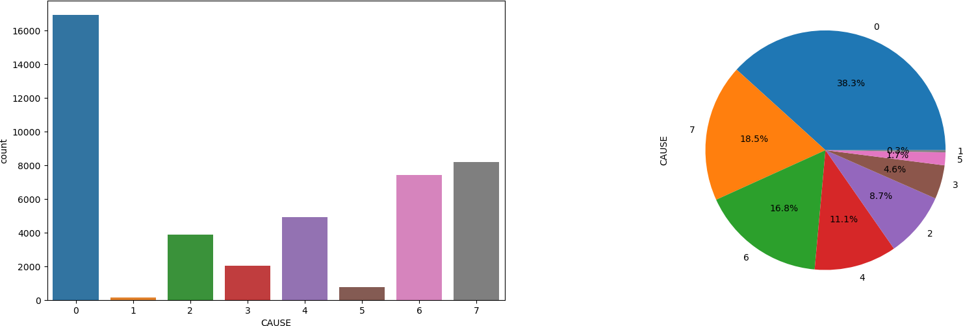

In [24]:

data_df['CAUSE']**.**value_counts()

Out[24]:

In [22]:

|  |  |
| --- | --- |
| ACCIDENTAL DAMAGE | 16950 |
| WINDSTORM | 8208 |
| THEFT | 7428 |
| FLOOD | 4916 |
| ESCAPE OF WATER | 3876 |
| FIRE | 2025 |
| SUBSIDENCE | 768 |
| EARTHQUAKE | 130 |
| Name: CAUSE, dtype: | int64 |

##### So there are 8 classes of CAUSE for which insurance is claims. We can see that the distribution of the classes is disbalanced. 'ACCIDENTAL DAMAGE' class is in majority while 'EARTHQUAKE' class is the minority here.

Let's check the distribution of data using Histogram and Density visualisation method.¶

data_df**.**hist(figsize**=**(15,15)) plt**.**show()

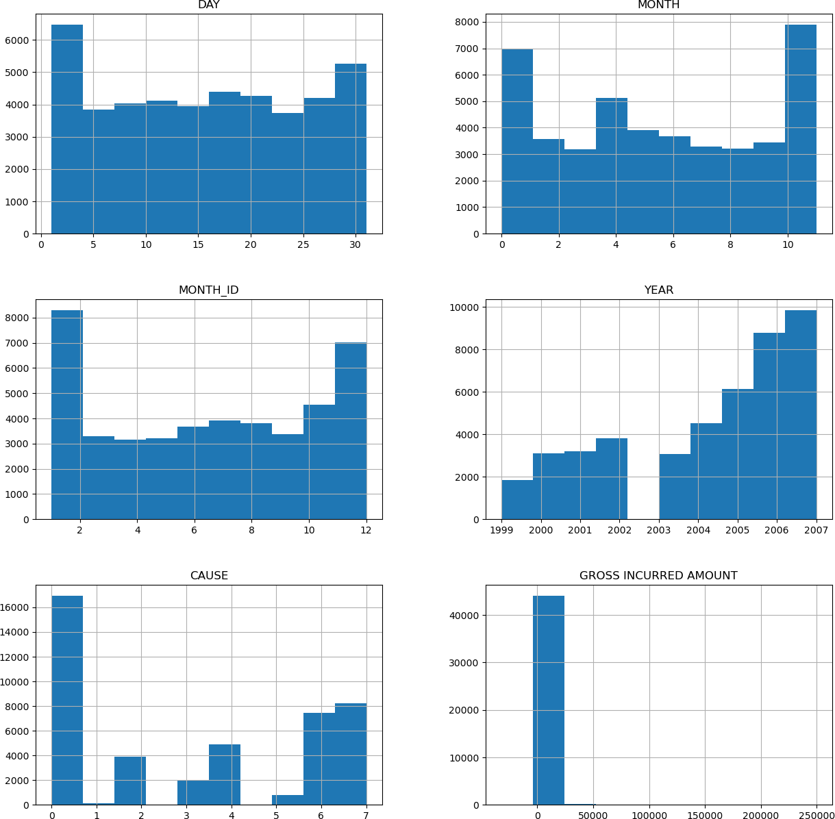

In [23]:

data_df**.**plot(kind**=**"density", layout**=**(6,5),

subplots**=True**,sharex**=False**, sharey**=False**, figsize**=**(20,20))

plt**.**show()

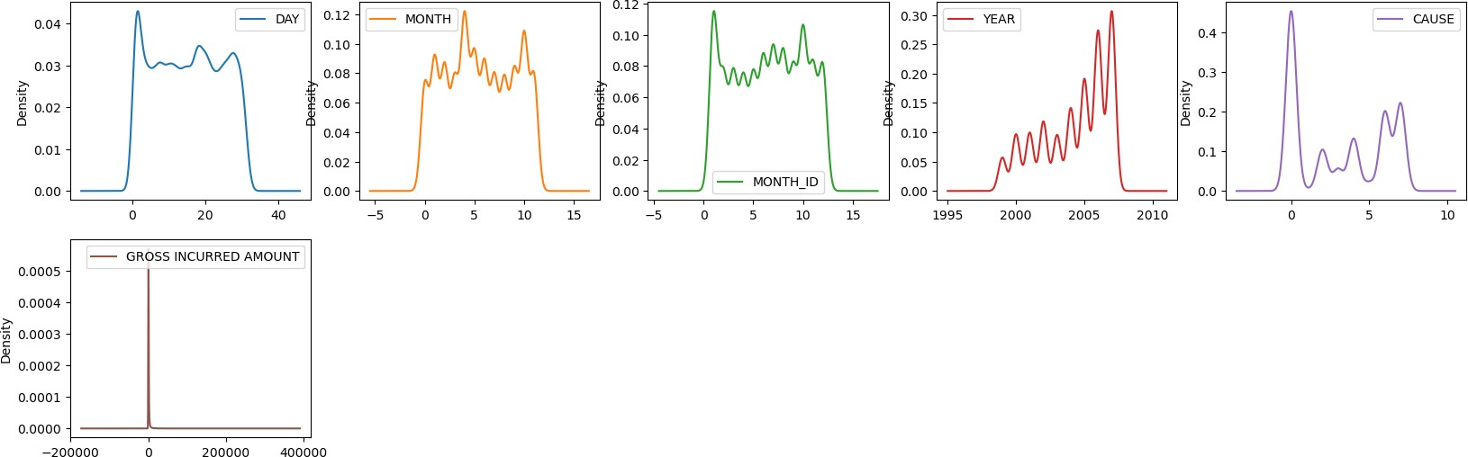

##### Checking the coorellation

In [24]:

*# coorelation between the featues and target*

sb**.**heatmap(data_df**.**corr(),annot **= True**) plt**.**show()

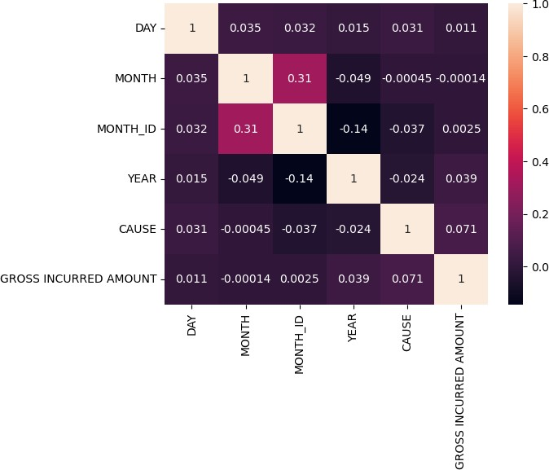

##### Now we will take features and target in seprate variable as an input X and output Y

In [25]:

*# Defining Input and target*

X **=** data_df**.**drop('CAUSE',axis**=**1) Y **=** data_df['CAUSE']

|  |  |  |
| --- | --- | --- |
|  | | Train-Test-Split |
| In | [26]: | **from** sklearn.model_selection **import** train_test_split  X_train,X_test,Y_train,Y_test **=** train_test_split(X,Y,test_size**=**0.2,random_state**=**1) |
|  |  | As we know that before giving data to machine we need to change unit of all data. |
| In | [27]: | **from** sklearn.preprocessing **import** StandardScaler |
|  |  | ss**=** StandardScaler() |
|  |  | X_train **=** ss**.**fit_transform(X_train) |
|  |  | X_test **=** ss**.**transform(X_test) |
|  |  |  |
| In | [28]: | X_train**.**shape |
| Out[28]: | | (35440, 5) |

In [29]:

Out[29]:

In [30]:

Out[30]:

X_test**.**shape

(8861, 5)

Y_train**.**shape

(35440,)

In [31]:

*#! pip install imblearn*

In [32]:

**from** imblearn.over_sampling **import** SMOTE

X_train1,Y_train1 **=** SMOTE()**.**fit_resample(X_train,Y_train) X_test1,Y_test1 **=** SMOTE()**.**fit_resample(X_test,Y_test) X_train**.**shape, Y_train**.**shape

Out[32]:

In [33]:

Out[33]:

In [34]:

**def** create_model(model): model**.**fit(X_train1,Y_train1) Y_pred **=** model**.**predict(X_test1)

print(classification_report(Y_test1, Y_pred))

print("Confusion Matrix",confusion_matrix(Y_test1,Y_pred)) print("Model Accuracy: ",model**.**score(X_test1,Y_test1)) **return** model

**from** sklearn.metrics **import** classification_report,confusion_matrix

((35440, 5), (35440,))

Y_test1**.**value_counts()

7 3398

|  |  |
| --- | --- |
| 6 | 3398 |
| 0 | 3398 |
| 3 | 3398 |
| 2 | 3398 |
| 4 | 3398 |
| 5 | 3398 |
| 1 | 3398 |

Name: CAUSE, dtype: int64

Creating a Model Function

# Using a Logistic Regression

In [35]:

**from** sklearn.linear_model **import** LogisticRegression

lr **=** LogisticRegression(random_state**=**1) lr **=** create_model(lr)

Confusion Matrix [[ 998 238 759 18 924 184 70 207]

|  |  |  |  |  |  |  |  |  |
| --- | --- | --- | --- | --- | --- | --- | --- | --- |
| [ | 18 | 3280 | 25 | 0 | 0 | 0 | 68 | 7] |
| [ | 633 | 50 | 1801 | 98 | 246 | 257 | 86 | 227] |
| [ | 595 | 174 | 1005 | 117 | 735 | 480 | 53 | 239] |
| [ | 616 | 361 | 154 | 77 | 1604 | 322 | 101 | 163] |
| [ | 242 | 311 | 648 | 183 | 637 | 1041 | 128 | 208] |
| [ | 699 | 254 | 950 | 62 | 883 | 242 | 82 | 226] |
| [ | 557 | 127 | 1153 | 40 | 980 | 157 | 57 | 327]] |

Model Accuracy: 0.34027369040612127

# Decision Tree Classifier with Gini

In [36]:

**from** sklearn.tree **import** DecisionTreeClassifier

dt **=** DecisionTreeClassifier(random_state**=**1) dt **=** create_model(dt)

Confusion Matrix [[1070 8 414 242 506 89 647 422]

|  |  |  |  |  |  |  |  |  |
| --- | --- | --- | --- | --- | --- | --- | --- | --- |
| [ | 4 | 3217 | 11 | 40 | 11 | 113 | 2 | 0] |
| [ | 543 | 24 | 785 | 689 | 196 | 344 | 456 | 361] |
| [ | 354 | 41 | 496 | 949 | 367 | 509 | 383 | 299] |
| [ | 639 | 25 | 147 | 500 | 871 | 304 | 570 | 342] |
| [ | 275 | 68 | 373 | 760 | 320 | 1096 | 268 | 238] |
| [ | 758 | 18 | 438 | 489 | 517 | 169 | 663 | 346] |
| [ | 545 | 10 | 343 | 264 | 341 | 143 | 343 | 1409]] |

Model Accuracy: 0.3700706297822248

# Decision Tree Classifier : Pruning Technique : max_depth

In [37]:

dt1**=**DecisionTreeClassifier(random_state**=**1,max_depth**=**8) *#bydefault gini*

dt1**=**create_model(dt1)

Confusion Matrix [[1478 18 827 88 671 168 27 121]

|  |  |  |  |  |  |  |  |  |
| --- | --- | --- | --- | --- | --- | --- | --- | --- |
| [ | 24 | 3219 | 0 | 0 | 89 | 66 | 0 | 0] |
| [ | 606 | 13 | 1612 | 411 | 142 | 494 | 9 | 111] |
| [ | 515 | 30 | 769 | 516 | 852 | 638 | 9 | 69] |
| [ | 864 | 6 | 91 | 154 | 1815 | 364 | 12 | 92] |
| [ | 173 | 25 | 470 | 275 | 683 | 1730 | 15 | 27] |
| [ | 914 | 26 | 894 | 249 | 941 | 252 | 23 | 99] |
| [ | 611 | 3 | 752 | 148 | 679 | 235 | 3 | 967]] |

Model Accuracy: 0.41789287816362564

# Decision Tree Classifier : Pruning Technique

:min_samples_leaf

In [38]:

df2 **=** DecisionTreeClassifier(random_state**=**1, min_samples_leaf**=**87) df2 **=** create_model(df2)

Confusion Matrix [[ 946 15 655 274 667 178 373 290]

|  |  |  |  |  |  |  |  |  |
| --- | --- | --- | --- | --- | --- | --- | --- | --- |
| [ | 14 | 3218 | 0 | 6 | 0 | 159 | 1 | 0] |
| [ | 411 | 28 | 1162 | 698 | 107 | 499 | 275 | 218] |
| [ | 219 | 58 | 576 | 914 | 504 | 789 | 178 | 160] |
| [ | 476 | 27 | 158 | 383 | 1391 | 520 | 188 | 255] |
| [ | 67 | 45 | 321 | 640 | 507 | 1734 | 50 | 34] |
| [ | 497 | 31 | 600 | 536 | 735 | 338 | 384 | 277] |
| [ | 331 | 18 | 438 | 207 | 418 | 233 | 189 | 1564]] |

Model Accuracy: 0.41616391995291346

# 3 Decision Tree Classifier with Entropy

In [39]:

dt_entropy **=** DecisionTreeClassifier(random_state**=**1, criterion**=**'entropy')

*# Criterion should be entropy if you want to calculate with Entropy other wise by defaul*

dt_entropy **=** create_model(dt_entropy)

Confusion Matrix [[1110 12 435 209 480 93 644 415]

|  |  |  |  |  |  |  |  |  |
| --- | --- | --- | --- | --- | --- | --- | --- | --- |
| [ | 5 | 3214 | 18 | 71 | 4 | 70 | 7 | 9] |
| [ | 573 | 11 | 802 | 633 | 173 | 352 | 464 | 390] |
| [ | 349 | 41 | 512 | 962 | 347 | 530 | 380 | 277] |
| [ | 638 | 27 | 190 | 494 | 829 | 313 | 550 | 357] |
| [ | 237 | 77 | 405 | 773 | 336 | 1110 | 258 | 202] |
| [ | 755 | 11 | 450 | 478 | 517 | 186 | 634 | 367] |
| [ | 515 | 7 | 330 | 305 | 352 | 132 | 340 | 1417]] |

Model Accuracy: 0.3707327839905827

# Random Forest Classifier

In [40]:

**from** sklearn.ensemble **import** RandomForestClassifier

rfc **=**RandomForestClassifier(random_state**=**1) rfc **=** create_model(rfc)

Confusion Matrix [[1141 6 394 217 523 73 637 407]

|  |  |  |  |  |  |  |  |  |
| --- | --- | --- | --- | --- | --- | --- | --- | --- |
| [ | 4 | 3202 | 4 | 73 | 1 | 112 | 2 | 0] |
| [ | 504 | 11 | 925 | 758 | 152 | 383 | 409 | 256] |
| [ | 290 | 44 | 522 | 1196 | 322 | 579 | 271 | 174] |
| [ | 603 | 16 | 171 | 511 | 977 | 350 | 462 | 308] |
| [ | 171 | 45 | 347 | 802 | 331 | 1430 | 141 | 131] |
| [ | 751 | 10 | 446 | 530 | 543 | 193 | 614 | 311] |
| [ | 487 | 5 | 338 | 275 | 375 | 145 | 313 | 1460]] |

Model Accuracy: 0.40262654502648615

In [41]:

'''for i in range(1,9):

rfc1 = RandomForestClassifier(random_state=1, max_depth=i) print("Max_depth: ", i)

rfc1 = create_model(rfc1)'''

Out[41]:

In [42]:

'for i in range(1,9):\n rfc1 = RandomForestClassifier(random_state=1, max_depth=i)\n print("Max_depth: ", i)\n \n rfc1 = create_model(rfc1)'

Confusion Matrix [[1408 10 878 15 744 163 9 171]

rfc1 **=** RandomForestClassifier(random_state**=**1, max_depth**=**8) rfc1 **=** create_model(rfc1)

|  |  |  |  |  |  |  |  |  |
| --- | --- | --- | --- | --- | --- | --- | --- | --- |
| [ | 19 | 3218 | 7 | 35 | 61 | 58 | 0 | 0] |
| [ | 523 | 26 | 1907 | 241 | 128 | 479 | 5 | 89] |
| [ | 449 | 28 | 1003 | 438 | 771 | 636 | 1 | 72] |
| [ | 779 | 12 | 130 | 114 | 1775 | 421 | 5 | 162] |
| [ | 132 | 42 | 386 | 273 | 617 | 1910 | 3 | 35] |
| [ | 860 | 9 | 1074 | 129 | 933 | 254 | 12 | 127] |
| [ | 551 | 5 | 839 | 60 | 643 | 224 | 3 | 1073]] |

Model Accuracy: 0.43190847557386697

# AdaBoostClassifier

In [43]:

**from** sklearn.ensemble **import** AdaBoostClassifier '''for i in range(1,14):

ada = AdaBoostClassifier(n_estimators=i, random_state=1) print("No of Decision Stump: ", i)

ada = create_model(ada)'''

Out[43]:

In [44]:

'for i in range(1,14):\n ada = AdaBoostClassifier(n_estimators=i, random_state=1)\n

\n print("No of Decision Stump: ", i)\n \n ada = create_model(ada)'

ada **=** AdaBoostClassifier(n_estimators**=**10, random_state**=**1)

ada **=** create_model(ada)

Confusion Matrix [[ 920 111 858 267 790 201 0 251]

|  |  |  |  |  |  |  |  |  |
| --- | --- | --- | --- | --- | --- | --- | --- | --- |
| [ | 24 | 3218 | 25 | 42 | 89 | 0 | 0 | 0] |
| [ | 511 | 67 | 1316 | 574 | 142 | 478 | 0 | 310] |
| [ | 359 | 146 | 745 | 439 | 1099 | 379 | 0 | 231] |
| [ | 523 | 150 | 125 | 168 | 1916 | 326 | 0 | 190] |
| [ | 97 | 154 | 527 | 215 | 1092 | 1124 | 0 | 189] |
| [ | 570 | 132 | 802 | 402 | 998 | 236 | 0 | 258] |
| [ | 321 | 33 | 803 | 349 | 708 | 232 | 0 | 952]] |

Model Accuracy: 0.3636330194231901

# Gradient Boosting

In [45]:

**from** sklearn.ensemble **import** GradientBoostingClassifier

'''for i in range(10,101):

gbc = GradientBoostingClassifier(n_estimators=99, random_state=1) # n_estimators >= print("Esimators: ", i)

gbc = create_model(gbc)'''

Out[45]:

In [46]:

'for i in range(10,101):\n gbc = GradientBoostingClassifier(n_estimators=99, random_s tate=1) # n_estimators >=10 and <=100\n print("Esimators: ", i)\n \n gbc = cre ate_model(gbc)'

Confusion Matrix [[1467 10 755 29 729 102 54 252]

**from** sklearn.ensemble **import** GradientBoostingClassifier

gbc **=** GradientBoostingClassifier(n_estimators**=**99, random_state**=**1) *# n_estimators >=10 a*

gbc **=** create_model(gbc)

|  |  |  |  |  |  |  |  |  |
| --- | --- | --- | --- | --- | --- | --- | --- | --- |
| [ | 5 | 3232 | 15 | 29 | 0 | 117 | 0 | 0] |
| [ | 365 | 35 | 1552 | 616 | 91 | 523 | 46 | 170] |
| [ | 246 | 52 | 609 | 981 | 517 | 844 | 37 | 112] |
| [ | 476 | 16 | 162 | 317 | 1717 | 448 | 76 | 186] |
| [ | 55 | 45 | 243 | 508 | 323 | 2155 | 2 | 67] |
| [ | 683 | 22 | 874 | 353 | 893 | 251 | 113 | 209] |
| [ | 454 | 10 | 579 | 165 | 556 | 210 | 46 | 1378]] |

Model Accuracy: 0.4633240141259564

In [48]:

*#!pip install xgboost*

Collecting xgboost

Downloading xgboost-1.7.3-py3-none-macosx_10_15_x86_64.macosx_11_0_x86_64.macosx_12_0_ x86_64.whl (1.8 MB)

━━━━━━━━━━━━━━━━━━━━━━━━━━━━━━━━━━━━━━━━ 1.8/1.8 MB 1.9 MB/s eta 0:00:0000:0100:010

m

Requirement already satisfied: numpy in /opt/anaconda3/lib/python3.9/site-packages (from xgboost) (1.21.5)

Requirement already satisfied: scipy in /opt/anaconda3/lib/python3.9/site-packages (from

xgboost) (1.9.1)

Installing collected packages: xgboost Successfully installed xgboost-1.7.3

# XGBClassifier

In [49]:

**from** xgboost **import** XGBClassifier '''for i in range(10,100):

xgc = XGBClassifier(n_estimators= i,reg_alpha =1, random_state =1)

xgc = create_model(xgc)'''

Out[49]:

In [50]:

'for i in range(10,100):\n xgc = XGBClassifier(n_estimators= i,reg_alpha =1, random_s tate =1)\n \n xgc = create_model(xgc)'

Confusion Matrix [[1966 7 382 50 498 60 182 253]

xgc **=** XGBClassifier(n_estimators**=** 90,reg_alpha **=**1, random_state **=**1)

xgc **=** create_model(xgc)

|  |  |  |  |  |  |  |  |  |
| --- | --- | --- | --- | --- | --- | --- | --- | --- |
| [ | 1 | 3262 | 2 | 8 | 0 | 125 | 0 | 0] |
| [ | 390 | 9 | 1203 | 862 | 98 | 487 | 183 | 166] |
| [ | 175 | 51 | 445 | 1231 | 456 | 829 | 113 | 98] |
| [ | 439 | 18 | 153 | 488 | 1542 | 417 | 190 | 151] |
| [ | 63 | 40 | 211 | 766 | 295 | 1953 | 33 | 37] |
| [ | 759 | 12 | 605 | 529 | 759 | 229 | 330 | 175] |
| [ | 464 | 6 | 411 | 247 | 438 | 186 | 113 | 1533]] |

Model Accuracy: 0.47895821071218364

# Linear SVC

In [51]:

**from** sklearn.svm **import** LinearSVC svc **=** LinearSVC(random_state**=**1) svc **=** create_model(svc)

Confusion Matrix [[ 473 553 912 1 1140 205 12 102]

|  |  |  |  |  |  |  |  |  |
| --- | --- | --- | --- | --- | --- | --- | --- | --- |
| [ | 15 | 3303 | 67 | 0 | 0 | 0 | 13 | 0] |
| [ | 223 | 243 | 2188 | 5 | 390 | 276 | 5 | 68] |
| [ | 315 | 450 | 1246 | 1 | 760 | 504 | 10 | 112] |
| [ | 336 | 714 | 195 | 7 | 1689 | 356 | 15 | 86] |
| [ | 51 | 556 | 820 | 11 | 826 | 1058 | 16 | 60] |
| [ | 341 | 534 | 1116 | 5 | 998 | 286 | 21 | 97] |
| [ | 231 | 663 | 1329 | 0 | 780 | 163 | 7 | 225]] |

Model Accuracy: 0.32953207769276044

In [52]:

svc1 **=** LinearSVC(random_state**=**1,C **=** 0.9) svc1 **=** create_model(svc1)

Confusion Matrix [[ 470 554 912 1 1141 206 12 102]

|  |  |  |  |  |  |  |  |  |
| --- | --- | --- | --- | --- | --- | --- | --- | --- |
| [ | 15 | 3303 | 67 | 0 | 0 | 0 | 13 | 0] |
| [ | 220 | 243 | 2190 | 4 | 390 | 278 | 5 | 68] |
| [ | 314 | 447 | 1247 | 1 | 762 | 505 | 10 | 112] |
| [ | 335 | 711 | 195 | 6 | 1692 | 358 | 15 | 86] |
| [ | 51 | 556 | 820 | 11 | 826 | 1058 | 16 | 60] |
| [ | 341 | 534 | 1116 | 5 | 997 | 288 | 21 | 96] |
| [ | 231 | 660 | 1330 | 0 | 782 | 163 | 7 | 225]] |

Model Accuracy: 0.329605650382578

# Result : As we got 7 class in the target and we have unbalance sample like

##### ACCIDENTAL DAMAGE : 16950 WINDSTORM : 8208

THEFT : 7428

##### FLOOD : 4916

ESCAPE OF WATER :3876 FIRE :2025

##### SUBSIDENCE :768

EARTHQUAKE :130

Just because of unbalance data we have to apply SMOTE to balance our data where we add more duplicate value.

Because of duplicate value our accuracy is below 50 % . To increase our accuracy we need to collect more data of low frequency sample.

# We got 47 % accuracy from the XGB Classifier which maximum from the other classification algorithms.

In [ ]: