SonarQubeHTML

Friday, June 07, 2019

10:25 AM

Please follow below steps to configure SonarQube Reporting in CICD build -

1. Add a command line step to run a node command as below -

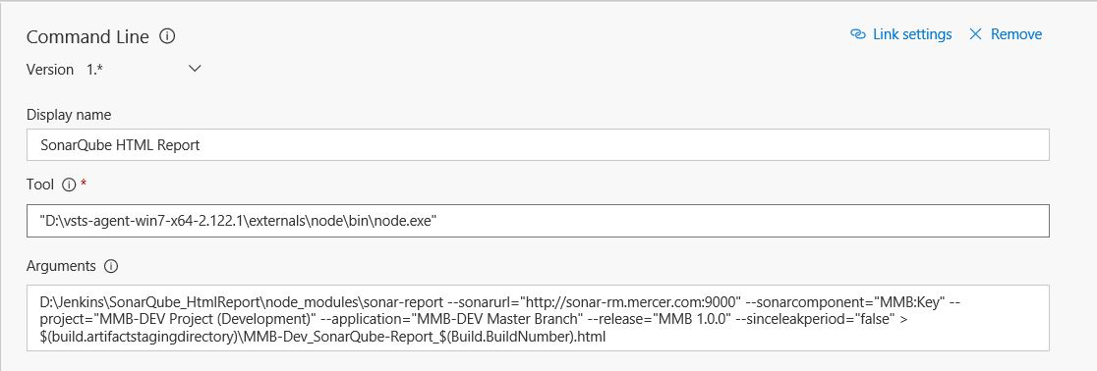

D:\Jenkins\SonarQube_HtmlReport\node_modules\sonar-report --sonarurl="[http://sonar-rm.mercer.com:9000](http://sonar-rm.mercer.com:9000/)" --sonarcomponent="Project Key Here" --project="Project Name Project (Development)" --application="Project Name Master Branch" --release="Project Name 1.0.0" --sinceleakperiod="false" > $(build.artifactstagingdirectory)\Project Name_SonarQube-Report_$(Build.BuildNumber).html

1. Add one PowerShell step to send the HTML report in email -

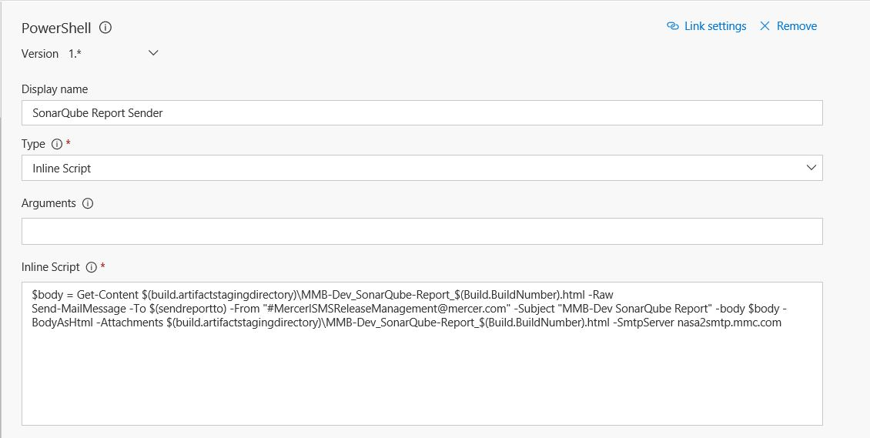

$body = Get-Content $(build.artifactstagingdirectory)\Project Name_SonarQube-Report_$(Build.BuildNumber).html -Raw  
Send-MailMessage -To $(sendreportto) -From "[#MercerISMSReleaseManagement@mercer.com](mailto:#MercerISMSReleaseManagement@mercer.com)" -Subject "Project Name SonarQube Report" -body $body -BodyAsHtml -Attachments $(build.artifactstagingdirectory)\Project Name_SonarQube-Report_$(Build.BuildNumber).html -SmtpServer nasa2smtp.mmc.com

Please create a build variable to define the users who you want to send report e.g.. Sendreportto