* Create an IAM user with S3, EC2 and CloudWatch services.

{

"Version": "2012-10-17",

"Statement": [

{

"Sid": "VisualEditor0",

"Effect": "Allow",

"Action": [

"cloudwatch:\*",

"s3:\*",

"ec2:\*"

],

"Resource": "\*"

}

]

}

* Create an Ubuntu EC2 instance

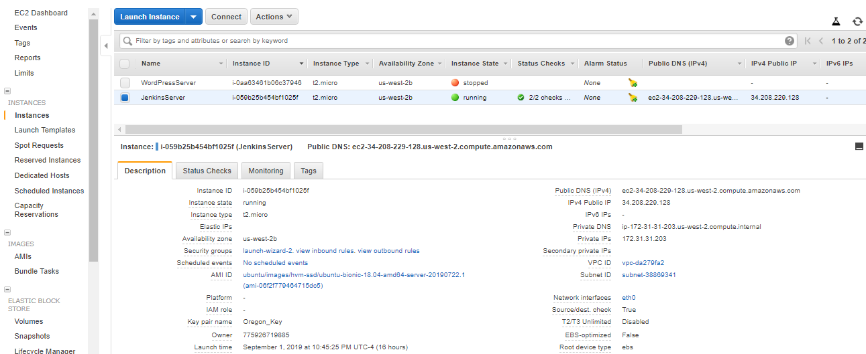

* Login to the instance and install jdk.

apt update -y

apt install –y default-jdk

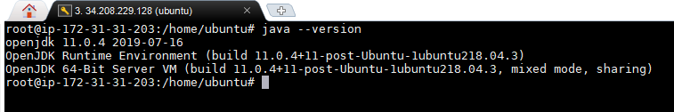

* Install Jenkins

sudo apt-get update

sudo apt install -y default-jdk

wget -q -O - https://pkg.jenkins.io/debian/jenkins.io.key | sudo apt-key add -

sudo sh -c 'echo deb https://pkg.jenkins.io/debian-stable binary/ > /etc/apt/sources.list.d/jenkins.list'

sudo apt-get update

sudo apt-get install -y Jenkins

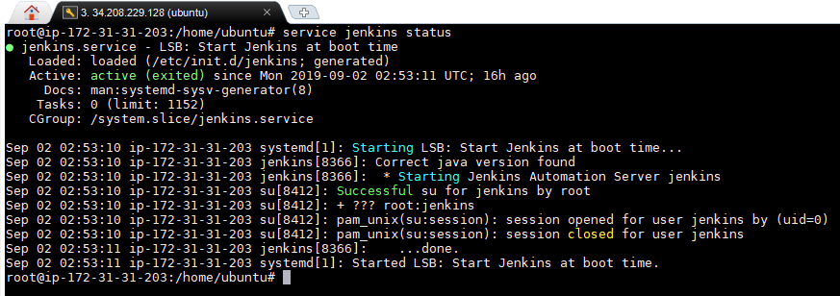

* Login to the browser using the public IP address with the port

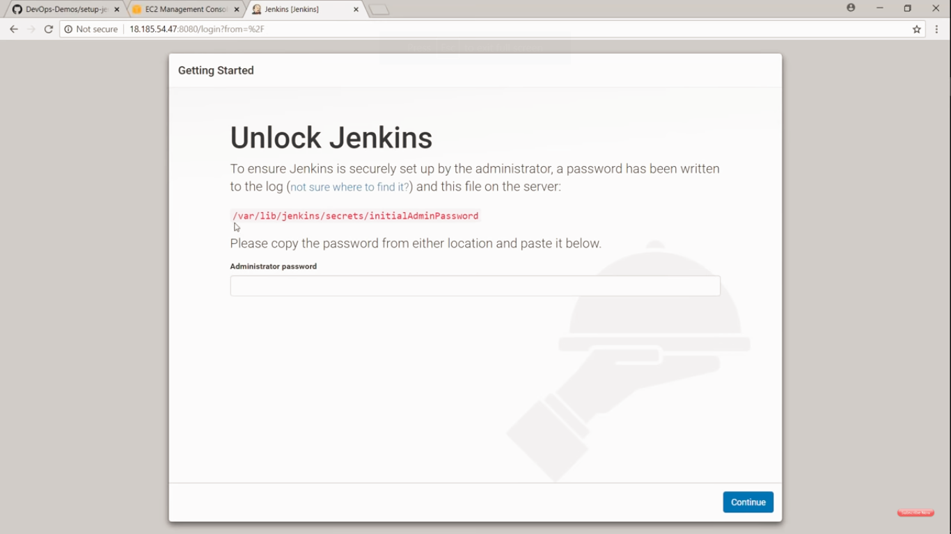

Enter the Password situated in the mentioned location.

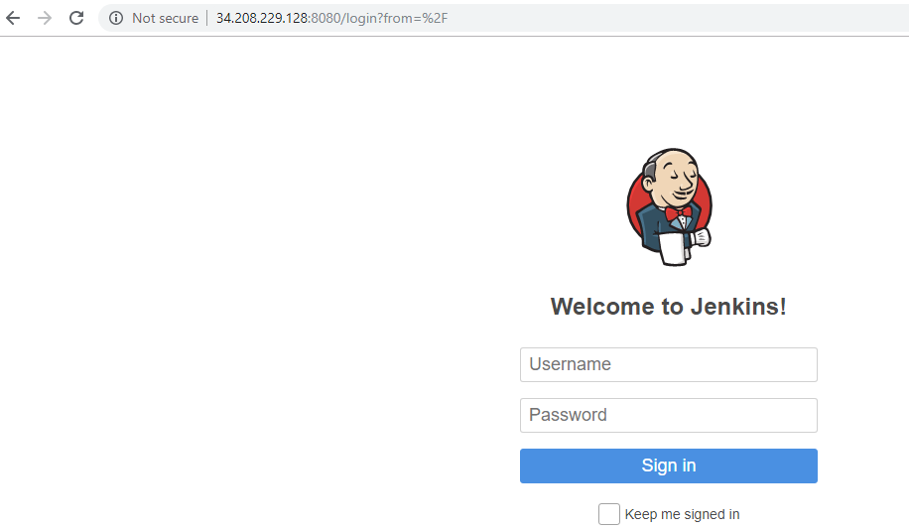

* Login to the Jenkins

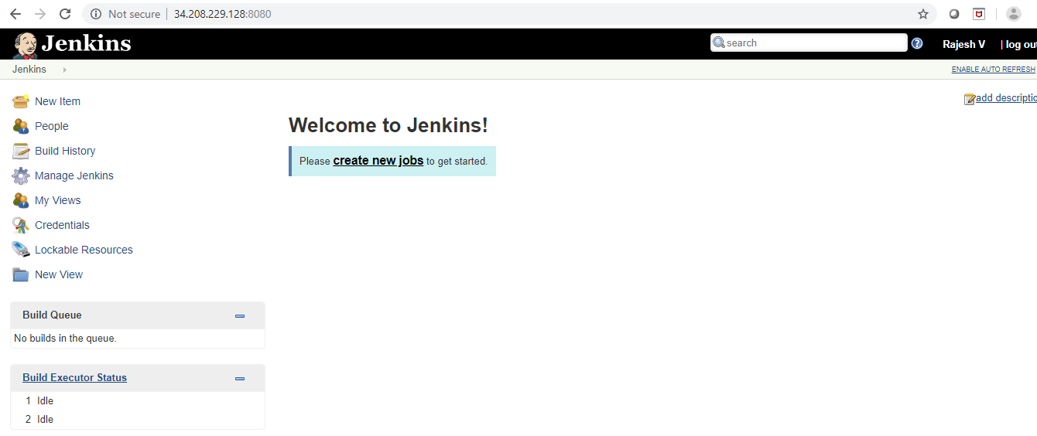

* Navigate to Manage Jenkins and install the BlueOcean related plugins.

