Created the S3 bucket “rajeshs3project-1”

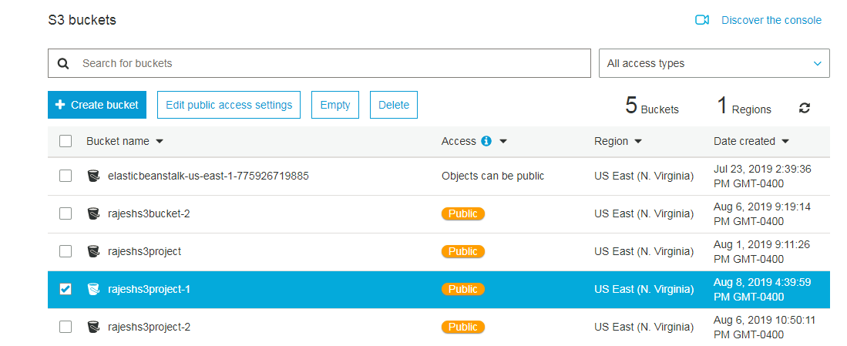

Uploaded the website related files to the bucket

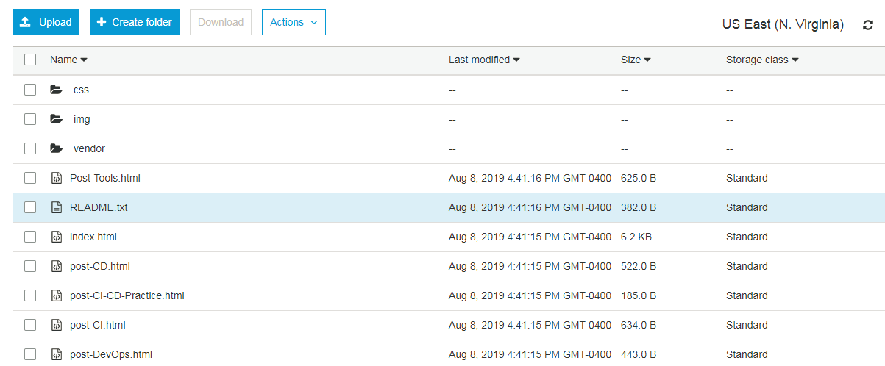

Configured the S3 bucket for website hosting

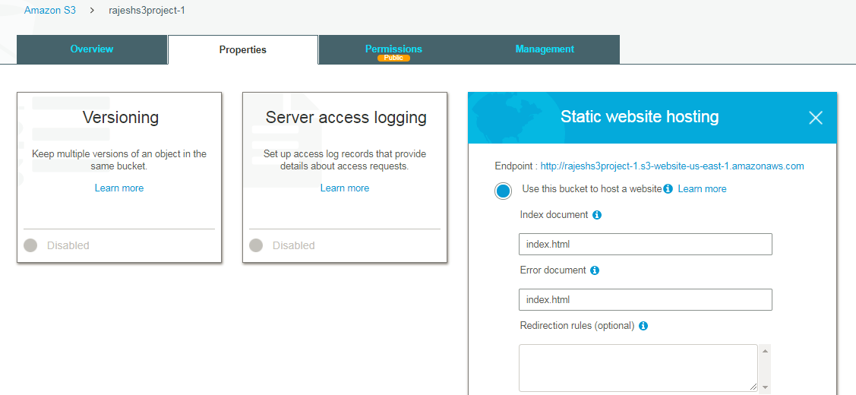

IAM bucket policy set for the S3 bucket to make the bucket content public accessible

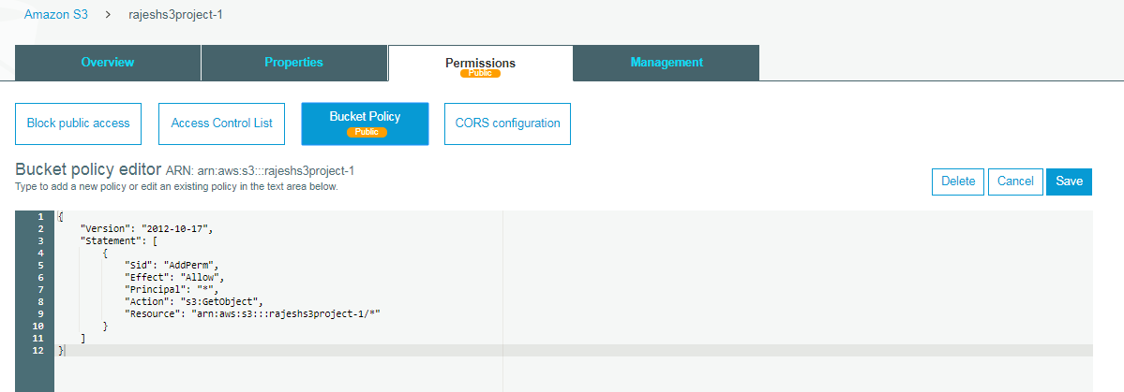

Cloud front has been configured to distribute the website files

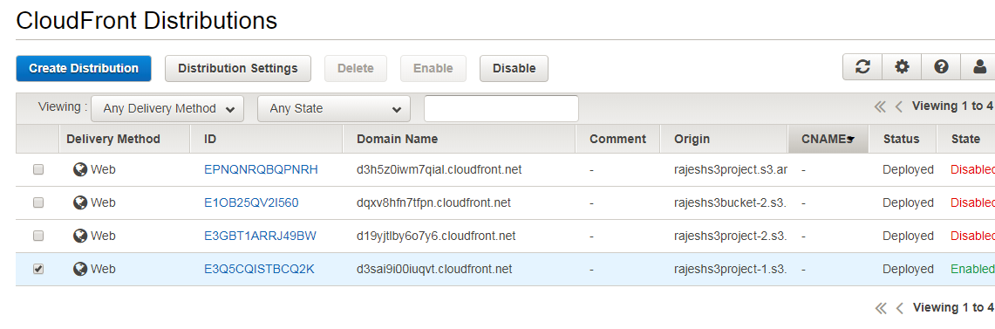

The website should be accessible using the url,

<http://rajeshs3project-1.s3-website-us-east-1.amazonaws.com>

