

VIVEKANAND COLLEGE FOR ADVANCED COMPUTER AND INFORMATION SCIENCE SURAT
VEER NARMAD SOUTH GUJARAT UNIVERSITY, SURAT
PROJECT REPORT ON
“CAMPUS FLOW”
AS A PARTIAL REQUIREMENT FOR THE DEGREE OF
BACHELOR OF COMPUTER APPLICATION (B.C.A)
2024-25

GUIDED BY:

Dr. Nidhi Mehta

SUBMITTED BY:

Acknowledgement

The reason of completing the project work successfully is not just our efforts but efforts of many people. The people, who trusted, guided and encouraged us with every means. Guide is a person who provides you the direction towards success, so we feel great pleasure to express our gratitude to all our guides, our faculty members as well as every person who helped me directly or indirectly with our project.

We would like to thank Mrs. Sumathi Shenoy (Campus director of Vivekanand College for BCA), Dr. Sandip Surati (In charge Principal of Vivekanand College for BCA) heart fully, who granted us project. Their skill and experience were a guiding path in this learning process. They made constant efforts to shape up our skills as per the industry Standards. They provided us a very homely and friendly environment which made it the best place to work. Their guidance were really priceless and will always be a guiding light in Industry.

We are also indebted to our Dr. Nidhi Mehta who provided constant encouragement, support & valuable guidance before and during our project. It was her effort who led us to this place for project work. Her guidance and suggestions were invaluable.

Thank you very much.

Index

Chapter | Content | Page No.
- Project Profile
2. Project Introduction
3. Hardware Requirement
4. Software Requirement
5. Scope
6. Use cases
7. Database design
8. Test Cases
9. Screen Layout

1
Project Profile

- Project Name : CAMPUS FLOW

- Project Type : Enterprise Resource Planning

- Project Guide : Dr. Nidhi Mehta

- Front End : React Js + Vite

- Back End : Node Js and Express

- Database : Mongo DB

- Submitted To : Vivekanand College For BCA

2
Project Introduction

  - The project titled as "Campus Flow" is a comprehensive web-based college management system.

  - This project provides an online platform where Admin, Faculty, and Students can efficiently manage and access important academic and administrative functions.

  - The platform is designed to facilitate seamless interaction between the different roles, allowing Admins to manage modules like Attendance, Timetables, Student and Staff information, while Faculty and Students can view and engage with these modules.

  - Efficient management of attendance records, timetables, student data, and staff information ensures smooth academic operations, enhancing the overall experience for users.

  - In this project, we will explore the core components, functionalities, and benefits of the college management system in detail.

3
Hardware Requirements

Development Tools:

      - Processor : core i5 or any above

      - Memory : 8 GB minimum or more

      - Hard Disk : 2 GB minimum or more

Client Tools:

      - Processor : core i3 or any above

      - Memory : 2 GB minimum or more

      - Hard Disk : 1 GB minimum or more

Server Tools:

      - RAM : 8 GB

      - Disk space : 16 GB or Above

4
Software Requirements

Core Technology:

      - Visual Code Studio
      - React JS + Vite
      - Mongo DB Compass

Documentation Tools:

      - MS – PowerPoint
      - MS – Word

- Visual Code Studio



- Visual Studio Code, a leading Integrated Development Environment (IDE), offers a versatile platform for coding across multiple programming languages, including JavaScript, Python, and HTML.

  - With its sleek and customizable interface, it simplifies the development process by providing tools like IntelliSense for code completion, debugging, and version control integration.

  - Visual Studio Code is a lightweight, yet powerful, code editor that supports a broad range of programming languages and frameworks. It offers advanced features like syntax highlighting, code refactoring, and integrated debugging, enhancing the development experience.

  - Its versatility makes it suitable for web development, data science, and software engineering, ensuring a seamless workflow from coding to deployment.

React + Vite



- Using React with Vite provides a powerful and efficient development experience for building modern web applications.

- Vite is a fast build tool that leverages native ES modules, enabling instant server starts and hot module replacement, which greatly enhances productivity.

- Setting up a React project is straightforward: developers can quickly create a new project using Vite’s template, install dependencies, and start the development server with just a few commands.

  - Vite also supports optimized production builds with Rollup, ensuring high performance.

Mongo DB Atlas (Database)



- MongoDB Compass is a powerful graphical user interface (GUI) tool that provides an easy and intuitive way to interact with MongoDB databases.

- It allows developers to explore, manage, and visualize their data without needing to write complex queries manually.

- MongoDB Compass is an ideal solution for developers looking to interact with MongoDB in a more visual and user-friendly manner, simplifying tasks like querying, performance monitoring, and schema analysis.

- Its rich feature set and flexibility make it suitable for various use cases, from small-scale development to large-scale database management.

5
Scope

Admin:

- Admin can perform the following functionalities:

    - The Admin can manage data requirements and oversee all users, including faculty, staff, and students.

    - Define the data fields and structures for school operations, such as name, class, staff details, student details, attendance records, and holidays, as well as the ability to remove or update entries.

    - Specify the features and functionalities of the system for the admin side, including:

      - School registration and management.
      - Adding and removing staff and students.
      - Attendance creation and management.
      - Monitoring and tracking attendance, staff, and student records.
      - Managing Holidays.
      - Admin also generate the Quiz exam for student.
      - Faculty lecture schedule.
      - Managing student detail.

Faculty:

- Faculty can perform the following functionalities:

    - Faculty can log in using their email ID.

    - Faculty can edit own Profile.

    - Faculty can view multiple functionalities, including attendance management.

    - Faculty can view attendance records for their classes and students.

    - Faculty can add and update attendance for their students.

    - Define the data that Faculty needs to input, such as student attendance records and relevant class details.

    - Faculty take the student Real-time attendance for class and online Meeting.

    - Faculty can apply the Leave and Reminder the Schedule and also take the Appointment for Meeting.

    - Faculty can generate Quiz Exam for student and give the point for correct Answer.

Student:

- Student can perform the following functionalities :

    - Student can log in using their Email ID.

    - Student can view their attendance details in the dashboard.

    - Student can check attendance records month-wise for better tracking.

    - Define the data that Student needs to input, such as login credentials and any relevant profile information. 

    - Student can buy the Course using the Quiz Question Point.

    - Student can use the Real-time coding Tool for solve the Question.
 
6
Use cases

Use Case Diagram
    - Admin Side
    - Faculty Side
    - Student Side

    - Admin :

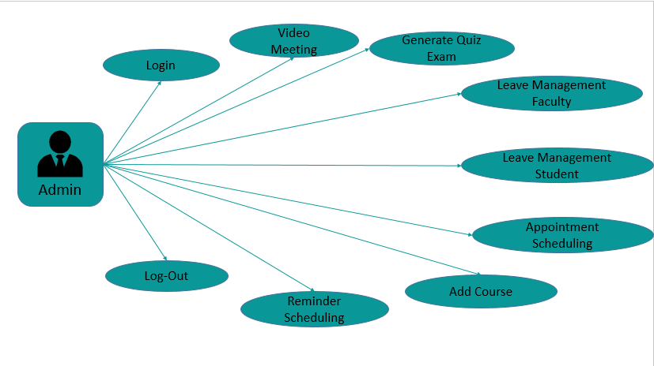

- Faculty :

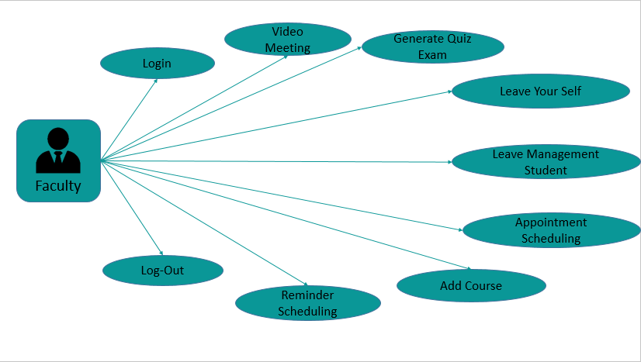

- Student :

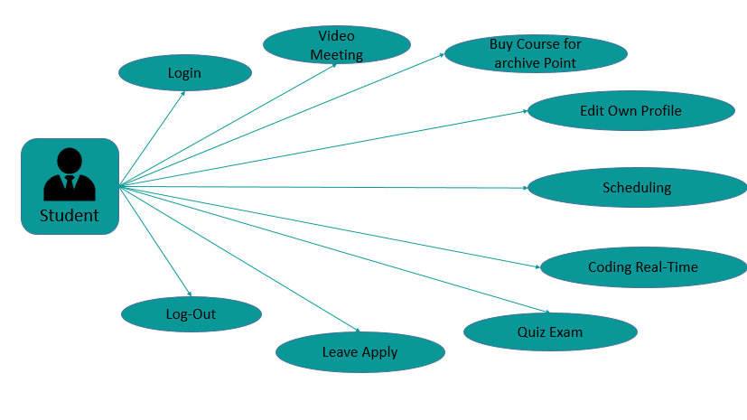

7
Database design

Mongo DB Structure

    - Collection Name : College_Master
    - Collection Description : Store College Information

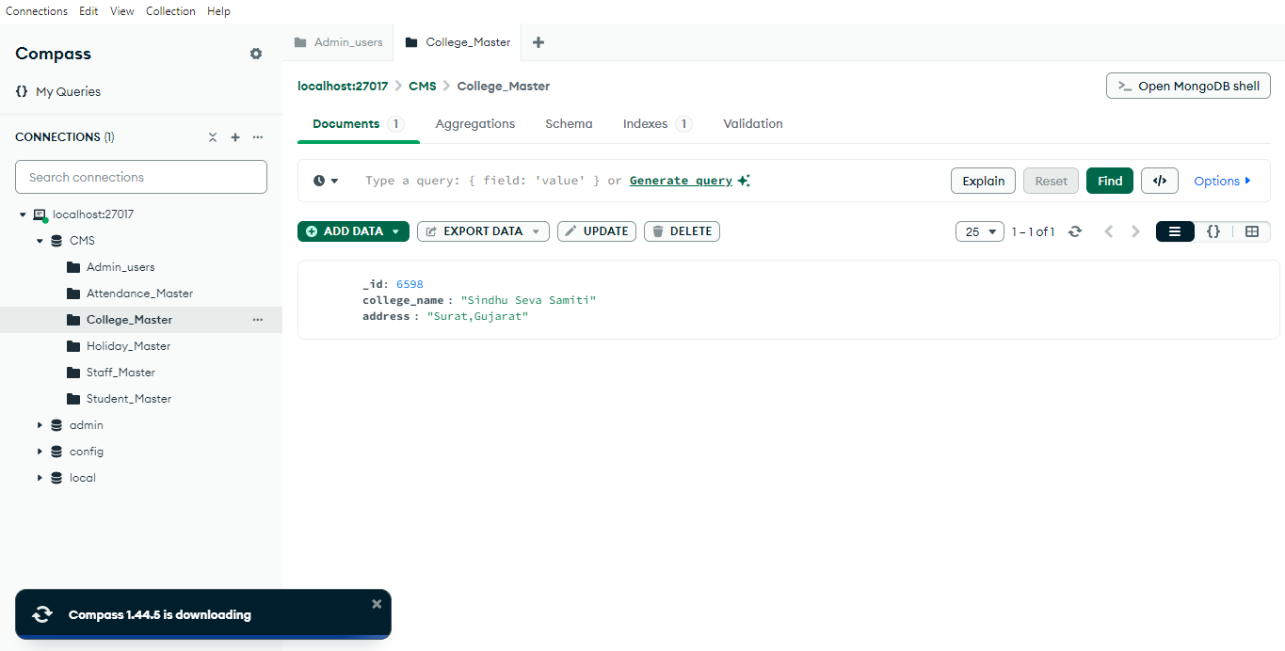

    - Collection Name : Admin_Users
    - Collection Description : Store information about Admin Users

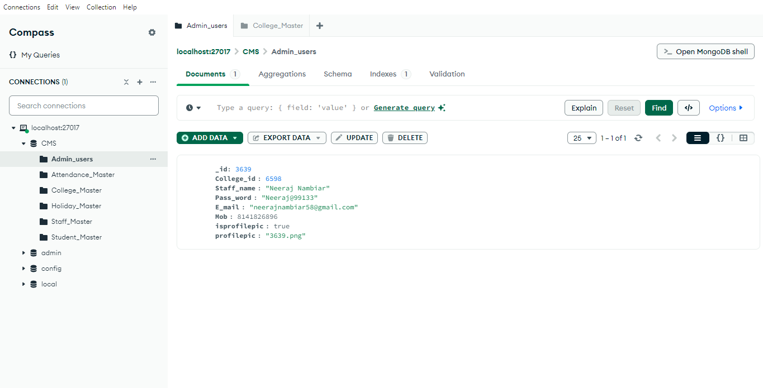

    - Collection Name : Student_Master
    - Collection Description : Store Student ‘s Information

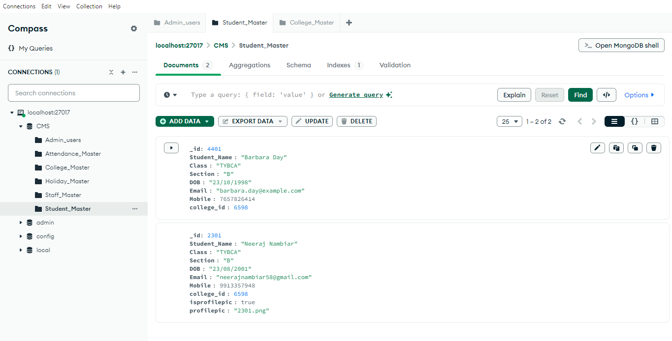

    - Collection Name : Staff_Master
    - Collection Description: Store Staff ‘s Information.

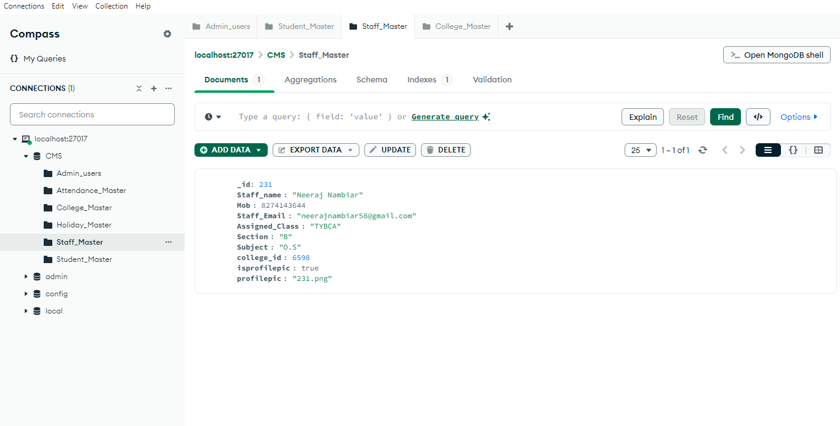

    - Collection Name : Attendance_Master
    - Collection Description : Store Attendance Information.
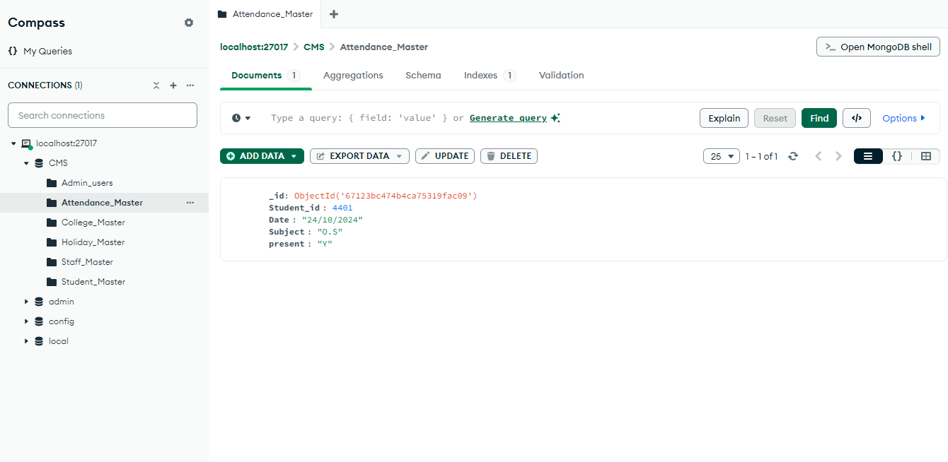

    - Collection Name : Holiday_Master
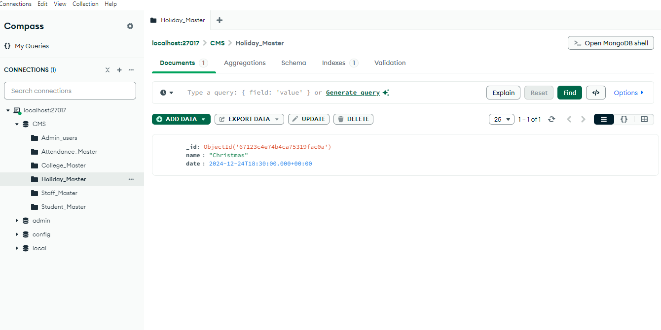
    - Collection Description : Store Holiday Informations.

8
Test Cases
College Register

Test Case No | Component | Description | Input  Value | Expected  Output | Actual  Output | Remark
1 | College Name | All input | Null | Address field does’nt get Enabled | Address field does’nt get Enabled | Pass
 | College Name | All input | a-z,  A-Z,0-9 | Address field gets Enabled | Address field gets Enabled | Pass
2 | Address | All input | Null | The screen will not move to next page | The screen will not move to next page | Pass
 | Address | All input | a-z,  A-Z,0-9 | The screen will move to next page | The screen will move to next page | Pass
3 | Name | All input | Null | The Next Toggle button will not be enabled | The Next Toggle button will not be enabled | Pass
 | Name | All input | a-z,  A-Z | Accept | Accept | Pass
4 | Password | All input | Null | The Next Toggle button will not be enabled | The Next Toggle button will not be enabled | Pass
 | Password | All input | a-z, A-Z,0-9 | The Next Toggle button will be enabled | The Next Toggle button will be enabled | Pass
5 | Email | All input | a-z,A-Z,0-9 | Please enter a valid Email | Please enter a valid Email | Pass
 | Email | All input | a-z,A-Z,0-9,@ and .com | Enter toggle the next toggle button | Enter toggle the next toggle button | Pass
6 | Phone Number | All input | 0-9 (<) 10 | Phone number exactly must be 10 digits | Phone number exactly must be 10 digits | Pass
 | Phone Number | All input | 0-9 (==) 10 | Enable the next Toggle Button | Enable the next Toggle Button | Pass
 | Student Excel | Select Excel File | File Not Selected | The page will not move to next screen | The page will not move to next screen | Pass
 | Student Excel | Select Excel File | File Selected | The page will move to next screen | The page will move to next screen | Pass
 | Staff Excel | Select Excel File | File Not Selected | The page will not move to next screen | The page will not move to next screen | Pass
 | Staff Excel | Select Excel File | File Selected | The page will move to next screen | The page will move to next screen | Pass

Faculty - Login

Test Case No | Component | Description | Input  Value | Expected  Output | Actaul  Output | Remark
1 | Email | All input | a-z,A-Z,0-9 | Enter valid Email and Submit button should be disabled | Enter valid Email and Submit button should be disabled | Pass
 | Email | All input | a-z,A-Z,0-9, @,.com | The Submit button should be enabled | The Submit button should be enabled | Pass
2 | Take Photo | Camera | Camera Access is disabled | The camera permission is disabled | The camera permission is disabled | Pass
 | Take Photo | Camera | Camera is enabled | Append section to click photo | Append section to click photo | Pass
3 | OTP | All input | Enter wrong OTP | The verify button is disabled | The verify button is disabled | Pass
 | OTP | All input | Enter Correct OTP | The verify button is enabled | The verify button is enabled | Pass

Student - Login

Test Case No | Component | Description | Input  Value | Expected  Output | Actaul  Output | Remark
1 | Email | All input | a-z,A-Z,0-9 | Enter valid Email and Submit button should be disabled | Enter valid Email and Submit button should be disabled | Pass
 | Email | All input | a-z,A-Z,0-9, @,.com | The Submit button should be enabled | The Submit button should be enabled | Pass
2 | Take Photo | Camera | Camera Access is disabled | The camera permission is disabled | The camera permission is disabled | Pass
 | Take Photo | Camera | Camera is enabled | Append section to click photo | Append section to click photo | Pass
3 | OTP | All input | Enter wrong OTP | The verify button is disabled | The verify button is disabled | Pass
 | OTP | All input | Enter Correct OTP | The verify button is enabled | The verify button is enabled | Pass

Faculty - Login

Test Case No | Component | Description | Input  Value | Expected  Output | Actaul  Output | Remark
1 | Email | All input | a-z,A-Z,0-9 | Enter valid Email and Submit button should be disabled | Enter valid Email and Submit button should be disabled | Pass
 | Email | All input | a-z,A-Z,0-9, @,.com | The Submit button should be enabled | The Submit button should be enabled | Pass
2 | Take Photo | Camera | Camera Access is disabled | The camera permission is disabled | The camera permission is disabled | Pass
 | Take Photo | Camera | Camera is enabled | Append section to click photo | Append section to click photo | Pass
3 | OTP | All input | Enter wrong OTP | The verify button is disabled | The verify button is disabled | Pass
 | OTP | All input | Enter Correct OTP | The verify button is enabled | The verify button is enabled | Pass

Add – Student

Test Case No | Component | Description | Input  Value | Expected  Output | Actaul  Output | Remark
1 | Student Name | All input | Null | Add Button should be disabled | Add Button should be disabled | Pass
 | Student Name | All input | 0-9 | Only Letters are allowed | Only Letters are allowed | Pass
 | Student Name | All input | a-z,A-z | No error | No error | Pass
2 | Date or Birth | All input | Null | Add button should be disabled | Add button should be disabled | Pass
 | Date or Birth | All input | Select Date | No error | No error | Pass
3 | E-mail | All input | Null | Enter valid  E-mail | Enter valid  E-mail | Fail
 | Class | All input | A-Z,a-z | Accept | Accept | Pass
 | Class | All input | 0-9 | Only Letters are allowed | Only Letters are allowed | Pass
4 | Section | All input | A-Z,a-z | Accept | Accept | Pass
 | Section | All input | 0-9 | Only Letters are allowed | Only Letters are allowed | Pass
5 | Email | All input | a-z,A-Z,0-9 | Enter valid Email and Add button should be disabled | Enter valid Email and Add button should be disabled | Pass
 | Email | All input | a-z,A-Z,0-9, @,.com | The Add button should be enabled | The Add button should be enabled | Pass
6 | Phone Number | All input | Null | The Add button should be enabled | The Add button should be enabled | Pass
 | Phone Number | All input | A-Z,a-z | The Phone number should exactly be 10 digits | The Phone number should exactly be 10 digits | Pass
 | Phone Number | All input | 0-9 | The Add button should be enabled | The Add button should be enabled | Pass

Add – Staff

Test Case No | Component | Description | Input  Value | Expected  Output | Actaul  Output | Remark
1 | Staff Name | All input | Null | Add Button should be disabled | Add Button should be disabled | Pass
 | Staff Name | All input | 0-9 | Only Letters are allowed | Only Letters are allowed | Pass
 | Staff Name | All input | a-z,A-z | No error | No error | Pass
2 | Class | All input | Null | Add button should be disabled | Add button should be disabled | Pass
3 | Section | All input | a-z,A-z | No error | No error | Pass
 | Section | All input | 0-9 | Only Letters are allowed | Only Letters are allowed | Pass
4 | Subject | All input | A-Z,a-z | Accept | Accept | Pass
 | Subject | All input | 0-9 | Only Letters are allowed | Only Letters are allowed | Pass
5 | Staff Email | All input | a-z,A-Z,0-9 | Enter valid Email and Add button should be disabled | Enter valid Email and Add button should be disabled | Pass
 | Staff Email | All input | a-z,A-Z,0-9, @,.com | The Add button should be enabled | The Add button should be enabled | Pass
6 | Phone Number | All input | Null | The Add button should be enabled | The Add button should be enabled | Pass
 | Phone Number | All input | A-Z,a-z | The Phone number should exactly be 10 digits | The Phone number should exactly be 10 digits | Pass
 | Phone Number | All input | 0-9 | The Add button should be enabled | The Add button should be enabled | Pass

9
Screen layouts

Home Page

The Home page contains Login options for Faculty, Admin, and Student, along with other CRM functionalities. Users can navigate through these sections seamlessly, ensuring an intuitive and enhanced user experience throughout the website.

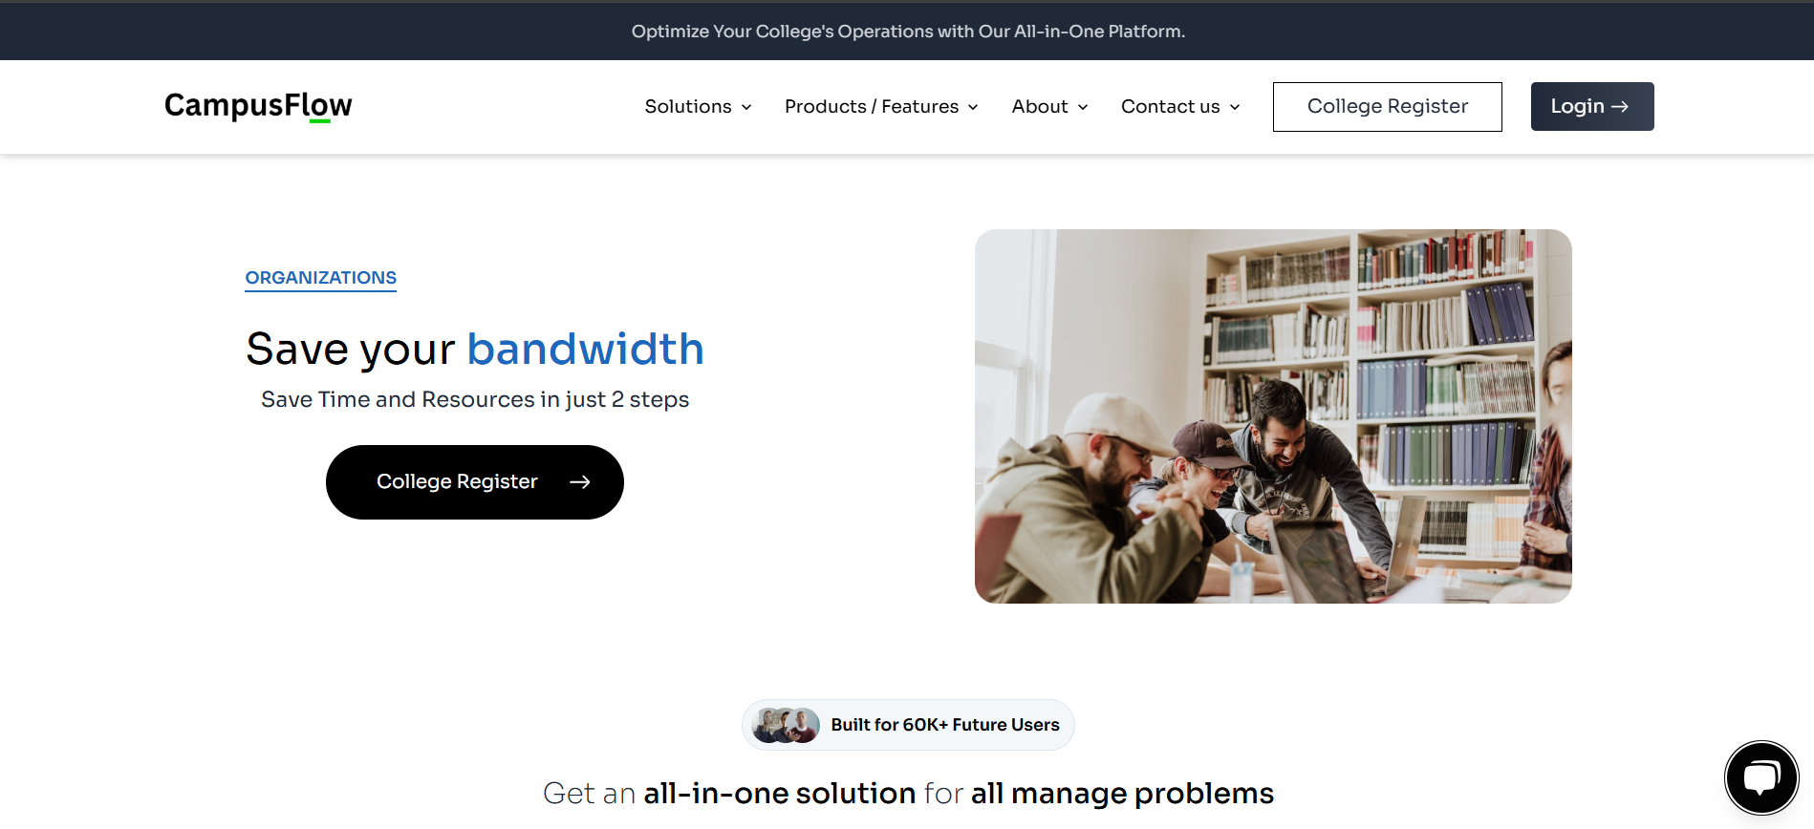

Login
The Login provides access to a personalized dashboard where Admin, Faculty, Student members can manage tasks such as viewing attendance, updating timetables, and managing student records. It offers a streamlined experience for Admin, Faculty, and Student to efficiently handle academic responsibilities.

zss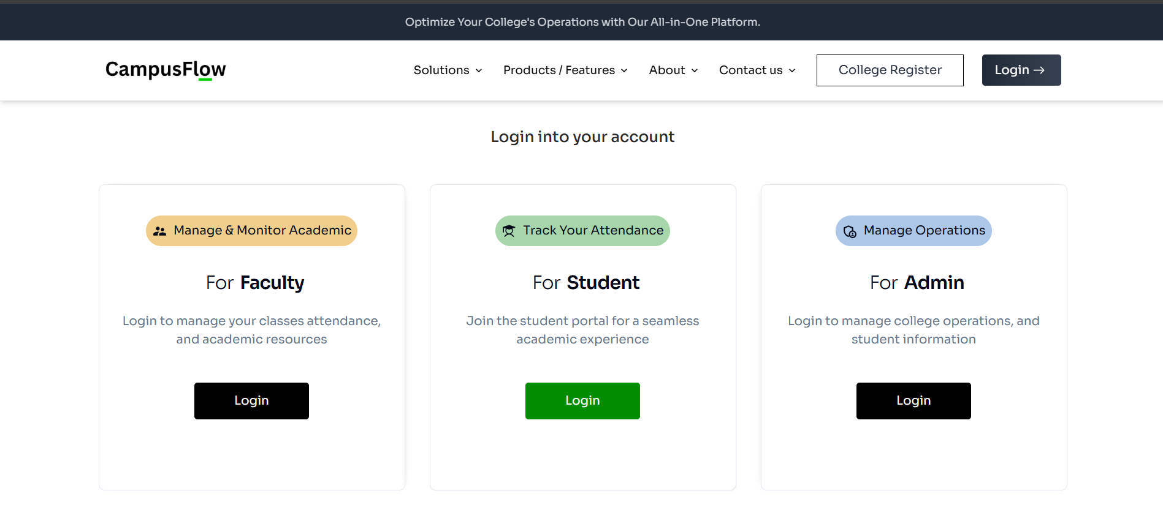

Admin Dashboard

The Admin Dashboard provides an overview of key attendance metrics, including Total Days, Absent, and Present days, all displayed with a graphical view for easy interpretation. Faculty members can change the month to review attendance data for different periods, enhancing their ability to monitor and manage student attendance effectively

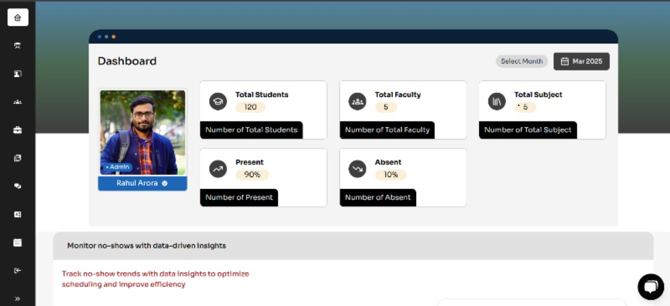

Online Zoom - Meeting

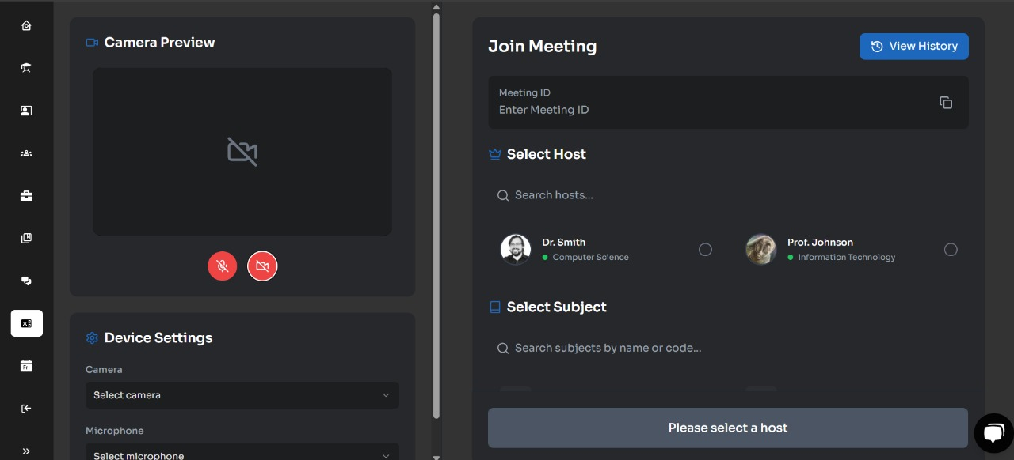

Time Table

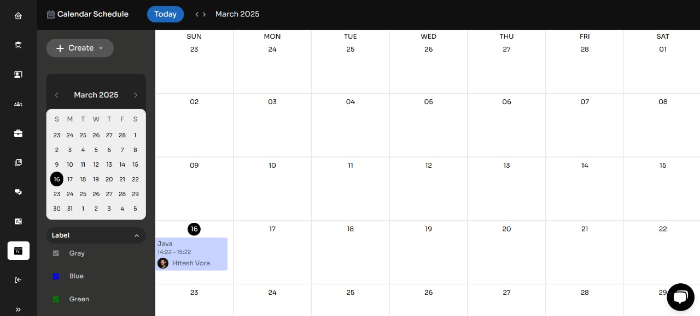

Student Attendance Sheet

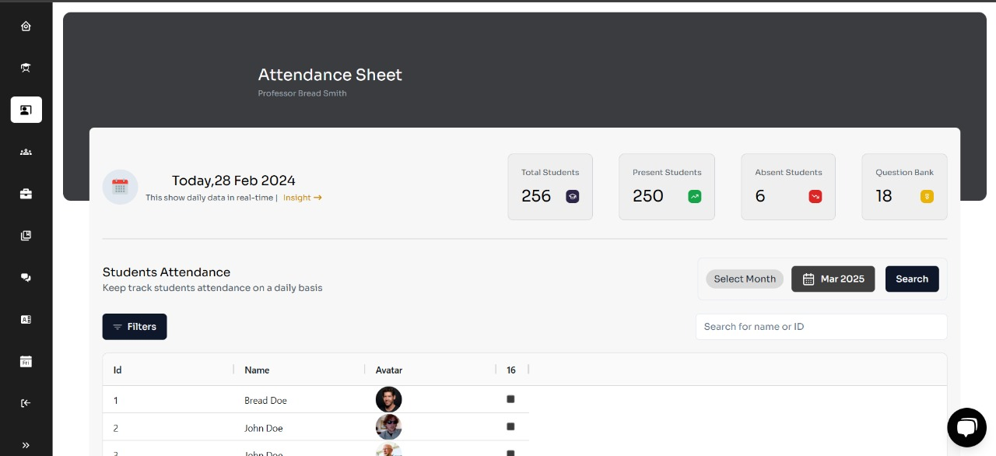

Student Code Editor

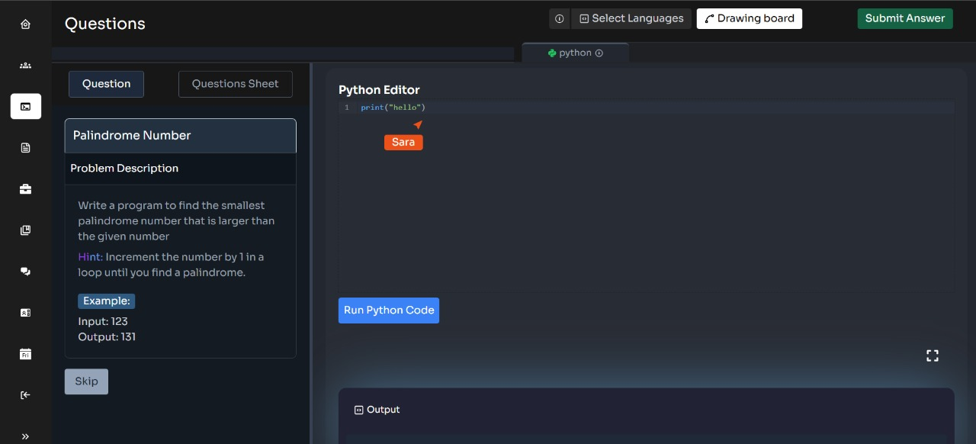
Quiz Exam

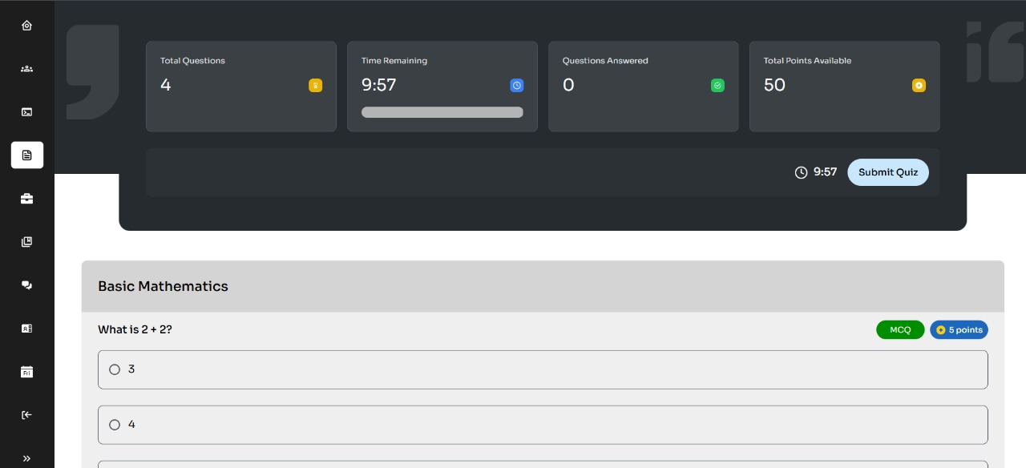

Generating Quiz

