EMUBT CONNECTING TO TUNERPRO

1 | Connecting to TunerPro will allow you to track engine data.  Please note that you can’t be connected to TunerPro and to EMUBT application at the same time: EMUBT boart has only one bluetooth device. It is possible if you have additional converter connected to MIL cable.
2 | Get adx and xdf files for Digidag program from (you may need to expand ‘Assets’ tag ): https://github.com/ravmiecznik/emub_bt_r/releases  Always choose the latest version.
 | 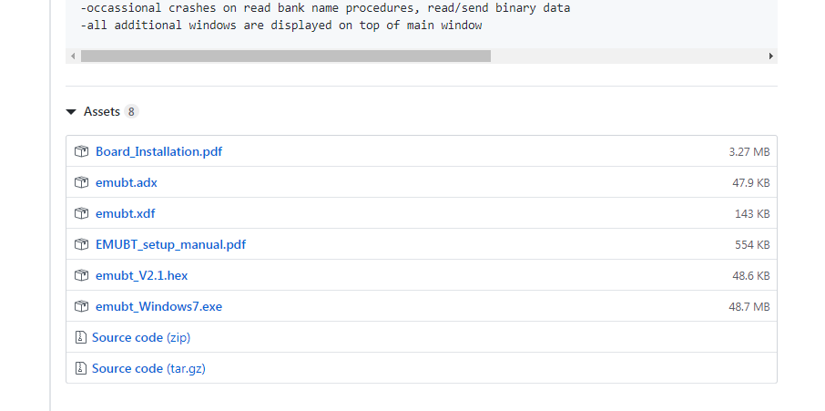
3 | ADX file defines how TunerPro will decode received data.  XDF file defines tables and maps and how to convert it to “human friendly” values.
4 | Loading ADX:  - Acquisition → Load Definition File
 | 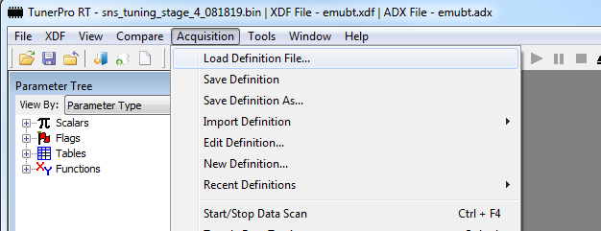
5 | Selecting XDF:  - XDF → Select XDF
 | 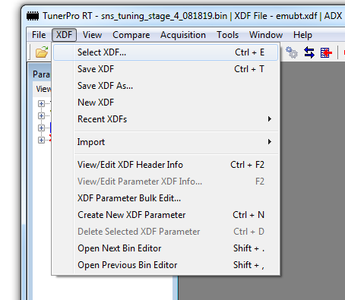
6 | Next step requires that your EMUBT board is already paired to WINDOWS system, check other manual how to pair EMUBT over bluetooth.  Once it is paired you need to find out on which COM port it is available.  Right click on Bluetooth icon and select “Show bluetooth devices”
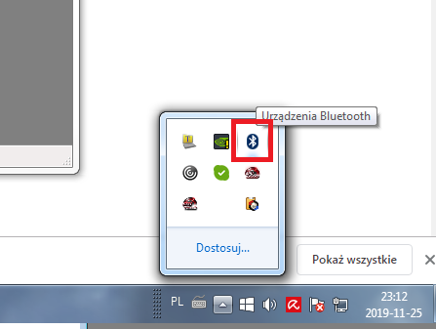

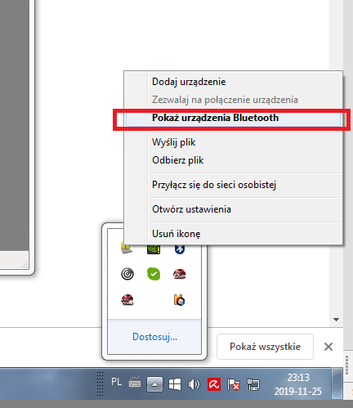

7 | Check properties of EMUBT
 | 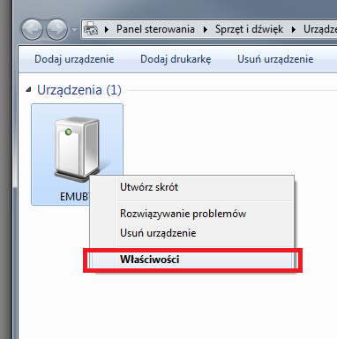
8 | In “Services” tab you should see your SPP Dev port number, if it is not there most probably you are running an outdated bluetooth driver ! Try to update in this case.
 | 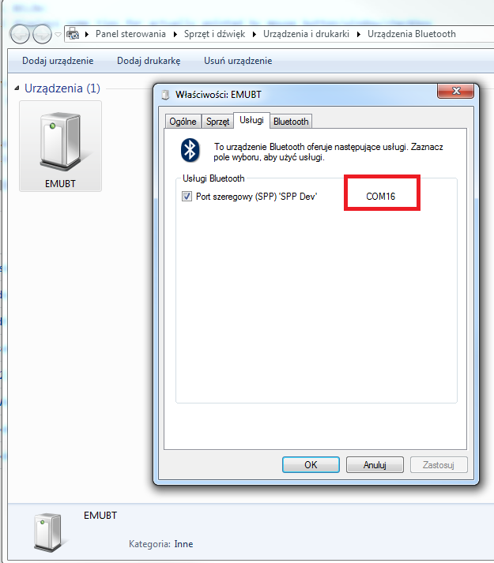
9 | Set this port in TunerPro Tools → Preferences → Data Acq./Emulation tab
 | 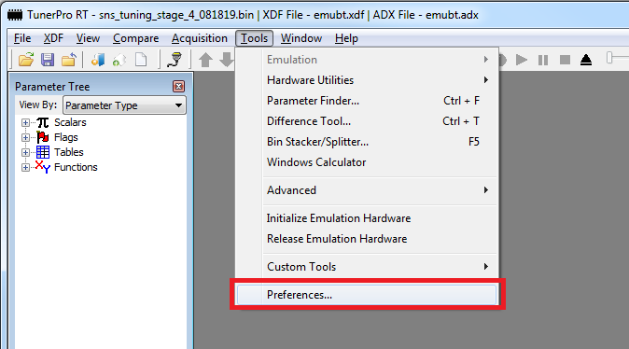
10 | Interface Type: Use Plug-in  Data Acq. I/O Plugin Component: TunerPro Data Acq…  Select Configure Plug-in Component
 | 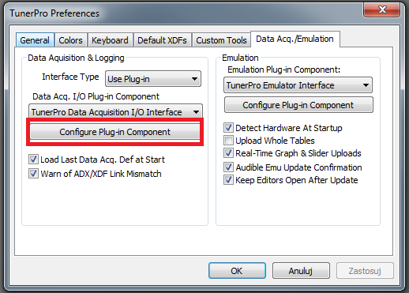
11 | Port Type: Standard Serial  and finally Port Number: port you read from Bluetooth Services tab  in my case COM16
 | 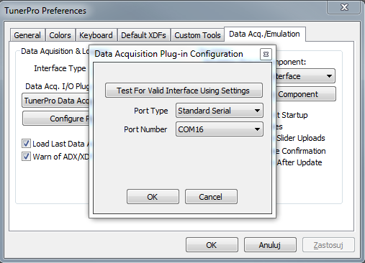
12 | Now you are ready to connect !
13 | Click two blue arrows:
 | 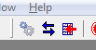
 | 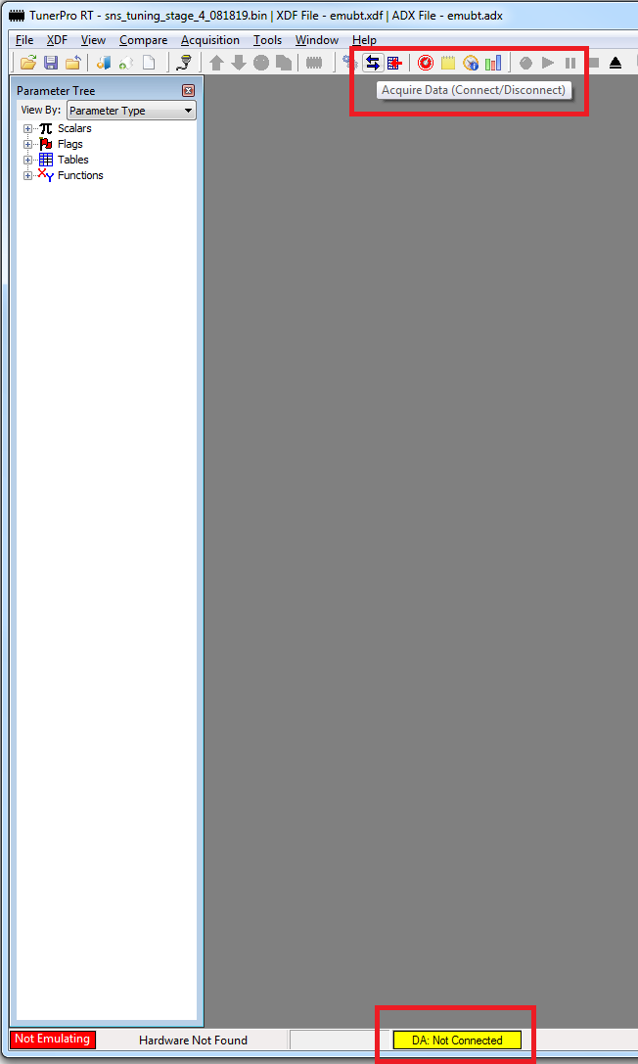
14 | Yellow status bar should switch to ‘Connecting’ status and after few seconds it should turn blue with ‘Connected’ status
 | 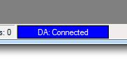
15 | It is done !
16 | Checkout the buttons to enable different views
 | 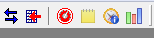
 | 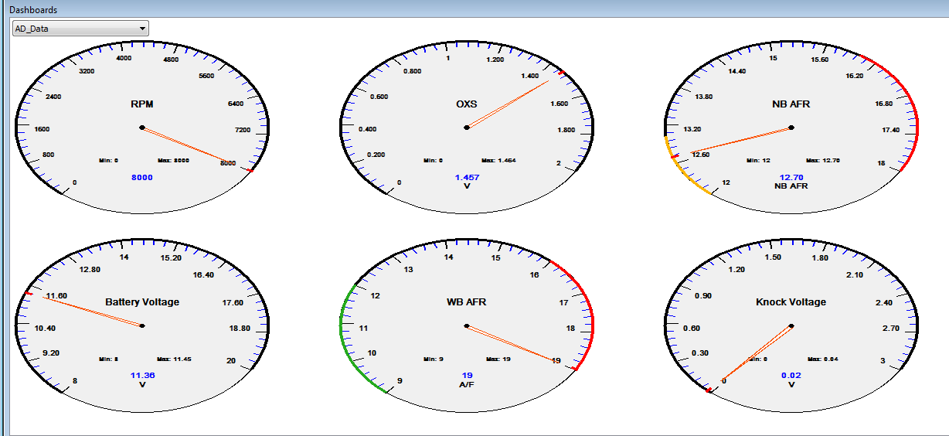
 | 