Analysing Singapore’s First 100 Covid-19 Cases

Ravneet Kaur

A0194965J

Description of Dataset:

|  |  |  |
| --- | --- | --- |
| **Column Name** | **Attribute Type** | **Description** |
| Confirmed Case ID | Categorial | ID number of the case |
| Date of Arrival in Singapore | Quantitative | Date when the patient arrived. Value can be empty incase the case was already residing in Singapore |
| Date Announced by MoH | Quantitative | Date of press release by MoH of the case (Ministry of Health) |
| Date of Symptoms | Quantitative | Date when the patient first experienced symptoms. |
| Date of Admission to Hospital | Quantitative | Date of patient admission to the hospital |
| Date Confirmed Positive | Quantitative | Date of Covid19 confirmation |
| Date Discharged | Quantitative | Date when the patient was discharged |
| Category | Categorical | Label to describe whether case was local or imported |
| Nationality | Categorical | Nationality of the patient |
| Age | Quantitative | Age of the patient |
| Gender | Categorical | Gender of the patient |

Source: <https://github.com/chuachinhon/covid_sg>

Purpose of the Visualization:

The purpose of the visualization is to analyse the lifecycle from the time the patient first experiences symptoms till the patient is fully discharged. Essentially, it compares the ‘Confirmation-Discharged Window’ with the ‘Symptoms-Confirmation Window’. It also gives a view on the average time taken by the first 100 fully recovered cases to get discharged.

Description of the Visualization:

* Here, each circle represents a case. The lifecycle of Covid-19 has been defined as - not infected, date of admission to the hospital, date of Covid19 confirmation and date of discharged.
* Each circle (or cases) goes through the different stages of this lifecycle.
* It took a total of 55 days for the first 100 fully recovered to go through the cycle of Covid-19.

Analysis of the confirmation-discharged window:

The window signifies the number of days between a patient’s Covid-19 confirmation date, and his/her official discharged data as announced by MoH. They are 2 key observations:

* There is a notable spike of infections especially in the early days of the pandemic. The proportions of confirmed cases were much more than those that have been discharged. This is in line with observation that Covid-19 is 3x more contagious that a common cold [1].
* The recoveries are slow as compared to the rate of confirmation. As there is no cure for the virus, the treatment continues to be support treatment. This also proves why healthcare system can become easily overwhelmed incase of an uncontrolled outbreak (eg: Italy).

Analysis of the symptoms-confirmation window:

It signifies the number of days between the reported onset of symptoms and the official confirmation of the infection. From the visualization we can observe:

* Singapore has managed to decrease the wait time between the date when the symptoms are first reported and the date of confirmation. This can be attributed to the [new testing kits](https://www.channelnewsasia.com/news/singapore/covid19-new-test-kits-swab-three-hours-12505658) that have been developed.

[1]:<https://www.channelnewsasia.com/news/cnainsider/scale-of-covid-19-contagion-may-be-more-serious-than-we-think-12437412>

Screenshot of the Visualization:

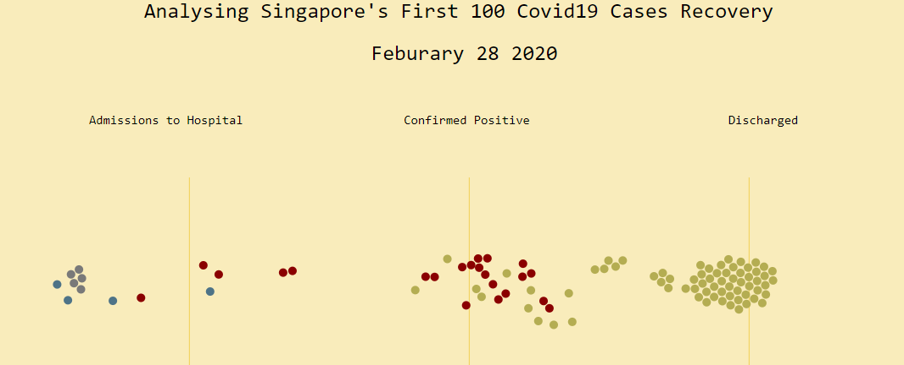

Visual Encoding:

|  |  |  |  |
| --- | --- | --- | --- |
| Data | Data Type | Encoding | Description |
| Confirmed Case ID | Categorial | node | Each node represent a unique case |
| Number of Admissions to the hospital | Quantitative | Color, position | Blue nodes located in “admissions to hospital” column |
| Number of confirmed positive | Quantitative | Color, position | Red nodes located in “confirmed positive” column |
| Number of discharged | Quantitative | Color, position | Yellow nodes located in “discharged” column |

Link: <https://ravneetkaur2159.github.io/VisualizingSingaporeCovidCases/>