Matsuzawa MXT50 Vickers Hardness Tester – Student Guide
TSM2370 Materialteknikk · USN Kongsberg · Updated 10 Nov 2026
You will measure Vickers hardness at HV1 (1 kgf). First you check the machine on the reference block, then you test your own samples. One indent takes about 2 minutes once you know the routine.

1. Before you start
The machine: Matsuzawa MXT50 digital microhardness tester, serial no. MX2294, built December 1992. Spare parts no longer exist, so treat it gently.
Safety and care rules
- Never let the diamond or the objective touch the sample. The diamond tip is small, brittle and expensive. Before you turn the turret, check that nothing on the stage is taller than your sample surface.
- Never press START while the turret is on an objective. START only when the diamond is clicked into position over the sample.
- Never turn the turret while the LOADING lamp is lit. Wait until the lamp is off and the indenter has lifted.
- Raise the stage very slowly when you bring the diamond close. Watch from the side: the tip must almost touch, but never touch, the sample before START.
- Do not touch the diamond or the lens glass with fingers or cloth.
- Do not turn the load dial while a test is running.
What you need
- Your polished sample. The surface must be flat, parallel to the bottom and polished to at least a fine finish (1 µm diamond or better). A scratched or rough surface makes the corners of the indent impossible to see.
- The HMV700 reference block (black box marked Standard Block for Hardness Test, Yamamoto, Japan).
- The rechargeable flashlight kept next to the machine. It is the light source for the microscope. Charge it after use so the next group can work.
- Lint-free tissue and ethanol to clean the sample surface.
- The results table at the end of this guide.
Support blocks: put one or two of the steel support blocks kept by the machine in the V-block holder, under the sample or the reference block. They lift it high enough to reach focus.
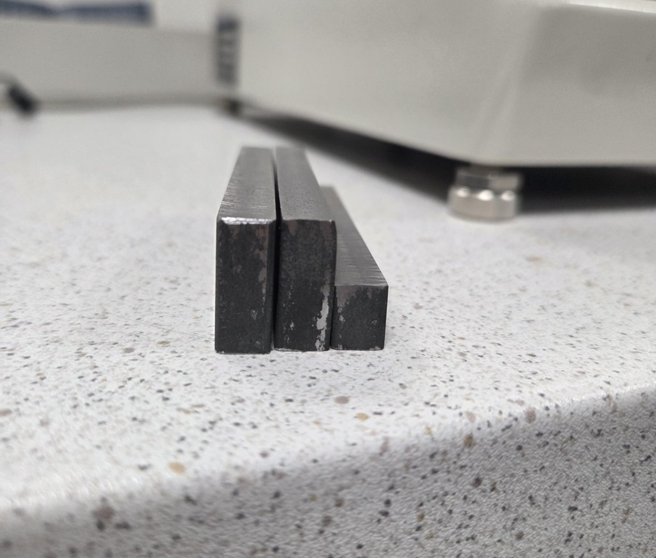
Support blocks. Use one or two under the sample or the reference block.
Sample rules (ISO 6507-1)
- Sample thickness must be at least 1.5 × the indent diagonal. At HV1 any sample thicker than 0.5 mm is fine.
- The centre of an indent must be at least 2.5 × d from the sample edge (steel).
- The centres of two indents must be at least 3 × d apart (steel).
- At HV1, d is 50–110 µm on steels, so keep 0.5 mm between indents and from the edge. One full turn of a stage micrometer = 0.5 mm.

2. Machine overview
The numbers in the tables match the numbered labels on the photos below.
Front and sides (Figures 1 and 2)
No. | Part | What it does
1 | Eyepiece (WF10X Micro) | Look through here to focus and measure. Contains two measuring lines.
2 | Left measuring knob (marked 0) | Moves the measuring lines sideways across the view.
3 | Right measuring knob with READ button | Turning it (direction marked OPEN ▲) opens or closes the gap between the two lines. Pressing READ stores the measured length.
4 | Light tube with flashlight | The flashlight slides into this tube and lights the sample.
5 | Turret | Holds the orange-ring objective, the green-ring objective and the diamond indenter. Turn it by hand until it clicks into place.
6 | Stage with V-block holder | Holds the sample or the reference block.
7 | X micrometer | Moves the stage left–right. 0.01 mm per mark, 0.5 mm per turn.
8 | Y micrometer | Moves the stage forward–back. 0.01 mm per mark, 0.5 mm per turn.
9 | Elevating handwheel | Raises and lowers the stage to focus.
10 | Load selector dial | Sets the test force. Turn it so 1 Kgf lines up with the pin.
11 | LIGHT knob | Brightness of the built-in lamp. Not used when the flashlight is in.
12 | BACKUP lamp | Memory backup indicator. No action needed.
13 | ON / OFF switch | Turns the machine on and off.
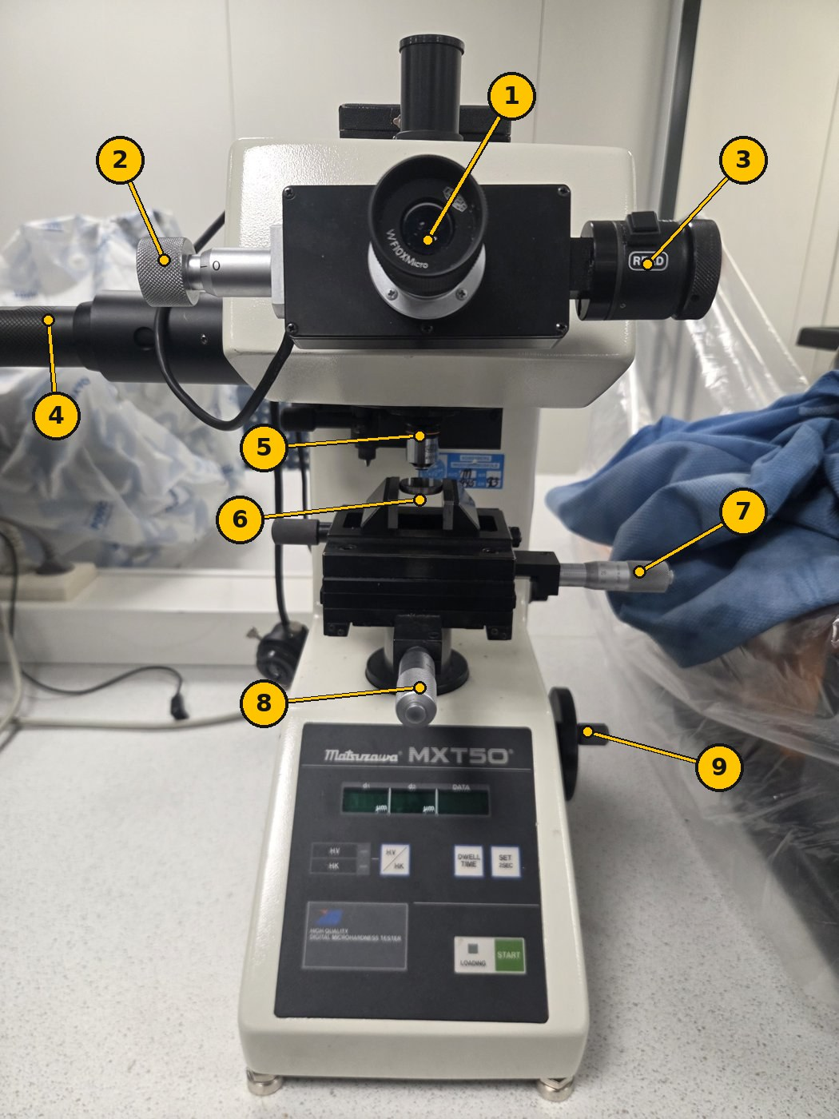
Figure 1. Front view.
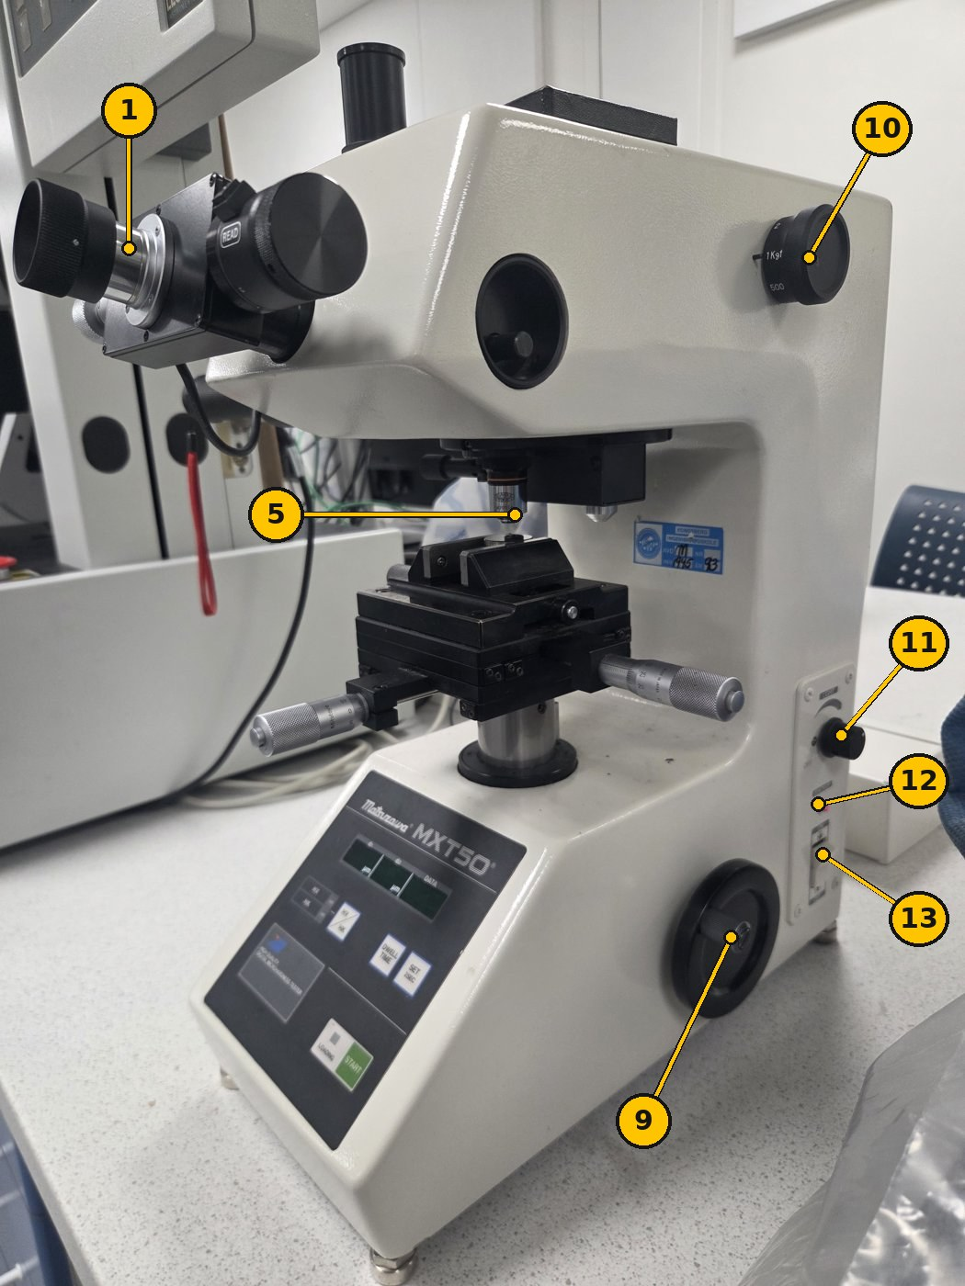
Figure 2. Right side: load dial (10), side panel (11–13) and elevating handwheel (9).
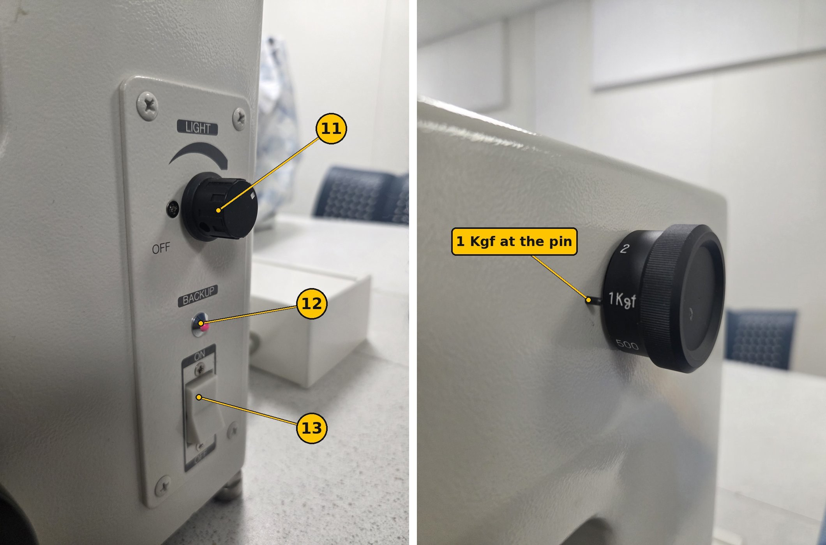
Figure 2b. Side panel close-up (left) and the load dial set to 1 Kgf (right).
The MAIN POWER switch is on the back. Leave it ON. Use switch 13 on the right side every day.
The shutter pin sits inside the round opening on the right side of the head. It must be pushed in. If it is pulled out, it blocks the view in the eyepiece.
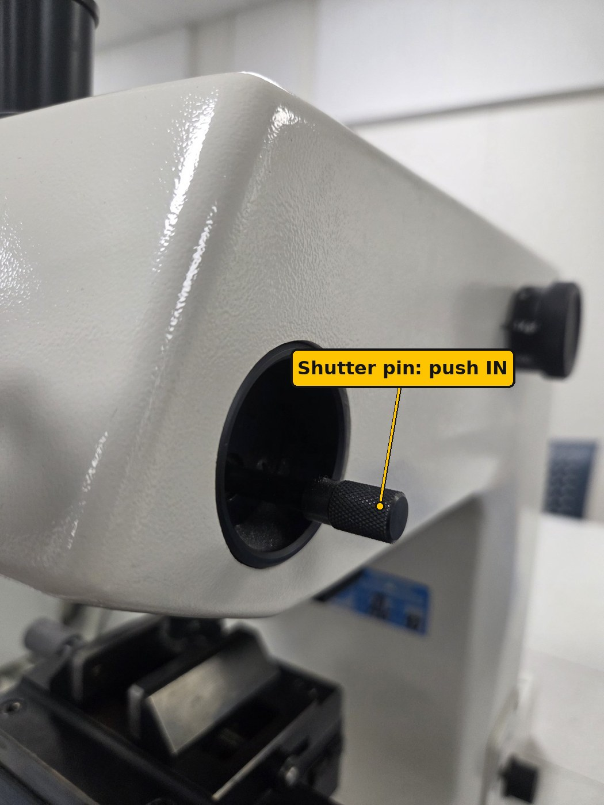
Figure 2c. Shutter pin. Push it in before you look through the eyepiece.
Turret positions (Figure 3)
Position | Use it for
Orange-ring objective | Finding a spot and focusing (wide view). Do not measure with it: the readout then shows only about 1/4 of the real length.
Green-ring objective | Measuring the indent (higher magnification). The digital readout is set up for this objective. Refocus slightly after switching.
Diamond indenter | Making the indent. Only press START in this position.
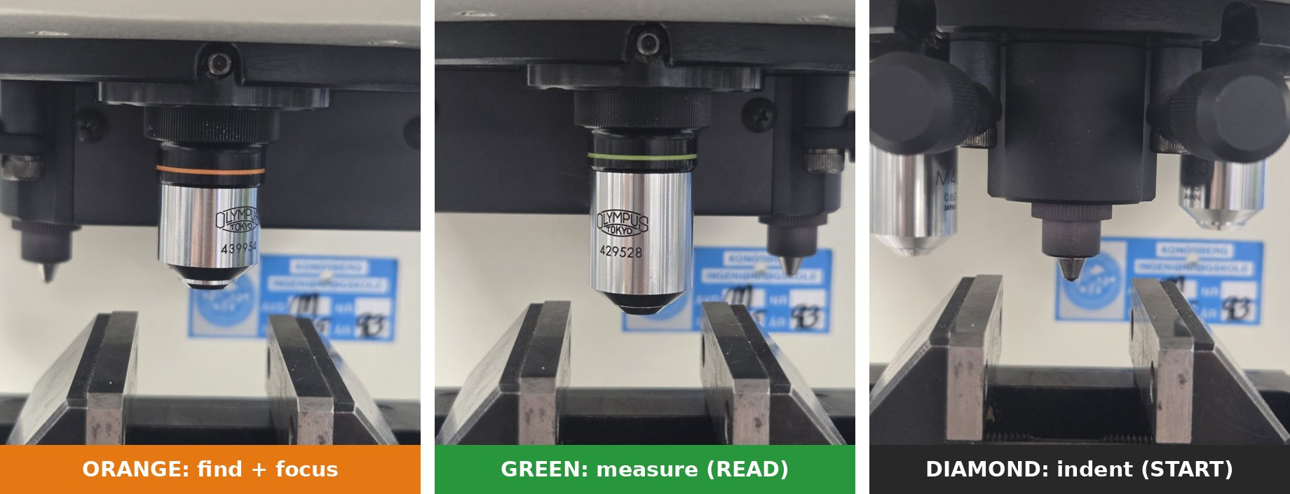
Figure 3. The three turret positions: find and focus with orange, indent with the diamond, measure with green. Turn the turret by hand until it clicks.
Control panel (Figure 4)
Control | What it does
Display d1 (µm) | First diagonal, after you press READ the first time.
Display d2 (µm) | Second diagonal, after you press READ the second time.
Display DATA | The calculated hardness value.
HV / HK key and lamps | Switches between Vickers (HV) and Knoop (HK). The HV lamp must be lit green.
DWELL TIME key | Sets how long the full load is held. Each press steps to the next value shown on the display.
SET 2SEC key | Hold for 2 seconds to confirm a setting or zero the measuring lines.
START key | Starts the indent: load on, hold for the dwell time, load off.
LOADING lamp | Lit while the indenter is loading the sample. Do not touch anything while it is lit.
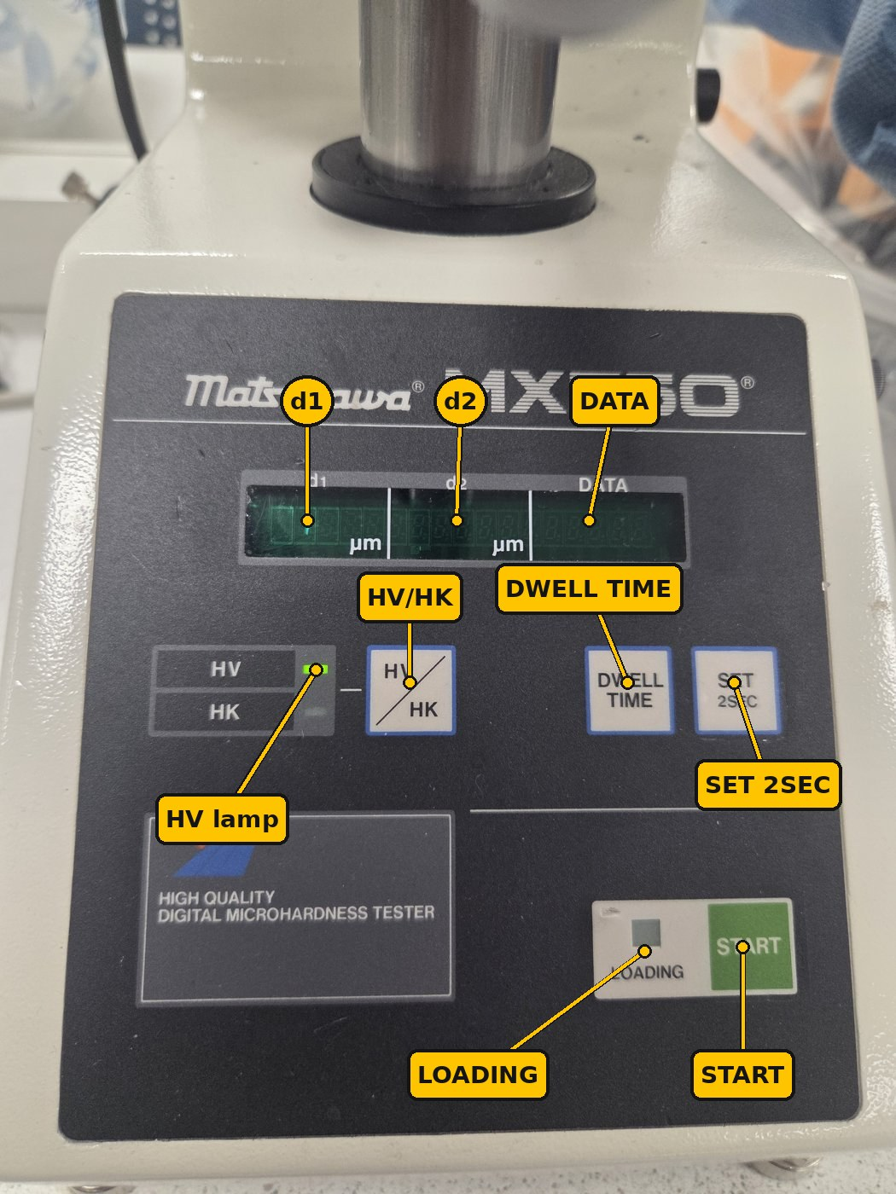
Figure 4. Control panel. The HV lamp is lit green.

3. Start-up
- Power on. Flip the ON/OFF switch (13) on the right side to ON. The display lights up green. If nothing happens, check that MAIN POWER on the back is ON.
- Insert the light. Switch on the charged flashlight and push it fully into the light tube (4) on the left side. Then check that the shutter pin on the right side of the head is pushed in (Figure 2c).
- Select Vickers. Check that the HV lamp is lit. If HK is lit, press HV / HK once.
- Set the load. Turn the load selector dial (10) until 1 Kgf lines up with the pin. Your results are then reported as HV1.
- Set the dwell time. Press DWELL TIME until the display shows 15 seconds. Then hold SET 2SEC for 2 seconds to store it. ISO 6507-1 requires 10–15 s.
- Lower the stage. Turn the elevating handwheel (9) to lower the stage, so there is room to place the block without hitting the turret.

4. Check the machine on the reference block
Make 3 indents on the HMV700 block. If their mean is within ±5 % of 700 HV (665–735 HV), the machine is OK and you can test your samples. This is a daily check (indirect verification, ISO 6507-1 Annex), not a full calibration.
A. Zero the measuring lines (once per session)
- Look through the eyepiece (1). You see two vertical lines.
- Turn the right measuring knob (3) to close the lines until they almost touch. Stop when only a very thin gap of light is left between them.
- Hold SET 2SEC for 2 seconds. The d1 display should now read 0.
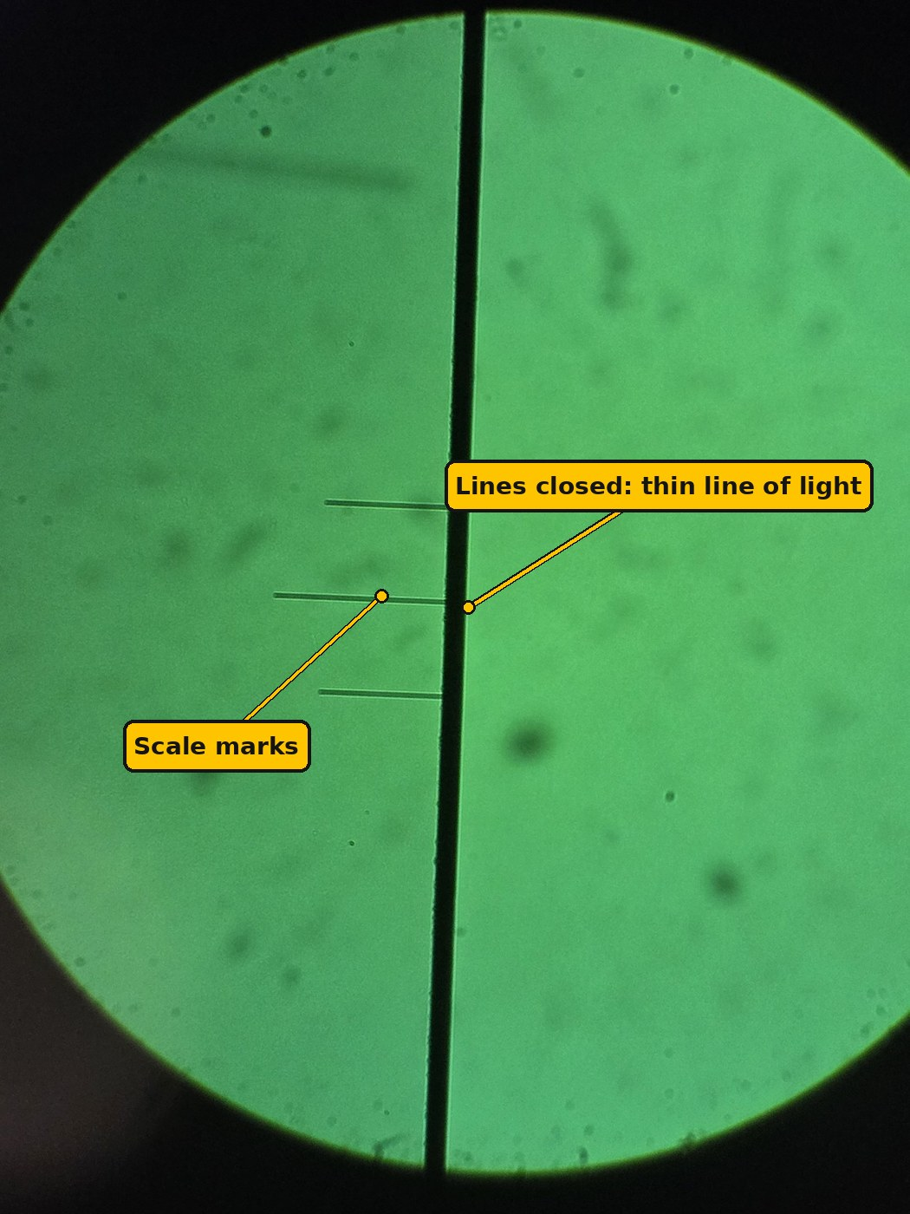
Figure 5. Lines closed for zeroing: the two lines form one dark band with only a thin line of light left.
B. Focus on the block
- Put one or two support blocks in the V-block holder (6). Place the reference block on top, polished face up. Do not touch the polished face.
- Turn the turret to the orange-ring objective until it clicks.
- Look through the eyepiece. Slowly raise the stage with the elevating handwheel (9) until the surface is sharp. Raise it slowly: the objective must never touch the block.
- Use the X and Y micrometers (7, 8) to find a clean spot at least 0.5 mm from the edge and from old indents.
The block already has many old indents. Find a clean area between them before you indent.
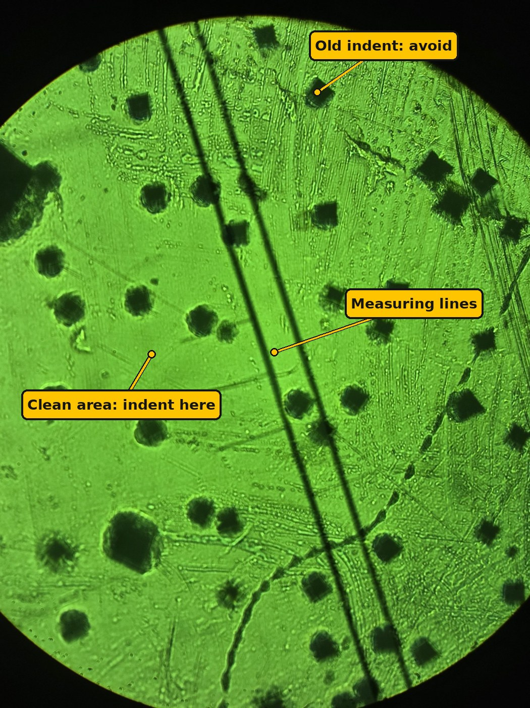
Figure 6. The reference block through the eyepiece. The dark squares are old indents. Choose a clean area at least 0.5 mm from them.
C. Make the indent
- Turn the turret to the diamond indenter until it clicks.
- Bring the tip close. Watch from the side at eye level. Raise the stage very slowly with the handwheel until the tip almost touches the surface: the tip and its reflection in the polished surface nearly meet (Figure 7). It must not touch.
- Press START. The LOADING lamp lights. Do not touch the machine or table.
- Wait until the LOADING lamp goes off (about 25 s with 15 s dwell).
- Lower the stage a few turns with the handwheel. The objectives reach lower than the diamond tip, so they would hit the sample if you turned the turret without lowering.
- Turn the turret to the green-ring objective (measuring objective). Raise the stage slowly again until the indent is sharp.
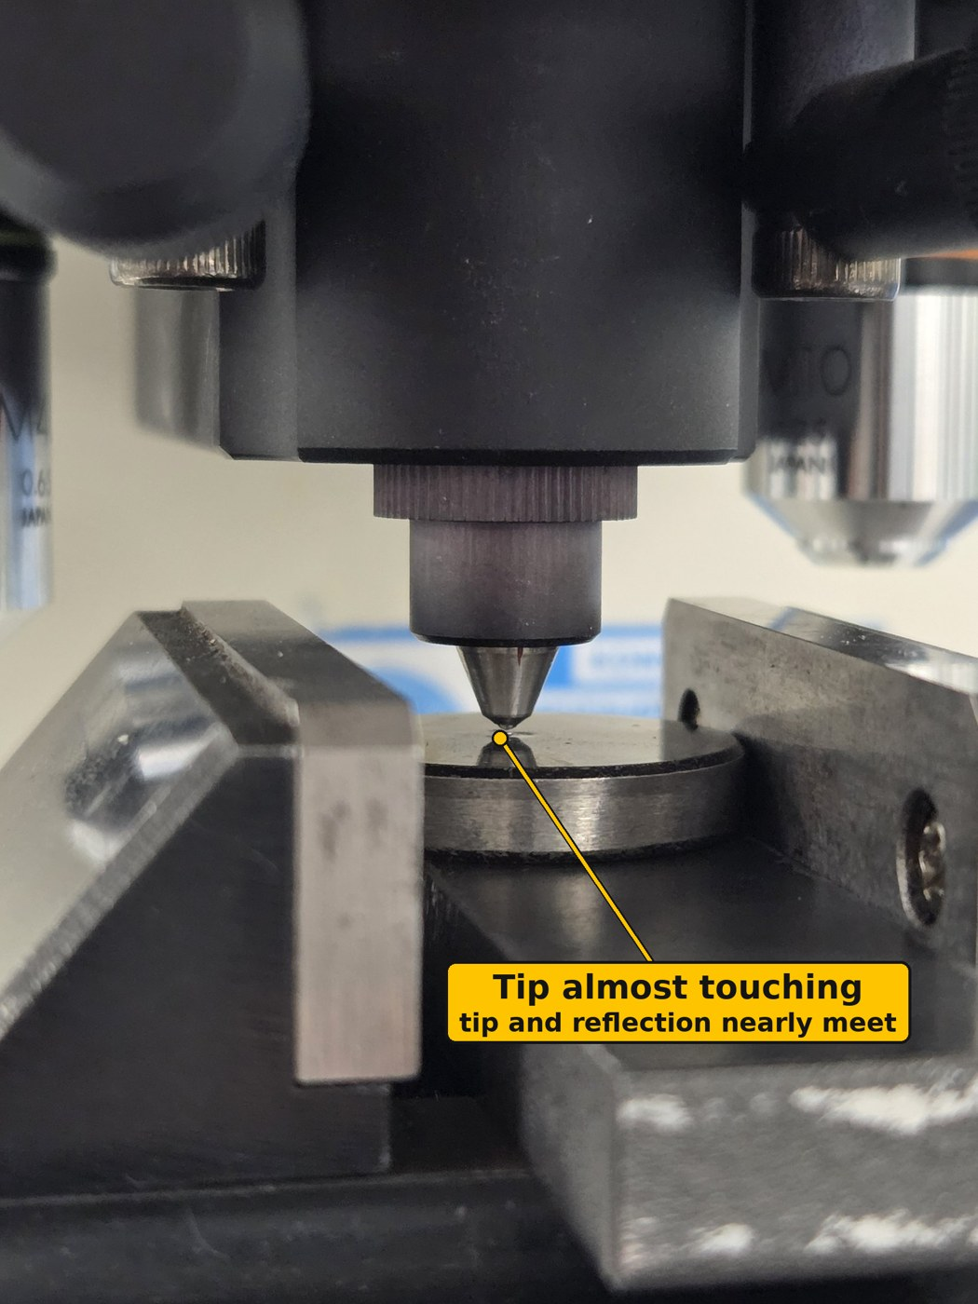
Figure 7. The diamond brought close before START: the tip and its reflection nearly meet, with a tiny gap between them.
D. Measure the indent
- Look through the eyepiece. You see a dark square (a diamond shape). Refocus slightly with the handwheel if the corners are not sharp. Always measure with the green-ring objective.
- Diagonal 1: Use the left knob (2) to put one line on the left corner of the square. Use the right knob (3) to move the other line to the right corner. The lines should just touch the tips of the corners.
- Press READ. The length appears under d1.
- Diagonal 2: Turn the eyepiece measuring head 90° so the lines are horizontal. Frame the top and bottom corners the same way.
- Press READ again. The length appears under d2, and the hardness appears under DATA.
- Write d1, d2 and HV in the results table.
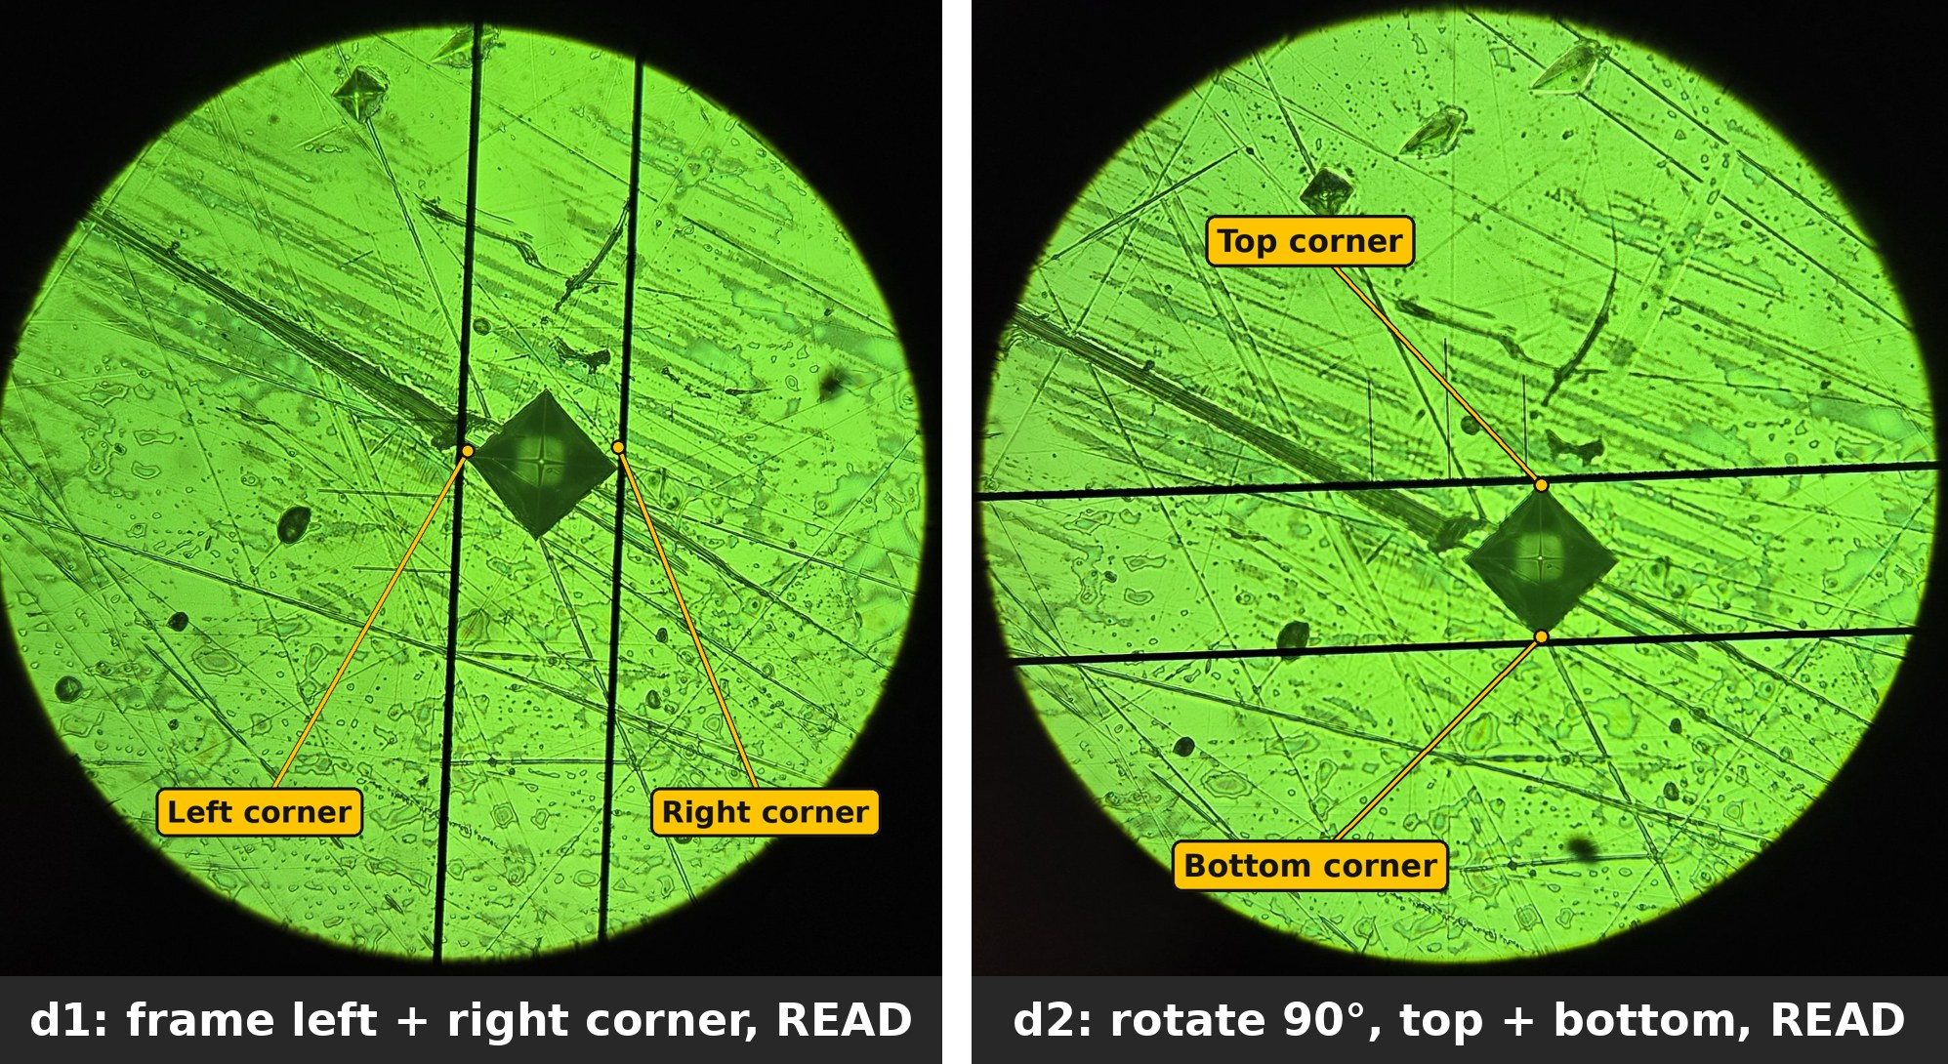
Figure 8. Measuring an indent on the HMV700 block with the green objective. Left: d1, the lines on the left and right corners. Right: d2, the eyepiece turned 90° and the lines on the top and bottom corners. Result: d1 = 51.5 µm, d2 = 50.7 µm, 710 HV1.
E. Accept or reject
- Repeat B–D for 3 indents, 0.5 mm apart.
- Calculate the mean HV of the 3 indents.
- Mean between 665 and 735 HV: the machine is OK. Continue to section 5.
- Outside 665–735 HV: re-zero the lines (A), check the load dial and dwell time, and measure again. Still outside: stop and tell the lab supervisor.
For an HMV700 block at HV1, each diagonal should be about 51 µm. If you read something very different (for example 25 µm or 100 µm), check the load dial. If you read about 13 µm, you are measuring with the orange objective: switch to green.

5. Test your sample
The routine is the same as on the block: focus, indent, measure. Make at least 3 indents per sample and report the mean.
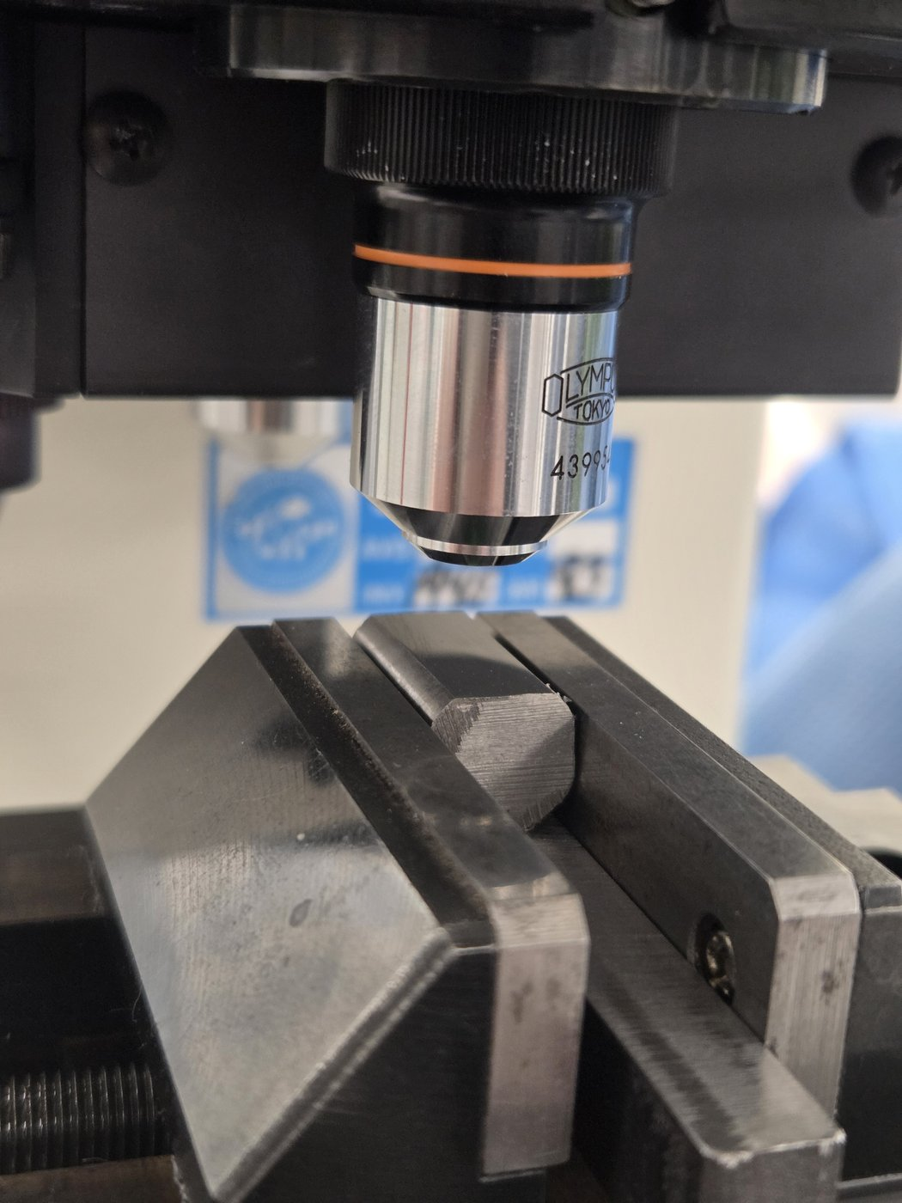
Figure 9. A Sølvstål 2210 sample in the V-block holder (6), polished face up, under the orange-ring objective. This is how it should look before you focus.
- Lower the stage and take the reference block out. Put it back in its box.
- Clean the sample surface with ethanol and tissue. Put one or two support blocks in the V-block holder (6) and place the sample on top, polished face up and level (Figure 9).
- Check the HV lamp, 1 Kgf on the load dial and the dwell time. These must be the same as for the block check.
- Turn the turret to the orange-ring objective. Raise the stage slowly until the surface is sharp.
- Choose a spot with the X and Y micrometers, at least 0.5 mm from the edge.
- Turn the turret to the diamond (click). Raise the stage very slowly until the tip almost touches the surface (Figure 7).
- Press START. Wait for the LOADING lamp to go off.
- Lower the stage a few turns. Turn the turret to the green-ring objective and refocus.
- Measure d1, press READ. Turn the measuring head 90°, measure d2, press READ. Read the HV value under DATA.
- Write d1, d2 and HV in the results table.
- Move the stage one full turn (0.5 mm) on the X micrometer for the next indent. Repeat steps 4–10.
What a good indent looks like: a sharp, dark square with straight edges and pointed corners. If the two diagonals differ by more than 5 %, the sample is probably not level. Re-seat it and make a new indent.

6. Results, troubleshooting and shutdown
Check the display by hand. The machine calculates HV from the mean diagonal d = (d1 + d2) / 2:
HV = 1.8544 × F / d² (F in kgf, d in mm)
or, with F in newtons: HV = 0.1891 × F / d²
Example: d1 = 51.5 µm and d2 = 50.7 µm (measured on the HMV700 block) give d = 0.0511 mm. HV = 1.8544 × 1 / 0.0511² = 710 HV1. Check one of your own indents this way in your report.
Results table
Sample | Indent | d1 (µm) | d2 (µm) | HV1
HMV700 block | 1
HMV700 block | 2
HMV700 block | 3
Sample ___ | 1
Sample ___ | 2
Sample ___ | 3
Report results as, for example, 450 HV1 (mean of 3 indents, with the standard deviation).
Troubleshooting
Problem | Likely cause | What to do
View is dark | Flashlight off, flat or not pushed in, or shutter pin pulled out | Switch it on, push it fully in, or charge it. Push the shutter pin in
Cannot focus | Stage too low or too high | Lower the stage fully, then raise slowly while looking through the eyepiece
Indent corners blurry | Surface scratched or rough | Polish the sample again (1 µm or finer)
d1 and d2 differ a lot | Sample not level | Re-seat the sample flat in the holder
No indent visible | Diamond not brought close enough, turret not clicked, or wrong spot | Check the turret click, search around the spot with X/Y
HV far off on the block | Measured with the orange objective, wrong load, lines not zeroed, or HK selected | Measure with green, check 1 Kgf and the HV lamp, re-zero the lines
d1 is not 0 after zeroing | SET 2SEC released too early | Close the lines again and hold SET 2SEC a full 2 seconds
Shutdown
- ☐ Turn the turret to the orange-ring objective and lower the stage.
- ☐ Remove your sample. Put the reference block back in its box.
- ☐ Take out the flashlight, switch it off and put it on charge.
- ☐ Flip the ON/OFF switch on the right side to OFF.
- ☐ Clean the stage and put the dust cover over the machine.

