Stepcraft M700 CNC Mill – UCCNC and SolidWorks CAM – User Manual
Mechanical engineering, product development · USN Kongsberg · Author: Rasmus Ullestad Relling · Updated 25 Feb 2026
Health and safety (HMS) is not covered in this manual. Follow the lab supervisor's instructions, and do not use the machine without training.
Translated from the Norwegian original. The Norwegian version is the master copy.

1. About this document
Scope. This document shows how
- students set up a part in SolidWorks and make it ready for SolidWorks CAM (chapter 2);
- teachers post-process G-code (NC code) from SolidWorks for use in UCCNC (3.04, 3.07);
- teachers and students export a DXF file from SolidWorks for use in UCCNC CAM (3.05);
- teachers start the Stepcraft M700, set it up for normal use and shut it down (3.01, 3.08, chapter 4);
- teachers use a 3D Touch Probe with the Stepcraft M700 and UCCNC (4.03);
- teachers edit a post-processor for the Stepcraft M700 in SolidWorks (chapter 5);
- teachers find the machine coordinates and calibration values of our M700 (chapter 6) and Stepcraft's own manuals (chapter 7).
Audience. Students and teachers at USN Kongsberg.
Location. The Stepcraft M700 is in the composites lab (Komposittlabben).
Limitations.
- The document does not cover health and safety. That has to be considered separately.
- It does not cover the changes made earlier to the Stepcraft M700 macro codes.
- It does not cover what to do if the machine loses its zero point while milling, which can happen. A technical fix is to upgrade the Stepcraft M700 with a digital counter for planned steps: Semi-Closed Loop System for M-series till 04/2025.
Prerequisites. The document is for students and teachers in mechanical engineering, product development. You should know SolidWorks and have taken DAK 1 and DAK 2 (CAD 1 and 2). Product Development 1 helps but is not required.

2. SolidWorks CAM | Students

2.01 Adding a coordinate system to a part
It is important to add a coordinate system for milling. It becomes the starting point (zero point) of the part. The coordinate system must be parallel to the surface. A teacher should also be able to find the zero point again on the real part with a 3D Touch Probe. If the zero point is lost during milling and the job has to start again, the part can then be "rescued", and less material is wasted.
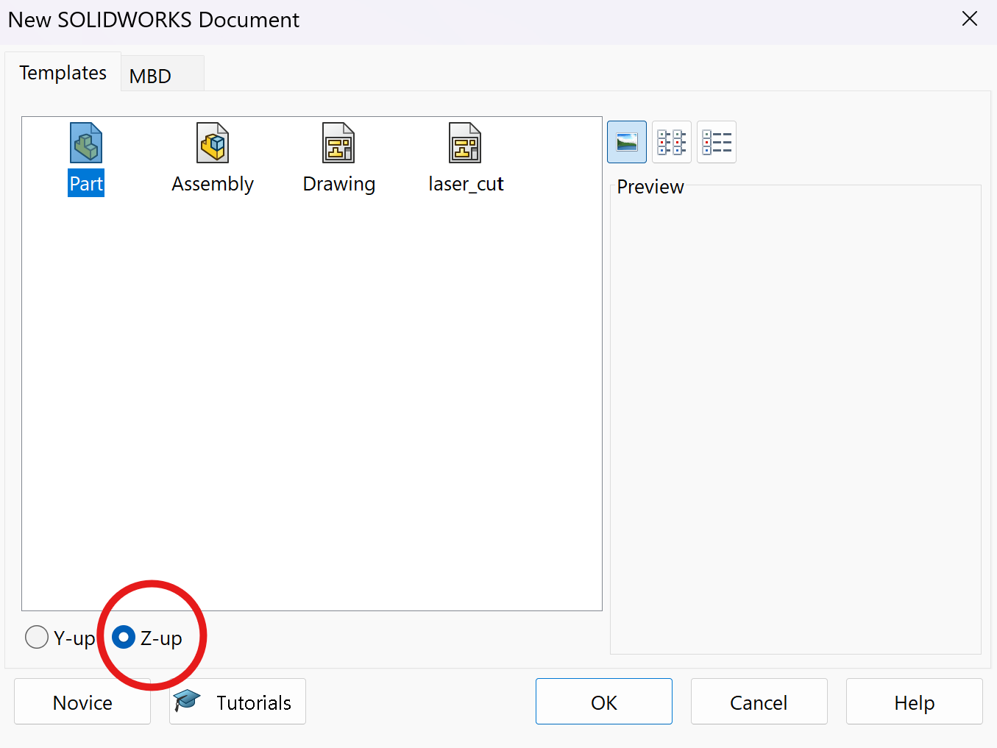
Think about a natural place for the zero point before you model the part. That saves a lot of time adjusting the coordinate system later. It also saves time to set Z up, not Y (the usual), because the CNC machine uses a coordinate system with Z up, which has to be defined in SolidWorks CAM anyway.
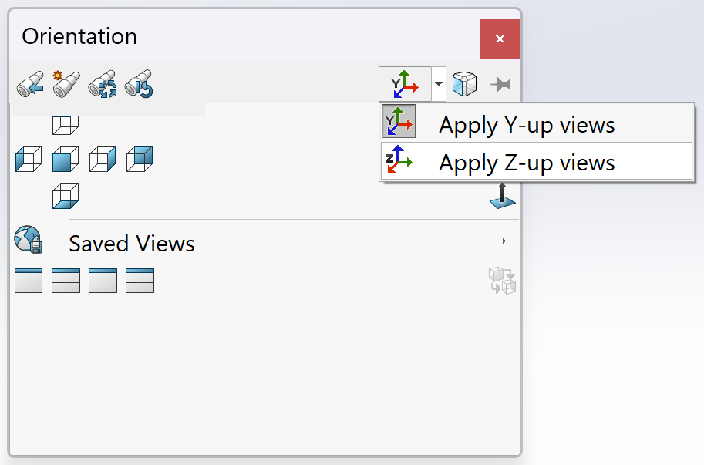

(a) The milling area of the Stepcraft M700
Setting the X and Y axes to match how the part will be milled in the machine also saves time later. You need a clamping margin of about 50 mm on each side of, for example, a carbon fibre plate or a 3 mm aluminium plate, so the machine does not crash.
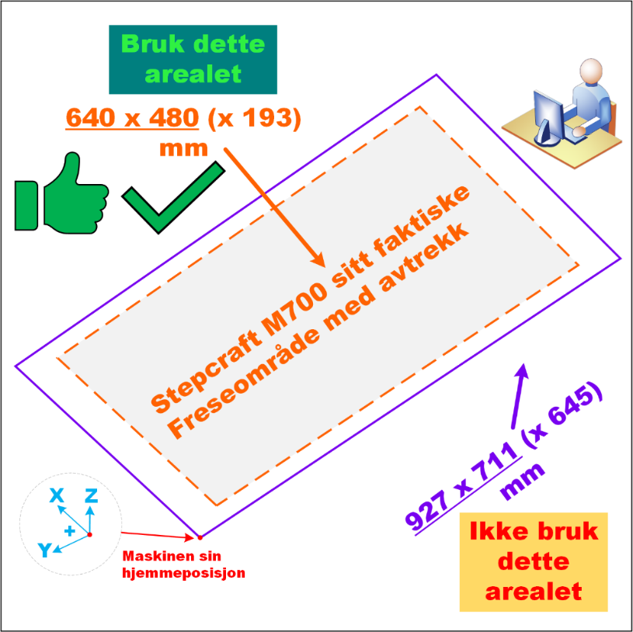
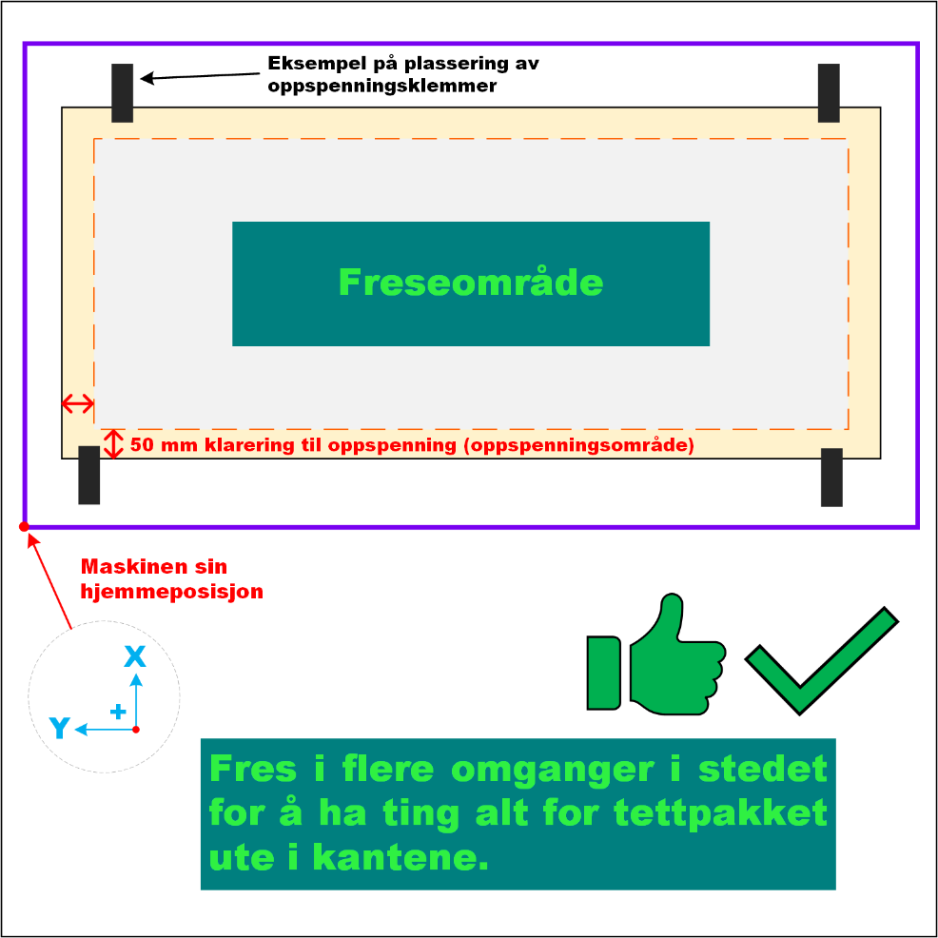
Remember not to design parts too large!

(b) Designing a good coordinate system for milling
A part drawn with a coordinate system for 3D printing can be hard to mill on a CNC. A 3D printer does not care about the coordinate system, and the G-code is made in a separate program, often called a slicer.
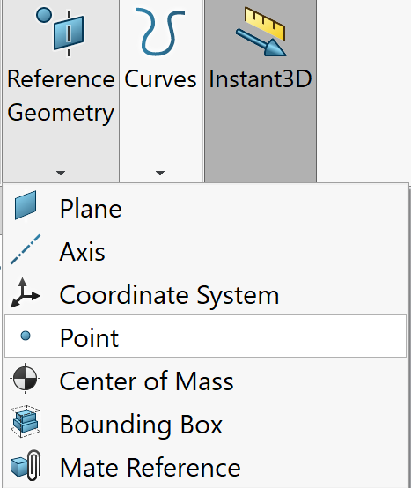
A coordinate system made for a CNC mill, on the other hand, is usually easy to 3D print, because you can rotate the part and choose how it is printed in the slicer.
As an example, the author wants the origin at the centre of a circular feature. That is because the 3D Touch Probe can find the centre of circles and squares/rectangles, both inside and outside.
Click "Reference Geometry" → "Point".
Click the top edge (contour line) of the feature. It will also be parallel to the Z axis.
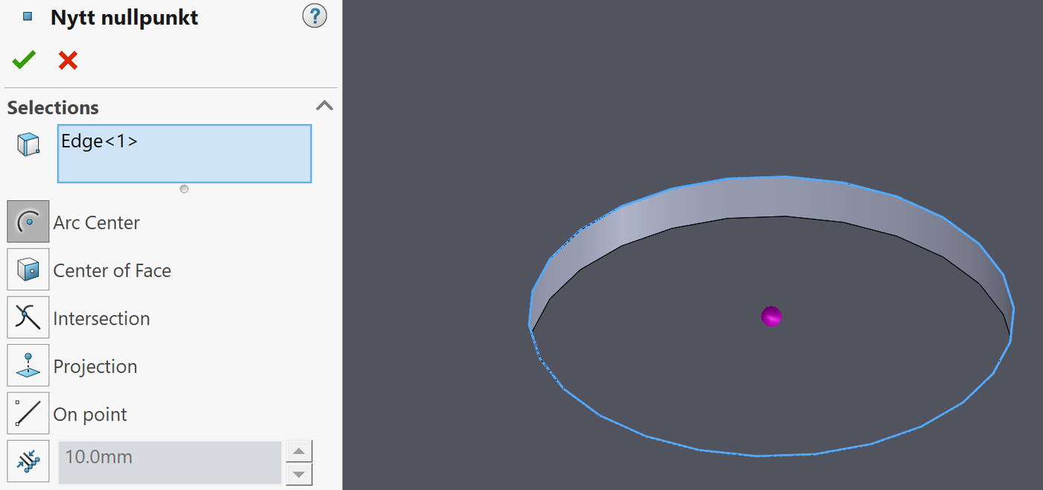
Then click "Reference Geometry" → "Coordinate System" and select the new point ("Nytt nullpunkt").
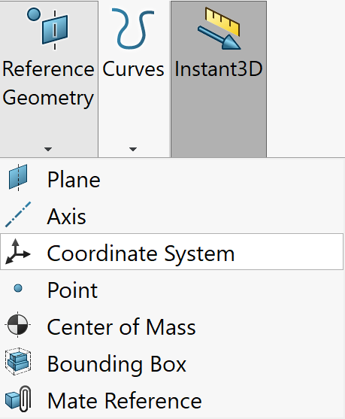
Check that the X and Y axes match how the part will be milled in the machine. If they are wrong, flip the X and/or Y axis under "Orientation" by clicking, for example, a straight edge.
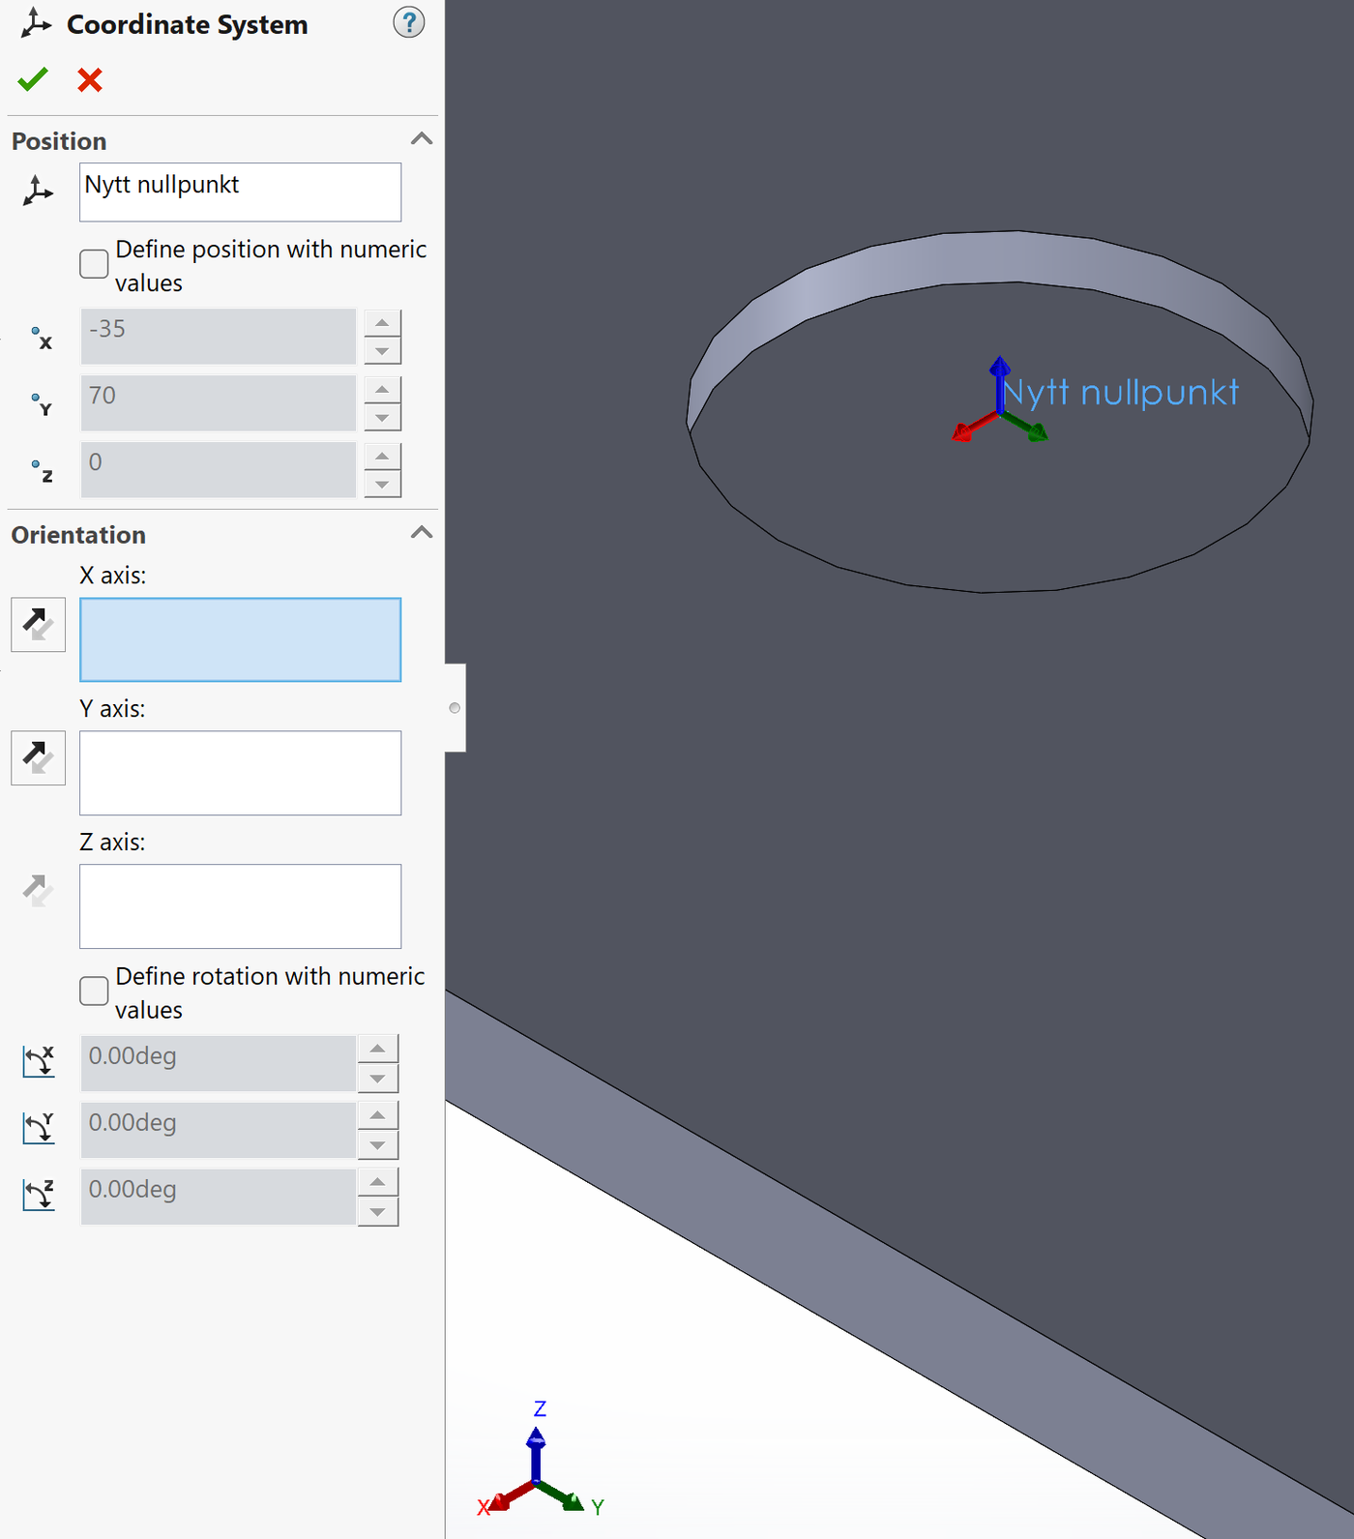
Click "OK" and check that the coordinate system looks right. Well done, your part now has a coordinate system!
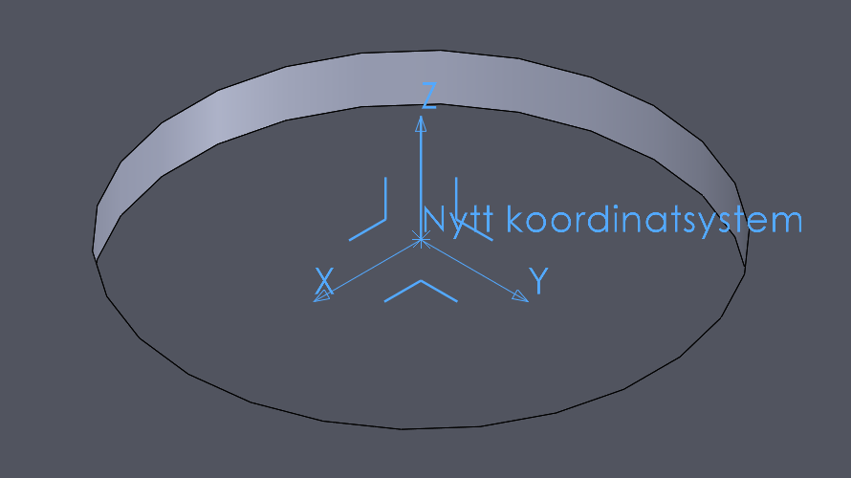

2.02 Making sketch(es) for CAMWorks
To mill a part efficiently, you have to prepare its features. This matters especially on a small, light CNC machine like the Stepcraft M700.
The features are holes, pockets or other shapes where all the material inside has to go. You can either mill away everything inside into dust, or cut around it (like a saw), leaving a piece that can be thrown away. You can also add "tabs" that stop the scrap piece from going astray (does not happen often).
Cutting around is the better choice in almost every case: it is faster, wears the cutter less, and the home position is less likely to be lost. As an engineer you have to judge this yourself, and the person responsible for production may question your choice.
Before you use one of the methods below: You can also make a DXF file (as for laser cutting) and import it into the UCCNC M.700 software on the computer at the CNC. Then you can skip the steps below. See 3.05.

(a) Method 1: Offset Loop (boss toolpath)
With a boss toolpath in SolidWorks (SW) CAM you have to make an offset curve, because a boss in SW CAM is locked to the outside of the contour line.
To use the "saw method" and cut around, make a 2 mm offset sketch from the contour line of the original feature. Right-click the contour line and click "Select loop".
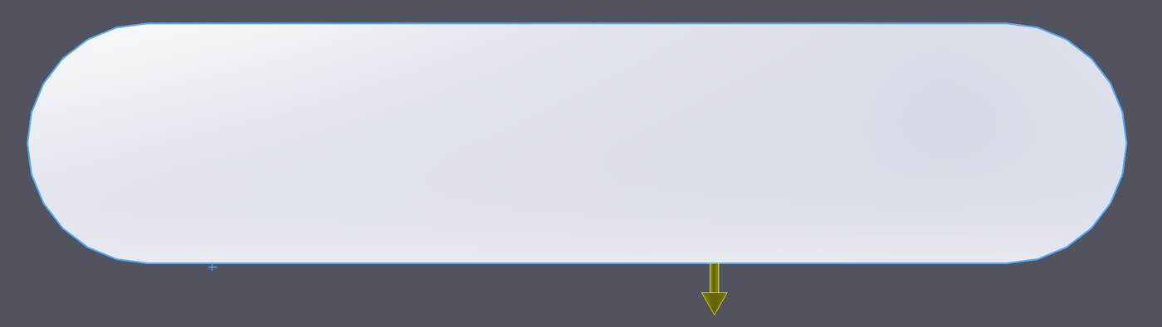
Then click "Convert Entities", or go straight to "Offset Entities".
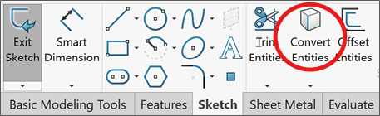
Select the new contour line in the sketch, tick "For construction" and close the dialog.
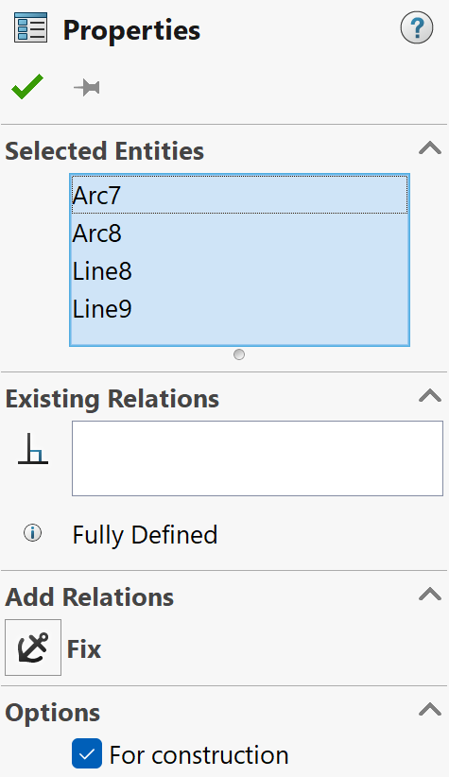
Select the new construction lines. Click "Offset Entities", tick "Reverse" and use an offset of 2 mm.
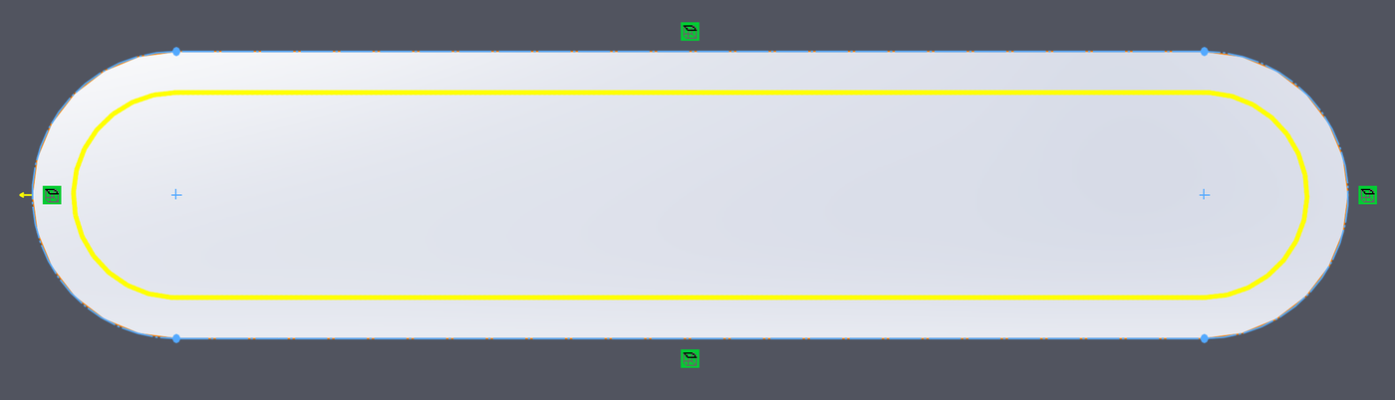
Now a 2 mm cutter can "saw" out the shape with boss programming in SolidWorks CAM.
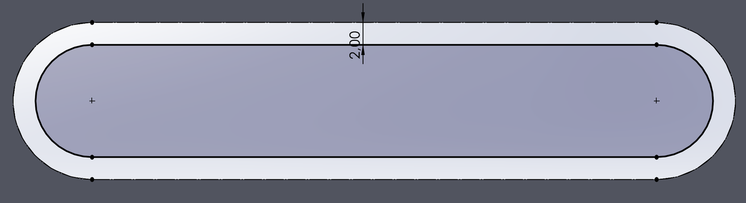
Remember to make several sketches, for example one for Ø4 mm holes, one for Ø6 mm holes and one for pockets of another shape. SolidWorks CAM has to tell holes of different shape and depth apart.

(b) Method 2 (recommended): Without Offset Loop (pocket toolpath)
With a pocket (Contour) toolpath in SW CAM you do not need an offset curve. A pocket (Contour) runs on the inside of the contour line and does not mill out everything inside.
Remember: a Contour Mill (made with, for example, the Finish or Fine strategy) only mills around the contour line, while a Rough Mill (made with, for example, the Rough strategy) mills out everything inside. That is usually only needed if you are not cutting all the way through, or the stock is so high that the cutter could crash into it. It wears the tool a lot.
You can leave the features as drawn (with a Ø2 mm cutter in mind), or, as recommended, make sketches if you want the features milled in a particular order.

(c) Important about circular holes with a given diameter
It can be a good idea to set all holes to Ø2 mm for milling, and drill them out to the exact diameter afterwards with a hand drill. All holes smaller than Ø6 mm have to be drilled out by hand afterwards (drill bits are in the prototype lab – ask for access to the lock).
The engineer/designer must either change these holes to Ø2 mm before production or, as recommended, make a new sketch (often easier) on the same plane with Ø2 mm holes at the centres of the holes. Give the sketches clear names, so the person responsible for production can see what they are for.

3. UCCNC for Stepcraft | Teachers

3.01 Starting up the CNC
- Turn on the compressed air to the machine.
- Turn on the vacuum (dust extraction) – switch it on with the switch above the mill when needed.
- Release the emergency stops on the outside and the inside of the door.
- Start UCCNC on the local computer.
- Turn on the spindle switch (it should flash blue/red when no program is running).
- Click "Reset" in the bottom right corner.
When you are done, shut down in the reverse order: see 3.08.

3.02 Exporting a Technology Database for import
Do this before you update SolidWorks to a new version, so the database is not lost!
Go to "Tools" → "SOLIDWORKS CAM" → "Technology Database…" to open the Technology Database (TechDB).
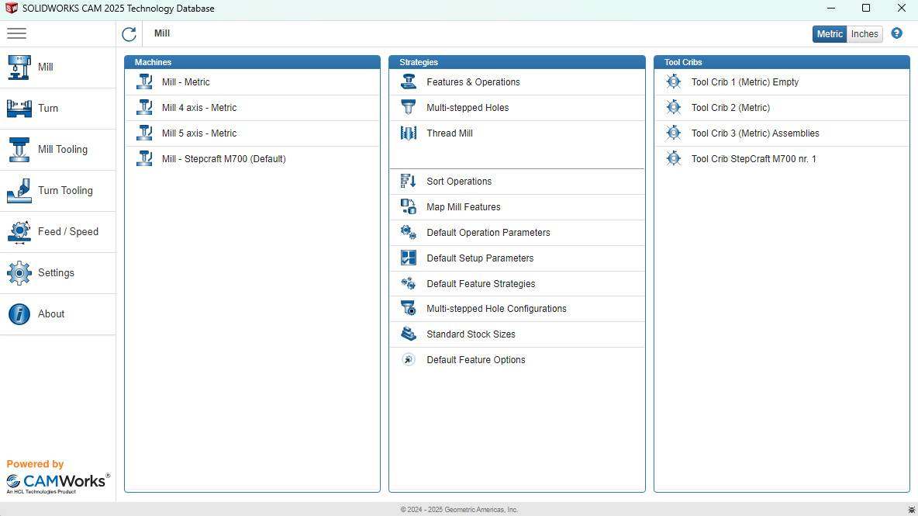
Click "Settings" in the menu on the left.
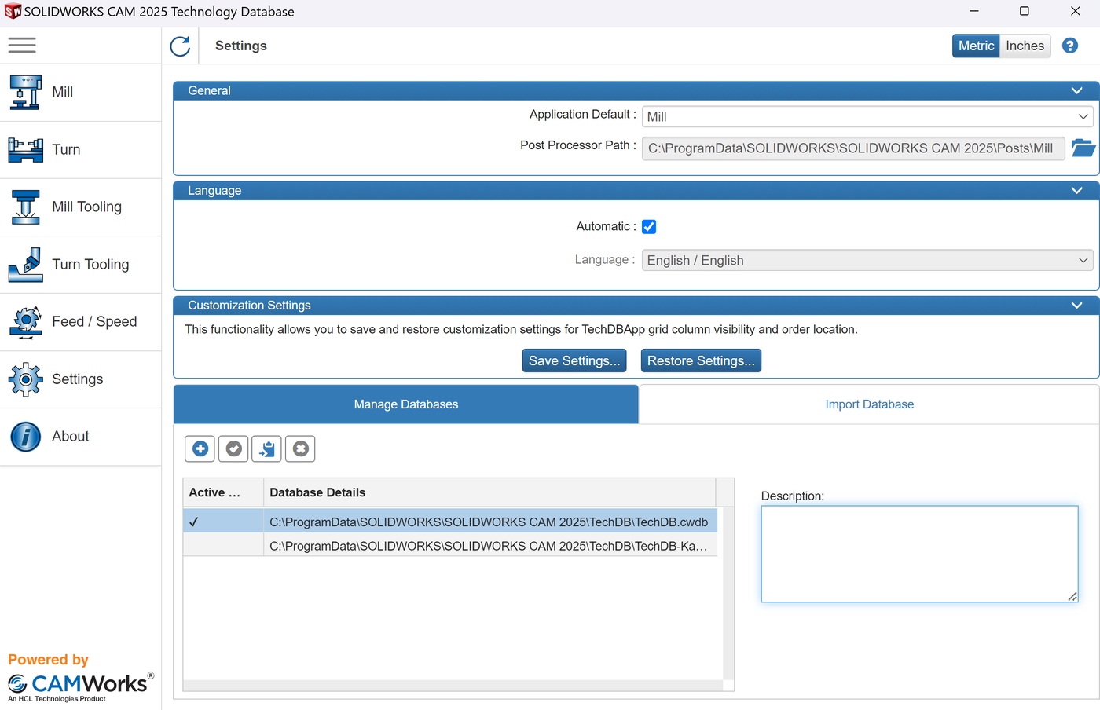
The "Manage Databases" tab shows where the databases linked to TechDB are stored. Click the database you want to keep and click "Copy".
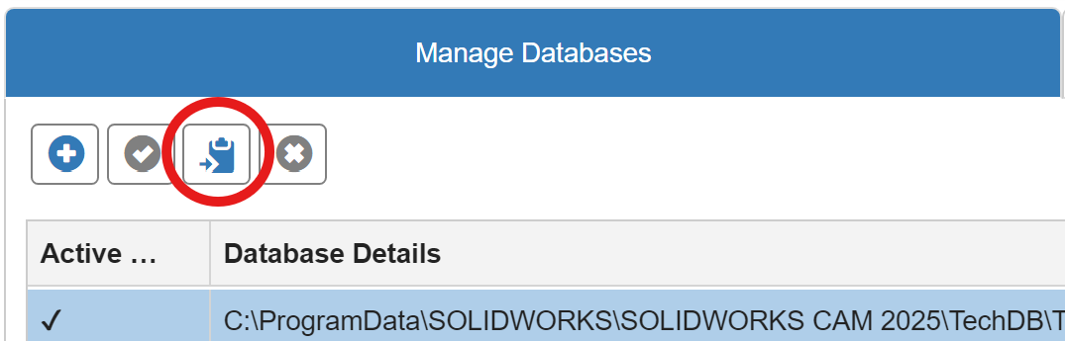
Choose where to save the copy. This is strongly recommended before you upgrade to a new version of SolidWorks!
After the new SolidWorks version is installed, go to the "Import Database" tab, click "Browse", choose the exported database and import it. Remember to close SolidWorks (but not TechDB) before you start the import!
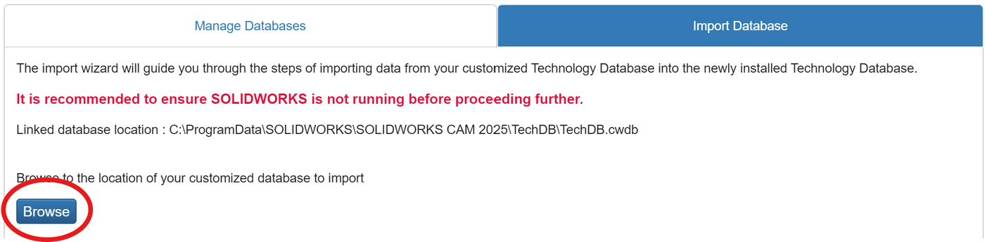

3.03 Adding a new tool to TechDB (example)
Tools are edited in the SolidWorks CAM Technology Database. If possible, use only one tool at a time. The Stepcraft tool holder tends to jam when dust or chips get in during use. See 4.05 for how to release a stuck tool.
Open the Technology Database: "Tools" → "SOLIDWORKS CAM" → "Technology Database…".
Choose the tool type, for example Flat End Mill (at the bottom of the picture).
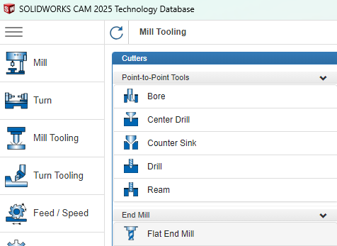
You now get a long list of tools that come with SolidWorks.
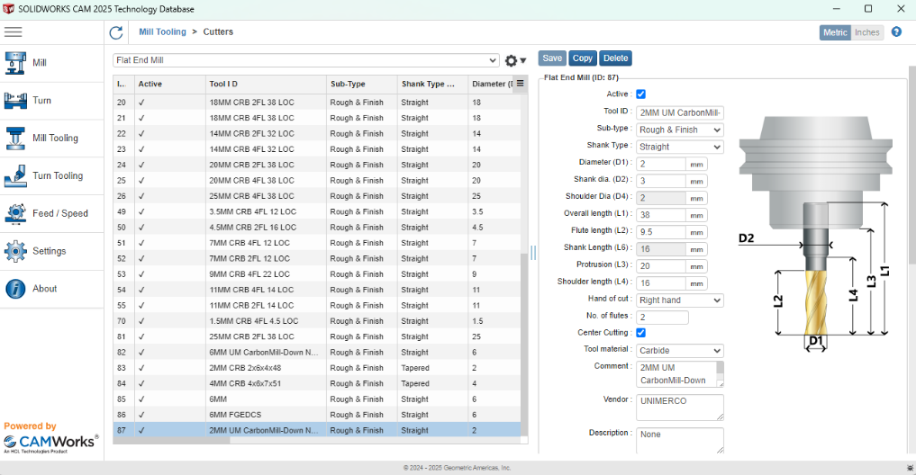
Find a tool similar to the one you want to add, and copy it.
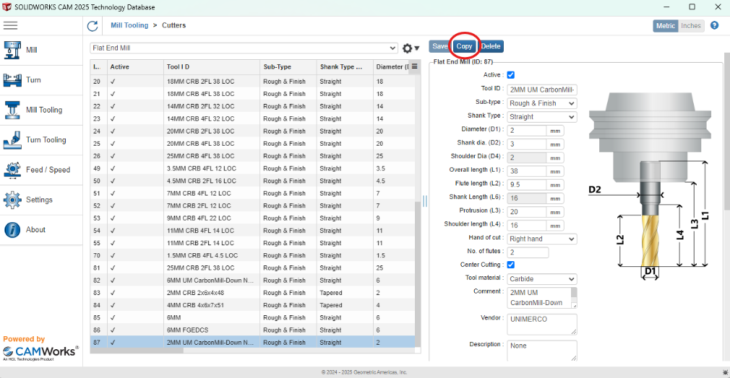
Fix your tool in the tool holder and measure it. Adjust the lengths to match.
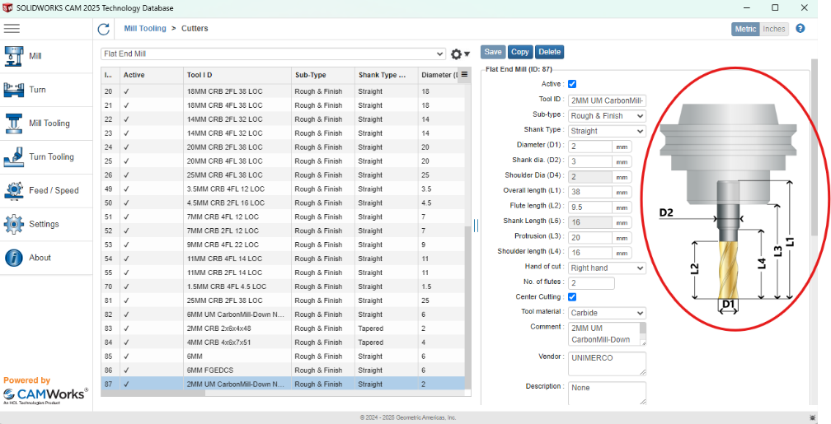
Scroll down and adjust the allowed speeds. These are the speeds that can reach the Stepcraft M700, so it is important that they are correct and as expected.
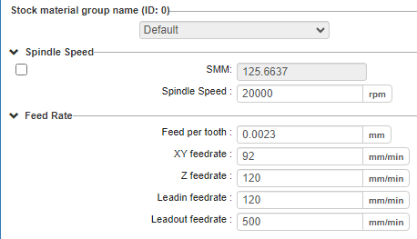
When you are done, click "Save" (to the left of "Copy") and close TechDB.

3.04 Making a toolpath in SOLIDWORKS CAM
Before you use one of the methods below: You can also make a DXF file and import it into UCCNC M.700. See 3.05.
How the part is prepared for each method is described in 2.02 (students).

(a) Method 1: Offset Loop (boss toolpath)
Milling on the outside. A boss strategy is often used to mill out a part at the end. Choose a new 2.5 Axis Feature with Type = Boss. Then choose the offset sketch of the feature(s).
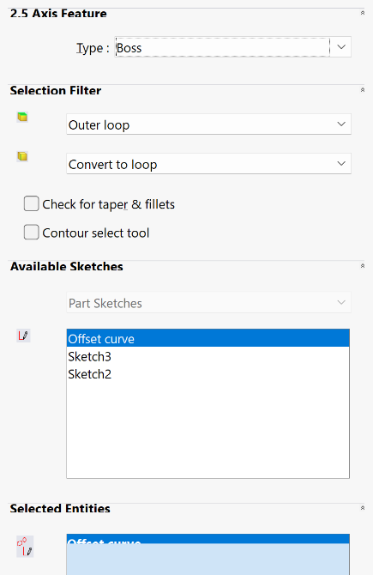
You can now add a Contour Mill. Click OK when you have set the cutting depth.
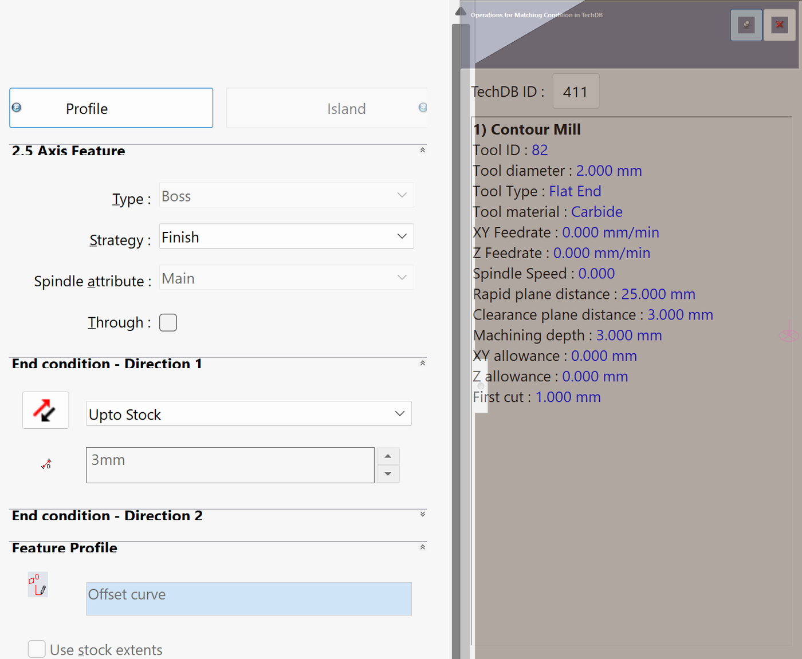
Click "Generate Operation Plan". If everything is defined correctly, the text turns from blue to black, and the view switches from the "SOLIDWORKS CAM Feature Tree" tab to the "SOLIDWORKS CAM Operation Tree".
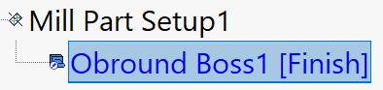
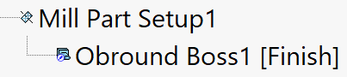
Click "Generate Toolpath" to make the toolpath. The text again turns from blue to black.
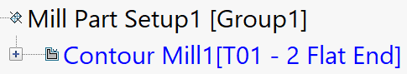
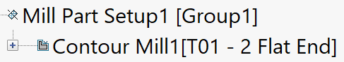
The next step is to simulate the toolpath with "Simulate Toolpath" and post-process it into G-code (NC code) that can be imported into UCCNC.
Example of a simulation with boss (outside cut). An inside cut is often wanted here, but a 2 mm inward offset contour with a Ø2 mm cutter gives the same result:
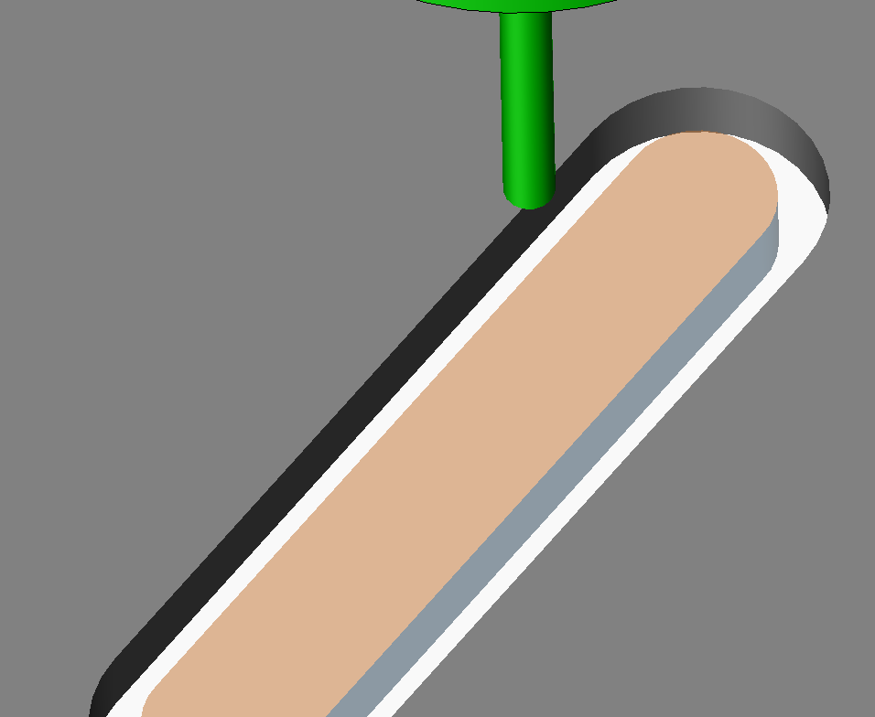

(b) Method 2 (recommended): Without Offset Loop (pocket toolpath)
Pocket without tabs or bridges (milling on the inside). First define each edge or sketch in the pocket to be milled out. Choose a new 2.5 Axis Feature with Type = Pocket.
Click "End Condition" to continue.
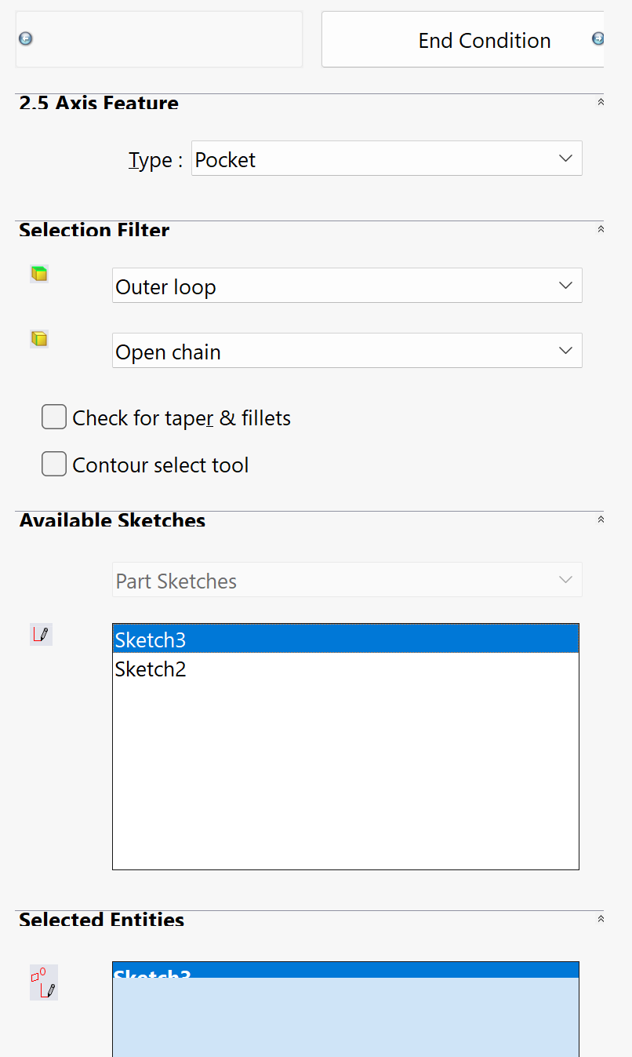
Choosing the strategy matters now. Set "Strategy" to, for example, Finish or Fine, so you get a "Contour Mill" and not a "Rough Mill". This decides whether you can add tabs.
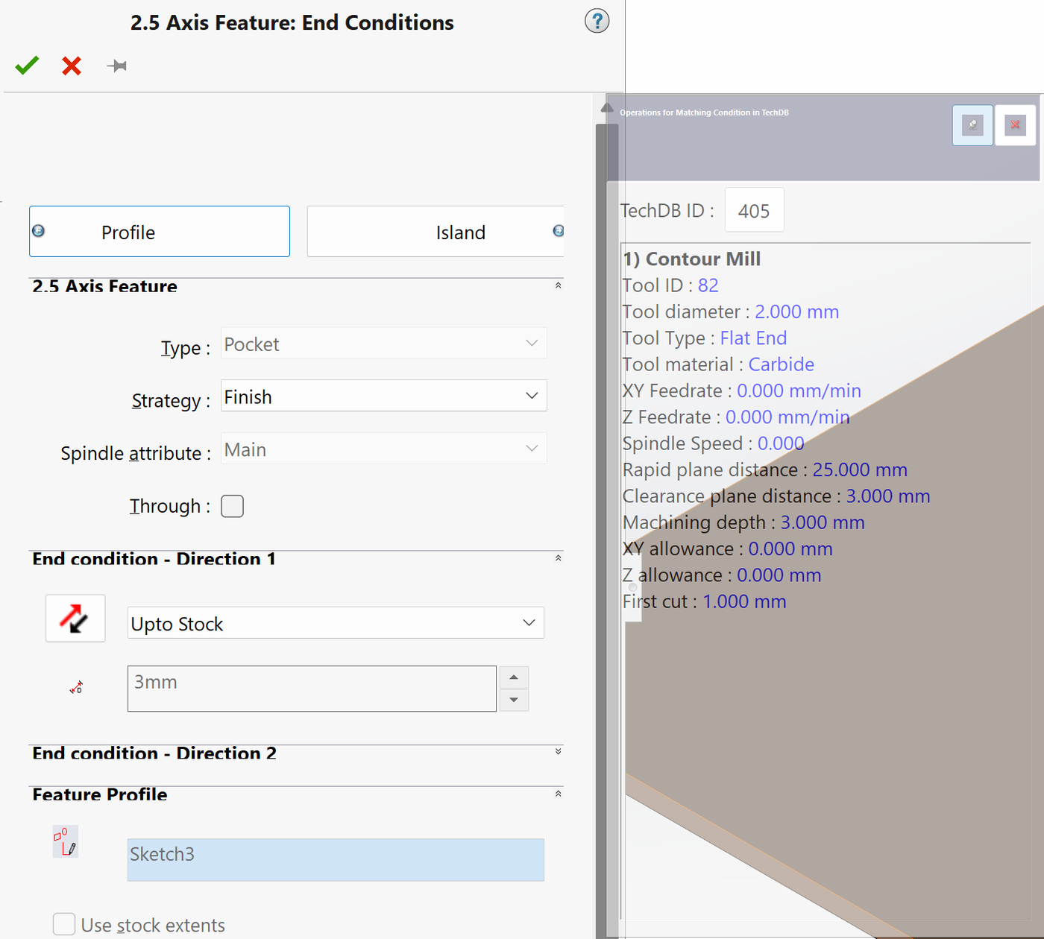
Click OK and then "Generate Operation Plan". If everything is defined correctly, the text turns from blue to black, and the view switches from the "SOLIDWORKS CAM Feature Tree" to the "SOLIDWORKS CAM Operation Tree".
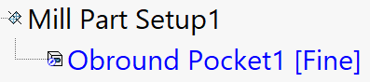
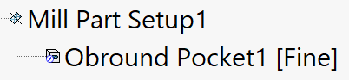
Click "Generate Toolpath". The text again turns from blue to black.
The next step is to simulate the toolpath with "Simulate Toolpath" and post-process it into G-code for UCCNC.
Example of a simulation with pocket (inside cut):
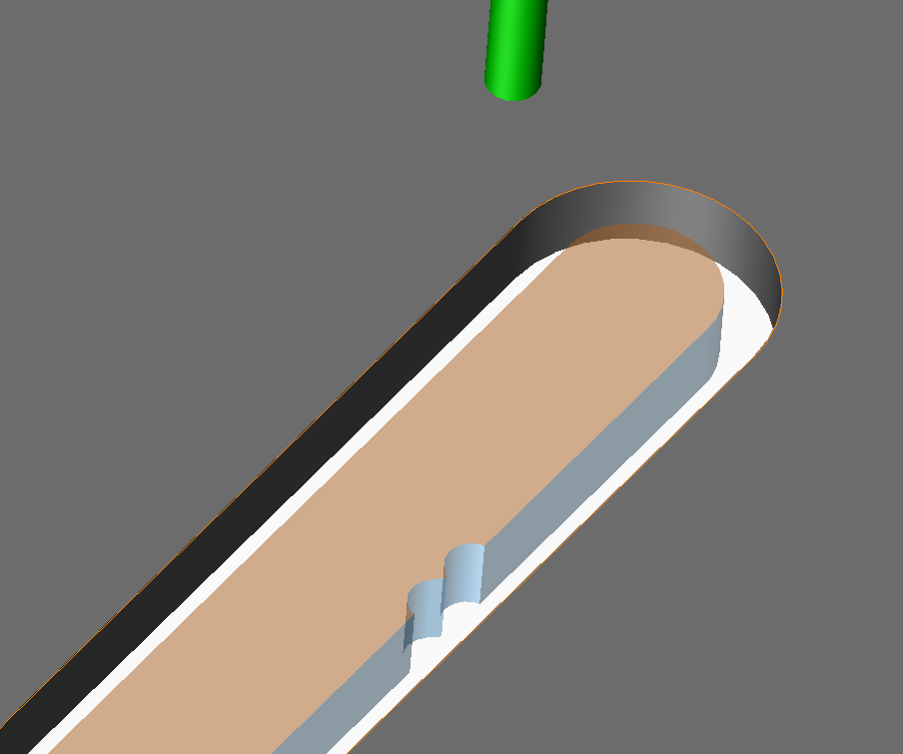
Pocket with tabs or bridges (milling on the inside). If you want to hold the scrap piece with "tabs", SolidWorks CAM can make them automatically. Normally a pocket toolpath mills away everything along the contour line, but with tabs the scrap piece is held in place while the inside is milled. See examples of tabs and bridges in this video (0:46).
Do the same steps as above: a new 2.5 Axis Feature with Type = Pocket, "End Condition", "Strategy" = Finish or Fine (not Rough), OK, "Generate Operation Plan" and "Generate Toolpath".
Right-click the new Contour Mill operation, choose "Edit Definition…", go to the Contour tab and tick "Tab cutting" in the bottom right corner.
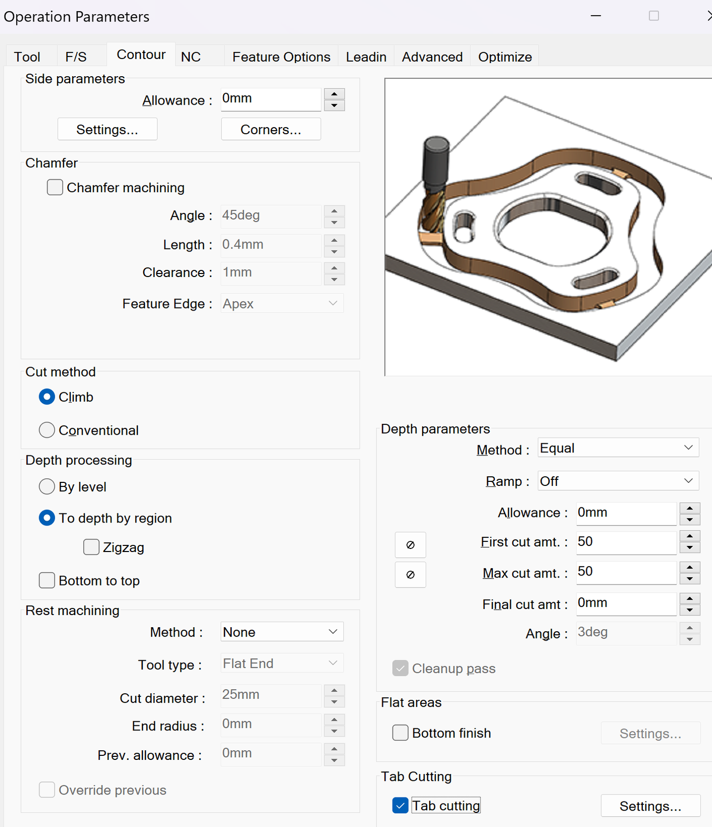
Under Tab cutting, choose "Settings…". Adjust the number of tabs, length, thickness, lead-in/lead-out etc., and click OK.
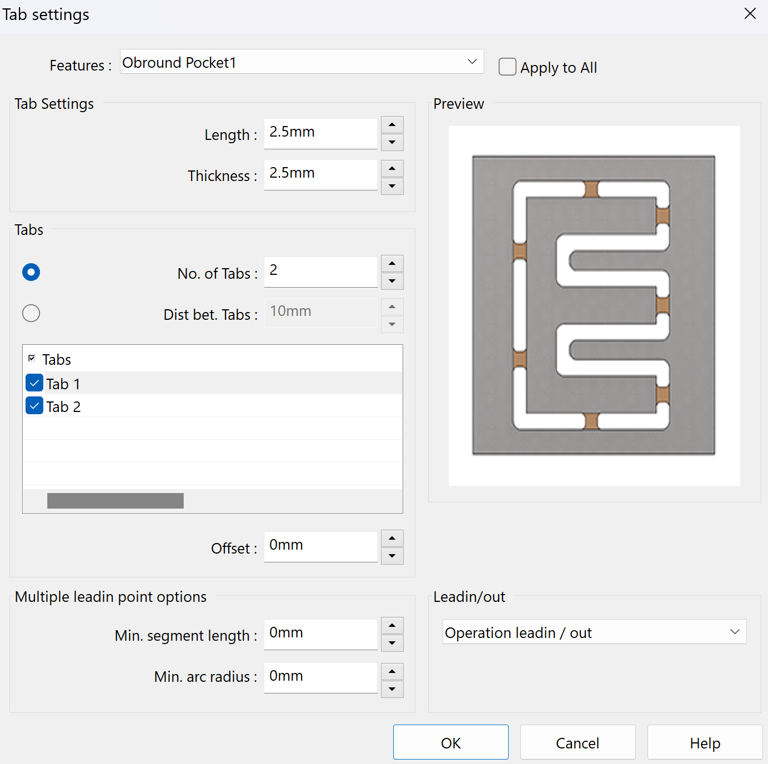
Now make the toolpath as usual. The tabs hold the scrap piece in place.
The next step is to simulate the toolpath with "Simulate Toolpath" and post-process it into G-code for UCCNC.
Example of a simulation with pocket (inside cut) with four tabs, 2.5 mm long and 1.5 mm thick:
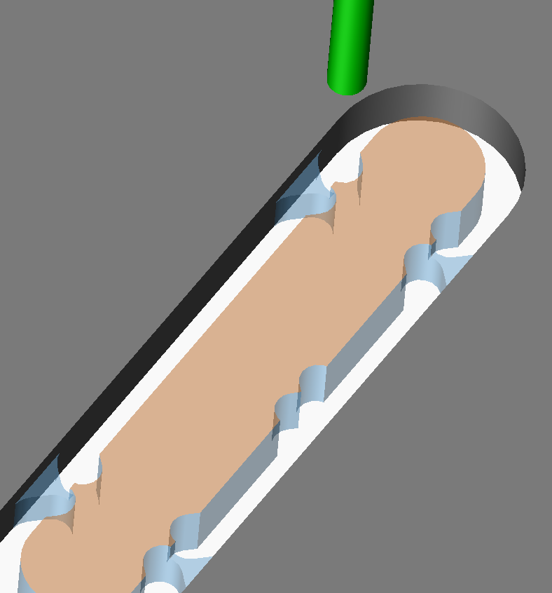

3.05 Making a toolpath in UCCNC CAM from a DXF file
You can also make G-code from a DXF file in UCCNC CAM. It works very well for simpler parts, prototypes, or when the work does not all need to be documented. It is a bit more manual, but works very well.
Find a view of the part (usually from the top) that gives the right contour lines for the DXF file.

Choose File → Save As…, set the file type to Dxf (*.dxf) and click Save.
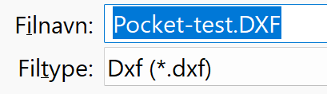
Choose the view you want to export and click OK.
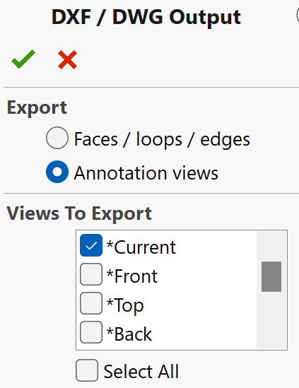
Click "Save". Do not worry about the zero point or the coordinate system – they are defined in UCCNC.
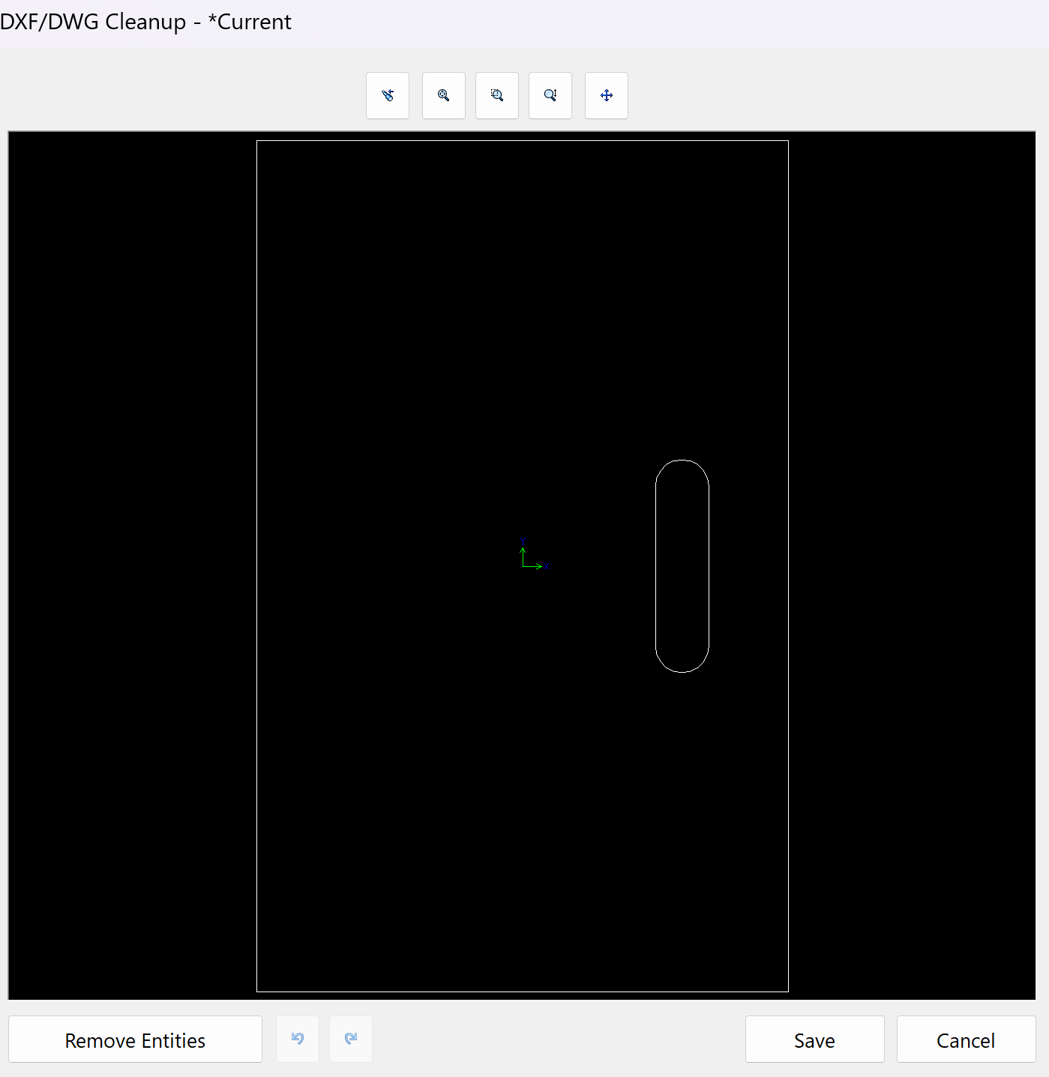
With a student licence the DXF file has to be cleaned up (the unwanted text removed). You can also add layers to the DXF file (as in a drawing program) to separate what is milled on the inside or outside, depths etc. The free program QCAD is recommended for this.
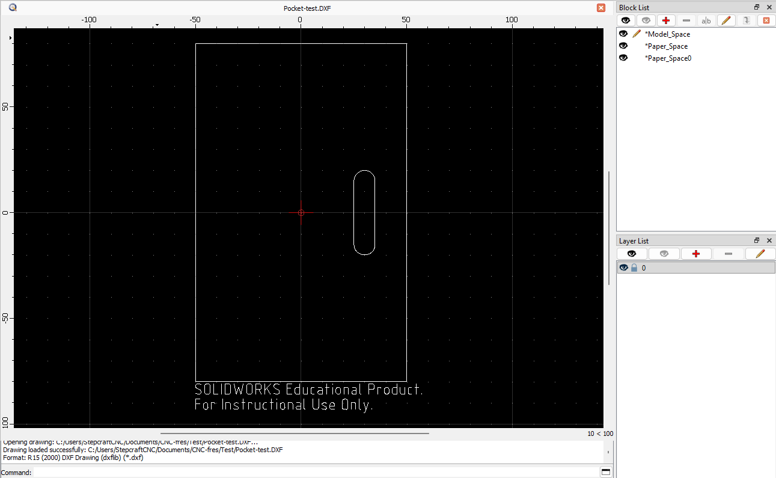
The DXF import in UCCNC is strict – for example, you cannot use any layer names you like. Layer no. 1 must be named 0. Layer no. 2 must be named 11. The layers after that must be named 12, 13, 14 and so on.
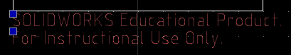
When you have finished editing, save the file (Ctrl+S).
Move features that will get a different strategy later to a new layer.
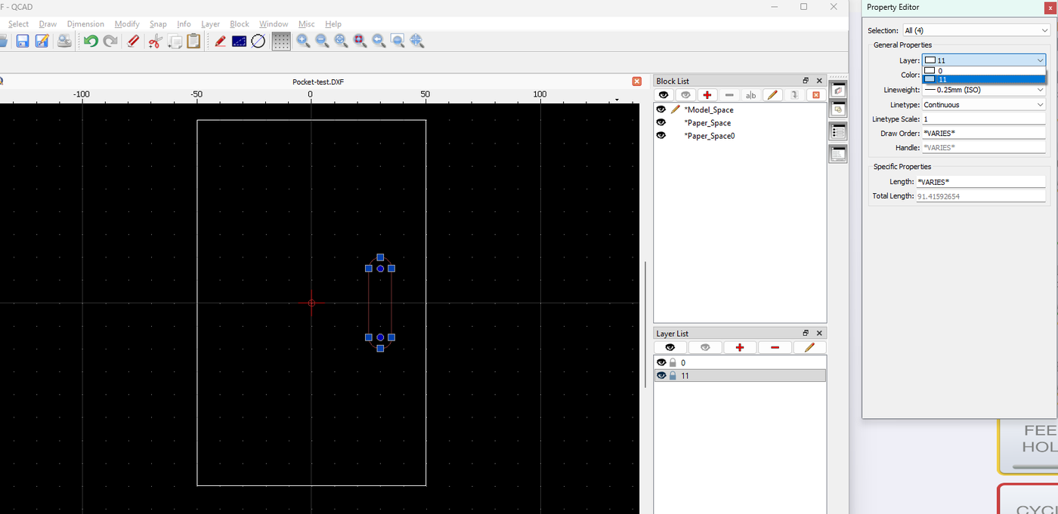
Open UCCNC and go to the CAM tab.
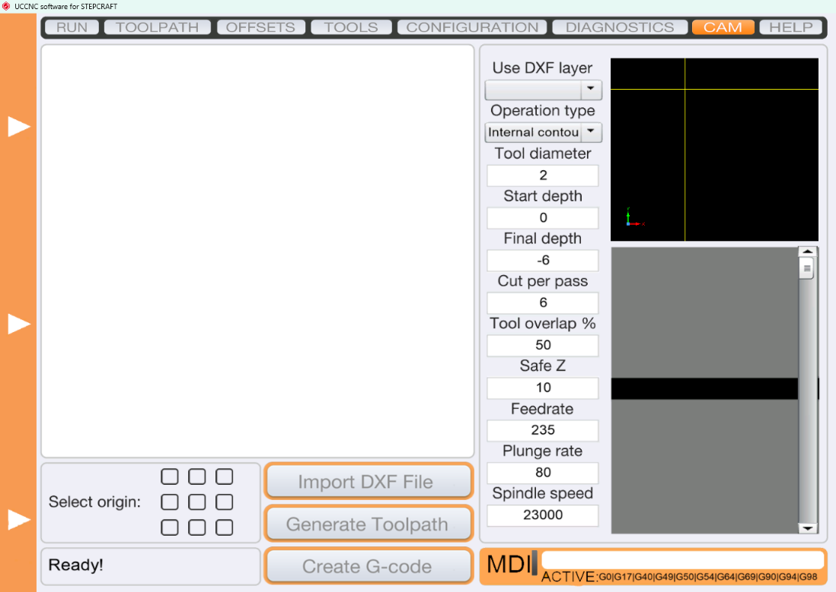
Import the file into UCCNC. Here you choose which DXF layers to make G-code for.
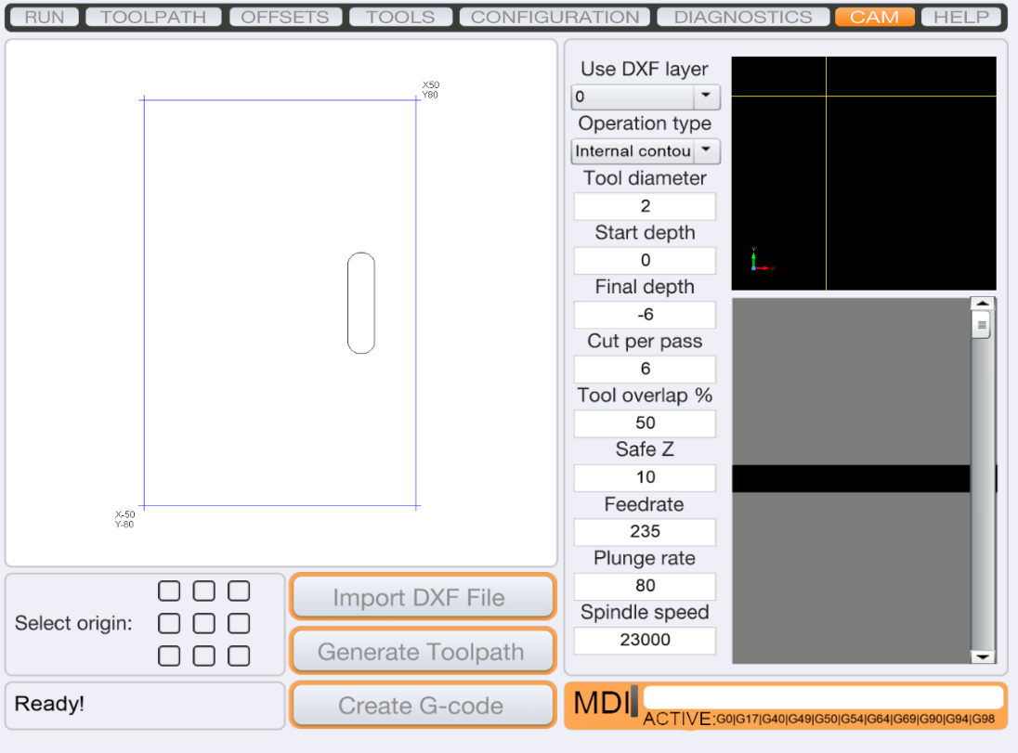
In this example there are two layers: one for the outer contour (outside cut) and one for the features (inside cut).
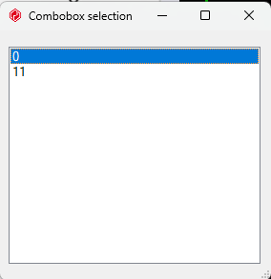
Choose where the zero point should be.
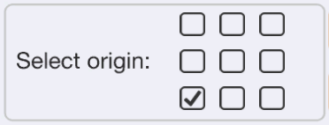
Choose the strategy ("Operation Type"), for example inside or outside.
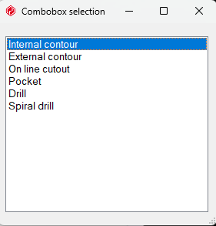
Example of settings that work with the Stepcraft M700:
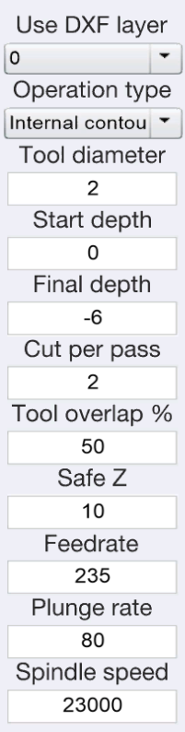
Make G-code for each layer you want to mill, with different strategies if needed (inside/outside): 1. "Generate Toolpath", 2. "Create G-code". The result looks like this:
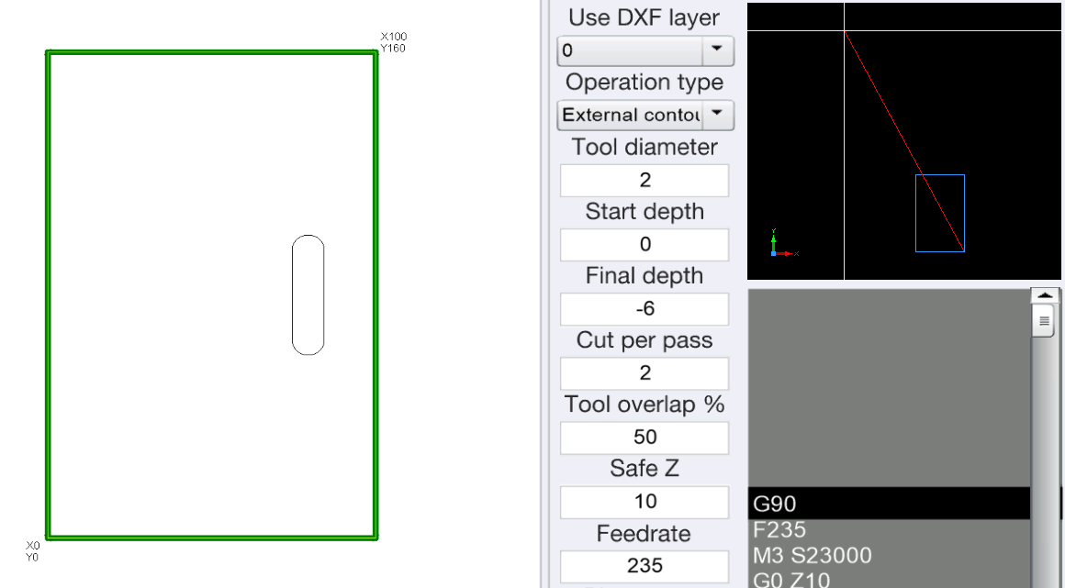
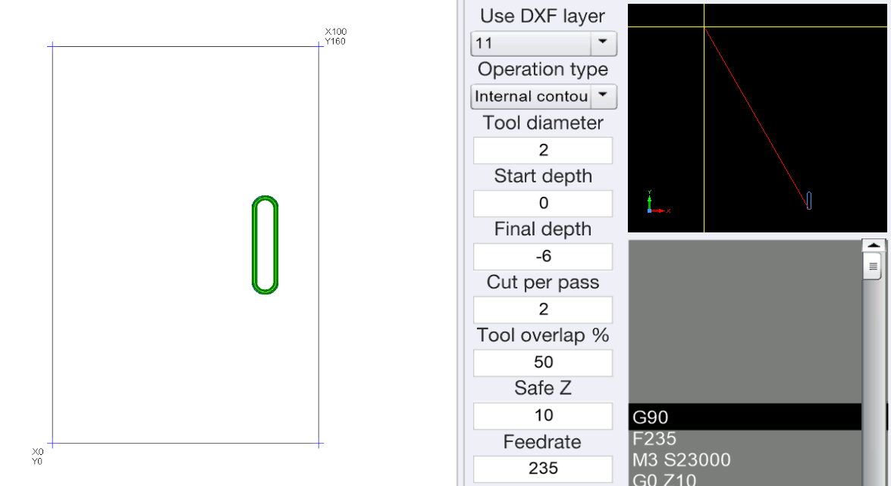

3.06 Changing the lead-in/-out (holes over Ø4 mm can be milled out)
To change the lead-in/-out, you must first have clicked "Generate Toolpath" and got a Contour Mill. Right-click the Contour Mill, click "Edit Definition…" and go to the "Leadin" tab.
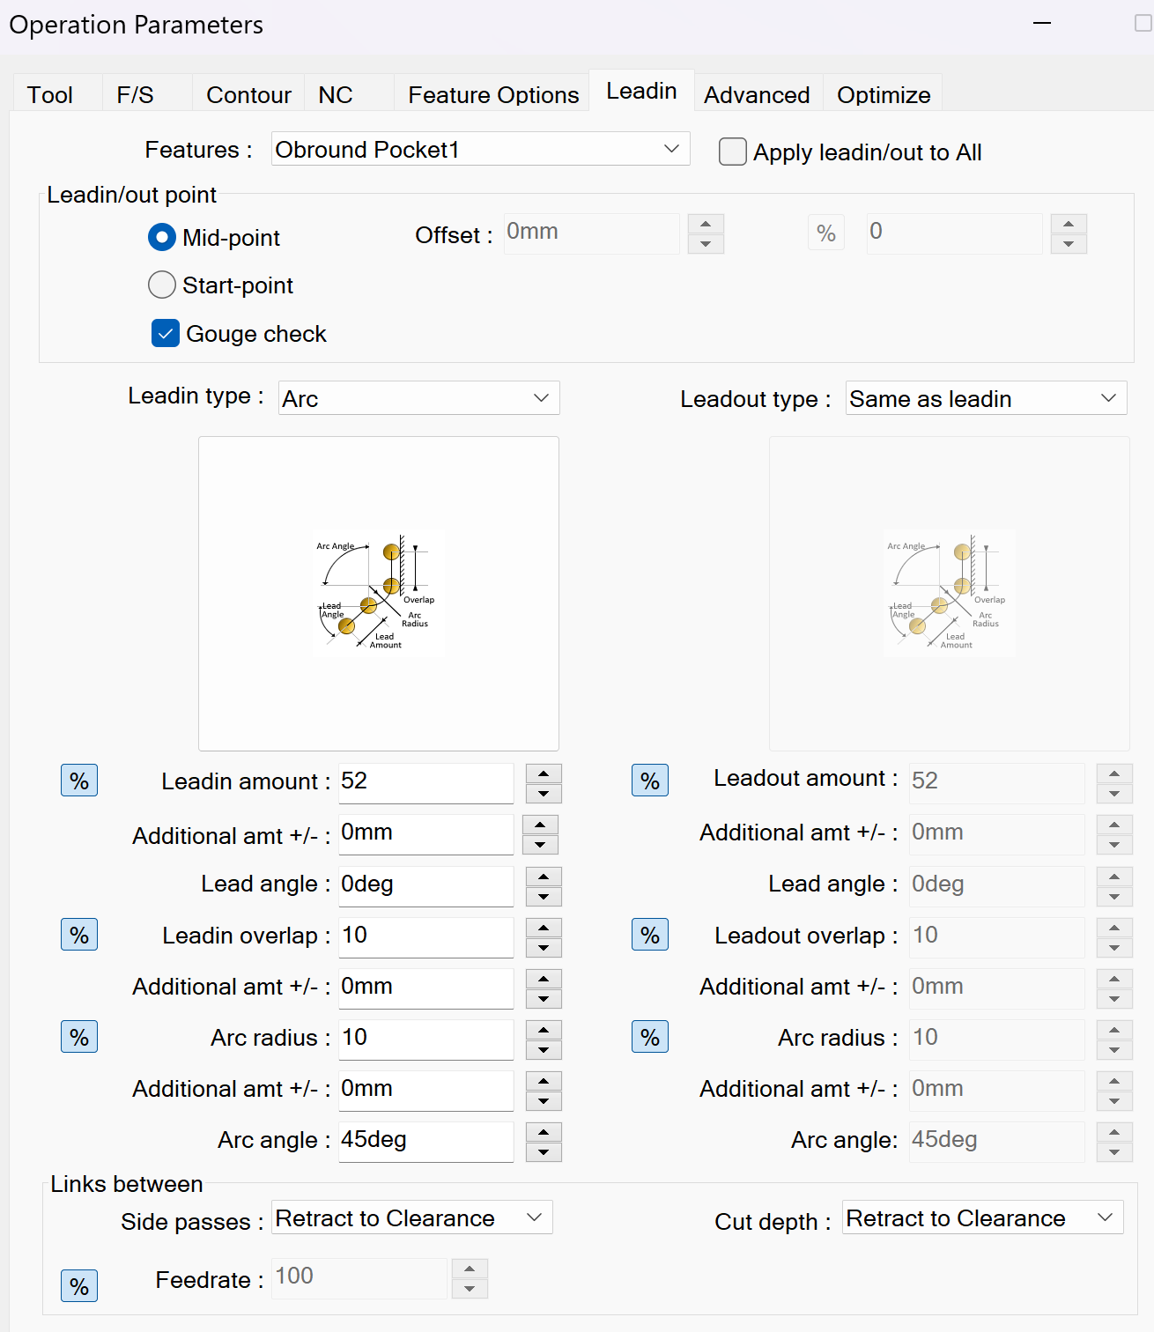
Here you can change the Leadin amount and the Leadin/out point, which you often want in special cases – for example when you mill out holes and do not want a "Mickey Mouse" shape with two "ears".

3.07 Post-processing to NC code for UCCNC
If UCCNC does not make the right toolpath from the imported NC code, first try restarting the program (close and open it). That often solves the problem if everything is fine in the SolidWorks CAM simulation.
A dedicated post-processor for the Stepcraft has been made with Universal Post Generator (based on FANUC11M). It is defined for the machine in SolidWorks (Technology Database/TechDB). For programs such as Fusion, Stepcraft already provides a post-processor that can be downloaded.

3.08 Shutting down the CNC
Shut down in the reverse order of the start-up (3.01):
- Wait until the program has finished and the spindle has stopped.
- Put the tool back in the magazine (M6) and move the machine to its home position.
- Turn off the spindle switch.
- Close UCCNC.
- Press in the emergency stops (outside and inside the door).
- Turn off the vacuum (the switch above the mill).
- Turn off the compressed air.
- Vacuum chips and dust from the table and the tool holder (see 4.04).

4. Getting the Stepcraft ready | Teachers

4.01 Adding a new tool to the tool magazine
Clamp the tool in a free holder, or replace a tool. Remember to add the tool in SolidWorks (3.03) if you want to use and simulate it there.
Then go to 4.02 to calibrate the tool's offset.

4.02 Calibrating the offsets of the tools in the tool magazine
First click "DOUBLE HOME ALL". Then calibrate the offsets of all the tools in the magazine – eight at most, because no. 9 (disabled) and no. 10 are set to the 3D Touch Probe – by clicking "OFFSETS".
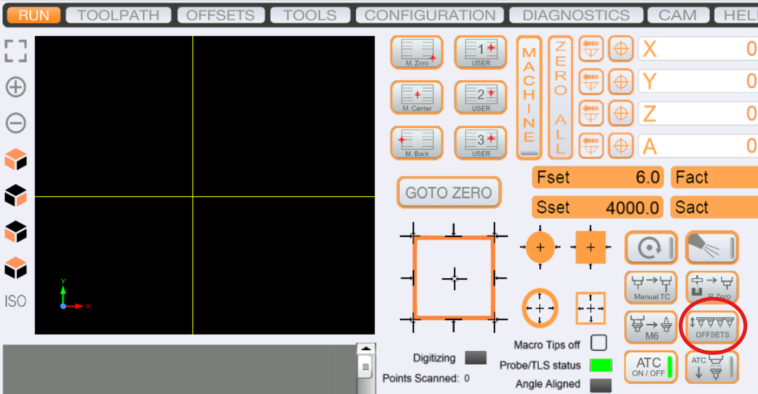

4.03 Calibrating the 3D Touch Probe in the tool magazine (Z)
To use the 3D Touch Probe to set the zero point on the Z axis, its offset has to be calibrated against tool no. 1 in the magazine. This is the standard for all tools on the Stepcraft M700 in UCCNC.
Note: tool 1 is shorter than tool 10 in the example below.
Start UCCNC and go to "TOOLS". Tool no. 9 is disabled in a custom M6 macro. Scroll down to tool no. 10, set its offset to 0 and press Enter on the keyboard.
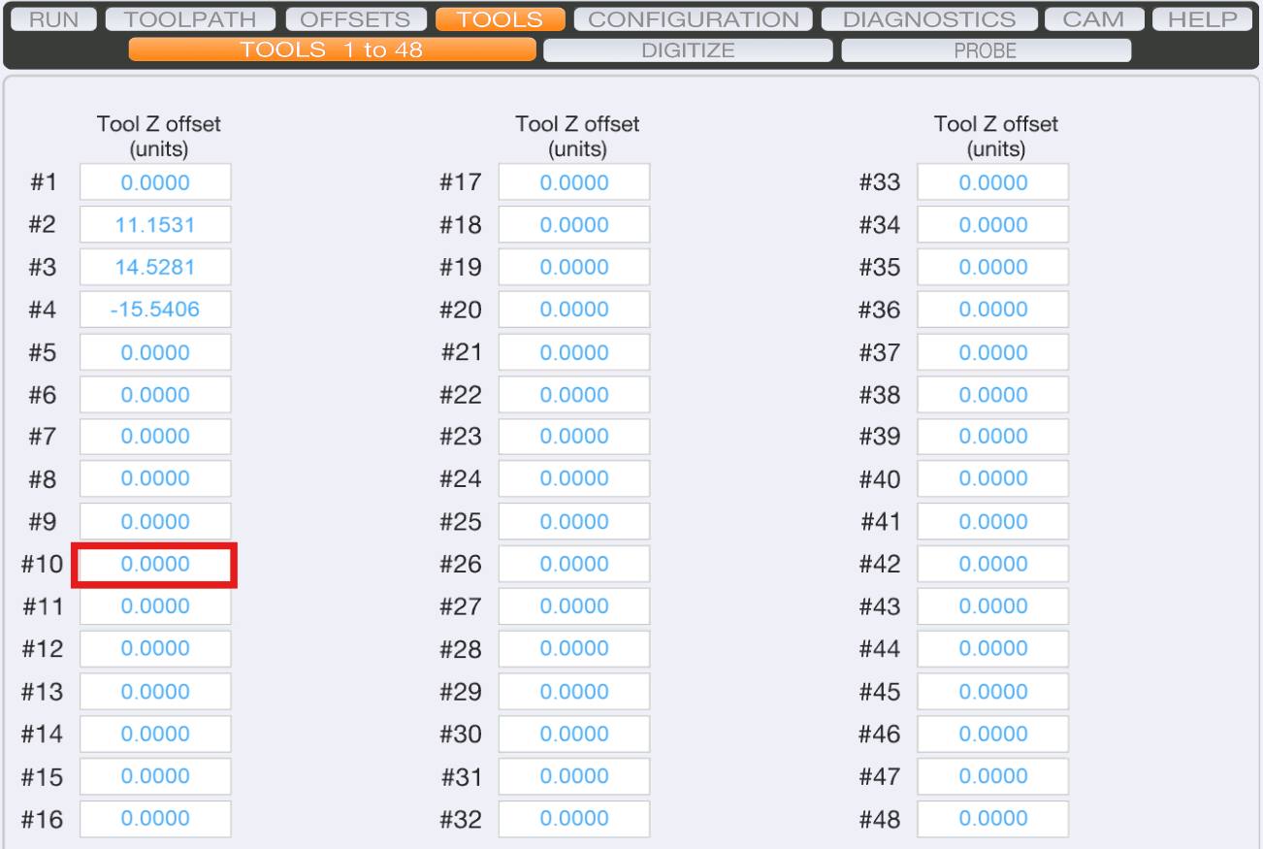
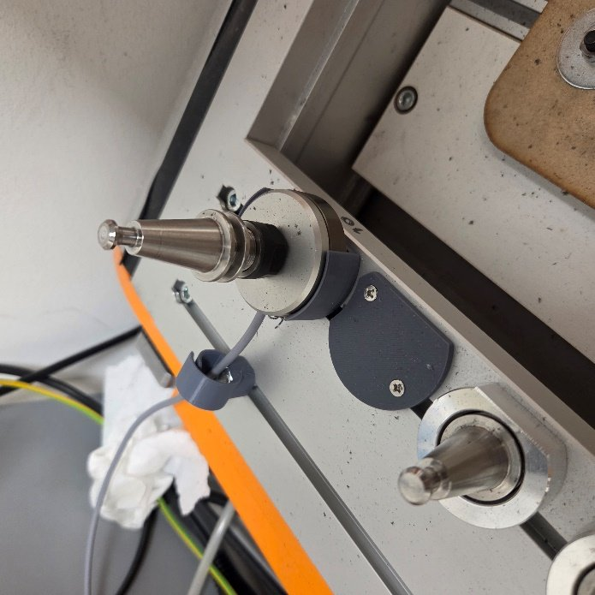
Click "DOUBLE HOME ALL" and calibrate the offsets of the tools in the magazine with "OFFSETS", as in 4.02.
Change to the 3D Touch Probe by clicking "M6" and typing 10. When the probe is in, move to an X/Y position where the probe is directly above a fairly flat piece of material (10 mm thick at most). You will put a piece of tape there later.
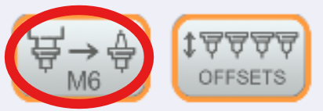
Zero X and Y with the buttons marked in the picture below, so the position is saved until you press "GOTO ZERO" later.
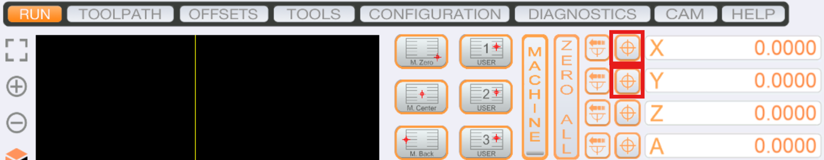
Go to "TOOLS" → "PROBE". Check that the right settings are set under "SETUP" and "PAGE 1".
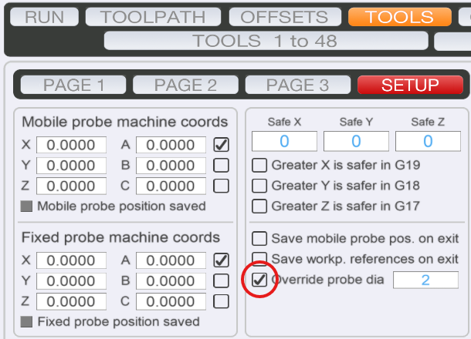
Set "P1" to -50 (the probe goes down 50 mm at most before it hits a surface), and enable only "Z" to measure the Z axis. Also make sure "Simple probe" is enabled.
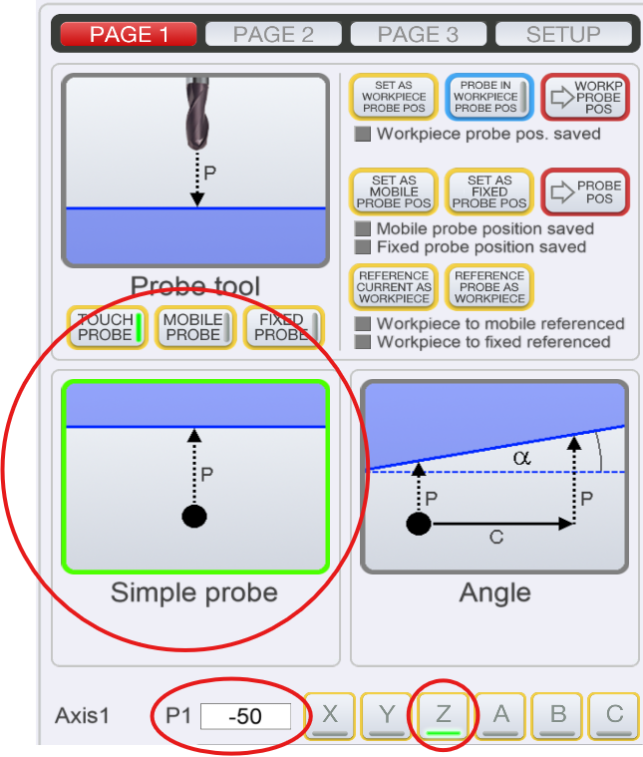
Turn on "ZERO PROBED AXES", "AXIS COUNT GAGE" and "AXIS 1 COUNT DIA.", and set the values in the red frames as in the picture below.
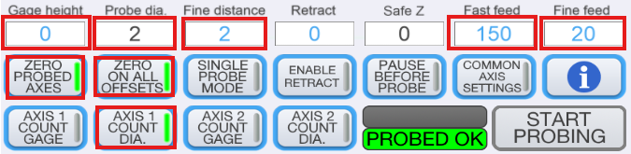
Press "START PROBING" to set a new zero point for the 3D Touch Probe (tool no. 10).

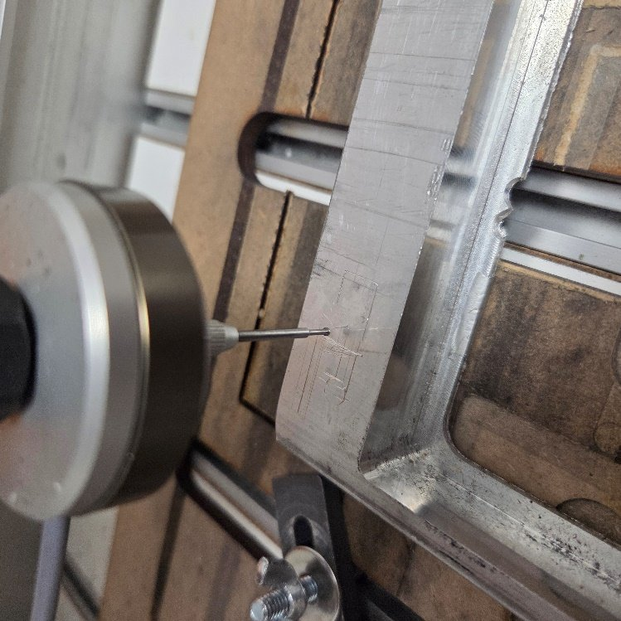
Click "M6" again and change to tool 1, since it is the reference. Then click "GOTO ZERO" to move to the zero point.
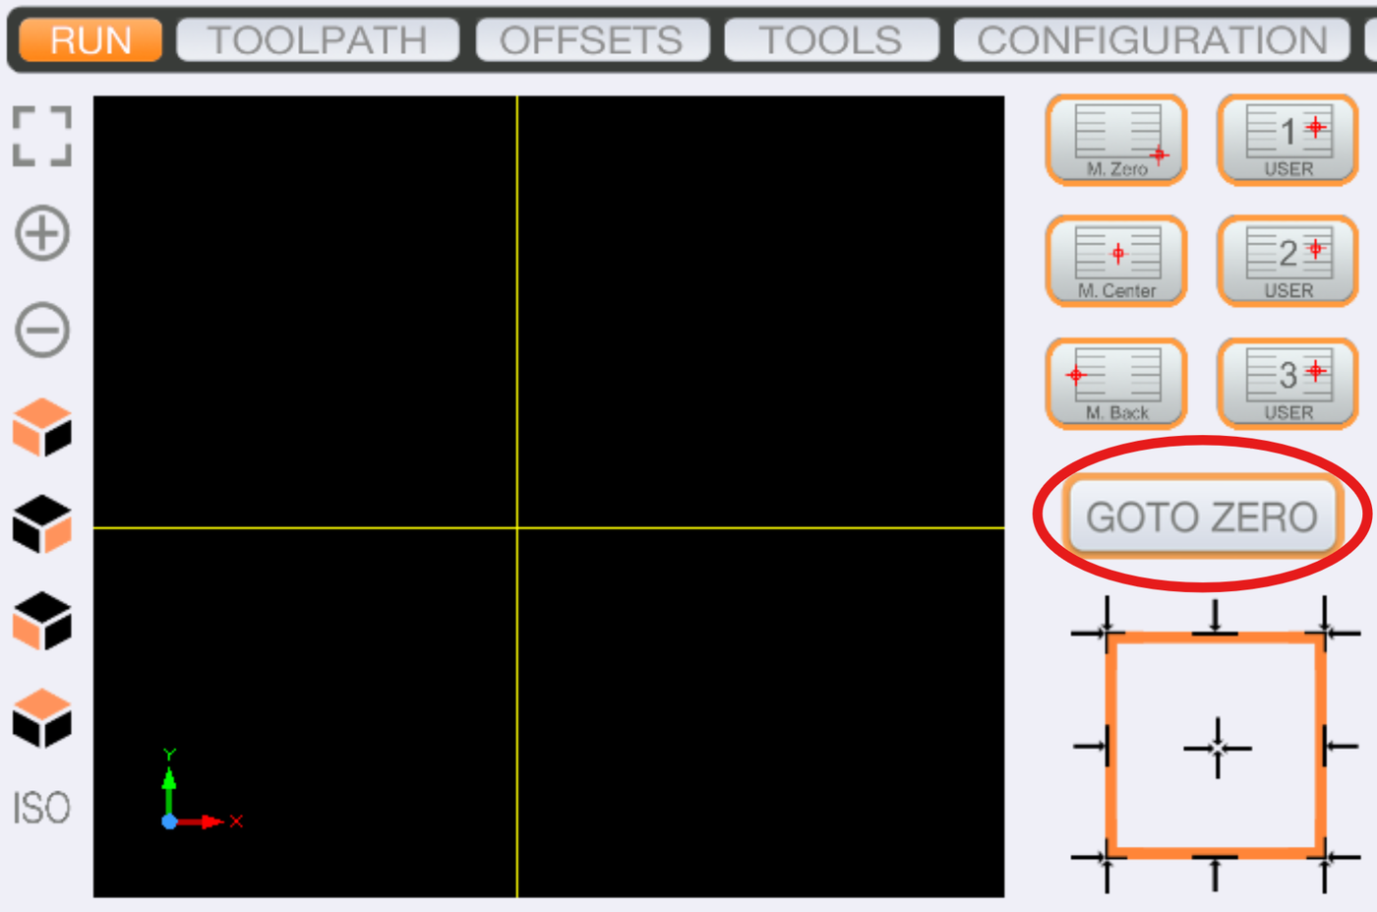
Stick a piece of tape on the surface where you set the zero point for the 3D Touch Probe.
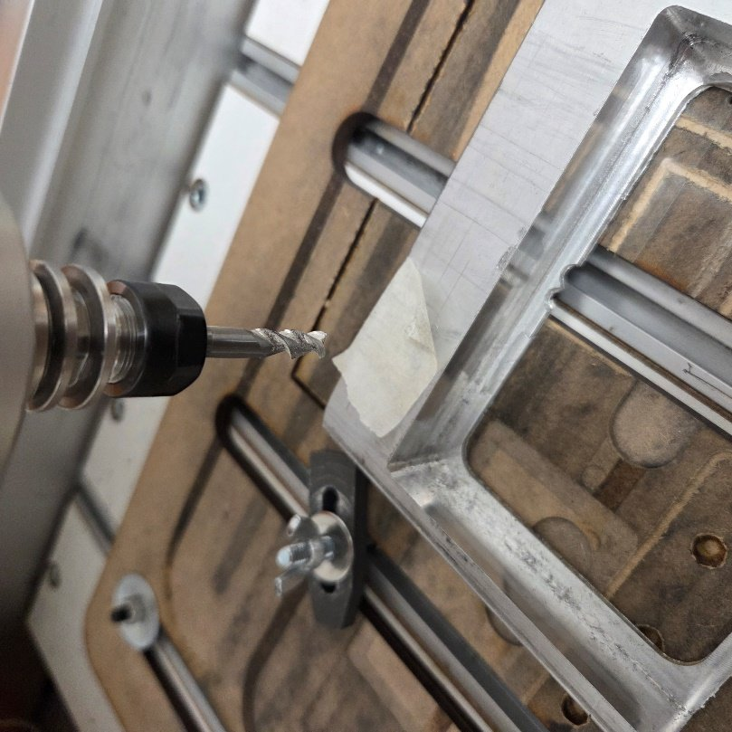
Move tool 1 down until it just scratches the tape. Use Page Up and Page Down on the keyboard. If you hold Ctrl, it moves in steps (the step size can be set in the orange panel on the left).
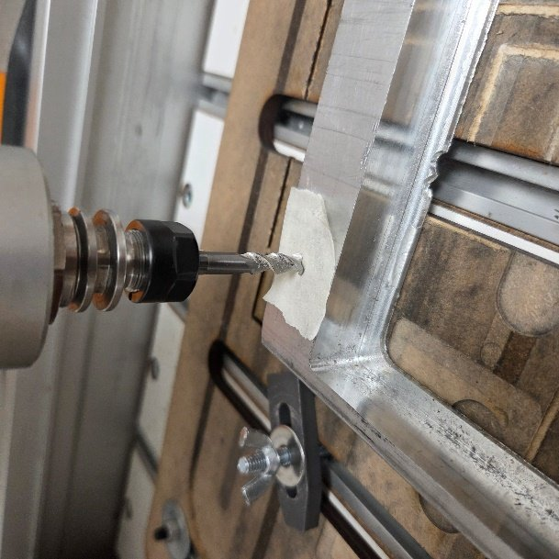
When you have found a suitable offset, enter the opposite value as the offset for tool 10, for example (−25.1219) × (−1) = 25.1219, and press Enter.
Refine the value by changing to tool 10 again, setting the zero point and changing to tool 1. Check whether the gap between the tape and the tool is OK. Adjust, for example, by adding (−0.6906) × (−1); the total offset then becomes 25.8125 mm in this example.
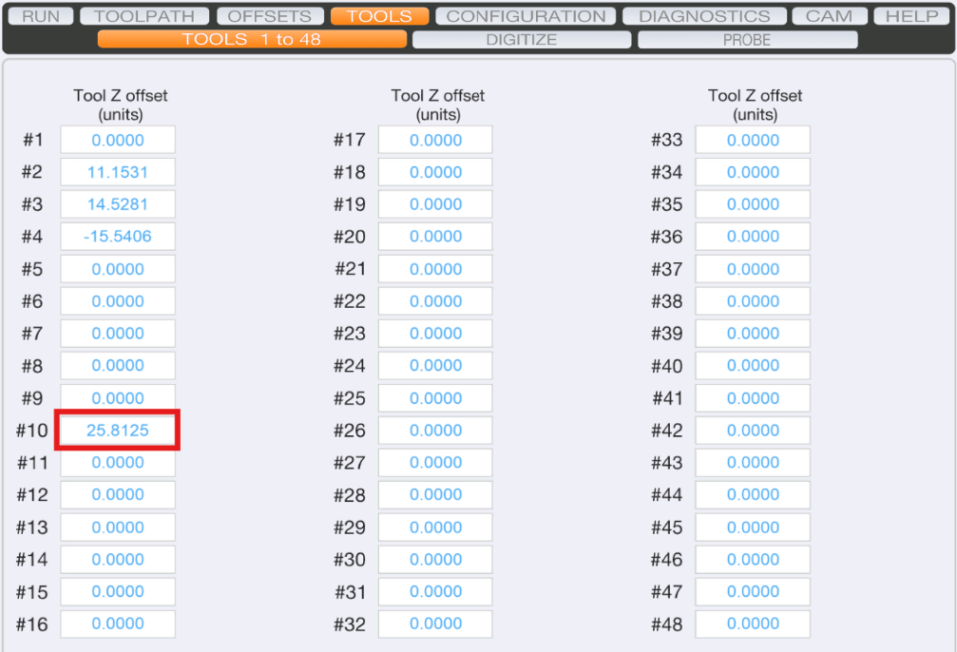

4.04 Preventing tools from sticking during a tool change
Dust or chips can get into the tool holder. Keep the chuck clean during service: vacuum it, and polish off any burnt-on dust.

4.05 Releasing a stuck tool
If a tool does not release during a tool change, release it by hand:
- Press in the chuck lock on the spindle.
- Put the spanner on the chuck and turn until it comes loose.

4.06 Finding the X and Y zero point with the probe
Coming soon.

4.07 Setting the Z zero point with the tool length sensor (TLS)
The TLS (Tool Length Sensor) is used every time you mill stock of a new thickness. It can also be done by hand, but with the TLS it is automatic.
- Clamp the stock.
- With the "M6" macro, change to the tool that is used first in the milling program.
- Move the spindle with the tool above one of the highest points of the stock.
- Put the TLS on the stock, under the tool.
- Move the tool up/down with Page Up or Page Down until it is just above, but not touching, the TLS.
- Press the TLS button in UCCNC and wait until the procedure has finished.
The Z zero point is now set with the selected tool.

4.08 Updating SolidWorks (and keeping the database)
Before you update SolidWorks, for example from the 2021 to the 2025 version, the Technology database has to be exported, and imported again after the update. The procedure is in 3.02.

5. Editing the post-processor | Teachers

5.01 Universal Post Generator (CAMWorks)
Coming soon.

6. Machine coordinates and calibration of our M700 | Teachers
The settings below were found when the tool magazine (automatic tool changer, ATC) was calibrated on the USN Stepcraft M700. Keep them, so the machine can be set up again after a software update or a reinstall. They follow Stepcraft's procedure in Quick Start Guide UCCNC v3.6, page 11, "M6 Macro: A New Way of Changing Tools in UCCNC" (see chapter 7). The calibration means editing the M6 and M20204 macro files.

6.01 Summary of the calibration
Step | Question / setting | Value on our M700
1 | Which automatic tool changer is used? | SK15 pneumatic lifting function
2 | How long does the spindle take to stop completely? | 7 seconds
3 | Where is the magazine mounted (1–4)? | 1 (rear)
4 | Which tool is T1? | The one furthest to the left, next to the tool length sensor (WLS)
5 | Find the coordinates of T1. | Done (see 6.02)
6 | Calculate the coordinates of the other tools. | Done: +45 mm per tool in X (see 6.03)
7 | Define the Z offset. | Done
8 | Open M6.txt and set the variables:
 | WaitSpin | 7000
 | Xtooloffset | 50
 | Ytooloffset | 50
 | Ztooloffset | 70.5
 | ToolRackHeight | -84.3156
 | ToolRackPosition | 1
 | ToolRackType | 1
 | ToolX (T1) | 60.2281
 | ToolY (T1) | 742.850
 | UsedToolRack | 1
WaitSpin is the spindle stop time in milliseconds (7 s × 1000).

6.02 T1 position and the SK15 adapter
Use machine coordinates when you measure. T1 is the first tool holder to the left, next to the tool length sensor (WLS) in the magazine. Find it as Stepcraft describes: home the machine, move the tool holder (without a tool) slowly into the centre of the T1 retaining ring from above, and use a sheet of paper to find the Z height where the holder meets it. With the SK15 adapter there are about 6 mm of travel left from there until the holder is seated.
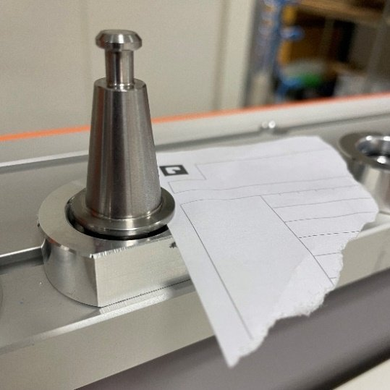
Ztooloffset is easiest to see with normal (work) coordinates after setting the zero point. On our machine, lowering the Z position by a further 1.5 mm and increasing the offset by 1.5 mm made sure the SK15 went all the way down.
Measured value | Value
ToolX[1] | 60.2281
ToolY[1] | 742.850
ToolRackHeight[1] | -84.3156
Ztooloffset | 70.5
WaitSpin | 7000

6.03 Tool positions in the magazine
The holders of the SK15 pneumatic tool magazine (in-table) are 45 mm apart, so X increases by 45 mm per tool while Y stays the same.
Tool | X (machine) | Y (machine)
T1 | 60.2281 | 742.850
T2 | 105.2281 | 742.850
T3 | 150.2281 | 742.850
T4 | 195.2281 | 742.850
T5 | 240.2281 | 742.850
T6 | 285.2281 | 742.850
T7 | 330.2281 | 742.850
T8 | 375.2281 | 742.850
T9 | 420.2281 | 742.850
T10 | 465.2281 | 742.850
In UCCNC, tool 9 is disabled in our M6 macro and tool 10 is the 3D Touch Probe (see 4.02).

6.04 Testing the tool changer
Click M6 and enter 0 (no tool). Then type m6t1 in the MDI field and press Enter for tool 1. Repeat for tool 2 (m6t2), tool 3 (m6t3) and so on, as needed.

6.05 Tool length sensor and probe
Under TOOLS → DIGITIZE, check that the tool length sensor height is set. Default values:
- Probe radius: 2
- Tool length sensor height: 32.5 mm
- Accuracy: 0.07 mm
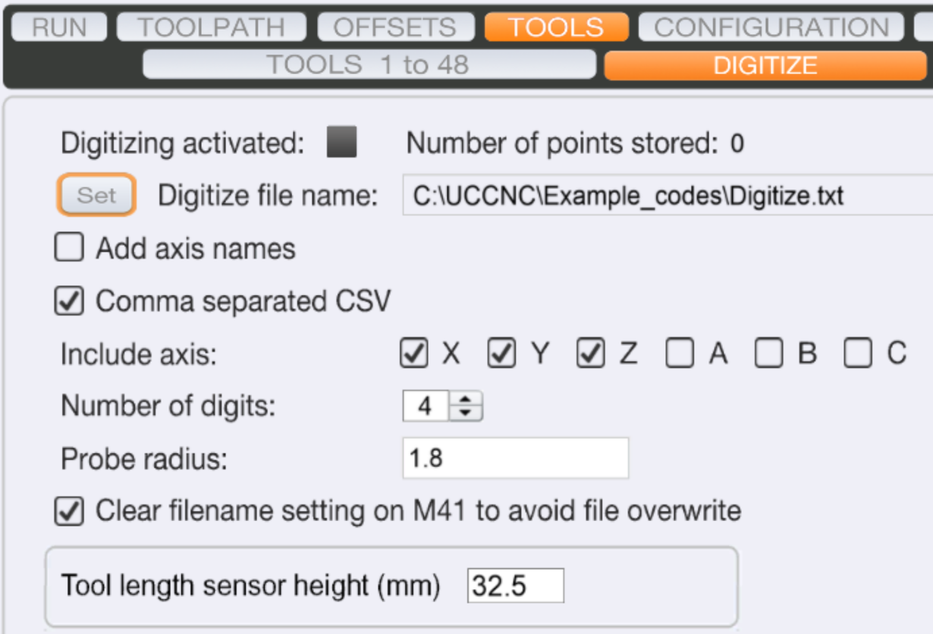

6.06 Spindle
Starting the spindle (MM-1000 DI): click "Single Line" to start the spindle at the set speed (Sset). With G-code, M03 S5000 starts the spindle clockwise at 5000 rpm, and M05 stops it.
For the MM-1000 DI, Stepcraft gives these speeds for the dial settings on the spindle:
Dial setting | 1 | 2 | 3 | 4 | 5 | 6
Speed (rpm) | 4,000 | 8,200 | 12,400 | 16,600 | 20,800 | 25,000
Spindle settings in UCCNC: under CONFIGURATION → AXIS SETUP → SPINDLE, set the spindle speed to min. 4000 and max. 25000 rpm.
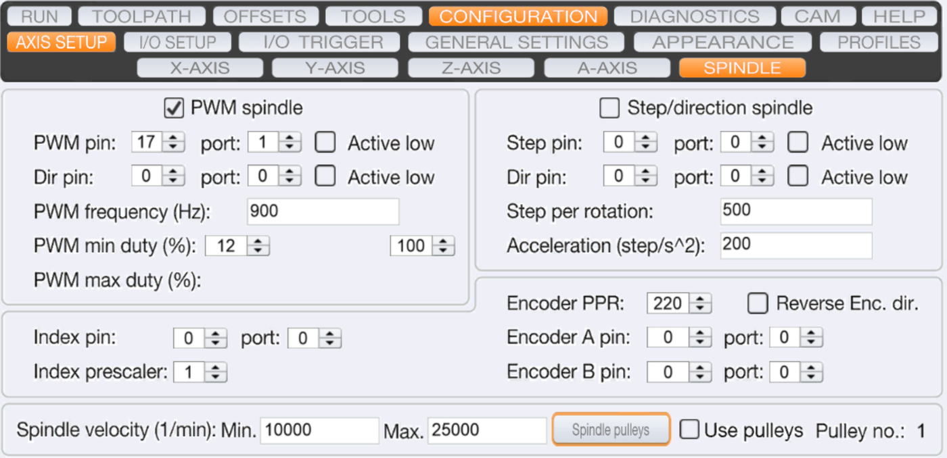

6.07 Warming up
To warm up the stepper motors, click Warmup on the RUN screen.
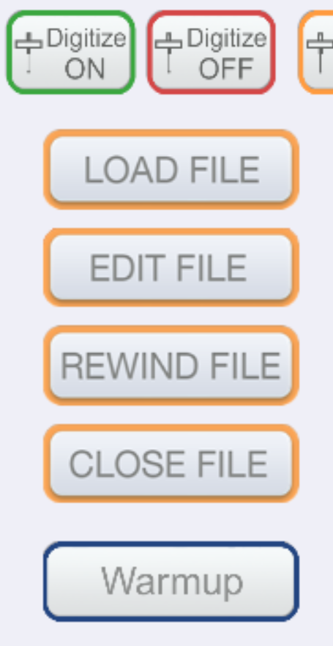
To warm up the spindle, run it at about 10,000 rpm for a little while if it has not been used for a long time.

6.08 The M6 macro while calibrating
Under CONFIGURATION → GENERAL SETTINGS, "On tool change code (M6) do the following" must be set to Run the tool change macro (M6). Then every change you save to the M6 file during calibration is used by the software straight away.
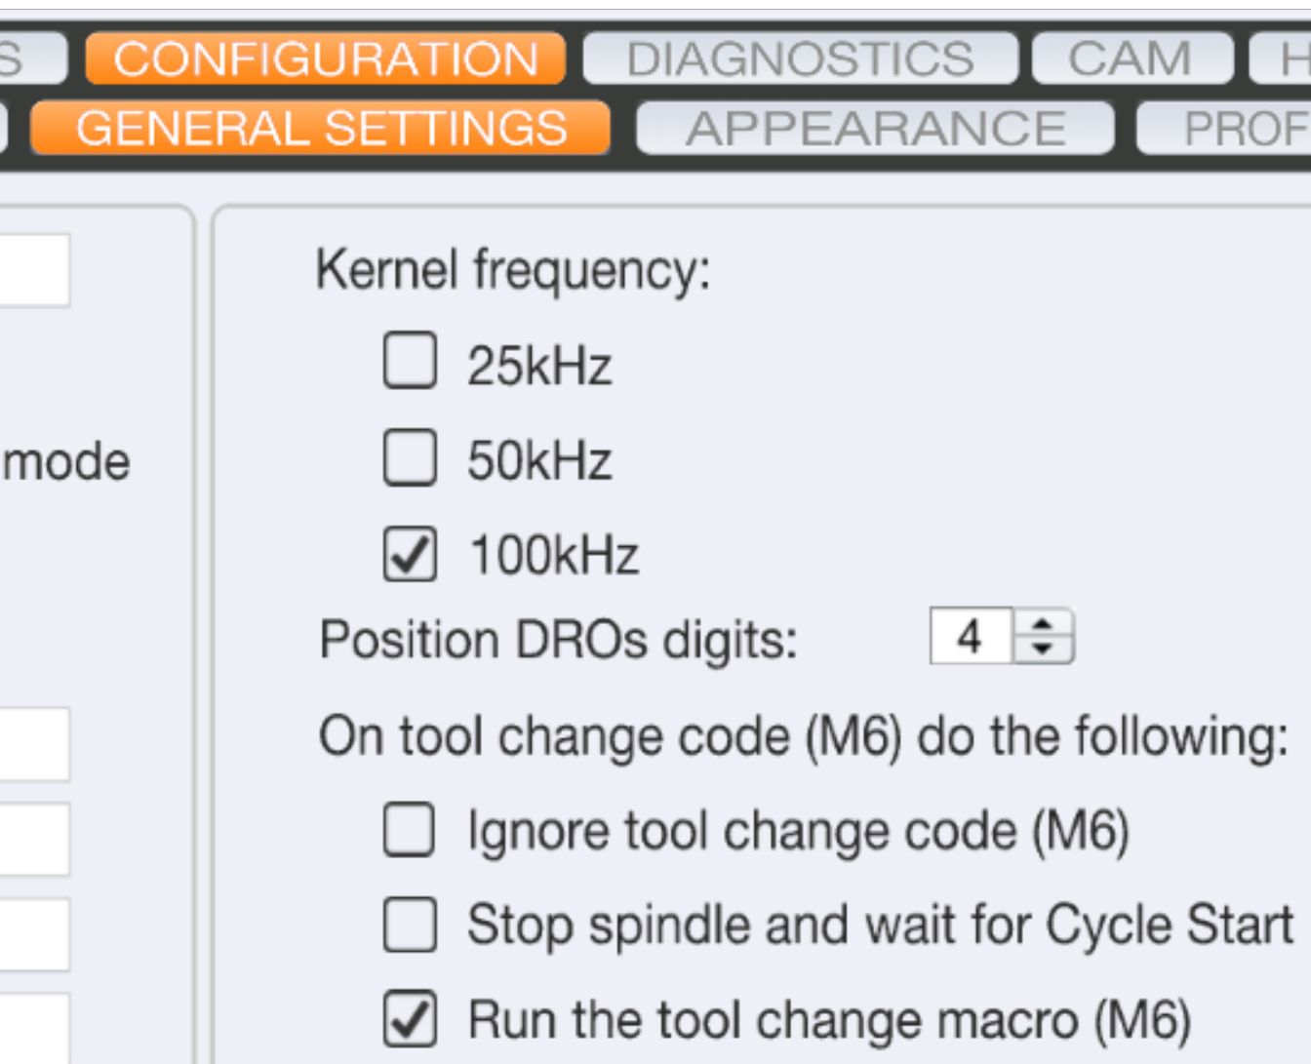

6.09 Diagnostics, supported codes and hotkeys
Diagnostics: the DIAGNOSTICS tab shows whether everything works, for example the limit sensors.
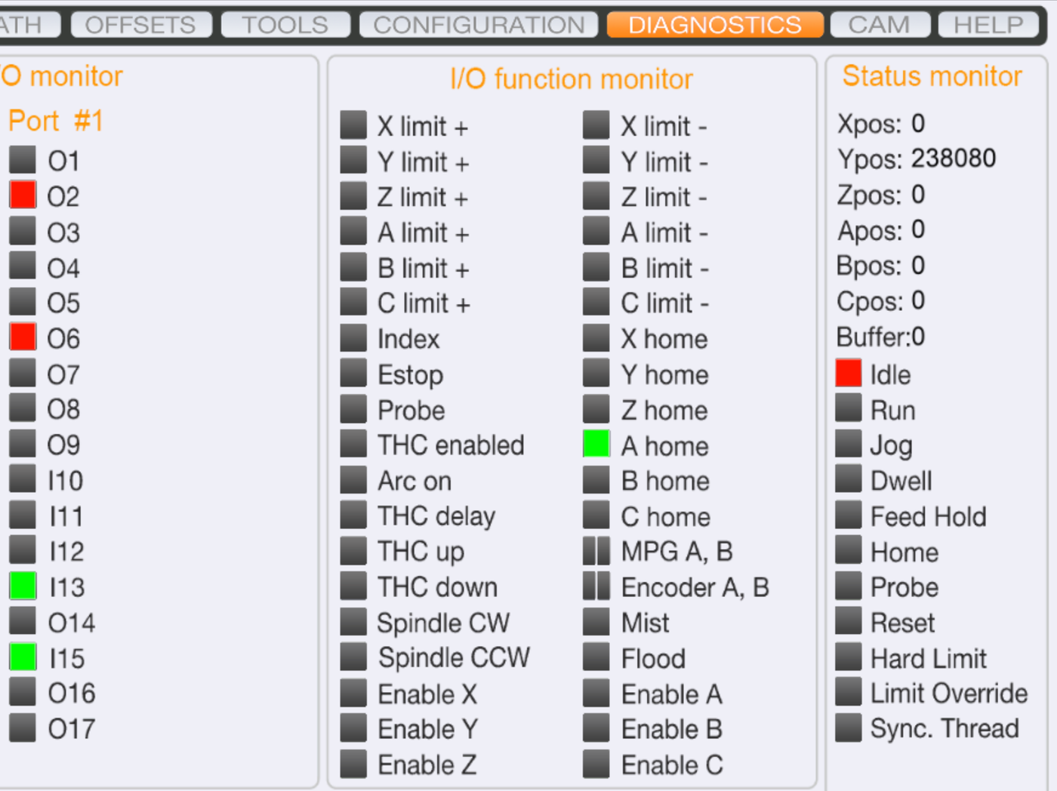
Supported G- and M-codes: an overview is under the HELP tab.
Hotkeys: custom hotkeys are added under CONFIGURATION → I/O TRIGGER → HOTKEYS. The usual keys for moving the machine are the arrow keys for X and Y and Page Up/Down for Z. Hold Shift for fast movement or Ctrl to move in steps. Tab switches between mouse and keyboard operation.

6.10 Tool offsets for the tool changer
When you add new tools, update the Z offset of each tool. The OFFSETS button does this automatically and applies the result temporarily or permanently, as you choose (see 4.02).

6.11 Plugins
Plugins such as a webcam, an Xbox 360 controller or AutoLevelerCA can be turned on under CONFIGURATION → GENERAL SETTINGS → Configure plugins. There you can enable and show plugins and have them start with UCCNC.
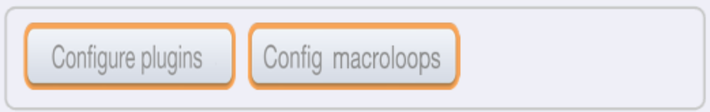

6.12 Z offset from a datum on the part
To add a fixed offset when the Z zero point is set from a datum, edit the M31 macro:
- Make a copy of M31.txt as a backup, and edit the original.
- Add these lines below line 28:
- // Add an offset (mm). Positive is up, negative is down:
double ZOffset = 0.335;
newZ = newZ-ZOffset;
- Adjust ZOffset to suit, save the file and test. Repeat until it is right.
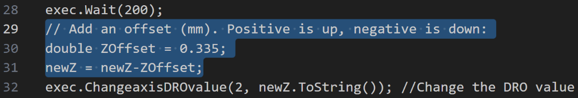
To set a new Z zero point from a datum, put the simple probe calibration tool on the datum, right under the tool, and click the TLS button. GOTO ZERO then moves to the new Z zero point.

7. External documentation (Stepcraft)
These manuals are made by STEPCRAFT, not by USN, and are © STEPCRAFT, so they are not stored on this site. Download them, in their latest versions, from Stepcraft's manuals page: stepcraft-systems.com/en/services/manuals.
Document | What it covers
Quick Start Guide – UCCNC STEPCRAFT OEM Version 3.6 (06/23, English) | Installing UCCNC, licence and machine profile, troubleshooting, and the M6 macro for tool magazines (page 11), used in chapter 6
First Steps – Tool Magazine M-Series, UCCNC v3.4 (English) | Setting up the tool magazine in UCCNC: preparing the tool changer and editing the macros
Operating Manual – Tool Magazine incl. pneumatic lifting function, M-Series (01/22, English) | The tool magazine itself: safety, installation (piston in the Z axis, magazine, electrical connection), operation (tool changer switch, software setup, tool length sensor, tool offsets in UCCNC) and technical data
Operating Manual – Tool Length Sensor TS-32 and TS-39 (English) | Safety, assembly and connection of the tool length sensor (TLS), and setup in UCCNC; the sensor is used to set the Z zero point (4.07, 6.05)
User's manual – UCR200 USB wireless jog pendant (plug-in V1.032, English) | The wireless hand control (jog pendant). Note: this manual describes the pendant with Mach3 software
Milling parameters (English) | How to calculate spindle speed and feed rate (n = vc · 1000 / (π · d), vf = n · z · fz) with a worked example, and a speed and feed benchmark by material and cutter diameter
Milling (English) | Cutter types (2-flute, diamond, single flute, spiral, radius, V-bit) and what each is for, and cutting data (infeed depth, rpm, feed) for Ø1–3 mm cutters in wood, plastics, composites, aluminium and brass

