STEPCRAFT M700 Machine Settings
Summary is at last page. Use the document Stepcraft_UCCNCv3.6_QuickStartGuide.pdf to help calibrate the Tool Magazine (page 11). You need to edit the M6 and M20204 file.


T1 tool placement (first tool)
[Picture from STEPCRAFT’s documentation removed in the published version.] [Drawing of the tool magazine (WLS and T1) from STEPCRAFT’s Quick Start Guide removed in the published version. T1 is the first holder next to the WLS.]

Adapter SK15 (6 mm travel)
USE MACHINE COORDINATES
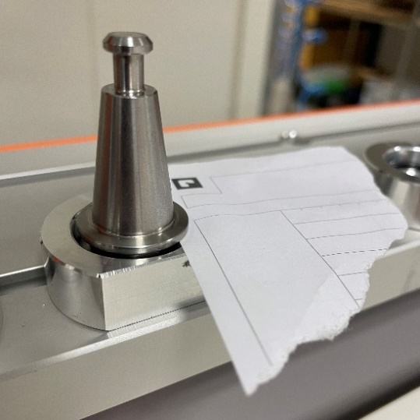
Ztooloffset can be measured with normal coordinates to see the offset easily after setting the zero point . For me, lowering the Z-position after with -1.5 mm and increasing offset with 1.5 mm made sure the SK15 was all the way down.
Measured value | Value
ToolX[1] | 60.2281
ToolY[1] | 742.850
ToolRackHeight[1] | -84.3156
Ztooloffset | 70.5
WaitSpin | 7000

MM-1000 DI: Click on “Single Line” to start the spindle (Sset)
[Table of spindle speeds from STEPCRAFT’s documentation removed in the published version. MM-1000 DI dial settings 1–6: 4,000 / 8,200 / 12,400 / 16,600 / 20,800 / 25,000 rpm.]
[Table from STEPCRAFT’s documentation removed in the published version. M03 S5000 starts the spindle clockwise at 5000 rpm; M05 stops it.]

Tool magazine – Tool position
[Table from STEPCRAFT’s documentation removed in the published version. SK15 pneumatic lifting function: 45 mm spacing, in-table.]
Tool | X coordinate | Tool | Y coordinate | Toolrack
ToolX[1] | 60.2281 | ToolY[1] | 742.850 | T1
ToolX[2] | 105.2281 | ToolY[2] | 742.850 | T2
ToolX[3] | 150.2281 | ToolY[3] | 742.850 | T3
ToolX[4] | 195.2281 | ToolY[4] | 742.850 | T4
ToolX[5] | 240.2281 | ToolY[5] | 742.850 | T5
ToolX[6] | 285.2281 | ToolY[6] | 742.850 | T6
ToolX[7] | 330.2281 | ToolY[7] | 742.850 | T7
ToolX[8] | 375.2281 | ToolY[8] | 742.850 | T8
ToolX[9] | 420.2281 | ToolY[9] | 742.850 | T9
ToolX[10] | 465.2281 | ToolY[10] | 742.850 | T10
ToolX[11] |  | ToolY[11]
ToolX[12] |  | ToolY[12]

Summary
Step |  | Value
1 | Which Automatic Tool Changer are you using? | SK15 pneumatic lifting function
2 | What is the time it takes for the spindle to come to a  complete halt? | 7 seconds
3 | In which position is your magazine mounted (1-4)? | 1 (rear end)
4 | Which of your tools should be handled as T1? | All to the left. The first one besides the WLS.
5 | Find the coordinates of T1. | OK
6 | Calculate the coordinates for the remaining tools. | OK  +45 mm for every tool.
7 | Define the appropriate ZOffset. | OK
8 | Open the M6.txt macro and adjust the variables. | OK
9 | WaitSpin | 7000
9 | Xtooloffset | 50
9 | Ytooloffset | 50
9 | Ztooloffset | 70.5
9 | ToolRackHeight | -84.3156
9 | ToolRackPosition | 1
9 | ToolRackType | 1
9 | ToolX | 60.2281
9 | ToolY | 742.850
9 | UsedToolRack | 1

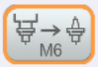
Testing the tool changer
Click on and insert 0. Then in the MDI field type m6t1 for tool 1 and click Enter on the keyboard. Repeat process for tool 2 (m6t2), 3 (m6t3) etc. if needed.

Tool length sensor height (mm) 3D probe
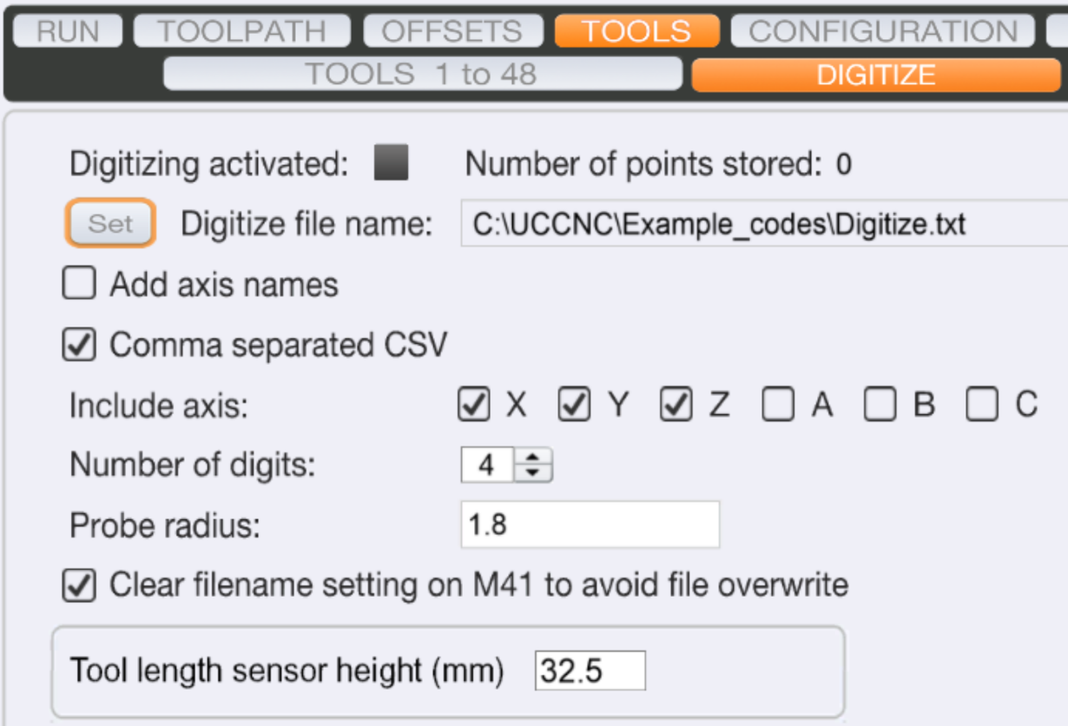
Make sure the length of the tool length is the set value. Default values:
Probe radius: 2
Tool length sensor height (mm): 32.5
Accuracy: 0.07 mm

Spindle settings
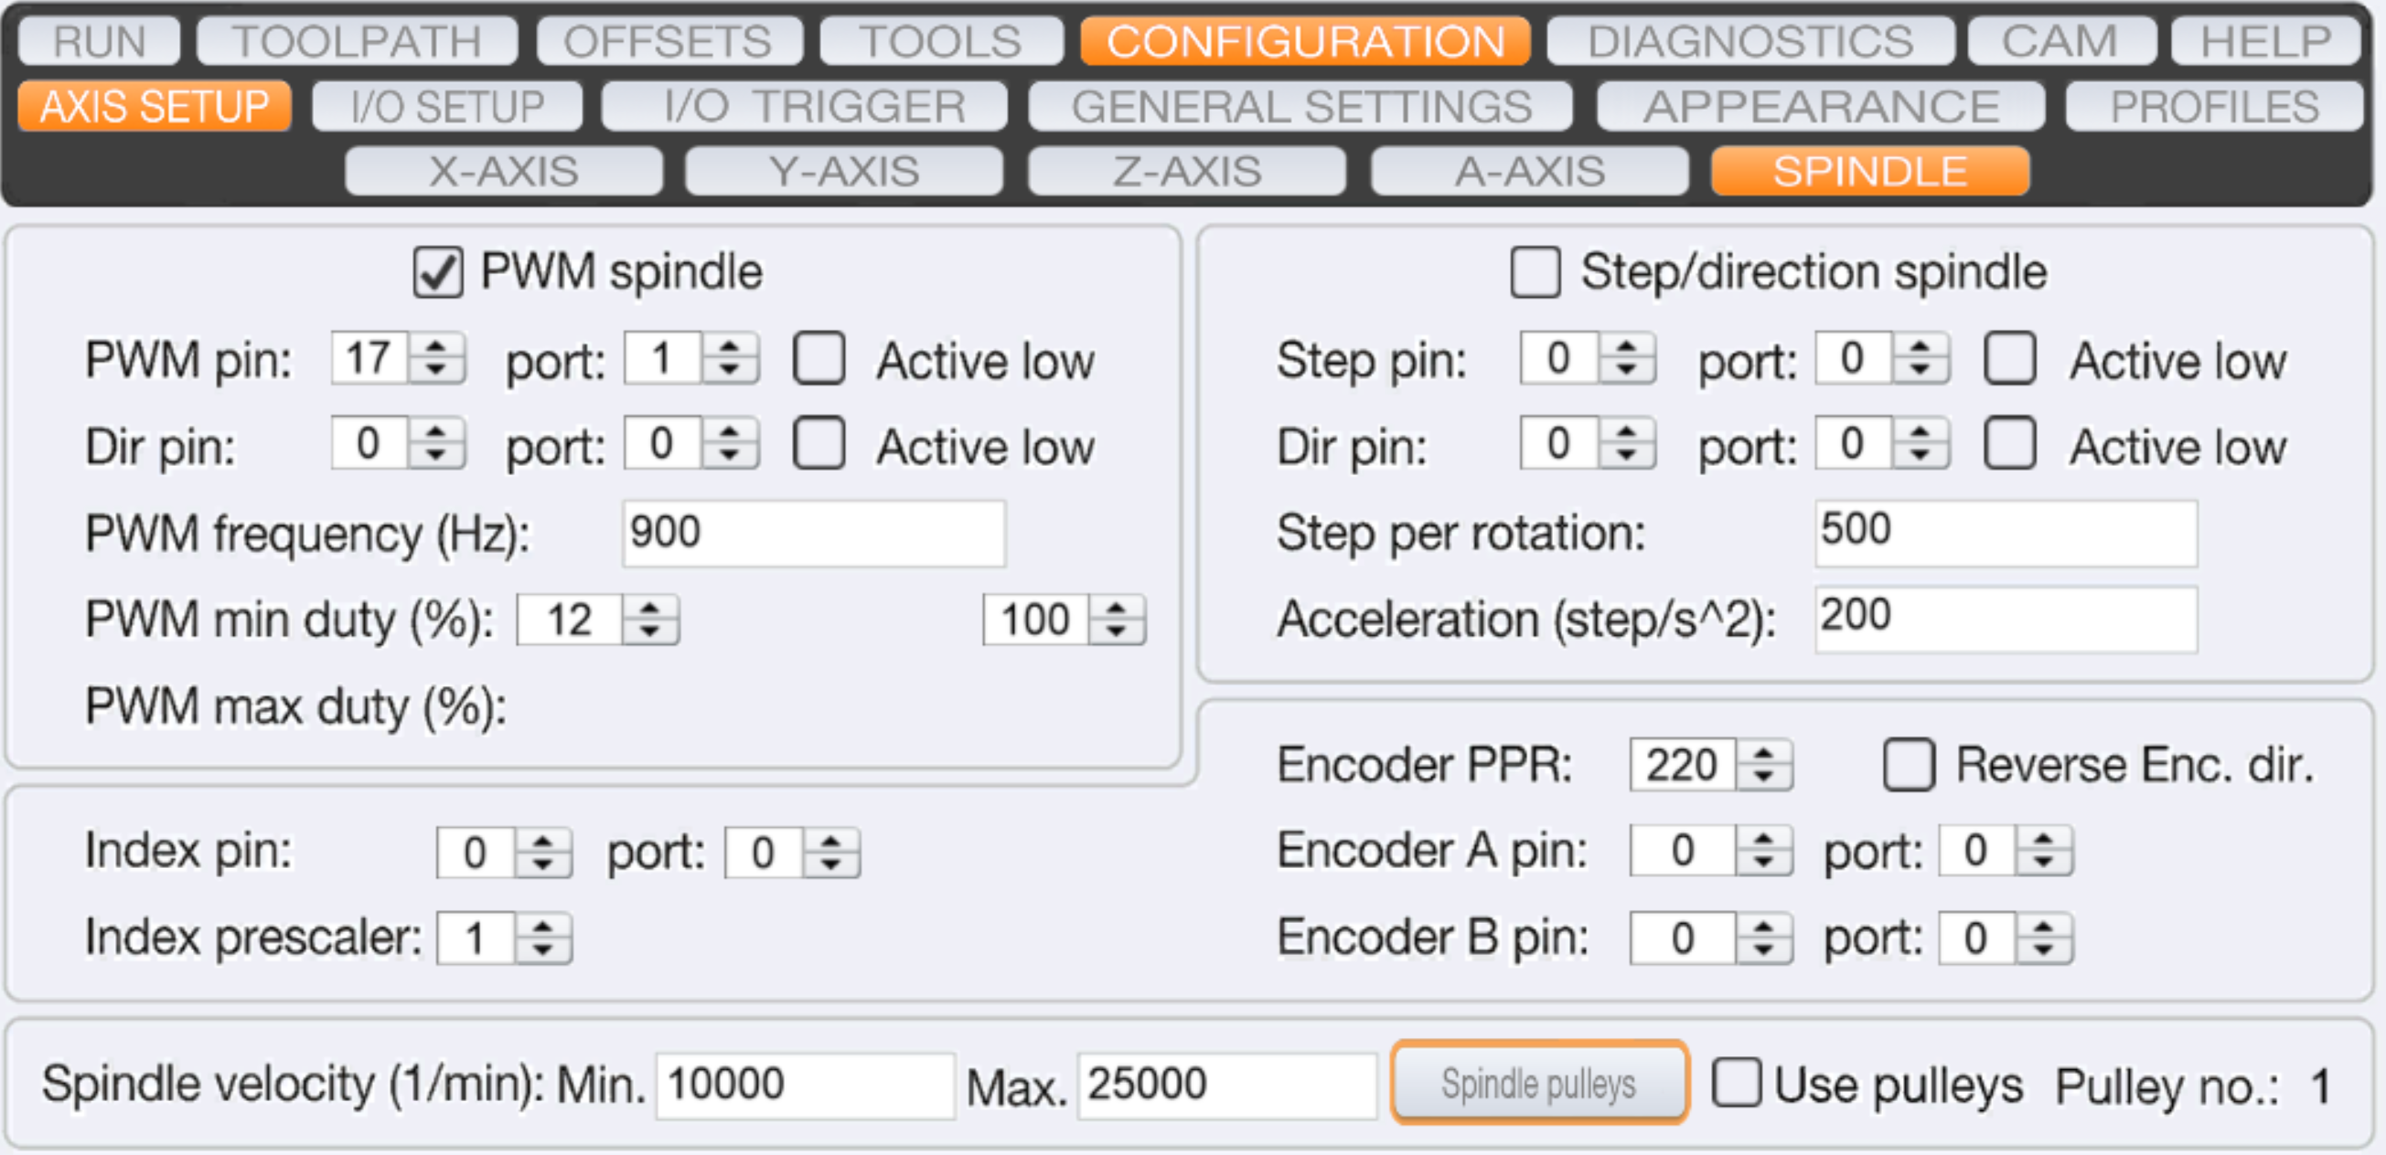

Warmup
To warm up the stepper motors, one can click the warmup button:
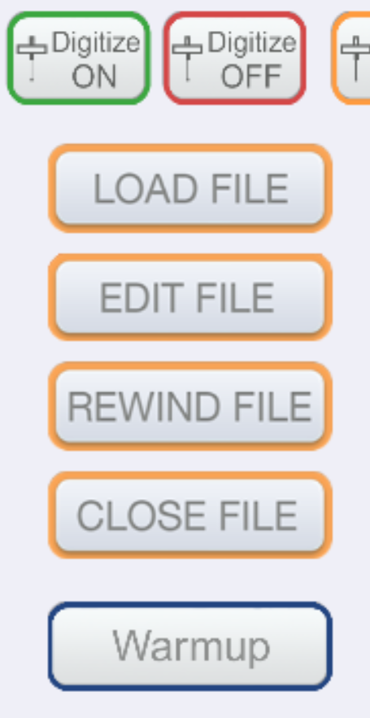
To warm up the spindle, one can start the spindle at around 10000 RPM and let it run for a little while if it’s a long time since it has been operating.

M6 “file mode”
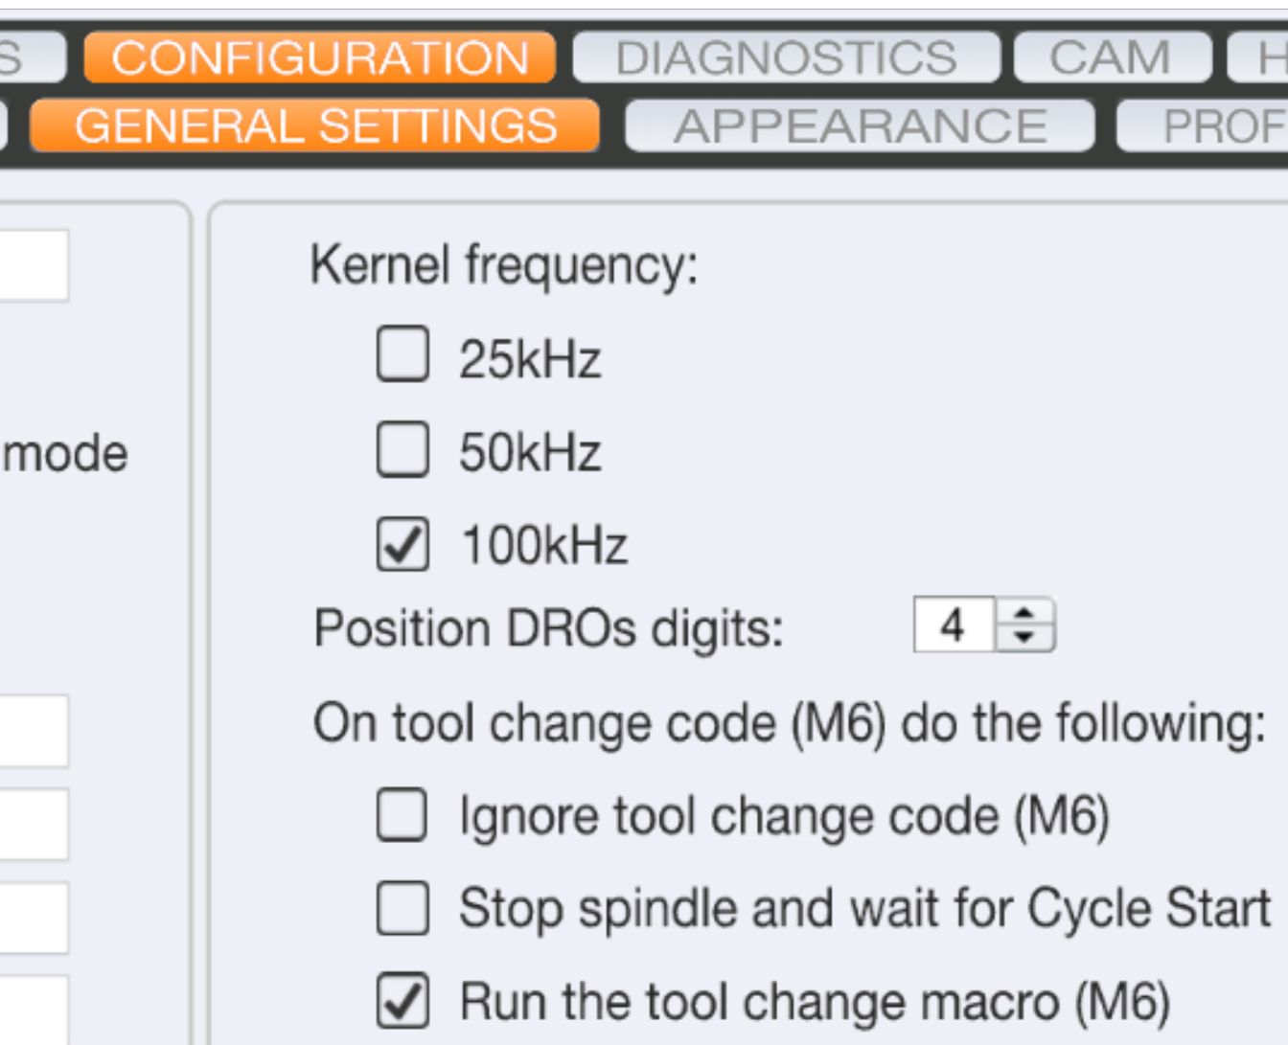
Every time you save the M6 file during calibration, changes will be reflected in the software straight away if “Run the tool change macro (M6)” is checked.

Spindle settings
Spindle settings can be changed under “Axis setup”. Set min to 4000 and max to 25000.

Diagnosing
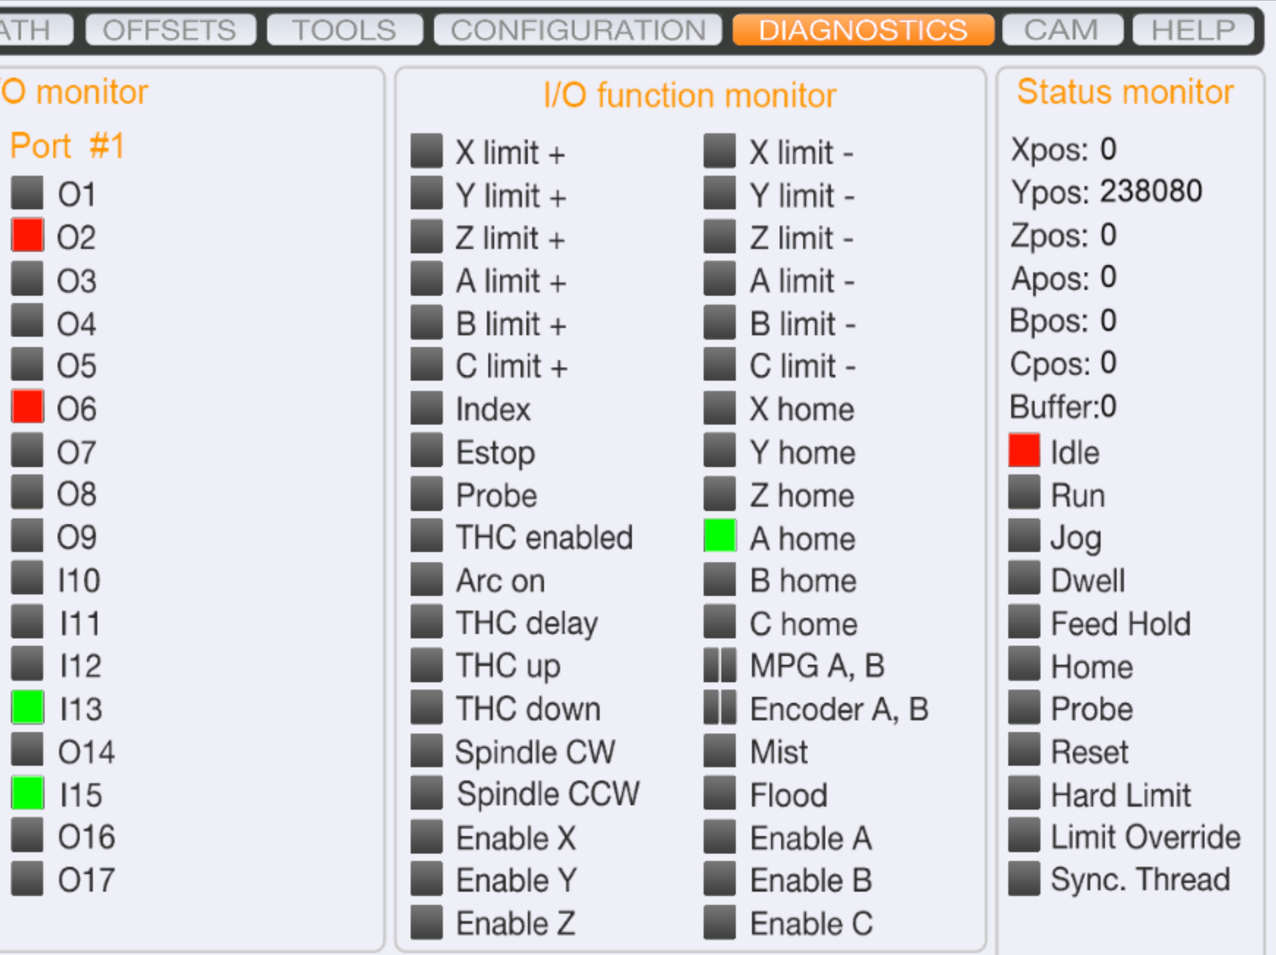
Use the diagnostic tab to diagnose if everything is working correctly (like limit sensors etc.).

Supported G- and M-codes
Supported G-codes can be seen as an overview under the “Help” tab.

Operation of the software
It is easy to add custom hotkeys. Normal hotkeys for navigating the machine are the arrow keys for X- and Y-axis + the page up/down for Z-axis. Then one can hold either the shift or ctrl key down at the same time for fast movement (shift) or use the step functionality (ctrl). Can also use the Tabular key to go from mouse movement to normal keyboard operation.

Setting the tools offset for ATC
When you add new tools, you need to update the Z-offset for each tool. This can be done automatically by using the Offset function 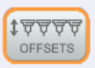. This will calibrate and apply it temporarily or permanently, from what you want.

Enabling plugins for UCCNC
You can activate plugins for UCCNC for adding webcam, Xbox 360 controller, AutoLevelerCA etc.:
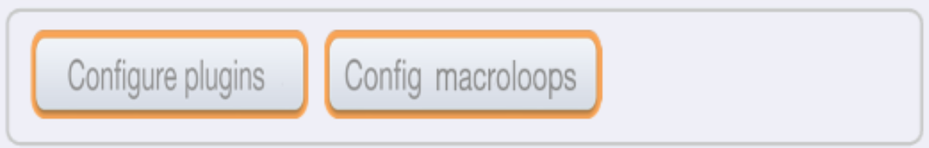
From here you can enable and show plugins and make them call on startup.

Adjusting the Z-offset from a datum on your part
First make a copy of M31.txt and edit the original file. Make changes underneath line 28:
// Add an offset (mm). Positive is up, negative is down:
double ZOffset = 0.335;
newZ = newZ-ZOffset;
It should look something like this – Adjust the ZOffset to your liking!
Save the file and repeat to try it out, and repeat.
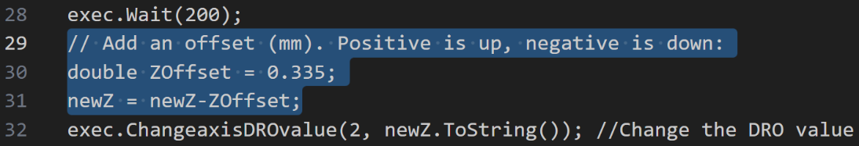
To set a new Z-offset from a particular datum as zero point, place the simple probe calibration tool on the datum and click this button  – make sure the calibration tool is right underneath the tool! Now when you click  you will go to the new Z-offset.

