Modix BIG-60 3D Printer – Connecting, Web Interface and Macros
USN Kongsberg · Metrology lab (Måleteknisk lab) · Updated 12 Nov 2026
Location: the metrology lab (Måleteknisk lab).
Health and safety is not fully covered here. Follow the lab supervisor's instructions, and do not use the printer without training.
The Modix BIG-60 is a large FDM 3D printer. It is controlled by a Duet 2 WiFi board running RepRapFirmware 3 (RRF3), and you use it either from the touchscreen or wirelessly from Duet Web Control (DWC) in a browser. This page collects the essentials from Modix's guides: connecting for the first time, setting up the network, using the web interface, uploading the configuration and macro files, and using the macros. Links to Modix's own guides and files are in chapter 7.
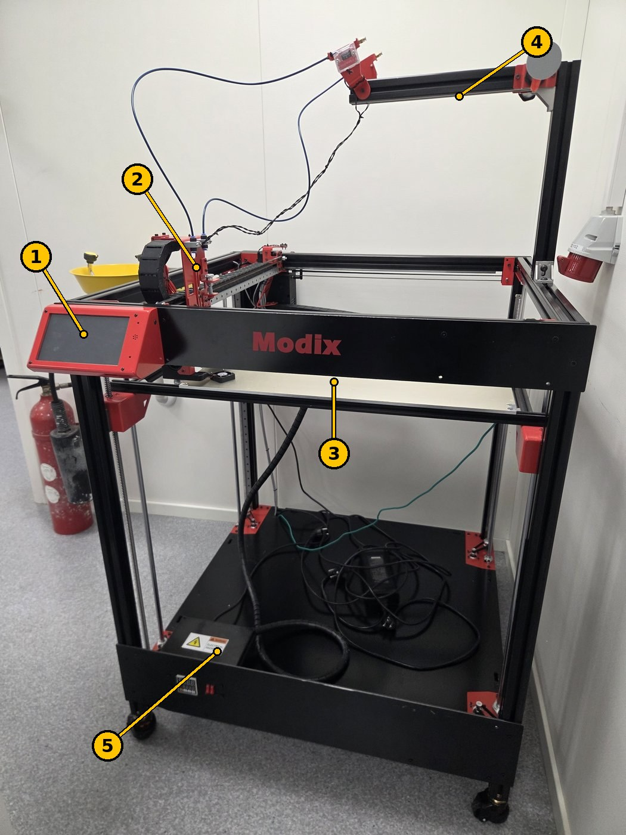
Figure 1. The Modix BIG-60 in the metrology lab. The numbers match the table.
No. | Part | What it does
1 | Touchscreen | Control the printer, start prints and run macros on the machine itself.
2 | Print head | Melts and lays down the filament.
3 | Build plate (bed) | The part is printed on it. It moves up and down (Z).
4 | Arm on top | Guides the filament from the spool down to the print head.
5 | Electronics box | The Duet board and the power supply. Electrical hazard – do not open it with the power on.

1. Safety and care
- Do not leave the printer unattended during PID tuning, or when a print is resumed after a power failure.
- "Allow unhomed moves" turns off the crash protection. The print head can then be driven into the bed. Use it only for maintenance, and restart the printer afterwards.
- When connecting by USB, the main power switch must be OFF. Power from both USB and mains at the same time can cause a ground loop.
- Give the printer's Wi-Fi or access point a strong password.

2. Connecting to the Duet board by USB (first time)
The network is set up by sending G-code commands to the Duet board from a terminal program over USB.
- First time only: take the microSD card out of the board. (When you connect later to change something, leave it in.)
- Close slicers and other programs that may use the COM port (Cura, PrusaSlicer, Simplify3D, Pronterface).
- Turn the main power switch off, and connect the Duet to the PC with a microUSB cable that carries data (not a charge-only cable).
- Windows: install the Duet USB driver if the device shows a yellow triangle or "Generic USB" in Device Manager. The Duet appears under Ports (COM & LPT) as USB Serial Device (COM#). macOS and Linux need no driver.
- Start a terminal program and connect to the port:
  - Windows: YAT. Choose the COM port under Terminal → Settings, set Text Settings → EOL sequence to <LF>, and click the green tick.
  - macOS: SerialTools (App Store), 115200 baud, Local Echo on. Or screen /dev/tty.usbmodem… 115200.
  - Linux: CuteCom (sudo apt install cutecom), port /dev/ttyACM0. Add your user to the dialout group first.
- Messages like "WiFi reported error: no known networks found" are normal.
- Send M115. If the board answers with the firmware version, the connection works.
Use a proper terminal program: some 3D printer host programs send everything in capitals, and the Wi-Fi name and password are case-sensitive. Use straight double quotes (").

3. Setting up the network
The Duet board can either join an existing network (local network) or create its own Wi-Fi (access point). It supports only 2.4 GHz networks with WPA2. For 5 GHz or enterprise networks (such as eduroam), use the access point.

3.1 Local network
M552 S0 ; Wi-Fi module to idle mode
M588 S"*" ; delete stored networks
M587 S"network-name" P"password" ; store the network (add I192.168.x.x for a fixed IP)
M587 ; check that the network is stored
M552 S1 ; turn the Wi-Fi module on
The board replies with its IP address, for example "WiFi module is connected to access point …, IP address 192.168.68.126". Write it down. Disconnect the USB, put the microSD card back in and reconnect. Then open the IP address in a browser on a computer on the same network.

3.2 Access point (the printer's own Wi-Fi)
M552 S0 ; Wi-Fi module to idle mode
M589 S"DuetSSID" P"password" I192.168.0.1 ; name, password (at least 8 characters) and IP
M552 S2 ; turn on as an access point
To make the printer start as an access point every time: open /sys/config_networking.g on the microSD card and change M552 S1 to M552 S2. Connect to the printer's Wi-Fi and go to the IP address (here 192.168.0.1).
The password must be at least 8 characters. You get no error if it is shorter, but the command does not work.

3.3 Wi-Fi troubleshooting
- Send M552 S1 again.
- Check the spelling of the network name and password.
- Restart the printer and wait a few minutes.
- M997 S1 resets the Wi-Fi firmware.
- Check that the Wi-Fi antenna is connected correctly.
- Try another network, or restart the router.
- Remember: 2.4 GHz only.
- Delete the stored networks (M552 S0, then M588 S"*") and set up again.
The MAC address (if IT needs it) is shown by M122 from the terminal or the web interface, near the end of the diagnostics. The printer's screen does not show it.

4. Duet Web Control (DWC 3.3)
The web interface is similar to the touchscreen. The main parts:
Area | What it is for
Top bar | The printer's name, a small G-code field, Upload & Start (upload a G-code file and start it) and Emergency Stop (stops everything immediately).
Status | Tool position in X/Y/Z, extruder position, speeds, input voltage on the board, board temperature and Z probe.
Tools / Heaters | Choose the tool (print head), set the active and standby temperatures, and see the heater status.
Machine movement | Home all axes or one at a time, and move the axes by hand. Extrude and retract filament, and control the fans.
Macros | Macros for calibration, tuning and other functions (see chapter 6).
Console | Send G-code and see the replies.
Height Map | The bed's height map, after calibration.
Job Status | Information and control while printing: pause, babystepping (adjust the first layer while printing), speed and extrusion factor, layer chart.
Files → Jobs / Macros / System | Uploaded G-code files, macro files and the printer's configuration files.
Settings → General / Machine-Specific | Interface settings, and printer-specific settings, diagnostics and firmware versions.

5. Uploading the configuration and macro files
A new Duet board comes with factory test files, and the printer does not work with them. They have to be replaced with Modix's files, and the firmware must be the right version. The same applies when upgrading from RepRapFirmware 2.05: the old files do not work with RRF3.
The files are in Modix's GitHub repository. The version for our printer: Modix V3 configuration and macro files, v3.4.5.c.
Choose the right variant. The wrong configuration can damage the printer.
- Check the printer's generation and type (Modix has separate files for, among others, Generation 4 IDEX, Generation 4 first batch, the V3–V4 upgrade and Version 3).
- Open the electronics box: 1 board = regular configuration, 2 boards = DUEX configuration.
- If the printer has a Griffin print head, there are separate Griffin variants.
Configuration files
- Download the right files and unpack them.
- In DWC: System → Upload System Files, select all the files and click Open.
- Answer Yes when asked to restart. "Connection is lost" appears, and the interface reconnects when the printer has booted.
If the printer uses the access point: change M552 S1 to M552 S2 in config_networking.g before uploading. If the board has Ethernet (Duet 2 Ethernet): remove the ; in front of ;M552 P0.0.0.0 in config.g.
Macro files
- Delete all old macro files first. The upload does not overwrite old files properly, and some have been renamed.
- Upload the macro zip file under Macros. It is unpacked automatically.
The macro files for V4, V4 IDEX and V3 cannot be used on each other's printers.
Check: the printer's model name should be shown at the top left of the screen. If it says DuetTest, the factory files are still in use. Check that the files are in the root folder of the microSD card, and try again.

6. Macros (RRF3)
The macros can be run from the touchscreen and the web interface, and they ask whether to continue before they start. They apply to configuration 3.3 Config B and later.

6.1 On the main screen
Macro | What it does
LED Toggle | Turns the LED light on and off (for printers with an enclosure).
Filament change | Changes filament during a print: pauses, parks the print head at the front left and unloads the filament. Insert the new filament, click Continue and then Resume.
Move to the front | Parks the print head at the front left, for maintenance.

6.2 General macros (Macros → General)
Macro | What it does
Allow cold extrusion | Allows extrusion below 160 °C, for example when cleaning the nozzle.
Allow unhomed moves (!) | Allows movement without homing, and outside the print volume. Risk of a crash. Restart the printer afterwards.
BLTouch self-test | Clears BLTouch errors and moves the pin up and down ten times.
Move bed down 50mm | Lowers the bed 50 mm, also when not homed. Take care near the bottom.
Power out recovery | Continues a print from the last layer after a power failure. Stay and watch, and abort if anything has shifted.
WiFi reset | Tries to reconnect to Wi-Fi, and otherwise offers to reset the Wi-Fi firmware. Touchscreen only.

6.3 PID tuning (Macros → PID)
PID tuning finds the best settings for the print head's temperature control by heating up and cooling down several times. It takes about 10 minutes per print head. Do not leave the printer.
- Get the printer ready as for printing: filament in the nozzle, bed at printing temperature (50–100 °C), lid and doors closed if you print with them closed.
- Run PID Tuning E0. It is done when the console shows "Auto tune heater 0 completed".
- Repeat with PID Tuning E1 for the second print head.
With configuration 3.4.1 Config D and later, the values are saved automatically. With older versions, copy the M307 line from the console into config.g (Settings → System editor), under Heaters, without a ; in front, and click Save changes.
The macro tunes at 240 °C with the fan at 100 %. For other temperatures or fan speeds, change the last line of the macro file, for example M303 H0 T0 P0 S400 F1.0 for 400 °C, or F0.35 for a 35 % fan.

7. External documentation (Modix)
These guides are made by Modix, not by USN, and are on Modix's support site. Search for the title there for the latest version, with all pictures.
Guide (Modix) | What it covers
Getting Connected to Duet (29 Nov 2022) | USB connection, drivers and terminal program for Windows, macOS and Linux (chapter 2)
RRF3 – Duet Networking Setup – Via USB (29 Nov 2022) | Local network, access point, troubleshooting and MAC address (chapter 3)
Duet Web Interface Introduction – DWC3.3 (26 Jan 2022) | A tour of the web interface with screenshots (chapter 4)
Configuration and Macro files upload (29 Nov 2022) | Choosing the right variant and uploading the files (chapter 5)
General Macros Guide RRF3 (17 Jan 2022) | All the macros and PID tuning (chapter 6)
Firmware and files: Modix V3 configuration and macro files, v3.4.5.c (GitHub).

