ASSIGNMENT #02 – CLASS ACTIVITY
Actuators, Sensors and Signals – Fall Semester 2026
ROS 2 Based Ultrasonic Sensor and Servo Motor Control System

Course | Actuators, Sensors and Signals
Submitted to | Prof. Muhammad Ilyas, Ph.D. in Robotics Engineering
Student | Kaldybekov Adilkhan
Platform | Arduino Uno + Ubuntu 24.04 + ROS 2 Jazzy
Final hardware | HC-SR04 ultrasonic sensor + SG90 servo motor

School of IT & Engineering (SITE)
Kazakh-British Technical University

1. Assignment Requirements and Objective
The assignment requires the use of a studied actuator/device, an input sensor, and at least two ROS nodes. The ROS part must include a subscriber that receives sensor information and a publisher that sends a command to a device. The implemented project satisfies these requirements using an HC-SR04 ultrasonic sensor, an Arduino Uno, an SG90 servo motor, and two ROS 2 Python nodes.

1.1 Project Objective
The objective is to build a simple proximity-controlled actuator system. The ultrasonic sensor measures the distance to an object. The measured distance is transmitted from the Arduino to ROS 2 over USB serial communication. ROS 2 evaluates the distance and sends a servo angle command back to the Arduino. When an object is within 50 cm, the servo moves to 90°. When the object is farther than 50 cm, the servo returns to 0°.

1.2 Functional Requirements
- Measure object distance using an ultrasonic sensor.
- Transmit distance readings from Arduino Uno to a ROS 2 node.
- Publish the sensor reading on the ROS topic /distance_cm.
- Use a second ROS 2 node to subscribe to /distance_cm and apply the 50 cm decision threshold.
- Publish the desired servo angle on /servo_angle.
- Transmit the command back to Arduino Uno over USB serial.
- Drive the SG90 servo to either 0° or 90° according to the ROS decision.

2. System Components
Component | Type | Purpose | Interface
Arduino Uno | Microcontroller | Reads the ultrasonic sensor and controls the servo | USB serial, digital I/O, PWM
HC-SR04 | Ultrasonic sensor | Measures object distance | TRIG and ECHO digital signals
SG90 | Servo actuator | Provides angular motion | PWM control on D9
Ubuntu 24.04.4 LTS | Operating system | Runs ROS 2 and the Python nodes | USB serial to Arduino
ROS 2 Jazzy | Middleware | Implements publisher/subscriber communication | /distance_cm and /servo_angle topics

2.1 Why the SG90 Servo Was Used
The SG90 is a standard PWM-controlled micro servo and can be driven directly from an Arduino control pin using the Arduino Servo library. This makes it appropriate for demonstrating an actuator controlled by a ROS-generated command while keeping the hardware interface simple and reliable.

3. Hardware Circuit
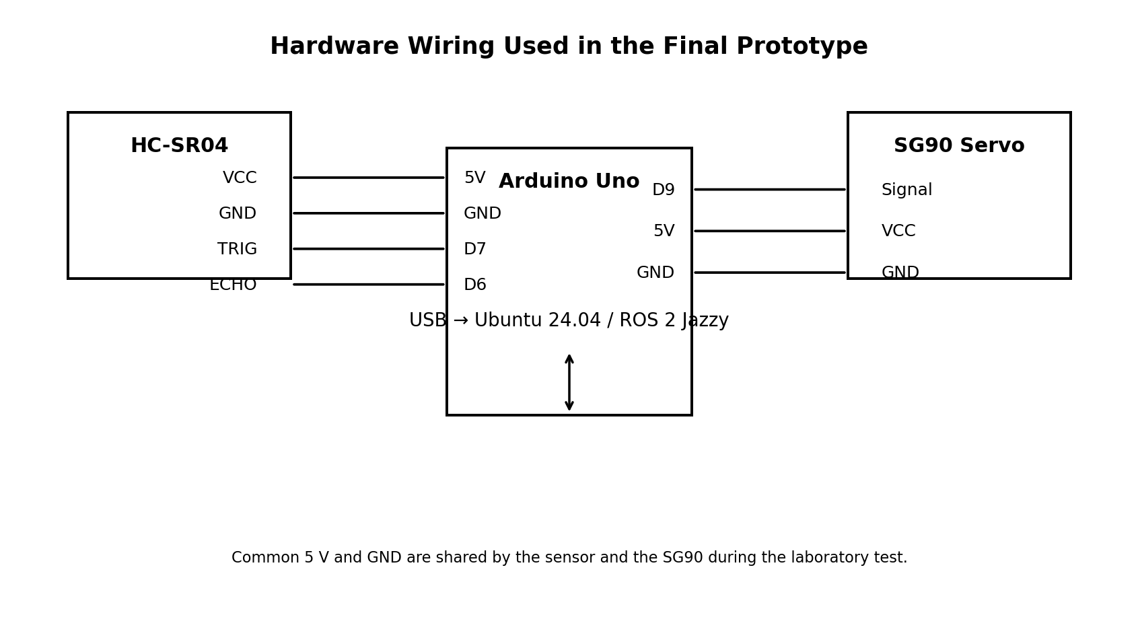
Figure 1. Hardware wiring of HC-SR04, Arduino Uno and SG90 servo.

3.1 Connection Table
Device pin | Arduino Uno pin | Function
HC-SR04 VCC | 5V | Sensor power
HC-SR04 GND | GND | Sensor ground
HC-SR04 TRIG | D7 | Ultrasonic trigger pulse
HC-SR04 ECHO | D6 | Echo pulse input
SG90 signal | D9 | Servo PWM command
SG90 VCC | 5V | Servo power for laboratory test
SG90 GND | GND | Servo ground

3.2 Ultrasonic Distance Formula
The HC-SR04 measures the round-trip travel time of an ultrasonic pulse. The distance is calculated using:
distance = duration × 0.0343 / 2
Here, duration is measured in microseconds. The value 0.0343 cm/µs is the approximate speed of sound in air. The result is divided by two because the sound travels from the sensor to the object and then back to the sensor.

4. Tinkercad Simulation Stage
Before the real prototype was connected to ROS 2, the sensor-actuator logic was verified in Tinkercad. The simulation used an ultrasonic distance sensor and a standard servo motor. The Arduino code measured distance and directly selected the servo position.
if (distance <= 50)
{
servo.write(90);
}
else
{
servo.write(0);
}
This first stage verified the electrical connections, the ultrasonic distance calculation, the 50 cm threshold, and the mechanical response of the servo. For the final ROS 2 implementation, this decision logic was removed from Arduino and moved into a ROS node.

5. Final Arduino Firmware
In the final design the Arduino acts as a hardware interface rather than the main decision-maker. It periodically measures the distance and sends a serial line in the format D:<distance>. It also listens for commands from ROS in the format S:<angle> and applies the received angle to the SG90.
Direction | Serial message example | Meaning
Arduino → ROS | D:61.50 | Measured distance is 61.50 cm
ROS → Arduino | S:90 | Move servo to 90°
ROS → Arduino | S:0 | Move servo to 0°
A baud rate of 115200 bit/s was used for communication. The Arduino Serial Monitor must be closed during ROS operation because only one process should own the serial port at a time.

6. ROS 2 Architecture
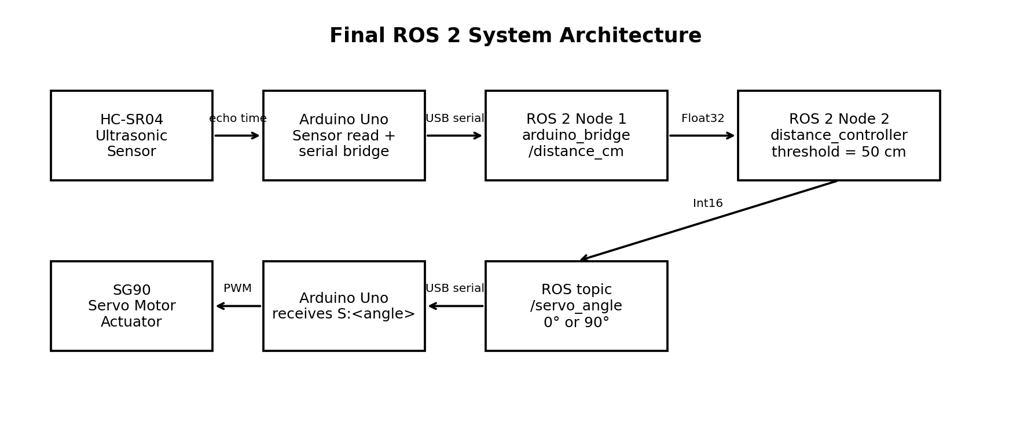
Figure 2. ROS 2 publisher/subscriber architecture used in the project.

6.1 Node 1 – arduino_bridge
The arduino_bridge node is the hardware interface. It opens /dev/ttyUSB0 at 115200 baud, reads lines sent by Arduino, converts D:<distance> messages into ROS Float32 messages, and publishes them on /distance_cm. The same node subscribes to /servo_angle and writes S:<angle> back to Arduino.

6.2 Node 2 – distance_controller
The distance_controller node contains the decision logic. It subscribes to /distance_cm. If the received value is less than or equal to 50 cm, it publishes 90 on /servo_angle. Otherwise, it publishes 0. Repeated identical commands are suppressed using a last_angle variable.

6.3 ROS Topics
Topic | Message type | Publisher | Subscriber
/distance_cm | std_msgs/Float32 | arduino_bridge | distance_controller
/servo_angle | std_msgs/Int16 | distance_controller | arduino_bridge

7. ROS 2 Installation and Package Setup
The project was run on Ubuntu 24.04.4 LTS with ROS 2 Jazzy. The workspace and Python package were created with the following commands:
mkdir -p ~/ros2_ws/src
cd ~/ros2_ws/src
ros2 pkg create --build-type ament_python ultrasonic_servo --dependencies rclpy std_msgs
The package was built and sourced with:
cd ~/ros2_ws
colcon build --packages-select ultrasonic_servo
source ~/ros2_ws/install/setup.bash
The two nodes were started in separate terminals:
ros2 run ultrasonic_servo arduino_bridge
ros2 run ultrasonic_servo distance_controller

8. Experimental Procedure and Results

8.1 Serial Communication Test
The Arduino appeared in Ubuntu as /dev/ttyUSB0. A minicom test at 115200 baud confirmed that distance data were being transmitted correctly. Observed readings included values around 280 cm for a distant object and approximately 61 cm when an object was moved closer.
D:279.92
D:66.94
D:280.35
D:61.50
D:61.10
The reverse communication path was also tested by sending S:90 and S:0 from the computer to the Arduino. The SG90 responded correctly, confirming bidirectional serial communication.

8.2 ROS 2 Test
After starting arduino_bridge, the node continuously received distance values from the Arduino. Example ROS log output is shown below.
[INFO] [arduino_bridge]: Distance: 61.5 cm
[INFO] [arduino_bridge]: Distance: 61.1 cm
[INFO] [arduino_bridge]: Distance: 60.7 cm

8.3 Expected Final Behaviour
Measured distance | ROS decision | Published angle | Servo state
> 50 cm | Object is outside threshold | 0° | Returned / closed position
≤ 50 cm | Object detected inside threshold | 90° | Activated / open position
The system therefore demonstrates the complete sensor → ROS decision → actuator loop required by the assignment. The main control condition is executed by ROS 2 rather than locally on the microcontroller.

9. Discussion
Separating hardware access from control logic makes the system modular. Arduino is responsible for timing-sensitive sensor and actuator interfacing, while ROS 2 handles communication and decision-making. The two ROS nodes can be replaced or extended independently without changing the physical wiring. For example, the threshold controller could later be replaced by a more advanced state machine, a GUI, or another sensor-processing node.
The use of ROS topics also makes the system observable during operation. Commands such as ros2 topic echo /distance_cm and ros2 topic echo /servo_angle can be used to inspect the information flow in real time.

10. Conclusion
A complete ROS 2 sensor-actuator system was implemented using an HC-SR04 ultrasonic sensor, Arduino Uno, and SG90 servo motor. The project was first validated as a direct Arduino/Tinkercad control system and then converted into a ROS 2 architecture. The Arduino transmits sensor data to ROS 2, the distance_controller node evaluates the 50 cm threshold, and the resulting servo command is sent back through the arduino_bridge node. The implementation demonstrates sensor acquisition, actuator control, serial communication, ROS publishers and subscribers, and a clear separation between hardware interfacing and high-level control.

Appendix A – Arduino Uno Firmware
#include <Servo.h>
Servo servo;
const int trigPin = 7;
const int echoPin = 6;
const int servoPin = 9;
unsigned long lastMeasure = 0;
void setup()
{
pinMode(trigPin, OUTPUT);
pinMode(echoPin, INPUT);
servo.attach(servoPin);
servo.write(0);
Serial.begin(115200);
}
void loop()
{
if (millis() - lastMeasure >= 100)
{
lastMeasure = millis();
digitalWrite(trigPin, LOW);
delayMicroseconds(2);
digitalWrite(trigPin, HIGH);
delayMicroseconds(10);
digitalWrite(trigPin, LOW);
unsigned long duration = pulseIn(echoPin, HIGH, 30000);
if (duration > 0)
{
float distance = duration * 0.0343 / 2.0;
Serial.print("D:");
Serial.println(distance);
}
}
if (Serial.available())
{
String command = Serial.readStringUntil('\n');
command.trim();
if (command.startsWith("S:"))
{
int angle = command.substring(2).toInt();
angle = constrain(angle, 0, 180);
servo.write(angle);
}
}
}

Appendix B – ROS 2 Node 1: arduino_bridge.py
import time
import serial
import rclpy
from rclpy.node import Node
from std_msgs.msg import Float32, Int16
class ArduinoBridge(Node):
def __init__(self):
super().__init__('arduino_bridge')
self.serial_port = serial.Serial(
'/dev/ttyUSB0', 115200, timeout=0.01
)
time.sleep(2)
self.distance_pub = self.create_publisher(
Float32, '/distance_cm', 10
)
self.servo_sub = self.create_subscription(
Int16, '/servo_angle', self.servo_callback, 10
)
self.timer = self.create_timer(0.02, self.read_arduino)
self.get_logger().info('Arduino bridge started')
def read_arduino(self):
if self.serial_port.in_waiting > 0:
line = self.serial_port.readline()
try:
line = line.decode().strip()
except UnicodeDecodeError:
return
if line.startswith('D:'):
try:
distance = float(line[2:])
msg = Float32()
msg.data = distance
self.distance_pub.publish(msg)
self.get_logger().info(
f'Distance: {distance:.1f} cm'
)
except ValueError:
pass
def servo_callback(self, msg):
angle = max(0, min(180, msg.data))
command = f'S:{angle}\n'
self.serial_port.write(command.encode())
self.get_logger().info(
f'Servo command: {angle} degrees'
)
def main(args=None):
rclpy.init(args=args)
node = ArduinoBridge()
try:
rclpy.spin(node)
except KeyboardInterrupt:
pass
finally:
node.serial_port.close()
node.destroy_node()
rclpy.shutdown()
if __name__ == '__main__':
main()

Appendix C – ROS 2 Node 2: distance_controller.py
import rclpy
from rclpy.node import Node
from std_msgs.msg import Float32, Int16
class DistanceController(Node):
def __init__(self):
super().__init__('distance_controller')
self.threshold = 50.0
self.last_angle = None
self.distance_sub = self.create_subscription(
Float32,
'/distance_cm',
self.distance_callback,
10
)
self.servo_pub = self.create_publisher(
Int16,
'/servo_angle',
10
)
self.get_logger().info('Distance controller started')
def distance_callback(self, msg):
distance = msg.data
if distance <= self.threshold:
angle = 90
else:
angle = 0
if angle != self.last_angle:
command = Int16()
command.data = angle
self.servo_pub.publish(command)
self.get_logger().info(
f'Distance: {distance:.1f} cm -> Servo: {angle} deg'
)
self.last_angle = angle
def main(args=None):
rclpy.init(args=args)
node = DistanceController()
try:
rclpy.spin(node)
except KeyboardInterrupt:
pass
finally:
node.destroy_node()
rclpy.shutdown()
if __name__ == '__main__':
main()

References
1. Assignment #02 – Class Activity, Actuators, Sensors and Signals, Fall Semester 2026, Prof. Muhammad Ilyas.
2. ROS 2 Jazzy documentation – ROS 2 concepts, nodes, topics, publishers and subscribers.
3. Arduino Servo library documentation – standard hobby servo control on Arduino Uno.
4. HC-SR04 ultrasonic sensor technical documentation – ultrasonic ranging principle and trigger/echo timing.

