Vehicle Dynamics Workshop

Bicycle Model

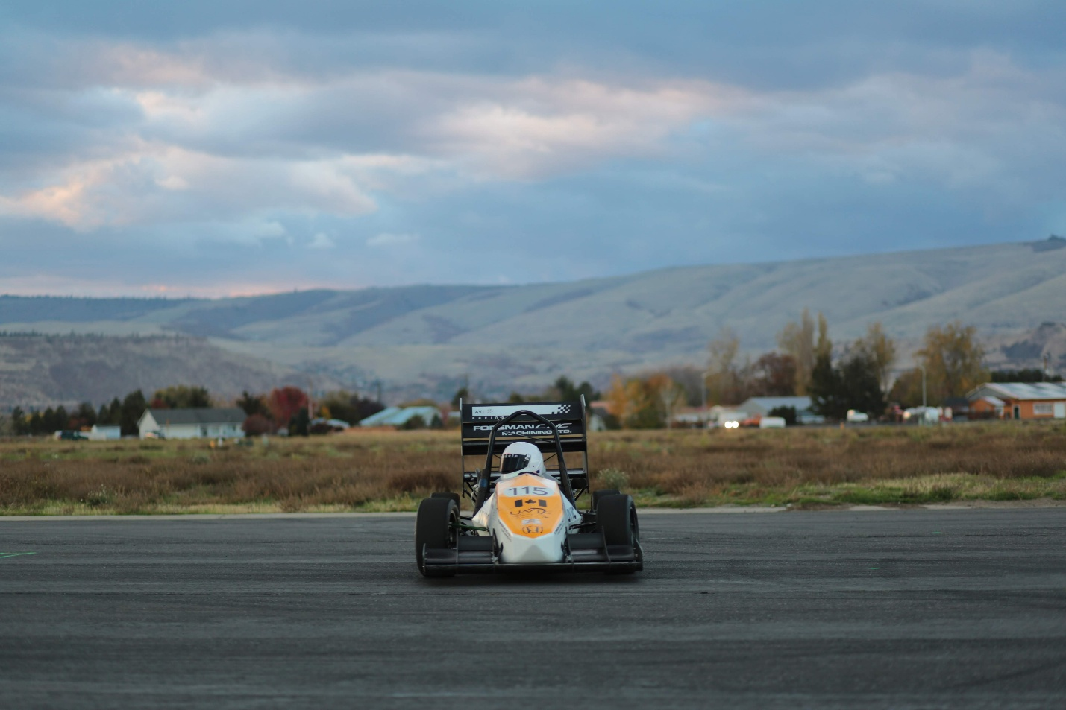

Contents
Learning Outcomes 3
Requirements 3
Lateral Tire Dynamics [1] 4
MATLAB Tire Model Implementation 5
The .TIR File 6
Syntax 6
Force Function Syntax 6
Tire Force Relationships 7
Lateral Force vs Slip Angle and Normal Force 8
The Bicycle Model [3] 10
Control & Stability 10
Slip Angle Derivation 11
Summary of Slip Angle Derivation 13
Control & Stability Derivatives 13
Lateral Acceleration 15
Programming 15
References 21

Learning Outcomes
This lab session aims to introduce learners to the fundamentals of vehicle dynamics by using an experiential learning approach, assuming no previous knowledge except an introduction to calculus and rigid body equilibrium.
Vehicle dynamics is the study of external forces and moments that work to move a vehicle and how the configuration of a vehicle can optimize those forces and moments. Vehicle dynamics engineers often work with virtual models to understand and predict performance. This lab introduces learners to two of the most fundamental vehicle dynamics models: the Magic Formula tire model and the bicycle model.
By the end of this lab session, learners will be able to:
- Draw the free-body diagram of a bicycle model
- Derive external forces & moments in steady-state cornering
- Derive slip angles for the chassis and both tires
- Derive stability and control derivatives
- Create a virtual model (using their programming language of choice) of a vehicle in steady-state cornering with:
  - Single wheel at each axle (bicycle model)
  - Magic formula tire model
- Exercise their virtual model to
  - Test how the front-rear location of the center of gravity affects control & stability

Requirements
- A laptop with a MATLAB installation
  - Free for UVic Students: https://matlab.uvic.ca/student/
  - It takes a while to install so please do this beforehand
- No programming experience necessary
- No vehicle dynamics experience necessary
- MECH 141: Engineering Mechanics
- MATH 100: Calculus

Lateral Tire Dynamics [1]
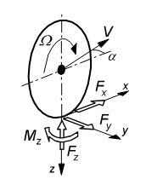
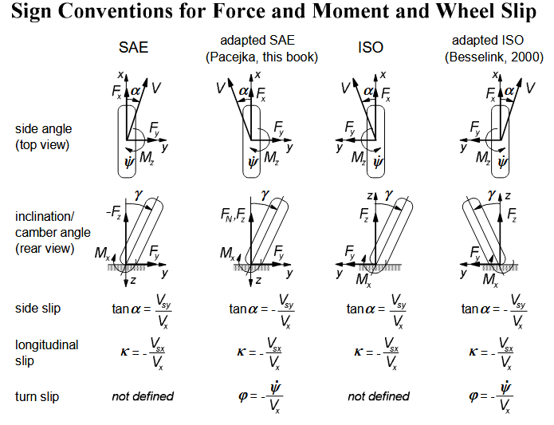
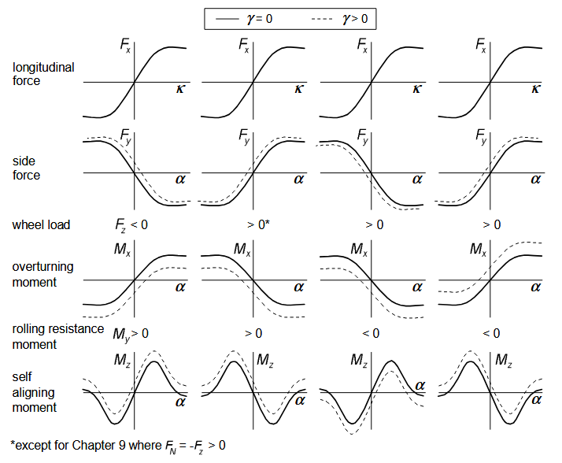

MATLAB Tire Model Implementation
[2] details the “Magic Formula” (MF) (also known as “Swift”, “Pacejka”) tire model. A file called “magicformula.m” is provided for you. This file implements the MF equations for longitudinal force (Fx), lateral force (Fy), and aligning moment (Mz). The coefficients for the MF equations are typically stored in a “.tir” file. A file for the current tires on the FSAE car has been provided for you: “Hoosier 43100 18.0x6.0-10 R20 7in Rim.tir”. The coefficients in the .tir file have been extracted to the .mat file (also provided): “Hoosier 43100 18.0x6.0-10 R20 7in Rim.mat”.

The .TIR File
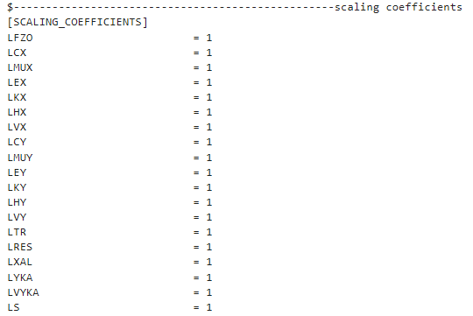
The .TIR file is a formatted text file, as shown above. Coefficients are stored line-by-line under their respective headings. This format is standardized, so don’t modify the format. You can, however, add coefficients and change the values of the coefficients.

Syntax
The tire force calculator is implemented as a class, with the coefficients stored as a property and public methods to calculate forces. There is a class constructor that takes the filename of the coefficients file.
To create an instance of the magicformula class:
>> m = magicformula('Hoosier 43100 18.0x6.0-10 R20 7in Rim.mat')

Force Function Syntax
Each force function in this implementation has five inputs:
Input | Description
Sa | Slip angle [radian]
Sr | Slip ratio [-]
Ia | Inclination Angle [radian]
Fz | Normal Force [Newton]
p | Inflation Pressure [Pa]

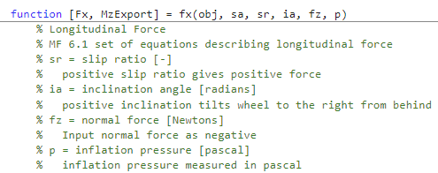

Force is calculated by using the class methods:
fx = m.fx(0, 0.8, 0, -888, 70000);
The above command calculates longitudinal force with:
Input | Value
Sa | 0
Sr | 0.8
Ia | 0
Fz | 888
p | 70,000

Tire Force Relationships
- Open magicformula.m in MATLAB
- Instantiate the class object
  - m = magicformula(“Hoosier 43100 18.0x6.0-10 R20 7in Rim.mat”)
- Plot Fy vs slip angle
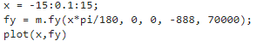
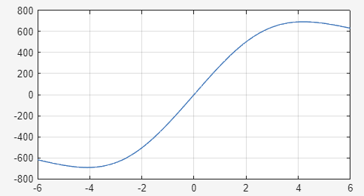

Lateral Force vs Slip Angle and Normal Force
Use the tire model to see how slip angle and normal force affects lateral force. Re-create the following script and run it to bring up a plot of lateral force vs slip angle and normal force (left), and lateral friction coefficient vs slip angle and normal force (right).
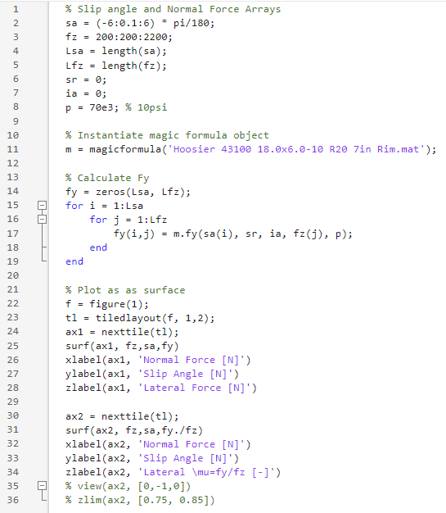
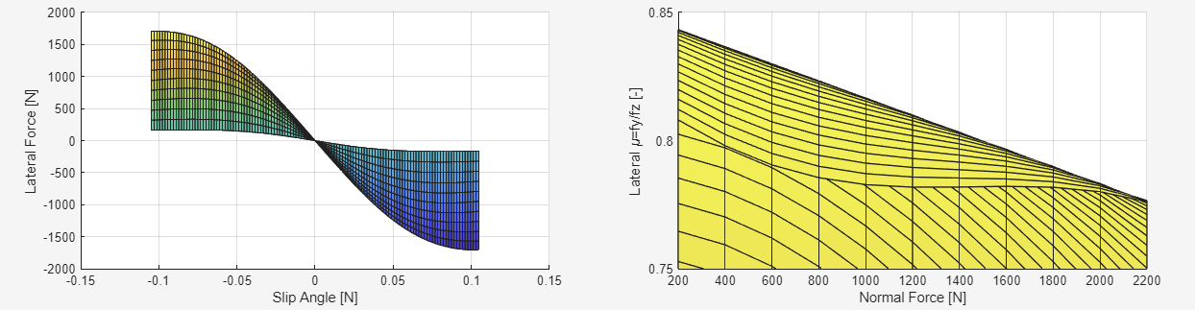
The relationship between friction coefficient and normal force is linear with a negative slope! As normal force increases, friction coefficient decreases.

The Bicycle Model [3]
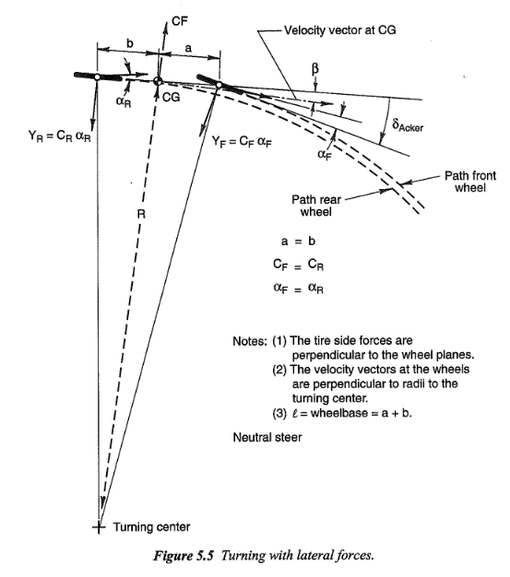
$$δ=\frac{l}{R}+(-α_{F}+α_{R})$$

Control & Stability
Assume there is an imbalance between the moment caused by the force acting at the front wheel about the center of gravity, and the force acting at the rear wheel about the center of gravity.

Some notation:
Symbol | Description
$$β$$ | Chassis slip angle
$$V$$ | Vector sum velocity
$$v$$ | Lateral velocity
$$r$$ | Yaw velocity
$$α_{R}$$ | Rear tire slip angle
$$α_{F}$$ | Front tire slip angle
$$b$$ | Distance from rear tire to CoG
$$a$$ | Distance from front tire to CoG
$$δ$$ | Steer angle
$$Y_{F}$$ | Lateral force from front axle
$$Y_{R}$$ | Lateral force from rear axle
$$Y$$ | Total lateral force
$$N$$ | Total yawing moment

Slip Angle Derivation
Slip angles in this model are a function of only two motion variables: $β$ and $r$.
At the rear tire: if the vehicle has velocity forward and laterally, there is a $β$ (chassis slip angle) at the center of gravity.
$$\sin\left(β\right)=\frac{v}{V}$$
By the small angle assumption:
$$β=\frac{v}{V}$$
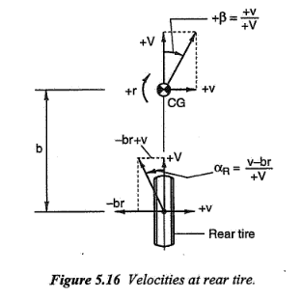
If there is $β$, then there is $α_{R}$ slip angle at the rear tire, since the rear tire is rigidly connected to the chassis. If the vehicle experiences a positive yaw velocity $r$, the rear tire experiences a lateral velocity component $v-br$ geometrically. The hypotenuse component is $V$. Therefore, using trigonometry:
$$\sin\left(α_{R}\right)=\frac{v-br}{V}$$
By the small angle assumption:
$$α_{R}=\frac{v-br}{V}=β-\frac{br}{V}$$
At the front tire the steer angle adds an extra degree of freedom. The front tire experiences yaw velocity $ar$ due to $r$ at the center of gravity.
$$\sin\left(α_{F}\right)=\frac{v+ar}{V}-δ$$
By the small angle assumption:
$$α_{F}=\frac{v+ar}{V}-δ=β+\frac{ar}{V}-δ$$
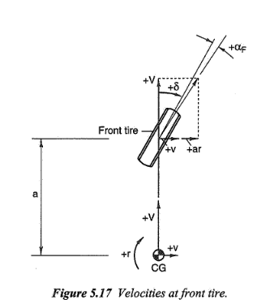
The total lateral force is simply the sum of the lateral force from the front and rear tires:
$$Y=Fy_{R}+Fy_{F}$$
The yawing moment is the sum of the moments about the center of gravity:
$$N=aF_{YF}-bF_{YR}$$

Summary of Slip Angle Derivation
Value | Equation
$$β$$ | $$\frac{v}{V}$$
$$α_{R}$$ | $$β-\frac{br}{V}$$
$$α_{F}$$ | $$β+\frac{ar}{V}-δ$$
$$Y$$ | $$F_{YF}+F_{YR}$$
$$N$$ | $$aF_{YF}-bF_{YR}$$

Control & Stability Derivatives
There are three degrees of freedom in this system: $β, r, δ$. We want to see how the total lateral force and yawing moment change as each of these parameters change. These are the stability and control derivatives. By using a simple linear tire model where $Y=αC$, with $C$ being a cornering stiffness (slope of $ΔY/Δα$ at some $α$), we can gain an intuitive understanding of how these derivatives affect performance. Cornering stiffness is a negative quantity, as shown in the graph of Fy vs slip angle earlier.
$$Y_{F}=C_{F}\left(β+\frac{ar}{V}-δ\right)$$
$$Y_{R}=C_{R}\left(β-\frac{br}{V}\right)$$
$$Y=Y_{F}+Y_{R}=β\left(C_{F}+C_{R}\right)+\frac{r}{V}\left(aC_{F}-bC_{R}\right)-C_{F}δ$$
$$N=aY_{F}-bY_{R}=β\left(aC_{F}-bC_{R}\right)+\frac{r}{V}\left(a^{2}C_{F}+b^{2}C_{R}\right)-aC_{F}δ$$
$N_{β}$: Derivative of yaw moment with respect to chassis slip angle. How does yaw moment change as chassis slip increases? Static directional stability, or understeer (stability) derivative. 0 = neutral steer, + = understeer, - = oversteer.
$$N_{β}=aC_{F}-bC_{R}$$
$N_{r}$: Derivative of yaw moment with respect to yaw velocity. Proportionality between yaw velocity and yaw moment. This is the yaw damping derivative. It is always negative. It is analogous to viscous damping, always trying to reduce the yaw velocity.
$$N_{r}=\frac{1}{V}(a^{2}C_{F}+b^{2}C_{R})$$
$N_{δ}:$ Derivative of yaw moment with respect to steer angle. This is the control moment derivative. It increases with cornering stiffness and the distance to the front axle
$$N_{δ}=-aC_{F}$$
$Y_{β}$: Derivative of lateral force with respect to chassis slip angle. Lateral force derivative. Rate that lateral force develops as the vehicle sideslips
$$Y_{β}=C_{F}+C_{R}$$
$Y_{r}$: Derivative of lateral force with respect to yaw velocity. Lateral force/yaw coupling derivative. Small in practice
$$Y_{r}=\frac{1}{V}\left(aC_{F}-bC_{R}\right)$$
$Y_{δ}:$ Derivative of lateral force with respect to steer angle. Control force derivative. Rate that force is developed as the vehicle applies steer.
$$Y_{δ}=-aC_{F}$$

Lateral Acceleration
Lateral acceleration in this reference frame has two components: a centrifugal force term and a direct lateral acceleration term:
$$a_{y}=Vr+\dot{v}$$
We know that $\sin\left(β\right)=\frac{v}{V}$, and by the small angle approximation: $β=\frac{v}{V}$. Therefore, $\dot{v}=V\dot{β}$ by differentiation by time of both sides and if $V=const$. Therefore:
$$a_{y}=V(r+\dot{β})$$
If we assume the vehicle is travelling in a perfect circle (not moving laterally), then $\dot{v}=0$.

Virtual Model
You will create a function that evaluates the following quantities: lateral force sum, moments sum, yaw velocity and turning radius.
Start by defining a function that calculates the center of gravity location distances a and b, and the normal forces on the two axles given the mass, wheelbase and percentage of weight on the front axle:
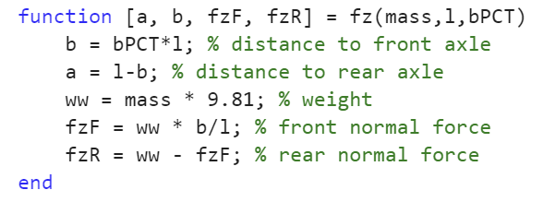
Next, create a function that calculates slip angles and tire forces. The front and rear tire models are independent of each other. This is done so each tire can have specific scaling factors applied to it. For this workshop, it means we can investigate the influence of the front and rear axle force and stiffness. In practice, the front tires could be more worn than the rears and so could require different scaling.
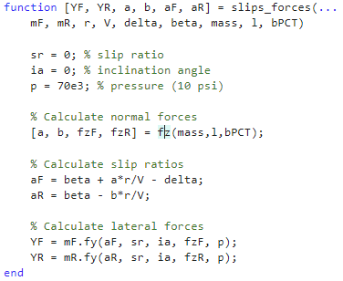
Next, create a function to calculate the sum of lateral force and the sum of moments:
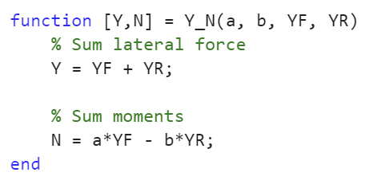
We’re ready to evaluate the bicycle model. The next function requires some explanation. The inputs are explained in the documentation comments. The function takes in steer and chassis slip angle (as well as vehicle constants speed, mass, wheelbase, CG location) to calculate yaw moment and lateral force sum.
Posed this way, the calculation is undefined because the yaw rate $r$ is unknown. The slip angle calculation requires all of $r, β, δ, V$, but $r$ is dependent on $V$ and $a_{Y}$ and $a_{Y}$ is also unknown. An iterative technique is used to solve the system. An initial guess at r and ay is made. Tire forces are calculated assuming these initial guesses are correct. $a_{Y}$ and $r$ are calculated from results of the tire force calculations. An error between the current and previous iteration is calculated and the loop continues until the error is less than the success threshold.
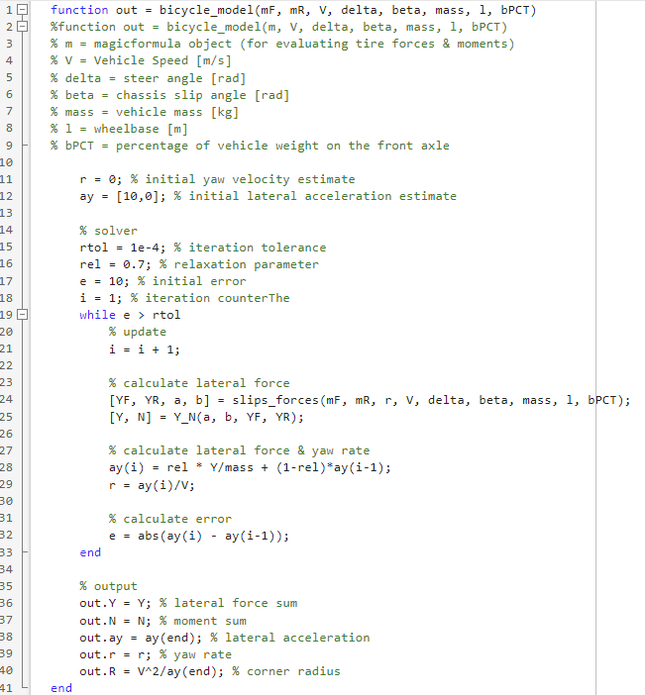

The derivatives we care most about are with respect to delta and beta, which is why the model is defined this way. The model will be evaluated at an array of delta and beta, and the derivatives will be evaluated from the result.
Write the following script and run it:
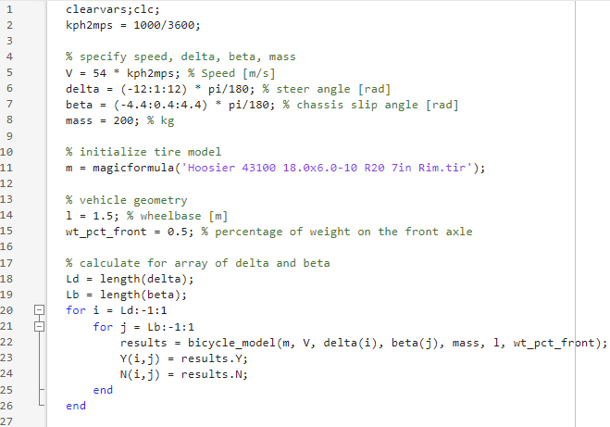
Now, plot the results. We are going to plot lines of constant delta and lines of constant beta so it’s easier to evaluate the derivatives.
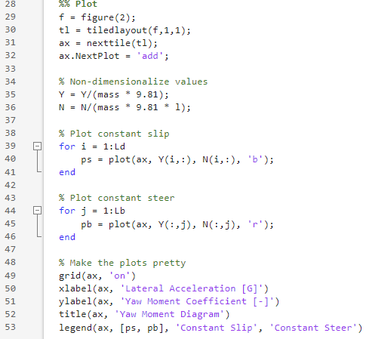

Congratulations, you’ve just plotted a yaw moment diagram!
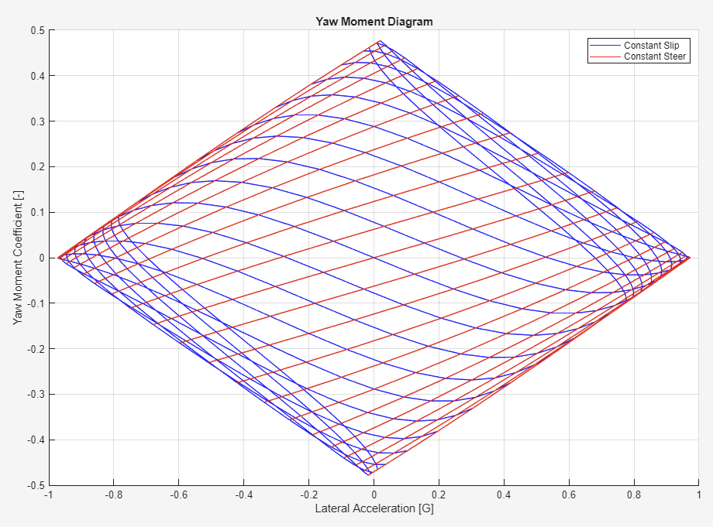
The stability derivative $\frac{dN}{dβ}$ is evaluated on lines of constant delta between line of constant beta. The control derivative $\frac{dN}{dδ}$ is evaluated on lines of constant beta between lines of constant delta. Write your own function to evaluate these quantities.

Influence of Center of Gravity Location
What happens to the derivatives if center of gravity location is moved forwards? Rearwards?
- Change wt_pct_front on line 16 of your script from 0.50 to 0.40 and re-run the analysis.
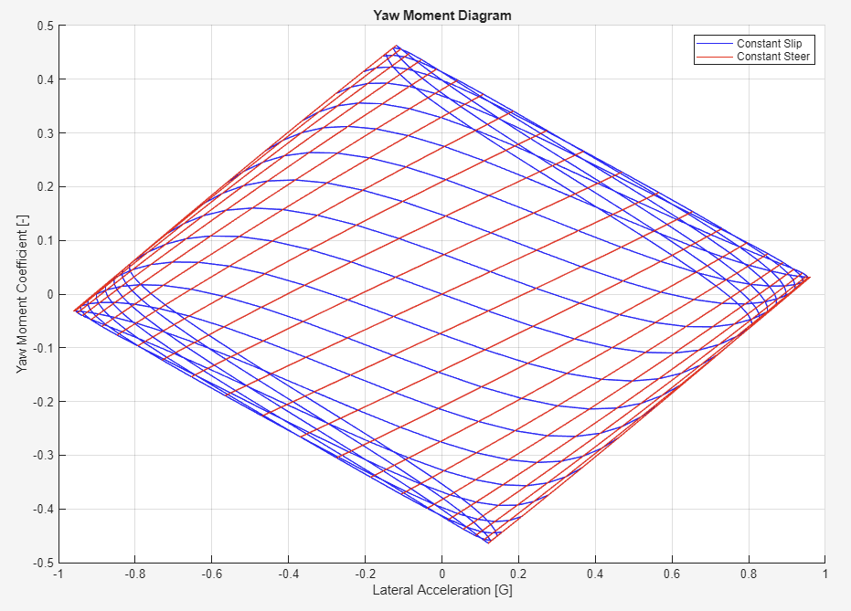
The change in CG location changes the slope of the lines. It also changes how much residual moment there is at the point of maximum lateral acceleration. Positive moment means there is a yawing moment into the corner, which means the car is oversteering at the limit. Moving the center of gravity rearwards results in more oversteer.
- Where is the point of maximum stable lateral acceleration? Did that increase or decrease?
- What happens when the center of gravity shifts the other way?
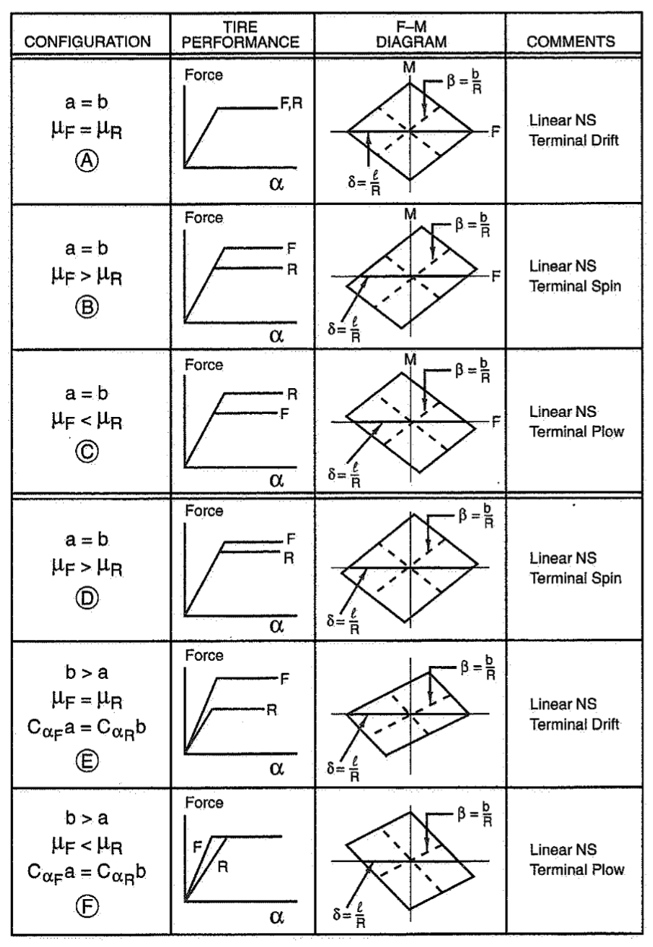[3]

Reflection Questions
- What is the mechanism that causes the change in balance when the center of gravity moves longitudinally?
  - Change the PDY2 coefficient in the tire model (multiply it, but do not change the sign). How does this affect the tire model? How does this affect the control & stability derivatives & the yaw moment diagram?
- How does the wheelbase length change the control & stability derivatives and the yaw moment diagram?
- What happens if the front axle has a lower lateral force potential than the rear?
  - After the tire models are instantiated, change the lateral force scaling factors to shift the balance by 5%:
  - 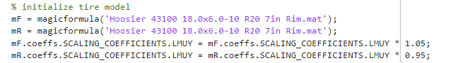
- Add aligning moments to the bicycle model
  - How does this change the model?

References
[1] “Appendix 1 - sign conventions for force and moment and wheel slip,” in Tire and vehicle dynamics (third edition), Third Edition., Oxford: Butterworth-Heinemann, 2012, p. 609. doi: https://doi.org/10.1016/B978-0-08-097016-5.15001-6.
[2] Besselink, I. J. M., Schmeitz, A. J. C., & Pacejka, H. B. (2010). An improved Magic Formula/Swift tyre model that can handle inflation pressure changes. Vehicle System Dynamics, 48(sup1), 337–352. https://doi.org/10.1080/00423111003748088
[3] W. F. Milliken and D. L. Milliken, Race car vehicle dynamics. in Premiere series. SAE International, 1995. [Online]. Available: https://books.google.ca/books?id=EOHPjgEACAAJ
[4] https://www.edy.es/dev/docs/pacejka-94-parameters-explained-a-comprehensive-guide/

