**INSURANCE PREMIUM PREDICTION**

**Wireframe Documentation**

**First thing anyone will see is a pop-up window on Homepage which will ask for User Inputs**

**like whether he/she wants insurance premium prediction for what purpose.**

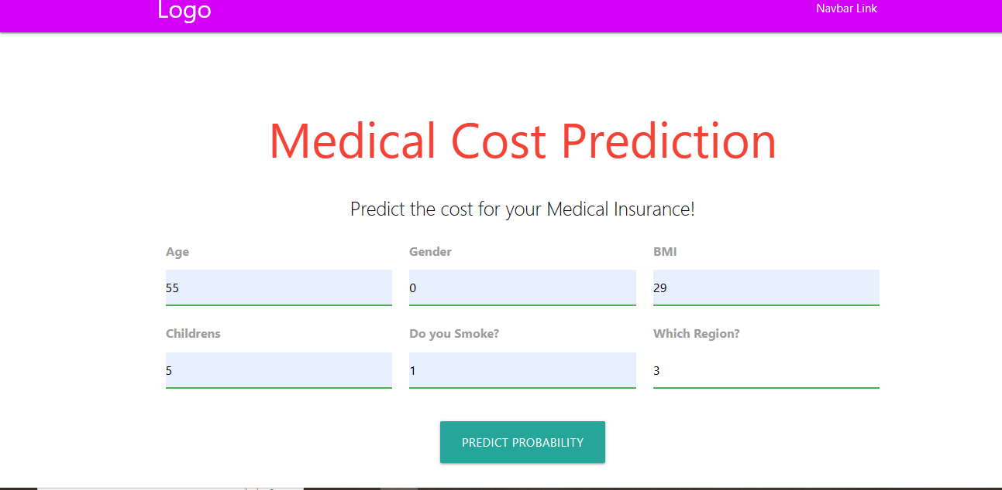

After putting some value we get some output:

Some basic parameter such as:  
1.age: enter the age

2.genter: enter in which gender you belongs to:

3.bmi: enter the bmi in the form of digit.

4.childer: enter total number of children you have in your family.

5.smoke: enter you smoke or not in “yes” or “o”.

Region: enter which region you belongs to .

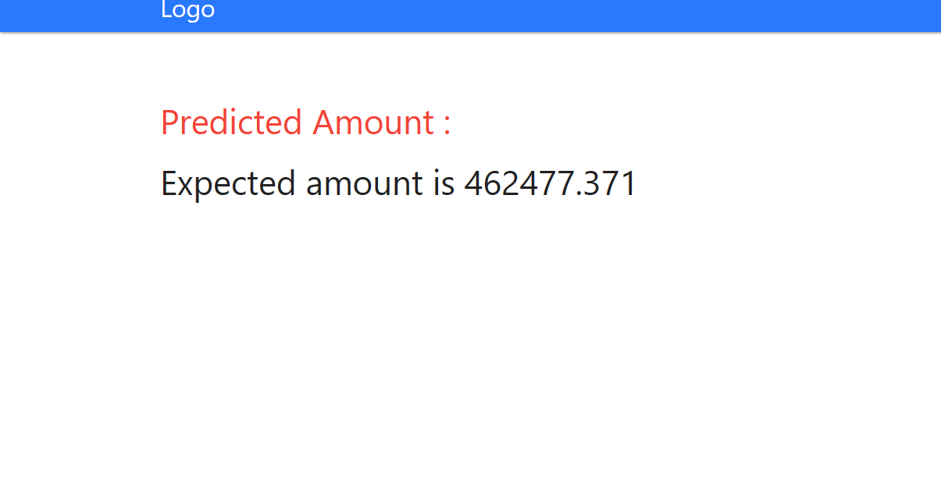

Here we get predicted amount through the model ,which you get predicted.