1. When tried to click on lowest fare & Fare rules, page loading after 10 seconds- Need to fix-Ravi[26May18]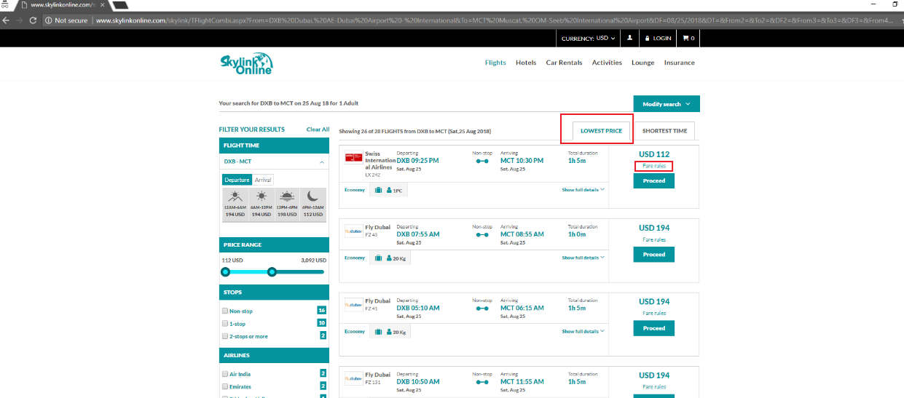
2. Hide the seat Map in review page - Need to fix-Ravi[26May18]

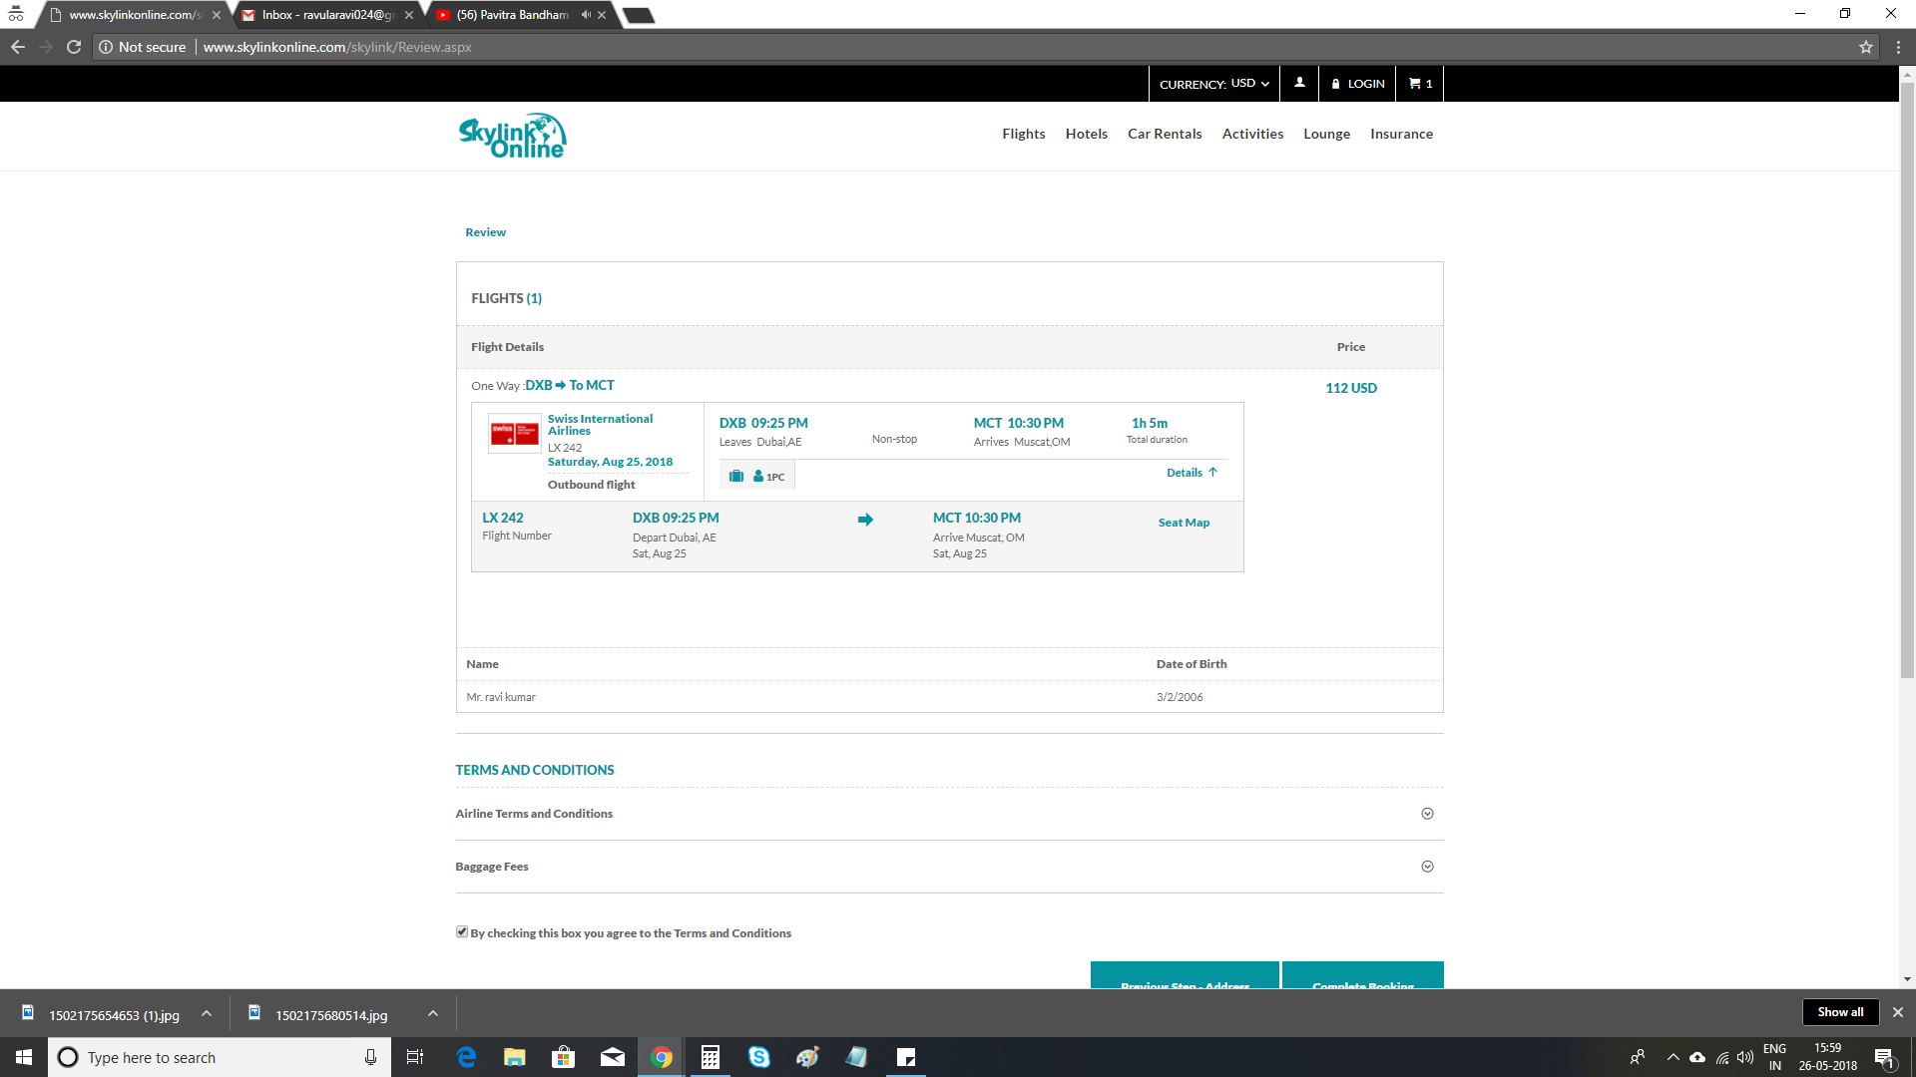

1. Hotel Trip summary: General Policies content is repeated - appears a Continuous paragraph on the first section and again as Bullet in second section - Need to fix-Ravi[26May18]

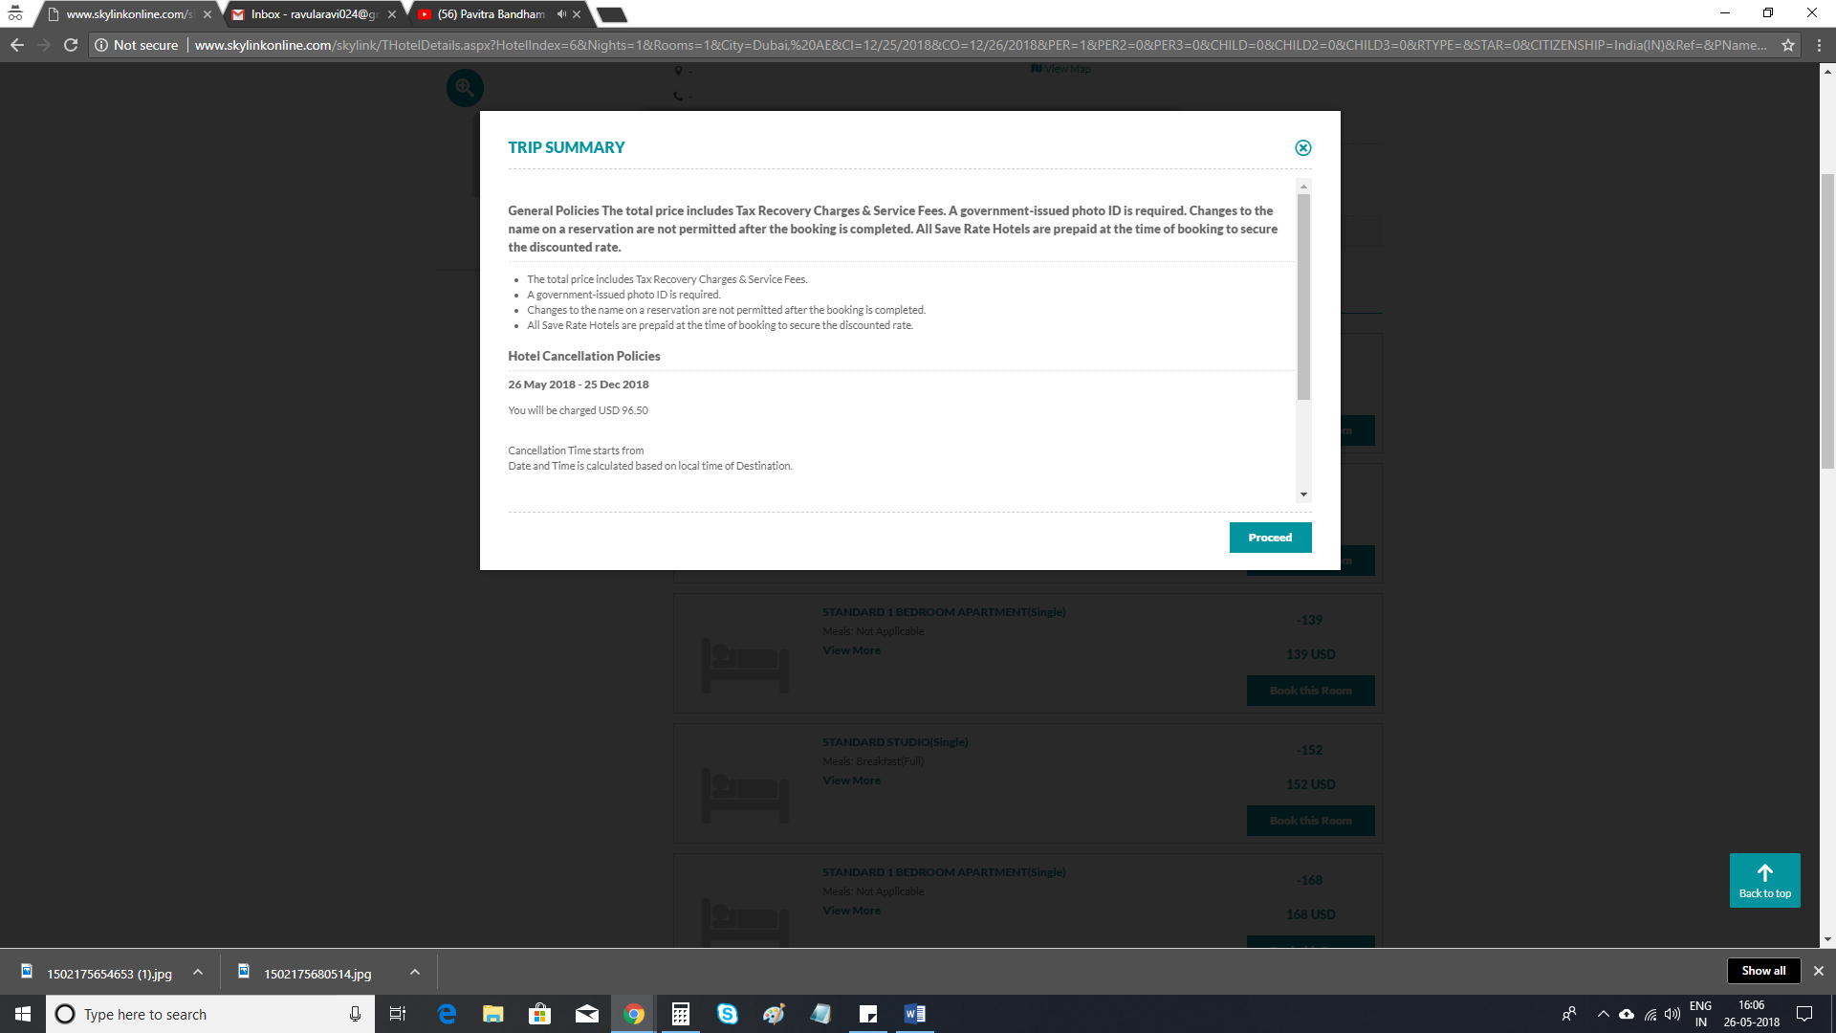

1. Re-modified contact number is not saved when we return from review page – - Need to fix-Ravi[26May18]

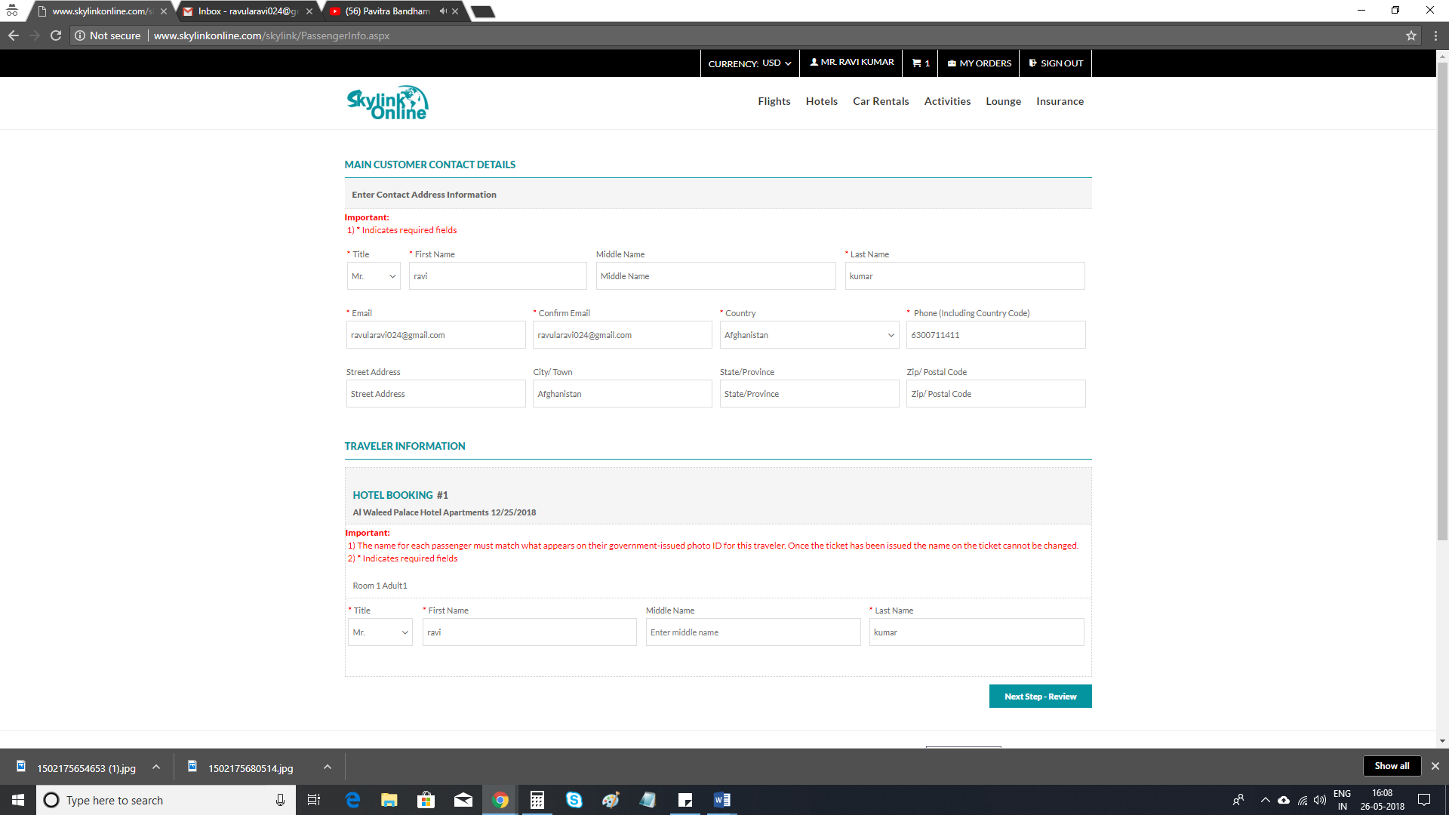

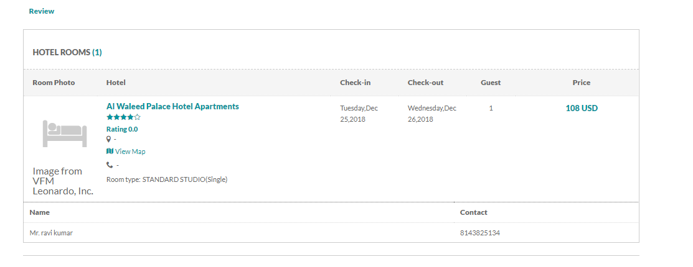

1. Location/Address: On Search Results page, Hotel address/Location is coded as Link, but it doesn't have any functionality to navigate to Maps- Need to fix-Ravi[26May18]

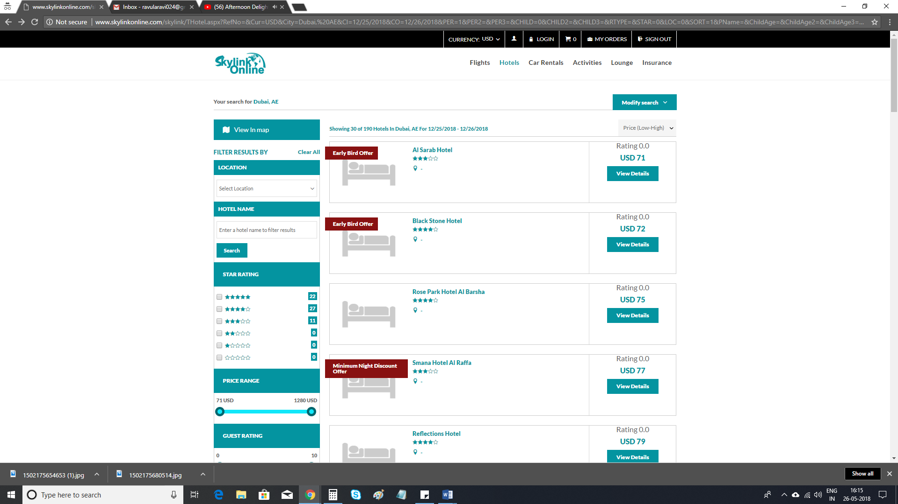

1. On Hotel Details page, on clicking View map Link, the page doesn't scroll down to the Map section - Need to fix-Ravi[26May18]
2. Hotel address & contact info not displayed - Need to fix-Ravi[26May18]

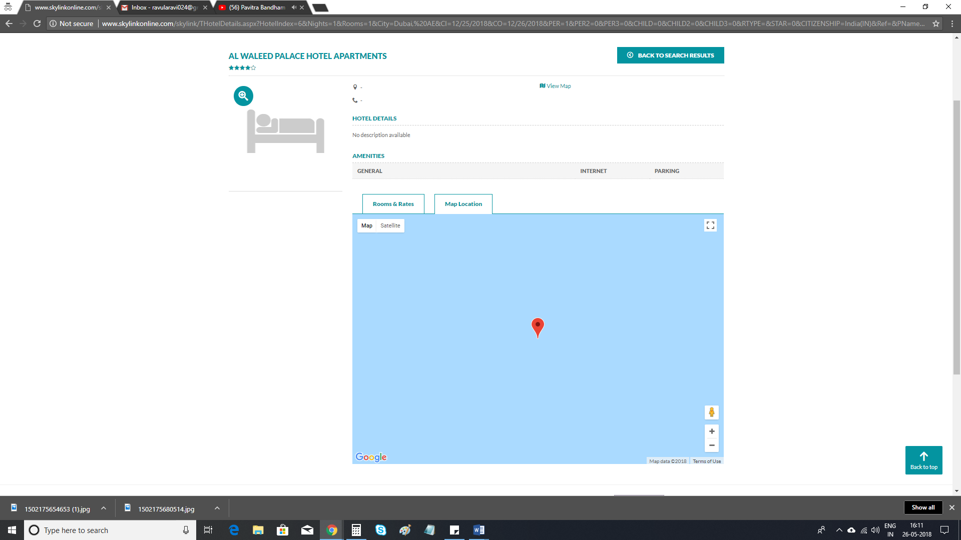

1. Car rentals: In your filers section, Text (IN-) is hiding behind the number 14, Text is clearly not visible. - Need to fix-Ravi[26May18]

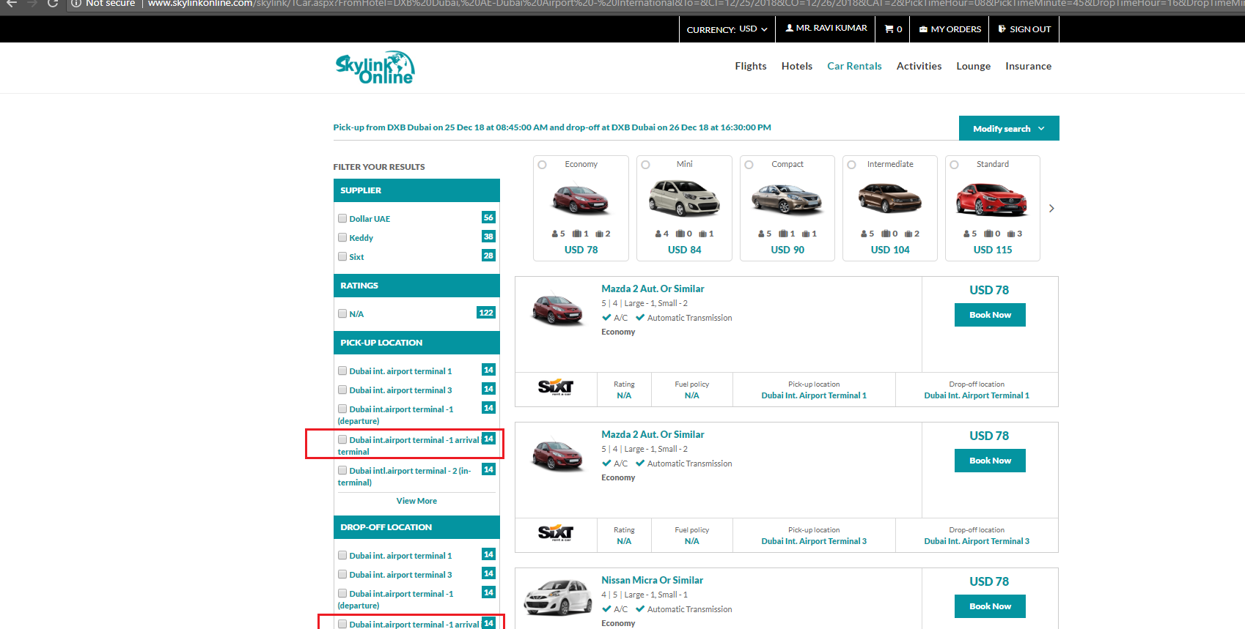

1. Hotel: Currency amount should display with 2 decimals, where as it displayed with USD78.0 – Need to fix-Ravi[26May18]

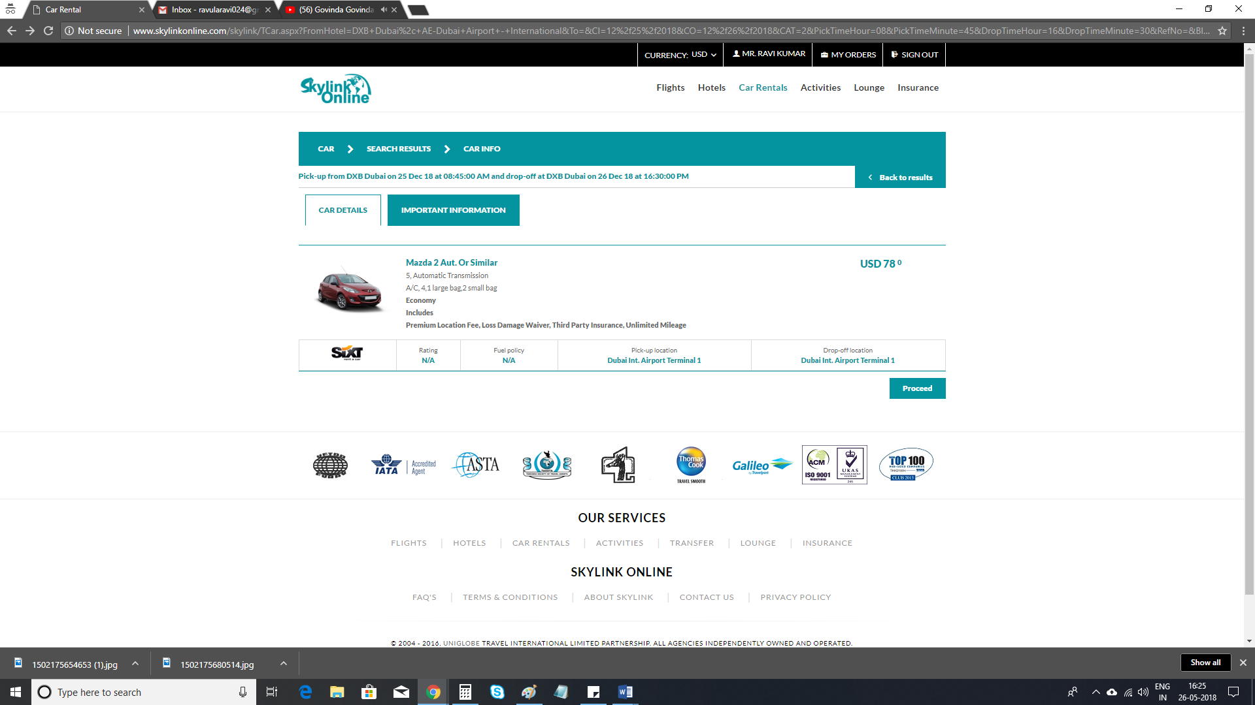

1. Cart total showing Zero Value - Need to fix-Ravi[26May18]

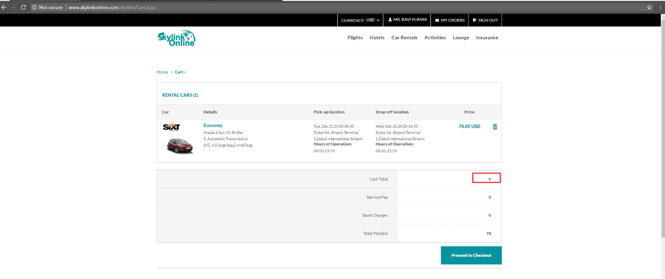

1. Lounge: Cities selection does not work - Need to fix-Ravi[26May18]

