PRDA-04 CUSTOMER DATA ANALYSIS
Project Analysis Report

Team ID: PTID-CDA-AUG-26-11187
Course: CDA

TEAM MEMBERS:
- Ravuri Lalitha Venkata Phani Krishna Sri
Email: ravurilalitha051@gmail.com
- Abhay Pratap Singh
Email: sabhaysingh143@gmail.com

1. Introduction
- The project analyzes customer shopping behavior to identify purchasing patterns, customer demographics, product preferences, payment methods, and revenue trends.
- The submitted project states that Excel, MySQL, Python, and Power BI were used across the analysis workflow.
- The project data is retrieved from a MySQL database and loaded into Python for analysis.
- Power BI is used to communicate the results through business-friendly visuals.
- The overall objective is to convert raw transaction-level information into measurable customer, sales, and revenue insights that can support business decisions.

2. Dataset Source and Dataset Description

2.1 Dataset Source
- The assignment describes a shopping dataset containing information from 10 different shopping malls between 2021 and 2023.
- The dataset covers multiple age groups and genders and is intended to provide a view of shopping habits in Istanbul.

2.2 Dataset Structure
Item | Description
Records | 1,000
Original columns | 10
Gender values | 2
Product categories | 8
Payment methods | 3
Distinct invoice dates | 580
Shopping malls | 10

3. Problem Statement
- Problem Statemet: To understand customer shopping behavior based on gender, age, product category, payment method, and shopping mall.
- Analytical Goal: To identify sales patterns, customer preferences, and top-performing categories.
- Visualization Goal: To create an interactive Power BI dashboard that clearly shows key sales and customer insights.

4. Work Flow
Raw Data file Cleaned Data Analysis Insights

(MySQL) (Python) (Python + MySQL (Power BI)
Power BI)

5. Tools and Technologies
Tool / Technology | Role in Project | Why It Helps
MySQL | Database and SQL analysis | Handles structured transaction data and enables grouped, filtered, and multi-dimensional analysis.
Python | Cleaning, transformation, EDA | Automates repeatable data preparation and makes calculations and exploratory analysis efficient.
Pandas | Data handling | Loads CSV data, checks quality, creates derived columns, groups data, and exports the cleaned dataset.
NumPy | Numerical support | Supports numerical data handling within the Python workflow.
Matplotlib | Plotting / exploration | Supports visual exploration of analytical results.
Power BI | Dashboard and business reporting | Turns analytical outputs into interactive KPIs, charts, slicers, and business views.
Excel | Supporting data work | Included in the submitted project technology stack for supporting data handling.

6. Python – Data Cleaning, Transformation and Exploratory Data Analysis

6.1 Why Python Was Used
- Python provides a repeatable workflow for loading, checking, transforming, analyzing, and exporting data.
- The output customer_cleaned.csv creates a prepared analytical dataset for downstream SQL/Power BI use.

6.2 Libraries Used
- Pandas — primary library for DataFrame-based data handling and analysis.
- NumPy — numerical computing support.
- Matplotlib.pyplot — plotting and exploratory visualization support.

6.3 Feature Engineering:
- Verifies 1000 records across 10 columns
- Checked for null values – none were found.
- Checked for duplicates – none were found.
- Reviewed categorical values and unique counts.
- Created a derived Revenue field:
Revenue = Quantity x Price
This Metric was used to compare revenue across customer segments, age groups and payment methods.
- Created age groups: 0 – 18, 19 – 30, 31 – 45, 46 – 60 and 61+
- Exported the prepared dataset as cleaned_customer.csv

6.4 Python Key Results
Gender | Products Sold | Revenue
Female | 1,853 | 1,408,881.11
Male | 1,128 | 956,486.66

Age Category | Products Sold | Revenue
0–18 | 74 | 35,724.36
19–30 | 707 | 533,548.82
31–45 | 869 | 663,419.18
46–60 | 799 | 616,237.97
61+ | 532 | 516,437.44

Payment Method | Transactions | Products Sold | Revenue
Cash | 420 | 1,271 | 1,041,239.48
Credit Card | 366 | 1,069 | 770,272.60
Debit Card | 214 | 641 | 553,855.69

6. SQL Documentation

6.1 Why SQL Was Used
- SQL makes it possible to group, aggregate, sort, and compare large sets of transactions using concise, repeatable queries.
- SQL is especially useful for business questions involving transaction counts, product quantities, revenue, customer segments, product categories, and payment methods.
- The project uses SQL to create analytical views that can be consumed by reporting and dashboard workflows.

6.2 SQL Query Documentation

Transaction Distribution by Gender
Purpose: Counts transactions for each gender.
SELECT gender, COUNT(*) AS total_transactions
FROM customer
GROUP BY gender;

Products Sold by Gender
Purpose: Measures physical product volume by gender.
SELECT gender, SUM(quantity) AS total_products_sold
FROM customer
GROUP BY gender
ORDER BY total_products_sold DESC;

Revenue by Gender
Purpose: Measures revenue contribution by gender.
SELECT gender, SUM(revenue) AS total_revenue
FROM customer
GROUP BY gender
ORDER BY total_revenue;

Category Performance
Purpose: Ranks categories using quantity and revenue.
SELECT category, SUM(quantity), SUM(revenue)
FROM customer
GROUP BY category
ORDER BY total_revenue DESC;

Category + Gender
Purpose: Shows category performance within each gender.
SELECT category, gender, SUM(quantity), SUM(revenue)
FROM customer
GROUP BY category, gender
ORDER BY category, revenue DESC;

Category + Age Cohort
Purpose: Shows which categories perform within age cohorts.
SELECT age_group, category, SUM(quantity), SUM(revenue)
FROM customer
GROUP BY age_group, category
ORDER BY age_group, revenue DESC;

Age Cohort Analysis
Purpose: Creates SQL age cohorts and compares volume and value.
SELECT
CASE
WHEN age < 20 THEN 'Under 20'
WHEN age BETWEEN 19 AND 30 THEN “19-30'
WHEN age BETWEEN 31 AND 45 THEN '31-45'
WHEN age BETWEEN 46 AND 60 THEN '46-60'
ELSE '61+'
END AS age_group,
COUNT(*) AS total_transactions,
SUM(quantity) AS total_products_sold,
SUM(revenue) AS total_revenue
FROM customer
GROUP BY age_group
ORDER BY age_group;

Payment Distribution
Purpose: Measures checkout frequency by payment method.
SELECT payment_method, COUNT(*) AS total_transactions
FROM customer
GROUP BY payment_method
ORDER BY total_transactions DESC;

Payment + Gender
Purpose: Cross-checks payment preference against gender.
SELECT payment_method, gender, COUNT(*), SUM(revenue)
FROM customer
GROUP BY payment_method, gender
ORDER BY payment_method, revenue DESC;

Payment + Category
Purpose: Maps payment methods to category-level revenue.
SELECT payment_method, category, COUNT(*), SUM(revenue)
FROM customer
GROUP BY payment_method, category
ORDER BY payment_method, revenue DESC;

7. Power BI Dashboard

7.1 Why Power BI Was Used
- Power BI converts analytical results into an interactive, business-friendly dashboard.
- The dashboard combines demographic, product, payment, and location perspectives so that a business user can move from 'who buys' to 'what they buy' to 'how they pay' and 'where the value is generated'.

7.2 Dashboard Overview

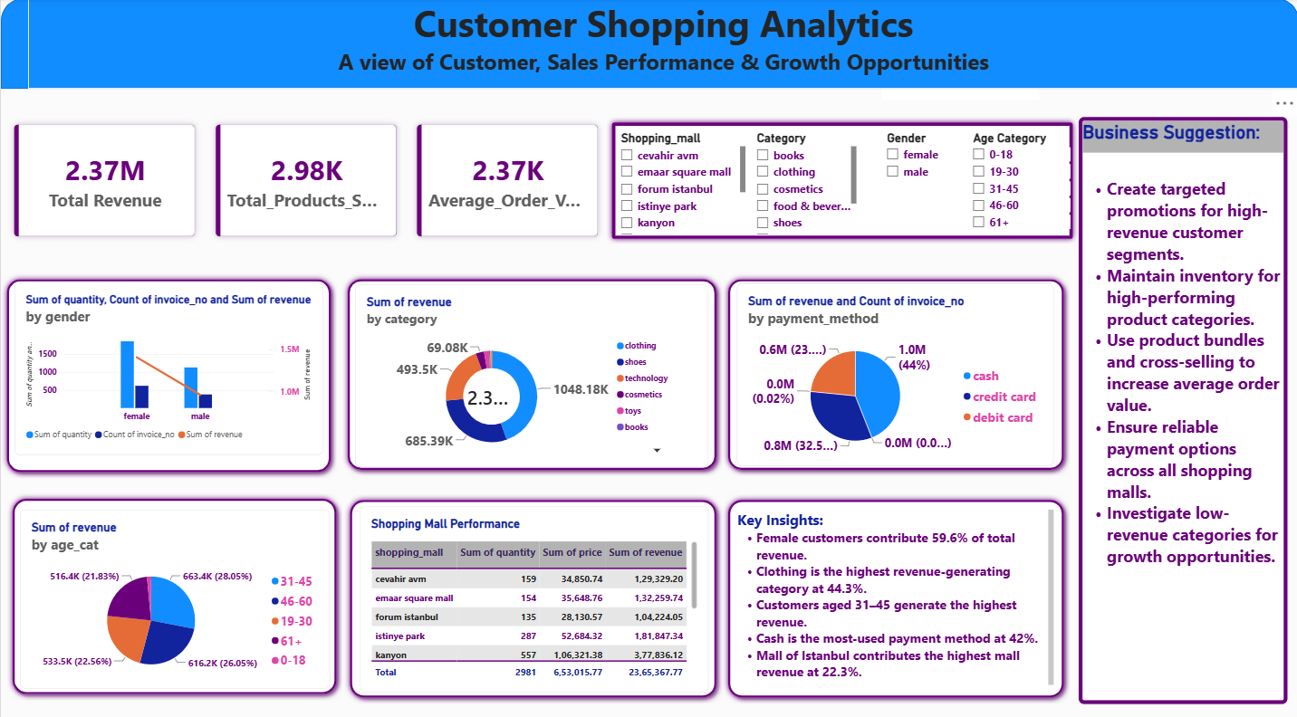

7.3 Slicers – Purpose and Business Use
Slicer | Purpose
Shopping Mall | Filters the entire dashboard to a selected shopping mall and supports location-level performance comparison.
Category | Filters visuals to selected product categories and helps investigate category-specific behavior.
Gender | Filters customer behavior by gender and supports demographic comparison.
Age Category | Filters the analysis by the defined age bands and helps examine age-specific revenue and quantity patterns.

7.4 Dashboard Visuals – Detailed Documentation
Visual | What It Represents | Submitted Interpretation
1. Quantity, Transactions and Revenue by Gender | Shows differences in customer activity, product volume, and financial contribution by gender. | The submitted dashboard states that female customers contribute 59.6% of total revenue.
2. Revenue by Category | Highlights the relative size of each category and identifies the strongest revenue-generating category. | The dashboard identifies Clothing as the highest revenue-generating category at 44.3%.
3. Revenue and Transactions by Payment Method | Shows checkout preference and the financial contribution associated with each payment option. | Cash is identified as the most-used payment method at 42%.
4. Revenue by Age Category | Shows which customer age group contributes the largest share of revenue. | Customers aged 31–45 are identified as the highest-revenue age group.

7.5 DAX & KPIs Documentation
Measure | DAX Logic | Purpose
Total Revenue | SUM(customer_cleaned[revenue]) | Calculates total revenue generated from all purchases.
Total Products Sold | SUM(customer_cleaned[quantity]) | Calculates total products sold.
Total Transactions | DISTINCTCOUNT(customer_cleaned[invoice_no]) | Counts distinct invoice numbers as transactions.
Average Order Value | DIVIDE([Total Revenue],[Total Transactions]) | Calculates average revenue per transaction.

8. Business Insights
- Female customers account for 1,853 products sold versus 1,128 for male customers in the Python analysis.
- Female customers generate 1,408,881.11 in revenue versus 956,486.66 for male customers in the Python analysis.
- The female customers contribute 59.6% of total revenue.
- The 31–45 age category has the highest revenue at 663,419.18.
- The 31–45 age category also has the highest product volume among the Python-defined age bands at 869 products.
- Clothing is identified in the highest revenue-generating category, with a 44.3% share.
- Cash has the highest transaction count at 420 and the highest revenue at 1,041,239.48.
- The Analysis identifies Mall of Istanbul as the highest mall revenue contributor at 22.3%.

9. Suggestions
- Create targeted promotions for high-revenue customer segments.
- Maintain inventory for high-performing product categories.
- Use product bundles and cross-selling to increase average order value.
- Ensure reliable payment options across all shopping malls.
- Investigate low-revenue categories for growth opportunities.

10. Conclusion
- The project combines database querying, Python-based data preparation and exploratory analysis, and Power BI visualization into one customer-shopping analytics workflow.
- Python validates the raw dataset, creates Revenue and Age Category fields, performs key aggregations, and exports the prepared customer_cleaned.csv file.
- SQL provides a structured way to answer transaction, quantity, revenue, category, demographic, and payment-related business questions.
- Power BI converts the analytical outputs into KPIs, slicers, charts, tables, insights, and suggestions that are easier for business users to interpret.
- The dashboard provides a single interactive view for exploring these patterns and supporting data-driven decision-making.
- The project can be extended with more historical data, additional customer attributes, time-series analysis, repeat-purchase metrics, customer lifetime value, and predictive analytics.

END OF THE REPORT

