REPORT

Q. 1) Find all the unique 'Wind Speed' values in the data.

**CODE**

df['Wind Speed_km/h'].unique()

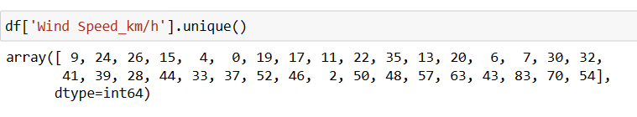

**Explanation**

The result shows the unique values in the column Wind Speed_km/h

Q. 2) Find the number of times when the 'Weather is exactly Clear'.

**CODE**

df['Weather'].value_counts().Clear

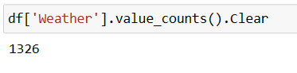

**Explanation**

The result shows the count of values in the Weather column which is clear

Q. 3) Find the number of times when the 'Wind Speed was exactly 4 km/h'.

**CODE**

df['Wind Speed_km/h'].value_counts()[4]

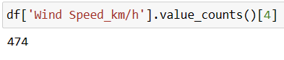

**Explanation**

The result shows the count of values in the Wind Speed_km/h column which is “4Km/h”

Q. 4) Find out all the Null Values in the data.

**CODE**

df.info()

df.isnull().sum()

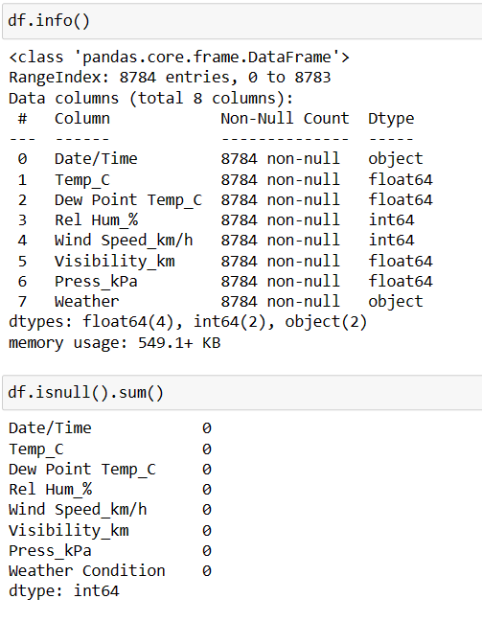

**Explanation**

The result shows that there are no null values in the given dataset.

Q. 5) Rename the column name 'Weather' of the dataframe to 'Weather Condition'.

**CODE**

df.rename(columns={'Weather':'Weather Condition'},inplace=True)

df

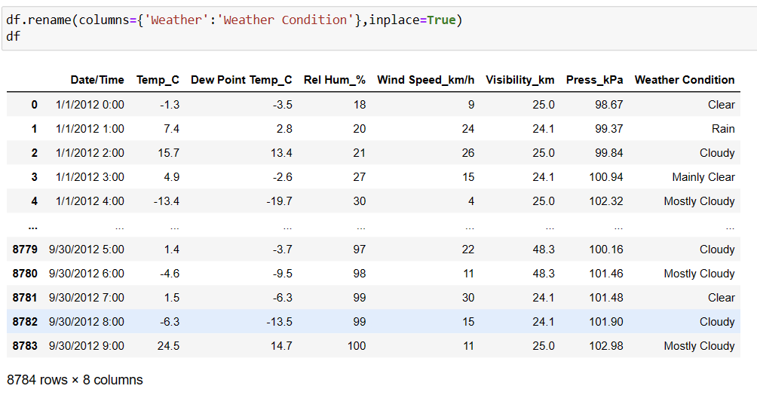

**Explanation**

The result shows that the name of “Weather” column changed to “Weather Condition”

Q. 6) What is the mean 'Visibility' ?

**CODE**

df['Visibility_km'].mean()

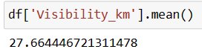

**Explanation**

The result shows that the mean of column “Visibility_km”

Q. 7) What is the Standard Deviation of 'Pressure' in this data?

**CODE**

df['Press_kPa'].std()

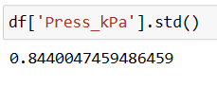

**Explanation**

The result shows that the standard deviation of the column “Press_kPa”

Q. 8) What is the Variance of 'Relative Humidity' in this data ?

**CODE**

df['Rel Hum_%'].var()

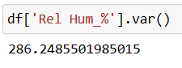

**Explanation**

The result shows that the variance of the column “Rel Hum_%”

Q. 9) Find all instances when 'Snow' was recorded.

**CODE**

df[df['Weather']=='Snow']

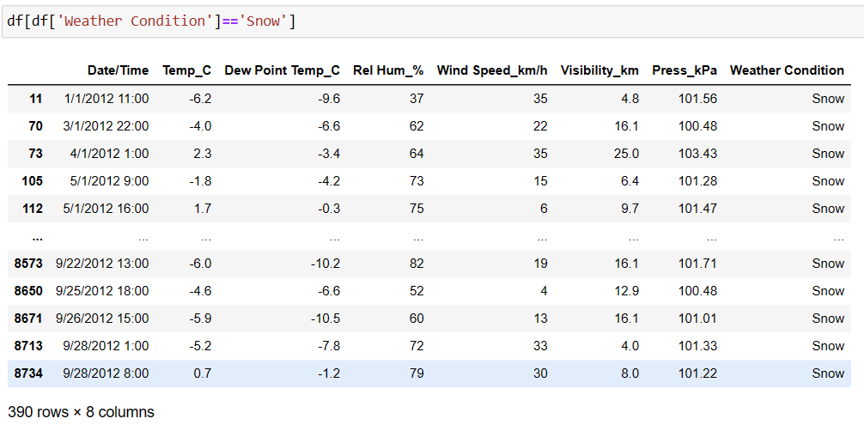

**Explanation**

The result shows that the rows which has the Weather Condition is “Snow”

Q. 10) Find all instances when 'Wind Speed is above 24' and 'Visibility is 25'.

**CODE**

df[(df['Wind Speed_km/h']>24) & (df['Visibility_km']==25)]

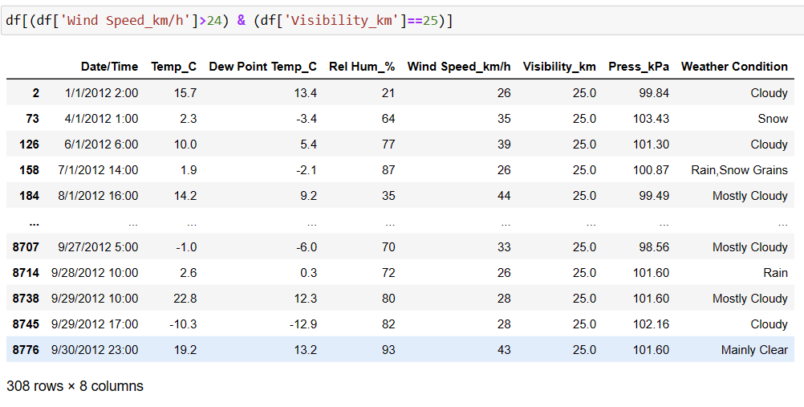

**Explanation**

The result shows that the rows which has ‘Wind Speed is above 24' and 'Visibility is 25'

Q. 11) What is the Mean value of each column against each 'Weather Condition ?

**CODE**

df.groupby('Weather Condition').mean()

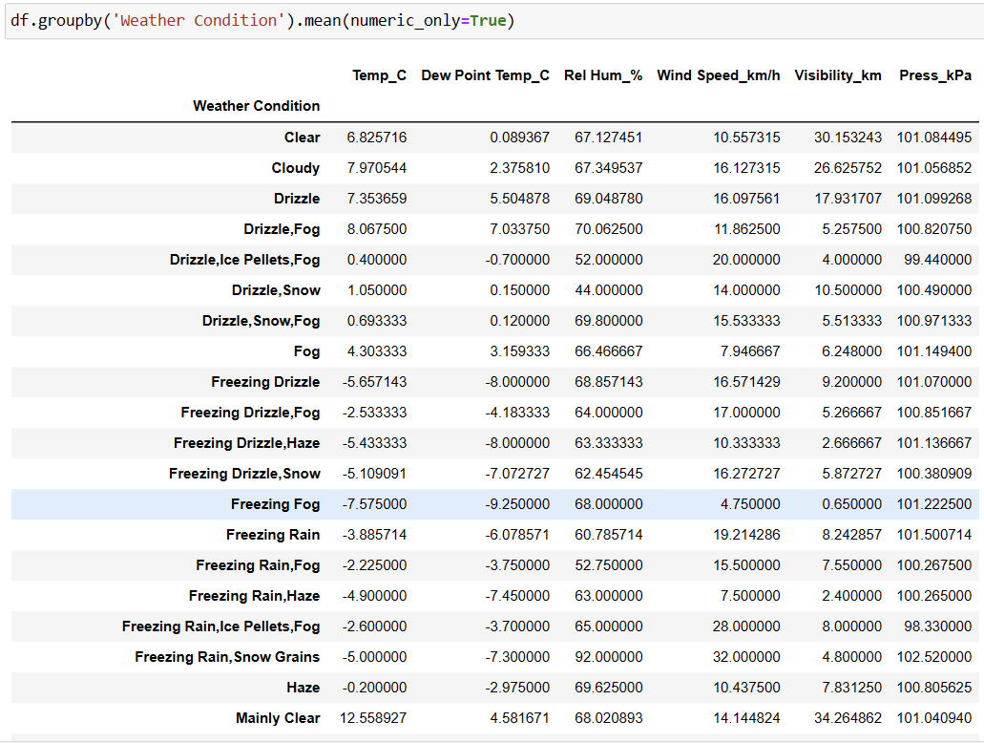

**Explanation**

The result shows the mean of each column grouped by the Weather condition

Q. 12) What is the Minimum & Maximum value of each column against each 'Weather Condition ?

**CODE**

df.groupby('Weather Condition').min()

df.groupby('Weather Condition').max()

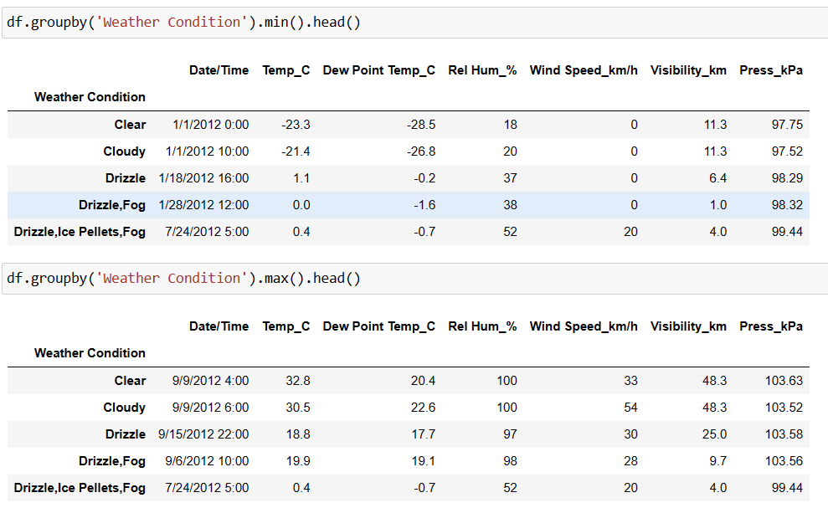

**Explanation**

The result shows the minimum and maximum of each column grouped by the Weather condition

Q. 13) Show all the Records where Weather Condition is Fog.

**CODE**

df[df['Weather Condition']=='Fog']

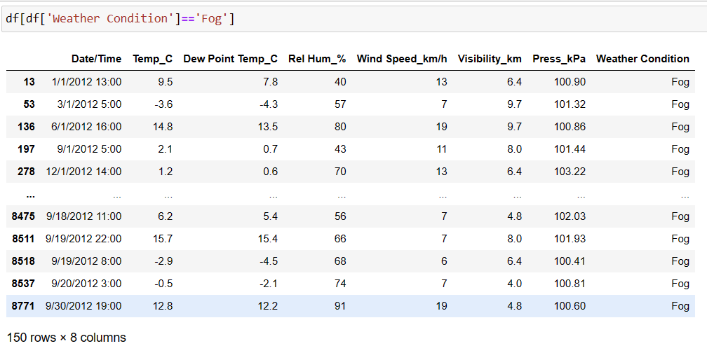

**Explanation**

The result shows the rows which has the Weather Condition is “Fog”

Q. 14) Find all instances when 'Weather is Clear' or 'Visibility is above 40'.

**CODE**

df[(df['Weather Condition']=='Clear') | (df['Visibility_km']>40)]

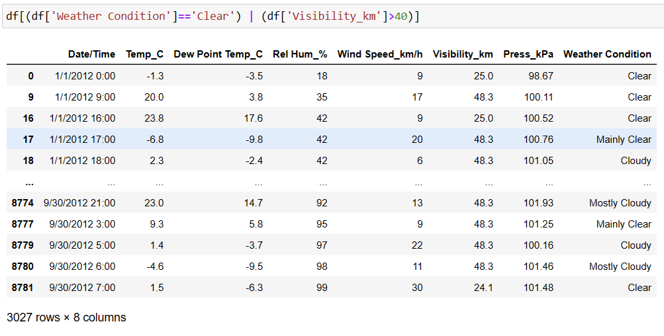

**Explanation**

The result shows all instances when 'Weather is Clear' or 'Visibility is above 40'.

Q. 15) Find all instances when :

A. 'Weather is Clear' and 'Relative Humidity is greater than 50'

or

B. 'Visibility is above 40'

**CODE**

df[(df['Weather Condition']=='Clear' ) & (df['Rel Hum_%'] >50) | (df['Visibility_km']> 40)]

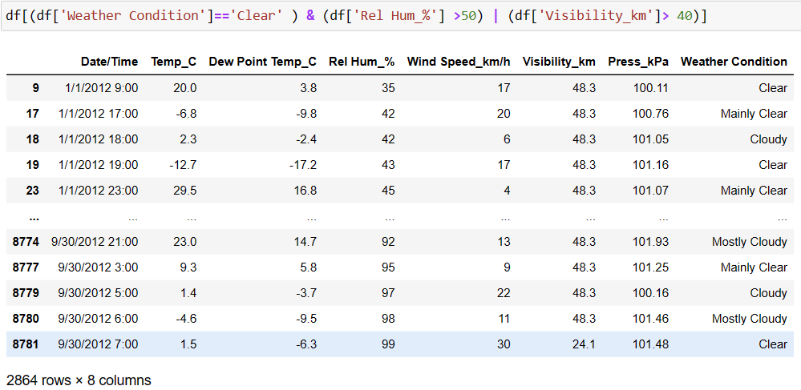

**Explanation**

The result shows the all instances when 'Weather is Clear' and 'Relative Humidity is greater than 50' or 'Visibility is above 40'