ERRORS
- Mismatch of Java versions in Master and slave
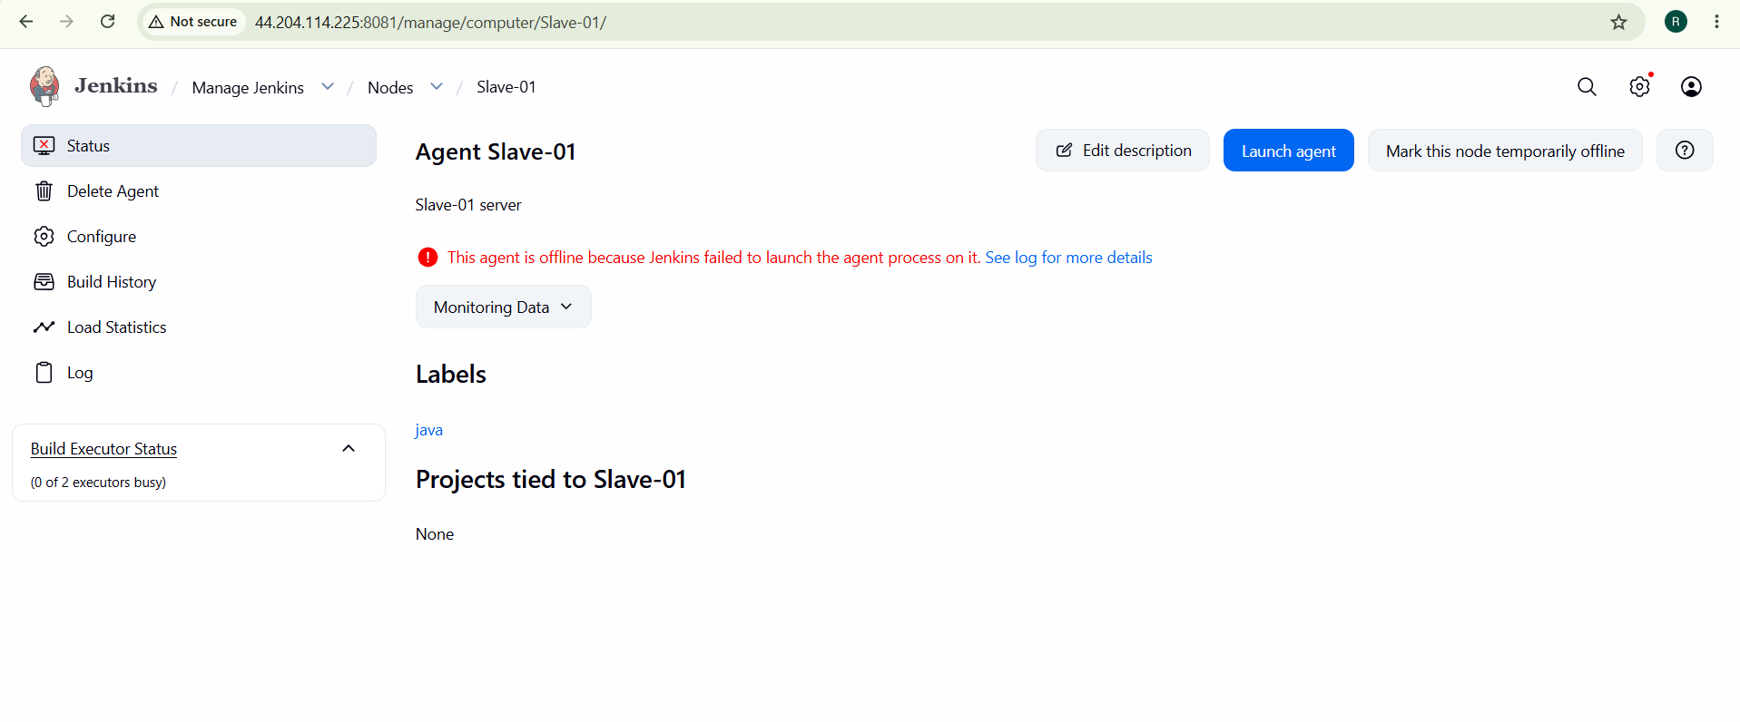
- Use same java versions to resolve this.
- Security group add all traffic
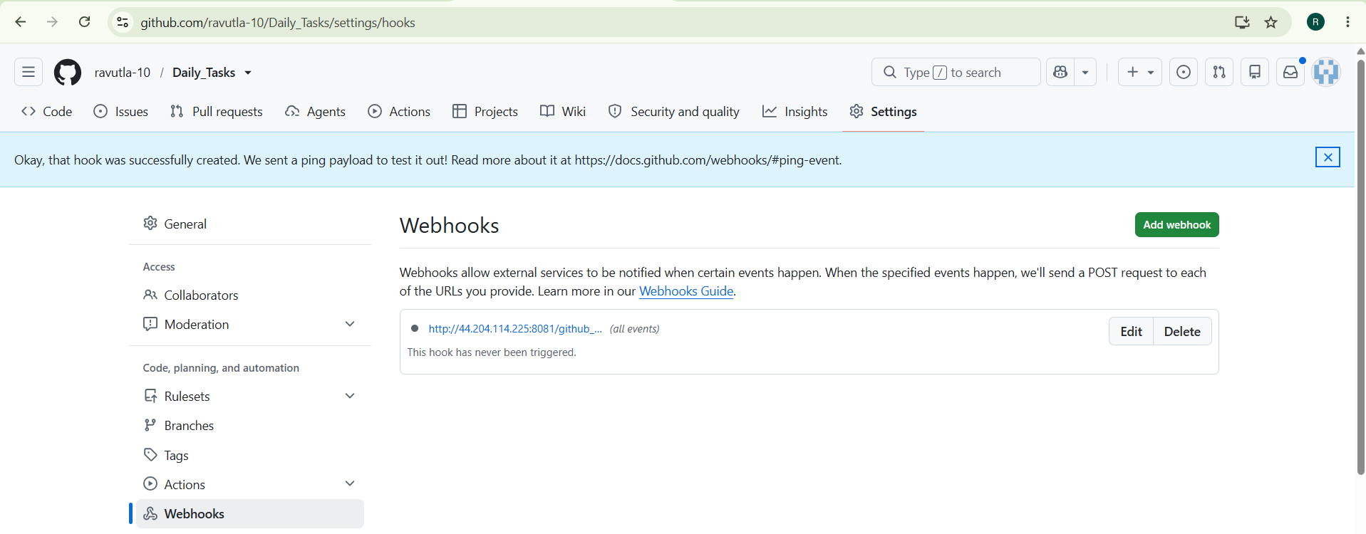
- Git prerequisite
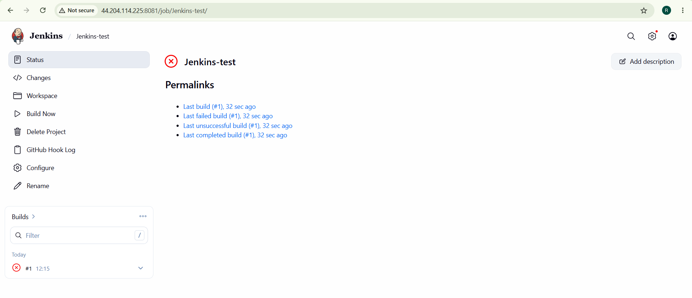
- Install git in server to reslove
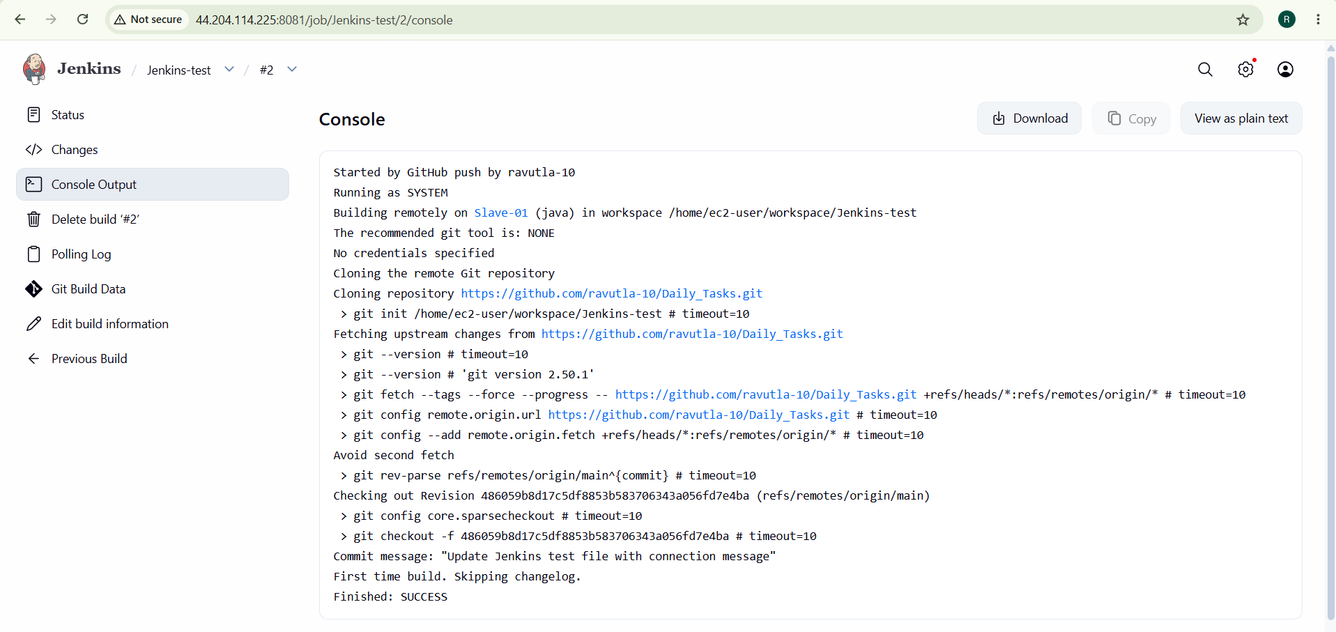

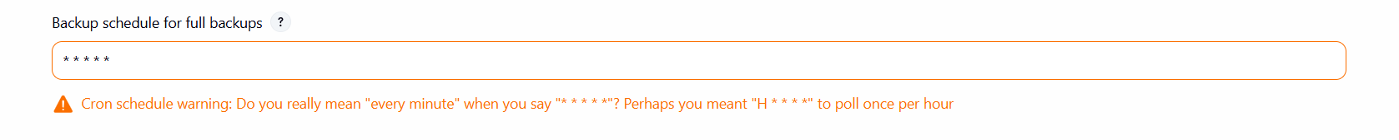
- Unable to download sonarqube 6.0 zip file
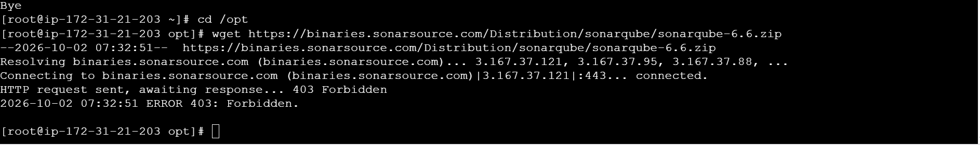
Unable to find sonar.properties
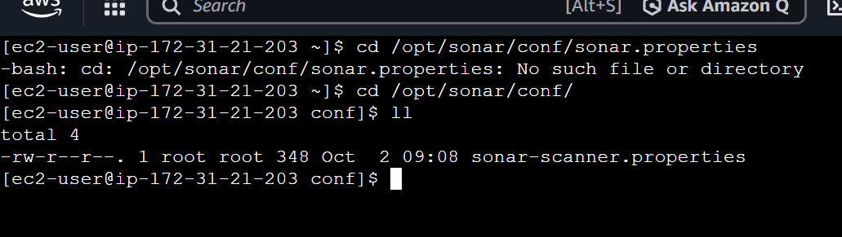

6. Issue Encountered and Resolution
Issue – Jenkins Could Not Find Git Revision
During the first build attempt, Jenkins returned:
ERROR: Couldn't find any revision to build.
Cause
The Jenkins job was configured to build:
*/master
However, the Hiring App GitHub repository uses:
main
as its branch.
Resolution
The branch configuration was changed from:
*/master
to:
*/main
The job was executed again after saving the configuration.
The second build successfully cloned the repository, performed the SonarQube analysis, and sent the Slack notification.
Observation
This demonstrates the importance of verifying the actual branch name in the Git repository before configuring Jenkins SCM.
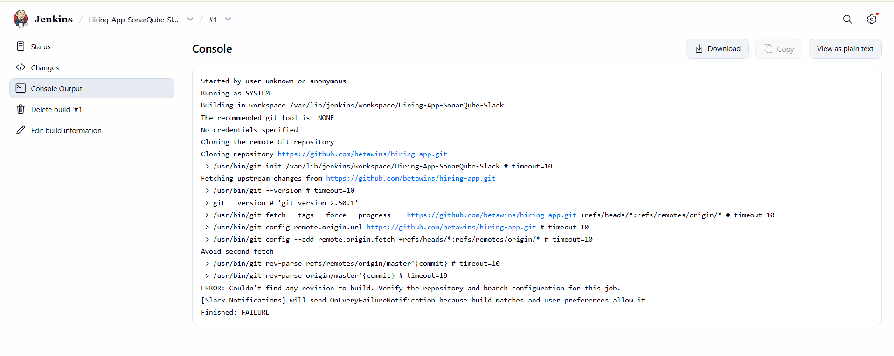
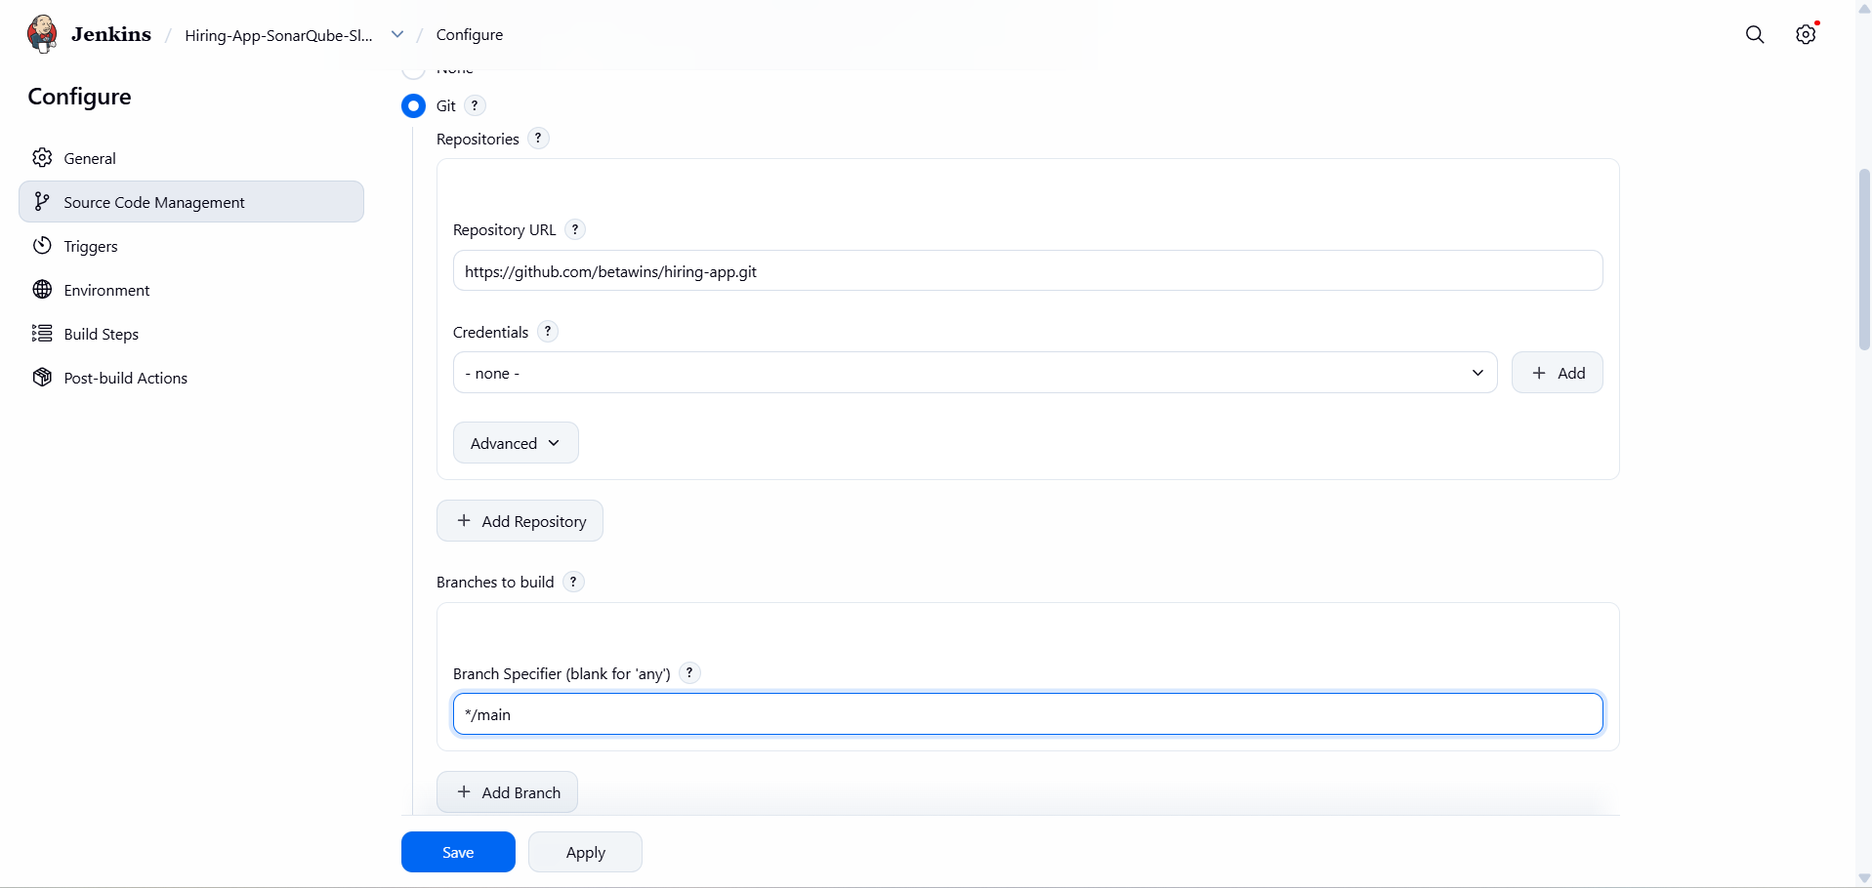
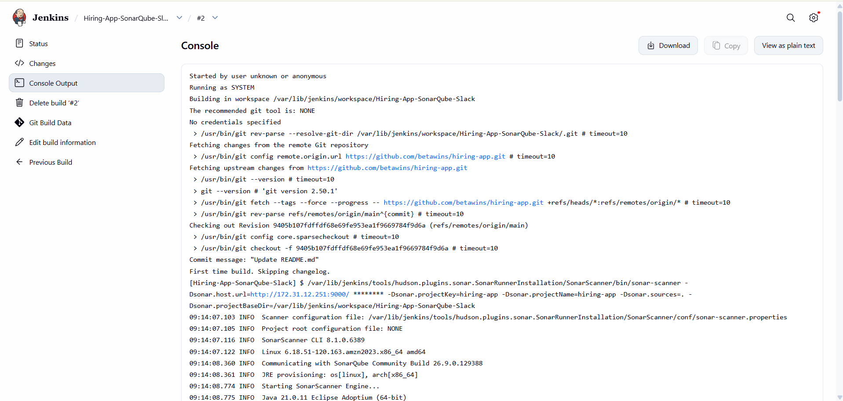
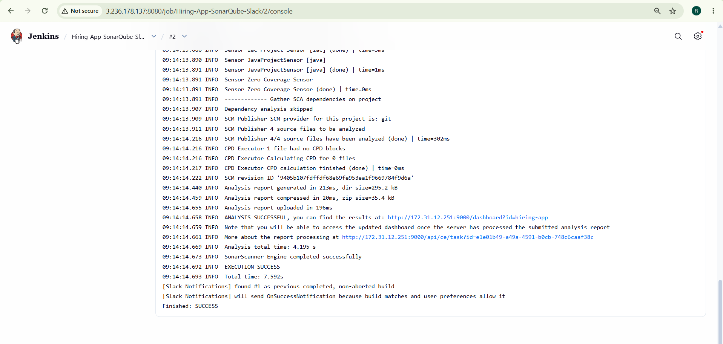

Used main in place of Master for git repo
