**Agenda**

Board Meeting #1

February 18, 2021

**HOST:**  Jessica McMillan (CEO)

**ATTENDEES:** Stevie Clemens (CTO), Dr. B Baynes (CFO)

**Time (PDT) Topic Presenter**

2:30 - 2:35 Welcome CEO

2:30 - 2:37 Opening statements CEO

2:37 - 2:40 Approval of Agenda CEO

2:40 - 3:00 Presentation CEO/CTO/CFO

3:00 - 3:25 Round Table Discussion All

3:25 - 3:30 Adjournment CEO

Make the time slots with spaces.

**Agenda**

Board Meeting #1

February 18, 2021

**Business summary**

*The problem*

There is currently no quantitative method to determine the freshness or expiration of food on the market.

*Company value proposition*

Is your food good to go? Know when to throw using Good to Go food storage systems.

We aim to sell food storage products that tell you when your food has gone bad. Our products are family-friendly and easy to use.  We will provide a service that is useful and affordable to everyone and one that does not add to environmental pollution.

*Team*

We are everyday people who spend time at the fridge wondering if our leftovers are still good enough to eat. We have experienced the uncertainty of whether our food is good to eat and share the fear of adding to food wasted each day. We believe that our product will change the world for the better and want every household to be a part of that change. GTG is founded by a small group of dedicated scientists from various backgrounds:

CEO: Jessica McMillan

B.S. in Psychology

Minor in Biology and Chemistry

M.S. Biology (in progress)

CTO: Stevie Clemens

B.S. in Biology

Minor in Mathematics

M.S. Bioinformatics (in progress)

CFO: Dr. B Baynes

B.S. in Chemistry

Minor in Math

M.S. Science and Math Ed.

Ph.D. Science and Math Ed.

*Corporate structure*

We are a for-profit organization established as an LLC (Limited Liability Corporation) in the state of North Carolina.

*Product/Tech details*

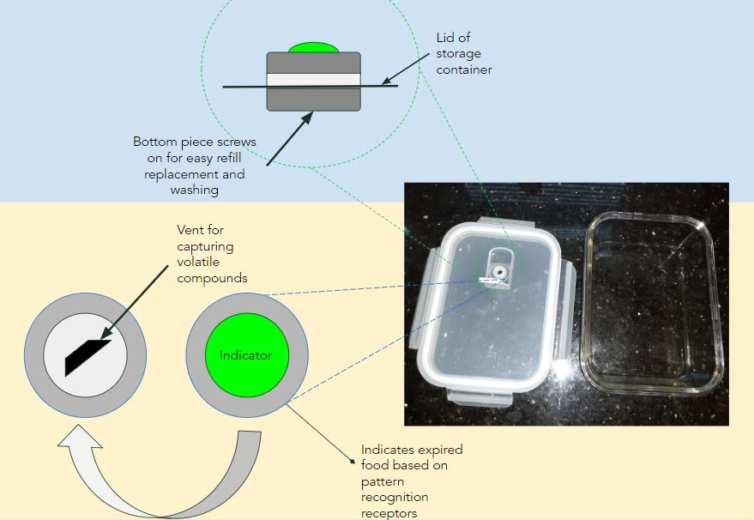

Figure 1. GTG food storage with indicator prototype.

**Financial summary**

*Customer discovery data*

90% of respondents say they would buy this product.

¾ of surveyors say they don’t trust their sense of smell for bad food

*Market size (TAM/SAM/SOM)*

Total Addressable Market: 128M

Serviceable Available Market: 90M

Serviceable Obtainable Market: 22M (24% market share)

*Profits and/or funding to date*

We have amassed over $28M profit

*Wins to date (what you have done thus far)*

Designed GTG products

Held a focus group with a representative customer base

Reached minimum viable product

*Hurdles to overcome*

Our current customer base is not as concerned with environmental waste as younger generations. We would like to increase our market share to include customers that will buy refills faster than the current customer base.

**Milestones**

*Financial*

We currently hold 24% of the market share in food storage systems.

*Product/Tech development*

20% of customers found our indicators hard to replace. We have since shortened the tread length for refills to twist on and off easier for our users.

*Customers*

Our customer base consists of men and women aged 18-75 who live with 3 or more people in a household.

*Regulatory*

We are a global distributer of recyclable food storage and safety products. We partner with retailers and sell our product online. We sell an affordable product that is long lasting and environmentally friendly. We operate by drop-shipping to cut warehousing costs. We fulfill orders once they are placed.

*Paths toward your milestones*

We would like to buy advertisement space on social media platforms and websites frequented by college-age to middle-age populations as they make up the smallest percentage of our customer base.

Make sure these points are included to mirror your pitch deck:

1. Start with the problem slide

2. Your vision and value proposition

3. Target market and opportunity

4. The solution

5. Revenue model or business model

6. Traction and validation/roadmap

7. Marketing and sales strategy

8. Financials

9. Competition

10. Investment and use of funds