Yarmouk University
Faculty of Computer Science and Information Technology

DA220 – Machine Learning Project
Car Price Prediction Using Machine Learning

Name: روعه حسن الحوراني
ID.No: 2023057048
Instructor: Rami Mohawesh

Project Problem

1.1 Problem Statement
The price of a used car can vary depending on several characteristics, such as its manufacturing year, kilometers driven, fuel type, seller type, transmission type, ownership status, company, and model. Therefore, estimating the selling price of a used car based on its characteristics can be challenging.
The problem addressed in this project is to predict the selling price of a used car based on its available characteristics using machine learning techniques.

1.2 Project Goal
The main goal of this project is to develop machine learning regression models that can predict the selling price of used cars based on their characteristics.
The project also aims to evaluate and compare the performance of the developed models using appropriate evaluation metrics and determine which model provides the best prediction performance.

1.3 Hypothesis
We hypothesize that the characteristics of a used car, including its manufacturing year, kilometers driven, fuel type, seller type, transmission type, ownership status, company, and model, have an effect on its selling price.
We expect that machine learning models can learn the relationships between these characteristics and the selling price and provide reasonable predictions of car prices.

Type of Machine Learning Problem
This project is a Supervised Learning problem because the dataset contains the actual selling price of each car. Therefore, the models can learn from the known selling prices during the training process.
It is also a Regression problem because the target variable, selling_price, is a numerical value that the models aim to predict.

Classification of the Problem
- Learning Type: Supervised Learning
- Problem Type: Regression
- Target Variable: selling_price

- Data Description
The dataset used in this project is a tabular dataset containing information about used cars and their selling prices. The main purpose of using this dataset is to study the relationship between different characteristics of cars and their selling prices, and to use these characteristics to predict the selling price of a car.
The dataset contains 4,340 records and 8 variables. The variables provide information about different characteristics of the cars, including the car name, manufacturing year, kilometers driven, fuel type, seller type, transmission type, and owner type. The dataset also contains the selling price, which will be used as the target variable in this project.
The dataset was obtained from Kaggle and is provided in CSV format, making it suitable for tabular data analysis and machine learning applications. The dataset represents the Indian used-car market, and the selling price is recorded in Indian Rupees (INR).
The main variables in the dataset are:
- name: The name or model of the car.
- year: The manufacturing year of the car.
- selling_price: The selling price of the car.
- km_driven: The number of kilometers driven by the car.
- fuel: The type of fuel used by the car.
- seller_type: The type of seller.
- transmission: The type of transmission.
- owner: The ownership status/type of the car.
The dataset will be examined and cleaned before applying the machine learning models. Duplicate records and other data-quality issues will be checked during the data preprocessing stage.

Data Preprocessing
Before applying the machine learning models, the dataset was examined and prepared to ensure that it was suitable for analysis and prediction.
First, the dataset was loaded and its structure was examined using basic data exploration methods. The number of records, variables, data types, and descriptive statistics were checked to understand the characteristics of the dataset.
The dataset was also checked for missing values. No missing values were found in the dataset. Duplicate records were then identified, and the duplicated rows were removed to avoid using repeated observations during the analysis and machine learning process.
The categorical variables were also examined to identify their different categories, such as fuel type, seller type, transmission type, and owner type.
In addition, the original name variable was processed to extract two separate features: company and model. The original name variable was then removed from the dataset, while the newly created company and model variables were used as input features.
Finally, the data was prepared for machine learning by separating the target variable, selling_price, from the input features. The categorical features were encoded into numerical representations, and the numerical features were standardized where required. The dataset was then divided into training and testing sets to allow the models to be trained and evaluated on separate data.

- Exploratory Data Analysis (EDA)

Exploratory Data Analysis was conducted to better understand the distribution of the variables and explore the relationships between the car characteristics and selling price. Different statistical visualizations were used to identify patterns, trends, and relationships within the dataset before building the machine learning models.

Figure 1: Distribution of Selling Price
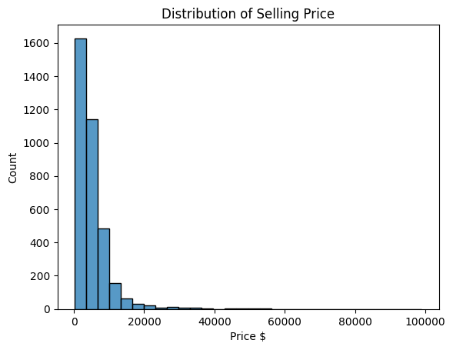

The selling price distribution is right-skewed, with most cars concentrated at lower prices and a small number of cars having much higher prices.

Figure 2: Year vs. Selling Price
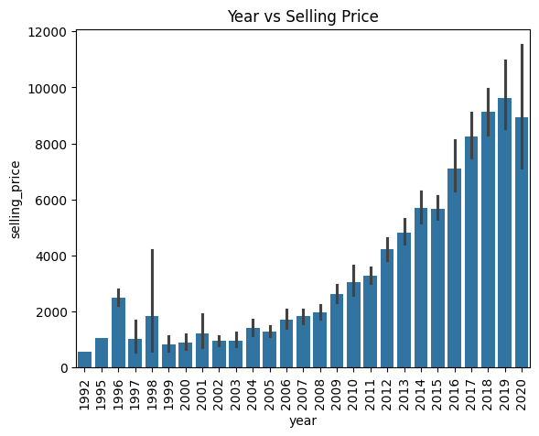
The plot shows a clear positive relationship between car year and selling price, indicating that newer cars generally tend to have higher selling prices.

Figure 3: KM Driven vs. Selling Price
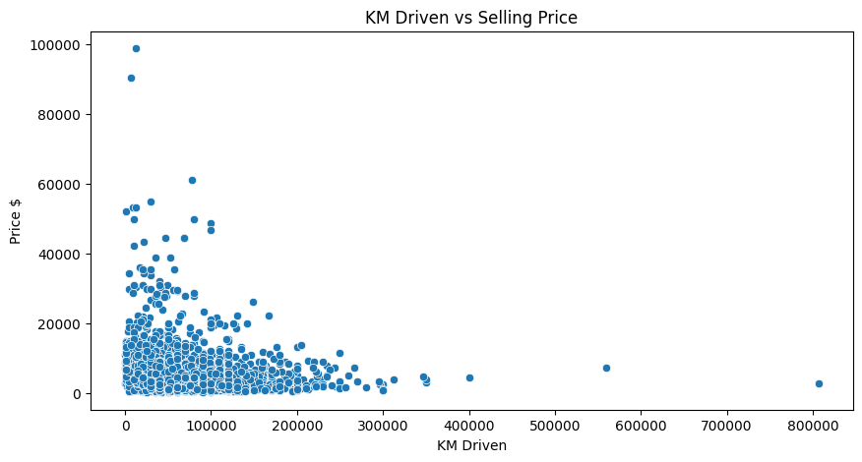
The plot shows a generally negative relationship between kilometers driven and selling price, as cars with higher mileage tend to have lower prices. The plot also shows some high-value observations and outliers.

Figure 4: Selling Price by Transmission
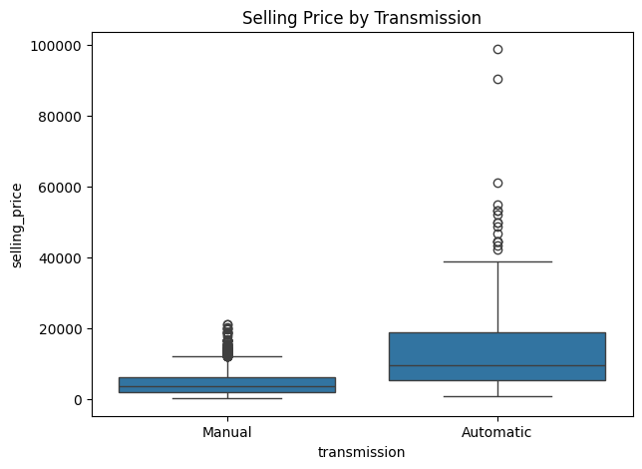
Automatic cars generally have higher selling prices than manual cars, although both groups contain some high-price outliers.

Figure 5: Correlation Matrix
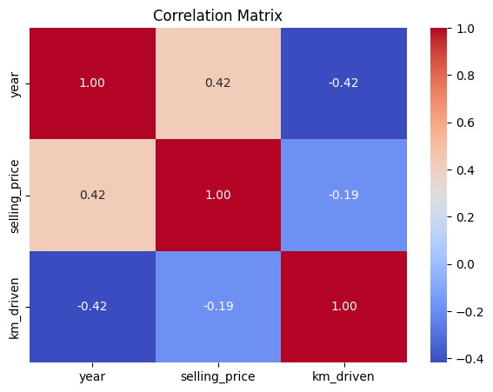

The correlation matrix shows a moderate positive correlation between year and selling price (0.42), while kilometers driven has a weak negative correlation with selling price (-0.19). Year and kilometers driven also have a moderate negative correlation (-0.42).

Figure 6: Car Companies Distribution
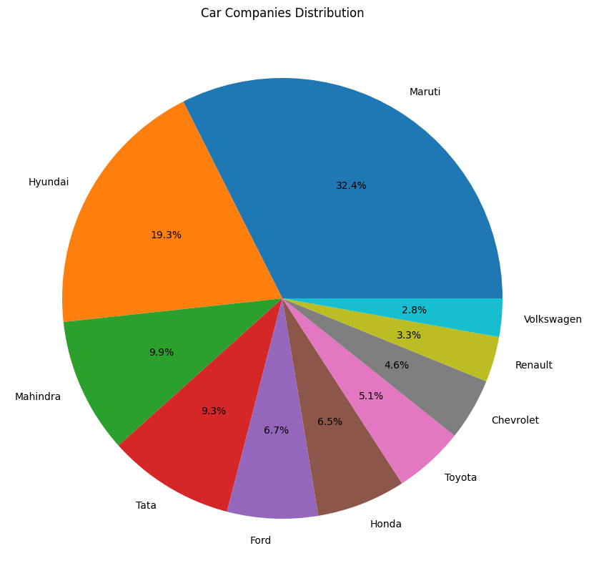

Maruti has the largest share of cars in the dataset (32.4%), followed by Hyundai (19.3%), while the remaining companies represent smaller proportions of the dataset.

- Machine Learning Models
After completing the data preprocessing and exploratory data analysis, machine learning regression models were trained to predict the selling price of used cars. The dataset was divided into training and testing sets. The training set was used to learn the relationship between the car features and selling price, while the testing set was used to evaluate the models on unseen data. Four regression models were used and compared: Linear Regression, Random Forest, Gradient Boosting, and CatBoost.

- Linear Regression
Linear Regression was used as a simple baseline regression model to estimate the relationship between the input features and the selling price.

- Random Forest Regressor
Random Forest Regressor was used to capture more complex relationships between the car features and selling price by combining multiple decision trees.

- Gradient Boosting Regressor
Gradient Boosting Regressor was used to improve prediction performance by combining multiple weak models sequentially, where each model focuses on reducing the errors of the previous models.

- CatBoost Regressor
CatBoost Regressor was included to handle categorical features effectively and capture nonlinear relationships between the car characteristics and selling price.
- Model Evaluation
The performance of the regression models was evaluated using Mean Absolute Error (MAE), Root Mean Squared Error (RMSE), and R² score. These metrics were used to compare the prediction errors and determine which model provided the best performance.

Model | MAE | RMSE | R²
Linear Regression | 1440.08 | 3181.61 | 0.7478
Random Forest | 1468.26 | 3439.51 | 0.7053
Gradient Boosting | 1679.23 | 3253.84 | 0.7362
CatBoost | 1549.45 | 3132.27 | 0.7556

Based on the evaluation results, CatBoost achieved the highest R² score (0.7556) and the lowest RMSE (3132.27) among the tested models. Therefore, CatBoost was selected as the best-performing model for the car price prediction task.

- Streamlit Application (GUI)

A Streamlit-based graphical user interface was developed to make the car price prediction model easier to use. The application allows users to enter the main characteristics of a used car and obtain an estimated selling price without directly interacting with the Python code.
- User Inputs
The application allows the user to enter or select the following car characteristics:
- Company
- Model
- Year
- Kilometers Driven
- Fuel Type
- Seller Type
- Transmission
- Owner

- Prediction Process

After entering the car information, the user clicks the Predict Price button. The application applies the saved preprocessing pipeline to the input data and passes the transformed data to the saved CatBoost model. The predicted selling price is then displayed to the user.

GUI Result
Streamlit Car Price Prediction Interface
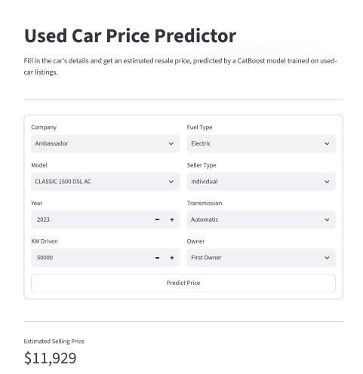

The interface displays the estimated selling price together with a summary of the selected car characteristics. This provides a simple and user-friendly way to use the machine learning model for car price prediction.

- Conclusion
This project developed a machine learning solution for predicting used car selling prices based on different car characteristics. The dataset was first cleaned and explored using statistical and visual analysis. Several regression models were then trained and evaluated using MAE, RMSE, and R² metrics. Among the tested models, CatBoost achieved the best overall performance, with an R² score of 0.7556 and an RMSE of 3132.27.
The selected model was saved and integrated into a Streamlit application. The application provides a simple interface where users can enter the main characteristics of a used car and obtain an estimated selling price. The final application demonstrates how the machine learning model can be used in a practical and user-friendly way.

