TASK 3

SMART IoT
AUTOMATION SYSTEM
ESP32-Based Smart Distance Monitoring
and Obstacle Alert System
MAINCRAFTS TECHNOLOGY
VIRTUAL INTERNSHIP PROGRAM

Submitted By: Swapnil Rawade

Branch: Electronics and Telecommunication Engineering (ENTC)

College: RMD Sinhgad College of Engineering, Pune
Internship: Virtual Internship - Embedded Systems & IoT
Academic Year: 2026–27

Simulation Platform: Wokwi | Cloud Platform: ThingSpeak

1. Abstract
This project upgrades a Smart Distance Monitoring System into a connected automation system. An HC-SR04 ultrasonic sensor measures the distance to a nearby object. An ESP32 reads the sensor signal, calculates the distance, applies threshold-based decision logic, updates an OLED display, and controls a buzzer automatically. The ESP32 also connects to the Wokwi simulated Wi-Fi network and uploads distance and status data to a ThingSpeak cloud channel at 20-second intervals. The project demonstrates sensor interfacing, embedded decision-making, output control, local feedback, and basic IoT data monitoring.

2. Objective
- Upgrade the existing distance-monitoring prototype with automatic decision-making.
- Measure object distance using an ultrasonic sensor.
- Display live distance, object status, and buzzer status on an OLED display.
- Activate the buzzer automatically when an object enters the danger zone.
- Send sensor readings and encoded status values to a ThingSpeak cloud dashboard.

3. Hardware and Software Requirements
Item | Component / Platform | Purpose
1 | ESP32 DevKit V1 | Main controller; reads the sensor and provides Wi-Fi connectivity.
2 | HC-SR04 ultrasonic sensor | Measures distance to an object.
3 | OLED display (128 × 64, SSD1306) | Displays distance and system status locally.
4 | Buzzer | Provides an audible warning in the danger condition.
5 | Wokwi | Simulates the ESP32 circuit and sensor behaviour.
6 | ThingSpeak | Receives and plots uploaded sensor data in the cloud.
7 | Arduino libraries | Wire, Adafruit_GFX, Adafruit_SSD1306, WiFi, HTTPClient.

4. Circuit Connections
The project uses the following pin assignments in the Arduino sketch:
Module pin | ESP32 connection | Notes
HC-SR04 TRIG | GPIO 5 | Trigger output from ESP32.
HC-SR04 ECHO | GPIO 18 | Echo input to ESP32.
HC-SR04 VCC / GND | 5V / GND | Common ground is required.
OLED SDA / SCL | GPIO 21 / GPIO 22 | I²C communication.
OLED VCC / GND | 3.3V / GND | OLED supply connections.
Buzzer positive / negative | GPIO 25 / GND | Controlled by the ESP32.
Hardware safety note: A physical HC-SR04 module powered at 5V can produce a 5V ECHO signal. ESP32 GPIO inputs are not 5V tolerant. For a real hardware build, use a suitable voltage divider or logic-level shifter between ECHO and GPIO 18. The Wokwi simulation does not replace this physical electrical precaution.
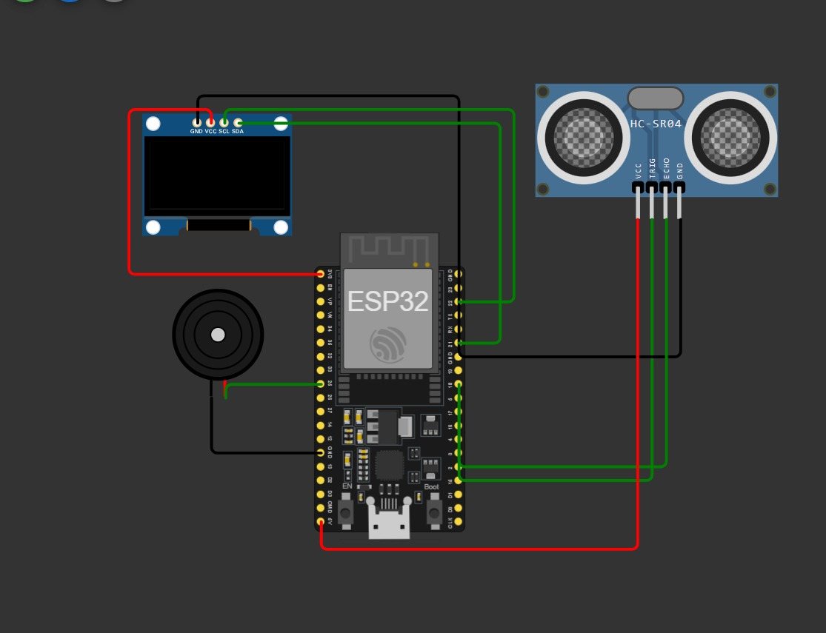

5. Working Principle
- The ESP32 sends a short trigger pulse to the HC-SR04 sensor.
- The sensor emits an ultrasonic burst and returns an ECHO pulse whose duration corresponds to the sound travel time.
- The ESP32 measures the ECHO pulse duration and calculates distance in centimetres using: Distance = duration × 0.0343 / 2.
- The calculated distance is compared with the programmed threshold values.
- The ESP32 updates the OLED display and controls the buzzer according to the detected condition.
- At regular intervals, the ESP32 sends the measured distance and numeric status codes to ThingSpeak using an HTTP request.

6. Automation Logic
The system uses the following threshold-based IF / ELSE decision logic:
Measured distance | OLED status | Buzzer | Status code
> 50 cm | SAFE | OFF | 1
20 cm to 50 cm (inclusive) | OBJECT NEAR | OFF | 2
< 20 cm | DANGER | ON | 3
No valid echo reading | NO READING | OFF | 0
The buzzer is activated continuously in the DANGER state by the tone() function and is switched off in the other states using noTone(). The OLED shows the measured distance, status, buzzer state, and Wi-Fi state.

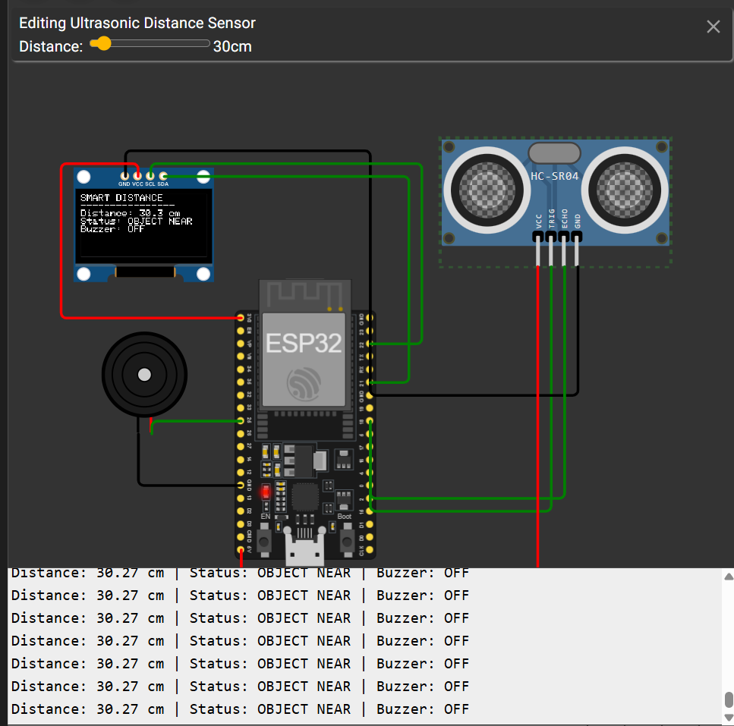
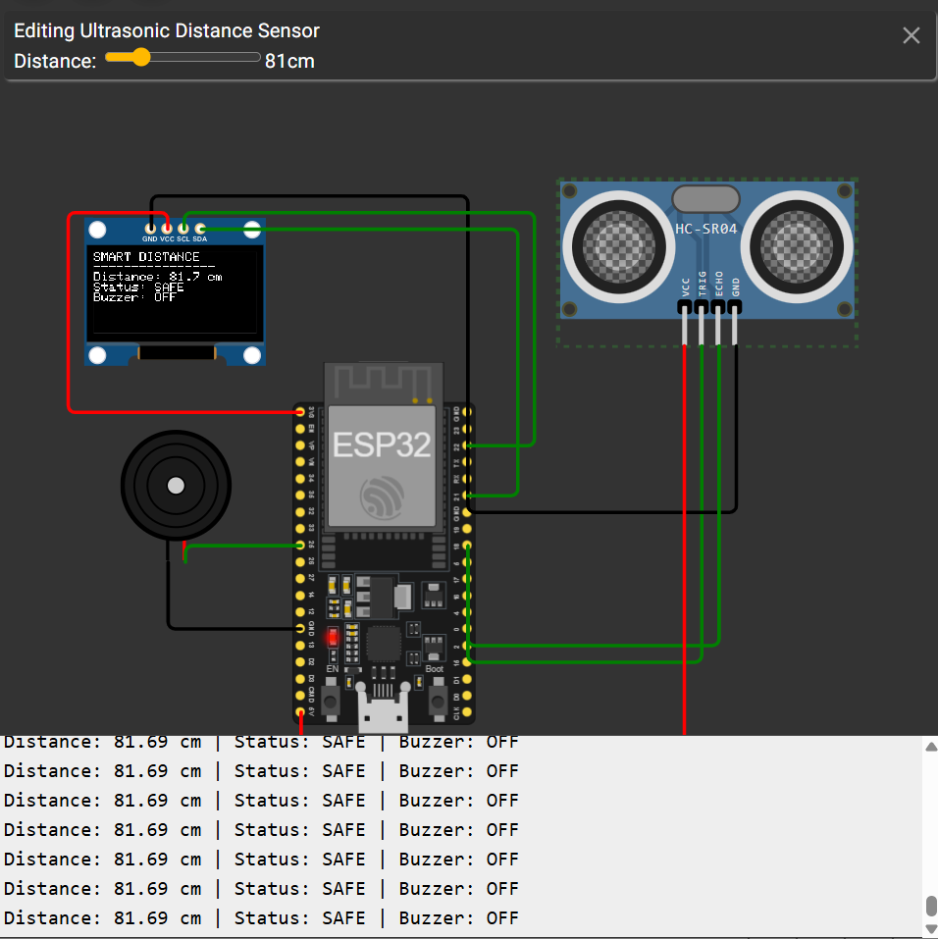
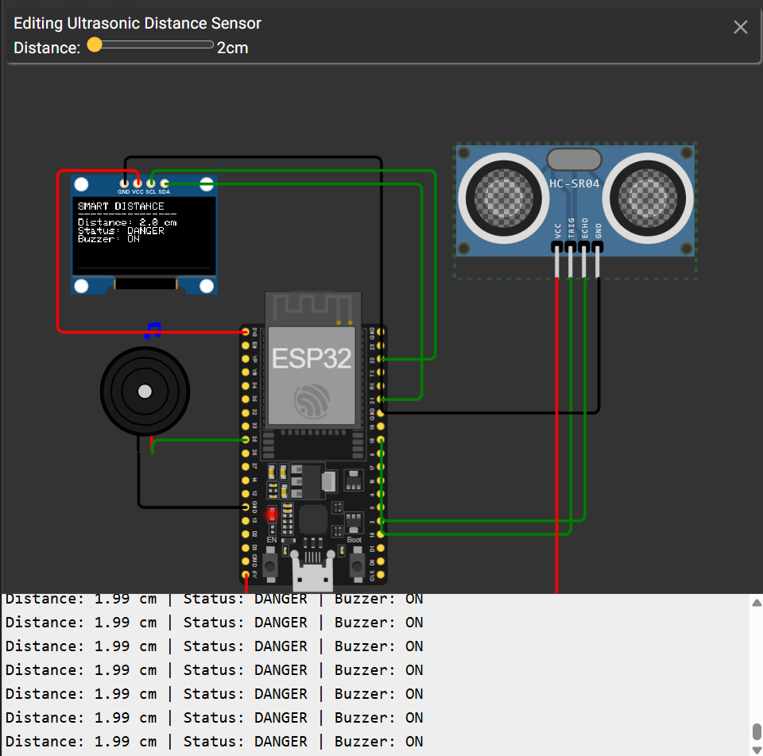

7. IoT Connectivity and ThingSpeak Data
The ESP32 connects to the Wokwi simulated wireless network using the SSID Wokwi-GUEST with an empty password and Wi-Fi channel 6. After connecting, it sends data to the ThingSpeak channel using its HTTP update endpoint. The sketch is configured to attempt an upload every 20 seconds, which is compatible with the usual free-tier minimum update interval.
ThingSpeak field | Uploaded value | Meaning
Field 1 | Measured distance | Distance in centimetres.
Field 2 | 0 / 1 / 2 / 3 | 0 = no reading, 1 = SAFE, 2 = OBJECT NEAR, 3 = DANGER.
Field 3 | 0 / 1 | 0 = buzzer OFF, 1 = buzzer ON.
API key security: The ThingSpeak Write API Key is a secret. It must not be committed to a public GitHub repository. Use a placeholder in the published source code and keep the real key private.

8. Testing and Observed Results
The project was tested in the Wokwi simulation using representative object distances. The expected behaviour is summarised below. The user also verified successful Wi-Fi connection and successful ThingSpeak HTTP updates during simulation.
Test | Input distance | Expected status | Expected buzzer
1 | 70 cm | SAFE | OFF
2 | 35 cm | OBJECT NEAR | OFF
3 | 10 cm | DANGER | ON
During the cloud test, the Serial Monitor displayed a successful Wi-Fi connection and a ThingSpeak HTTP response code of 200. The ThingSpeak dashboard showed data in all three configured fields. A successful HTTP response confirms that the request was accepted; the dashboard should also be checked to confirm the values and timestamps.

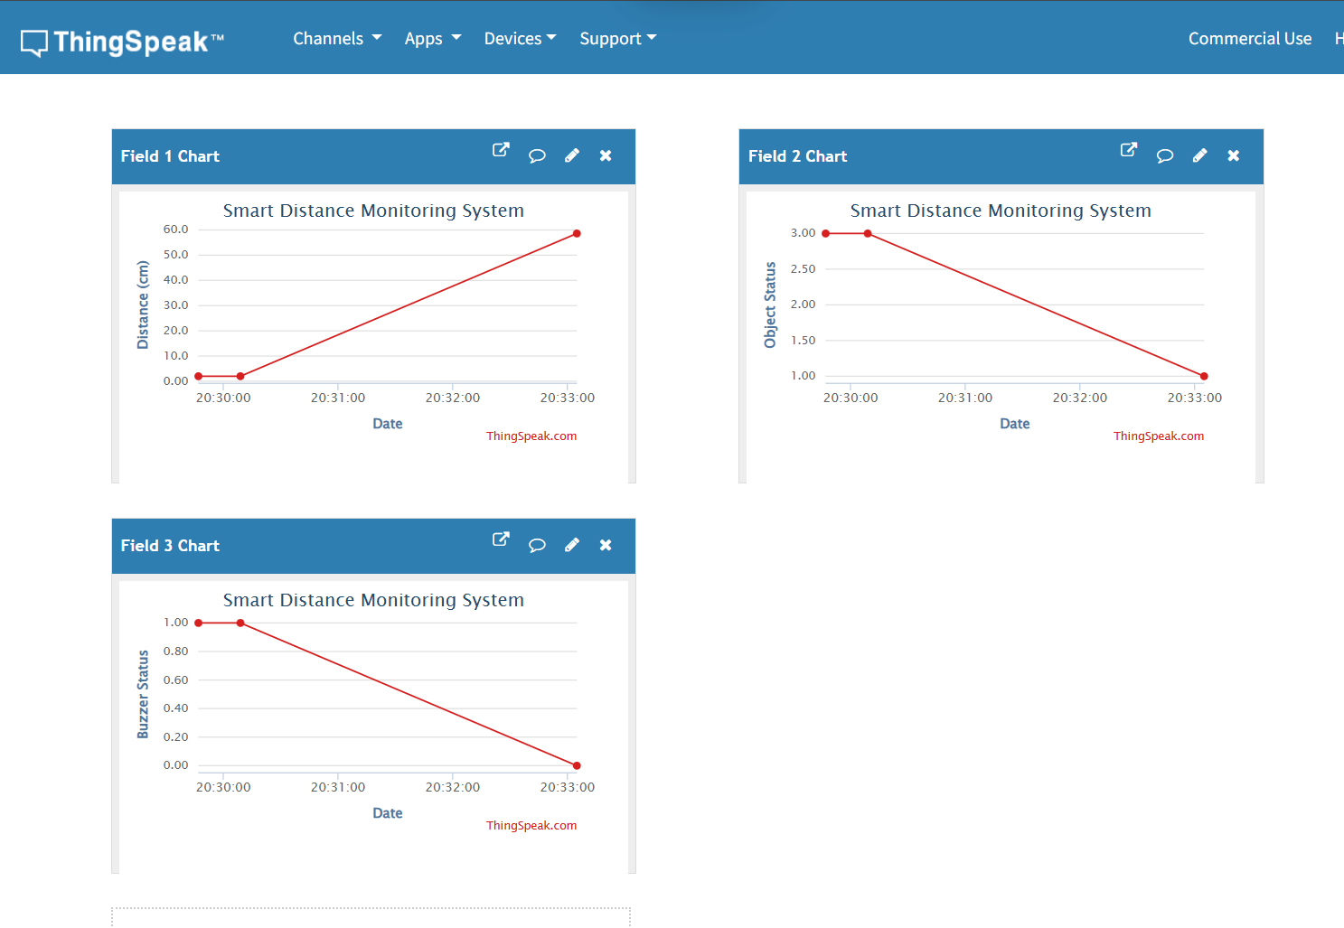
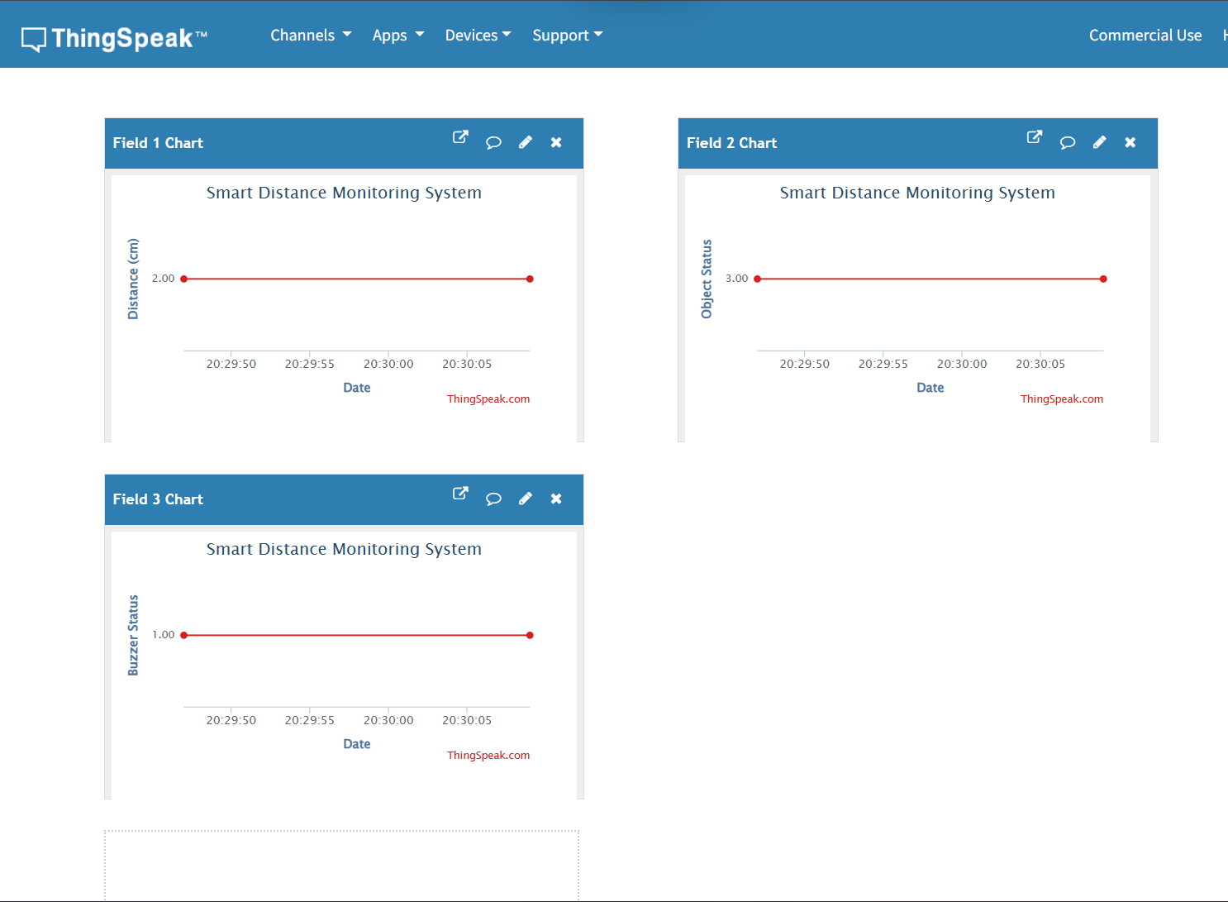

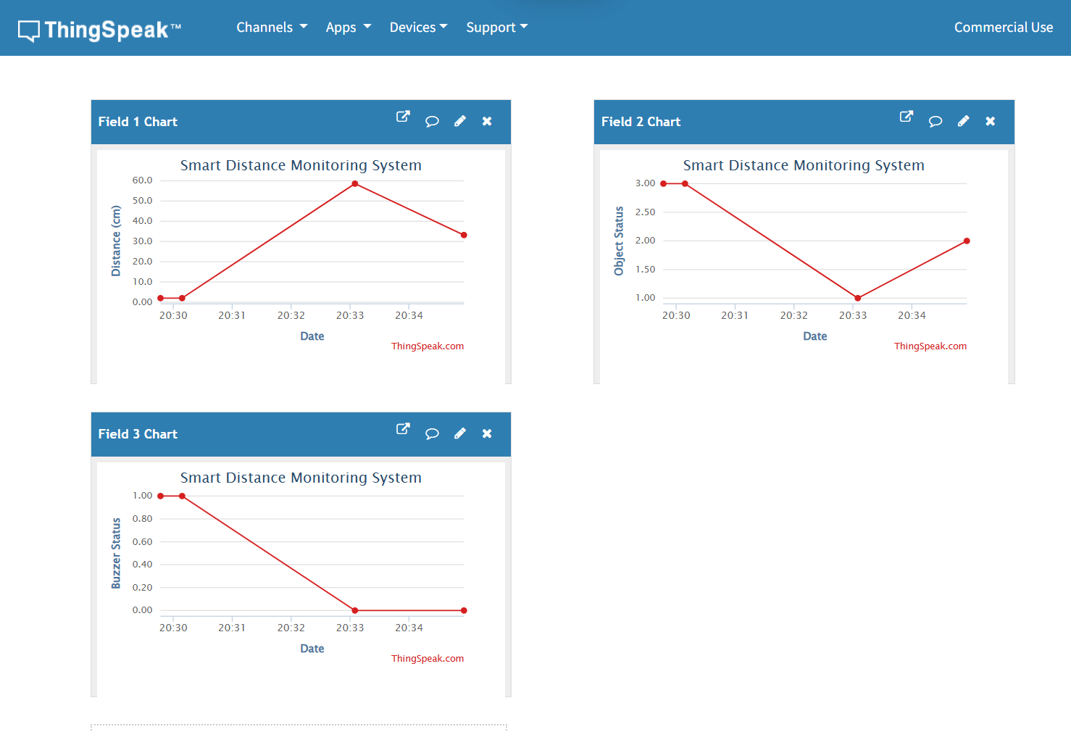

9. Applications
- Smart parking assistance and vehicle proximity alerts.
- Obstacle detection for mobile robots.
- Restricted-area proximity warnings.
- Basic industrial distance monitoring.
- Educational demonstrations of embedded automation and IoT.

10. Limitations and Future Improvements
- The current implementation is validated in Wokwi; physical hardware testing is still required.
- The HC-SR04 may give unreliable readings on soft, angled, or irregular surfaces.
- The cloud dashboard stores numeric status codes; labels can be clarified in the dashboard description or a separate legend.
- Future work may include a physical prototype, improved filtering of sensor readings, a mobile notification system, and a more detailed dashboard.

11. Conclusion
The Smart IoT Automation System demonstrates how an ultrasonic sensor, ESP32, OLED display, and buzzer can be combined to create an automatic distance-monitoring and alert system. The ESP32 makes decisions using predefined distance thresholds, provides local visual and audible feedback, and uploads data to ThingSpeak over Wi-Fi. The project fulfils the core aims of sensor monitoring, IF / ELSE automation, feedback, and introductory IoT cloud connectivity in a simulated environment.

12. Submission Evidence Checklist
- Wokwi circuit screenshot showing ESP32, HC-SR04, OLED, buzzer, and connections.
- Wokwi diagram.json file.
- Final Arduino source code (public copy with API key replaced by a placeholder).
- OLED / Serial Monitor screenshots for SAFE, OBJECT NEAR, and DANGER conditions.
- ThingSpeak dashboard screenshot showing Fields 1, 2, and 3.
- This working explanation document.

