Fontys Hogescholen

User Requirements Specifications

Media Bazaar project

**Group name: R2DA**

**Team members**:

Rawan Abou Dehn (**Leader**)

Anas Ahmad

Rareş Băluţoiu

Denys Sytnyk

**Supervisor**: André Postma

Eindhoven, 2-19-2020

**Version number:** 0.2

Document Change Record

|  |  |  |  |
| --- | --- | --- | --- |
| *Date* | *Version* | *Author* | *Comments* |
| 23-02-2020 | 0.2 | Rawan Abou Dehn | 1. Version number was added to front page. 2. User requirements was adjusted. 3. In ‘Constraints’ section, database was added. 4. In ‘Functional requirements’, login and logout cases were added, refuse or accept a proposed shift was separated into two cases. 5. In ‘Use cases’, login and logout cases were added. 6. Created and included new version of GUI. |
| 27-02-2020 | 0.2 | Anas Ahmad | 1. The use case number FR-06, FR-08 and FR-12 were created 2. Figures were added 3. Cross-references were added to the figures 4. User requirement was adjusted accordingly. |
| 01-03-2020 | 0.2 | Rareş Băluţoiu | 1. Manager use cases were adjusted. |

Table of Contents

1 Introduction 4

1.1 Document Purpose 4

1.2 Document Overview 4

2 Background 5

2.1 Scope and Objectives 5

3 Stakeholder and User Analysis 6

4 User Requirements 7

4.1 Functional Requirements 7

4.2 Non-Functional Requirements 9

5 Assumptions/Constraints 10

6 Use Case Models 11

7 GUI 22

# Introduction

## Document Purpose

This document is the definitive specification of the user requirements for the “Media Bazaar” project. It is a primary input to the technical development and the primary specification for the acceptance criteria for those evaluating the outcome after the development has been finalized. This document is intended to be read by all responsible for the management of the development.

## Document Overview

Section 2 provides a general description of the products and the factors that affect their requirements.

Section 3 provides a list of the stakeholders.

Section 4 describes the functional and non-functional requirements.

Section 5 describes all constraints/assumptions for the project.

Section 6 describes use cases of each functionality.

Section 7 provide pictures of the Graphical User Interface.

# Background

We are requested by a client that just opened a hardware stores and needs help administrating their employees and be able to see stock and re-stock.

Our project is consisted by a software application in C# and a website. Our application will allow the client to administrate their employees, i.e. view and change personal information, view and change theirs shifts, view statistics about employees or stock, etc. Our website will allow the client to give employees the ability to see information about shifts and stock.

## Scope and Objectives

Make an application that helps the client administrate its employees, i.e. shifts, personal data and stock.

# Stakeholder and User Analysis

**Stakeholders:**

The stakeholders of our project are the client and the development team.

Stakeholder engagement:

In order to understand our stakeholders, we used two techniques:

With our client:

1. Interviewing our client
2. Contacting our client per email whenever we had questions or some points that needed clarification.

Internally in the team:

Nominal group technique (ideas are gathered and combined in a face-to-face, nonthreatening group environment)

**User Analysis:**

The users will be the staff of the company. And there are four different types of users.

1. Administrators
2. Managers
3. Depot workers
4. Employees

The user’s views are represented by the client, the manager of the company.

# User Requirements

## Functional Requirements

**The management app:**

|  |  |  |
| --- | --- | --- |
| *ID* | *Name* | *Priority*  *(MoSCoW)* |
| FR-01 | Administrators should be able to see the data of the employees | M |
| FR-02 | Administrators should be able to add new employees to the system. | M |
| FR-03 | Administrators should be able to remove employees from the system. | M |
| FR-04 | Administrators should be able to adjust employee details (address, phone number and hourly wage). | S |
| FR-05 | Administrators should be able to accept proposed shifts. | S |
| FR-06 | Administrators should be able to reject proposed shifts. | S |
| FR-07 | Administrators should be able to assign shift to employees | M |
| FR-08 | Administrators should be able to remove an employee’s shift (in case of error, illness, request, etc.). | M |
| FR-09 | Administrators should be able to check the schedule of the employees | M |
| FR-10 | Administrators should be able to view stock. | M |
| FR-11 | Administrators should be able to edit the stock | M |
| FR-12 | Administrator should be able to Add a new product in the stock | M |
| FR-13 | Administrators should be able to remove products. | M |
| FR-14 | Administrators should be able to view statistics (e.g. the most bought product, how many employees are working in a day and a shift…) | M |
| Statistics could be stock or employees related. |
| FR-15 | Administrators should be able to restock the shop by sending a request to depot workers. | S |
| FR-16 | Managers should be able to view employees. | M |
| FR-17 | Managers should be able to view employees schedule. | M |
| FR-18 | Managers should be able to view stock. | M |
| FR-19 | Managers should be able to view statistics. | M |
| Statistics could be stock or employees related. |
| FR-20 | Depot workers should be able to see data about stock. | M |
| FR-21 | Depot workers should be able to see incoming shelf restock requests. | S |
| FR-22 | Depot workers should be able to restock warehouse. | S |
| FR-23 | Depot workers should be able to restock shop. | S |
| FR-24 | Users (managers, administrators and depot workers) should be able to log in. | M |
| FR-25 | Users (managers, administrators and depot workers) should be able to log out. | M |

**The website for the employees:**

|  |  |  |
| --- | --- | --- |
| *ID* | Name | *Priority*  *(MoSCoW)* |
| FR-26 | Employees should be able to view their schedule, information and hourly wage. | M |
| FR-27 | Employees should be able to declare their availabilities. | C |
| FR-28 | Employees should be able to confirm their attendance. | C |
| FR-29 | Employees should be able to log in. | M |
| FR-30 | Employees should be able to log out. | M |

**In the first six weeks we will work on the C# management app with focus on the employee’s administration and we will solve the following requirements:**

|  |  |  |
| --- | --- | --- |
| *ID* | *Name* | *Priority*  *(MoSCoW)* |
| FR-01 | Administrators should be able to see the list of the employees | M |
| FR-02 | Administrators should be able to add new employees to the system. | M |
| FR-03 | Administrators should be able to remove employees from the system. | M |
| FR-04 | Administrators should be able to adjust employee details (address, phone number and hourly wage). | S |
| FR-05 | Administrators should be able to accept proposed shifts. | S |
| FR-06 | Administrators should be able to reject proposed shifts. | S |
| FR-07 | Administrators should be able to assign shift to employees | M |
| FR-08 | Administrators should be able to remove an employee’s shift (in case of error, illness, request, etc). | M |
| FR-09 | Administrators should be able to check the schedule of the employees | M |
| FR-14 | Administrators should be able to view statistics (e.g. the most bought product, how many employees are working in a day and a shift…) | M |
| FR-17 | Managers should be able to view employees. | M |
| FR-18 | Managers should be able to view employees schedule. | M |
| FR-20 | Managers should be able to view statistics related to employees. | M |
| FR-24 | Users (managers, administrators and depot workers) should be able to log in. | M |
| FR-25 | Users (managers, administrators and depot workers) should be able to log out. | M |

## Non-Functional Requirements

|  |  |  |
| --- | --- | --- |
| *ID* | *Name* | *Priority*  *(MoSCoW)* |
| N-FR-01 | Security (Encryption of passwords) | C |
| N-FR-02 | Maintenance | W |
|  |  |  |

# Assumptions/Constraints

1. We have 18 weeks to finish this project. During the first 6 weeks we will focus on the most important requirements of our client: a fully functional application which will keep track of employees.
2. Our application and website will be developed using C# and PHP.
3. The database will be deployed on the HERA server.

# Use Case Models

**Administrator:**

1. **UC: To check the data of the Employees in the System (Refers to:** Figure 6 : Administration Tab**)**

|  |  |
| --- | --- |
| Use case: | To check the data of the employees in the system (FR-01) |
| Actor: | Administrator |
| Pre-condition: | User must be login |
| Trigger: | Employee Administration tab is pressed |
| Main Success Scenario: | 1. System displays a list of employees 2. End of case |

1. **UC: Add a new employee in the system** **(Refers to:** Figure 6 : Administration Tab**)**

|  |  |
| --- | --- |
| Use case: | Add a new Employee in the system (FR-02) |
| Actor: | Administrator |
| Pre-condition: | Administrator must be logged in should be in the administrator tab |
| Trigger: | Add button is pressed |
| Main Success Scenario: | 1. System requests for the information of the new employee 2. Administrator fills in the information and confirm 3. System requests for confirmation in yes or no 4. Administrator press yes 5. System Add the information in the system 6. System display a message that a new employee has been added 7. End of case |
| Extensions: | 1a: No information is added  .1: System displays a message that the information is not complete  .2: Return to MSS 1  2a: Wrong Information is entered, and the user confirms  .1: System displays a message that information is not in a correct format  .2: Return to MSS 2  4a: Administrator decides not to add a new employee  .1: Administrator press no  .2: End of case |

1. **UC: Remove an employee from the system (Refers to:** Figure 6 : Administration Tab**)**

|  |  |
| --- | --- |
| Use case: | Remove an Employee from the system (FR-03) |
| Actor: | Administrator |
| Pre-condition: | Administrator must be logged in and should be in administrator tab |
| Trigger: | Remove button is pressed |
| Main Success Scenario: | 1. Administrator selects an employee from the list and press remove 2. System ask for confirmation in yes or no 3. Administrator press yes 4. System removes the employee from the system 5. Systems shows a message that Employee is Fired 6. End of case |
| Extensions: | 1a: No employee is selected and remove is pressed  .1: System displays a message that no employee is selected  .2: Return to MSS 1  3a: Administrator Decides not to fire the employee and presses no  .1: End of case |

1. **UC: Modify employee’s information (Refers to:** Figure 6 : Administration Tab**)**

|  |  |
| --- | --- |
| Use case: | Modify the employee’s information in the system (FR-04) |
| Actor: | Administrator |
| Pre-condition: | Administrator must be logged in and should be in the administrator tab |
| Trigger: | Modify button is pressed |
| Main Success Scenario: | 1. Administrator selects an employee from the list and press modify 2. System request the changes 3. Administrator enter the new changes and confirm 4. System updates the information 5. Systems shows a message that information has been updated 6. End of case |
| Extensions: | 1a: No employee is selected and modify is pressed  .1: System displays a message that no employee is selected .2: Return to MSS 1. 3a: Info is not correct  .1: Systems shows a message that information is not in a correct format  .2: Return to MSS 1 |

1. **UC: Accept the proposed shifts** (**Refers to:** Figure 7 Shift Tab**)**

|  |  |
| --- | --- |
| Use case: | Accept the proposed shifts (FR-05) |
| Actor: | Administrator |
| Pre-condition: | Administrator must be logged |
| Trigger: | Shift tab button is pressed |
| Main Success Scenario: | 1. Administrator selects a proposed shift 2. Administrator press confirm 3. System checks if the shift is free 4. System checks if the proposed shift is according to the rules e.g. an employee can work only five shifts per week and one shift per day. And a week starts from Monday. 5. System approves the proposed shift 6. System add the information in the schedule 7. System send a notification to the employee about the approval 8. End of case |
| Extensions: | 1a: No shift is selected and presses confirm  .1: System displays a message that select a proposal  .2: Return to MSS 1.  4a: Proposed shift is not according to the rules  .1: System rejects the proposed shift  .2: End of case |

1. **UC: Reject the proposed shift** (**Refers to:** Figure 7 Shift Tab)

|  |  |
| --- | --- |
| Use case: | Reject the proposed shifts (FR-06) |
| Actor: | Administrator |
| Pre-condition: | Administrator must be logged in |
| Trigger: | Shift tab button is pressed |
| Main Success Scenario: | 1. Administrator selects a proposed shift 2. Administrator press rejects 3. System requests the verification in yes or no. 4. Administrator press yes 5. System removes the proposed shift from the list 6. System sends a not to the employee about the rejection 7. End of case |
| Extensions: | 1a: No shift is selected  .1: System displays a message that select a proposal  .2: Return to MSS 1.  3a: Administrator press no  .1: System does not remove that shift from the proposed shifts  .2: Return to MSS 1. |

1. **UC: Assign a shift to an employee** (**Refers to:** Figure 7 Shift Tab)

|  |  |
| --- | --- |
| Use case: | Assign a shift to an employee (FR-07) |
| Actor: | Administrator |
| Pre-condition: | Administrator must be logged in |
| Trigger: | Shift tab button is pressed |
| Main Success Scenario: | 1. Administrator chooses the name of the employee, a date, a shift from the combo boxes and confirm 2. System checks if the assigned shift is free 3. System checks if the assigned shift is according to the rules 4. System approves the assigned shift 5. System sends the shift details to the employee 6. System display a message that the shift has been assigned to the employee 7. End of case |
| Extensions: | 1a: No information is selected  .1: System displays a message that the information is not complete  .2: Return to MSS 1  2a: Shift is not free  .1: Systems shows a message that the shift is not free .2: Return to MSS 1  3a: Assigned shift is not according to the rules  .1: Systems rejects the assigned shift  .2: Return to MSS 1 |

1. **UC: To remove an employee’s shift (in case of error, illness, request, etch**) **(Refers to:** Figure 9: Schedule Tab**)**

|  |  |
| --- | --- |
| Use case: | Administrator should be able to remove an employee’s shift (FR-08) |
| Actor: | Administrator |
| Pre-condition: | Administrator must be logged in |
| Trigger: | Schedule tab button is pressed |
| Main Success Scenario: | 1. System requests to choose from select all or specific schedule 2. Administrator choose a specific schedule 3. Administrator selects the name of the employee and the date 4. System shows the schedule in the list 5. Administrator selects a schedule from the list and pressed confirm 6. System asks for verification in yes or no 7. Administrator Presses yes 8. Systems removes the shift of that employee from the schedule 9. System displays a confirmation message and send a notification to the employee. 10. End of case |
| Extensions: | 1a: No name is selected and show button is pressed  .1: System displays a message that the information is not complete  .2: Return to MSS 1  3a: Administrator presses no  .1: System does not remove the shift from the schedule  .2: Return to MSS 1 |

1. **UC: Check the schedule of the workers (Refers to:** Figure 9: Schedule Tab**)**

|  |  |
| --- | --- |
| Use case: | Check the schedule of the workers (FR-09) |
| Actor: | Administrator |
| Pre-condition: | Administrator must be logged in |
| Trigger: | Schedule tab button is pressed |
| Main Success Scenario: | 1. System requests to choose from select all or specific schedule 2. Administrator decides to check a specific a schedule of a specific person 3. Administrator select the name of the employee or the specific shift from a drop-down list and write the date in a text box 4. System shows the schedule in the list   5. End of case. |
| Extensions: | 2a: Administrator decides to check the schedule for every worker  .1: Administrator check the select all checkbox.  .2: Return to MSS 4  3a: Only Name and Date is selected  .1: Return to MSS 4  3b: Only Shift and Date is selected  .1: Return to MSS 4 |

1. **UC: View the stock (Refers to:** Figure 10 Stock Info Tab**)**

|  |  |
| --- | --- |
| Use case: | View the stock (FR-10) |
| Actor: | Administrator |
| Pre-condition: | 1. Administrator must be logged in |
| Trigger: | Stock tab is selected |
| Main Success Scenario: | 1. System shows a list of products with category, product name and quantity. 2. End of case |

1. **UC: Edit the stock (Refers to:** Figure 10 Stock Info Tab**)**

|  |  |
| --- | --- |
| Use case: | Edit the stock (FR-11) |
| Actor: | Administrator |
| Pre-condition: | 1. Administrator must be logged |
| Trigger: | Stock tab is selected |
| Main Success Scenario: | 1. System shows a list of products with category, product name and quantity. 2. Administrator select a product and presses modify 3. System allows to edit the saved information of that product 4. Administrator changes some information e.g. quantity or product name etc and confirm 5. System saves the new information and displays a confirmation 6. End of case |
| Extensions: | 2a: Administrator added an invalid information and confirm  .1: System shows an error message  .2: Return to MSS 3. |

1. **UC: Add a new product (Refers to:** Figure 10 Stock Info Tab**)**

|  |  |
| --- | --- |
| Use case: | Edit the stock (FR-12) |
| Actor: | Administrator |
| Pre-condition: | Administrator must be logged in |
| Trigger: | Stock tab is selected |
| Main Success Scenario: | 1. Administrator selects the category 2. Administrator enters the product name, quantity, Price and presses add 3. System ask the verification in yes or no 4. End of case |
| Extensions: | 1a: Administrator added an invalid information e.g. quantity is entered in negative numbers and confirm  .1: System shows an error message  .2: Return to MSS 3. |

1. **UC: Remove a product (Refers to:** Figure 10 Stock Info Tab**)**

|  |  |
| --- | --- |
| Use case: | Remove a product (FR-13) |
| Actor: | Administrator |
| Pre-condition: | 1. Administrator must be logged in 2. Stock tab must be selected |
| Trigger: | Remove button was pressed |
| Main Success Scenario: | 1. System requests for the item that needs to be removed. 2. Administrator selects the item and confirms. 3. System checks if the item quantity is zero and if so, it removes the product and sends a request to the depot workers. 4. End of case |
| Extensions: | 3a: Item’s quantity isn’t zero  .1: System gives a message that the selected item can’t be removed.  .2: End of case |

1. **UC: View statistics (Refers to:** Figure 8 Statistics Tab**)**

|  |  |
| --- | --- |
| Use case: | Administrators should be able to view statistics. (FR-14) |
| Actor: | Administrator |
| Pre-condition: | 1. Administrator must be logged in 2. should be in the Statistics tab |
| Trigger: | Statistics tab button is pressed |
| Main Success Scenario: | 1. System shows a tab with drop-down list to choose the category and a list 2. Administrator select the category from the drop-down list 3. System shows the statistics in the list   4. End of case. |
| Extensions: | 1a: No Category is selected for checking the statistics  .1: System displays a message that the category is not selected  .2: Return to MSS 1 |

1. **UC: Re-stock request to the depot worker (Refers to:** Figure 8 Statistics Tab**)**

|  |  |
| --- | --- |
| Use case: | To send a restock request to the depot worker (FR-15) |
| Actor: | Administrator |
| Pre-condition: | 1. Administrator must be logged in 2. Stock tab must be selected |
| Trigger: | Stock tab is selected |
| Main Success Scenario: | 1. System shows a list of products with category, product name and quantity. 2. Administrator selects a product, quantity and confirms. 3. System sends a request to depot worker to restock 4. 4. End of case |
| Extensions: | 2a: Administrator entered the quantity in negative numbers  .1: System shows an error message  .2: Return to MSS 1. |

**Manager**

1. **UC: View employees in the system**

|  |  |
| --- | --- |
| Use case: | Managers should be able to see employees in the system (FR-16) |
| Actor: | Manager |
| Pre-condition: | Manager should be logged in |
| Trigger: | Manager opens Employee Tab |
| Main Success Scenario: | 1.System automatically opens the application in the ”Employees” Tab  2.Manager can see the employees in the system |

1. **UC: See the schedule of the employees**

|  |  |
| --- | --- |
| Use case: | Managers should be able to see the schedule of employees. (FR-17) |
| Actor: | Manager |
| Pre-condition: | Manager should be logged in |
| Trigger: | Manager opens the Schedule Tab |
| Main Success Scenario: | 1.Manager presses the Schedule Tab  2.System opens the Schedule Tab  3.Manager can see the Schedule with the shifts of the employees. |
| Extensions: | 3a: Manager decides to check a schedule of an employee .1: Manager enters the name, date and presses confirm .2: Return to MSS 3. |

1. **UC: View stock**

|  |  |
| --- | --- |
| Use case: | Managers should be able to view stock (FR-18) |
| Actor: | Manager |
| Pre-condition: | Manager must be logged in |
| Trigger: | Manager presses the Stock Tab |
| Main Success Scenario: | 1.Manager presses the Stock Tab  2.System opens the Stock Tab  3.Manager can see the stock |

1. **UC: View statistics**

|  |  |
| --- | --- |
| Use case: | Managers should be able to view statistics. (FR-19) |
| Actor: | Manager |
| Pre-condition: | Manager must be logged in |
| Trigger: | Manager presses the Statistics Tab |
| Main Success Scenario: | 1. Manager presses the Statistics Tab 2. System opens the Statistics Tab 3. Manager selects a statistics category 3. System shows the selected statistics. 4. End of case. |

**Depot worker:**

1. **UC: See data about stock (Refers to:** Figure 11 Stock Tab- DEPOT WORKER**)**

|  |  |
| --- | --- |
| Use case: | See data about stock (FR-20) |
| Actor: | Depot worker |
| Pre-condition: | Depot worker must be logged in |
| Trigger: | Stock tab was selected |
| Main Success Scenario: | System displays a table of info of the stock which includes category, name, quantity and price. |

1. **UC: See incoming shelf restock requests (Refers to:** Figure 11 Stock Tab- DEPOT WORKER**)**

|  |  |
| --- | --- |
| Use case: | See incoming shelf restock requests (FR-21) |
| Actor: | Depot worker |
| Pre-condition: | Depot worker must be logged in |
| Trigger: | Requested stock tab was selected |
| Main Success Scenario: | 1. System displays a table of info of the request which was sent from the shop to restock and it includes category, name, quantity and status. |

1. **UC: Restock the warehouse (Refers to:** Figure 11 Stock Tab- DEPOT WORKER**)**

|  |  |
| --- | --- |
| Use case: | Restock the warehouse (FR-22) |
| Actor: | Depot worker |
| Pre-condition: | 1. Depot worker must be logged in 2. Stock tab must be selected |
| Trigger: | Order was triggered |
| Main Success Scenario: | 1. System requests for quantity and a selection of an item from the table. 2. Depot worker selects an item and fills in the quantity and orders. 3. System confirms that the order was successful. |
| Extensions: | 1a: Depot worker hasn’t selected an item from the table 1) 1) System notifies customer of error.  2) Return to MSS step 2.  2a: Quantity is invalid   1. System notifies customer of error. 2. Return to MSS step 1. |

1. **UC: Restock the shop (Refers to:** Figure 12: Requested Stock T**)**

|  |  |
| --- | --- |
| Use case: | Restock the shop (FR-23) |
| Actor: | Depot worker |
| Pre-condition: | 1. Depot worker must be logged in 2. Requested stock tab must be selected |
| Trigger: | Restock was triggered |
| Main Success Scenario: | 1. System requests for a selection of an item from the table. 2. Deport worker selects an item from the table and presses restock. 3. System checks the stock in the warehouse and displays a message accordingly. |
| Extensions: | 1a: Depot worker hasn’t selected an item from the table 1) System notifies customer of error.  2) Return to MSS step 2. |

**Login and logout:**

1. Users should be able to login (Refers to: Figure 1: Login)

|  |  |
| --- | --- |
| Use case: | Login (FR-24) |
| Actor: | User (manager, administrator or depot worker) |
| Trigger: | Login was triggered |
| Main Success Scenario: | 1. System requests for a username or email and a password. 2. User fills in his username or email and password and presses login. 3. System checks the information provided and if they are correct creates a session for the user. |
| Extensions: | 3a: Credentials provided by the user are wrong   1. System notifies user of error. 2. Return to MSS step 1. |

1. Users should be able to logout

|  |  |
| --- | --- |
| Use case: | Logout (FR-25) |
| Actor: | User (manager, administrator or depot worker) |
| Trigger: | Logout was triggered |
| Main Success Scenario: | 1. System destroys the user’s session and goes back to login screen. |

# GUI

Here you can see the first version of the GUI of the management app.

**Login Form**

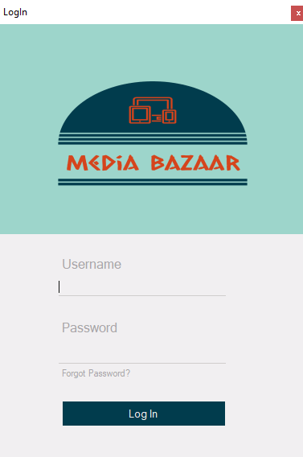

Figure 1: Login

**Manager**

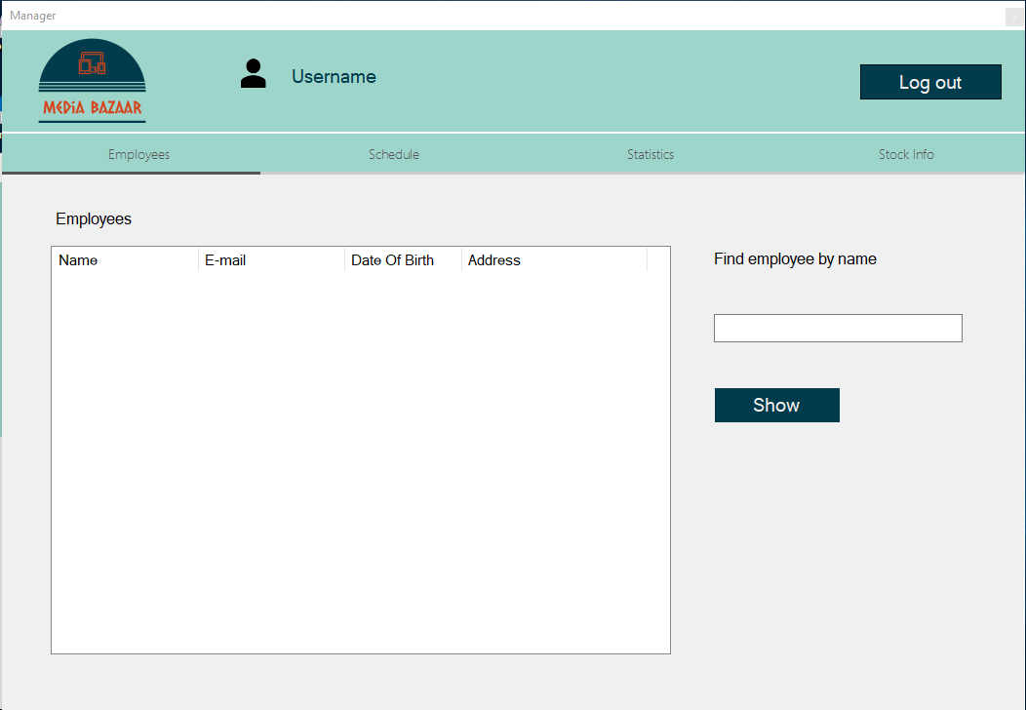

Figure 2: Employee Tab

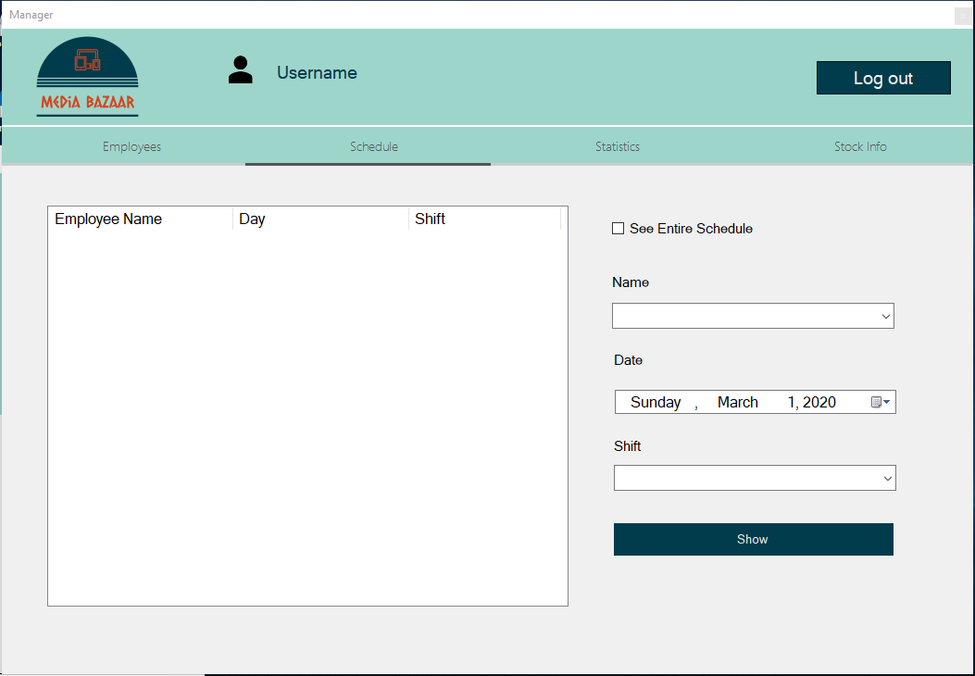

Figure 3: Schedule Tab

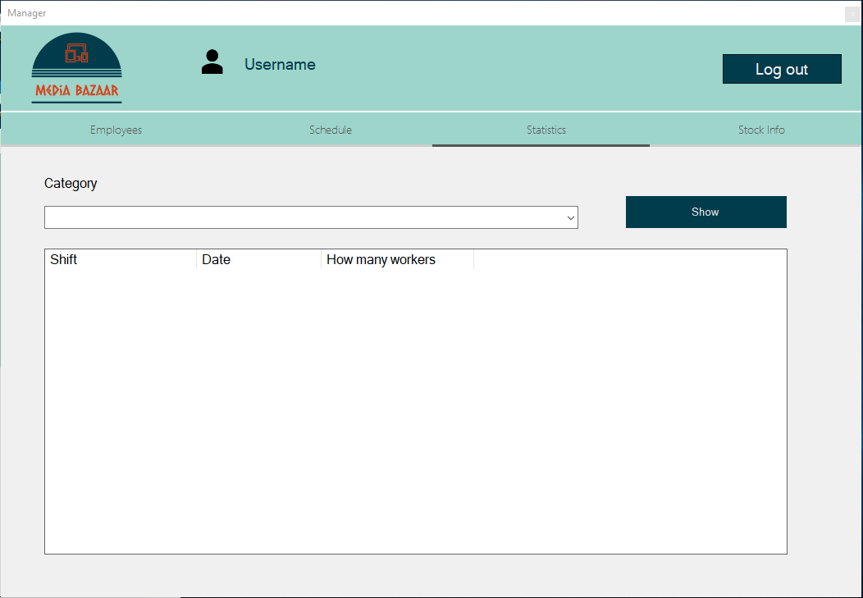

Figure 4: Statistics Tab

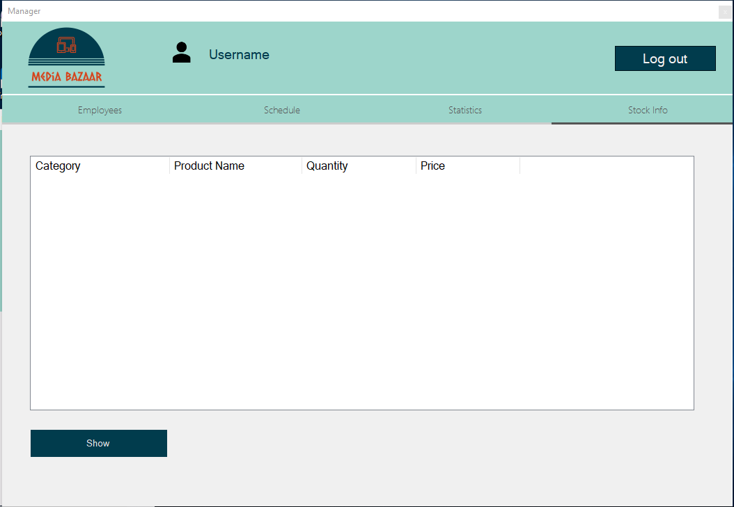

Figure 5: Stock Info Tab

**Administrator**

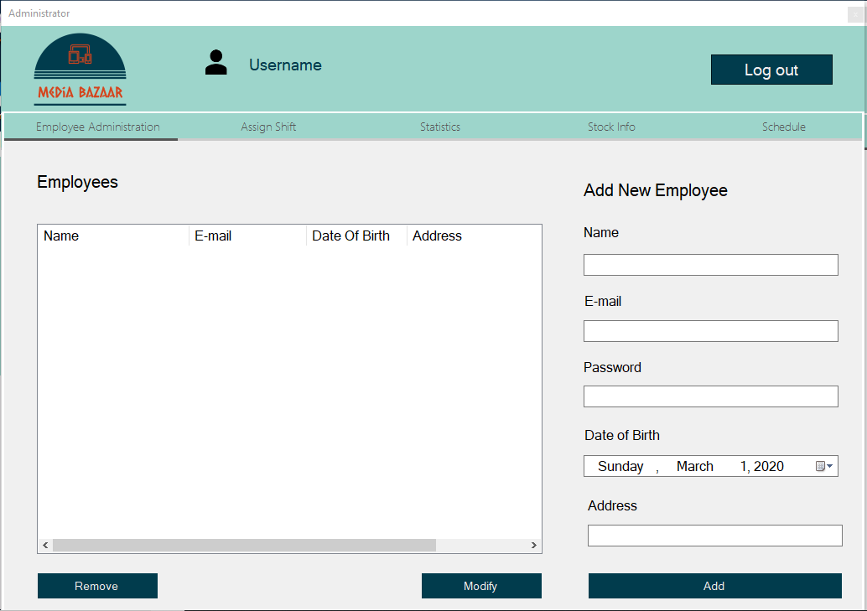

Figure 6 : Administration Tab  
  
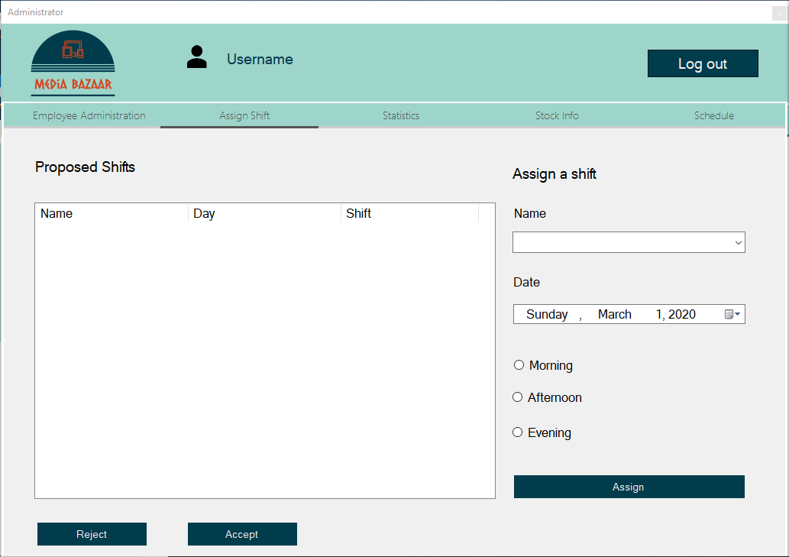

Figure 7 Shift Tab

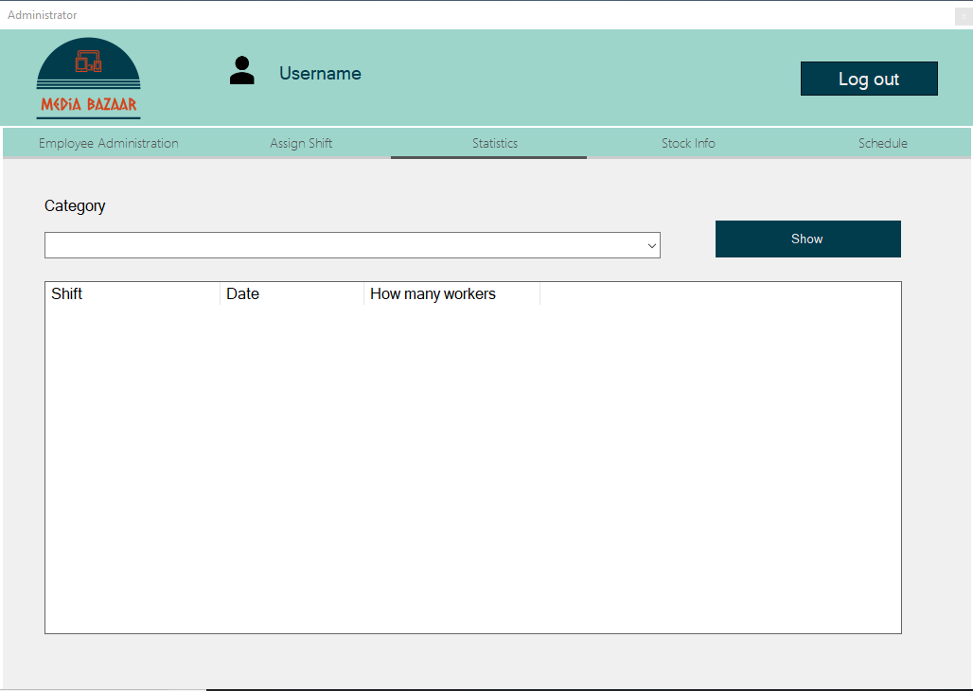

Figure 8 Statistics Tab

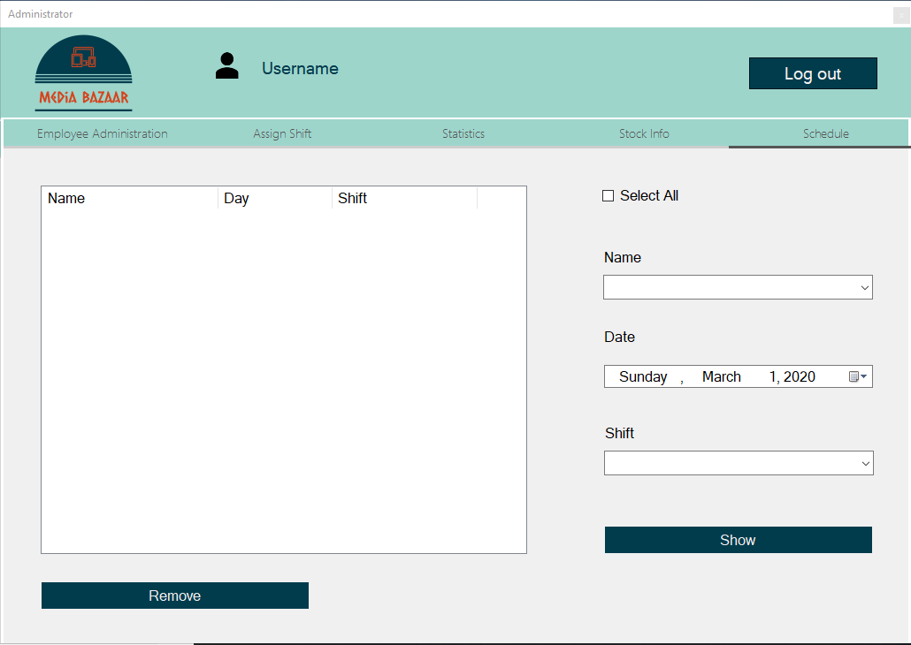

Figure 9: Schedule Tab

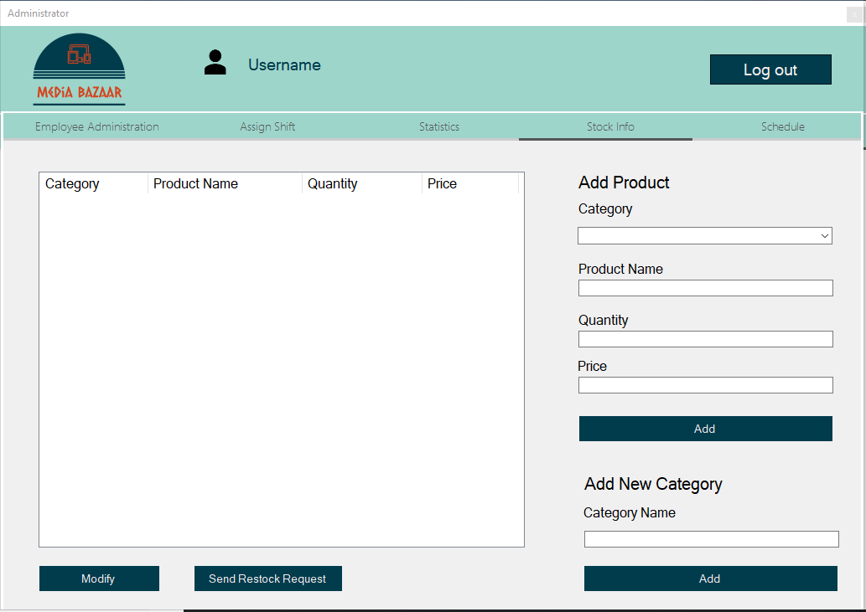

Figure 10 Stock Info Tab

**Depot worker**

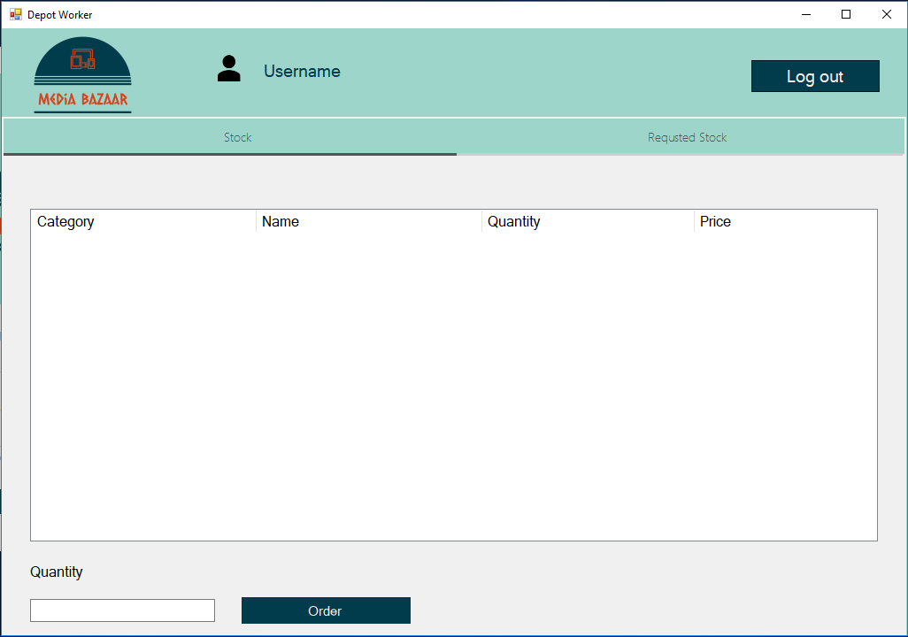

Figure 11 Stock Tab- DEPOT WORKER

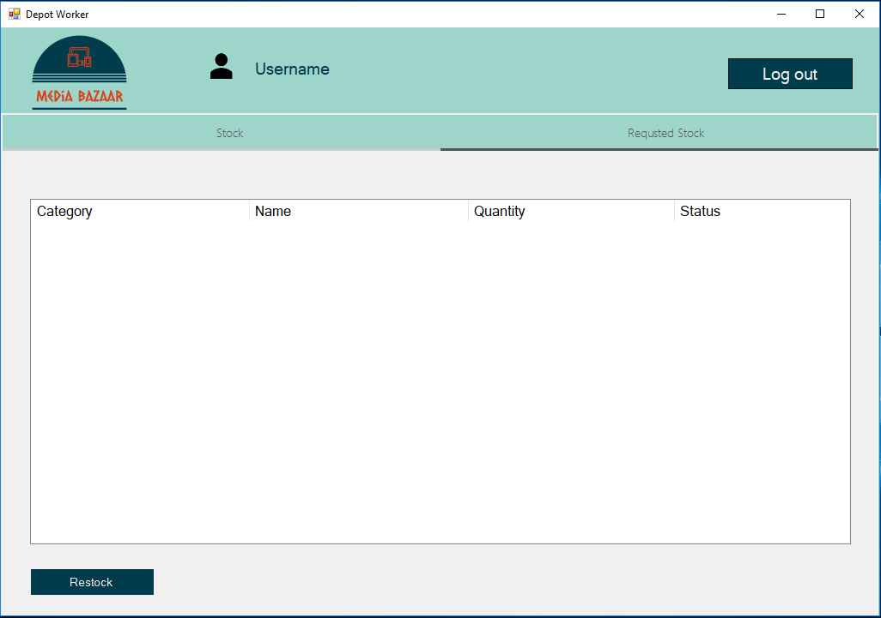

Figure 12: Requested Stock Tab