Part 1: Capturing HTTP Traffic.
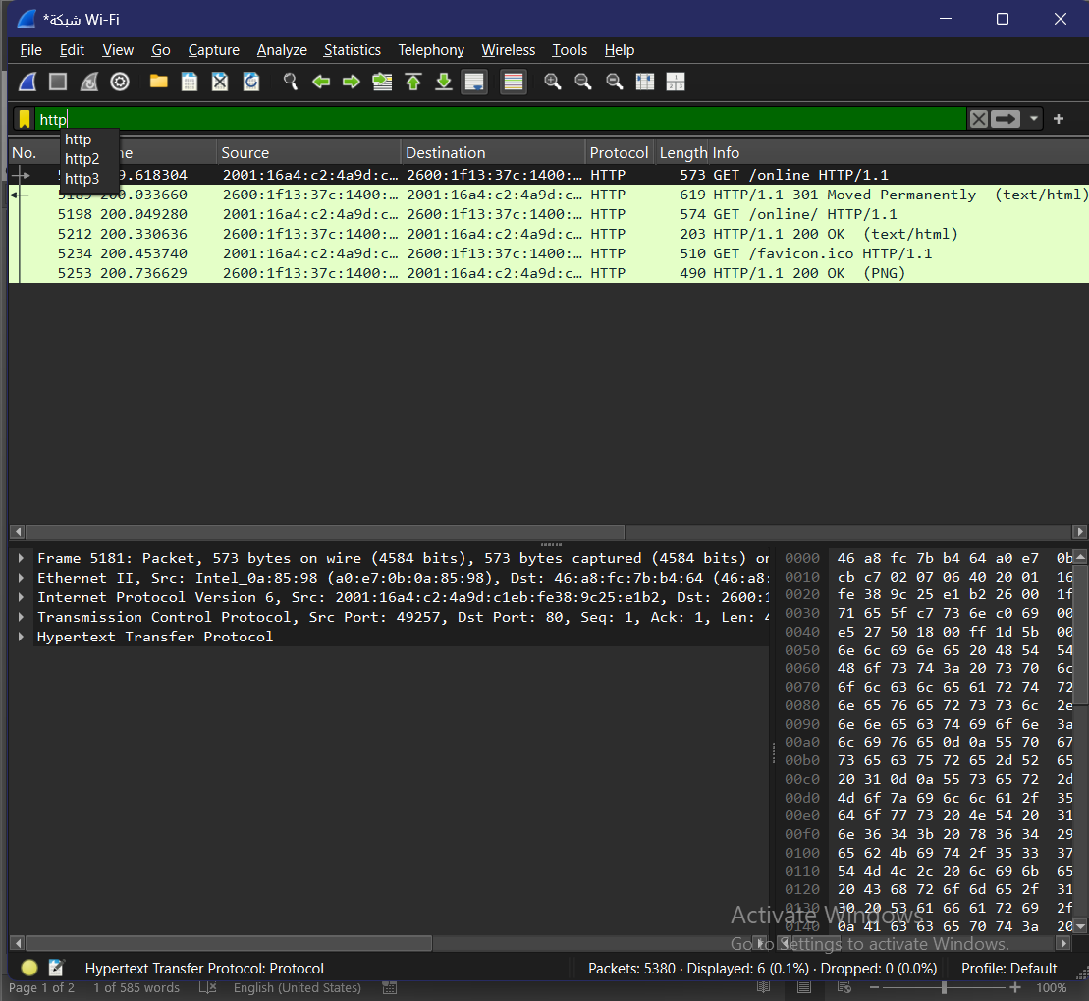

Part 2: Analyzing TCP/IP Traffic.
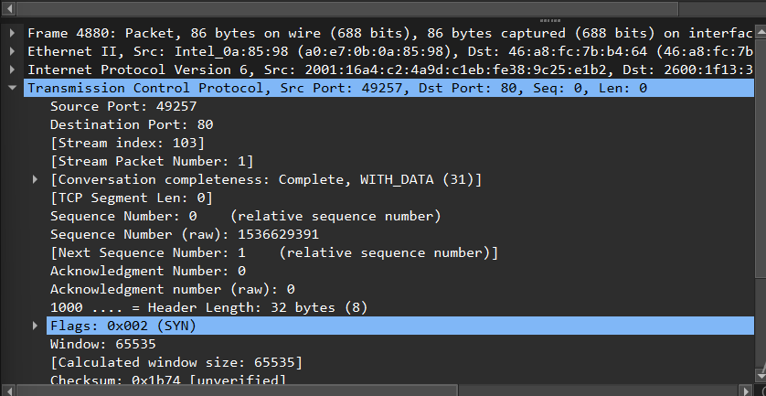
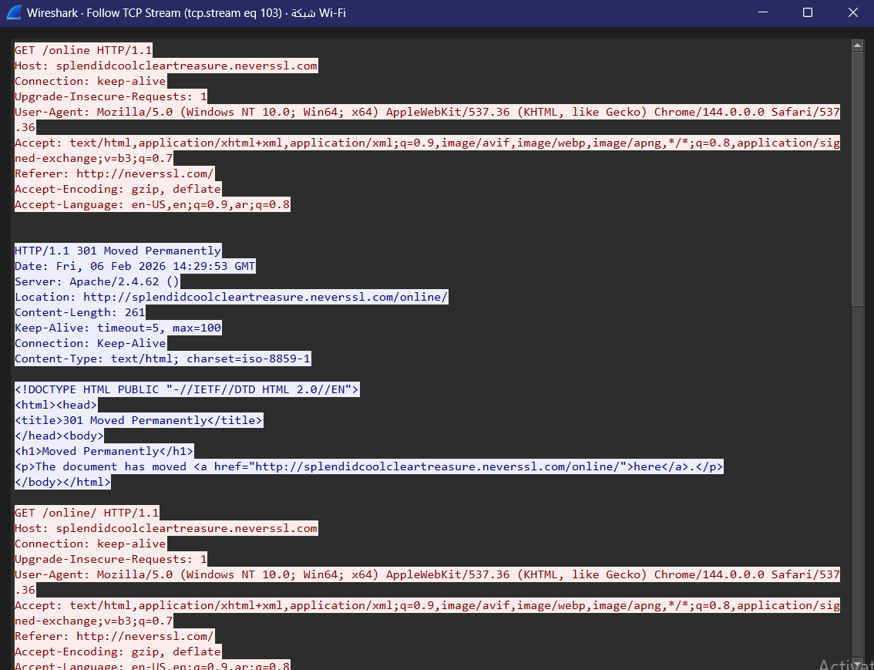

Part 3: Capturing and Analyzing UDP Traffic
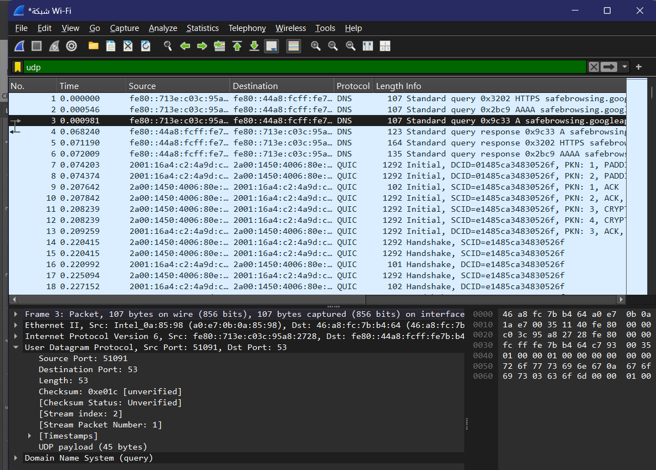
Part 4: Comparing TCP and UDP by filling in the following tables.
Task 1: Fill in the following table and provide reasons.
TCP or | Reasons

UDP

Reliability and Connection Establishment | TCP | It uses the three-way handshake (SYN, SYN-ACK, ACK) to establish a connection and ensures all packets are  delivered.
Data Integrity and Ordering | TCP | It uses Sequence Numbers to reorder packets if they arrive out of order and retransmits lost data.
Task 2: Identify the use Cases and Performance of TCP and UDP.
TCP | UDP

Use cases | Web browsing (HTTP/HTTPS), Email (SMTP), File transfer (FTP). | Video streaming, Online gaming, VoIP (Voice over IP), DNS.
Performance | Slower due to the overhead of connection setup, error checking, and flow control. | Faster and more efficient because it has no handshake and minimal header overhead.

